Sakara Lauren Campbell-Smith
1908201
Molly jack – lecturer
BMSW4002 – GROUP 9

EFFECTIVE WORKING AND COMMUNICATION REPORT

CONTENT PAGE
- INTRODUCTION……………………………………………………………. PAGE 3
- COMMUNICATION METHODS …………………………………. PAGE 4
- MODULES OF COMMUNICTION …………………………… PAGE 6
- COMMUNICATION AT THE WORKPLACE ……………………… PAGE9
- BARRIERS OF COMMUNICATION ……………………………………… PAGE 9
- HOW COMMUNICATION CAN BE IMPROVED……………………… PAGE 13
- CONCLUSION………………………………………………………………. PAGE 13
- REFERENCE…………………………………………………………………… PAGE 13

INTRODUCTION
The purpose of this report is to understand the different ways employees communicate and the effectiveness of the communication when its is done well in the workplace.
Communication is crucial in the workplace as it helps employees send messages to others for understanding, communication comes in full effect at work when you are working as a team. Teamwork means “that people will try to cooperate, using their individual skills and providing constructive feedback”. Ref. Effective teamwork in a workplace can make a business very successful as everyone Is working together for the better of the business, communication and teamwork play hand in hand as in order to have great teamwork you need to be able to communicate well.
I am a professional hairdresser and cleaner, being self-employed it’s very important that I communicate effectively with my customers for my business to grow, get clients and be successful, as promotion can come from word of mouth its important I can communicate with understanding to all my customers no matter their background or culture . The main duties of my workplace are to keep a safe and tidy environment, book and confirm styles, promote myself through social media. I also have a system where you must pay half of your service on PayPal before you come and get your style done, my services I include is: weaves, wig application, wig making, haircuts, colouring hair, perms, treatments, Brazilian blow dry is just some of the services I provide.

Communication methods
Communication methods refer to verbal, nonverbal and written all of this are ways in which we communicate at work to get a message across to other employees or customers.
Verbal communication
Verbal communication is a distinct (linear) distinct means that messages have a clear beginning and end and are expressed in a linear fashion. (ref). verbal communication is a single way of communicating by using words. At work I use verbal communication more than anything as to get customers I have to use my words for example I have to be able to speak to customers about the services I provide and if a customer is running late they will call me and communicate that they are running late and I will communicate back with them, if its more then half an hour late I will charge a 10 pound late fee.
Nonverbal communication
Nonverbal communication is communicating without speaking, so that’s the use of body language, facial expressions, gestures, eye contact, posture and tone of voice (MICHEAL COOPER) effective communication.
All of these nonverbal methods of communication works well in the working world to get your points across or how you may be feeling to your colleagues or customers, take for example in my work my body language and facial expressions can be taking wrong if am not careful how I conduct myself.
I try to stand with my legs shoulder length apart to give myself the right standing structure because if I am slouching, bent over this is not sending the right message to my customer. If I am rolling my eyes or fidgeting a customer could perceive that I am not really interested in what they have to say or that I am not sure with what I am saying to them. At work a customer came into my salon and just by her facial expression I could see she was really upset without her even having to express that to me, so from that I was able to adapt my approach to her being sensitive to her emotions and wat she was going through at that moment in time.
Written communication
Written communication helps “ laying down apparent principles, policies and rules for running of an organization, it is a permanent means of communication, where record maintenance is required” ( ref) this could be the use of a register at work where each employee will have to sign in on a sheet to mark their attendance in order to get paid and for safety reason, the manager needs to know who is in da building at all times in case of a emergency. Also at work written communication can be very useful because if your manager calls a meeting you will be able to write down notes of what is being said and always return back to your notes for more understanding and to remember what was said in the meeting.

Modules of communication
Shannon weaver (in organisational communication)
Information source → Transmitter → Channel
(sender) (encoder) ↙↙↙( noise source) ↙

Destination ←← reception ←
(receiver) (decoder)
Sender – The originator of message or the information source selects desire message.
Encoder – The transmitter which converts the message into signals.
Decoder – The reception place of the signal which converts signals into messages. A reverse process of the encode.
Receiver – The destination of the message from sender.
Noise – The messages are transferred from encoder to be decoded through the channel. During this process the message may get distracted or affected by physical noise like horns, thunder and crowd noise or encoded signal may distract in the channel during the transmission process which affects the communication flow, or the receiver may not receive the correct message.
We did some in class exercises which help us gain more understanding of the Shannon weaver module, we were given a scenario of a typical day at work and had to see why the message the manager was trying to get across to his employee please see below my evidence explaining the barriers to why the communication got disrupted (noise).
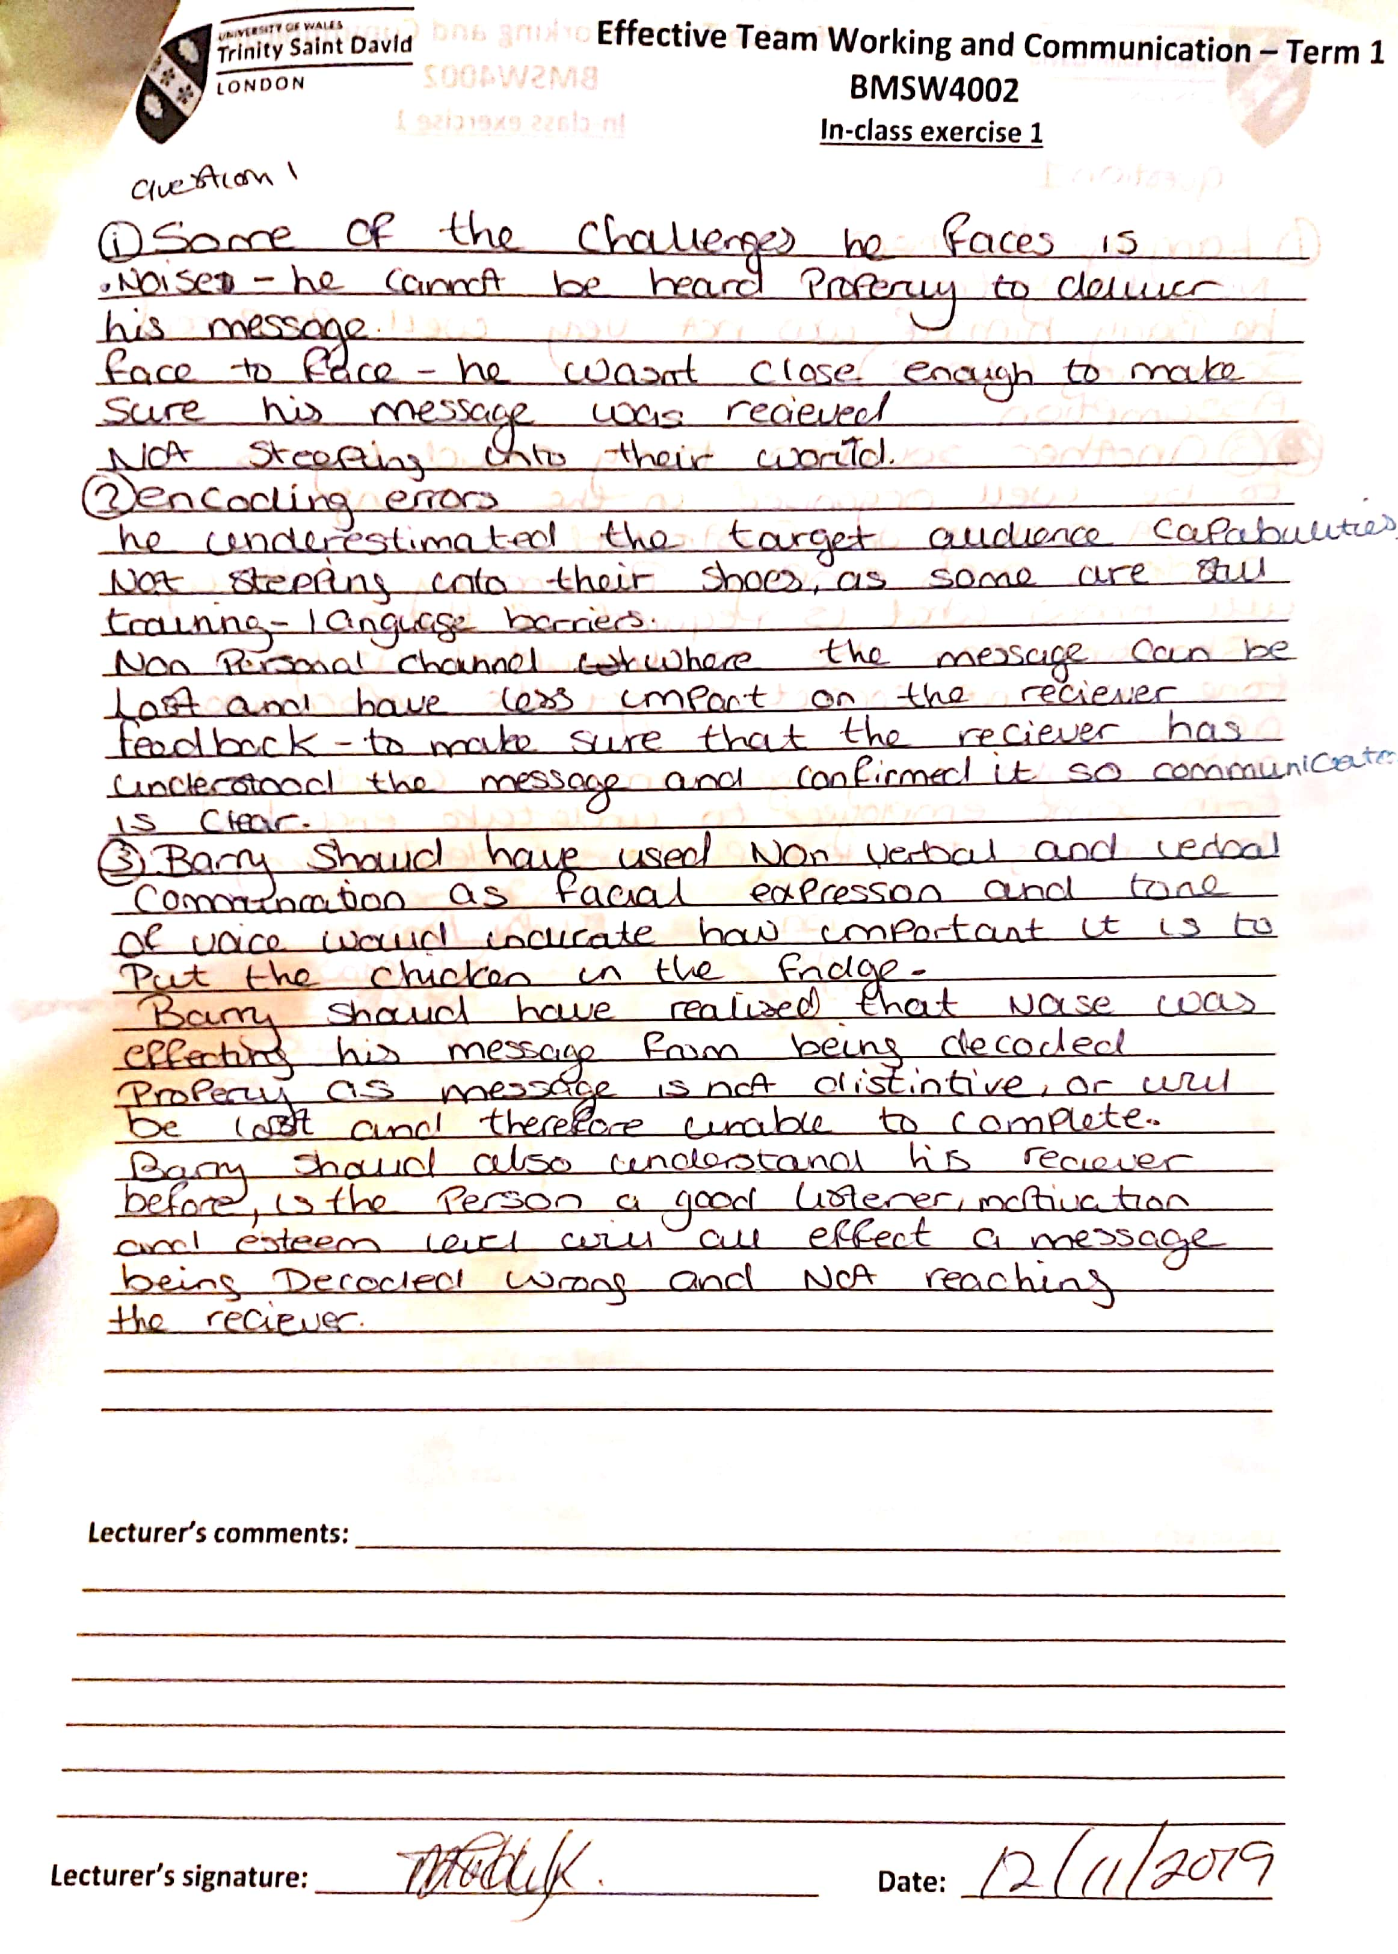
At work your manager can call you while you are serving customer which the communication can be blocked, I am self employed with my business being based at home for example Shannon weaver module can play a big part in miscommunication at work as I am usually very busy in the daytimes with lots of clients coming into my home so there can be a lot of (noise) in my home at one time, I remember a client became very distress with the noise as I couldn’t hear what she was asking me about her hair, she showed me her hair style that she wanted but I wasn’t aware that she was trying to inform me that her scalp was feeling very tender today if I can please be gentle so when I didn’t hear her request she got quite upset which I had to apologise sincerely. It’s important to communicate well with others so there is no room for misunderstanding or mis communication, I have taken into consideration this incident and I no longer allow clients to come with children or friends when getting there hair done to limit the amount of noise.
SCHRAMMS
(in organisational communication)refrence
ENCODER MESSAGE DECODER
INTERPRETER INTERPRETER
DECODER MESSAGE ENCODER

Encoder -who does encoding or sends the message
Decoder -who receives the message
Interpreter -person trying to understand (analyse), or interpret
Ref “according to Schramms communication model, communication is circular, the sender and recipient of the message can be the same person or a different person.
Schramms model is stating that the person who starts the message the communication can be the same person to decode and interpret the message to the same person or a different person, basing the communication being a two-way thing.
It is effective to use Schramms model at work as most transactions take two people communicating back and forth. For example I use Schramms method at work when I am talking to my clients about payment as it requires me to start the conversation and my client to interpret what I have said and decode it and send back a message to me stating if the payment price is ok and how they are going to be paying for the service they received.
BERLOS MODULE OF COMMUNCATION
SOURCE → ENCODES MESSAGE → CHANNEL DECODES RECIEVER
↓ ↓ ↓ ↓
COMMUNCATION SKILLS CONTENT HEARING COMMUNCATION
ATTITUDES ELEMENTS SEEING ATTITUDES
KNOWLEDGE TREATMENT TOUCHING KNOWLEDGE
SOCIAL SYSTEM STRUCTURE SMELLING SOCIAL SYSTEM
CULTURE CODE TASTING CULTURE
Berlos model of communication focuses on four main principles they are sender, message, channel and receiver. (In businesstopia, February 4 2018)
This module is basing its methods of communication on the source being the main person to speak after collecting their thoughts and sending it to the receiver leaving no room for noise or any other aspect that could affect the communication.
The use of Berlos model of communication at work is by me the hair stylist taking into account when I speak to my clients if there is any barriers which could affect out communication for example when I am dealing with a client from a different culture or knowledge, me as the origin of the message has to take into account and making speak more clear and slower for better understanding and communication.
CULTURE
Culture plays an exceptional part in communication as to communicate effectively you need to firstly understand where the other person is coming from, be able to understand the person speech and dialect.
Culture is based on attitudes, knowledge and your social system it plays a big part in the way you communicate as Berlos model suggest, so taking into consideration when communicating you should try and relate to someone with the same life experiences and culture to make them have a better understanding. Muslims who choose to cover their faces and bodies have a cultural way of showing they have strong beliefs in their religious faith.
COMMUNCATION AT THE WORKPLACE
Verbal communication
At work I use verbal communication by writing to customers by emails, booking appointments, confirming a style, request all by contacting my clients verbally so I can get a response. I also communicate at work by speaking to my customers making sure the service they are getting is what they wanted, as a hair dresser it is vital to communicate with my clients to build rapport with them so they are comfortable and trust me to do their hair.
Nonverbal communication
At work I use nonverbal communication such as gesture and body language to show my clients that I am ready to commence the service for them. I also use nonverbal communication with some clients for example most of my clients are very religious and without speaking to me I know that I must have my music playing non offence songs and my environment suitable for their needs.
Sometimes I find clients coming over to me asking me if I am ok if I am tired and would like a rest, this is just simple because of the way I am standing and my posture is communicating to my clients that I am tired or been standing with the wrong body structure for comfort, altogether at work nonverbal communication can say a lot without the use of speaking.
Barriers of effective communication
André Gide (French author and winner of the Nobel Prize in literature in 1947).Nobel Prize in literature in 1947).
. Physical barriers
. Attitudes
. Physiological barriers
. Language barriers
. Problems with structure design
. Cultural noise
. Lack of common experience
. Ambiguity and abstraction overuse
. Information overload
. Assumptions and jumping to conclusions
All the list above are barriers to effective communication I am going to talk on 4 of them.
. Language barriers effect communication because you need to be able to understand a person’s dialect or speech to be able to communicate back to them, specially at work it can be a very confusing time for the other person if you cannot speak the same language as them as they will find it really hard to understand what is being communicated to them as it’s a different cultural noise therefore being a barrier in communication.
. Attitudes being a barrier to effective communication for example if you are extremely nervous all the time and find it hard to get a point across or communicate as you are too shy this can be a barrier in effective communication, at work you need to be able to communicate well with full understanding of the others you are communicating with so being nervous will block you from having a successful conversation with clients.
. Physical barriers can affect communication such as if where you are trying to communicate is to noisy that is a barrier to communication because the conversation will become lost in the background noise.
. Physiological barriers are a barrier because as it covers ill health and poor eye sight and hearing, in order to communicate at work effectively you need to have fairly good eyesight and be able to hear when a client is speaking to you so there is no barrier to communication.
How communication could be improved in the workplace
I personally think that being a self employed hair dresser helps me take full control of my surrounding and how I communicate with my clients, a couple things I can take into consideration is use open ending questions and if I don’t know something just say I don’t know and lastly do not enter a conversation thinking that I know it all.
Conclusion
This report is about how I communicate at work, it has shown me different ways of communication and how I can use more effective ways of communicating with my clients. I think in all its very useful to educate yourself on different ways of communicating so you can be successful.

Reference
Effective communication skills MICHEAL COOPER
www.communcationtheory.org/shannon-andweavermodel-of-communication
www.communicationtheory.org/osgood-schramm-model-of-communication
www.businesstopia.net/communcation/berlo-model-communcation
www.toolshero.com/communation-skills/schramm-communcation-model

