

Changemakers: Creativity and Value Creation
Professions (BMHP5014)

Student name: Onyemaechi Christian Meregini
Student number: 2413001
Lecturer’s name: Laila Surani

Topic:
Component 2: Poster & Pitch

Date of Submission
1st May 2026

Table of contents
Poster……………………………………………………………………………….3
Pitch…………………………………………………………………………………4
Introduction…………………………………………………………………………4

The Scale of Childhood Obesity in London………………….…………………..5

Contributing Factors………………………………………………………………..5

Poor Diet and Food Environment………………………………………………….5

Physical Inactivity……………………………………………………………………5

Socioeconomic Inequality…………………………………………………..………5

Parental Influence and Awareness………………………………………..………6

Impact on Children and Services…………………………………………..………6
Recommendations………………………………………………………………………………….6
Conclusion……………………………………………………………………………………………..7
References………………………………………………………………………………………………8

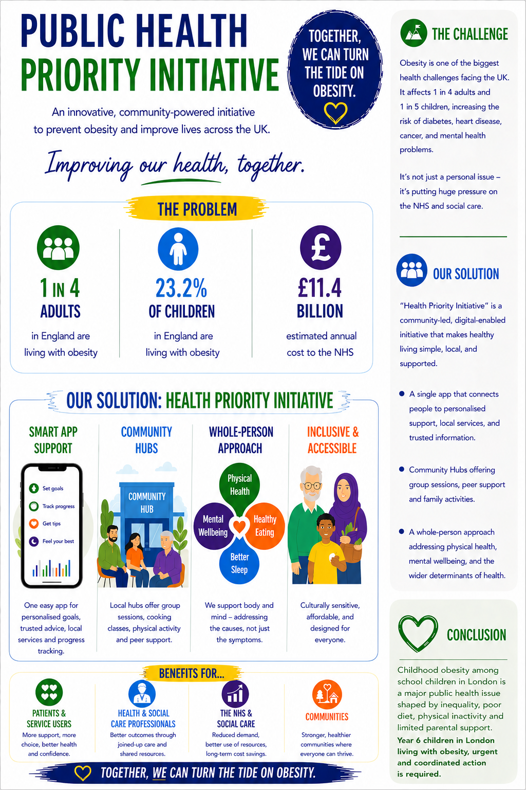
POSTER

PITCH

Childhood Obesity in School Children in London:

A Public Health Priority “Initiative”

Introduction
Childhood obesity is one of the most pressing public health challenges affecting school-aged children in London. It is associated with significant short- and long-term health consequences, including type 2 diabetes, cardiovascular disease, poor mental health, and reduced quality of life. In the United Kingdom, childhood obesity is increasingly recognised not only as a clinical issue but also as a social and structural concern shaped by poverty, food environments, physical inactivity, and health inequalities (NHS England, 2024).
London presents a particularly important context for examining childhood obesity because prevalence rates are higher than the national average, and inequalities between boroughs are stark. Recent data show that 23.2% of children in Year 6 (aged 10–11) in London are classified as obese, compared with 22.2% nationally. Rates are significantly higher in deprived boroughs such as Southwark (29.7%), Tower Hamlets, Barking and Dagenham, and Newham, compared with more affluent boroughs such as Richmond upon Thames (12.1%) and Kingston upon Thames (14.6%) (Trust for London, 2026).
This report explores childhood obesity in school children in London, examining its causes, consequences and contributing social determinants. It also considers the role of parents, schools and communities in tackling obesity and proposes a practical, time-framed strategy for prevention and intervention. The report concludes with recommendations to improve awareness, early intervention and long-term outcomes for children and families.

The Scale of Childhood Obesity in London
Childhood obesity in London is a significant and growing concern. The National Child Measurement Programme (NCMP) continues to show that London has some of the highest childhood obesity rates in England, particularly among children leaving primary school. In 2024/25, almost one in four Year 6 children in London were classified as obese, and obesity was more than twice as common in some deprived boroughs than in wealthier areas (Trust for London, 2026).
The problem begins early. NHS England reported that 9.6% of children in Reception (aged 4–5) were obese in 2023/24, rising to 22.1% by Year 6 (aged 10–11), suggesting that unhealthy weight gain often develops during the primary school years (NHS England, 2024). This trend is concerning because obesity in childhood is strongly associated with obesity in adulthood, leading to increased lifetime risk of chronic illness and health inequalities (NHS England Digital, 2026).
The burden is not equally distributed. Children living in deprived areas are significantly more likely to be obese than those in affluent communities. NHS England Digital (2026) found that among children aged 11–15, obesity prevalence was 30% in the most deprived areas compared with 8% in the least deprived areas. This highlights the strong relationship between deprivation and childhood obesity and reinforces the need for targeted public health responses.

Contributing Factors

Poor Diet and Food Environment
One of the main drivers of childhood obesity in London is poor diet, particularly the high consumption of calorie-dense, nutrient-poor foods. Children in urban areas are often exposed to unhealthy food environments, including fast-food outlets near schools, aggressive marketing of high-fat, salt and sugar foods, and easy access to sugary drinks and snacks. These environments disproportionately affect low-income communities, where cheaper, processed foods are often more accessible than healthier alternatives (The Guardian, 2024).
School food also plays a significant role. While school meals can improve nutrition, inconsistent food quality and poor uptake remain challenges. Evidence suggests that universal free school meals can reduce obesity among primary school children by improving access to nutritious food and reducing stigma (The Guardian, 2024).

Physical Inactivity
Reduced physical activity is another major contributor. Many children in London have limited access to safe green spaces, playgrounds and recreational facilities. Urban density, traffic, safety concerns and reduced school play spaces all limit opportunities for active play. Children are also increasingly sedentary due to screen time and digital entertainment. A lack of safe outdoor space has been linked to worsening childhood obesity and widening inequalities in physical activity (The Guardian, 2024).

Socioeconomic Inequality
Childhood obesity in London is closely tied to poverty. Families on lower incomes may face barriers to healthy eating, including food insecurity, high costs of fresh food, lack of cooking facilities, and limited time due to work pressures. Obesity is therefore not simply a matter of personal choice but is shaped by structural inequality and social determinants of health (NHS England Digital, 2026).

Parental Influence and Awareness
Parental awareness is central to tackling childhood obesity. Parents shape children’s diets, routines, physical activity, and health behaviours. However, some parents may not recognise when their child is overweight, may normalise unhealthy eating habits, or may lack confidence in making dietary changes. NHS England Digital (2026) found a clear association between parental BMI and childhood obesity, with children significantly more likely to be obese if their parents were overweight or obese.
This demonstrates that tackling childhood obesity requires not only targeting children but also increasing parental knowledge, confidence and engagement.

Impact on Children and Services
Childhood obesity has significant consequences for children’s physical, emotional and social wellbeing. Physically, obesity increases the risk of asthma, joint problems, sleep difficulties, insulin resistance and early-onset type 2 diabetes. Emotionally, children living with obesity are more likely to experience low self-esteem, stigma, bullying and anxiety. These effects can affect school attendance, social participation and educational outcomes (NHS England, 2024).
The impact extends beyond the child. Childhood obesity places growing pressure on NHS and social care services. NHS England estimates obesity-related ill health costs the NHS approximately £6.5 billion annually across all age groups, with increasing demand for specialist paediatric obesity services (NHS England, 2024). Without early intervention, this burden will continue to rise.

Recommendations
Addressing childhood obesity in London requires a coordinated, long-term and community-led response. The following recommendations propose a practical framework with clear timeframes.

Short-Term (0–12 Months): Awareness and Early Engagement
In the first 12 months, the focus should be on awareness and prevention. Schools, local authorities and NHS partners should deliver borough-wide parental awareness campaigns to improve understanding of healthy weight, nutrition, portion sizes and physical activity. These campaigns should be culturally sensitive, accessible and delivered through schools, GP surgeries, faith groups and community centres.
Parents should receive:
- simple nutrition guidance
- healthy lunchbox resources
- sugar reduction advice
- support to understand NCMP feedback
Schools should also introduce regular parent workshops on healthy eating and active lifestyles.

Medium-Term (1–3 Years): Community-Based Intervention
Over 1–3 years, London boroughs should establish community-based healthy weight hubs offering:
- family cooking sessions
- child-friendly exercise programmes
- healthy shopping support
- parenting groups
- referral pathways to weight management services
These services should be targeted in high-prevalence boroughs such as Southwark, Newham and Barking and Dagenham, where need is greatest (Trust for London, 2026).
Schools should also expand:
- daily movement initiatives
- breakfast clubs
- active travel schemes
- school food monitoring

Long-Term (3–5 Years): Structural and Policy Change
Long-term action should focus on structural change. Local authorities should:
- restrict fast-food outlets near schools
- expand access to green spaces
- improve school meal standards
- embed obesity prevention in borough health strategies
Policy should also support sustained investment in prevention and universal family health programmes.

Conclusion
Childhood obesity among school children in London is a major public health issue shaped by inequality, poor diet, physical inactivity and limited parental support. With almost one in four Year 6 children in London living with obesity, urgent and coordinated action is required.
Tackling childhood obesity requires more than individual behaviour change. It requires whole-system action involving schools, parents, communities, public health and local government. Raising parental awareness, strengthening community support and improving local environments are essential to reducing childhood obesity and improving long-term health outcomes.
A phased approach—combining short-term awareness, medium-term intervention and long-term structural reform—offers the most effective strategy for tackling childhood obesity in London and creating healthier futures for children.

References
NHS England (2024) Almost one in ten children obese in first year of school. Available at: https://www.england.nhs.uk (Accessed: 24 April 2026).
NHS England Digital (2026) Health Survey for England 2024: Children’s overweight and obesity. Available at: https://digital.nhs.uk (Accessed: 24 April 2026).
The Guardian (2024) Free school meals cut obesity and help reading skills in England, study finds. Available at: https://www.theguardian.com (Accessed: 24 April 2026).
The Guardian (2024) Alarming lack of access to green space fuelling UK child obesity crisis, doctors warn. Available at: https://www.theguardian.com (Accessed: 24 April 2026).
Trust for London (2026) Childhood obesity by London borough. Available at: https://trustforlondon.org.uk (Accessed: 25 April 2026).
Gatineau M, Dent M (2011) Obesity and Mental Health. Oxford: National Obesity Observatory.
Yvonne Kelly, Alice Goisis, and Amanda Sacker (2015) Why are poorer children at higher risk of obesity and overweight? A UK cohort study. The European Journal of Public Health
Chanfreau et al (2016): Out of school activities during primary school and KS2 attainment
Public Health England (2015) Sugar Reduction: the evidence for action.
Brooks, F. et al (2010) Health Behaviours in School-aged Children
The Scientific Advisory Committee on Nutrition (2015) Carbohydrates and Health

