University of Wales Trinity Saint David
School of Engineering
Advanced Computational Methods
Ashley Morris
P149364
Mechanical engineering
23/01/2020
Transient Thermal Diffusion
Model using the Finite Difference Method
M6X00408


Contents
1 Introduction to the problem under consideration 2
2 The constitutive equation of the problem 2
3 Description of the numerical method chosen to discretised the constitutive equation 4
4 The initial and boundary conditions implemented. 5
5 Details of your Finite Difference model 5
6 Analysis of the code results 11
7 A discussion as to the limitations of the model 15
8 Suggested improvements to the model 15
9 Conclusion 15
10 References 16
11 Appendices 16

Introduction to the problem under consideration
This assignment gave a task to implement a model in MATLAB of a time-dependant thermal diffusion equation using the finite difference method. This is to help calculate the temperature distribution within a rectangular plate; done through using initial temperature boundaries on top of the plate. The plate used will be an aluminium plate and will contain a temperature distribution over time. This will then be illustrated over time as the plate heats up until it hits equilibrium. Within the MATLAB code several inputs have to be implemented by the user. This user will then enter in their inputs, these include such things as, dimensions along the “X” axis, dimensions along the “Y” axis; a time step value and a grid spacing value, from this the code should be able to determine whether the equation is correct and valid. The code with then calculate the temperature at each time step. The code will finally stop running once it his equilibrium within the plate. Users inputs must follow certain rules, these include; no negative values, no letters and in the case of the time step, no number bigger than the value displayed on the screen. The grid spacing has to be in complaints with the “X” and “Y” values. There are properties that the aluminium plate must follow, these include conductivity, density and specific heat. The main body of the code will follow finite differential equation, this will include looking at the Taylor series and heat transfer within finite differential equation.

The constitutive equation of the problem
Conduction is a type of heat transfer in which energy exchange takes place in solids or fluids while at rest. This is because of the internal temperature gradient. Direct contact is required for conduction to happen: Conduction in solids is described by the following thermal diffusion equation (Lewis, et al., 1996).
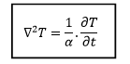
Figure 1 (Lewis, et al., 1996)

Is the laplacian, this can also be put into a separate equation shown below in three dimensions;
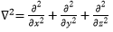
Figure 2 (Lewis, et al., 1996)
In regards to figure one, the ‘T’ is the temperature, where ‘t’ is the time, alpha has the equation α=k ⁄ (ρ.c) is the thermal diffusivity measured in [m2.s-1], the thermal conductivity is ‘k’ and is measured in [W.m-1.K-1], ‘p’ is the density [kg.m-3], and finally ‘c’ is the specific heat [J.kg1.K-1]. If an internal heat is added to the equation, this changes the equation to the following;
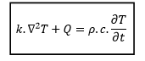
Figure 3 (Lewis, et al., 1996)
As is shown in figure 3, Q is added to the equation as internal heat and the has been changed [ρ.c]. The plate being used will be covered as a uniform grid. This will later on give us our grid spacing. This is measured by the following equation h=∆x=∆y=∆z (Lewis, et al., 1996).
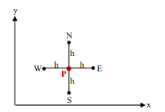
Figure 4 (Lewis, et al., 1996)
Figure four shows the directions in which the code will be working from. For simplicity the code will be looking at values as if it’s a compass, using north, south, east and west. This is within a 2D plate. So, the idea behind the finite difference technique is to substitute the original coordinate, by using original coordinate and the various points of the compass. This is called the Taylor series expansion. Thus, changing differential equation into a set of algebraic equations. These algebraic equations can then be solved once an initial boundary condition is set (Lewis, et al., 1996). The Taylor series is shown in the figure below;
Figure 5 (Lewis, et al., 1996)
The Taylor series can also be written as shown below;
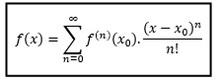
Figure 6 (Lewis, et al., 1996)

Description of the numerical method chosen to discretise the constitutive equation
The differential equation is represented by the finite difference form, this is by using the central differences to discretize and forward differences to discretise (Lewis, et al., 1996). This allows us to come up with the following equation;
$$\frac{1}{F0}Tp^{n+1}=TN^{n}+TS^{n}+{TE}^{n}+{TW}^{n}-\left(4-\frac{1}{F0}\right).{Tp}^{n+1}$$
This equation is for the 2D conduction region.
Where F0 is the expression known as Fourier number. Fourier number has its own equation as stated below;
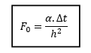
Figure 7 (Lewis, et al., 1996)
The number also has certain criteria that it cannot exceed, this is dependant conduction region, with 3D conduction area the Fourier number cannot surpass and must not reach zero (Lewis, et al., 1996). Whereas, for this assignment we will be looking at the limits for a 2D conduction region which are shown in the figure below.
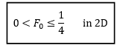
Figure 8 (Lewis, et al., 1996)
Therefore, as the script is running a Fourier’s number will be produced and if this number is outside of the Fourier’s number. The script will not run and new values will need to be entered into the script; these will be done through a stability section.

The initial and boundary conditions implemented.
The initial boundary conditions were based on an aluminium rectangular plate. The top or north edge of the boundary condition is based on Gaussians distribution or otherwise known as a normal distribution curve of temperatures of an amplitude at 100ºc. Where the lowest temperature is at 10ºc, this is at both ends of the north plate. This then increases in a mean distribution until it reaches its peak of 60ºc. The peak temperature of the north plate will be found at the midpoint of the north plate, from the distribution curve. This will give a bell curve to the north plate. The boundary conditions on the east, west and south walls are perfectly insulated where there is no heat flow through the part of the boundary. The heat temperature of the plate internally is 0ºc. The initial temperature of the plate itself is 0ºc A figure showing the boundary conditions is presented below.
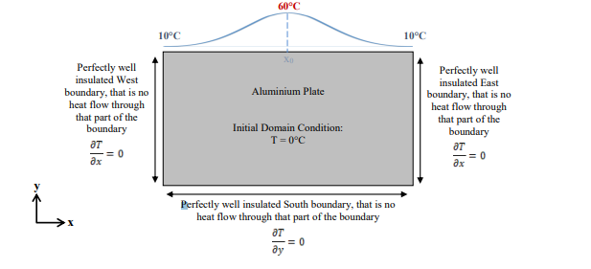
Figure 9 Boundary condition given

Details of your Finite Difference model
First thing done within the script was to enter the constants of the equation. These included the first and last temperature within the Gaussian curve, this is shown within the boundary conditions. A max temperature given in the boundary conditions. There are also constants used for, conductivity, density and specific heat. These are all labelled and given specific values. The constants such as these will be used later on in equations.
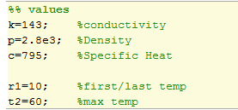
Figure 10 Values
The image above shows values that are concreate within the assignment, these have all been given their own letter to represent each constant. There a several script options available to the user, this is dependent on the user what is typed in. These options are X and Y axis, time step and the spacing of the grid spacing. The X and Y axis inputs are the dimensions of the plate, the time step measures the gap between each irritation of the matrix, the grid spacing size between each node of the matrix.
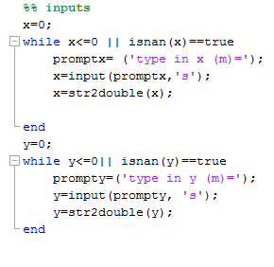
Figure 11 Inputs
Here are the imputes for the X and Y axis, first put x and y equal to zero this allows a ‘while loop’ to open for both. With a ‘while loop’ will allow a loop expression continuously as long as the expression is not met. The conditions are set above, ‘isnan’ is another function to stop the uses from putting in a letter or a value that is not a number. The other criteria for the input are to stop x value being zero or below. The user will then be asked to enter a value, once a credible value is entered, the code uses the function ‘str2double’ converts the text of Y into double precision value. By using this function, it prevents the user from putting a value in such as ‘k’ and taking the number from that, instead the script will reject this and ask the user to input a new value.
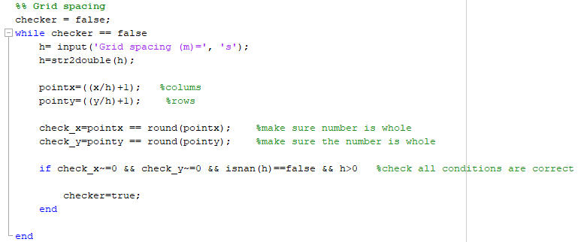
Figure 12 Grid spacing
Figure 12 shows the checker for the grid spacing, first we name our checker to make sure our grid spacing is correct. This is done through another ‘while loop’ using the checker as our statement for; the checker, next input a value for the grid spacing, this then goes through the function ‘str2double’, once this has done there are two equations which the code runs through, to see if the value placed for the grid spacing equals correctly to the next section which is for the values to be rounded to their nearest hole number. This is done for the X and Y axis. This is then proved with a ‘if’ statement, which allows me to put in certain conditions that if they are met. These include that the x input does not equivalated to zero, this is also replicated for the ‘y’ input; the other condition that needs to be met is for our entered grid spacing, this is done by stopping the grid spacing from being a letter or a number smaller than zero.
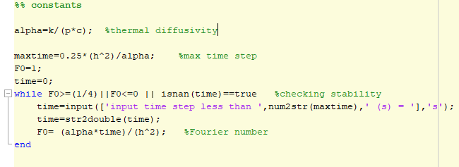
Figure 13 Constants
The next stage was to enter the constants within the code. This is done through using equations such as thermal diffusivity, this is labelled above. The max time step is then calculated through an equation. We then set our Fourier’s number to one and our time to zero, this puts a ‘while loop’ where Fourier’s number cannot exceed the limits presented, this checks the stability of the model. Within the ‘while loop’ the time will be input of the max time step which is shown as ‘num2str(maxtime)’, this tells the user the max time step that the user can use. Once the time step is entered, the time will equal ‘str2double(time)’ this is to make sure the entered value is a credible number. The fourth check is to put the number for the time step through Fourier’s figures, if the number comes back within the limits of the Fourier’s number the script will move on into the next section of the code.

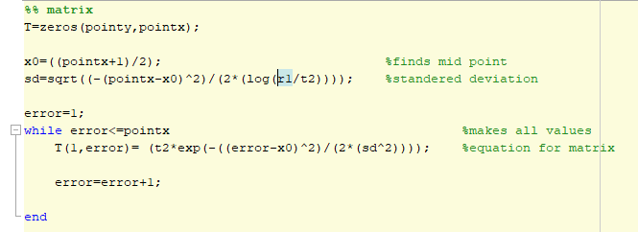
Figure 14 Matrix
At this stage a matrix can be made through y axis and x axis. The plate will be labelled as ‘T’, this has made a matrix of zeros before adding in our boundary condition. Next an equation is made to find the midpoint along the top of the matrix, this is then followed by the equation for standard deviation. This equation will evolve the max time: the first and last time placed in the equation, the standard deviation equation as spoken in the boundary conditions. An error point is first made equivalent to one, to set a ‘while loop’, where error is made smaller than our x axis. We then select the top row of the matrix and applying the Gaussian distribution curve, as spoken about in the boundary conditions. We then increase error by one, so that the while loop will close as soon as error matches the x value.
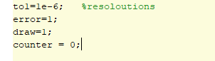
Figure 15 Resoloution
The resolutions were set at $1×{10}^{-6}$, this will be changed throughout the analysis to see results, along with the time step and grid spacing. Error was then re-set to one along with a draw value that will be used throughout the graph section of the code. The counter is the amount iterations it takes to finish the code, this will be displayed at the end of the code.
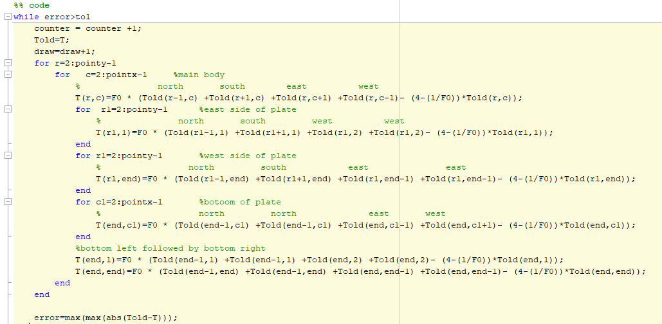
Figure 16 Code
This section of the code is on the finite difference method. First, we equal an old matrix with a new matrix, this is so the new matrix will add values based off the previous matrix, hence showing the finite difference equation working. The script will then proceed with ‘for’ loops to match the ‘x’ point with columns labelled by ‘c’ and y axis with rows marked ‘r’, next the plate is matched up with the finite difference method. The equation that follows is the finite difference method, and the irritations coming down are irritations of the equation changed slightly depending on what boundary the code is at; for example, when the code reaches the east boundary the west figure will be doubled. This is followed by the west boundary where the plate will take the east part of the point twice and the south will take the north part of the point twice. With the bottom right corner and bottom left corner, we want to find the north point twice, however they change depending on which corner is added. So, the bottom left corner will use east twice, whereas, the bottom right will use the west figure twice. The end section concludes when equilibrium will be met.
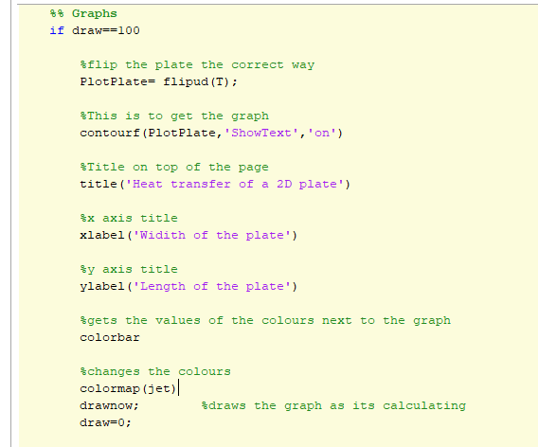
Figure 17 Graphs
This section of the code continues in the while loop however, it focuses on the graphical plots of the assignment. Within the while loop we put a ‘if’ statement in place to allow the graph to be drawn every 100 plots of the matrix. The matrix will then be flipped to plot the graph the correct way. The ‘contourf’ allows the plot of the heat graph, with the ‘showtext’ and ‘on’ within the line, showing the temperatures of the plate on the right-hand side; followed by tile page above the graph and the markings of x and y axis. The colours of the graph were changed to ‘colourmap(jet)’ and values of the temperature are displayed through the ‘colorbar’ function. The graph is then drawn live at every irritation.
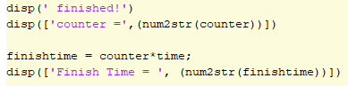
Figure 18 End condition
This is the end of the code where ‘finished will be displayed followed by the finish time “the time it will take for equilibrium to reach in seconds” along with the iterations it took to finish the code.

Analysis of the code results
A script was developed, originally, to prove the point of concept. This was to prove that method of the code worked, by making a code that produced clear sections of equilibrium. This was done through a linear code; the linear code would start with boundary condition of 50 degrees on the left-hand side, the top and bottom boundary would have values decreasing all the way to zero with equal spacing. The proof that the thermal differential equation worked in MATLAB, was to get all of the values in equilibrium within their respected columns. This is shown by the figure below;
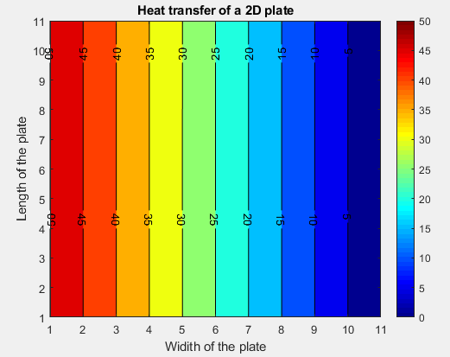
Figure 19 Heat transfer
The figure shows the temperature at equilibrium, the graph is labelled showing each temperature, this is also replicated on the right-hand side with a physical bar showing the temperature. This graph clarifies that the differential equation used, had worked as intended.
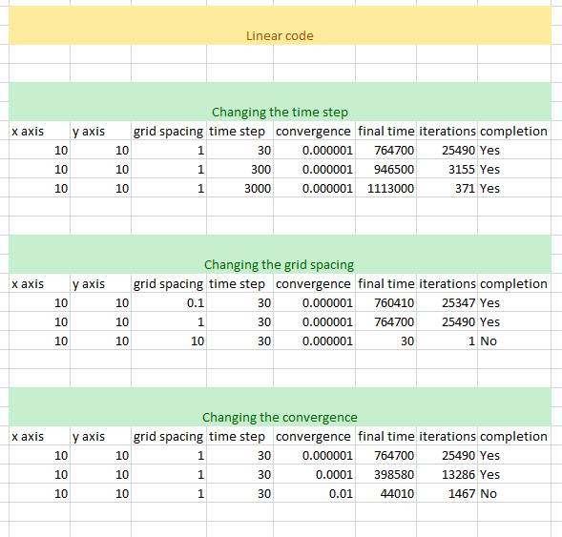
Figure 20 changing in linear code
These results above show what happens within the linear code when certain criteria are changed. These were broken into three sections, time step, grid spacing and convergence of the code. Then analysis was looking at the final time in seconds and iterations to completion of the code to see what each change effects. The final criteria that had to be met, was whether the code would run to equilibrium.
Figure 21change in time step
First the time step was changed to see the effects it had on the code. It was found that as the time step increased the iterations of the code decreased, however it was found that the final time increased. The script also manged to finish to completion with the time step changing at each point. The iterations would be expected to decrease as the time step is increased, this is due to time step taking larger steps over a given time. Where final time is affected by both iterations and time step, this shows that time step has a greater effect by percentage on the code than the iterations.
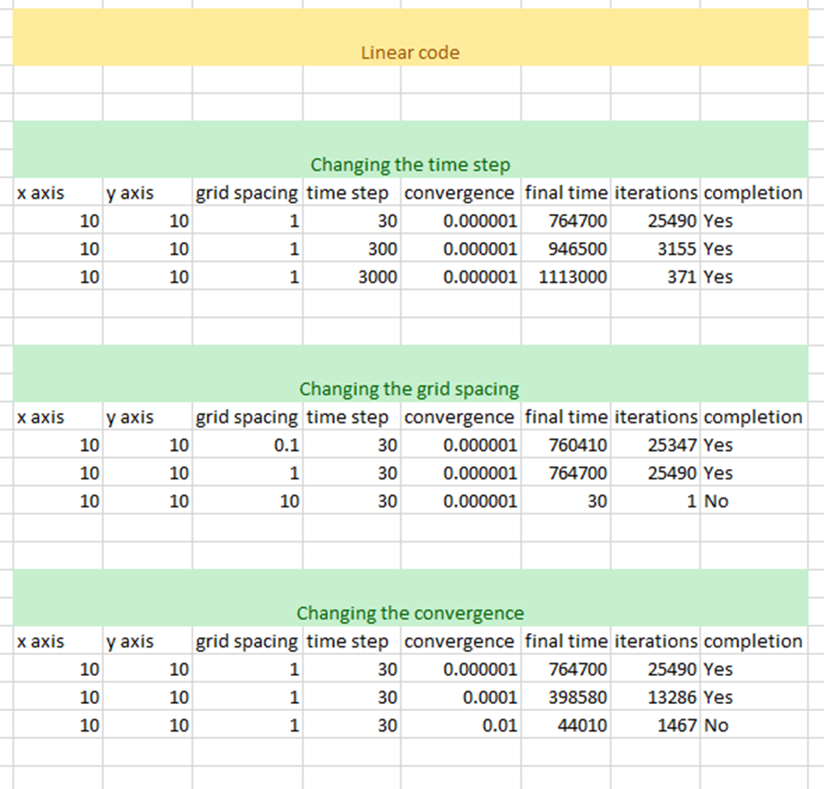
Figure 22 change in grid spacing
With changing the grid spacing it was evident that the final time would increase slightly and slight increase in the iterations. However, with the third test the script failed to produce the graph due to the grid spacing being too high. Further grid spacings would have to be implemented to find the precise point where the grid spacing was too big. The results do show that the grid spacing only marginally increases the final time and iterations.
Figure 23 change in convergence
The final change that was done to the script was to change the convergence; this was done by increasing the convergence. The following results show that the final time and iterations decrease as the convergence decreases. This would be expected, as the convergence number increases the acceptance for equilibrium would reduce. The third test had such a big acceptance of equilibrium that the script did not run to completion. This is caused by the convergence being too large.
Results with Gaussian code is more difficult to have due to the process time taking longer. The results that were found are very similar, just takes longer for the Gaussian equation as the heat has to travel through the hole plate to reach equilibrium.
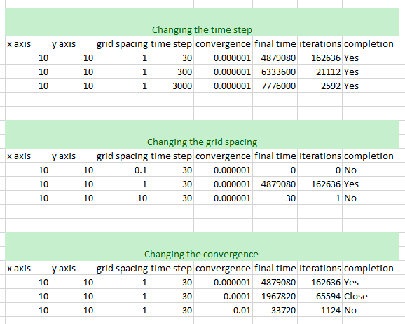
Figure 24 change in the Gaussian curve
These were the results gathered with the Gaussian curve. With the change in time step given the same values as the linear code, the code ran to completion in every test. The changes were increased, such as the iterations and final time. Due to the change in grid spacing, the Gaussian curve was unable to complete, this was because the first grid spacing was too small. It would eventually run to completion, however, the time it would take was too much time to process. The third test gave the same results as the linear code, where the grid spacing was too big to produce the matrix. Finally, with the convergence change the first test ran as expected, but the second test ran close to equilibrium, however, the code did not quite reach equilibrium. This is caused by the acceptance for equilibrium being too high. The third test continued the same as the linear code, showing results as expected.

A discussion as to the limitations of the model
The model is limited in the size of the plate due to process speed of the computer. It is also limited with how the code was written, in terms of the figures implemented. The code could be more user friendly by suggested inputs for each section that the user will need; the value used. The model is in a 2D setting instead of being with a 3D, as it would be in real life. The model will also never reach full equilibrium, due to it being so many decimal points out of a degree. The model is only working to an accepted equilibrium that the writer of the script has decided upon.

Suggested improvements to the model
There are several improvements that can be made to the code. Such of these include a user input, where the user can decide to put his own inputs in or use a suggested input system from the maker of the code. This would be set for the “X” and “Y” values, this would then give a range of suggestions for the grid spacing and time step. So, that the user does not have to think too much about the numbers being inputted into the system. After an incorrect value is entered by the user a suggested value could appear to ask the user to utilise that figure instead. The use of graphs could be improved by incorporating a 3D model to simulate heat traveling through the plate, instead of the top down version, which is currently being looked at.

Conclusion
The task of the assignment was to be able to create a 2D heat transfer through a plate using Gaussian curve within MATLAB. This was successful through using the thermal differential equation and followed by the finite difference form and the Taylor series. Two codes were then designed, one to prove the concept of the thermal differential equation “the linear code” and one for the task at hand the “Gaussian code”. The linear code proved that the equation inputted was correct and that equilibrium to a point could be reached. This is also proven to be difficult depending on the convergence of the code affects, where the code will stop for equilibrium. This was shown with the analysis: as we change the convergence value, the smaller the value the longer the code will take to reach equilibrium, even though the code almost reached equilibrium. Whereas, the bigger the convergence the faster the code would reach equilibrium, however, the code will be several degrees off equilibrium state. As found within the analysis that our grid spacing has a slight effect on the final time and iterations, this continues until the grid spacing is too large and the code will not be completed. Then our final analysis on the time step showed that the higher the time step the smaller the iterations become however, the final time would increase.

References
Foy, W. H., 1976. Position-Location Solutions by Taylor-Series Estimation. IEEE Transactions on Aerospace and Electronic Systems, Aes-12(2), pp. 187-194.
Lewis, R. W., Morgan, K., Thomas, H. R. & Seetharamu, K. N., 1996. The Finite Element Method in Heat Transfer. Swansea: John Wiley and Sons.
Xuerong, M., 1994. Exponential stability of stochastic differential equations. 1st ed. s.l.:ISBN.

Appendices

clear
clc
close all
%% values
k=143; %conductivity
p=2.8e3; %Density
c=795; %Specific Heat

r1=10; %first/last temp
t2=60; %max temp
%% inputs
x=0;
while x<=0 || isnan(x)==true
promptx= ('type in x (m)=');
x=input(promptx,'s');
x=str2double(x);

end
y=0;
while y<=0|| isnan(y)==true
prompty=('type in y (m)=');
y=input(prompty, 's');
y=str2double(y);
end

%% Grid spacing
checker = false;
while checker == false
h= input('Grid spacing (m)=', 's');
h=str2double(h);

pointx=((x/h)+1); %colums
pointy=((y/h)+1); %rows

check_x=pointx == round(pointx); %make sure number is whole
check_y=pointy == round(pointy); %make sure the number is whole

if check_x~=0 && check_y~=0 && isnan(h)==false && h>0 %check all conditions are correct

checker=true;
end

end
%% constants

alpha=k/(p*c); %thermal diffusivity

maxtime=0.25*(h^2)/alpha; %max time step
F0=1;
time=0;
while F0>=(1/4)||F0<=0 || isnan(time)==true %checking stability
time=input(['input time step less than ',num2str(maxtime),' (s) = '],'s');
time=str2double(time);
F0= (alpha*time)/(h^2); %Fourier number
end

%% matrix
T=zeros(pointy,pointx);

x0=((pointx+1)/2); %finds mid point
sd=sqrt((-(pointx-x0)^2)/(2*(log(r1/t2)))); %standered deviation

error=1;
while error<=pointx %makes all values
T(1,error)= (t2*exp(-((error-x0)^2)/(2*(sd^2)))); %equation for matrix

error=error+1;

end

to1=1e-6; %resoloutions
error=1;
draw=1;
counter = 0;

%% code
while error>to1
counter = counter +1;
Told=T;
draw=draw+1;
for r=2:pointy-1
for c=2:pointx-1 %main body
% north south east west
T(r,c)=F0 * (Told(r-1,c) +Told(r+1,c) +Told(r,c+1) +Told(r,c-1)- (4-(1/F0))*Told(r,c));
for r1=2:pointy-1 %east side of plate
% north south west west
T(r1,1)=F0 * (Told(r1-1,1) +Told(r1+1,1) +Told(r1,2) +Told(r1,2)- (4-(1/F0))*Told(r1,1));
end
for r1=2:pointy-1 %west side of plate
% north south east east
T(r1,end)=F0 * (Told(r1-1,end) +Told(r1+1,end) +Told(r1,end-1) +Told(r1,end-1)- (4-(1/F0))*Told(r1,end));
end
for c1=2:pointx-1 %botoom of plate
% north north east west
T(end,c1)=F0 * (Told(end-1,c1) +Told(end-1,c1) +Told(end,c1-1) +Told(end,c1+1)- (4-(1/F0))*Told(end,c1));
end
%bottom left followed by bottom right
T(end,1)=F0 * (Told(end-1,1) +Told(end-1,1) +Told(end,2) +Told(end,2)- (4-(1/F0))*Told(end,1));
T(end,end)=F0 * (Told(end-1,end) +Told(end-1,end) +Told(end,end-1) +Told(end,end-1)- (4-(1/F0))*Told(end,end));
end
end

error=max(max(abs(Told-T)));

%% Graphs
if draw==100

%flip the plate the correct way
PlotPlate= flipud(T);

%This is to get the graph
contourf(PlotPlate,'ShowText','on')

%Title on top of the page
title('Heat transfer of a 2D plate')

%x axis title
xlabel('Widith of the plate')

%y axis title
ylabel('Length of the plate')

%gets the values of the colours next to the graph
colorbar

%changes the colours
colormap(jet)
drawnow; %draws the graph as its calculating
draw=0;

end
end
disp(' finished!')
disp(['counter =',(num2str(counter))])

finishtime = counter*time;
disp(['Finish Time = ', (num2str(finishtime))])

