
Cloud Computing
Assessment 2

Andrian Gontea
Student ID:2114820
Submit data:06.05.2022
Module code: ACCB4002
Data Analysis and Visualisation
Experimental Data Analysis
Lecturer:Koushik Modak

Contents
Introduction 2
Description of the dataset 2
Visualisation of the dataset 3
Analysis 3
T-test: Two sample assuming equal variances: 3
Selection of T-test process for presenting the result 4
Techniques and process for presenting the result 4
Testing of Hypotheses to various significant level 4
Outliers in the dataset 7
1. Detecting value 7
2. Using different analysis methods 7
3. Calculating the Z score 7
Factors affecting Hypotheses testing 8
Results 8
Conclusion 8
References 8

Introduction
In this report that has been given to us we must to analyse the data and provide some recommendations to the company after they start using the app if that has a success or not.
In this situation we are going to use Excel to get the faster result. First thing we must to introduce all data were will be included a set of descriptive statistics. The second thing we must to test hypotheses at the significant level and to see which one we can accept or reject. The last thing we must to discus which factors could affect the result.

Description of the dataset
Dataset is that set were we collect data that can be found in tables, graphs or charts.In this report our dataset it is given to us in a table form. The company has created a new app for student and try to test it in which case is better before using the app or after. This app has been given to 40 students. The result in data set shows us all data about two variables and we can see clearly that there is not big difference between them
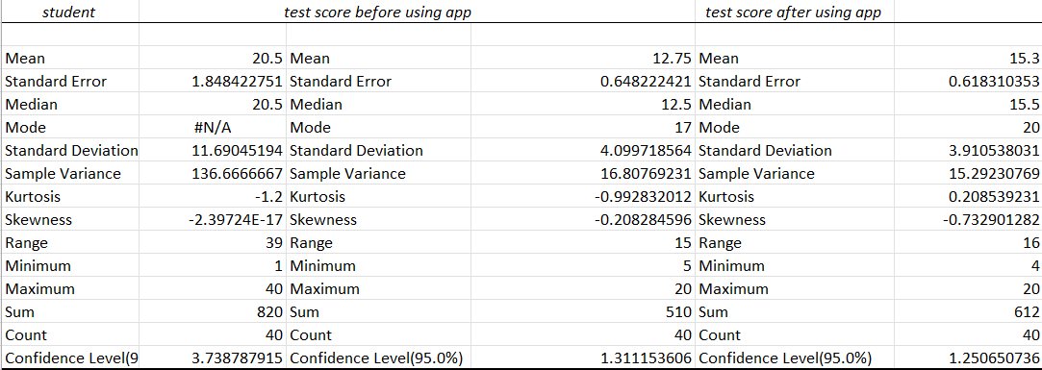

Visualisation of the dataset


The best way to visualize the data set is to use the chart that will show the result .In this data set we have 40 student that use an app and we can see clear the difference between using the app and before that.

Analysis

T-test: Two sample assuming equal variances:
This hypothesis determines the test score that has been use before and after app by Students. In analysing our hypotheses we are going to use t- test that can be of two types one-tiled and two-tiled. The data set has been given with same variances but with difference between when test score was used before the app and test score after using the app.

Selection of T-test process for presenting the result
this test is selected because we have the same variance in which we go to make a difference when the application was used more successfully and had a result. All these analyses are given to us in excel which allows us to calculate and pay attention to the changes made. These data are similar only to the different data in the accumulated result we can do analyses when this application has been used better.

Techniques and process for presenting the result
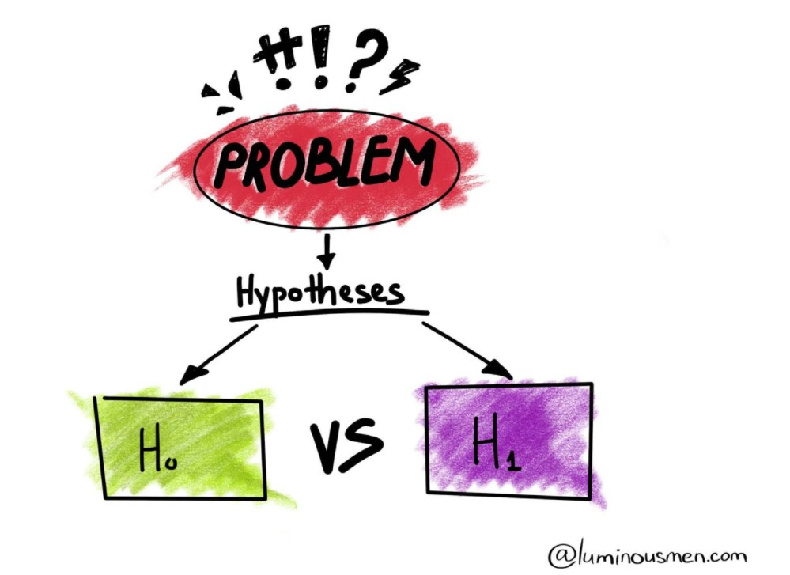
The Null hypotheses -is that statement when that has not relationship between the variables.Most useable to calculate the null hypothesis is p-value 0.05.When the p-value is less than 0.05 then we can say that the null hypothesis can not be true.
The Alternative hypothesis-is that hypotheses when we collect data to reject or to accept. The alternative hypotheses is opposite to null hypothesis. By that we can understand that the alternative hypothesis advice us or suggest the result that may we expect.

Testing of Hypotheses to various significant level
1.P=0.05
In testing our hypothesis to various significant level we must to identify the dependent and independent variables in our hypothesis. Independent variable are those variables which we can change and control and for dependent variables we just measure the affect has been on it.We must write our hypothesis in that way when we can prove or disprove it and demonstrate if there exist relationship or not.
For testing hypotheses of significant value p=0.05 we are going to check if it can be rejected or not. In this case we will start with T-stat value to see if it is smaller or bigger than critical two-tail. The significant of p=0.05 value shows that the t-Stat value |-2.8465| is greater than t-critical value 1.990 and we can explain that the Null hypothesis can be rejected.

When the p two-tail is larger that the value o significance, we know that the null hypothesis can be rejected because the p two-tail value 0.005 is smaller than value of alfa which is 0.05 and we can reject in this situation the null hypothesis. The result of value of significance p=0.05 can be rejected.
t-Test: Two-Sample Assuming Unequal Variances
 | test score before using app | test score after using app
Mean | 12.75 | 15.3
Variance | 16.80769231 | 15.29230769
Observations | 40 | 40
Hypothesized Mean Difference | 0
df | 78
t Stat | -2.846542418
P(T<=t) one-tail | 0.002822714
t Critical one-tail | 1.664624645
P(T<=t) two-tail | 0.005645427
t Critical two-tail | 1.990847069

2.P=0.01

In testing the significance value of p=0.01 we are going to apply same method. The first thing we must to understand by calculating and get the result if the t-stat value is smaller or bigger than t-critical. In using the significance value of p=0.01 we can see that the T-stat value |-2.8465| is greater than the T-critical value 2.6403 so the null hypothesis can be rejected.
Another thing is that the value of two-tail is smaller than the significance of value
This we can clearly see the result of p two-tail value 0.005 is smaller than value of alpha which is 0.01
So the null hypothesis is false and that can be rejected.

t-Test: Two-Sample Assuming Unequal Variances
 | test score before using app | test score after using app
Mean | 12.75 | 15.3
Variance | 16.80769231 | 15.29230769
Observations | 40 | 40
Hypothesized Mean Difference | 0
df | 78
t Stat | -2.846542418
P(T<=t) one-tail | 0.002822714
t Critical one-tail | 2.375110958
P(T<=t) two-tail | 0.005645427
t Critical two-tail | 2.640340015

3.P=0.10
The significance level is given to test hypotheses for every values to consider which is less or equal and are statistically significant. The testing hypothesis is that process which the goal is
To draw a conclusion in the observations made. In this case we have to draw a conclusion for a company that would like to know about the app which was tested to know when they more succeed before or after. In this case we are going to apply the significant value of p=0.10 and make observation if the null hypothesis can be accepted or rejected.
The result shows to us that the t -stat is greater than t-critical were we can conclude that t-stat |-2.8464| is greater that t-critical 1.664 and the null hypothesis can be rejected.Also we can explain that the p two-tail value 0.005 is smaller than value of alfa which is 0.10 and the null hypothesis can be rejected.

t-Test: Two-Sample Assuming Unequal Variances
 |  | test score before using app | test score after using app
Mean |  | 12.75 | 15.3
Variance |  | 16.80769231 | 15.29230769
Observations |  | 40 | 40
Hypothesized Mean Difference |  | 0
df |  | 78
t Stat |  | -2.846542418
P(T<=t) one-tail |  | 0.002822714
t Critical one-tail |  | 1.292499597
P(T<=t) two-tail |  | 0.005645427
t Critical two-tail |  | 1.664624645

Outliers in the dataset
The outliers in data set are those records that differ from and contain different characteristics. We also can define the outlier as a data value that is numerically distant from data set. It falls from outside the main pattern data points and it can be the largest or the smallest value in the given data set. Sometimes the outlier and data set may not be obvious. The outliers can negatively affect the result that we try achieve .
In order to get rid of these problems we need to pay attention to the data from the beginning if it is written correctly and there are no errors.
In our data set that has been given we have an outliers and that outliers was the number 4. Our range of number starts from 4 until 20 and it does not have any smallest or largest number that can affect our data set .This outlier you can see on the next two examples were the test score has been made in the Residual Plot.

There are some methods how to deal with outlier if they appear in our data set:
- Detecting value-In detecting the value it means that we can find the outliers and erase them if we are convinced that they exist.
- Using different analysis methods-In this case we can use different statistical sets for example the median to compare the data in this result we can find if there exist any outliers.
- Calculating the Z score-In calculating z score we know that the centre of that is 0 .The z-score is that number of standard deviation away of the mean. Identifying the outlier help us when we can understand that Z-score is high for higher values and low for lower values.

Factors affecting Hypotheses testing
In affecting the hypothesis test we know 3 factors:
The first factor is the “true” value of the parameter being tested-The “true “factor is that process that can generate the data. This process explain to us that there is a process that contain some parameters. The only way to define the true
The second factor is the Sample size (n). That explain that the power of
Test will be greater when the sample size will be larger. The data has been given is not to large and big to make observations and analyse efficient our hypothesis were we are going to take decision to reject or accept the null hypothesis.
The third factor is Significance level (α)-----------+The significance level of alfa happens when we can make the wrong decision explained by the Null hypothesis can be true. We have
Two errors that can affect our hypotheses. First is when Supporting the alternate hypothesis when the null hypothesis is true. The Second one is when Not supporting the alternate hypothesis when the alternate hypothesis is true.

Results
In the result for all p-values we tasted our hypothesis explain that the Null hypothesis can be rejected in all three cases. The result explain about existence of an outlier that we have seen in our previous test score that has been made in Residual plot. Our range of data started from 4 until 20 and our outlier have been present before 5.In better results and how to deal with outlier will help us the Least of absolute Deviations that helps to filter our data and detect all existence outliers that in future can be excluded.

Conclusion
In this report we made analysis of data set that has been given were a company wanted to know in which case The test score had more success before using app or after. In getting results and give to a company a recommendation we have use The T-test two samples assuming unequal variances were we used 3 difference p values and with result that there have been detected one outliers and the Null hypothesis could be rejected.Also we gave some example how to deal with Outliers if they exist and which factors could affect the hypothesis testing. As we know that any outlier can be removed and for that can helps us The Least Absolute Deviations or L1-Norm Method that will filter the data with all possible outliers and it will be much more effective.

References

