Sameena Hassan
Assignment 1
Zahra
Local Authority Community Engagement Process

The invention of Mind, Birmingham was established in 1962, and are a registered charity organisation who help anyone who suffers from mental health. Mind branch in Birmingham are an individualised, person centred organisation who thrive to deliver valued support and outcome as they hold a great value that everyone has a right to live lives that are meaningful and everyone is able to reach their maximum potential with just the right support and guidance. Mind also works in active partnership with a range of other local organisations who deliver the same sort of service that is surrounded by mental health or distress. The reason for which I have chosen this particular engagement project is because I believe that it is a very meaningful and important one and it holds all the values and support in which an individual would require and is very popular and easily locatable.
Community engagement is centric on fairness, justice, empowerment, participation and self determination which also is a critical skill that everyone must develop at Mind. Engagement does come with its challenges, dealing with the public and stakeholders can be complex and unpredictable and can be a very touching topic for some public members where it may take time for them to open up to express their feelings and thoughts to seek advise and help. Mind, Birmingham uses a variety of different community engagement principles, planning and design and standards as well as impact. At Mind, they focus and thrive to give each person the individual care and attention, they use different skills and tools such as listening skills and patience. As this community project solely looks to support individuals who suffer with mental health, it is vital that that these skills are interpreted as the individuals look to offload and let an outsider know how they are feeling and how they can be supported furthermore in the future.
The skills required from Mind to be able to provide the necessary support would be to ensure you are a great listener as this is a vital skill needed to deal with these type of sensitivity as you will not know what the next person is going through or thinking. You should also be empowered and empathetic and have the can- do attitude to help others.
Looking at mind and their community engagement principles used, we can identify how they have interpreted certain rules and goals to achieve a better community engagement. Looking at the SMART Goals principle model which was discussed in lectures we can see and reflect on how this was used at Mind. Mind’s goal is to provide “Better Mental Health For All and that people are in control of their lives and this aspiration emphasises the need to build upon peoples strengths underpinned at all times by a well established recovery approach.” Looking at how this can be measurable and be known when this overall goal has been reached is when more vulnerable members of public who need to seek advise and help regarding their mental health approach Mind, this can be measured via many platforms such as forms, leaflets, social media and a helpline where they can call to get to speak to someone and last but not least there is also a chat line which is available on their website where someone will be available for messaging if they do not want to call the helpline. This is in Mind’s power to be accomplished if they follow the different principles which they desire to follow and advocate. Moving on to if the goal is realistic for Mind, as per their information and reputation, yes. They have a wide range of guests who use their service from all different ages as mental health does not have a certain age range for. They provide all different support systems and ways to contact them which are suitable to everyone such as pop up stores, helpline which is available 24/7. Chat box on their website and more. Lastly, as Mind is an ongoing organisation which only thrive to grow larger over the upcoming years, it is to show more awareness and support to the public and that you can seek the right support and help if you wish too and everything will be kept confidential.
Mind’s planning and designing process has been very clear from the beginning of their journey and as different technologies have come into play, they have implanted this. The different tools and platforms they use are website, helpline, leaflets, hubs, pop up stores and an urgent line, team and telephone calls and even face to face sessions to offer the focused support which is required. If some individuals are comfortable with including more than one member of staff or another member of public, they do offer private social media groups and outdoor sessions when you can share experiences and share your ideas and increase your confidence.
How was Mind planned and what stages did the design of the project go through?
Mind, Birmingham started its life in 1962 by Dr Charles Davies a south Birmingham General Practitioner and his wife. This project was invented in the hope of wanting to make a change and a difference in the lack of social contact experience by people admitted to Birmingham mental hospitals and departments. This project was not as popular to begin with as back in 1962, mental health was not openly heard of but as the years have progressed it is somehow apart of everyone’s lives. The 1959 Mental health act provided a new legal framework for the treatment receiving and care of people with mental health. While it did emphasise the importance of enabling “ mentally ill people to live, as far as possible in the community” it did not make the provision of community base health and social care support services a legal requirement. However in 1961 the minister of health announced that there was a reduce of number of beds in mental illness hospitals which gave Mind the more boost to create a project so they were able to provide support to the needy. It took Mind from 1972-1982 to build solid foundations.
Gibbs reflecting cycle
Taking the opportunity to use the GIBBS reflective cycle on Mind, Birmingham we will begin with the description. Mind is an community engaging charity who provide support for mental health and provide a one to one service and which is tailored to your needs. They are available in many different ways to be contacted. Moving onto the feelings which is important every member attached with Mind entail, is that they should be a great listener and support system and have a very soft and supportive approach and also willing to want to help the person who requires. It is very important that you are friendly and mostly keep everything confidential as the people approaching you will have trust issues and be sensitive. Evaluating Mind, they use all the appropriate skills and techniques in order to make each individual experience as unique and special and confident as possible. There is always someone on hand 24/7 available to talk and especially being connected with Mental health, it is vital you always seek the right support when needed. Concluding Mind, they are a great service and provide loads of activities and support which will enable you to regain your confidence such as bike runs, walks and much more with a small people of group if you are comfortable or just yourself and a coach. It is tailored to your needs.

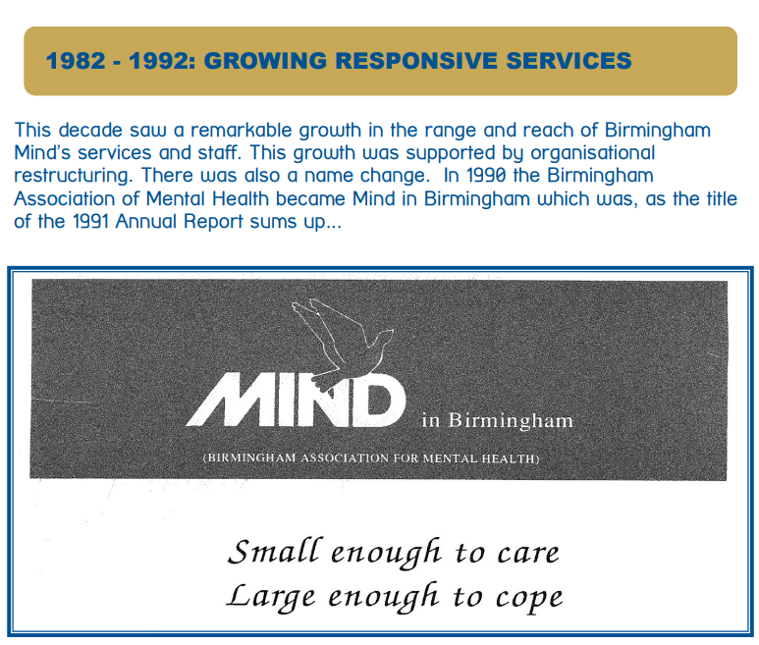


As you can see above, they had many little hospital and centres which has now led them to their success with £5,000,000 and working with over 1700 people. It is the largest mind association and has a very large voluntary sector. As the years of progressed, they have become very popular on social media and in the town centres as they do hold frequent little pop up stands and do have their own stores where you can go and visit. This is all due to their publicising such as social media, approaching the public and being able to provide the help over the phone by helpline and chat line.
The community engagement project did need to be assessed by the appropriate regulations as this was becoming a very supported community and they had a huge number of volunteers and sponsors and donations.
Mind have introduced a 3 year strategic plan for the next three years until 2025 to identify their aims and actions and a clearer image of the goal. “As a priority, we will make a positive impact on people’s mental health and wellbeing and speak out to make “Better Mental Health For All” become a reality.”
Evaluation and impact
How is the impact of the purpose measured is in the last two years they have supported over 50,000 people and that they continue to ensure that their person-centred care is effective, efficient, empathic and can impact the most to the public. They evaluate this and monitor by publishing their years plan and measuring how many members they have helped and what help they would need if any from sponsors or donations.
Concluding this report, we can identify that Mind, Birmingham are on the right path to helping the mental health needy people and are doing a fantastic role of this. This has helped many people who do not wish for GP appointments and be on waiting lists for a long time so this has filled the gap to seek advise and try to lead a better life with regular support from Mind Birmingham. As we have identified that they have a lot of strengths and they have many centres available and many platforms and ways to contact and communicate with Mind. They also provide an urgent line which is available 24/7 which weighs over the NHS as your GP is not available at all times. Mind also provide a chat line where if you do not feel comfortable speaking to them over the phone, you are able to chat online with a clinician or support team member. However as we progress with time I would advise that they should have a mobile phone app just like the NHS do with some surgeries where you can book appointments.

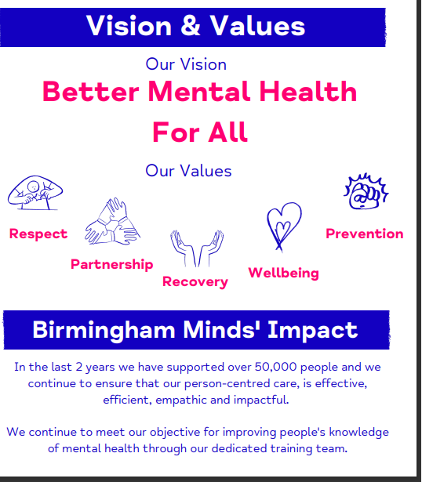

References :
What We Do - Birmingham Mind accessed 1st July 2023
Mental Health & Wellbeing Hubs - Birmingham Mind accessed 2nd July 2023
community engagement principles - Google Search accessed 1st July 2023
MindTools | Home accessed 4th July 2023
Course: Community Engagement (LCBB4002_BIRM) (uwtsd.ac.uk)
50-Yrs-of-MInd.pdf (birminghammind.org) accessed 20th July 2023

