Blog posts
contemporarychallengesmakingadifferenceuk.wordpress.com
Post 1. The biggest threat to humankind
Climate change is unquestionably the largest threat to humanity today. Climate change has long been accepted as a fact by the scientific community, with the Intergovernmental Panel on Climate Change (IPCC) stating that "human influence on the climate system is apparent, and recent anthropogenic emissions of greenhouse gases are the largest in history" (IPCC, 2014, p. 17). In addition to having a significant impact on ecosystems and economies, climate change has far-reaching effects on human health. The effects of climate change that we are now seeing include increased temperatures, sea level rise, and more frequent and severe natural catastrophes like hurricanes, floods, and droughts (IPCC, 2014). The frequency and severity of natural disasters like hurricanes, floods, and wildfires are also increasing due to climate change. The National Oceanic and Atmospheric Administration (NOAA) reports that the hurricane season of 2020 had the most named storms ever (NOAA, 2021). Extreme weather conditions have the potential to produce significant destruction, fatalities, and financial losses. Maybe most concerning is the harm that climate change poses to human health. The World Health Organization (WHO) has issued a warning, stating that between 2030 and 2050, "climate change is estimated to cause an additional 250,000 fatalities each year from hunger, malaria, diarrhoea, and heat stress" (WHO, 2018). Additionally, it is anticipated that climate change would worsen pre-existing medical conditions like respiratory ailments and cardiovascular disease and increase instances of mental health disorders like anxiety and sadness (WHO, 2018). A significant issue is the effects of climate change on agriculture and food security. Crop failures brought on by extreme weather conditions can result in food shortages and higher costs for essentials. Climate change has already compelled farmers in some regions of the world to give up their land or switch to other crops that are more resistant to shifting weather patterns (IPCC, 2014). Also noteworthy are the effects of climate change on the economy. Natural disasters and other climate-related occurrences can result in billions of dollars in losses, which puts communities and businesses in a difficult financial situation. If climate change is not addressed, the World Bank predicts that by 2050, the global GDP will have decreased by more than 5%. (World Bank, 2020). It is crucial that we act now to solve this issue given the severity and urgency of the climate situation. To reduce greenhouse gas emissions and make the transition to a more sustainable, low-carbon economy, governments, businesses, and people all have a part to play. This can entail making investments in alternative energy sources, boosting energy efficiency, and lowering dependency on fossil fuels. By incorporating more sustainable habits into their everyday routines, individuals can likewise make an impact. Less energy use at home, a plant-based diet, the use of public transportation or carpooling, and support for companies that place a high value on sustainability and environmental responsibility are a few examples of how to do this. As a result of its extensive effects on ecosystems, economics, agriculture, and health, climate change is currently the greatest threat to humanity. To lessen the effects of climate change, adapt to them, and build a more sustainable future for both current and future generations, urgent action is required.
Post 2 : Skills you need in your chosen field
Success in the management industry depends on a number of abilities. As a manager, your duties include overseeing a team or department, establishing priorities, making choices, and ensuring that your company meets its goals. You will require a variety of abilities to complete this task successfully, including :
- Leadership: For any boss, the capacity to uplift and encourage people is crucial. You must be able to successfully communicate with your team, establish clear expectations, and set an excellent example.
- The ability to communicate clearly is essential for management. Your employees, stakeholders, and clients will all require clear and unambiguous communication from you. The ability to provide and receive comments as well as be a good listener is also necessary.
- Thinking Strategically: As a manager, you must be able to establish and carry out plans that are in line with the objectives of your firm. In order to make choices that advance the company, you must be able to recognise opportunities and dangers.
- Addressing issues: Every manager will run into issues that need to be resolved. You'll need to be able to locate the source of an issue, create solutions, and successfully implement them.
- Effective time management is crucial since managers frequently have a lot on their plates. To accomplish your goals, you must be able to properly prioritise projects, assign duties, and manage your time.
- Understanding and controlling your own emotions as well as those of others requires emotional intelligence, which is crucial in management. Building relationships, managing disagreements, and inspiring your team are skills you'll need. Financial management: Depending on the degree of management you are in; financial management abilities may be essential. You'll need to be able to make decisions that have an influence on the financial performance of your firm, as well as comprehend budgets and financial reports.
As a whole, management is a demanding yet rewarding profession that calls on a wide variety of abilities. To succeed in this sector, you will need to possess a variety of crucial talents, including leadership, financial management, strategic thinking, problem-solving, time management, emotional intelligence, and problem-solving. You can succeed as a manager who can advance your company and bring prosperity by learning these abilities.

Post 3: Design thinking
Design thinking has been lauded as a ground-breaking method of problem resolution that has transformed numerous sectors. One such area is where design thinking techniques have been widely used in business management. This blog post will discuss the benefits and drawbacks of design thinking in business management.
Positive Effects of Design Thinking on Business Management
User-centred Approach: Design thinking is based on the idea that users' needs, wants, and preferences must be understood. Businesses can more effectively identify the issues encountered by their consumers and provide solutions that address their demands by taking a user-centred approach. This strategy may boost client satisfaction and loyalty, which will benefit the company in the long run.
Iterative Process: Design thinking is an iterative method that promotes trial and error, criticism, and improvement. This strategy lowers the risk of failure by enabling organisations to recognise and fix possible problems early on. Because organisations can test out many concepts and solutions, the iterative approach also encourages creativity and innovation.
Holistic Problem-Solving: Design thinking advocates a comprehensive method of tackling issues. It pushes companies to look past minor issues and pinpoint the underlying cause of a problem. Businesses can create long-term solutions with a lasting effect by tackling the root issue.
Design thinking's shortcomings in business management
Lack of Organized Process:
The loose and unstructured nature of design thinking is frequently criticised. Due to its unclear principles and guidelines, design thinking may be difficult for certain firms to execute. Because of this, it could be challenging to gauge development and guarantee uniformity among projects.
Minimal Attention to Business Goals:
The main goal of design thinking is to comprehend user demands and create solutions to suit those needs. Unfortunately, this strategy might not always be in line with commercial goals, such as boosting earnings, cutting expenses, or expanding market share.
As a result, companies’ Resource-Intensive:
Design thinking can be a process that uses a lot of resources, including time, money, and skill. Effective design thinking implementation may be difficult for small businesses or those with few resources, which may need to strike a balance between their corporate goals and design thinking's user-centred methodology.
Design thinking is a useful strategy for firms due to a number of its advantages. Its user-centred methodology, iterative process, and comprehensive problem-solving can have a positive long-term impact on the company. It is less than ideal for all businesses because to its lack of structure, narrow emphasis on company objectives, and resource-intensive nature. In the end, companies must consider the advantages and disadvantages of design thinking to see if it fits with their objectives and available resources.

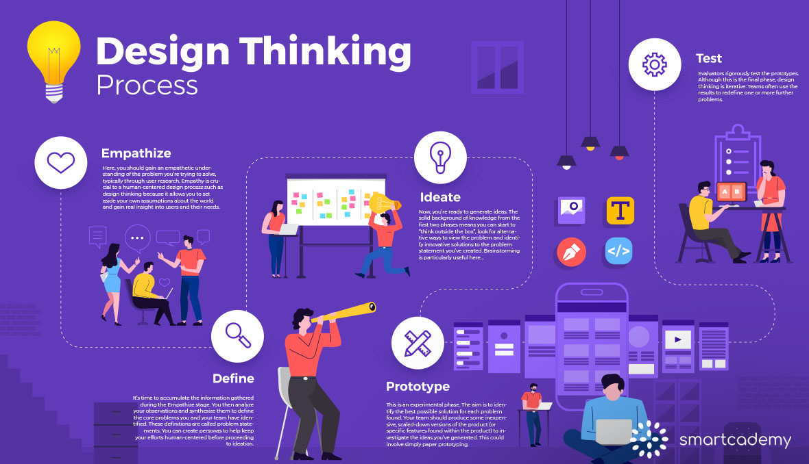

References list:

- https://smartcademy.sg/what-is-design-thinking-and-its-relevance-in-industries-today/
- Intergovernmental Panel on Climate Change (IPCC). (2014). Climate Change 2014: Synthesis Report. Retrieved from https://www.ipcc.ch/report/ar5/syr/
- World Health Organization (WHO). (2018). Climate change and health. Retrieved from https://www.who.int/news-room/fact-sheets/detail/climate-change-and-health
- NASA. (2020). Climate Change: Vital Signs of the Planet. Retrieved from https://climate.nasa.gov/vital-signs/sea-level/
- National Oceanic and Atmospheric Administration (NOAA). (2021). Record-breaking Atlantic hurricane season draws to an end. Retrieved from https://www.noaa.gov/media-release/record-breaking-atlantic-hurricane-season-draws-to-an-end
- World Bank. (2019). Air Pollution. Retrieved from https://www.worldbank.org/en/topic/environment/brief/global-overview-air-pollution
- Brown, T. (2008). Design thinking. Harvard Business Review, 86(6), 84-92.

- Buchanan, R. (1992). Wicked problems in design thinking. Design issues, 8(2), 5-21.
- Kelley, T., & Kelley, D. (2013). Creative confidence: Unleashing the creative potential within us all. Crown Business.
- Liedtka, J. (2015). Perspective: Linking design thinking with innovation outcomes through cognitive bias reduction. Journal of Product Innovation Management, 32(6), 925-938.
- Plattner, H., Meinel, C., & Leifer, L. (Eds.). (2012). Design thinking: Understand–improve–apply. Springer Science & Business Media. Katz, R. L. (1974). Skills of an effective administrator. Harvard Business Review, 52(5), 90-102.
- Robbins, S. P., Coulter, M., & DeCenzo, D. A. (2016). Fundamentals of management. Pearson.
- Kotter, J. P. (1990). What leaders really do. Harvard Business Review, 68(3), 103-111.
- Drucker, P. F. (2004). What makes an effective executive. Harvard Business Review, 82(6), 58-63.
- Luthans, F., Hodgetts, R. M., & Rosenkrantz‐Witt, R. (1988). Real managers. Cambridge, MA: Ballinger.
- Bennis, W. G. (1989). On becoming a leader. Perseus Books.
- Hambrick, D. C. (2007). Upper echelons theory: An update. Academy of Management Review, 32(2), 334-343.

