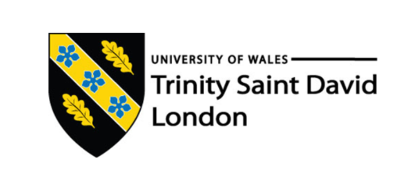

Task 2
Professional Career Development Report

Dariusz Brylewicz
Student ID: 2112261

Module name: Professional Career Development
Module Code: (BMSW4005_LON)
Lecturer Name: Bianca Sanfilippo
Word Count: 2353
Submission Date: 31/08/2022

Table of Contents
Introduction…………………………………………………………………………………………………………………………………….………..Page 3
Recruitment and Selection: Personal reflection on the roleplay applying Gibbs’ reflective cycle……………….Page 3
Skills and knowledge which contribute to working effectively…………………………………………………………………..Page 4
My personal strengths and areas for development: SWOT Analysis…………………………..……………………………..Page 5
My employment goals and personal career action plan/development plan……………………..……………………….Page 5
My short - medium – long term targets for the development of my own professional career plan (using SMART targets)……………………………………………………………………………………………………………………………………………………..Page 7
Conclusion………………………………………………………………………………………………………………………………………………..Page 8
References………………………………………………………………………………………………………………………………………………..Page 8
Appendix A: The questions asked as interviewer in the role play (A1)……………………………………………………….Page 8
Appendix B: Application Form completed as applicant for the role play (A1)…………………………………………….Page 9

Introduction
In this report I will be taking an in depth look at how I think my role play went, and what I could have done better. I will also review my career development planning, while applying the Gibbs reflective cycle. The Gibbs reflective cycle was designed to structure what we have learned from our experiences and has six different stages. (nursinganswers.net, 2018) I will also determine what my employment goals are, as well as create my own personal action/development plan. The benefits of this are gaining new perspectives on how to tackle future problems and gaining a deeper understanding of the skills you possess.

Recruitment and Selection
Personal reflection on the roleplay applying Gibbs’ reflective cycle

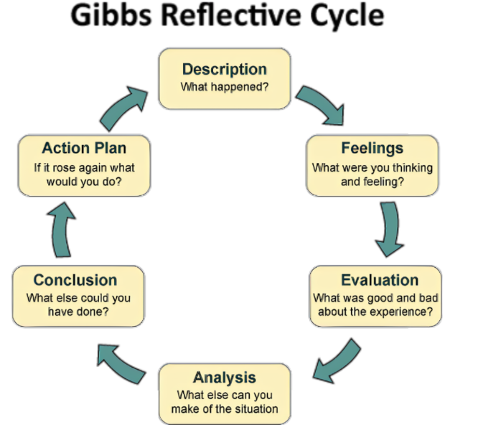
Description – I had a job interview for a renovation project manager role. Prior to this, I researched many possible job interview questions I could be asked and wrote down how I would answer them. I had my friend set up a mock job interview for me so that I could get into the correct mindset and have some practice.
Feelings – After I secured the job interview, I was feeling very happy and excited for being shortlisted to that stage. I had only a few days to plan and prepare, so after the initial excitement wore off, I was feeling more anxious and stressed. But I was also motivated to be prepared so I did all my research and practice so that I could feel ready and know what to expect. During the interview, I tried to shut off any negative feelings of stress and anxiety so that I could come across as professional. After the interview was finished, I felt relief as I knew I had done my best.
Evaluation – Any experience is good experience. This is because I am now able to reflect on what I did and how I can improve in the future. Something I think I could have done better was the introduction. Because I was feeling a little stressed and tripping over my words, I don’t think I made the best first impression however as the interview went on, I felt more relaxed and thought about my answers more clearly before saying them out loud. One good thing about my interview was that I was quite
Analysis – I’m happy to have had this experience as I now have more confidence with how to approach job interviews. I have a better understanding of what job interviewers look for with the questions they ask.
Conclusion – Something else I could have done was been more relaxed. The night before the interview I did not get much sleep as I went to sleep quite late. I think if I had gotten more sleep, I would have been more relaxed and alert for the interview.
Action Plan – In the future, when I get more opportunities for job interviews, I will research the company and its founders, what they do and what their vision is. This will help me to understand the type of candidates they want to employ. I will write up the type of questions I predict they will ask and type up what my answers would be to do mock interviews. As well as being thoroughly prepared, I will try to be as relaxed as possible so that I can appear more confident.

Skills and knowledge which contribute to working effectively

According to Forbes.com, some skills required to work effectively are:
Resilience – This skill allows you to keep moving forward, despite what you may encounter along the way. Being able to do this, means that you can achieve your goals faster as you do not give up.
Collaboration – Oftentimes, we can achieve more when multiple minds come together to work as a team. Being able to work well with others means that you can combine your skills in the most effective way possible to hit your targets.
Learnability – Our environment is always changing and evolving. Therefore, our learning never stops. You must be willing to educate yourself and be open-minded to what is around us in order to succeed in life.

The knowledge required in order to work effectively are:
This will vary from person to person depending on the type of career you want, and the different aims you have. For example, I work and wish to progress in the building/renovating sector. So, the type of knowledge I require is how to navigate building codes, which building materials are best used for different things and also have skills in mathematics as I have to use geometry and calculate angles while cutting, measuring and fitting things like wood, plastic etc. Other things I have to know in my profession are how to install windows, roofs and doors. (realtytimes.com, 2022)

My personal strengths and areas for development
SWOT Analysis
Strengths  - I have lots of experience in my chosen career path which is desirable to all employers.  - I am very knowledgeable and skilled in what I do, so I can say I specialise in my trade. | Weaknesses  - English is not my first language, so I sometimes have a language barrier with potential clients.  - Although I have lots of experience, I lack certain qualifications which employers may look for.
Opportunities  - More people are choosing to renovate their homes so there is a higher demand for renovation project managers.  - Because of the housing crisis, the government is building more council flats which gives people like me more job opportunities. | Threats  - New technology and machinery being produced means that people like me will be spending less hours working, therefore earning less profit.  - Like every job seeking individual, I will have competition which will be a threat to me securing a job role.

My employment goals and personal career action plan/development plan

My professional career pathway is:
Being a renovation project manager and advancing to bigger projects each time.
What are my current strengths?
- Resilient
- Hard working
- Willingness to learn
What are my achievements and areas of success since the beginning of the module/programme?
My grammar has gotten better, and I have passed all my assignments so far.
In what areas do I need to develop?
I would like to build more confidence in job interviews.
Why is it important to improve in these areas?
It will help me secure better projects to work on.
Who will help me? What resources will I need?
My lecturers, my children.
What are the constraints/barriers to achieving these key areas and how I will manage these – e.g. time, resources.
Sometimes it is hard to find the time. I will overcome this by managing my time more effectively.

What further action do I need to take now?
Actions to be taken - things to do, people to see.
I must finish my assignments to a good standard and hand them in on time.
Time scale – by when
Their due dates.

My short - medium – long term targets for the development of my own professional career plan (using SMART targets)
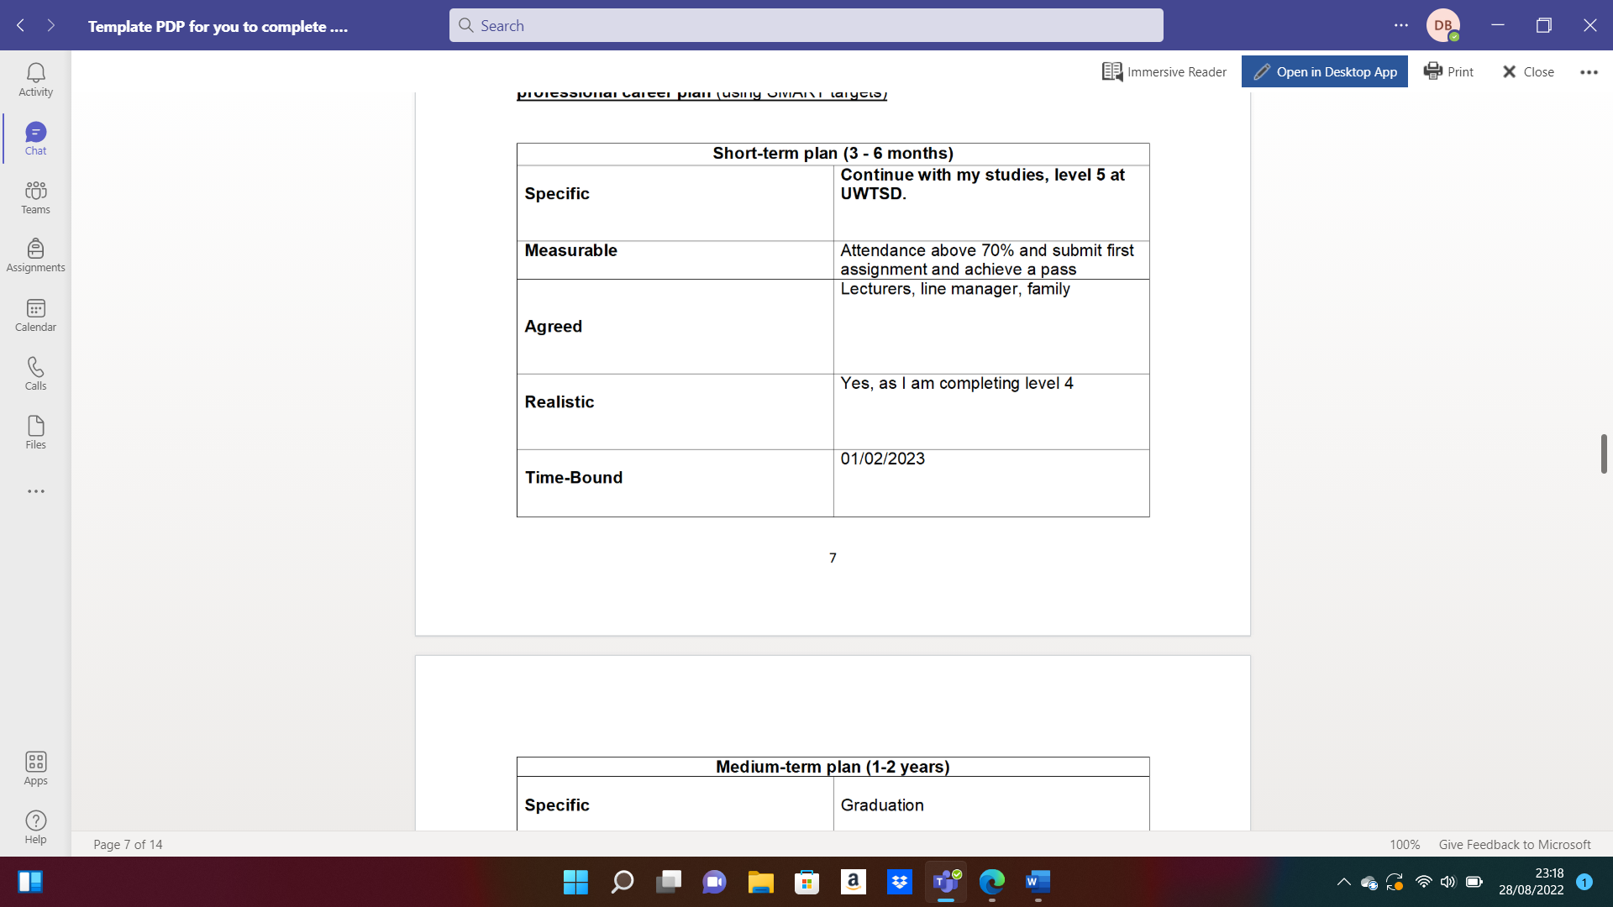
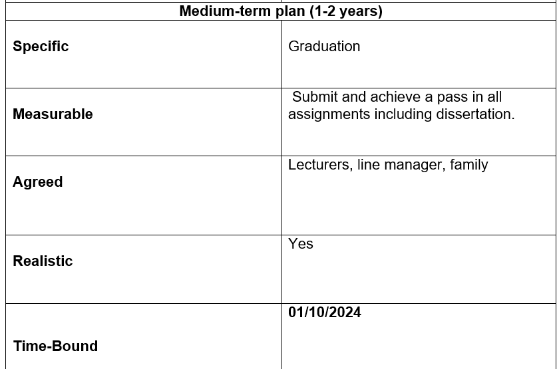
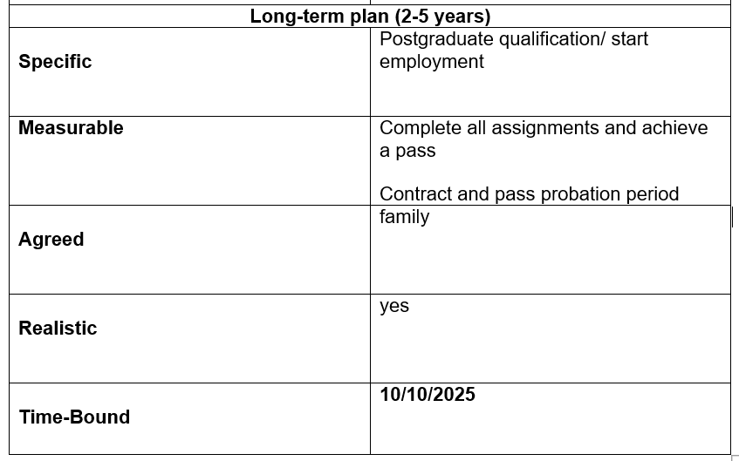

Conclusion
In conclusion, I have reflected upon how well I have done in my mock job interview and the areas which I would like to improve on. I have identified the characteristics and skills required to be successful in my chosen career path and conducted a SWOT analysis for myself. Finally, I have used SMART targets to identify my short-, medium- and long-term goals. This report will help me to build on my skills.

References
Gibbs, G. (1988) Learning by Doing: A guide to teaching and learning methods. Further Education Unit. Oxford: Oxford Polytechnic.
Business Bliss Consultants FZE. (November 2018). Gibbs' Reflective Cycle. Retrieved from https://nursinganswers.net/reflective-guides/gibbs-reflective-cycle.php?vref=1
FutureMe. 2022. Why Is Self-Reflection Important? The Benefits... – FutureMe Blog . [ONLINE] Available at: https://www.futureme.org/blog/the-benefits-of-self-reflection#:~:text=%20The%20Benefits%20of%20Self-Reflection%20%201%20AN,the%20one%20you%20have%20with%20yourself%21%20More%20. [Accessed 29 August 2022].
Natalia Peart. 2022. The 12 Most Important Skills You Need To Succeed At Work. [ONLINE] Available at: https://www.forbes.com/sites/nataliapeart/2019/09/10/the-12-most-important-skills-you-need-to-succeed-at-work/?sh=48688aea1c6a. [Accessed 29 August 2022].
admin. 2022. Top 12 Skills You Need When Building Or Renovating A Home - Realty Times. [ONLINE] Available at: https://realtytimes.com/advicefromtheexpert/item/1041367-skills-you-need-when-building-or-renovating-a-home#:~:text=Top%2012%20Skills%20You%20Need%20When%20Building%20Or,4.%20Design%20skills.%205%205.%20Flooring.%20More%20items. [Accessed 29 August 2022].

Appendix A: The questions asked as interviewer in the role play (A1)
- Tell me about yourself?
- Describe a difficult work situation or project and how you handled it.
- Why should we hire you?
- How do you handle stress and pressure?
- What are your goals for the future?

The question/s asked as interviewee in the role play (A1)
- What have you achieved in your career that makes you proud?
- How do you deal with working under pressure?
- Why should we offer you this job?
- Have you come across any challenging work situation, and how did you deal with them?
- What are your most significant strengths?

Appendix B: Application Form completed as applicant for the role play (A1).

Job application form
Application for [job title]- Renovation Project Manager
Your details

Name: Dariusz Brylewicz
Education and training
Please give details:
Education:
High school
Diploma received in various subjects including Maths, English and Science.
Poland, Szydlowiec 1995
Training:
Electrical Safety Training Online Course (2011)
Alison's free online Diploma in Electrical Studies course (2015)
Domestic Electrician Course (2019)

Qualifications
Please give details:
- Competent in general knowledge of electrics in domestic properties through completing a range of courses.
- A range of knowledge gained through work experience spanning from working in the industry for the last 20 years.
- Communication and interpersonal skills gained through being a positive and friendly professional.
- Domestic electrical circuit installation
- Domestic lighting circuit installation
- Domestic electrical earthing and bonding requirements
- Inspecting, testing and commissioning single phase domestic electrical circuits

Employment history
Your current or most recent employer
Name of employer: Self-employed
Job title: Renovation specialist
Length of time with employer: As of 2010
Reason for leaving: N/A
Duties:
Primary responsibilities include:
- Pre-acquisition
- Due diligence
- Generating scopes of work for renovation
- Identifying vendors to perform work
- Managing the renovation process
- Scheduling vendors and ensuring work is done to a satisfactory standard, on-time and within budget.

Previous employers
Please tell us about other jobs you have done and about the skills you used or learned in those jobs.
Prior to working as a freelance Renovation Specialist I started my working journey doing jobs since the age of 16 when I was working with my father doing various painting and decorating work. I moved to the UK when I was 18 and there I was able to work for a construction company where I started off as a handy man working the smaller jobs and helping out where possible. Through this I was able to learn new skills and picked up an interest working with the installation of electrical work in domestic properties, I was able to go through various courses whilst at this job to hone in on my skills. After 10 years of experience working with this company I decided I wanted to step into renovation and set myself up as freelance Renovation Specialist.

Supporting statement
Please tell us why you applied for this job and why you think you are the best person for the job.
Dear Sir / Madame
As an experienced renovation specialist with excellent client and project management skills I am someone that prides himself in always delivering the best results in my craft. Results-driven, quality-focused, and dedicated to delivering high quality renovations, with 15 years of proven experience in the industry of renovating domestic properties.
A challenge driven and self-motivated professional with breadth and depth of experience in all aspects of renovating domestic properties, I’m passionate about providing a finish to a property which the client can be proud of. From my 15 year experience I have proven ability to build trusted and constructive relationships. Experienced in painting and decorating, adding the finishing touches as well as general electrics of domestic properties.. Excellent negotiation skills and active listening skills to identify what a client wants as well as having the confidence in challenging and influencing and setting expectation levels. A highly collaborative individual – I enjoy working with others and managing teams within the renovation process, exceptional interpersonal skills with a passion for learning new skills within the trade, keeping up to date with the latest trends within the world of renovation and bringing this to life when meeting new clients to support in delivering a vision of a renovation they can be proud of.
I’ve been able to train and manage individuals that are new to the trade and are looking to build their experience, I’ve supported in building successful teams to support renovation projects. Strong presentation and facilitation skills, comfortable with ambiguity and productively managing multiple priorities and projects at one time.

I look forward to speaking with you and finding out about what projects I can support you with in delivering.

Kind regards,

Dariusz Brylewicz

Right to work in the UK
Do you need a work permit to work in the UK? Yes / No
No

References
Please give the names and contact details of 2 people who we can ask to give you a reference. We many ask them before an employment offer is made. We will not ask your currently employer until we get your permission.

Robert Pattinson – 07432134596
Angela Marron – 07943456913

Declaration
I confirm that to the best of my knowledge the information I have provided on this form is correct and I accept that providing deliberately false information could result in my dismissal.

Name: Dariusz Brylewicz
Signature:
Date: 04/07/2022

