

Living with care: The older person

Module code:BMHP6009

Lecturer:Diola Bijlhou

Student Name:

Marinela Ancuta Szeri (1917613)

Contents
Introduction 3
Older people 4
Statistics 4
The theoretical aspect of loneliness 4
Current legislation for the eldercare 5
Policies for the eldercare to remove loneliness 6
Future implications 7
Intervention 8
The role of innovation in attention to social confinement 8
Medical care framework's reaction to social segregation 9
General wellbeing informing: keeping up with the social association 9
Recommendations 10
Conclusion 11
References 12

Introduction
Usually, the senior individuals or "old" depict the ordered age as 65 years or more prominent than 65 years. In the United Kingdom, the period between 65 and 74 is known as early senior age, and more than 75 years is characterized as late senior age. In Australia, the "old" or "matured individuals" signifies more than 65 years remembered for the aged individuals. There is we discuss social isolation and loneliness in this report. Social isolation is directly related to the unhealthy condition of the elder individuals. Dejection and social detachment are developing general well-being worries in our aging society. While these encounters happen across the life expectancy, half of the people over 60 are in danger of social isolation, and 1/3rd will encounter some depression sometime in later stages (Vozikaki et al., 2018). The point of this report is to portray the scope of mediations to as an intervention of the mental impact due to loneliness and social isolation in elder individuals (Vozikaki et al., 2018). Here in this report, we discuss the statistics of the elder individuals in two countries, one in the UK and the second one is Australia which we choose for the comparison, then related theories for social isolation and loneliness and their impact on them on the aged people; further, we discuss the policies and regulations to remove the issues that are generated because of the loneliness after that we explain about the changes needed for it and best recommendation for the improvement in the cognitive health of aged individuals.

Older people
Traditionally the older people or “elderly” describe in chronological age as 65 years or greater than 65 years. In the United Kingdom, the period between 65 and 74 is known as early elder age, and over 75 years is defined as late elder age (Wittenberg et al., 2019). The “elderly” or “aged people” means those over 65 years, including older people in Australia. Social isolation is directly linked to an individual's social and emotional health (Vergeer et al., 2018). As individuals get older, they may experience their life changes, and they are isolated socially, which affects their emotional and psychological health. The Australian people suffer more from loneliness, and the risk of falls is high in Australia compared to the United Kingdom (Cotterell, Buffel, and Phillipson, 2018).

Statistics
Population aging is described as a global spectacle; each nation whole over the world has increased growth in the ratio of the older generation in their demographic data; in the year 2019, about 703 million individuals aged than 65 of the age, and this number will increase up to 1.5 billion that is double from the existing number by 2050 (Khadka et al., 2019). All around the world, the portion of the populace aged 65 years or over-expanded from 6% in 1990 to 9 percent in 2019. That extent is projected to rise further to 16% by 2050, with the goal that one of every six individuals in the biosphere will be aged 65 years or over (World Population Ageing 2019, 2022). The world population, mainly aged individuals, is changed drastically in the recent decade. The quickest expansion in the quantity of older people is expected in Northern Africa and Western Asia, ascending from 29 million in 2019 to 96 million by 2050 (an increment of 226%). The second quickest increment is anticipated for Africa, where the populace matured 65 or over might develop from 32 million in 2019 to 101 million by 2050 (218 %). Paradoxically, the increment is supposed to be moderately small in Australia and New Zealand (84%) and in Europe and Northern America (48%), locales where the populace is now essentially more established than in different regions of the planet (Nations, 2022).
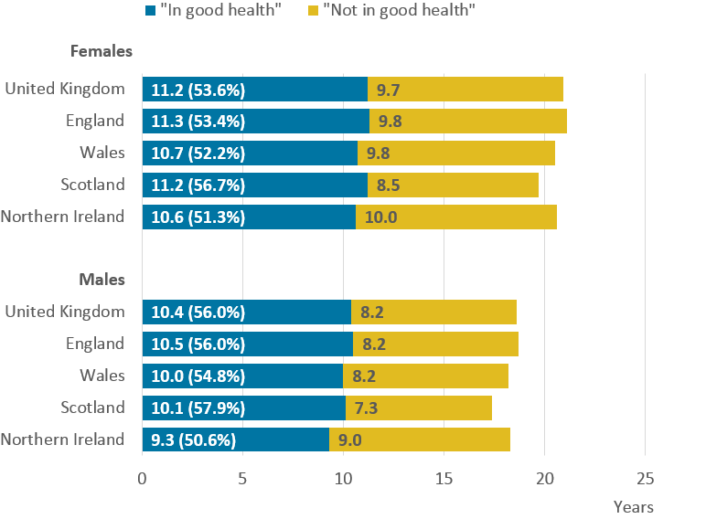
Figure 1: National statistics for older people
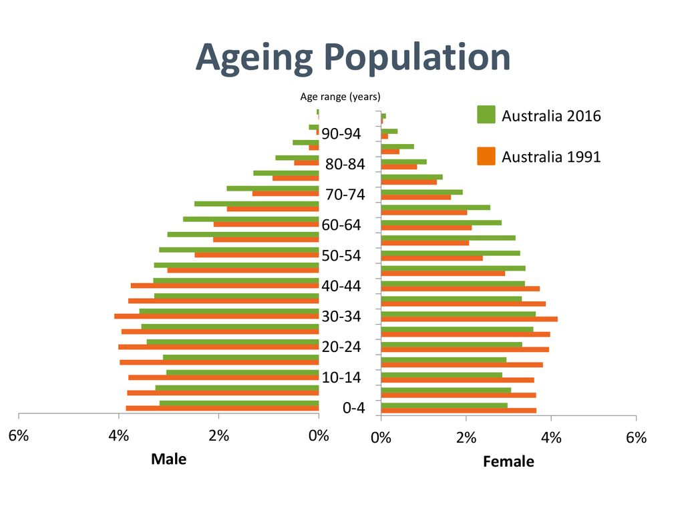
Figure 2: Aging people in Australia from the year 1991 to 2016

The theoretical aspect of loneliness
Loneliness and social segregation are overall public wellness give that explicitly affect the progress in years society worldwide. Social isolation and loneliness have great impact on the mental or social health of the individual. As per Valtorta and Hanratty (2012), one of the greatest widely utilized meanings of depression comprises social and enthusiastic dejection: forlornness is an awful abstract inclination connected with an apparent loss of a lot more extensive interpersonal organization (social depression) or nonappearance of a chosen favored acquaintance (passionate depression). There is abundance substantially less agreement roughly on the meaning of social disengagement; however, creators have moved toward it as a complex idea, characterizing social segregation because of the objective need or scarcity of social contacts and cooperation with own circle of family members, individuals, mates, or the more extensive local area (Valtorta, and Hanratty, 2012). Emotional loneliness is also a result of social exclusion that affects the individual’s emotional well-being. It majorly affects the older individuals compared to kids and adults because young or adult individuals are busy with their work most of the time, so they don’t have time to think. Psychologically, when we feel too much, it feels like loneliness and is long-lasting, called existential loneliness. HERE IT’S ABOUT DISCUSSING THEORIES OR CONCEPTS YOU WERE ABLE TO FIND IN THE LITERATURE ON LONELINESS AND ISOLATION.

Current legislation for the eldercare
In 2018, the British government designated a pastor for dejection as proof mounts that forlornness makes us wiped out (Prime Minister's Office, 2018). Universally, different clergy members — including the Australian and Canadian Ministers for Seniors (Australian Government, 2018) — are likewise worried about the effect of depression and social separation among more seasoned individuals (matured 65+). While related and with comparable adverse consequences, social confinement and dejection are unmistakable ideas of not providing proper care to individuals social isolation connects with low or non-existent degrees of social cooperation and diminished social connections and backing REFERENCES. Depression is an emotional encounter, alluding to an apparent distinction between wanted and genuine degrees of social relations and the resulting sensation of being separated from everyone else or lacking friendship (Smith, 2017).
Assessments of social isolation and dejection among more established individuals change, contingent upon the nation and measures applied (Tomstad et al., 2017). The writing demonstrates that somewhere in the range of 5% and 17% are socially secluded, and somewhere in the field of 12% and 30% experience forlornness (Ong, Uchino, and Wethington, 2016) Predominance is supposed to increment as the maturing populace develops (Alpert, 2017), disturbing because of the negative social and well-being impacts of forlornness and social isolation in later life. Forlorn and socially disconnected, more established individuals are bound to encounter melancholy (Gonyea et al., 2018), dementia (Holwerda et al., 2014), persistent agony (Smith, 2017), true delicacy (Gale, Westbury, and Cooper, 2017), and scope of terminal diseases (Widhowati et al., 2020). For some, this involves expanded care needs, influencing their freedom and social interest (Shankar et al., 2017). Separated or forlorn, more established individuals frequently face social avoidance, low friendly and city commitment, and a breakdown in family and local area connections (Weldrick and Grenier, 2018). Social isolation and dejection are consequently warm and general well-being concerns because they have a great effect on the health of the individual. Research on how more seasoned individuals experience and address depression and disconnection is essential to develop further rehearses and illuminate strategy mediations that recognize different individual settings and inclinations (Neves et al., 2019).
The equality act of 2010 and the discrimination Act are also helpful regulations in both countries to remove the risk of aging or falling due to aging (Burt, 2020). Equality act provides equality to older people in every aspect like care services and participation in social events. The discriminatory act is helpful in the removal of social exclusion. According to the act nobody can socially isolate the elder individuals.

Policies for the eldercare to remove loneliness
The WA (Western Australia) Government has a maturing structure, but this attentions of cooperation and commitment instead of social detachment and forlornness. The system recognizes the requirements of more established individuals that should be taken into arrange and underlines coordination across all relevant government offices. Focuses on that address confinement and forlornness (straightforwardly and in a roundabout way) includes the following:
- expanded acknowledgment and backing for careers;
- acknowledgment for the developing number of grandparents who give full-time care to their grandkids;
- concession and endowment plan to help seniors who are monetarily powerless • local area organizations to lessen social disengagement;
- The Department of Local Government and Communities helps neighborhood legislatures around the state to embrace the World Health Organization's 'Age-accommodating Communities' way to deal with anticipating a maturing populace;
- Supporting drives that unite the ages, build up regard for more seasoned individuals, and decrease social detachment;
- Providing deep-rooted learning and retraining open doors;
- Strategies to energize mature age work, schooling, and preparing; and
- Supporting the older person who feels loneliness (Siira, 2022).
The WA Department of Communities upholds the improvement of old enough, well-disposed networks. Neighborhood states in WA have emphasized maturing, with many fostering seniors' methodologies or conforming to the WHO's age-accommodating city plan. These plans address social isolation and depression in a roundabout way through transport drives, intergenerational exercises, and projects to help considerate more seasoned individuals in local area life (Jaremka et al., 2014).
The Red Cross Companionship and Social Support carrier The Red Cross offers a companionship and social assistance carrier which operates in all states and territories besides Queensland and the Northern Territory. The policies of the red cross company is for older individuals who stay alone (including human beings on domestic care applications or residing in elderly care domestic), older human beings with few social connections outside of the doors of the household, other human beings with incapacity, and those who are improving from intellectual illness (Finegan et al., 2020). The software pairs volunteers who help contributors of the network to participate in network groups, pass on outings to cafes or galleries and opt for walks, among different activities.
The Australian Institute of Health and Welfare (AIHW) and the Australian Psychological Society utilize unhappiness as a parameter to make sense of feeling detached from others and allude to a pessimistic view of one's connections. As indicated by the Australian Loneliness Report, gathered by the Australian Psychological Society and Swinburne University: Loneliness is a sensation of misery individuals experience when their social relations are not how they would like (AIHW, 2020). It is a unique sensation of social disconnection. It is not the same as feeling alone: we can be encircled by others yet sad, or we can be separated from everyone else except not feel desolate. Depression might indicate that an individual's connections are deficient or don't measure up to their assumptions or requirements. As people are friendly creatures, dejection emerges because an inborn need to have a place with a gathering is neglected. Depression flags a need to shape a significant association with others. Research has observed that sadness is connected more to quality than the number of connections. A sad individual feels that their connections are not significant and that others don’t perceive the person (AIHW, 2020). Depression is not the same as physical, geographic, and social detachment. The AIHW indicates that the number of companions an individual has is an unfortunate indicator of their forlornness. Likewise, in their report on social disconnection, COTA Victoria takes note that living alone is a restricted indicator of the gamble of social separation and that it is 'the abstract, felt insight of forlornness and the impression of an absence of social help which seems to affect most firmly on mental prosperity.
This methodology denotes a defining moment by how we see and follow up on forlornness, both inside government and in the public arena, all the more comprehensively. The approach mentioned above for the Australia is helpful for the elder’s mental helath. It expands on long work periods by numerous associations and people, united by the Jo Cox Commission on Loneliness in 2017. This methodology is the public authority's most outstanding significant commitment to a general discussion on depression and the significance of social associations. It sets out the public authority's drawn-out aspirations to work with others to construct a more muscular and more associated society. Close by this, it incorporates various beginning responsibilities that benefit both a more extensive community and individuals at explicit trigger focus when they are at a more severe gamble of depression. The UK is at the very front of the depression plan, named the world's most memorable Ministerial lead on sadness in 2018. The arrangement has acquired worldwide consideration, exhibiting that forlornness doesn't simply influence individuals across the current course but various countries (A connected society, 2022).

Future implications
To handle forlornness and support individuals
social associations, we as a whole need to make a move. This incorporates government, nearby specialists, organizations, and the intentional area, where there is a potential chance to implant depression as a thought across their work. Close by this, it is also the obligation of networks, families, and people. By cooperating, we can assist with making an all the more socially associated society. This method recognizes that there are driving bodies in every area that have previously acted to combat despondency and connect people, and this study highlights a few examples of their outstanding efforts. All through this methodology, government approaches them to proceed with their endeavors and for others to take cues from them. As a feature of this, teaming up will be fundamental to accomplishing private and limited ways to deal with handling depression. The focal government will give public administration on this plan through the acquaintance of action with be utilized reliably for forlornness. The government will grow straightforward messages and data through a mission about the significance of keeping up with great social prosperity (Ending Loneliness Together in Australia, 2022). It will likewise guarantee the successful execution of this system, working intimately with the Loneliness Action Group and its individuals to carry out the arrangements it contains and to catch and follow up on significant learning and bits of knowledge. Its work will keep on setting up the system to empower everybody in the public arena to have their impact in handling forlornness through arrangement making, gathering gatherings, and sharing figuring out how to speed up change. AI (Artificial intelligence) assists in all care home hospitals in the UK and Australia countries in real life (Panch, Mattie, and Celi, 2019). It is essential for security purposes. In each care center it provides the more security for the safety of elder people.

Intervention

The role of innovation in attention to social confinement
It is critical to foster creative innovation-based intercessions to work on friendly association for this populace. Versatile advances can be instrumental, as they are changing how we associate with others, track down data, access assets, and convey administrations [Ni et al., 2018]. The investigation discovered that 92% of the American more established grown-ups with low pay and schooling had a savvy gadget, and 72% utilized WeChat, the most regularly involved virtual entertainment programming application in the American populace. Episodic proof and our perception recommend that Americans use virtual entertainment applications, for example, WeChat, to associate with individuals from a distance to reduce social disengagement. The time has come to foster more individual-focused applications with the contribution of more seasoned grown-ups and their relatives. Existing proof-based mediations for more seasoned adults can be utilized to make required social help using texting applications or recordings. Also, peer support through virtual entertainment might upgrade the impacts of proof-based support like data assets, wellbeing advancement and advising, and critical thinking (Ending Loneliness Together in Australia, 2022). Then again, we also should know that likewise with different areas of medical care, moral and legitimate contemplations should be investigated when the innovation is utilized in mediations for isolation and sadness as well as it is helpful for Australian grown-ups.

Medical care framework's reaction to social segregation
Universally, more seasoned grown-ups have a lot higher utilization of the medical care framework contrasted with more youthful populaces. The medical services framework is strategically set up to foster techniques to distinguish social separation and forlornness in medical care settings. By determining those at most noteworthy gamble and whether their condition is intense or constant, medical services suppliers might have the option to utilize these discoveries to foster proper clinical and general wellbeing intercessions for patients (Lapid et al., 2020). These medications can then be taken on and executed to other significant needs nations/districts and populaces served. Wellbeing callings schools and direct consideration specialists to prepare projects that should incorporate instruction and preparation connected with social disengagement and dejection in their showing educational programs (National Academies of Sciences, 2020). The advancement of more tele-wellbeing approaches can furnish more established grown-ups and their family with better admittance to medical services suppliers and work with screening, conclusion, and therapy of social segregation. Proper medical care is essential for the social mental and emotional health of older people (Bierbaum et al., 2020).

General wellbeing informing: keeping up with the social association
While every nation has requested that their residents keep social removing, this message of social separation can deceive. The public information about keeping physical separation and keeping up with socially associated is turning out to be a higher priority than at any other time (Gong, Ni, and Wu, 2020). Studies have demonstrated how social help can intercede social isolation and further develop psychological well-being status. It is essential to prepare the assets from relatives, local area-based organizations, and investments that address social separation and depression in more seasoned grown-ups. Additionally, there is the extraordinary potential for more established health care system to be volunteers to give essential companion backing to segregated people (Wang et al., 2018). In our initial work, we tracked down those numerous individuals, including the most established advanced (age 85+), were effectively offering help to their family, companions, and neighbors, for example, giving friendship, giving solace, preparing dinners, and looking for other people (Wu et al., 2005). In nursing homes, family and staff can assume a fundamental part in assisting residents with socially associating through innovation, like video and virtual entertainment.
Future of the eldercare
with the help of elder care, the risk of falls will be reduced in Australia and the UK. Advanced technology is helpful in the care system, like Artificial Intelligence, which provides security to the older patients in care homes.

Recommendations
The elder individuals should focus on the meditation, yoga and other activities for the increasing internal energy. The relative or family members should provide proper care to them for the early recovery.
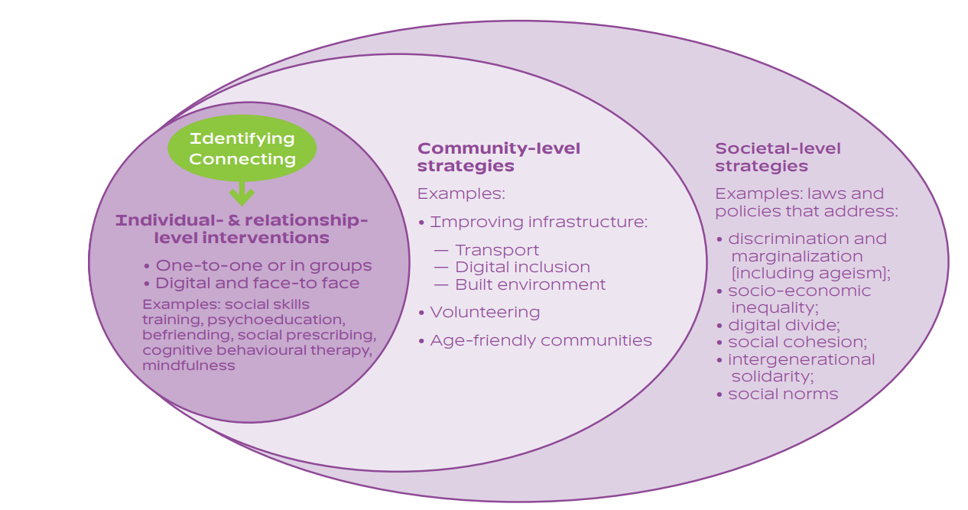
Figure 3: intervention strategy for the reduction of the social isolation
Six subjective surveys of the dejection intercession writing have been distributed starting around 1984 (Cattan and White, 1998), and all expressly or verifiably tended to four fundamental kinds of mediations: (1) upgrading interactive abilities, (2) offering social help, (3) expanding valuable open doors for social communication, and (4) tending to maladaptive social discernment. Everything except one of these surveys presumed that depression intercessions have met with progress, especially mediations that open doors for social cooperation. Findlay (Findlay, 2003) was more mindful in his audit, noticing that the primary six of the 17 mediation concentrates in his survey utilized a randomized gathering correlation plan, with the leftover 11 examinations subject to the deficiencies and imperfections pre-post and nonrandomized bunch examination plans.

Conclusion
The aging of the population has been defined as a global phenomenon, with each nation worldwide experiencing an increase in the ratio of the elderly. In 2019, there are around 703 million people over the age of 65, with this figure expected to rise to 1.5 billion by 2050, more than double the current level. Social isolation is intimately linked to an individual's social and emotional health. Forlornness is a vaguely unpleasant feeling associated with the apparent loss of a much more extensive social network (social depression) or the absence of a preferred acquaintance (passionate depression). There is a lot of disagreement on the definition of social disengagement, but creators have moved toward it as a complicated concept. Low or no social cooperation and a lack of social contacts and support are all linked to social isolation. The UK and Australian both elder people have mental health issues because of social isolation and loneliness so for the future recommendation the public, heath care system or government should focus on social activities to remove the risk of serious health issues or psychological health issues.

References

Alpert, P.T., 2017. Self-perception of social isolation and loneliness in older adults. Home Health Care Management & Practice, 29(4), 249-252.
Assets.publishing.service.gov.uk. 2022. A connected society. [online] Available at: <https://assets.publishing.service.gov.uk/government/uploads/system/uploads/attachment_data/file/936725/6.4882_DCMS_Loneliness_Strategy_web_Update_V2.pdf> [Accessed 22 April 2022].
Australian Institute of Health and Welfare (AIHW), 2020. People with disability in Australia 2020.
Barbosa Neves, B., Franz, R., Judges, R., Beermann, C., and Baecker, R., 2019. Can digital technology enhance social connectedness among older adults? A feasibility study. Journal of Applied Gerontology, 38(1), pp.49-72.
Bierbaum, M., McMahon, C.M., Hughes, S., Boisvert, I., Lau, A.Y., Braithwaite, J. and Rapport, F., 2020. Barriers and facilitators to Cochlear implant uptake in Australia and the United Kingdom. Ear and hearing, 41(2), pp.374-385.
Burt, C.H., 2020. Scrutinizing the US Equality Act 2019: A feminist examination of definitional changes and sociolegal ramifications. Feminist Criminology, 15(4), pp.363-409.
Cattan, M. and White, M., 1998. Developing evidence-based health promotion for older people: a systematic review and survey of health promotion interventions targeting social isolation and loneliness among older people. Internet Journal of Health Promotion, 13(2), pp.1-9.
Cotterell, N., Buffel, T. and Phillipson, C., 2018. Preventing social isolation in older people. Maturitas, 113, pp.80-84.
Findlay, R.A., 2003. Interventions to reduce social isolation amongst older people: where is the evidence?. Ageing & Society, 23(5), pp.647-658.
Finegan, O., Fonseca, S., Guyomarc’h, P., Mendez, M.D.M., Gonzalez, J.R., Tidball-Binz, M., Winter, K.A. and on the Management, I.A.G., 2020. International Committee of the Red Cross (ICRC): General guidance for the management of the dead related to COVID-19. Forensic Science International: Synergy, 2, pp.129-137.
Gale, C.R., Westbury, L. and Cooper, C., 2018. Social isolation and loneliness as risk factors for the progression of frailty: the English Longitudinal Study of Ageing. Age and ageing, 47(3), pp.392-397.
Gong, X., Ni, Z. and Wu, B., 2020. The mediating roles of functional limitations and social support on the relationship between vision impairment and depressive symptoms in older adults. Ageing & Society, 40(3), pp.465-479.
Gonyea, J.G., Curley, A., Melekis, K., Levine, N. and Lee, Y., 2018. Loneliness and depression among older adults in urban subsidized housing. Journal of aging and health, 30(3), pp.458-474.
Holwerda, T.J., Deeg, D.J., Beekman, A.T., van Tilburg, T.G., Stek, M.L., Jonker, C. and Schoevers, R.A., 2014. Feelings of loneliness, but not social isolation, predict dementia onset: results from the Amsterdam Study of the Elderly (AMSTEL). Journal of Neurology, Neurosurgery & Psychiatry, 85(2), pp.135-142.
Khadka, J., Lang, C., Ratcliffe, J., Corlis, M., Wesselingh, S., Whitehead, C. and Inacio, M., 2019. Trends in the utilisation of aged care services in Australia, 2008–2016. BMC geriatrics, 19(1), pp.1-9.
Lapid, M.I., Koopmans, R., Sampson, E.L., Van den Block, L. and Peisah, C., 2020. Providing quality end-of-life care to older people in the era of COVID-19: perspectives from five countries. International psychogeriatrics, 32(11), pp.1345-1352.
National Academies of Sciences, Engineering, and Medicine, 2020. Social isolation and loneliness in older adults: Opportunities for the health care system. National Academies Press.
Nations, U., 2022. International Day of Older Persons | United Nations. [online] United Nations. Available at: <https://www.un.org/en/observances/older-persons-day> [Accessed 21 April 2022].
Ni, Z., Liu, C., Wu, B., Yang, Q., Douglas, C. and Shaw, R.J., 2018. An mHealth intervention to improve medication adherence among patients with coronary heart disease in China: development of an intervention. International Journal of Nursing Sciences, 5(4), pp.322-330.
Ong, A.D., Uchino, B.N. and Wethington, E., 2016. Loneliness and health in older adults: A mini-review and synthesis. Gerontology, 62(4), pp.443-449.
Panch, T., Mattie, H. and Celi, L.A., 2019. The “inconvenient truth” about AI in healthcare. NPJ digital medicine, 2(1), pp.1-3.
Siira, E., 2022. lnnovating eldercare. Exploring older adults' peer-to-peer practices in the outskirts of public care.
Smith, T., 2017. “On their own”: social isolation, loneliness and chronic musculoskeletal pain in older adults. Quality in Ageing and Older Adults, 18(2), pp.87-92.
Tomstad, S., Dale, B., Sundsli, K., Saevareid, H.I. and Söderhamn, U., 2017. Who often feels lonely? A cross‐sectional study about loneliness and its related factors among older home‐dwelling people. International journal of older people nursing, 12(4), p.e12162.
Un.org. 2022. World Population Ageing 2019. [online] Available at: <https://www.un.org/en/development/desa/population/publications/pdf/ageing/WorldPopulationAgeing2019-Highlights.pdf> [Accessed 21 April 2022].
Valtorta, N. and Hanratty, B., 2012. Loneliness, isolation and the health of older adults: do we need a new research agenda?. Journal of the Royal Society of Medicine, 105(12), pp.518-522.
Vergeer, I., Bennie, J.A., Charity, M.J., van Uffelen, J.G., Harvey, J.T., Biddle, S.J. and Eime, R.M., 2018. Participant characteristics of users of holistic movement practices in Australia. Complementary Therapies in Clinical Practice, 31, pp.181-187.
Vozikaki, M., Papadaki, A., Linardakis, M. and Philalithis, A., 2018. Loneliness among older European adults: Results from the survey of health, aging and retirement in Europe. Journal of Public Health, 26(6), pp.613-624.
Wang, J., Mann, F., Lloyd-Evans, B., Ma, R. and Johnson, S., 2018. Associations between loneliness and perceived social support and outcomes of mental health problems: a systematic review. BMC psychiatry, 18(1), pp.1-16.
Weldrick, R. and Grenier, A., 2018. Social isolation in later life: Extending the conversation. Canadian Journal on Aging/La revue canadienne du vieillissement, 37(1), pp.76-83.
Widhowati, S.S., Chen, C.M., Chang, L.H., Lee, C.K. and Fetzer, S., 2020. Living alone, loneliness, and depressive symptoms among Indonesian older women. Health care for women international, 41(9), pp.984-996.
Wittenberg, R., Hu, B., Barraza-Araiza, L. and Rehill, A., 2019. Projections of older people with dementia and costs of dementia care in the United Kingdom, 2019–2040. London: London School of Economics.
Wu, B., Yue, Y., Silverstein, N.M., Axelrod, D.T., Shou, L.L. and Song, P.P., 2005. Are contributory behaviors related to culture? Comparison of the oldest old in the United States and in China. Ageing International, 30(3), pp.296-323.

