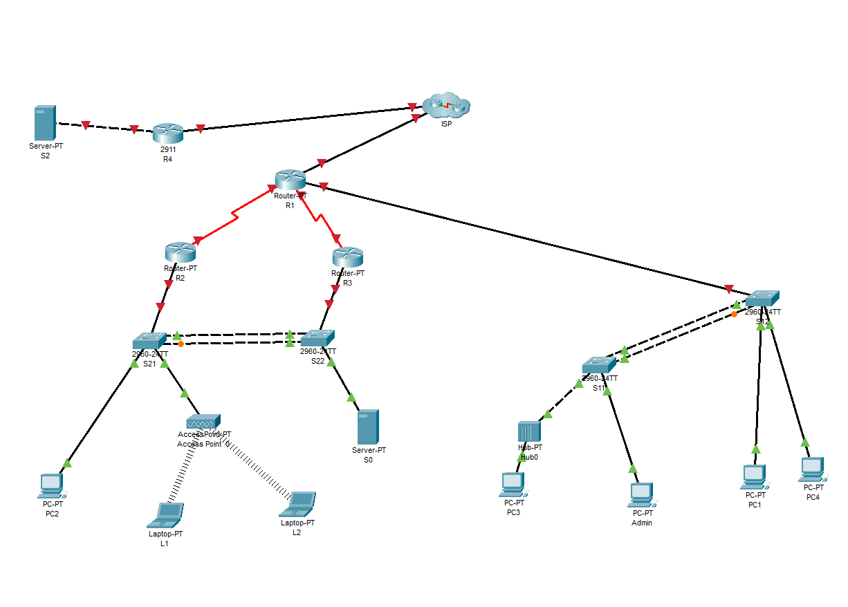
Topology

Addressing Table

Device | Interface | IP Address | Subnet Mask | Default Gateway
R1 | G0/0/0.10 | 192.168.1.1 | 255.255.255.0 | N/A
 | G0/0/0.20 | 192.168.2.1 | 255.255.255.0 | N/A
 | S0/2/0 | 10.0.0.1 | 255.255.255.252 | N/A
 | S0/1/0 | 10.0.12.1 | 255.255.255.252 | N/A
 | S0/1/1 | 10.0.23.1 | 255.255.255.252 | N/A
R2 | S0/1/0 | 10.0.12.2 | 255.255.255.252 | N/A
 | Gi0/0/0 | 172.16.0.1 | 255.255.255.0 | N/A
R3 | S0/1/1 | 10.0.23.2 | 255.255.255.252 | N/A
 | Gi0/0/0 | 172.16.0.2 | 255.255.255.0 | N/A
S12 | VLAN 1 | 172.16.0.11 | 255.255.255.0 | 172.16.0.3
S11 | VLAN 1 | 172.16.0.12 | 255.255.255.0 | 172.16.0.3
S21 | VLAN 20 | 192.168.1.2 | 255.255.255.0 | 192.168.1.1
S22 | VLAN 30 | 192.168.2.2 | 255.255.255.0 | 192.168.2.1
S0 | NIC | 172.16.0.254 | 255.255.255.0 | 172.16.0.3
PC1 | NIC | DHCP | DHCP | DHCP
PC2 | NIC | DHCP | DHCP | DHCP
PC3 | NIC | DHCP | DHCP | DHCP
PC4 | NIC | DHCP | DHCP | DHCP
Admin | NIC | 172.16.0.253 | 255.255.255.0 | Provide your own
L1 | NIC | 172.16.0.252 | 255.255.255.0 | Provide your own
L2 | NIC | 172.16.0.252 | 255.255.255.0 | Provide your own
VLAN Table

VLAN | VLAN Name
20 | Employee
30 | Admin

Task 2: - Device Configuration

:Basic Configuration: (On all devices)
    - Configure hostname on all devices as per the Addressing table
    - Disable DNS lookup
    - Configure all devices with IP address shown in the above tables and network topology.
  - EIGRP Configuration
    - Configure EIGRP with AS 12 on R1, R2 & R3. Advertise directly connected Networks.
Disable automatic summarization. Use the Network IDs and Wild-card masks
    - Set Router ID, 1.1.1.1 on R1, 2.2.2.2 on R2 and 3.3.3.3 on R3.
    - Set LAN interfaces to Passive.
  - VLAN and STP Configuration
    - Configure VLANs as shown in the table.
    - Set Switch Interfaces appropriately as Trunk and Access ports as per the scenario enabling a successful and feasible network connectivity.
    - On switches S12 and S11, configure Rapid PVST+ as spanning tree mode.
    - Configure PortFast and BPDU Guard on the interfaces connected to PCs. Shutdown all unused ports.
  - EtherChannel Configuration

Configure the port channel interfaces as trunk links.
    - On S12, configure a PAgP EtherChannel on interfaces connected to S22. Use group 1 and desirable mode

    - On S11, configure an PAgP EtherChannel on interfaces connected to S12. Use group 1 and desirable mode.

  - HSRP Configuration

    - Configure HSRP on R2 and R3. Group: 1, Virtual IP address: 172.16.0.3. Make R2 as the Active router with priority 110

DHCP Configuration

    - Configure Router RA as a DHCP Server. Create using the following details: DHCP Pool Name: RVlan20
Exclude the first 10 addresses from the RVlan20 Network: 192.168.1.0/24
Default Router: 192.168.1.1

DNS-Server: 172.16.0.254

DHCP Pool Name: RVlan30

Exclude the first 10 addresses from the RVlan30 Network: 192.168.2.0/24
Default Router: 192.168.2.1

DNS-Server: 172.16.0.254

Task3: Network connectivity

Using ping command, verify end-to-end connectivity:
From PC1, ping PC2 & L1. Is it successful? yes/no From PC1, ping default gateway. Is it successful? yes/no From PC2, ping 172.16.0.1. Is it successful? yes/no From PC1, ping 172.16.0.254. Is it successful? yes/no

Verify HSRP is working as expected
Issue the shutdown command on R1 G0/1, and then re-issue the following commands to verify that HSRP is working as expected:
From PC2, ping 172.16.0.1. Ping should not be successful yes/no From PC2, ping default gateway. Is it successful? yes/no From PC2, ping 209.165.200.225. Is it successful? yes/no

