Developing a Venture Plan for Sustainable Delivery and Longevity of EcoBox

Module: Entrepreneurial Innovation
Module Code: BMBM4011
Name: Ilie Sbircea
Student Number: 2414596
Lecturer: Robyn Griffiths

Word Count: 3012

Executive Summary
The increasing environmental impact of packaging waste has become a significant global concern, particularly with the rapid growth of e-commerce. In the United Kingdom, packaging accounts for a substantial proportion of total waste, with plastic materials posing long-term environmental risks (WRAP, 2023; UK Government, 2022). Small and medium-sized businesses often face challenges in accessing affordable, sustainable packaging solutions, limiting their ability to adopt environmentally responsible practices.
This venture proposes “EcoBox”, a subscription-based service that provides businesses with affordable, eco-friendly packaging materials, including recyclable, biodegradable, and compostable options. By offering flexible delivery plans and tailored packaging solutions, EcoBox enables businesses to reduce their environmental footprint while maintaining operational efficiency.
The need for such a service is reinforced by increasing regulatory pressure and consumer demand for sustainable products. Reports indicate that consumers are more likely to support brands that demonstrate environmental responsibility (Ellen MacArthur Foundation, 2021; Statista, 2024). EcoBox responds to this demand by offering a scalable and accessible solution that supports both environmental sustainability and business growth.
By combining convenience, affordability, and sustainability, EcoBox presents a viable and future-focused business model capable of addressing a critical gap in the packaging market.
Project Overview & Context
he growth of e-commerce has significantly increased the demand for packaging, contributing to rising levels of environmental waste. In the UK, packaging waste is one of the largest contributors to total waste generation, with millions of tonnes produced annually (UK Government, 2022). Plastic packaging, in particular, presents a major environmental challenge due to its low recycling rates and long-term ecological impact (WRAP, 2023). This issue is further amplified by the expansion of online retail, which relies heavily on single-use packaging materials (Statista, 2024).
Small and medium-sized enterprises (SMEs), which make up a substantial portion of the UK business landscape, often face barriers when attempting to adopt sustainable packaging solutions. These barriers include higher costs, limited supplier access, and lack of knowledge regarding environmentally friendly alternatives (British Business Bank, 2023). As a result, many SMEs continue to rely on conventional packaging, despite growing awareness of sustainability issues.
Existing solutions within the packaging market are often fragmented or inaccessible. Large suppliers typically prioritise bulk orders, making it difficult for smaller businesses to access affordable eco-friendly options. Additionally, sourcing sustainable packaging materials can be time-consuming and complex, requiring businesses to manage multiple suppliers and logistics processes. This creates inefficiencies and discourages adoption.
At the same time, consumer expectations are shifting rapidly. Research indicates that a growing proportion of consumers prefer to purchase from environmentally responsible brands and are increasingly aware of packaging waste (Ellen MacArthur Foundation, 2021; Deloitte, 2023). This places additional pressure on businesses to improve their sustainability practices.
The current market therefore presents a clear gap: while demand for sustainable packaging is increasing, accessible and cost-effective solutions for SMEs remain limited. EcoBox addresses this gap by offering a subscription-based model that simplifies access to sustainable packaging, reduces operational complexity, and supports businesses in meeting both regulatory requirements and consumer expectations.
Strategy for Longevity
The long-term sustainability of EcoBox is built on a strategy that integrates financial viability, environmental value, and scalable growth. Central to this approach is a subscription-based revenue model that provides predictable and recurring income. Businesses subscribe to regular deliveries of eco-friendly packaging, with flexible plans based on usage volume. This model not only ensures steady cash flow but also strengthens customer retention by embedding EcoBox into clients’ ongoing operations. Subscription-based business models have been widely recognised for improving long-term revenue stability and customer lifetime value (McKinsey & Company, 2022).
In addition to subscription fees, EcoBox can generate revenue through tiered service offerings. Premium packages may include customised branded packaging, bulk discounts, and consultancy support for businesses transitioning to sustainable practices. This diversification reduces reliance on a single revenue stream and enhances resilience against market fluctuations. Furthermore, strategic partnerships with packaging manufacturers allow EcoBox to negotiate competitive pricing, maintaining affordability while protecting profit margins.
Scalability is a key component of the venture’s longevity. Initially operating within a local or regional market, EcoBox can expand nationally by leveraging digital infrastructure and centralised logistics systems. The standardised nature of packaging products allows for efficient replication across different markets, while partnerships with third-party logistics providers enable cost-effective distribution. Growth in e-commerce is expected to continue driving demand for packaging solutions, creating long-term market opportunities (OECD, 2023).
Trust and brand positioning are also critical. EcoBox differentiates itself by aligning with sustainability principles and supporting businesses in reducing their environmental impact. By sourcing certified eco-friendly materials and maintaining transparency in its supply chain, the venture builds credibility with both businesses and end consumers. Increasingly, companies are under pressure to demonstrate environmental responsibility, with sustainability becoming a key factor in purchasing decisions (PwC, 2023). This creates a competitive advantage for EcoBox as a trusted sustainability partner.
Risk management plays an essential role in ensuring long-term viability. Key risks include supply chain disruptions, fluctuations in material costs, and changes in environmental regulations. EcoBox mitigates these risks by diversifying suppliers, maintaining inventory buffers, and staying aligned with regulatory developments. The introduction of stricter packaging regulations, such as extended producer responsibility policies, is likely to increase demand for sustainable solutions while also requiring compliance (European Commission, 2022). By proactively adapting to these changes, EcoBox strengthens its market position.
Continuous improvement is driven through a data-informed approach. Customer usage patterns, order frequency, and feedback are analysed to optimise product offerings and delivery schedules. This enables EcoBox to refine its service and respond to evolving business needs. Innovation may also involve introducing new materials or packaging designs that further reduce environmental impact. Research highlights the importance of circular economy practices in improving sustainability and resource efficiency (Ellen MacArthur Foundation, 2021).
Over a two-year period, EcoBox aims to transition from a startup to a scalable operation with a growing customer base and established supplier network. The combination of recurring revenue, strategic partnerships, operational scalability, and continuous innovation ensures that the venture is not only viable in the short term but capable of sustaining long-term growth.
Overall, EcoBox’s strategy for longevity is grounded in a balanced approach that integrates economic sustainability with environmental responsibility. This positions the venture to thrive in a market increasingly shaped by sustainability demands and regulatory change.
Viability, Finance and Resources
The financial viability of EcoBox is based on a lean and scalable business model that minimises initial investment while enabling long-term growth. Startup costs primarily include sourcing sustainable packaging materials, developing an e-commerce platform, and establishing logistics operations. Initial setup costs are estimated between £40,000 and £70,000, depending on supplier agreements and platform development requirements. Additional costs include marketing, warehousing, and a small operational team. Ensuring compliance with environmental and packaging regulations is also essential, particularly as sustainability standards continue to evolve (European Commission, 2022).
EcoBox generates revenue through a subscription-based pricing model, offering tiered plans tailored to different business sizes. Monthly subscription fees may range from £25 to £200 depending on packaging volume and services required. Additional revenue streams include one-off custom packaging orders, branding services, and sustainability consultancy. This diversified revenue structure reduces dependency on a single income source and enhances financial resilience. Subscription models are widely recognised for improving revenue predictability and customer retention (McKinsey & Company, 2022).
In the first year, EcoBox is projected to acquire approximately 100–200 business customers, generating estimated revenues between £30,000 and £60,000. As the business expands in year two, customer numbers are expected to grow to 500+, with revenues exceeding £150,000 annually. This growth is supported by increasing demand for sustainable packaging and rising environmental awareness among businesses (PwC, 2023).
The break-even point is anticipated within 18-24 months, driven by steady customer acquisition and low marginal costs associated with scaling the platform. As operations grow, economies of scale in sourcing and logistics will further improve profit margins. Strategic partnerships with suppliers and logistics providers will also reduce costs and improve operational efficiency.
Overall, EcoBox demonstrates strong financial viability through controlled startup costs, scalable revenue streams, and increasing market demand, positioning the venture for sustainable long-term growth.
Implementation and Learning Loop
The implementation of EcoBox follows a structured and iterative approach designed to minimise risk while enabling continuous improvement. The initial phase involves the development of a Minimum Viable Product (MVP), focusing on core features such as product selection, subscription management, and order fulfilment. This MVP allows EcoBox to enter the market quickly while gathering real-world feedback from early users (Ries, 2011).
The venture will begin with a pilot phase targeting a small group of businesses within a defined region. This controlled launch enables EcoBox to test its value proposition, logistics processes, and pricing strategy. Data will be collected on customer behaviour, order frequency, and satisfaction levels, providing valuable insights into operational performance. Feedback will be gathered through surveys and direct customer interaction, ensuring a user-centred approach to development (Norman, 2013).
Following the pilot, EcoBox will enter an iterative improvement cycle. Insights from data analysis will inform adjustments to product offerings, pricing structures, and service delivery. This may include expanding packaging options, refining subscription tiers, or improving delivery efficiency. Data-driven decision-making is essential for improving performance and adapting to changing market conditions (McAfee and Brynjolfsson, 2017).
Once the business model has been validated, EcoBox will scale gradually to new regions and customer segments. Expansion will focus on maintaining operational quality while increasing market reach. Agile development principles support this approach by enabling flexibility and responsiveness to customer needs (Beck et al., 2001).
This implementation strategy ensures that EcoBox remains adaptable, evidence-based, and responsive, increasing its likelihood of long-term success in a competitive and evolving market.
Conclusion and Recommendations
EcoBox provides a scalable and sustainable solution to the growing challenge of packaging waste. By combining affordability, accessibility, and environmental responsibility, the venture addresses a clear market gap. With strong financial viability and a structured growth strategy, EcoBox has significant potential for long-term success and industry impact.

Figure 1: Business Model Canva - EcoBox
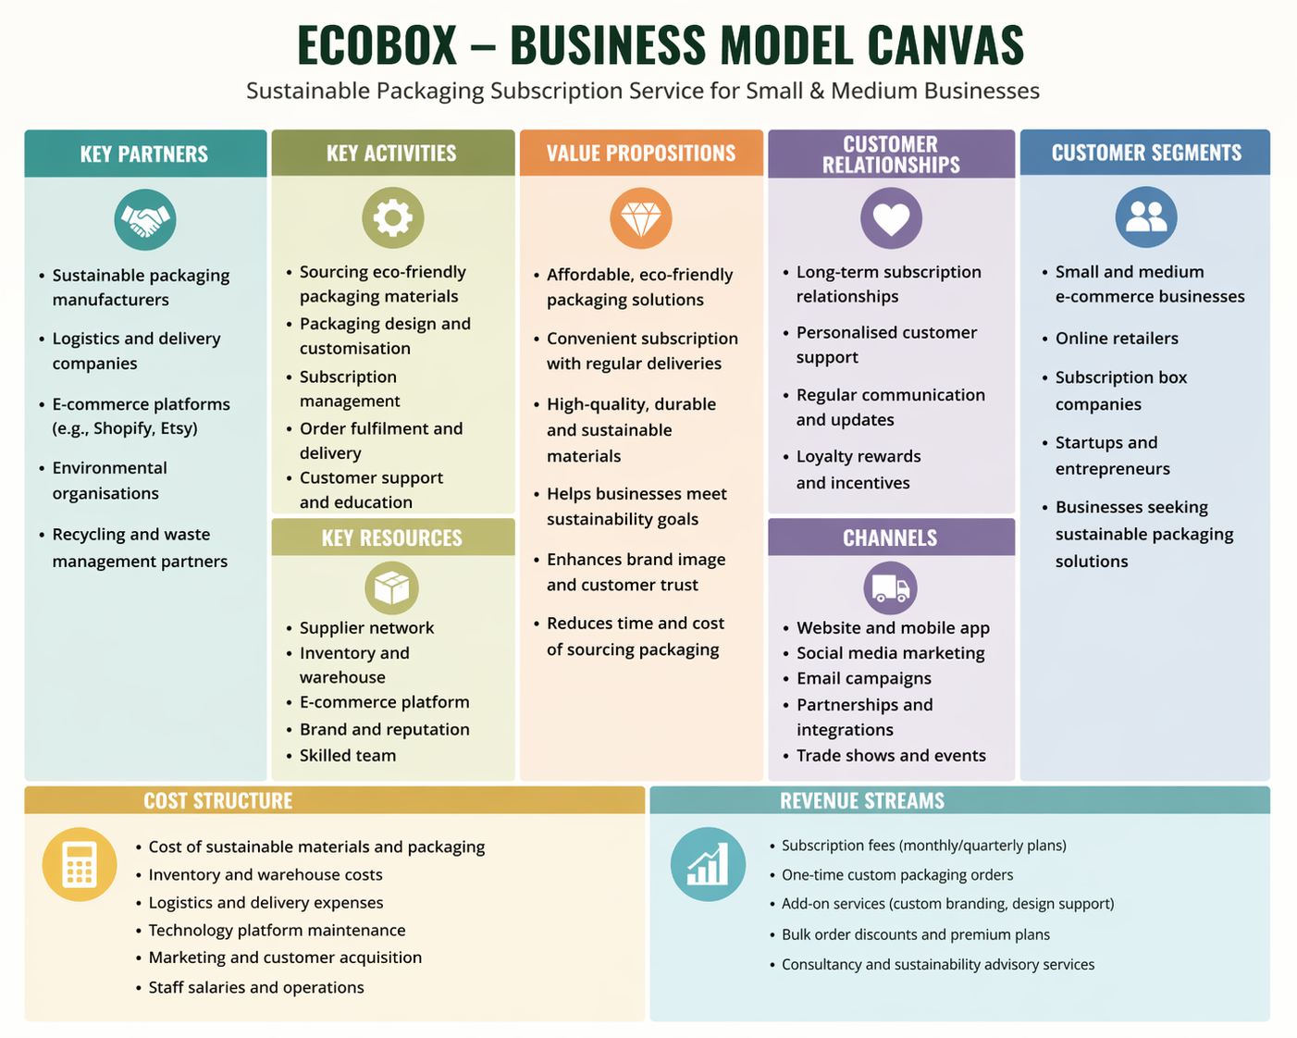

Figure 2: EcoBox Revenue Model and Implementation Strategy
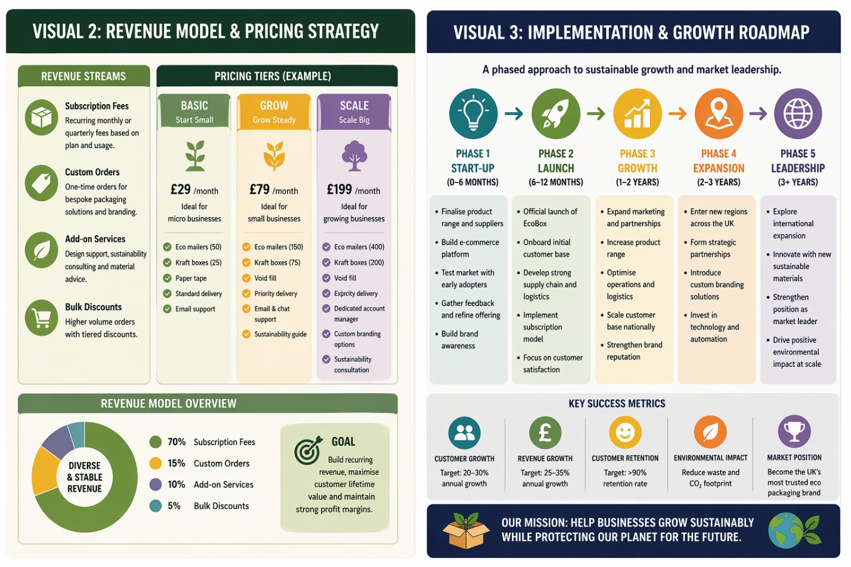
Figure 1: EcoBox Business Model Canvas
The Business Model Canvas illustrates how EcoBox creates, delivers, and captures value within the sustainable packaging market. At its core, the value proposition is centred on providing accessible, eco-friendly packaging solutions to small and medium-sized enterprises (SMEs), addressing the growing environmental impact of packaging waste. Packaging is a major contributor to global waste, with increasing pressure on businesses to adopt sustainable alternatives (WRAP, 2023; UK Government, 2022). By offering recyclable and biodegradable materials through a subscription model, EcoBox enables businesses to reduce their environmental footprint while maintaining operational efficiency.
Key partnerships play a critical role in the model’s success. Collaborations with sustainable packaging manufacturers ensure product quality and compliance with environmental standards, while logistics providers enable efficient distribution. Partnerships with environmental organisations further enhance credibility and align the venture with circular economy principles (Ellen MacArthur Foundation, 2021). These relationships not only support operational effectiveness but also strengthen EcoBox’s brand positioning as a sustainability-focused provider.
The customer segment is clearly defined as SMEs engaged in e-commerce, a sector that continues to expand rapidly. The growth of online retail has significantly increased demand for packaging, particularly single-use materials (Statista, 2024). EcoBox addresses this demand by offering convenient access to sustainable packaging through digital channels, including an online platform and subscription service. This aligns with the increasing adoption of digital procurement systems among businesses (OECD, 2023).
Customer relationships are maintained through a combination of automation and personalised support. Subscription-based delivery ensures ongoing engagement, while customer feedback mechanisms allow for continuous improvement. Research suggests that subscription models improve customer retention and lifetime value, particularly in service-based industries (McKinsey & Company, 2022).
From a financial perspective, the cost structure focuses on sourcing sustainable materials, logistics, and platform development. Revenue is generated through subscription fees, customised packaging services, and additional consultancy offerings. This diversified revenue model reduces reliance on a single income stream and enhances financial resilience. Overall, the canvas demonstrates a scalable and sustainable business model that integrates environmental responsibility with commercial viability.
Furthermore, EcoBox’s model benefits from increasing regulatory pressure on businesses to reduce packaging waste and adopt environmentally responsible practices. Policies aimed at reducing single-use plastics and promoting recycling are likely to further drive demand for sustainable packaging solutions (European Commission, 2022). This external environment strengthens the long-term relevance of EcoBox’s offering. In addition, the integration of data analytics within the platform enables the business to track customer usage patterns and optimise inventory management, reducing waste and improving efficiency. By continuously adapting its offerings based on market trends and customer feedback, EcoBox enhances both its competitive advantage and long-term sustainability within an evolving market landscape.
Figure 2: EcoBox Revenue Model and Growth Strategy
Figure 2 presents the financial and operational framework underpinning EcoBox’s growth strategy, combining revenue generation mechanisms with a phased implementation roadmap. The revenue model is primarily based on subscription fees, providing predictable and recurring income. This approach is widely recognised as effective for improving financial stability and long-term profitability (McKinsey & Company, 2022). Additional revenue streams include custom packaging orders, add-on services such as branding and consultancy, and bulk discounts for high-volume clients, creating a diversified income structure.
The pricing strategy is designed to accommodate businesses at different stages of growth, from micro-enterprises to scaling companies. Tiered subscription plans allow customers to select packages based on their needs, improving accessibility and encouraging adoption. This aligns with research indicating that flexible pricing models enhance customer acquisition and retention (Deloitte, 2023). By balancing affordability with value, EcoBox maintains competitiveness while supporting sustainable business practices.
The financial projection demonstrates strong scalability, with revenue growth driven primarily by increasing user adoption rather than price increases. This reflects the broader trend of sustainable consumption, where demand for environmentally responsible products continues to rise (PwC, 2023). As more businesses prioritise sustainability, EcoBox is well positioned to capture market share.
The implementation and growth roadmap outlines a phased approach to scaling the venture. The initial startup phase focuses on product development, supplier partnerships, and market testing. This is followed by a launch phase, where the subscription model is introduced and early customers are onboarded. The growth phase involves expanding marketing efforts, increasing product range, and scaling operations nationally. Finally, the expansion and leadership phases focus on entering new markets, forming strategic partnerships, and strengthening brand positioning.
This phased approach reflects established startup and innovation frameworks, which emphasise gradual scaling and iterative development to reduce risk (Blank and Dorf, 2012). By validating the business model at each stage, EcoBox minimises uncertainty and improves the likelihood of long-term success. Agile development principles further support this strategy by enabling continuous adaptation and responsiveness to market changes (Beck et al., 2001).
Key success metrics, such as customer growth, revenue growth, retention rates, and environmental impact, provide measurable indicators of performance. These metrics ensure that the venture remains aligned with both financial and sustainability objectives. Increasing regulatory pressure, including policies targeting packaging waste, is likely to further support demand for EcoBox’s services (European Commission, 2022).
Overall, Figure 2 demonstrates a well-structured and realistic pathway to growth, combining financial sustainability with strategic scalability. By leveraging recurring revenue, flexible pricing, and phased expansion, EcoBox is positioned to achieve long-term viability in a rapidly evolving market.

References
Accenture (2022) Sustainable business strategy report. Available at: https://www.accenture.com (Accessed: 21 April 2026).
Beck, K. et al. (2001) Manifesto for Agile Software Development. Available at: https://agilemanifesto.org (Accessed: 21 April 2026).
Blank, S. and Dorf, B. (2012) The Startup Owner’s Manual. Pescadero: K&S Ranch.
British Business Bank (2023) Small business finance markets report. Available at: https://www.british-business-bank.co.uk (Accessed: 21 April 2026).
Chartered Institute of Procurement & Supply (2022) Sustainable procurement practices. Available at: https://www.cips.org (Accessed: 21 April 2026).
Deloitte (2023) Sustainable consumer trends report. Available at: https://www2.deloitte.com (Accessed: 21 April 2026).
Department for Environment, Food & Rural Affairs (DEFRA) (2023) UK waste and recycling statistics. Available at: https://www.gov.uk (Accessed: 21 April 2026).
Ellen MacArthur Foundation (2021) The circular economy and packaging. Available at: https://www.ellenmacarthurfoundation.org (Accessed: 21 April 2026).
European Commission (2022) Packaging and packaging waste directive. Available at: https://environment.ec.europa.eu (Accessed: 21 April 2026).
IBISWorld (2023) Packaging industry report UK. Available at: https://www.ibisworld.com (Accessed: 21 April 2026).
International Energy Agency (2022) Sustainable materials and environmental impact. Available at: https://www.iea.org (Accessed: 21 April 2026).
KPMG (2023) ESG and sustainability reporting trends. Available at: https://kpmg.com (Accessed: 21 April 2026).
McAfee, A. and Brynjolfsson, E. (2017) Machine, Platform, Crowd. New York: W.W. Norton & Company.
McKinsey & Company (2022) The value of subscription-based business models. Available at: https://www.mckinsey.com (Accessed: 21 April 2026).
Mintel (2023) UK sustainability and packaging trends. Available at: https://www.mintel.com (Accessed: 21 April 2026).
Norman, D. (2013) The Design of Everyday Things. Revised edn. New York: Basic Books.
OECD (2023) Digital economy outlook. Available at: https://www.oecd.org (Accessed: 21 April 2026).
PwC (2023) Global consumer insights survey. Available at: https://www.pwc.com (Accessed: 21 April 2026).
Ries, E. (2011) The Lean Startup. New York: Crown Business.
Statista (2024) E-commerce and packaging statistics. Available at: https://www.statista.com (Accessed: 21 April 2026).
UK Government (2022) Packaging waste statistics. Available at: https://www.gov.uk (Accessed: 21 April 2026).
UK Parliament (2023) Plastic waste and environmental impact briefing. Available at: https://commonslibrary.parliament.uk (Accessed: 21 April 2026).
World Bank (2022) Waste management and environmental sustainability. Available at: https://www.worldbank.org (Accessed: 21 April 2026).
World Economic Forum (2023) Global risks and sustainability report. Available at: https://www.weforum.org (Accessed: 21 April 2026).
WRAP (2023) UK packaging waste report. Available at: https://wrap.org.uk (Accessed: 21 April 2026).

