Research Proposal
(LCMB7020)
Name - VIRAL JIVANI
Student Id - 2242374
Supervisor - Dr Liyanage Sampath Rodrigo
Course - MBA General Management

Subject - A study on the Double Paycheck Revolution in the

UK – A Systematic Literature Review.

Study on the Double Paycheck Revolution in the UK – A systematic literature review.

Contents
Introduction 3
Background of the research 3
Research Aim: 5
Research Objectives: 5
Research Questions: 5
Problem Statement 5
Literature Review 6
Economic Implications of Dual-Income Households 6
Policy, Taxation, and Unintended Consequences 7
The Social Sphere: Balance, Technostress, and Burnout 7
Childcare, Class, and Future Impacts 7
Gender, Power, and the Household 8
Social Mobility and the Next Generation 8
Literature Gaps 8
Conclusion 8
Methodology: 9
Data Collection: 11
Ensuring Validity and Reliability: 11
Ethical Considerations: 12
Discussion: 12
Policy and Practice Implications: 13
Limitations: 14
Project Timeline: (Jan 2024 - Apr 2024) 15
Reference List 16

Introduction
The UK has undergone a transformational change in household dynamics as the number of dual-income households, known as the “Double Paycheck Revolution”, increased significantly. Factors contributing to this are more options for childcare and better access to education for women resulting in higher female workforce participation rate (Belfield et al., 2017; Duxbury, Lyons & Higgins) Economic factors, such as globalization and technological innovations determine the necessity of dual incomes for preserving standards of living within various classes equally. Traditionally single-income households with young children, for example, prefer part-time or alternate work schedules to maintain dual income opportunities (Chung et al., 2021). This change has important social and economic implications. It has increased average household income, which could lower poverty rates (Croal 2022). Nevertheless, the impact on income inequality is contested with those emphasizing increased equality from higher women’s wages and others evidencing inequalities within dual-earner households. The “Double Paycheck Revolution” affects the other aspects of labour market dynamics, such as sectoral preferences; wage gaps and female workforce participation (Revill,&nbsp2008).Society is not immune to these changes. Longer working hours and increased caregiving obligations can generate pressure on family dynamics, highlighting the priority of work-life balance for Gemmano et al. (2023) Important issues that influence the development of a child include deciding for caring, their cost and standards (Abbott et al., 2013). To understand the full socia1 impact on UK society we need to appreciate how these factors interrelate and affect social mobility. The main objective of this paper is to analyze the different economic and social impacts that dual-income families have on the UK. In this process of developing policies and designing social actions concentrates on the linkages among women's higher incomes, labour market incorporation, work life balance and family well-being. During such consciousness, he will have to manoeuvre subtle ‘Double Paycheck’ signs.

Background of the research
The extended history of the British families social-financial economy is one of transition and continuity with the "Double Paycheck Revolution" as a latest revolution in the permanent household dual-earner reformer. This is a change that has manifested because of societal and economic changes including long hours of day-care, and increased female educational attainment, the ultimate effect of this being women’s rates of labour force participation (Belfield et al., 2017; Duxbury, Lyons & Higgins, 2022). The phenomenon of globalization and technological advancements that affect economic imperatives require all men, regardless of the social stratum, to have a parallel household income in order to achieve stability of living standards (Chung et al. 2021). This has the consequent effect of there being a growth in the average household income which theoretical has the potential for it to be used in poverty reduction (Croal, 2022) but the effects in reducing income inequality is a subject of debate. Work-life balance, otherwise overlooked, is becoming clearer as the result of the intelligent automation which not only recalibrated economic markers but also created a society where societies are now balancing the increased work duties and care-taking role. (Gemmanoet al., 2023) In this essay, I will parse the complex implications arising from the Having Two Parents In Work phenomenon in the UK, as I will scrutinize the association between the female’s enhanced wages, labour market participation and family’s welfare-indicating the needs to formulate policies aimed at reducing inequalities in the society.

Revolution’ which is a gift for UK households and society in managing its opportunities and threats.

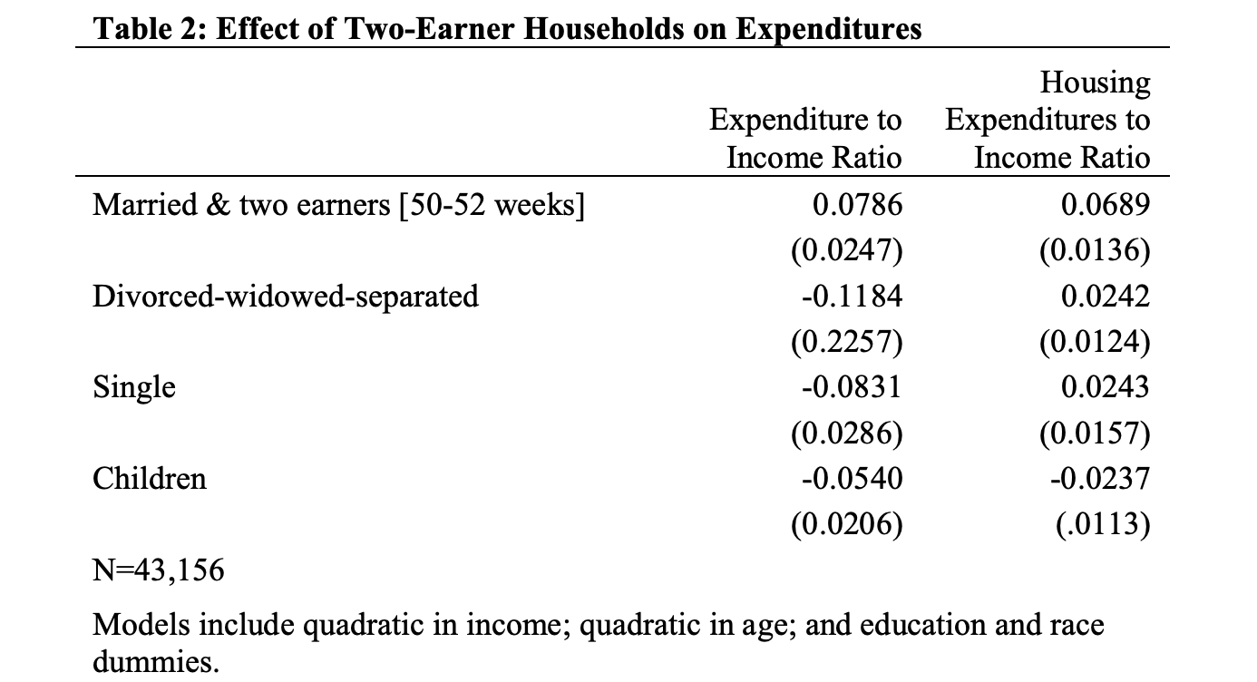

Source : Johnson, N at census.gov

Research Aim:
To explore the multifaceted economic impact of dual incomes on households and society in the UK.

Research Objectives:
To Analyse the economic implications of labour market participation in dual-earner households.
To Investigate the role of dual incomes in poverty reduction, especially among vulnerable groups.
To Evaluate the impact of dual incomes on the standard of living within households and its contribution to improving overall economic well-being in the UK.

Research Questions:
What is the effect of the shift toward dual-income households in the UK on income inequality and how do the tax policies determine the relationship?

What does the influence of labour market participation on dual earner households tell about the economic outcomes, related to labour income differences and sectorial preferences that affect income distribution?

How much does the Double Paycheck Revolution contribute to poverty eradication in the UK – notably among vulnerable groups – and which policy interventions could best optimize the positive impact of the Revolution on the three dimensions of household well-being and social mobility?

Problem Statement
The principal challenge addressed in this research is to discern the economic and social ramifications of the increasing prevalence of dual-income households in the UK. This widespread shift away from the traditional single-earner model has a profound impact on the nation's economy and society. While enhancing household earnings and potentially reducing poverty, the implications for income inequality, labour market dynamics, family well-being, and social mobility remain complex and contentious. This paper seeks to understand these multifaceted impacts, particularly in the context of rising female workforce participation, the ongoing struggle for work-life balance, and the potential widening of socioeconomic disparities.
In the UK, the prevalence of dual-income households has risen from 37% in 2002 to 47% in 2022, equating to 16.3 million out of 34.9 million households, according to the Office for National Statistics (ONS, 2022). This shift has seen the average gross weekly income for dual-earner couples increase to £992, a 79% rise compared to £555 for single-earner couples, significantly impacting economic dynamics and contributing to a decrease in child poverty from 30% in 1990 to 17% in 2022, as reported by the Children's Society (2022). Despite these gains, the income disparity within dual-income families is growing, with the top 10% earning 12 times more than the bottom 10%, a concern highlighted by the Institute for Fiscal Studies (IFS, 2023). Socially, 67% of such couples with children under 16 struggle to balance work and family life, leading to stress and burnout, and 31% rely on informal childcare, indicating challenges in accessing quality childcare (Work Foundation, 2022; ONS, 2022). The rise in female labour force participation from 57% in 2002 to 72% in 2022 has been significant, yet women continue to earn 15% less than men, perpetuating the gender pay gap within these households (ONS, 2022). The high cost of childcare, averaging £7,200 annually for a toddler (National Childcare Trust, 2023), underscores the need for policies that support affordable childcare, flexible working arrangements, and gender equality.

Literature Review
The "Double Paycheck Revolution" goes further beyond only the gender issues since the lower-income families could be enriched, and a certain social and economic change could be produced. Economically, one may observe that the contribution of both the partners in the workforce has been related to varied outcomes (Woodhams et al., 2015). According to Belfield et al. (2017), the growing female employment has a positive side: it improves the fighting with inequality and poverty, and it is even one of the reasons to be proud of (which is supported by Croal, 202). Put the same way, not all people are convinced of this view. Moreover, while O’Connor (2023) emphasizes the revolutionary impact of AI in terms of the role it can play in reducing employment levels which might cause more problems such as growing inequality and stagnation of wages among workers in dual-earner families, Leonce (2020) reports a discussion of more specific studies that consider this factor from a wider societal perspective.

Economic Implications of Dual-Income Households
The matter of dual-income households and income inequality fed many debates. Conversely, some see in the increase in the number of females employed people nothing but an indicator of befalling poverty and inequality (Belfield et al., 2017; Croal, 2002). However, others argue that this is a new way of making the disparities worse. O'Connor, 2023 (2023) points out that the low-paid employees in two-earners families encounter unbalanced income stagnation. Thus, the area of research needs to be carried out that considers the impact of this phenomenon across socio-economic layers (Léonce,2020).
The inverted U-curve theory brings to bear the fact that it has the potential to have explanatory power at least as far as (Teichgraeber and Van Reenen 2021) are concerned. With an increase of two-income households, our society is in a way enhancing inequality. Initially, the poor might have to pay more and higher income families seemed favored, but after a transition, we can see a more even wealth distribution. It is, however, still to unravel the exact simultaneous influence of such macro yearly or monthly trends with each other and their effects on the income earning (Gray & Evans, 2008).

Policy, Taxation, and Unintended Consequences
From the perspective of a policymaker it is important to note that policy changes to help the people need to face a conflict of interests. In fact, any idea like two child allowance caps, which at first look may be considered beneficial, might unfortunately have a negative impact on dual income families. Researches should spotlight on whether or not these programmes do bring this social mobility that families seek for (Bargain, Dorley & Van Kerm, 2019). Along with looking at policy purpose, a critical examination of policymakers in practice must be paired to analyze whether the policy goals are met with inequality reduction and how they contribute to the welfare of families.

The Social Sphere: Balance, Technostress, and Burnout
Beyond the purely economic, work-life balance in dual-income households poses formidable challenges. Studies link increased working hours and childcare burdens to technostress and burnout within the family unit (Cutanda & Sanchis-Llopis, 2021; Gemmano et al., 2023). Family systems come under strain, making understanding effective work-life strategies crucial for health and relationships (Blom & Cooke, 2023). Hughes' (2013) call for changes to the outdated 'dual-career household' concept signals the need to rethink support systems beyond the outdated breadwinner model.

Childcare, Class, and Future Impacts
Access to quality, affordable childcare is central to dual-income family success. Cross-European studies offer foundational insights (Abbott et al., 2013; Chung et al., 2016), Yet there's a gap in understanding how childcare choices relate to UK social class over the long term (Martin, 2020). Questions of whether high childcare costs reproduce inequality through generations demand serious scrutiny.

Gender, Power, and the Household
Jenson's gendered contract theory provides a powerful lens to scrutinize how rising female workforce participation intersects with traditional expectations in the home. While progress is undeniable, whether a true revolution in gender equality within dual-income households is underway is contested (Bargain, Doorley & Van Kerm, 2019; Hardill, 1999). Power dynamics, decision-making, and task division within couples warrant greater focus, with implications for long-term female economic empowerment.

Social Mobility and the Next Generation
The income of families with two parents seems to be an ability indicator, but there is a risk that inequality continues to be promoted by the differential in access to educational resources (Mazzocco, 2007). The precise interplay between dual incomes, life opportunities and mechanisms to improve social standing of children involves many factors, and the contribution of this interplay to the task of eliminating child poverty completely remains ambiguous.

Literature Gaps
- The double pernicious impact of two incomes on income inequality and economic development while some groups of society benefit the majority of the population is either in poverty or is uprooted.
- Tax and welfare policies and the dual role of these policies on family development and family welfare of dual income families and their consequences for the economy and the well-being of families.
- The long-run effects of having two incomes on job-life balance, family intimate relationships, and one’s health as an individual.
- For childcare choices to be equitable and to achieve a balanced development of children in dual-income families, social inequality and the long-term well-being of children must be considered.
- The power and gender norms schemas within the dual-income families working women encounter and their effect in reaching equality.

Conclusion
The "Double Paycheck Revolution" in the UK is a complicated phenomenon that varies upon a number of factors being economic, social and cultural aspects. Though there are positive consequences, there are also serious gaps in knowledge that deal with the intricate matters such as income disparity, family challenges, and social mobility at the same time. Academies should do more research in this area next time, utilizing various disciplines which would contribute to the formation of an integrated portrayal of the studied social issue and will inform the UK government on different kind of policy issues that need to be addressed.

Methodology:
For our study, we use a qualitative approach along with the layers of the onion model, which represent the interconnectedness of issues involved to examine the implications of dual earnings on households and the society at large in the UK. This teaching strategy is employed to reveal the intricacies and shades of the material, so that the students develop an intellectually rich and deep understanding of the relationships between the actors who come into the scene.
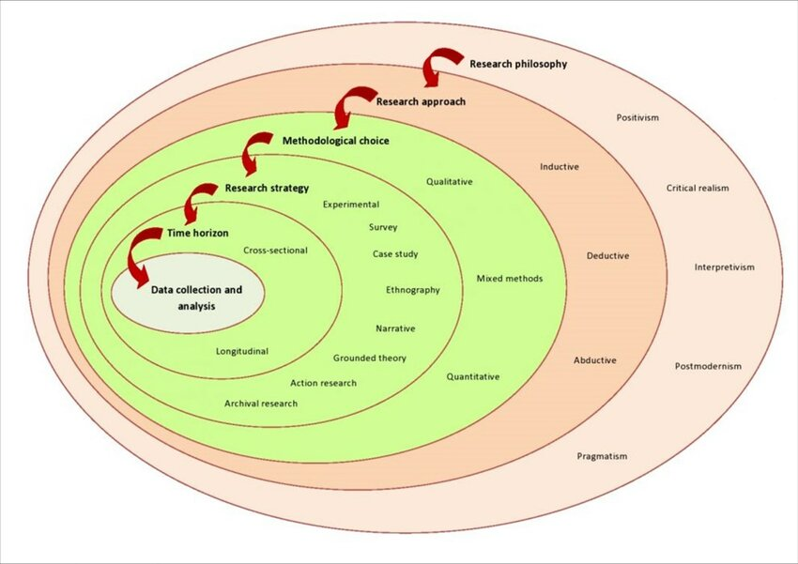
Figure 1/ Researchgate.net

Research Philosophy and Approach: At the outermost level of the research onion, we are interpretivists, to we subscribe to the understanding that reality is relative and the meanings of experiences are attached to people rather than the other way round This makes up the philosophy, in a qualitative style, where context and subjective interpretation are highlighted as the basis of their knowledge on the impacts of the dual income homes to the economy.

Research Strategies: In terms of inner logic, research strategy is cross-sectional, because we aim to seize the current moment on homeland of Dual Earners households in UK. The aforementioned strategy is further augmented by a case study approach, through which select dual-income families are studied in depth to unravel the general patterns and details that may not be apparent in large surveys.

Research Choices: As a respect to research options, we embrace multi-individual qualitative design. This progression involves the application of various qualitative techniques such as secondary data analysis with the help of a thematic approach, conversations with the key informants, as well as the assessment of the policy papers. Every method has its own particular perspective to which researchers can apply as one of the tools to further advance the general knowledge.

Time Horizons: The cross-sectional nature of the study specifies a particular segment being at a specific time period, which is the present and recent past to assess contemporary trends and its varying implications on joint-income households.

Data Collection and Analysis :- First of all, a systematic literature review is done which involved the secondary sources e.g. academic articles, government reports and statistical data from ONS (Office for National Statistics), google scholar among other reputable sources This will be broken down into key policy areas and a thorough analysis of primary data through semi-structured interviews with relevant sources, such as economists, sociologists and policymakers, will be helpful in the process. Through thematic analysis, data analysis studies will be conducted on those recurring themes and narratives which give an account on the economic effects of dual-income households in society.

Ethics and Validity: In validating the collected primary data, ethical considerations should be given a great priority, and data collected needs to be secure and the subjects should be aware of the impact they are taking. To have a valid qualitative study, we use triangulation, which means that we cross-check the results across different data-sources and methods, so we are sure that the credibility and validity of the conclusions of the study.

The economic implication of dual income not only households but society as a whole in the UK can be reliably assessed by digging deeper in layers of the research onion with emphasis on the systematic and comprehensive approach as this ensure that depth, rigor, and relevance of the findings.

Data Collection:
In the following, we will examine broader economic and social issues pertaining to dual-income households in the UK to the extent that the given secondary data from Google Scholar and other authoritative sources like ONS, DWP, SAGES, and Taylor & Francis have allowed us to. The same platforms provide an opportunity to access a plethora of academic articles, reports, and datasets critical to understanding what causes dual-income families to function effectively or ineffectively.
Our research method needs to provide the mixed-methods approach to succeed, using a framework of themes addition the onion research model to get through the complex effect of dual incomes. Thematic analysis suggested by Braun and Clarke is the fundamental tool that is used to derive generalized findings from qualified data. This method involves six steps: One should begin by getting familiar with the data, then move on to the initial coding, the search is subsequent and then comes the reviewing of themes, after that themes are defined and named and then the final report will be produced. This managed process ensures locating out vital patterns, themes, and trends, whose understanding plays a major role of getting something from the material of study.
Meanwhile, the given research onion framework developing the overall research design embraces both philosophical underpinnings and specified methodologies on one condition. In this multilayered approach we make use of all the research tools available to guarantee a systematic and meticulous study, which will make our findings valid and reliable.
Synthesizing theoretical analysis with focused research onion approach of the study, a broad-based understanding of economic and social aspects of the dual-income households in the UK, that is, bringing out major concerns and identifying gaps in the existing literature shall be the objectives of the study.

Ensuring Validity and Reliability:
The decision of a systematic literature review to conduct this qualitative approach on dual-income households in united kingdom is considered as well-founded because of its thorough and planned approach for ensuring validity and reliability. The use of a correlated and vitalized nature of second source from the top-rated sources narrows the gap of the biases and increases the credibility of results. A transparent methodology used within the systematic review, along with thematic analysis, develops and ties themes to the data, ensuring that themes thoroughly explore the reviewed data allowing for the identification of existing gaps for future research. By following this approach, it will certainly be ensured that the study carries out an in-depth research of economic and societal effects of dual-income households and also it supports the study in the application of research methods or finding results.
Data transparency: Data source, data collection methods, and data analysis methods should be described in a comprehensive manner in the study report to ensure that you give space to transparency, replicability, and openness.

Ethical Considerations:
As an example, the reactions of the research to secondary quantitative data will arise a number of ethical issues. The foremost things to do would be to ensure obtaining the original data from the participants involved in the research project in a manner that it does not violate their terms, as well as protecting their anonymity. It would also be important to maintain the confidentiality of the data subjects. It is paramount to conduct a critical data audit and verify the original source of the information to obtain a complete, true and meaningful picture. Ethical use calls for appropriating right sources through with one should have correct attribution, remain intellectual property and contributions. Researchers are required to treat private information with due care, for the undesirable consequences might come by if it leaked or something tantamount was not concealed. Additionally, companies have to adhere to requirements imposed by the law and ethics as in the case of copyright laws and personal data protection regulation. Exploring these matters carefully, researchers can tap into the widely available secondary sources, sustaining their ethics, and making novel contributions.

Discussion:
The anticipated findings of this research project will enhance our understanding of dual-income households and have implications for policy and practice:
Nuanced understanding of inequality: This study touches on the subtleties of economic disparities in dual-income families. Such information is vital for policymakers to respond to marginalized groups such as single mothers or minimum wage earners (O’Connor, 2023).
Insights into gendered labour dynamics: The correlation between dual incomes, female labor force participation and wage differential gives insights on gender issues vis-à -vis job market. This understanding may guide actions aimed at advancing career development and gender equity in the dual-income household (Duxbury et al., 2007; Revill, 2008).
Interplay between multiple incomes and social mobility: Children’s opportunities are defined as the determinants identified in examining long-term effects of dual income on intergenerational mobility through quality education and childcare. This data can contribute to policy options for affordable and accessible childcare and early education, regardless of family income (Croal 2022; Families relying on dads’ incomes only).
Work-life balance challenges: Yet understanding the hardships that dual-earner couples faced, including long working hours and flexible work arrangements, can be used to inform how best policies should be formulated. The result could be the promotion of flexible work arrangements, low-cost childcare facilities, and workplace policies focusing on employee wellness (Gemmano et al., 2023).
Recognizing childcare diversity: The above holistic understanding of the various childcare strategies used by dual-income families and their impacts on child development. These comprehensions can guide policies aimed at improving affordable, quality, and accessible childcare in all income groups as well as geographic areas (Abbott et al., 2013; Chung, 2022).

Policy and Practice Implications:
Informed policy formation: Research findings could inform the design of strategies aimed at effectively addressing problems and inequalities that double-income families continue to experience with a view to advancing social mobility as well as family welfare. This could include work-family balance programs, investments in childcare infrastructure and alterations to the taxation and benefit systems.
Support for the workplace: For instance, employers can gain a deeper insight into the challenges surrounding labor-life balance among dual-earners. This knowledge translates into the adoption of parental leave policies, flexible work schedules and childcare subsidies among other measures that enable an organization to recruit and maintain much-needed talent, increase productivity as well as create a more welcoming workplace.
Community-based initiatives: Therefore, this type of research can provide guidance towards building daycare centers or targeted support groups for families with two full-time jobs. These may be cheap nursery centers, family centers and parent education programs.
Public awareness campaigns: In addition to reinforcing legislative support for those laws that benefit dual income earners in society, enlightening the public about the “Double Paycheck Revolution” can also promote empathy among them as they understand what it means socially and dispel any myths around this phenomenon.

Limitations:
Dependency on secondary data: However, research grants and ethical issues would possibly necessitate use of already available data. However, as surveys and interviews reveal a broader view of the problem, this method might entail some disadvantages.
Potential biases: Bias cannot be avoided during data collection, and this implies that it is not easy to have an objective analysis of the collected statistical information. On the other hand, qualitative data comparing these findings may unveil further perspectives that would underline some of such issues.
Focus on the UK: Note that these findings may not necessarily apply to other states with a different social and economic background. Often, additional research is required to understand the implications of “Double Paycheck Revolution”.
Aiming to identify these limitations and find ways of overcoming them, our research wants to provide accurate results that significantly move forward the debate on multiple income households.

Project Timeline: (Jan 2024 - Apr 2024)
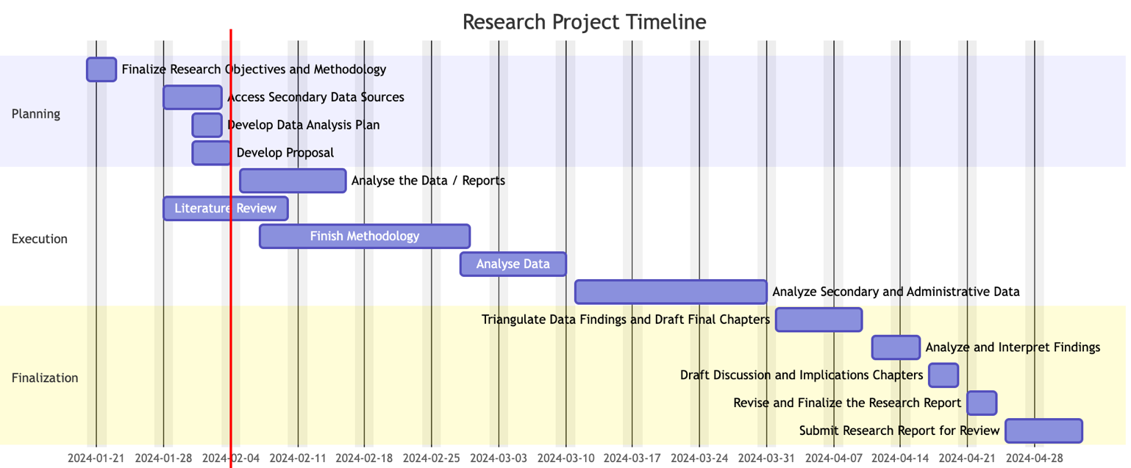

Reference List
Abbott, P., Nativel, C. and Wallace, C. (2013) “Dual earner parents’ strategies for reconciling work and care in seven European countries,” Observatoire de la société britannique, (14), pp. 73–97. doi: 10.4000/osb.1521.

Blom, N. and Cooke, L. P. (2023) “Wage effects of couples’ divisions of labour across the UK wage distribution,” Work, employment & society: a journal of the British Sociological Association. doi: 10.1177/09500170231180818.

Bearpark, T. and Glover, B. (2018) Why Britain needs a progressive VAT, Demos. Available at: https://demos.co.uk/blogs/why-britain-needs-a-progressive-vat/ (Accessed: January 29, 2024).

Belfield, C. et al. (2017) “Two decades of income inequality in Britain: The role of wages, household earnings and redistribution,” Economica, 84(334), pp. 157–179. doi: 10.1111/ecca.12220.

Black, Asian and minority ethnic groups at greater risk of problem debt since Covid-19 (2020) IPPR. Available at: https://www.ippr.org/articles/minority-ethnic-groups-face-greater-problem-debt-risk-since-covid-19 (Accessed: January 29, 2024).

Brown, T. L., Graves, T. A. and Williams, S. A. (1997) DUAL-EARNER FAMILIES: THE IMPACT OF GENDER AND CULTURE ON THIS NORMATWE FAMILY STRUCTURE AND THE IMPLICATIONS FOR THERAPY, Ebsco.com. Available at: https://openurl.ebsco.com/contentitem/gcd:24686204?sid=ebsco:plink:crawler&id=ebsco:gcd:24686204 (Accessed: February 14, 2024).

Crouter, A. C. et al. (1987) “Processes underlying father involvement in dual-earner and single-earner families,” Developmental psychology, 23(3), pp. 431–440. doi: 10.1037/0012-1649.23.3.431.
Dr. Justine N. Uvuza, Newcastle University. Feminist /Gender Perspectives and wellbeing. Outline Introduction Country context Key findings Policy Limitations (no date) Slideplayer.com. Available at: https://slideplayer.com/slide/7847764/ (Accessed: January 29, 2024).

Duxbury, L., Lyons, S. and Higgins, C. (2007) “Dual-income families in the new millennium: Reconceptualizing family type,” Advances in developing human resources, 9(4), pp. 472–486. doi: 10.1177/1523422307305488.
Family Time: The Social Organization of Care (no date) Google Books. Available at: https://books.google.com/books/about/Family_Time.html?id=pak7DVUXlKUC (Accessed: February 14, 2024).

From Work-Family Balance to Work-Family Interaction: Changing the Metaphor (no date) Google Books. Available at: https://books.google.com/books/about/From_Work_Family_Balance_to_Work_Family.html?id=lqskD5EsLpoC (Accessed: February 14, 2024).

Gottfried, A. E. and Gottfried, A. W. (1994) “Impact of redefined families on children’s development,” in Redefining Families. Boston, MA: Springer US, pp. 221–229.

Gray, E. and Evans, A. (2008) “Do couples share income? Variation in the organisation of income in dual‐earner households,” The Australian journal of social issues, 43(3), pp. 441–457. doi: 10.1002/j.1839-4655.2008.tb00112.x.

Haddock, S. A. and Rattenborg, K. (2003) “Benefits and challenges of dual-earning: Perspectives of successful couples,” The American journal of family therapy, 31(5), pp. 325–344. doi: 10.1080/01926180390223978.

Hanson, S. L. and Ooms, T. (1991) “The economic costs and rewards of two-earner, two-parent families,” Journal of marriage and the family, 53(3), p. 622. doi: 10.2307/352738.

Kierner, A. (2015) “Dual-income and dual-career couples in international context,” in Mäkelä, L. (ed.) Work and Family Interface in the International Career Context. Cham: Springer International Publishing, pp. 95–116.

Kim, Seunghee and Kim, Seonmi (2013) “A phenomenological study on the work-family compatibility of dual-earner families,” Family and environment research, 51(3), pp. 355–370. doi: 10.6115/fer.2013.51.3.355.

Kinnunen, U. and Mauno, S. (2001) “Dual-earner families in Finland: Differences between and within families in relation to work and family experiences,” Community, work & family, 4(1), pp. 87–107. doi: 10.1080/136688000200032461.

MaCurdy, T. E. (1981) “An empirical model of labor supply in a life-cycle setting,” The journal of political economy, 89(6), pp. 1059–1085. doi: 10.1086/261023.

Maret, E. and Finlay, B. (1984) “The distribution of household labor among women in dual-earner families,” Journal of marriage and the family, 46(2), p. 357. doi: 10.2307/352467.

Martin, W. M. (2020) “One size fits all: Do dual-income couples and families require different benefits?,” Compensation and benefits review, 52(2), pp. 53–63. doi: 10.1177/0886368720906236.

Mazzocco, M. (2007) “Household Intertemporal Behaviour: A Collective Characterization and a Test of Commitment,” The Review of Economic Studies, 74(3), pp. 857–895. doi: 10.1111/j.1467-937X.2007.00447.x.

Minimum Wages and the Gender Gap in Pay: New Evidence from the UK and Ireland (no date) Iza.org. Available at: https://www.iza.org/publications/dp/11502/minimum-wages-and-the-gender-gap-in-pay-new-evidence-from-the-uk-and-ireland (Accessed: February 14, 2024).

Nandi, A. and Nicoletti, C. (2014) “Explaining personality pay gaps in the UK,” Applied economics, 46(26), pp. 3131–3150. doi: 10.1080/00036846.2014.922670.

Parenting and Child Development in Nontraditional Families (no date) Google Books. Available at: https://books.google.com/books/about/Parenting_and_Child_Development_in_Nontr.html?id=ChSuBAAAQBAJ (Accessed: February 14, 2024).

Piotrkowski, C. S. and Repetti, R. L. (2014) “In defence of traditional values: The anti-feminist movement,” in Women and the Family. Routledge, pp. 31–48.

Psi Chi Journal of Psychological Research Vol 27 Issue 4 (2022) Issuu. Available at: https://issuu.com/psichieye/docs/27_4_issuu (Accessed: February 14, 2024).

Revolution at Point Zero: Housework, Reproduction, and Feminist Struggle (no date) Google Books. Available at: https://books.google.com/books/about/Revolution_at_Point_Zero.html?id=O7VHEAAAQBAJ (Accessed: February 14, 2024).

Rusconi, A., & Solga, H. (2008). A systematic reflection upon dual career couples. (Discussion Papers / Wissenschaftszentrum Berlin für Sozialforschung, Forschungsschwerpunkt Bildung, Arbeit und Lebenschancen, Abteilung Ausbildung und Arbeitsmarkt, 2008-505). Berlin: Wissenschaftszentrum Berlin für Sozialforschung gGmbH. https://nbn-resolving.org/urn:nbn:de:0168-ssoar-259166

Schwanen, T. (2007) “Gender differences in chauffeuring children among dual-earner families,” The Professional geographer: the journal of the Association of American Geographers, 59(4), pp. 447–462. doi: 10.1111/j.1467-9272.2007.00634.x.

The Inevitable Rise in Dual-Income Households and the Intertemporal Effects on Labor Markets - International Labour Organization (no date) Ilo.org. Available at: https://labordoc.ilo.org/discovery/fulldisplay/cdi_crossref_primary_10_1177_0886368719900032/41ILO_INST:41ILO_V1 (Accessed: February 14, 2024).

Tam, D. and Grimes, A. (2023) “Migration of dual-earner couples: a subjective wellbeing approach,” Review of economics of the household, 21(1), pp. 269–289. doi: 10.1007/s11150-021-09598-z.
Volling, B. L. and Belsky, J. (1991) “Multiple determinants of father involvement during infancy in dual-earner and single-earner families,” Journal of marriage and the family, 53(2), p. 461. doi: 10.2307/352912.

Woodhams, C. et al. (2015) “Multiple disadvantage and wage growth: The effect of merit pay on pay gaps,” Human resource management, 54(2), pp. 283–301. doi: 10.1002/hrm.21692.
Researchgate.net. Available at: https://www.researchgate.net/figure/The-Research-Onion-of-Mark-Saunders-Saunders-et-al-2019-further-developed_fig2_368874144 (Accessed: February 15, 2024).

