
Master of Business Administration
Module: Human Capital Management
Module Code: LCMB7023
Student Name: Urjefaben Patel
Student ID: 2504917
Lecturer’s Name: Charles Oham
Term 1
Group 3
Total word: 3602
Date of submission: 14 November 2025
Assessment Component: Individual Report

Executive Summary
This report focuses on how technological changes, demographic shifts, and geopolitical influences are impacting national and international labour markets, thereby shaping HRM and IHRM strategies. The fast pace of change is occurring in the fields of AI, automation, and digital platforms; these changes directly impact the nature and content of jobs and consequently the skills required, such as AI, cybersecurity, and digital literacy, but also problem-solving and other human-centred skills including creativity and collaboration. Ageing populations, young workforces, migration, and regulatory complexity add to the challenges. Strategic HRM approaches-upskilling and reskilling, global recruitment, and HR analytics-can help organizations close the gaps in skills and build a more agile, sustainable, competitive, and future-ready workforce.

Contents
Contents 3
Technological Advancements and Labour Markets 4
Overview of Technological Advancement Are Reshaping Labour Markets 4
Implications of Fastest-Growing Skills for HRM and IHRM 5
2. Demographic and Geopolitical Factors 6
Demographic and Geographic Dynamics 6
Ageing Populations and Talent Shortages 7
Youthful Workforces in Emerging Economies 7
Trends in Migration and Global Mobility 8
Geopolitical Tensions and Economic Instability 8
Evolving Regulations and Compliance Challenges 8
3. SHRM Strategies for Closing Skills Gaps 9
Recognising the Skills Deficit Challenge 9
Strategic HRM Interventions 10
Industry Illustrations 11
Review and Appraisal 11
4.Reflection on My Skills and Competencies 13
Clarifying the Task Expectations 13
Reflective Analysis 13
Self-Assessment Overview 13
Strengths and Weaknesses 14
Strengths: 14
Weaknesses 14
Development Action Plan 14
Conclusion: 16
References: 17
Appendix 1 HRM and HMC 21
Appendix 2 Difference 21

Technological Advancements and Labour Markets

Overview of Technological Advancement Are Reshaping Labour Markets
New technologies, including AI, automation, digital platforms, and hybrid work systems, are reshaping labour markets by transforming job roles, changing skill requirements, and modifying the organisation of the workforce. Automation and AI are making routine jobs redundant while creating demand for highly skilled, technology-savvy jobs. In essence, digital literacy is now an imperative across industries, compelling HR to explore avenues of continuous upskilling. Remote and hybrid work platforms expand the global talent pool, increasing international competition. HR technology enables data-driven decision-making; at the same time, employee expectations are rising, especially toward flexibility and digital tools. Altogether, technology is driving global competition and reshaping HRM and IHRM strategies.

 | Projected Growth | Source
  Skill / Competency
Artificial Intelligence (AI) & Big Data | Strongest growth; needed across tech, finance, healthcare | WEF 2025
Cybersecurity & Network Management | Rapid growth due to digitalisation & remote work | WEF 2025
Technological Literacy / Digital Skills | Essential for all sectors, including healthcare, education, business
  Universities UK 2035
STEM Skills (Science, Technology, Engineering, Maths) | High demand across research, energy, and industry sectors | Universities UK 2035
Health & Care Expertise | Increased demand due to aging population & healthcare innovation
  HEPI 2035
Creative Thinking & Problem Solving | Critical for innovation and AI-complementary roles
  HEPI 2035
Decision Making & Information Literacy | Needed for complex, data-driven roles
  HEPI 2035

This table illustrates the fastest-growing required skills by 2035, from advanced technological competencies to human-cantered ones. Accordingly, technical skills related to AI and Big Data, Cybersecurity, digital literacy, and STEM-related competency are expected to see the highest growth rate due to an increasing reliance on technology and automation in most industries, coupled with data-driven decision-making. Still, other skills-highly needed and in increasing demand-relate to creative thinking, problem-solving, decision-making, and information literacy, which underscores the growing need for cognitive adaptability and innovation. These trends support the idea that HRM and IHRM strategies must be balanced between technical upskilling and the development of soft skills for preparing the workforce against future challenges.
Organizations that invest now in development both in the technical and human-centric skill arenas will be in better positions from which to compete and innovate. This also emphasizes the crucial role of strategic HRM and IHRM with respect to designing training, talent acquisition, and workforce planning initiatives that are aligned with future skill demands.

Implications of Fastest-Growing Skills for HRM and IHRM
The forces of technological change, along with demographic shifts and transformations in the global labour market, continue to reshape approaches to HRM and IHRM-World Economic Forum [WEF], 2025. The top fastest-growing required skills include Artificial Intelligence, Big Data, cybersecurity, STEM competencies, and digital literacy, while upskilling, reskilling, and redesigning jobs continue to push organizations (Universities UK, 2035). Thus, HRM strategies need to be oriented toward capability building with targeted training, innovation labs, digital onboarding, and data-driven decision-making processes that will also allow employees to work alongside emerging technologies-Varsha & Shree, 2023.
While human-centred competencies, such as creative thinking, problem-solving, decision-making, and collaboration, are increasingly significant and enable employees to complement technologies, foster innovation, and adapt to complex and dynamic work environments, IHRM also supports organizations in managing cross-border talent in compliance with local and international regulations and in virtual collaboration across different cultural groups. For instance, multinational firms like Unilever and IBM train local employees in AI tools while hiring specialists from other countries or organize virtual international hackathons in order to stimulate innovation.

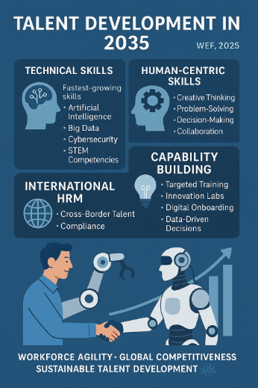
The integration of technical and human-centric skills in both human resources management and international HRM strategies secures workforce agility, global competitiveness, and sustainable talent development in the fast-changing 2035 labour market. WEF, 2025.

2. Demographic and Geopolitical Factors

Demographic and Geographic Dynamics
Demographic and geopolitical forces are reshaping the global employment markets, creating increasing complexities for organizations and HR professionals. The ageing population, migration flows, generational shifts, and political instability influence talent availability, workforce structures, and labour regulations. These, in turn, place an additional burden on HR professionals to manage workforce diversity, capability building, and compliance as organizations conduct business in increasingly unpredictable environments. The demographic and geopolitical shifts also make HR planning more challenging, demanding strategic agility and a globally aware profession.

Ageing Populations and Talent Shortages
Today, one of the important demographic factors is the rapid ageing of populations in developed countries like the UK, Europe, Japan, and South Korea. As organizations are facing an increasing shortage of skilled labour-particularly in healthcare, engineering, and digital sectors-finding replacements for retirees is a challenge.
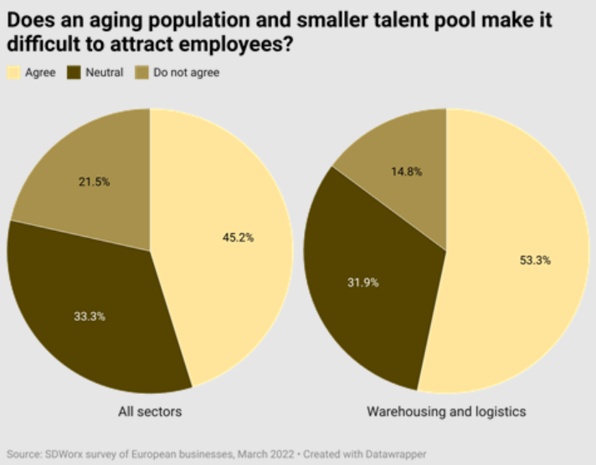
This places a strain on HR professionals to retain older workers, offer flexible working models, and develop succession planning approaches. In addition, they must establish knowledge-transfer initiatives to prevent the loss of critical expertise as large sections of the workforce exit the labour market.

Youthful Workforces in Emerging Economies
In sharp contrast, India, Nigeria, and other African regions have young populations entering the labour market in rapid numbers. Such demographic advantages offer global firms’ opportunities for fresh recruitments or expansion through offshoring and remote work.
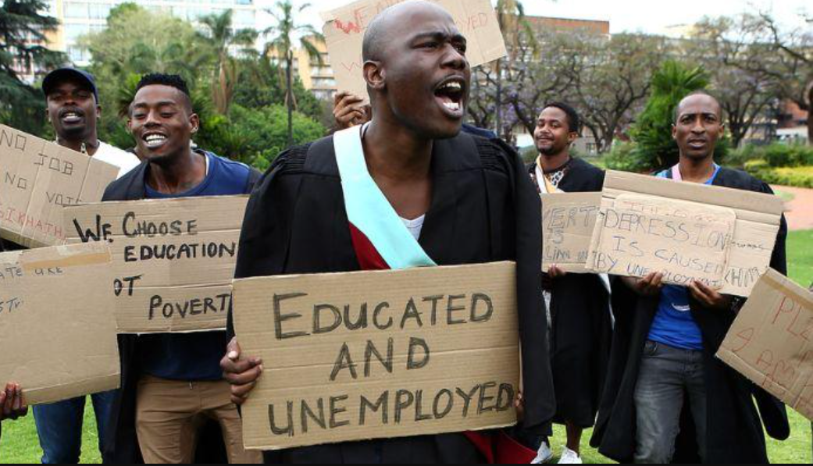
However, HR leaders will need to tackle challenges in terms of cultural diversity, variable education standards, and differing employment expectations among these youth. For harnessing such talent pools, HR would need to focus on cross-cultural training, equitable recruitment, and customized development programs.

Trends in Migration and Global Mobility
Another major demographic trend influencing employment markets is migration. Workers are crossing borders in search of better jobs, education, or due to climate-related displacement and political reasons. While migration fills the labor shortages, especially in the fields of hospitality, healthcare, and construction, restrictive immigration laws in many nations create hiring difficulties. It is mandatory for an HR professional to keep themselves informed about visa policy changes, ensure that the labor regulations are followed, and assist migrant workers with integration programs like language training and cultural orientation.

Geopolitical Tensions and Economic Instability
Geopolitical factors, such as wars, disputes over trade, sanctions, and changes in alliances, would cause disruptions to the labour markets through uncertainty and economic destabilization. Conflicts in Ukraine, Middle Eastern tensions, or even just global supply chain disruptions affect hiring plans, investment decisions, and the operational resilience of organizations. The emergence of geopolitical risks forces HR professionals to prepare for workforce redeployments, organizational restructuring, and expansions of remote work. They need to emphasize employee safety, ethical labor practices, and crisis management strategies in situations where organizations operate across politically sensitive regions.

Evolving Regulations and Compliance Challenges
Geopolitical changes also imply transitions in labour laws, policies on data governance, and standards around international employment. For instance, HR has to comply with the minimum wage, working hours, employee rights, data protection, and workplace 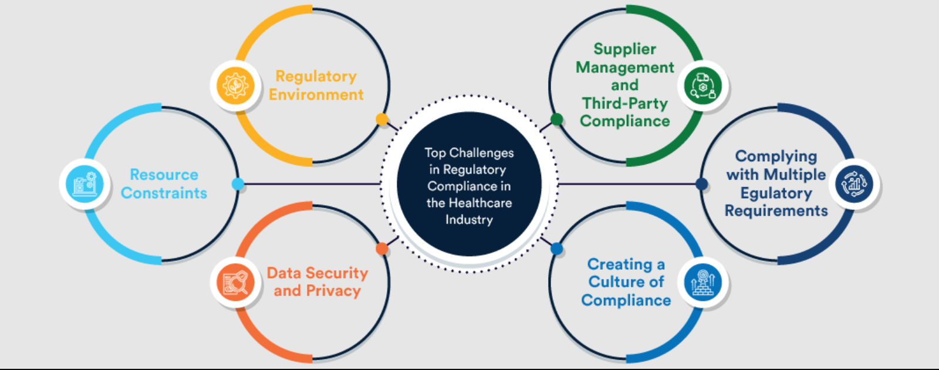safety in a wide array of different legal jurisdictions. As regulations vary substantially from country to country, managing the global workforce also becomes increasingly complicated. This requires operational HR knowledge in global mobility, legal compliance, and international human resource management practices.
Conclusion: Indeed, today's labour markets increasingly reflect the combination of demographic shifts-population ageing, youthful workforce, migration, and increasing diversity-with geopolitical ones such as conflicts, unstable economic conditions, and changes in regulatory requirements. In turn, these changes present HR professionals with a wide array of challenges: issues like agility in talent strategy development, workforce adaptability, legal compliance, and cross-cultural collaboration. Those organizations that respond most effectively to these demographic and geopolitical factors are the ones better positioned to be resilient, competitive, and develop their workforce in a sustainable manner within a rapidly changing global setting.

3. SHRM Strategies for Closing Skills Gaps

Recognising the Skills Deficit Challenge
Skills gaps and talent shortages in critical sectors of technology, health, and hospitality have gradually become more severe. These are driven by rapid technological changes, shifting demographics, and changing employer expectations. In the technology sector, there is an accelerating demand for skills in AI, data analytics, cybersecurity, and cloud computing that outpaces the pool of available qualified professionals.
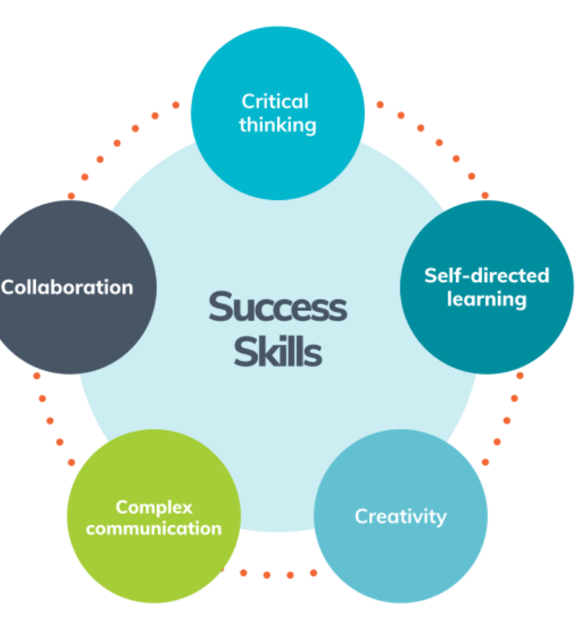

the health sector faces staffing gaps in nursing, doctors, and care assistants due to a growing aging population and higher demand for health services. In addition, hospitality suffers from high levels of labour turnover, seasonal fluctuations, and scarcity in the supply of workers with solid digital and customer service competencies. Such persistent gaps reflect a mismatch between available labour market capabilities and organizational requirements for competence. Thus, it has become imperative for employers to adopt strategic HRM approaches in a bid to guarantee a pipeline of sustainable talent, workforce resilience, and long-term organizational competitiveness.

Strategic HRM Interventions

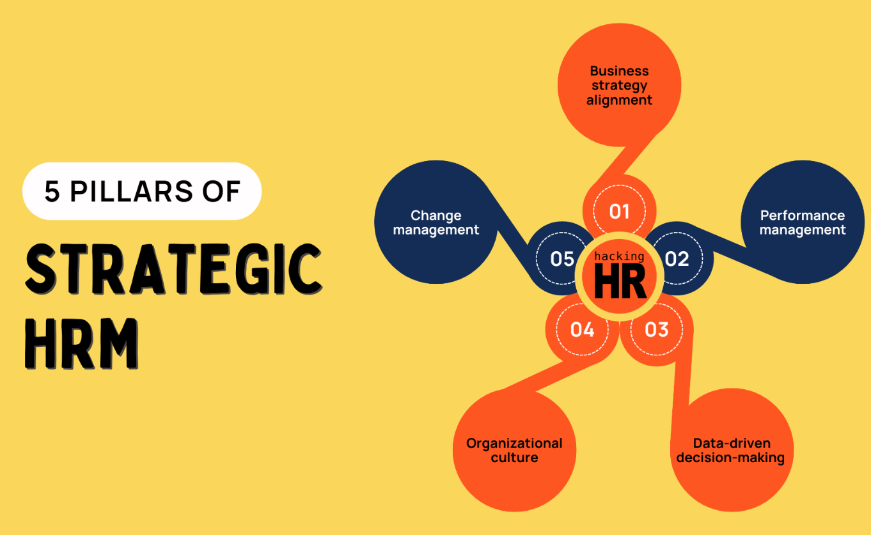
Strategic HRM offers a forward-looking framework to resolve the workforce shortages through integrated, long-term talent strategies. One principal approach includes strategic workforce planning, thus allowing organizations to analyse current capabilities, predict future skill needs, and implement targeted interventions. SHRM also upskills and reskills employees continuously to develop relevant skills through academies, micro-learning platforms, and partnerships with educational institutions. Other SHRM recruitment strategies include global talent acquisition, employer branding, and digital hiring tools to widen access to skilled professionals. In addition, SHRM advances collaboration with universities, colleges, and vocational institutes to create pipelines of job-ready graduates. Moreover, the strategy of employee retention, including competitive compensation, flexible work arrangements, wellbeing support, and career progression opportunities, is critical in preventing skill loss. Finally, SHRM uses HR analytics and technology to forecast skill shortages, personalize training, and foster evidence-based decision-making. All these strategies put together constitute a holistic, proactive approach to addressing competency gaps and shortages.

Industry Illustrations
Real-world examples show how the strategies of SHRM address skills shortages. Companies in the technology sector have invested in reskilling initiatives through their "Skills Build" programme, which trains employees and external learners in areas such as AI, cybersecurity, and cloud computing. This decreases dependency on external hiring and builds on internal talent pipelines. The NHS, meanwhile, has worked with universities to widen nursing programmes, promoted international recruitment drives to hire overseas nurses, and provided planned career development pathways to retain staff. In hospitality, Marriott International operates global training programs, electronic learning platforms, and cross-functional mobility opportunities to build future leadership and customer service competencies across global markets. These are clearly cases of how the different SHRM practices-developing capability on a global basis-enable organizations to take a proactive approach to dealing with skills shortages rather than simply competing for scarce talent.
Review and Appraisal
SHRM proves to be the highly effective method of addressing persistent skills gaps and talent shortages, especially if implemented as part of a long-term organisational strategy rather than short-term hiring solutions.
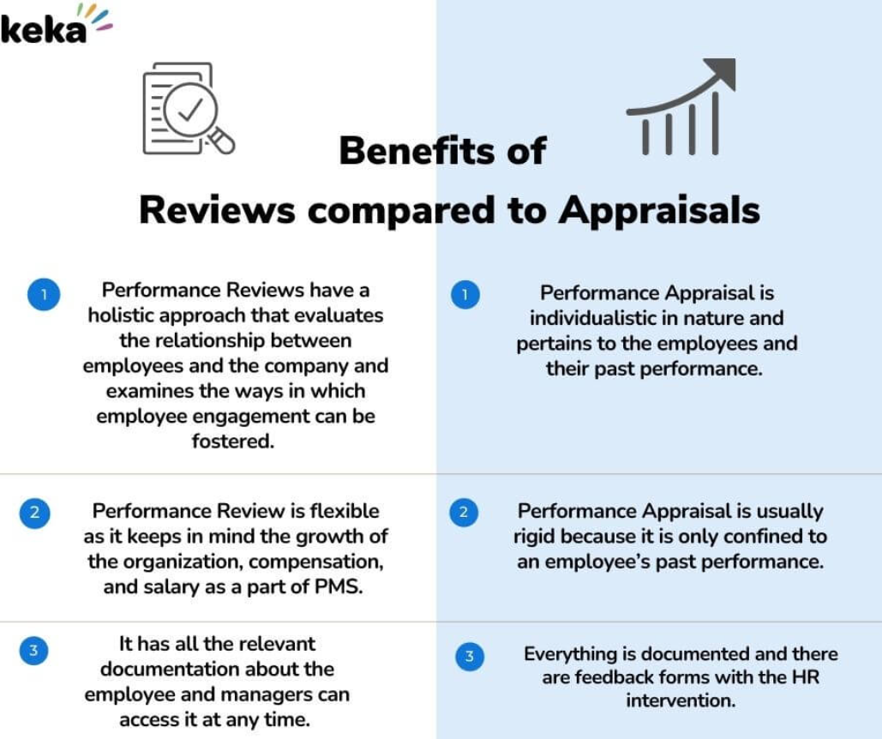SHRM integrates workforce planning, learning and development, global recruitment, and employee retention to enable organisations to build adaptable and future-ready workforces. However, formulating SHRM strategies requires investment, consistent support from leadership, and strong alignment between HR and business goals. Upskilling/reskilling reduces reliance on external hiring, yet is time-consuming and financially intensive, while employees need to be motivated about continuous learning. Global recruitment can help organizations address immediate shortages; however, it has its own challenges with respect to cultural integration and compliance. Despite these limitations, SHRM remains one of the most viable and strategic approaches to bridge the skill gaps and ensure organizational competitiveness in dynamic labour markets.

4.Reflection on My Skills and Competencies

Clarifying the Task Expectations
This assignment requires me to critically reflect on my current capabilities in working within an international environment, particularly focusing on technology, communication, teamwork, leadership, and self-directed learning. A student interested in working in global organisations must eventually analyse how well one can operate across cultures, adapt to rapid technological change, and effectively contribute to diverse teams. Throughout this term, I have been working in group projects, online learning tools, and collaborative activities that will help in the identification of strengths and areas for improvement. This reflection report uses those experiences as evidence for assessing my capability in regard to working in an international environment.

Reflective Analysis
Working in a globalized environment demands a mix of digital literacy, intercultural competence, collaboration, and continuous learning. My experiences with modules this term have taught me how important it is to remain adaptable when collaborating with people from diverse backgrounds. For instance, in the case of group discussions with international students, I have noted that differences in communication styles and perspectives enrich or hinder teamwork. Furthermore, the adoption of digital platforms, such as Microsoft Teams, Moodle, and virtual collaboration spaces, has underlined the importance of technological confidence. Critical reflection upon these experiences allowed me to recognize several personal capabilities which support my ability to work effectively in an international work context.

Self-Assessment Overview
My self-evaluation demonstrates that I have gained solid skills in many of the competencies required for global workplaces: certain technological tasks, communication with diverse peers, and participation in team-based activities. Again, through online research, digital presentations, and group assignments, I learned how to use digital tools proficiently and familiarize myself with new online platforms quickly. In addition, class debates and cross-cultural discussions have significantly improved my ability to communicate and interact with others. However, I have also recognized areas I need further development in, namely leadership confidence and structured self-directed learning.

Strengths and Weaknesses

Strengths:
One of my key strengths is technological adaptability; I am comfortable with using digital tools such as Microsoft Office, Google Workspace, and virtual meeting platforms. This has been demonstrated in multiple assignments where I was responsible for digital research and presentation design.
Another positive quality is communication. Working with peers from different parts of the world has helped me clearly articulate my ideas and really listen. Previous retail experience in India also taught me the way to communicate efficiently with customers and colleagues.
I also feel that one of my strong capabilities is teamwork. In group projects, I always contributed my ideas and respected others' opinions while helping with organization.
Weaknesses:
Despite these strengths, I recognize weaknesses in leadership: I usually hesitate to take up the leader's role and make decisions for the group when working with people with more experience.
One weakness is self-directed learning; sometimes, I have problems with time management regarding independent study. Considering the development and continuous changes in technologies, I really need to enhance my skills of planning learning goals and further monitoring my progress more consistently.

Development Action Plan
I will be more proactive in group work in the future, such as volunteering for a decision-making role and practicing confidence in expressing my ideas. This semester, I also plan to participate in workshops on campus regarding leadership and professional development.
For self-directed learning, I will use structured study techniques such as setting up weekly goals, maintaining digital planners, and managing time for online courses on digital skills and global communication. Platforms such as LinkedIn Learning and Coursera will support my development in technology and intercultural competence. Also, I will continue to develop my communication and teamwork skills by participating in multicultural activities, attending networking events, and working with international peers whenever possible. 4.6 Reflective Summary This reflective process has enabled me to understand my strengths and competencies that are relevant for an international working environment. These strengths include technology, communication, and teamwork. However, leadership confidence and self-directed learning need further development. Through the implementation of my action plan, I hope to develop these areas and become a far more competent, adaptive, and globally aware professional. Since advanced technologies and diverse teams are increasingly being used within a workplace setting, for my career growth in the long term and effectiveness in an international environment.
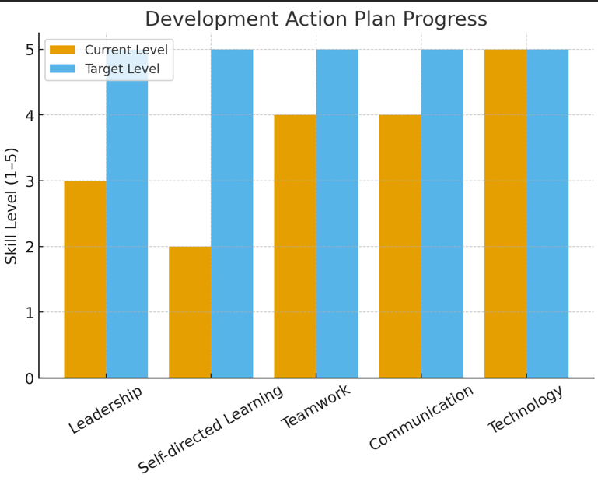

This chart represents my current capability levels versus my target goals in key competency areas required for effective performance in an international environment.

Conclusion:
This report has discussed the interaction of national and international labour markets, technology, demography, and strategic approaches to HRM. Driven by the rapid evolution of AI, automation, and digital technologies, jobs are continuously being redesigned, and the nature of work is changing, demanding upskilling and reskilling. Simultaneously, demographic and geopolitical complexities—such as ageing and youthful populations, migration, and global instability—pose major challenges for HR professionals in workforce planning, talent acquisition, and compliance. Strategic interventions by HRM and IHRM in workforce planning, global talent acquisition, and employee development programs help bridge persistent skills gaps, enhance organizational agility, and ensure competitiveness in dynamic labour markets. The integration of technical competencies with human-centred skills such as problem-solving, creativity, and cross-cultural collaboration ensures a resilient and future-ready workforce. Finally, the reflective analysis of personal capabilities identifies continuous self-improvement in leadership, self-directed learning, and intercultural competence as essential for successful operation in a global, technology-driven environment, enabling effective contribution in multinational organizations and adaptability to meet the evolving demands of international labour markets.

References:
OECD. Artificial Intelligence and the Changing Demand for Skills in the Labour Market. OECD 2024. https://www.oecd.org/content/dam/oecd/en/publications/reports/2024/04/artificial-intelligence-and-the-changing-demand-for-skills-in-the-labour-market_861a23ea6n.pdf OECD
SHRM. “Employers Train Employees to Close the AI Skills Gap.” HR Magazine, 8 Mar 2024. https://www.shrm.org/topics-tools/news/hr-magazine/ai-employee-training SHRM
Badhwar, P. “Artificial Intelligence – Challenges and Opportunities for HRM.” International Journal of Human Resource Management, 2022. https://www.tandfonline.com/doi/full/10.1080/09585192.2022.2035161 Taylor & Francis Online
Dima, J. “The effects of artificial intelligence on human resource activities.” Human Resource Management Review, 2024. https://www.ncbi.nlm.nih.gov/articles/PMC11188403/ PMC
Böhm, M. J. “Demographic change and regional labour markets.” Oxford Review of Economic Policy, 2021. https://academic.oup.com/oxrep/article-abstract/37/1/113/6211740 OUP Academic
Stehrer, R. “Demographic Challenges for Labour Supply and Growth.” wiiw Research Report 439, 2019. https://wiiw.ac.at/demographic-challenges-for-labour-supply-and-growth-dlp-4868.pdf wiiw.ac.at
Winkelmann-Gleed, A. “Demographic change and implications for workforce management.” EPSU study, undated. https://epsu.org/sites/default/files/article/files/study.pdf EPSU
Lisen Kova, K. “Demographic change and labour markets.” Strathprints, 2010. https://strathprints.strath.ac.uk/28159/6/rw.pdf Strathprints
Fertig, M. “The impact of demographic change on human capital accumulation.” Journal of Population Economics, 2009. https://www.sciencedirect.com/science/article/abs/pii/S0927537109000967 ScienceDirect
Greiling, D. “Demographic Change as a Challenge to Human Resource Management.” 2011. https://link.springer.com/chapter/10.1007/978-3-531-93195-1_6 SpringerLink
Ključnikov, A. “Global labour markets and workplaces in the age of machine technologies.” Global Business Review, 2023. https://www.sciencedirect.com/science/article/pii/S2444569X23001038 ScienceDirect
“Artificial intelligence and labour market matching.” OECD report, 2023. https://wecglobal.org/uploads/2023/02/OECD-report-on-Artificial-Intelligence-and-labour-market-matching.pdf World Employment Confederation
“The Impact of Demographic Changes on HR Processes: A Highlight on Management of Multigenerational Workforce.” ResearchGate, 2025. https://www.researchgate.net/publication/390425828_The_Impact_of_Demographic_Changes_on_HR_Processes_A_Highlight_on_Management_of_Multigenerational_Workforce ResearchGate
“Tech boom to create millions of jobs, but skills gap looms.” HRM Asia, Jan 2025. https://hrmasia.com/wef-tech-boom-to-create-millions-of-jobs-but-skills-gap-looms/ HRM Asia
CIPD & ILC-UK. Avoiding the Demographic Crunch: Labour Supply and the Ageing Workforce. 2014. https://www.cipd.org/globalassets/media/knowledge/knowledge-hub/reports/avoiding-the-demographic-crunch-labour-supply-and-ageing-workforce_tcm18-10235.pdf
Ključnikov, A. “Global labour markets & intelligent machines.” Global Business Review, 2023. https://www.sciencedirect.com/science/article/pii/S2444569X23001038 ScienceDirect
OECD. Labour shortages and labour-market inequalities. 2025. https://www.oecd.org/en/publications/labour-shortages-and-labour-market-inequalities_14e62ec0-en.htm OECD
Institute for Global Prosperity. The Impact of AI on the Labour Market. 2024. https://institute.global/insights/economic-prosperity/the-impact-of-ai-on-the-labour-market Tony Blair Institute
Donnelly, R. & et al. “Remote Working & HRM in Digital Economy: Framework.” International Journal of Human Resource Management, 2021. https://www.tandfonline.com/doi/full/10.1080/09585192.2020.1737834 Taylor & Francis Online
Martindale, N. “Labour market digitalization and social class: evidence of…”. Social-Economic Review, 2023. https://academic.oup.com/ser/article/21/4/1945/7260915 OUP Academic
Ericson, T. “Skills shortages and employers’ HRM strategies and …” 2024. https://www.diva-portal.org/smash/get/diva2%3A1918461/FULLTEXT01.pdf DIVA Portal
Musinszki, Z. “Analysis of Labour Market Expectations in the Digital World.” Behavioral Sciences, 2025. https://www.mdpi.com/2076-3387/15/7/282 MDPI
International Labour Organization (ILO). Skills shortages and labour. 2019. https://www.ilo.org/sites/default/files/wcmsp5/groups/public/%40ed_dialogue/%40sector/documents/publication/wcms_755663.pdf International Labour Organization
Dickerson, A., Rossi, G., Bocock, L., Hillary, J. & Simcock, D. “An analysis of the demand for skills in the labour market in 2035.” The Skills Imperative 2035 Working Paper 3, 2023. https://www.nfer.ac.uk/media/utwf2grb/the_skills_imperative_2035_working_paper_3_an_analysis_of_the_demand_for_skills_in_the_labour_market_in_2035.pdf NFER
Zhang, J. “Digital Transformation in HR: Digital Age.” Frontiers in Psychology, 2023. https://pmc.ncbi.nlm.nih.gov/articles/PMC9990565/
Huang, X., et al. (2023). “Personalized human resource management via HR analytics and AI”. Journal of Business Research. https://www.sciencedirect.com/science/article/pii/S1029313223000295 ScienceDirect
Stofkova, Z. (2020). “Sustainable Development of Human Resources in the Era of Globalization”. Sustainability, 12(18), 7681. https://www.mdpi.com/2071-1050/12/18/7681 MDPI
Nissen, A. B. (2021). The impact of strategic workforce planning and analytics on organisational change success. DBA thesis, University of Reading. https://centaur.reading.ac.uk/105306/1/830019383_NISSEN%20Alexander_Thesis_Redacted.pdf CentAUR
Anthun, K. S., et al. (2024). “What influences the use of HR analytics in Human Resource Management in Norwegian municipal health care services?” BMC Health Services Research, 24, 1131. https://bmchealthservres.biomedcentral.com/articles/10.1186/s12913-024-11610-y BioMed Central
McCartney, S. (2022). “Bridging the gap: why, how and when HR analytics can impact organisational performance.” Employee Relations. https://www.emerald.com/md/article/60/13/25/281971/Bridging-the-gap-why-how-and-when-HR-analytics-can Emerald
Warner, M. (2001). “Globalization, labour-markets and human resources in Asia-Pacific economies: an overview.” Judge Institute of Management Studies, University of Cambridge, WP 12/2001. https://www.jbs.cam.ac.uk/wp-content/uploads/2020/08/wp0112.pdf Cambridge Judge Business School
Reese, J. (2024). “Strategic workforce planning: navigating the future of HR.” SHRM Labs. https://www.shrm.org/labs/resources/strategic-workforce-planning-navigating-the-future-of-hr SHRM
Venugopal, M. (2024). “Transformative AI in human resource management.” Cogent Business & Management. https://www.tandfonline.com/doi/full/10.1080/23311975.2024.2432550 Taylor & Francis Online
McCartney, S. (2022). “People analytics enabling HR strategic partnership.” SAGE Open. https://journals.sagepub.com/doi/10.1177/23220937221119599

Appendix 1 HRM and HMC

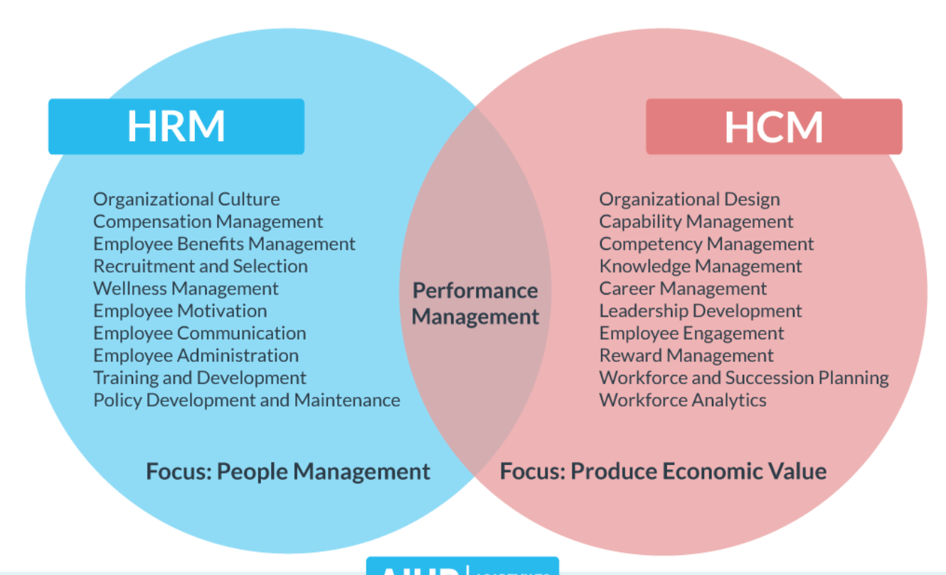

Appendix 2 Difference



