Global Marketing Plan Of Retailer Brand ZARA

Student Name: Noble Kuriakose Mathew

Student Number: 2132211

Wordcount: 5,329

Global Marketing Plan Of Retailer Brand ZARA

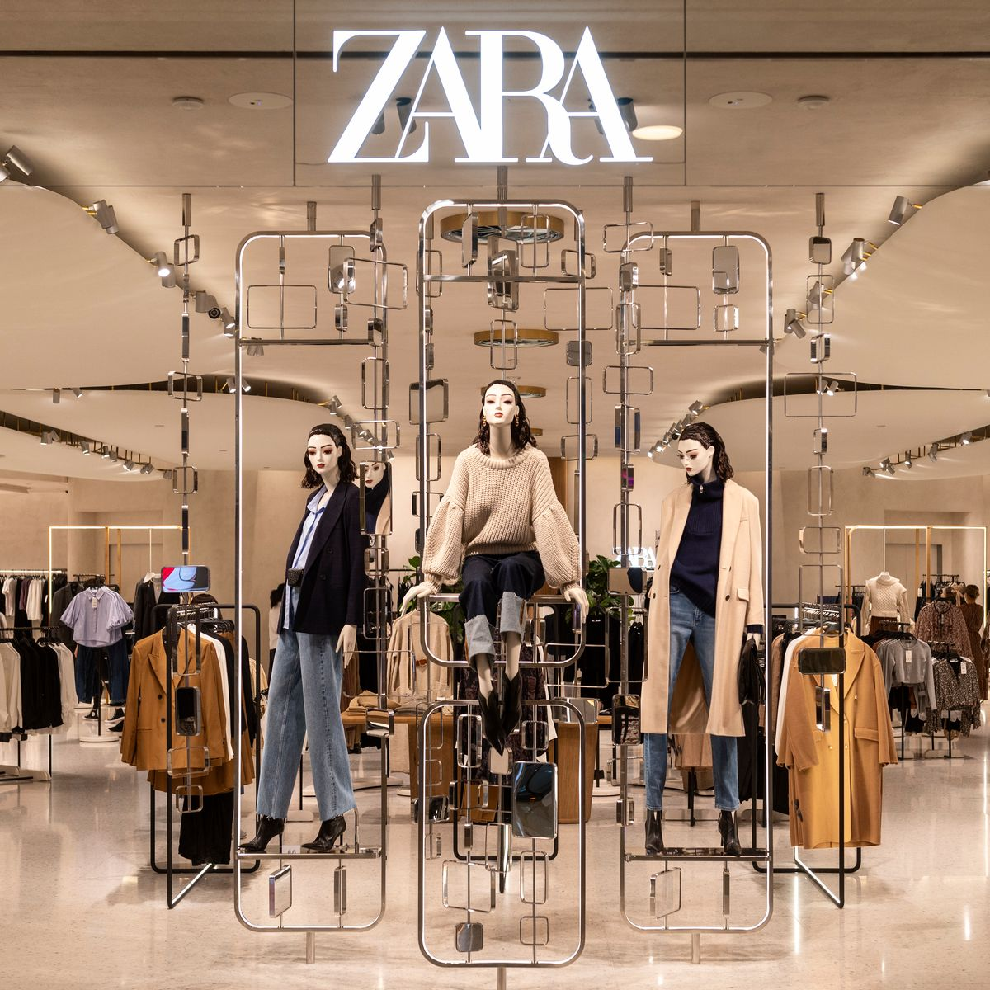

Table of Content

Introduction 3
Part 1: Global Marketing of Zara 4
Overview 4
Global Digital Representation of Zara 5
Social Media Presence of ZARA 8
Digital Asset of Zara 10
Information Architecture of Zara 12
Promotion of Zara’s products & Services 14
Effective Marketing Strategies 15
Recommendation 17
Part 2: Applications of Machine Learning In Digital Marketing To Maximize ROI 18
Importance of Machine Learning In Optimizing Digital ROI 20
Conclusion 21
Reference list 22

Introduction
Companies whether small or big must adopt any medium for the purpose of advertising their products and services. Considering this, Digital marketing has become a wider arena for the organisation to advertise the product and service. Adding more, digital or online marketing is the innovative type of marketing in which companies use the social sphere in order to make their products known. One of the leading and prominent retail clothing brands Zara also used the digital sphere to promote and sell their services to potential customers. This report also intended to explore the global digital marketing of the Spanish wearing brand. Plus, the brand also implemented the strategic information technology with the supply chain management. SCM is defined as a worldwide network used to transport goods from producers to consumers via the technology exchange of information, logistics, and money. Planning and managing all activities connected to design, procurement, production, distribution, retail, and logistics are all included in supply chain management. Additionally, it involves working in coordination and partnership with channel partners. Furthermore, this report also gives insight about the effective strategic management of Zara that distinguishes it from the other retail clothing brands. Location strategy, pricing strategy and customer-oriented strategy are considered to be the best practices that makes the presence of Zara even stronger not nationally but internationally also. Considering this, the report also discusses the potential effects of sales on the digital assets of the company. The company is of the view that designing trendy minimal party wear for men or women is a more ideal strategy to grasp the attention of the customer .Rather than spending the higher cost on advertising. Also, in house lean production also minimises the cost and time of the production. This is the reason due to which Zara can afford the extra labour and production cost. Thus, it is accurate to say that use of Machine learning and artificial intelligence in digital marketing can maximise the ROI of the company. So, this report consists of two parts, the first part thoroughly analysed the global digital marketing of Zara. Second part discusses the role of Machine learning and how it maximises the return on investment of the company.

Part 1: Global Marketing of Zara

Overview
ZARA is one of the largest fashion firms in the world. It first appeared in Spain in the early 1900s and then spread fast over the world (Zara, 2022). Plus, the target audience of Zara includes; both men and women while offering minimal party wear. Marketing initiatives are another part of ZARA's success. Marketing has evolved over time to meet today's demands and trends. The majority of successful advertisements have now shifted to other digital channels. Furthermore, the objective of these paper is to analyse the digital representation of the Zara retail brand, which will reveal that the use of successful marketing and social media techniques is the primary reason that it does not spend on traditional advertising.
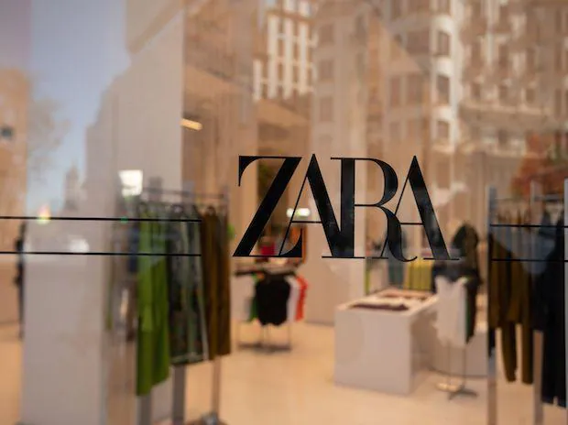
Picture: Elite Stores of ZARA Across the Globe. Source: Business Standard

It is worth noticing, that Zara does not spend cost on advertising its services on conventional media. Rather, with the advancement of technology, Zara also used digital means for production to sell it to the customer. For example, Zara used Store management terminal software in order to improve communication within the warehouse. Plus, the designer employs Computer-Aided Design and computer-aided manufacturing to swiftly develop finished items based on customer specifications. The reason for the popularity of Zara also lies in the marketing strategies that are effectively deployed while marketing their services. The marketing strategies of Zara includes; satisfying customer strategies, brand loyalty strategy, value effective-pricing strategies, and location strategies. Moreover, the primary economical source of Zara is its digital and social media marketing. In order to critically analyse the financial outcome of Zara UK, the digital assets of Zara are analysed in which the organic traffic is the indicator that Zara is successfully known among their target audience worldwide.

Global Digital Representation of Zara
The popularity of Zara can be recognized by the fact that there will be no television advertising, print advertisements, billboards, or online banners (Zara, 2022b). Zara does not prefer traditional advertisements in order to advertise their product and services. This exposition is astonishing in a world where each media fights for the greatest advertising space, such as fashion. Brands compete to display spectacular perfume advertisements during prime time, and fashion publications devote page after page to brand promotion. Zara does not promote in this world, how is it possible? The fact is that there is some marketing and advertising approach that Spanish multinationals adopt in order to become more prominent retailer clothing brands. Customers are bombarded with marketing messages in the age of modern media and technology, making it extremely impossible to run a commercial firm properly without some type of marketing, particularly internet-based marketing activities. This is because of the fast growth of the Internet, as well as the widespread use of computer technology and other associated gadgets. The marketing strategies of a dynamic and quickly changing retail organization in the sector may count on many new markets and customers with minimal investment in website and web-based marketing. It is one of the economy's major sectors in terms of the source of finance and transactions. As a result, it is a very active and highly developed sector.

Zara's new flagship shop, which recreates certain important characteristics of Zara's past pop-up stores, has recently opened at London's Westfield Stratford Shopping Centre. There are many digital service implications featured by Zara, these are RFID technology, in-store internet buying, and click-and-collect. The business provides mobile services to store personnel in order to help customers who can request same-day or next-day delivery or pickup. The store's functionality includes a product recommendation system with an information board incorporated into the mirror. When the customer scans the item, the screen displays the selected item as well as any extra goods that go with it, completing the ensemble. Moreover, Zara is well-known for 'copying' models from other companies, however, this is only partially accurate. Besides saying that Zara replicates the model of the other businesses. This is accurate to say that Zara' clone' big-brand trends and bring them to market in record time. That is right. Because of just-in-time manufacturing. One of the most important things is to invest every dollar available in advertising and media adoption in developing extremely successful marketing tactics. Zara's logistics and commercial technologies provide one of its most significant competitive advantages.

Zara, like Apple, is willing to pay for the best rent in the edgy, iconic heart of any big city, besides significant brands such as; Gucci, Armani, and Louis Vuitton contributing to the city's premium atmosphere. Shop Clothing averages between 2 and 50 euros. Zara's investment has resulted in stores on Fifth Avenue in New York, a six-story skyscraper in central Tokyo, many shops on London's Oxford Street, and some of Dubai's most luxury structures. An iconic, ancient, or strategic location in each city that stands out either in architecture or in a busy neighbourhood location. Zara eCommerce's marketing approach is built around omnichannel marketing and a fully integrated warehouse management method. Zara's e-business approach employs automated marketing technology to provide suitable and timely email messages to customers, ranging from demand-ordering progress updates to out-of-stock alerts. Brands provide tailored and customised messaging associated with purchasing requirements and web activity throughout the customer journey (Godman et al., 2021).
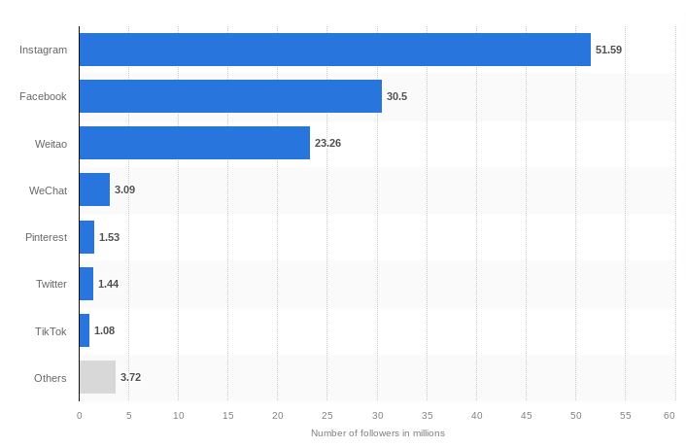
Figure: Number of Followers of Zara. Source: (Statista, 2021)

From the above figure, Zara's appraisal analysis can be easily determined. As, Zara Spain's flagship fashion shop and part of the more prominent apparel firm Inditex, is a globally recognized brand. The quantity of social media users who follow various accounts reflects the success of this worldwide corporation. According to Statista 2021, Zara will have 50 million followers on Instagram, 1.44 million Twitter followers, and 3.09 million WeChat supporters. Inditex and its brands are popular among Chinese consumers (Statista, 2021). Adding more, Zara is the most popular brand of the Spanish apparel corporation Inditex, with around 2,000 outlets worldwide. Zara has more stores than its two other brands combined, with Stradivarius and Bershka coming in second and third place, respectively, with over 900 locations globally. The global standard for rapid fashion. With over $23 billion in retail sales by 2020, Inditex will overtake H&M as the second-largest apparel and accessory retailer in the world. Aside from revenue, the Spanish business considerably increases the number of sales locations around the world, reaching over 7.5 000 in 2019, although this figure is expected to fall to roughly 6.5 000 in 2021. This year, Spain had the most Inditex shops, with over 1300 locations.

Social Media Presence of ZARA
Zara may create internet marketing campaigns in numerous locations such as Europe, America, and Australia by being informed of local and current market trends and doing an overall situational analysis. It is one of the trends in the area's expanding internet usage. The population of internet users has expanded dramatically over the last decade, growing to over 8.6 million in the present decade, with even more online users these days. This, however, is exclusively an African statistic. Asia has 1.1 billion people, whereas Europe has 80 million. 30 million live in the Middle East, whereas 1 billion live in North America (Ibrahim, Aljarah and Ababneh, 2020).

Over the last decade, we can observe that not only the main appeal of the Internet but also the increasing rate of Internet usage, has been noticeable in many parts of the world. You can readily comprehend the necessity to get in touch with the aid of internet marketing with the help of these figures. According to online contracting specialists, the majority of market shareholders favour the use of internet marketing strategies to promote shopping facilities, settings, and consumers by giving information on new items and designs as well as product offers. With the use of e-marketing, we want to enhance our market share by delivering - Relevant business policies. Also, Chunling, (2020) adds that you can usually target these folks as consumers in Asia without spending a lot of money to conduct business throughout China because there are over 80 million users in China alone. Both Japan and India are subject to the same rule. The business is no longer required to open a large physical store or an online marketplace, but housing rules in India and cyber stores, in general, may make this easier. Strategic sales offices are being established in the capital. and you may sell your items over the internet in all other regions, allowing buyers to locate your brand and experience its potential existence.

Most successful firms, including Zara, may employ this method. They don't have to keep all of their merchandise in your store whilst advertising Simply allowing visitors to utilize the website to look for potential product search choices can help the business sell its website in an original way. As stated, in the organization's search API guide, the corporation offers its items by every category, albeit in phases, because it only purchases things that closely match consumer preferences ( Li, C., and Ukhova, 2021). Zara has social media accounts that are on Facebook, LinkedIn, Instagram, YouTube, Twitter, Pinterest, and the parent business of the brand, Inditex. The two most popular social media platforms are Instagram and Facebook because of the prominence of her photographs and videos in her design. Zara shares production-related information of her numerous social networks to keep viewers up to date on the hottest deals.

Facebook – According to Facebook demographics, the majority of her fans are young women. ZARA is a high-end clothing company that advertises on Facebook. The most recent collections and visual information are available on Zara's Facebook page such as look book photographs (web Facebook, n.d.). Their attire also speaks for itself, since it generates the highest interaction in terms of likes and shares. ZARA runs social media initiatives throughout the year to encourage customers to endorse their items online and with the hashtag #livingzara.

Instagram – Using social media influencers as a marketing strategy for the company helps Zara to form ties with individuals who can help them form relationships. The company may reach out to customers via its networking sites. Businesses may collaborate with a wide range of well-known individuals, including celebrities and influencers (ZARA, 2018). Kylie Jenner is sponsored by a number of firms including the Zara retailer industry. This is owing to her fame on Instagram, where she has 127 million followers. The size of her crowd is incredible! Companies who collaborate with her receive advantages in promoting their products. According to Sharma, (2020), 90% of its consumers believe in peer referrals.

As a result, when influencers promote their products on social media, viewers are motivated to look like them. As a result, collaboration with influencers will continue. Zara approaches Instagram influencer marketing in an unusual way. Also, Zara’s "Timeless" commercial features models beyond the age of 40. Margosa Vera, Yasmin Warsame, and Cristina de Coninque were among the campaign's stars. These women discussed how aging influences their style in a video advertisement. On social media, their efforts were also lauded. As a result, engaging with influencers will continue to increase the company's sales because it is an excellent strategy for attracting both existing and new consumers (instagram.com, n.d.).

YouTube – As reported by (Reuters, 2022), Zara has accumulated over 10,000 subscribers in a rather short amount of time. They posted 17 films of him, most of which revolved around the shopping season. These brief one-minute movies of him are a catalogue of new items.

Digital Asset of Zara
To critically analyse the assets of Zara, a comparison with other clothing brands was necessary. The SEMrush tool is used to evaluate the number of people who visited the site, which depicts the interest of the public in different brands. From figure 2, it is clear that organic search traffic for Zara in the UK is 4.6 million. And digital assets of competitor Mango’s search traffic is 854.1k per month in the UK. These figures justify that Zara has gained more popularity and consumers than Mango. On the other hand, in figure 4 the Digital Assets of H&M are 6.8 million in the UK. That means H&M is generating more consumers than Zara. Zara should work on its strategies to beat H&M.

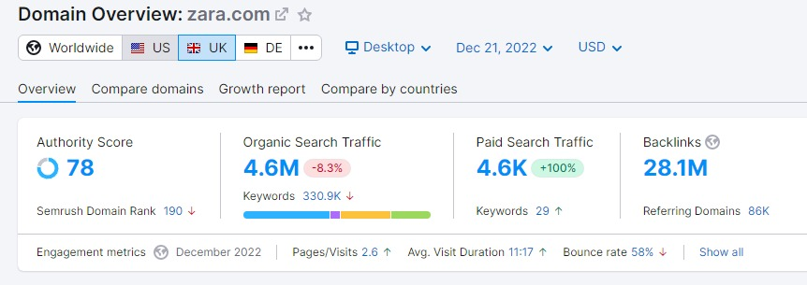
Figure 2: digital assets of Zara UK

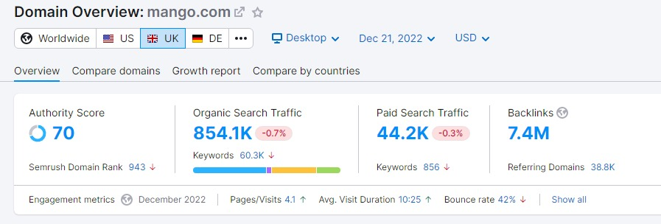
Figure 3: Digital assets of Mango UK

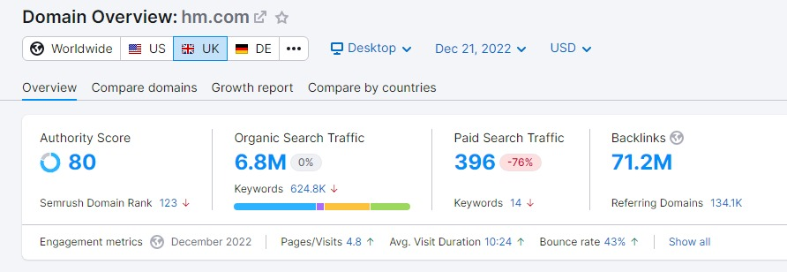Figure 4: Digital Assets of H&M UK

Information Architecture of Zara
The fashion sector is one of the most competitive marketplaces, with fierce competition among businesses and brands. Among them, Zara stood out as a one-of-a-kind corporation with extraordinary expertise and abilities in new delivery options, processes, management style, and information and information technology implementation (Yide, 2021). Considering this, Zara's Information System focuses on communication.

- Each Zara retail location has a PDA and DOS-based point-of-sale (POS) software that connects it to the company's La Corua headquarters, allowing all client orders to be sent there right away for confirmation. Additionally, the design team uses this technology to gather consumer feedback and ideas on style and design in order to create precise products that instantly satisfy consumer demand (Karayianni, 2022).
- Zara's information system may also be used to allow store managers to order impacted goods in quantities and designs that are likely to sell best in the local market. However, this information transfer technique employs technology more advanced than dial-up Internet to provide his data twice a week.
- As narrated by Jia et al., (2020), Zara chose to install a Store Management Terminal (SMT) in each store to improve communication across stores, warehouses, and administrative offices.
- The Internet store is yet another novel use of information technology. It all begins with an online order and the reception of client feedback (Godman et al., 2019).
- Also known as computer-aided design (CAD) and computer-aided manufacturing (CAM), these are the technologies that convert designs into physical objects. The designer employs CAD/CAM to swiftly develop finished items based on customer specifications (Bolzoni et al., 2020).

Moreover, one of Zara's differentiating advantages is that it shortens the entire process from consumer requests to shipping to shops and supplier networks. Zara employs this trend, like the Paris fashion show, to draught ideas and ship them to Spain for completion within 15 days. Other rivals, require roughly 6 weeks to complete this procedure. IT installation is one method for reducing lead times. In this process, Zara's staff must rely on information systems. Furthermore, information technology can be utilized in the processing at the ZARA stores in the following ways:

- The Design patterns are created and saved using computer hardware and software.
- The Spanish brand conveys these concepts to Spain using computers and the Internet.
- For communication, computers and the Internet are employed. Email, VoIP, and video conferencing.
- Information technology is utilized to monitor, control, and manage the whole product production process.

In factories, robotic systems are used to cut textiles, and software or programs are used to manage the robots that cut fabrics, print images on items, pack garments, and regulate conveyor belts. Information systems are also used to interact with material suppliers, communicate with manufacturing operations, and guarantee that the entire process is carried out properly and efficiently. It's also utilized to talk to shipping companies. As part of an important procedure, it is critical to get client feedback. It has also been improved by the development of information technology. However, information technology is the reason why Zara afford the extra shipping and labour cost.

Promotion of Zara’s products & Services
When compared to the average fashion shop, Zara spends extremely less money on advertising efforts; Zara doesn't market as aggressively as some other businesses, but it doesn't imply they don't. They emphasize word of mouth and store openings. Experience, exclusivity, pricing, and uniqueness are the four pillars on which their marketing strategy is built. The showrooms are painstakingly designed to reflect this, with everything being precise, expert, and upscale. Each shop manager has the opportunity to discuss issues with their Spanish counterparts. Zara is able to develop an excellent brand reputation with her image by concentrating on a company's fundamental attributes for buyers (Taylor, 2019). Zara also efficiently utilizes the power of social media networks for advertising.

Considering this, Zara should also adopt CSR camping while promoting their product and services. Doing this, also raise awareness among the customer, as it is one of the favourite brands of you nest especially. Zara does not even have any television advertising, despite its rivals spending millions of dollars on various advertising initiatives. Zara has a low-budget but incredibly effective social media advertising campaign. To promote an event or a new outfit they've developed, all they have to do is post a message on their Facebook page, which is then seen and shared by over 30 million followers. If that's insufficient, then the retailer brand can also share a couple of Zara photographs with your 45 million Instagram followers for them to like and share. Moreover, Zara invests in billboard advertising. Although it is costly, its advertising is incredibly appealing and particularly tailored to young people, who represent the majority of its client base. It's also worth mentioning that Zara doesn't brand any of its items by advertising.

Zara considers this an unnecessary cost and although Zara invests in the opening of new stores in attractive locations across the world. As was already said, Zara uses store locations as a marketing tactic rather than advertising store locations. But maintaining brand growth and luring new customers depend on effective brand communication. Zara doesn't advertise and instead relies heavily on social media and word-of-mouth marketing. As a result, the opinions of family and friends may skew a prospective customer's perception of Zara. Additionally, rather than being places for client interaction, Zara's social media platforms like Facebook and YouTube mostly serve as updated feeds. Zara's YouTube videos are also not ideal because they receive an unacceptably low number of views in comparison to the number of people who subscribe to the channel, which is crucial for fashion businesses. Considering this, Zara must work rapidly to close this gap as social media marketing's influence and reach grow. Target client groups for Zara are using social and digital platforms more and more to connect and share their lives, so Zara places a lot of importance on having a good presence on these sites.

Effective Marketing Strategies
This significant difference between Zara and the other leading retailer industry is that Zara does not emphasize spending the buck on advertising rather, the Spanish industry majorly focuses on customer needs, satisfaction, and demand. Considering this, there are certain marketing tactics of Zara including satisfying customer strategies, brand loyalty strategy, value effective-pricing strategies, and location strategies.

Satisfying Customer Strategies – Consumers today place a higher value on the customer experience than they do the actual goods. Zara is aware of this idea and has designed a shopping environment that makes people want to return. Their fast-fashion strategy offers a simple shopping experience in a well designed setting with limited stock and frequent updates of new trends. Consumers can be thought of as unique individuals with distinct personalities who not only have fashionable appearances but also feel like members of a select club.

Brand loyalty strategy – In terms of loyal customers, Zara's significant experiences and ideals enable regular shoppers to promote their brands. Customers become brand lovers thanks to Zara, who engages with and spread information about your company. Over 1 million people follow Zara on Twitter, and she has over 39 million Instagram followers. These are employed to assess social media claims and trends. This is utilized to enhance our processes, services, and products, as well as to better serve our consumers. For this, Zara does not feel the need to advertise its services via traditional media such as fashion magazines and newspapers.

Location Strategy – Zara does not invest substantially in advertising and marketing, but it spends considerably on the locations and looks of its 2,250 stores worldwide. Aside from that, Zara provides branded experiences and products where and when customers need them. The advancement of technology and the simplicity of mobile connectivity have made it possible for customers to easily get goods that are not readily available where they live. There are currently 39 online markets. Zara's shop placement strategy entails placing them among the city's major retail areas (Allam, Scagnelli and Corazza, 2020). Stores may be located next to retailers of luxury fashion brands. By closing underperforming locations, entering new regions, and ensuring that its big department stores maintain a loyal consumer base, Zara has the ability to significantly improve its portfolio.

Infrastructure of data analysis –Data will continue to be an essential part of the process of making wise business decisions. This acts as a quick way to get in touch with the clientele as well as a planning tool for the next move. Through the establishment of a comprehensive data system, Zara has made it possible to investigate what is being advertised and sold on social media. This is used to improve a variety of aspects of the firm, including the calibre of services and goods. It is a system of two-way communication that enables continuing development. In order to give clients, the best experience, Zara is dedicated to interacting with them in every manner. Due to its ability to deliver information on what consumers are saying about a brand, this strategy aids in the formation of business decisions.

Recommendation
Plus, Zara also faced stiff competition from another leading clothing brand that is H&M. The fact is that the marketing strategy of H&M is different from that of Zara because H&M used different multi-challenges in order to advertise their product and services. Plus, the biggest advantage that Zara enjoys is its lean production. Although H&M is a competitor of Zara still, Zara is one step forward to that as all the production work of the clothing is done in-house while H&M outsources their work to other clients. Also, Zara designed its product with the client in mind. As a consequence, they can immediately supply trendy fashion at reasonable pricing. Supply that is extremely efficient Zara, in addition to its chain, incorporates customers in the design process, providing a distinct competitive edge. Fashion trends change rapidly, but Zara has always been able to ride the wave and provide consumers with exactly what they want . In an age of huge data and instant gratification, it's easy to foresee more and more firms adopting Zara's approach to both product creation and customer service. Zara's next challenge will be to adapt to shifting markets. The 'quick fashion' attitude will be tested in the future, and it will be interesting to watch what happens.

Part 2: Applications of Machine Learning In Digital Marketing To Maximize ROI
Whether small or big, organizations do digital marketing or campaign in order to persuade, attract, aware the target audience. Doing so also seeks the business to compute how different marketing campaigns helped the company in terms of boosting its company sales. For determining the impact of that digital campaign, the effective way is to calculate the “Return on investment”. Precisely, the purpose of calculating the digital ROI is to see how much buck is generated from online marketing. Also, determine how much amount to get back from the spending.

As stated by Murakami and Okasaki, (2021), the ROI of Digital marketing is the process of calculating both profit and loss, produced in return by spending efforts on digital marketing. Although, the efforts also depend on how much cost the company invested in the marketing. Spending more money may provide better benefits than spending less money and vice versa. In other words, if the marketing activities of the company are cost-effective, then it shows, ROI generates more revenue than the company spent on it. Although, if the company would not measure the results of digital marketing then it merely seems the company sells its products & services blindly. The ROI in digital marketing is important because, the company is in need to know what the responses of the target audience are, and what they think about the product and services of their effort. Thus those customers’ buying factors have had an impact on the sales or the revenue of the company.

Plus, it also enables the company to make changes or advancement in the product and services, through which the attraction of the wider audience would be attained. With the technological advancements, Machine learning, at its most basic, is the use of Artificial Intelligence (AI) that enables computers to learn independently. AI aims to replicate human intellect, whereas machine learning uses previous data to execute tasks autonomously. Machines may learn from prior jobs and improve their decision-making and prediction accuracy as the amount of data rises over time. Adding more, Machine learning techniques in digital marketing may assist identify consumers’ buying behaviour. Plus evaluate those trends to determine how valuable and effective they may be over time.

With the invention of new advancements and attribution constraints, the prediction has become even more critical in ensuring that app marketers are equally effective. Simply put, Machine learning is also important in audience segmentation, media purchasing, customer personalisation, creative optimization, and process automation. The practicality of machine learning, like any investment, is dependent on providing value beyond cost. This is the standard ROI calculation, and in the context of machine learning, digital marketers measure the created value against the cost of error and accuracy.

Furthermore, the company also adopts the Machine Learning phase which is commonly known as a proof-of-concept. As the name implies, it is the method of evaluating whether the proposed idea generates favourable results in the real life or not. Thus, composing all the online/offline advertising channels and financial data from sales to execute ML in one usage, the proof of concept (POC) phase begins. Designed specifically to guarantee that ROI model. This phase has three primary functions:

- Determine if your data is robust, full, and useful. Is the dataset credible and comprehensive? Is there a sufficient number of data points? Was the data collected correctly? Could you please provide a link to the source? And would it offer enough value if the individual advertising channels were incorporated into the model?
- To ascertain whether the cost of each event is accessible. Is all relevant financial information available and related to each promotion (e.g., individual expenses for meetings, advertising, websites, etc., and financial summaries)?
- Form an informed opinion. Make confident yes-or-no judgments based on a comprehensive review of your facts to begin your ROI modelling process.

Importance of Machine Learning In Optimizing Digital ROI
Additionally, machine learning is one of the crucial factors in digital marketing. The primary purpose is that ML served a more tailored client experience. The improved and customized segmentation opens the door to more tailored experiences. The company also knows where its consumers are in their funnel and allows them to provide advertising that is appropriate for its stage and preferences. Machine learning may record data such as search history and normal activities when users use the app and combine it with behavioural data and searches from similar users to offer additional items and services. For instance, a clothes app may recognize the user's gender by assuming that women look at women’s wear and vice versa. Estimate prior purchases as well as how much they typically spend on things. When combined with variables such as time and location, the algorithm uses all of these factors to identify components to use in re-engagement creatives for a more personalized experience.

Moreover, Machine learning is more than just interacting with their consumers. Essentially, it is learning to complete a task without the assistance of an individual. Marketing campaigns are made up of several procedures, many of which are pragmatic, dull, and repetitive. Marketers may devote more attention to issues that require human interaction by automating these operations. As a result, operations are more streamlined and efficient, there is less human error, and marketers are better able to manage complicated and strategic responsibilities. Edge computing has been an effective technical advancement since the Internet of Things. Edge computing is a technology that allows intelligent gadgets to analyse data locally utilising deep learning and machine learning techniques. The Edge minimises network congestion and latency in this way, allowing the company to get the most out of its data. Businesses may utilize this data to enhance their performance. However, Edge is known to regularly create massive volumes of data, and organizations typically want real-time replies based on the data acquired. This is where machine learning comes into play. ML assists firms in data analysis through business intelligence and data warehousing. This enables firms to optimize inventories today and minimise future issues, resulting in less downtime and more revenues.
- Perform predictive analytics to decrease maintenance costs and enhance uptime.
- To automate and regulate quality inspection, use reactive and predictive capabilities.
- Improve production schedule and performance by estimating demand accurately.
- By anticipating and optimising use, you may cut energy costs and waste.
- Increased profitability and faster corporate expansion have always been the goals.

Conclusion
By all means, digital marketing is one of the effective media strategies deployed in the world famous Spanish brand "Zara." A thorough analysis of the report explained that using social media for the promotion and sale of services like clothes is one of the influential strategies which makes its presence well known, internationally. Simply said, ML may significantly enhance the company's ROI by efficiently addressing and overcoming various difficulties that organisations face today. This also enables the company to tackle various important operational difficulties that the clients encounter by adopting machine learning in the industrial and energy industry.

Reference list
Allam, I., Scagnelli, S. and Corazza, L. (2020). Sustainability Reporting, a New Type of Companies’ Hypocrisy: Zara and Volkswagen Cases. Responsible Business in a Changing World, pp.195–211. doi:10.1007/978-3-030-36970-5_12.
Bolzoni, A.R., Segna, E., Beltramini, G.A., Sweed, A.H., Giannì, A.B. and Baj, A. (2020). Computer-Aided Design and Computer-Aided Manufacturing Versus Conventional Free Fibula Flap Reconstruction in Benign Mandibular Lesions: An Italian Cost Analysis. Journal of Oral and Maxillofacial Surgery, 78(6), pp.1035.e1–1035.e6. doi:10.1016/j.joms.2019.03.003.
Chunling, L. (2020). Analysis on the Marketing Strategy of Fast Fashion Brand Zara Based on 4c Theory. Analysis on the Marketing Strategy of Fast Fashion Brand Zara Based on 4C Theory. [online] doi:10.25236/icemeet.2020.089.
Godman, B., Hill, A., Simoens, S., Kurdi, A., Gulbinovič, J., Martin, A., Timoney, A., Gotham, D., Wale, J., Bochenek, T., Rothe, C., Hoxha, I., Malaj, A., Hierländer, C., Sauermann, R., Hamelinck, W., Mitkova, Z., Petrova, G., Laius, O. and Sermet, C. (2019). Pricing of oral generic cancer medicines in 25 European countries; findings and implications. Generics and Biosimilars Initiative journal, [online] 8(2), pp.49–70. doi:10.5639/gabij.2019.0802.007.
Godman, B., Wladysiuk, M., McTaggart, S., Kurdi, A., Allocati, E., Jakovljevic, M., Kalemeera, F., Hoxha, I., Nachtnebel, A., Sauermann, R., Hinteregger, M., Marković-Peković, V., Tubic, B., Petrova, G., Tachkov, K., Slabý, J., Nejezchlebova, R., Krulichová, I.S., Laius, O. and Selke, G. (2021). Utilisation Trend of Long-Acting Insulin Analogues including Biosimilars across Europe: Findings and Implications. BioMed Research International, 2021, pp.1–16. doi:10.1155/2021/9996193.
Ibrahim, B., Aljarah, A. and Ababneh, B. (2020). Do Social Media Marketing Activities Enhance Consumer Perception of Brands? A Meta-Analytic Examination. Journal of Promotion Management, 26(4), pp.544–568. doi:10.1080/10496491.2020.1719956.
instagram.com (n.d.). #zara hashtag on Instagram • Photos and Videos. [online] www.instagram.com. Available at: https://www.instagram.com/explore/tags/zara/.
Jia, X., Hu, N., Yin, S., Zhao, Y., Zhang, C. and Cheng, X. (2020). A2 Chain: A Blockchain-Based Decentralized Authentication Scheme for 5G-Enabled IoT. Mobile Information Systems, 2020, pp.1–19. doi:10.1155/2020/8889192.
Karayianni, E. (2022). APA PsycNet. [online] psycnet.apa.org. Available at: https://psycnet.apa.org/record/2023-01899-001.
Murakami, Y.Y. and Okasaki, N. (2021). A Systematic Mapping Study of Digital Marketing and Large Manufacturing Firms: Perspective from Japan. Journal of Marketing and Communication, 4(2), pp.11–20. doi:10.53819/81018102t4019.
Reuters (2022). Zara UK customers offered in-house swap, mend and donate service. Reuters. [online] 21 Oct. Available at: https://www.reuters.com/business/retail-consumer/zara-uk-customers-offered-in-house-swap-mend-donate-service-2022-10-21/.
Sharma, S. (2020). 15 of the biggest social media stars in Newcastle. [online] ChronicleLive. Available at: https://www.chroniclelive.co.uk/news/north-east-news/newcastle-social-media-influencers-instagram-15879359.
Statista (2021). Zara: followers by social network 2018. [online] Statista. Available at: https://www.statista.com/statistics/762313/worldwide-number-of-followers-of-zara-on-social-networks/.
Taylor, K. (2019). Kylie Cosmetics, Nike, and Zara want shoppers to buy their products right on Instagram. Here’s the full list of retailers that are giving early access to the game-changing service. [online] Business Insider. Available at: https://www.businessinsider.com/instagram-shop-hm-zara-kylie-cosmetics-and-more-2019-3.
Wang, Y. (2018). An Exploratory Study of Brand Strategy in Fast Fashion Brand -- Using Zara as an Example. Proceedings of the 3rd International Conference on Contemporary Education, Social Sciences and Humanities (ICCESSH 2018). doi:10.2991/iccessh-18.2018.145.
webfacebook (n.d.). Log into Facebook. [online] Facebook. Available at: https://web.facebook.com/Zara/?_rdc=1&_rdr.
Yide, S. (2021). Value Creation Strategy Analysis of ZARA since Internationalization. Academic Journal of Business & Management, [online] 3(11), pp.13–19. doi:10.25236/AJBM.2021.031103.
ZARA (2018). ZARA Official. [online] Instagram.com. Available at: https://www.instagram.com/zara/.
Zara (2022a). ZARA United Kingdom | New Collection Online. [online] Zara.com. Available at: https://www.zara.com/uk/.
Zara (2022b). ZARA United Kingdom | New Collection Online. [online] Zara.com. Available at: https://www.zara.com/uk/.

