

Design and Implementation of an Integrated Data Capture and Visualization System using PowerApps and PowerBI

by
Dylan Thomas

Supervisor: Dr Divya Chidambaram

Project submitted as part of the requirements for the award of BSc (Hons) Computing (Data and Information Systems)

August 2024

Declaration
I, Dylan Emyr Thomas declare that I am the sole author of this Project; that all references cited have been consulted; that I have conducted all work of which this is a record, and that the finished work lies within the prescribed word limits.

This work has not previously been accepted as part of any other degree submission.

Date: 27th August 2024

Abstract
The project aims to improve data accuracy, collection, and reporting within the Management Information and Business Intelligence area by developing a user-friendly PowerApp for data entry integrated with Dataverse and Power BI. Using feature driven methodology, the research included a comprehensive literature review, observation of end users fulfilling current processes, and user feedback through surveys and prototyping. Key deliverables include, fit for purpose Data Input UI, secure storage solution and a responsive Power BI dashboard. Findings indicated improvements in data accuracy and reporting efficiencies. The iterative development process emphasized the importance of user feedback in refining the PowerApp and Power BI tooling. The project concluded that integrating modern data capture and visualization technologies can effectively support business decision-making processes. Recommendations include continuing iterative improvements based on user feedback and exploring further PowerApp implementations for additional databases.

Table of Contents
Declaration 2
Abstract 3
Table of Abbreviations 6
1. Introduction 8
1.1 Aims and Objectives 8
1.2 Research Questions 8
2. Review of Literature 10
2.1 Data Capture and Visualisation 10
2.2 User Experience (UX) in Data Input 10
2.3 PowerBI Visualisation 10
2.4 Integration of PowerApps with Storage 11
2.5 Data Quality 11
2.6 Data Security 12
2.7 GDPR 12
2.8 Feature Driven Development (FDD) 12
2.9 Conclusion 13
3. Research/Development Methodology 14
3.1 Research Philosophy 14
3.2 Research Methodology 14
3.2.2 Research and Data Collection Strategies 15
3.2.3 Data Analysis Techniques 16
3.3 Development Methodology 17
3.3.1 Feature Driven Development Process 17
3.3.2 Prototyping 18
3.3.3 User Feedback 18
4. Design & Implementation 19
4.1 Requirements 19
4.1.2 Requirements Prioritisation 19
4.1.3 Iterations 20
4.2 System Architecture 21
4.3 Design and Implementation of Data Structure 22
4.4 Design and Implementation of Data Input User Interface 24
4.5 Error Handling and Application Data 28
4.6 Design and Implementation of PowerBI Dashboard 31
4.6.1 Finance Report 38
4.7 Surveys 39
5 Evaluation 41
5.1 Evaluation Criteria 41
5.1.1 Relating to Literature Review 41
5.1.2 Relating to the Objectives 41
5.1.3 Relating to the Research Questions 41
5.1.4 Results Expectation 42
5.2 Project Management and Time Management 42
5.2.1 Project Management 42
5.2.2 Time Management 43
5.3 Tools and Technologies Used 43
6 Conclusions and Recommendations 45
6.1 Summary of Findings 45
6.2 Limitations of the Study 45
6.3 Recommendations for Future Work 46
7 Reflection 47
7.1 Personal Learning and Development 47
7.2 Overcoming Challenges and Obstacles 47
8. References 49
Bibliography 49
9. Appendix A – Screenshots 55
10. Appendix B – Requirements 61
10.1 Non Functional Requirements 61
10.2 Functional Requirements 62
10.3 Reporting Requirements PowerBI 63
11. Appendix C – SUS + Questionnaire 64
11.1 System Usability Scale 64
11.2 System Usability Scale Results 66
11.3 Data Input Survey 70
11.4 Data Input Survey Results 72

Table of Abbreviations

Abbreviation | Meaning
DVLA | Driver and Vehicles Licencing Agency
LAN | Local Access Network
ID | Identifier
UX | User Experience
FDD | Feature Driven Design
E2E | End to End
GDPR | General Data Protection Regulation
OI’s | Operating Instructions
UX | User Experience
CO2 | Carbon Dioxide
GDPR | General Data Protection Regulation
PII | Personally Identifiable Information
MI | Management Information

Figure 1 – FDD Overview Diagram [30] 13
Figure 2 – Example Survey used for PowerApp Feedback Collation 16
Figure 3 – Methodological Options [37] 16
Figure 4 – Write-off Project Backlog View 17
Figure 5 - Iterations 20
Figure 6 – Architecture Overview [45] 21
Figure 7 – Data Set Attributes 22
Figure 8 – Initial Homepage Prototype 23
Figure 9 – Data Entry Initial Prototype 24
Figure 10 – Second Iteration 24
Figure 11 – Example DVLA Online Transaction Screen 25
Figure 12 – Final Edit Screen with Validation 26
Figure 13 – Wroblewski.L’s Eye Movement [46]] 26
Figure 14 – Homepage Global variables 27
Figure 15 – Dataverse Table 28
Figure 16 – Invalid Date Error 28
Figure 17 – Application Variables Snippet 29
Figure 18 – PO Number Validation 29
Figure 19 – Action statement for Error counter within PowerApp 30
Figure 20 – Initial PowerBI Wireframe 30
Figure 21 – Connecting to Dataverse Data 31
Figure 22 – Secure Connection Made 31
Figure 23 – Dashboard underlying Dataset 32
Figure 24 – Value Groupings for Follow On process 32
Figure 25 – Date Table 33
Figure 26 – Basic ERD within PowerBI 33
Figure 27 – Publish Testing of Dashboard for PowerApps navigation Testing 34
Figure 28 – Example MIDAS PowerBI Dashboard 35
Figure 29 – Data refresh Query 35
Figure 30– Colour Wheel Deficiency 36
Figure 31 – Final Dashboard Design 36
Figure 32 – Final Finance Report View 38
Figure 33 – Project Tooling 43
Figure 34 – Landing Screen 54
Figure 35 – Homepage 54
Figure 36 – Data Entry 55
Figure 37 – Data Submission Confirmation 55
Figure 38 – Complete Confirmation 56
Figure 39 – Database View 56
Figure 40 – Database Edit 57
Figure 41 – Finance Reporting View 57
Figure 42 – PowerBI Redirect 58
Figure 43 – Final PowerBI Dashboard 58
Figure 44 – Final Finance Report 59

Introduction

1.1 Aims and Objectives
The Write-off Database is utilised predominantly by the Vehicles Casework team to capture underpayments of additional duty for the purpose of debt recovery. The rate of duty can vary and is calculated on various factors including CO2 value, Engine Size, Seating Capacity and gross weight.
The current solution uses a dated version of Access database, due to the limitations on multiple use with newer versions. The data is stored in a singular table, no look ups, with defined and documented fields. The front end is a simple form to capture manually inputted data, with a submit button to save the data to the database. Basic reporting is provided using Excel visuals.
The purpose of this project is to provide a modern solution to improve the data capture, storage and visualisation, as a proof of concept which could lead to the modernisation of other manual legacy data capture processes moving forward.
Aims:
- Improve Data Accuracy. Minimise data entry errors to ensure accurate data collection and improved quality.
- Improved Data Collection. Improved process of capturing manual input data for operational efficiency.
- Improved Reporting. Providing an improved solution for data visualisation and analysis to provide better management information to aid decision making.
Objectives:
- Providing a proof of concept to improve the existing data capture process with modern method (PowerApp Solution).
- Dataverse Integration with PowerApp. Implementing a scalable and secure storage system for the collected data.
- Providing the business with Improved MI using fit for purpose tooling (PowerBI solution).
- Solution Testing. Conduct thorough user testing and validation of PowerApp and Power BI dashboard to ensure they meet user requirements and standards.
- Creation of OI’s for knowledge sharing, to ensure the new solution is used effectively. The documentation will be readily available within confluence for end users and stakeholders to use if required.

Research Questions
Given the goal of this project is to provide a comprehensive data input, storage and visualisation solution, there are several areas that could lend itself to key research questions. The following are a list of questions I’ll seek clarification with the implementation of this project, as they relate closely to the aims and objectives:
- How effective is the usage of a PowerApps data capture solution in improving data accuracy and quality compared to other methods?
- How does the newly designed UI of the PowerApps solution affect user satisfaction?
- How effective is PowerBI in providing improved MI to enhance decision-making processes?
- What role does iterative feedback and application of Agile methodologies like FDD in influencing the success of a project?

2. Review of Literature
The advance of business intelligence systems progresses with the need for incorporating strong data collection, visualization, and user experience in data input systems. Development methodologies such as Feature Driven Development and utilising tooling like Power BI will aid delivery and decision making.

2.1 Data Capture and Visualisation
Data capturing and visualization play a crucial role in business intelligence systems, enabling the conversion of unprocessed data into practical insights. Keim et al. [1] stress the significance of visual data analysis in understanding complex datasets, outlining methods for efficient visualization. Stasko [2] examines the importance of visualization in improving understanding and decision-making abilities. Keim et al. [3] further explain visual analytics, outlining its procedures and the obstacles encountered in successfully merging data capturing and visualization. Wixom and Watson [4] investigate how business intelligence systems aid organizational objectives through enhanced data management and analysis. Chen, Chiang, and Storey [5] explore the development of business intelligence and analytics from big data, showcasing the substantial influence of these technologies on organizational effectiveness and decision-making. These studies collectively highlight the importance of robust data capturing mechanisms and sophisticated visualization tools to fully leverage the potential of business intelligence systems.

2.2 User Experience (UX) in Data Input
UX plays a pivotal role in data input systems to enhance data accuracy and user satisfaction. Zheng et al, [6] conducted a review focusing on UX design principles specifically tailored for applications involving data collection, pinpointing the integral factors that impact user engagement and data quality. Schneiderman [7] provided foundational guidelines for crafting user-friendly interfaces for data entry systems, emphasising on minimizing user errors through intuitive design. Fan et al [8] delved into strategies for preventing errors in user input, suggesting methodologies to enhance data quality through improved UX design. Norman [9] explored the principles of designing everyday objects and extended the idea to the creation of effective data input systems. Johnson [10] offered insights into cognitive psychology and its relevance to interface design, emphasizing techniques to develop interfaces appropriate with users' mental models to enhance usability. Collectively, these references establish a comprehensive framework for understanding and implementing UX principles in data input systems, leading to increased accuracy and efficiency.

2.3 PowerBI Visualisation
Power BI is a robust tool for data visualization, allowing users to create dynamic and informative dashboards. Goncalves [11] investigates advanced strategies for data visualization through Power BI, offering practical guidance on utilizing its functionalities for efficient data depiction. De Jonge [12] presents a thorough guide for data modelling and visualization utilizing Power BI, elaborating on the required procedures to develop powerful visual representations that facilitate business decision-making. Russo and Ferrari [13] examine the integration of Power BI with Excel, demonstrating the potential to merging these tools for enriching data analysis and visualization capacities. Few [14] underscores the significance of dashboard design, outlining optimal approaches for crafting dashboards that enable real-time monitoring and actionable insights. Rind et al. [15] explores interactive information visualization, particularly in electronic health records, showcasing the diverse applications of Power BI across various sectors and fields. Cumulatively, these sources underscore the versatility and potency of Power BI in converting data into precious insights.

2.4 Integration of PowerApps with Storage
The incorporation of PowerApps with storage solutions like Dataverse, SharePoint, and SQL Server is essential in the development of effective systems for capturing and managing data. Laaksonen [16] offers guidelines for the implementation of PowerApps, emphasizing the seamless integration with various storage options to guarantee the integrity and availability of data. Marella [17] explores the digitization of essential key performance indicators, showcasing the integration of PowerApps with Microsoft platforms like Power Automate and Power BI. Rajaram et al. [18] present a case study on establishing a virtual pathology education platform using PowerApps and Microsoft Teams, exampling the integration with SharePoint for data storage. These sources reiterate the significance of integrating PowerApps with reliable storage solutions to improve data capture, availability and management, supporting better informed decision-making processes and ultimately outcomes.

2.5 Data Quality

Data integrity is paramount for the efficiency of data capture and visualization frameworks such as those utilized by PowerApps and Power BI. The fundamental dimensions of data integrity encompass accuracy, completeness, consistency, timeliness, and relevance, as outlined by Wang and Strong [19]. Difficulties in upholding data integrity frequently arise from human error, suboptimal system architecture, insufficient validation protocols, as explored by Batini and Scannapieco [20]. To achieve superior data integrity, methodologies such as stringent data validation, systematic data cleansing, and the implementation of standardized data architectures are imperative, as recommended by Lee et al. [21]. Furthermore, user education significantly contributes to sustaining data integrity, well-informed users are more inclined to adhere best practice and report discrepancies Redman [21]. Inadequate data integrity can result in incorrect visual representations and misguided business strategies, highlighting the critical role of dependable data in business intelligence, as emphasized by English [23]. By assimilating these methodologies within PowerApps and overseeing data integrity through Power BI, organisations can enhance the reliability of their data-driven decision-making.

2.6 Data Security
In the realm of constructing a PowerApps application that interfaces with data storage solutions and Power BI, the issue of data security emerges as a paramount concern. Anderson et al. [22] asserts that the protection of data within systems necessitates safeguarding both the stored data within storage solutions and the data in flight between PowerApps, storage, and Power BI dashboards. The emergence of cloud-based solutions, frequently utilized in PowerApps and Power BI deployments, presents additional security complexities, as noted by Zissis and Lekkas [23]. Highlighting the significance of fortifying cloud environments against unauthorized access and data breaches, which is particularly relevant considering the cloud-native architecture that is often adopted in PowerApps and Power BI frameworks. Furthermore, Stallings [24] examines the function of encryption in protecting sensitive information within these applications, ensuring that data remains confidential and impervious to tampering, both during storage and while being represented in Power BI.
2.7 GDPR
The General Data Protection Regulation (GDPR) [25] establishes rigorous stipulations regarding the collection, retention, and manipulation of personal data, which are especially pertinent in the context of developing applications such as PowerApps that integrate with Power BI. Albrecht et al. [26] underscore the necessity for data anonymization and minimization to adhere to GDPR standards, particularly within data visualization frameworks. Furthermore, Zarsky [27] examines the ramifications of GDPR on big data analytics, accentuating the critical importance of transparency and user consent in initiatives driven by data.

2.8 Feature Driven Development (FDD)
FDD is a well-known methodology within the area of agile methodologies, emphasizing incremental provision of tangible software functionalities through iterative cycles. Research conducted by Firdaus et al. [28] explores the use of FDD in the development of secure web applications, illustrating its effectiveness in managing the integration of features alongside security considerations. Conversely, Fuentes et al. [29] expand upon the TENTE paradigm, which is focussed on feature-driven model-based software product lines, demonstrating the integration of FDD with model-driven development to address variability in software product lines. Concurrently, Chowdhury and Huda [30] undertake a comparative analysis between adaptive software development and FDD, highlighting the capabilities of FDD in navigating complex software projects through a feature-oriented framework for planning and delivery. These studies highlight the practicality of FDD in the context of project management within software engineering, accentuating its iterative characteristics and dedication to delivering essential features.
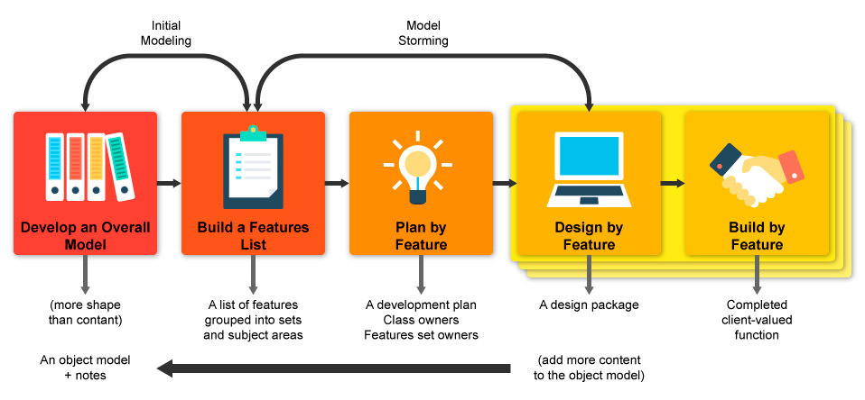

Figure 1 – FDD Overview Diagram [30]

2.9 Conclusion
To conclude, the incorporation of advanced methods for capturing data, visualizing information, and designing user-friendly interfaces in data entry systems is crucial for maximising the effectiveness of business intelligence solutions. The findings emphasize the vital role of visual analytics and UX design in interpreting data and improving decision-making processes. Power BI is recognized as a versatile tool for generating impactful visuals. Additionally, the seamless integration of PowerApps with storage solutions enhances the capabilities of data management. The iterative and feature-oriented approach of FDD is evidenced to be successful method in handling complex software projects.
Overall, the research highlighted within the review emphasizes the significance of embracing comprehensive strategies and innovative technology to fully utilize the potential of business intelligence systems, promoting organizational efficiency and better-informed decision-making.

Research/Development Methodology
Within this chapter I will detail the research philosophy, methodology, data collection strategies and Project Development methodology, along with rationale as to why I’ve selected these options.

3.1 Research Philosophy
Pragmatism is considered the most appropriate research philosophy due to the focus on practical outcomes and flexibility in utilizing both qualitative and quantitative methods, making it well-suited for a mixed methods approach Tashakkori and Teddlie [31]. It's in alignment with the project's objective of improving data accuracy and reporting efficiency by emphasizing the application of research to address real-world issues. Furthermore, this philosophy works favourably with Agile methodologies promoting iterative development, continuous feedback, and adaptation, all of which are crucial elements for the success of this project.
Pragmatism serves as a bridge between Positivism and Interpretivism, allowing for a balanced research approach with a focus on outcomes. Morgan [32] has underlined the significance of Pragmatism in applied research, particularly in cases where practical impact takes precedence over philosophical alignment. Therefore, Pragmatism offers a comprehensive framework to steer the project towards achieving the tangible enhancements in business intelligence practices.

3.2 Research Methodology
As indicated, the mixed methods approach facilitates a comprehensive understanding of the problem and the efficiency of the solution by leveraging the strengths of qualitative and quantitative research. This approach is vital in initiatives that require technical execution alongside user involvement. According to Creswell and Plano Clark [33], the amalgamation of mixed methods in research provides a more profound insight into research challenges than the employment of either method in isolation.
Utilizing a blend of qualitative and quantitative research methods enables researchers to engage in triangulation, a mechanism that fortifies the credibility and reliability of the findings. Triangulation involves the verification of data by cross-referencing information from diverse sources to ensure the consistency and robustness of the results. Jick [34] underscores the significance of triangulation in augmenting the precision of research inquiries.
Qualitative data serves to interpret and put into context the quantitative results, whereas quantitative data offers a broad perspective that reinforces the qualitative insights. This symbiotic relationship between the two types of data enhances the overall robustness of the research.

3.2.2 Research and Data Collection Strategies
Research methodologies and data collection techniques are integral components of any project, as they establish the groundwork for decision-making, ensuring the project is founded on precise, pertinent, and relevant information. These methodologies are vital for projects that rely on data-driven solutions where proficient data collection, storage, and visual representation is required. [35]
Examining prior studies through Literature Review can identify the resources that exist to either substantiate or challenge any preconceptions I have. A comprehensive review of the literature will also enhance the credibility of my research, as it demonstrates a thorough engagement with the topic. As a methodological approach, it contributes to contextualizing the research conducted, consolidate current knowledge, historical developments, and identifying potential gaps in the existing literature.
Observations involve methodical observation and documentation of behaviours within their natural context, providing immediate insights into user interactions and system operations. This approach captures genuine user conduct, providing extensive, nuanced qualitative data and prompt feedback regarding system uses and obstacles encountered. It is beneficial for detecting variances between anticipated and actual behaviours. As articulated by Denzin and Lincoln [36], observational methodologies are vital for comprehending interactions within natural settings, delivering insights that are unachievable through alternative approaches.
Surveys/Questionnaires are a highly effective method of data collection that is efficient in terms of both resources and time. It is considered the most optimal approach for reaching many participants in a timely manner. In the context of this project, surveys are the sole method capable of concurrently gathering qualitative and quantitative data. By employing standardized questions, these surveys aim to provide insights into the organizational culture, generating comparative and quantitative results. The distribution of surveys to the team is aimed at gathering their opinions on the proposed changes, which are anticipated to impact the work practices of this process. To ensure team engagement, their opinions and suggestions have been consistently valued throughout the design process.

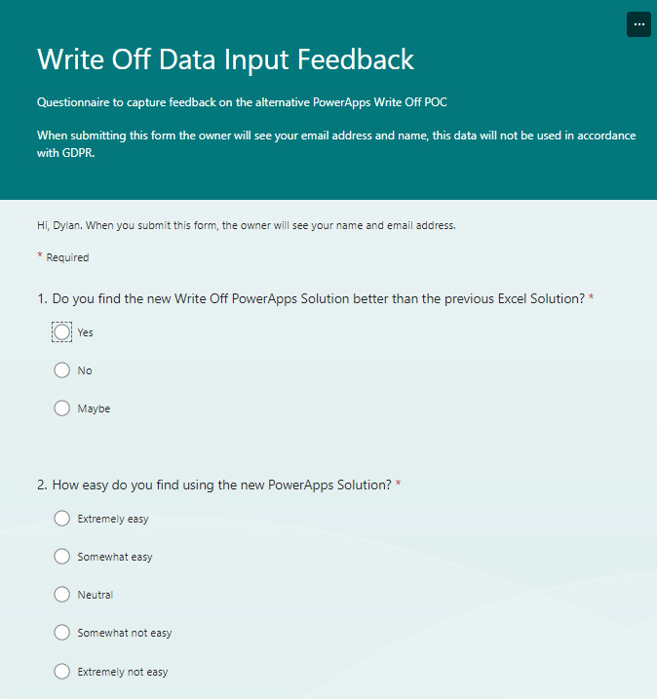

Figure 2 – Example Survey used for PowerApps Feedback Collation
To supplement the surveys, regular checkpoint meetings (commonly referred to as stand-ups) have been scheduled to evaluate the ongoing impact of the solution and to identify prospective improvements that could enhance the project further. The insights garnered from both the surveys and meetings are being evaluated for potential implementation, promoting the agile culture of Continuous Improvement.
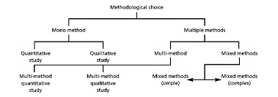

Figure 3 – Methodological Options [37]
The figure above depicts the various methodological options; however, Saunders et al [38]. contend that these can be encapsulated within a more extensive framework comprising three primary categories: quantitative, qualitative, and mixed methods.

3.2.3 Data Analysis Techniques
Qualitative data will be collected through the implementation of a survey, complemented by prototyping and user feedback processes. To identify patterns and trends within the qualitative data, thematic analysis may be conducted, which, as articulated by V. Clarke, serves as a “method for identifying, analysing, and interpreting patterns of meaning within qualitative data.” [39]
The thematic analysis procedure encompasses the aggregation of data, identification of themes within the dataset, and categorization of responses according to the overarching themes. This approach yields a numerical representation of the themes, which can subsequently be analysed to highlight prominent themes and produce visual representations if required. Importantly, the subsequent findings can inform the formulation of recommendations and guide decision-making regarding potential solutions.
Quantitative data will be acquired through the mentioned methodologies, supplemented by artificially generated dummy data for software testing purposes, which can be subjected to statistical examination. Upon the completion of data collection and analysis, a Kimball method [40] could be employed for modelling the data if required. These visualizations will facilitate the exploration of benefit realization of the project's implementation. Depending on the data characteristics, it could provide statistics concerning averages, mean, median, and mode, if desired by the business, employing various visual formats such as bar, line, and scatter graphs within PowerBI. Bryman [41] emphasizes the significance of quantitative data in establishing findings that can be generalized.

3.3 Development Methodology

3.3.1 Feature Driven Development Process
FDD is relevant to this project as it emphasizes the incremental delivery of user-valued features, which aligns to the development timelines of the PowerApps and Power BI dashboard. By chunking the project into manageable features, FDD facilitates early user engagement and feedback, allowing for the iterative enhancement of the applications. This methodology ensures that the product evolves in alignment with user requirements, minimizing the risk of significant future rework.
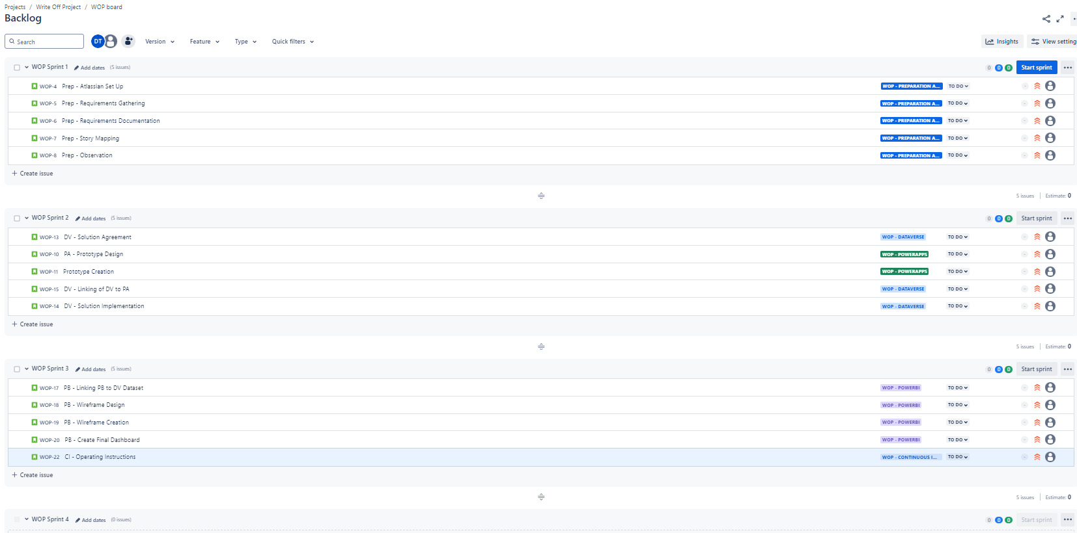

Figure 4 – Write-off Project Backlog View
FDD's focus on preliminary design and methodical planning is essential for navigating the complexities of this project, especially in addressing intricate PowerApps workflows and data integrations within Power BI. This approach lends itself to well-defined milestones and progress monitoring, assisting in keeping the project on track.

3.3.2 Prototyping
There are many aspects to prototyping, and the first is preparatory in articulating the objectives and requirements of the PowerApps, Power BI dashboard and align with the overarching aims as explored in chapter 4.1. The objectives serve as a framework for the features, design, and functionalities that the prototypes will incorporate.
Once this is in place, constructing preliminary wireframes or mock-ups for the PowerApps and Power BI dashboard can begin. Depending on timing the PowerBI dashboard mock-ups could be completed further down the timeline if more effort is required on the Data Input and Storage aspects. The wireframes should focus on the arrangement, user interface components, and data visualization concepts while refraining from technical specifics and detailed visuals.
Following the creation and critique of the wireframes, functional prototypes of the PowerApps and Power BI dashboard utilizing Microsoft Power Platform tools can be created. The PowerApps prototype should encompass essential functionalities alongside a basic user interface, whereas the Power BI prototype should present key data visualizations linked to dummy datasets.

3.3.3 User Feedback

User feedback is essential for this development initiative, serving not only to ensure that the outputs align with user specifications, also influencing the aspects of data collection and visualization. The integration of user feedback as a development strategy involves the active engagement of end-users throughout the development cycle to collect insights that guide iterative enhancements of the product.
This methodology is fundamental to Agile practices, which prioritize ongoing interaction between developers and users. Critical aspects include early and sustained user engagement, prototyping and testing, iterative refinement, and final validation to guarantee that the product fulfils user requirements Beck et al. [42].
The benefits of this methodology include heightened user satisfaction, as products are more likely to align with user expectations, diminished development risk through the early detection of issues, and enhanced usability stemming from continuous testing and refinement Rubin and Chisnell [43]. Nonetheless, the process may prove to be resource-intensive, and developers might encounter difficulties in reconciling diverse and occasionally conflicting feedback from various users Norman [9]. Despite these challenges, user feedback continues to be a vital mechanism for developing user-centric products that are functional, intuitive, and broadly accepted.

Design & Implementation
Within this chapter I will detail the build of the various elements of the project along with rationale as to why they were built in this way.

4.1 Requirements
The diverse requirements compiled for the project are documented in Appendix B. While adhering to an Agile methodology that employs feature-driven development, a degree of structure is still essential, particularly during the requirements gathering phase. A systematic approach exists for conducting this process.
Identify and Engage Stakeholders: Understand who will be using the system and who will be impacted by it. Identification of key stakeholders like End Users, Service Designers, Midas (Data Science and Engineering). By engaging with the stakeholders in a workshop setting I was able to gather their views and requirements.
Understanding the “As is” Current Process: I was fortunate to find documentation relating to the current system and process, which saved me from having to create a process map of my own. The vast documentation allowed me to grasp the current process, and understand the key deliverables required for the solution.
Define Business Objectives: This has been documented within the Introduction, the necessity to move to a fit for purpose solution that improves data input and storage. Introduction of KPI’s could aid comparisons of the systems.
Requirements Elicitation: Having conducted a workshop and discussed the project with the key stakeholders the work could be split into relevant features and broken down further into User stories. Following on from the progression of user stories and initial development wireframes can be used to gain further feedback before developing the final solutions.
Documentation of Requirements: A formal documentation of both the Functional and Non-functional Requirements of the system.
Validation and sign off: Agreement of the requirements before the commencing of an iteration, along with the official sign off and acceptance of work delivered following the conclusion of a sprint.
Continuous feedback and iteration: Feedback loops during the development process to continually refine the requirements to produce a fit for purpose solution.

4.1.2 Requirements Prioritisation

During the initial discovery phase of the project, requirements were systematically identified through a methodical approach designed to address the distinct needs associated with enhancing data capture and visualization mechanisms within the existing frameworks of the DVLA. Engagement with stakeholders, which included end-users from the Vehicles Casework team along with the Service Design and Data Science teams, was facilitated through organized workshops. These interactions proved essential in collecting comprehensive insights regarding their requirements, challenges posed by the current system, and aspirations concerning the forthcoming PowerApps and Power BI solution. An examination of the existing system was conducted by scrutinizing available documentation and observing user interactions with the current frameworks. This evaluation highlighted areas necessitating enhancements in data quality, operational efficiency, and overall user experience. A variety of elicitation methods, including user story mapping, prototyping, and surveys, were utilized to further refine and validate requirements, ensuring alignment with both user expectations and the overarching objectives of the project aimed at improving data quality and reporting.

Following the compilation of requirements, they were prioritized employing an array of techniques to guarantee that the most vital features were addressed promptly, aligned with the project’s goals of optimizing data capture and reporting. The MoSCoW prioritization method [44] was implemented to classify requirements, ensuring critical features such as data validation and secure storage were designated as "Must haves." Moreover, a value versus effort analysis was conducted, particularly emphasizing features that would provide the most substantial enhancement in data accuracy and user satisfaction with minimal developmental input. Feedback from stakeholders, particularly from the Vehicles Casework team and Service Managers, was instrumental in this prioritization process. Regular feedback sessions facilitated the resolution of any conflicting priorities, ensuring the project maintained its focus on delivering the most beneficial features. The adoption of FDD practices enabled ongoing refinement and re-prioritization of requirements throughout each iteration, guided by continual feedback and dynamic project demands, ensuring that the project remained aligned with its objectives of providing a functional and user-centred solution.

4.1.3 Iterations

The figure presented below serves as a preliminary outline of the iterations established for this project, along with the tasks accomplished within each respective iteration. Regrettably, as is often the case in project management, certain iterations and associated tasks experienced delays due to unforeseen complications, such as networking and Active Directory challenges, as well as the initial estimations of effort allocated to specific activities proving to be excessively optimistic.
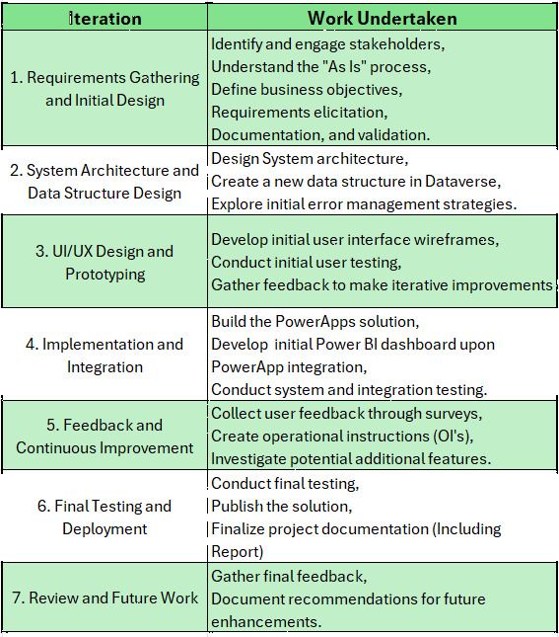

Figure 5 - Iterations

4.2 System Architecture

The figure below illustrates an architectural model sourced from Microsoft, which closely resembles the architecture currently employed at the DVLA. This model aligns with the proof of concept this project aims to implement, transitioning manual data entry from Excel spreadsheets and SharePoint to a PowerApps interface that will store data in Dataverse, enabling subsequent reporting through PowerBI. This architecture diagram also indicates other potential data source alternatives; though, Dataverse has been selected. The architecture and integration capabilities inherent in PowerApps can enable future modifications should another data source be deemed more suitable.
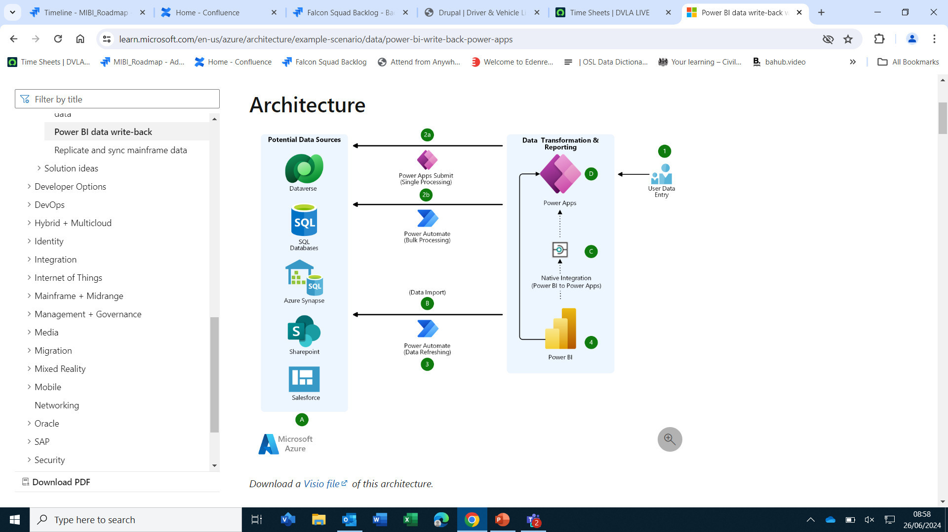

Figure 6 – Architecture Overview [45]

4.3 Design and Implementation of Data Structure

To reproduce the existing Write-off process and associated data collection, the table presented below has been established to enhance visibility regarding the data requirement. The dataset adheres to a camel case convention for clarity and compliance with coding standards. This dataset exhibits minor deviations from the original, as it will now capture Staff Name and Email address upon system entry, with the Email being less sensitive data relative to LAN ID concerning Personally Identifiable Information (PII). With PII and the General Data Protection Regulation (GDPR) in consideration, the dataset has retained substantial similarities to that utilized by the current process. Although additional fields could have been incorporated, their inclusion would lack value to the process or potential Management Information (MI), rendering the data's value obsolete.

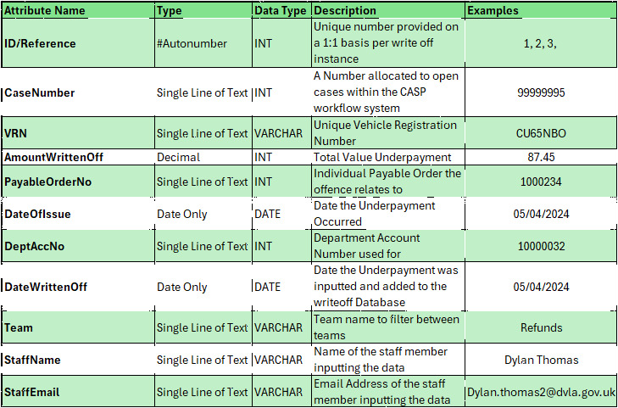

Figure 7 – Data Set Attributes
I contemplated the inclusion of supplementary data within the dataset, such as a descriptor for the transaction value to group by the further action required; however, I opted against this approach, as transactional data is utilized across a multitude of reports within the agency and these groupings are process specific. I've decided to incorporate the additional information into a separate 'Mappings' table, as further variables can be appended over time. These will correspond to the transaction, and within Power-BI, it is feasible to establish relationships among data tables to retrieve associated data variables.
In the context of Dataverse, I concluded that the write off data should be maintained in a singular table due to data management considerations. The write-off information will be input daily, unlike other datasets it won't be subject to frequent updates. When undertaking the removal of bulk data from a dataset, it is best practice to execute deletions from a singular table to mitigate the risk of errors and inadvertent deletion of incorrect data. This rationale aligns with the findings that advocate for a singular staging area for each application, and the merit of employing a singular table for the sake of simplicity. The Dataverse tables were established in accordance with the insights from the literature reviewed. To synthesize the data and construct a narrative within Power-BI, relationships are required to establish interconnections among the data points. This process can be implemented within Power-BI, which as standard is implemented in reports generated by the MIDAS team who are responsible for Report creation and maintenance within the Agency.

4.4 Design and Implementation of Data Input User Interface
Engaging in active observational sessions provided insights regarding the separation of functionalities within the application. The initial strategy entailed mirroring the sequence found in the existing solution; however, monitoring user interactions with the system indicated the necessity to separate certain functionalities, utilizing a streamlined user interface, as the present screen is congested. The guidance from Gov.uk advocates for a 'one thing per page' approach, with the PowerApps designs aligning more closely with this principle than the existing solution.
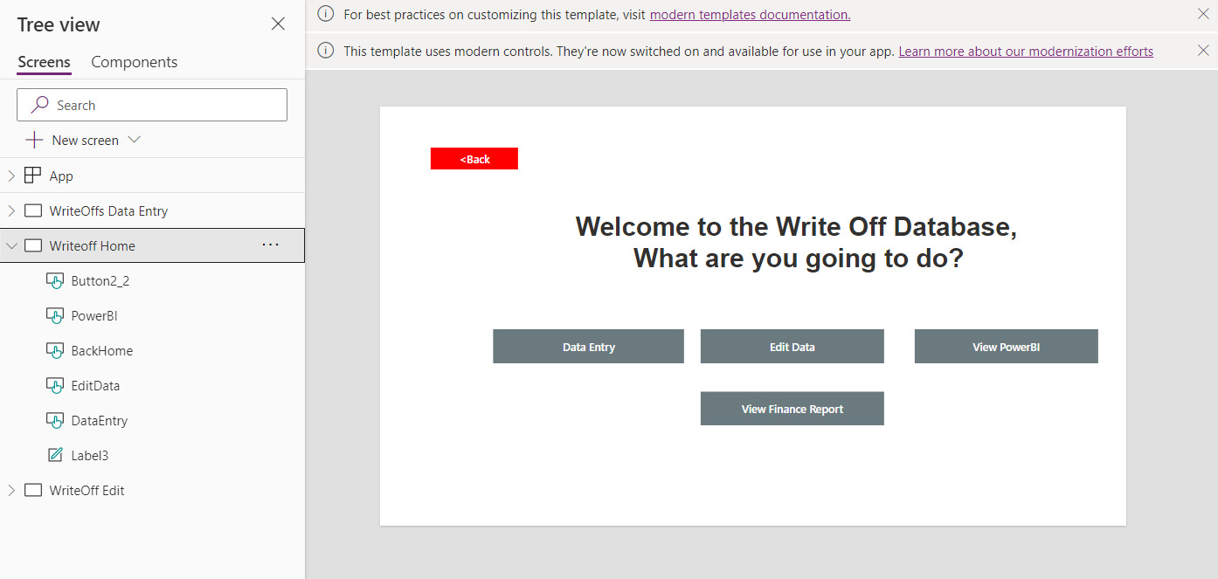

Figure 8 – Initial Homepage Prototype

Observational sessions undertaken have positively influenced the design process. I developed an initial prototype of a homepage along with the Data Input interface [Figure], which varied in aesthetic from the original solution. This design aimed to integrate observations highlighting that staff regularly made errors while entering date values and frequently encountered spelling errors with Account numbers, due to the extensive length of the values. Such feedback was instrumental in effecting functional modifications to the original design, which now includes Staff details and the current day's collection within the user interface, a date picker feature for the Date of Issue, and prepopulated dropdown options for Account numbers and teams. A significant portion of this rationale is directly aligned with the primary project objective of Enhancing Data Quality.
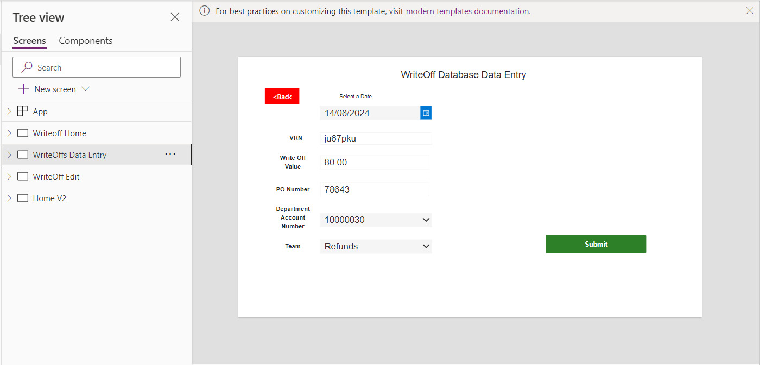

Figure 9 – Data Entry Initial Prototype

In the subsequent iteration, I presented a page dedicated to selecting a date and entering the required data. While DVLA’s online services typically employ a ‘one thing per page’ methodology, I opted against this approach, as creating a separate page for each input field appeared excessive. A. Silver, [45] undertook a case study evaluating the efficiency of this method compared to a ‘multi-question on a page’ approach, discovered superior conversion rates with the ‘one thing’ methodology, asserting that it facilitates error management by necessitating users to rectify mistakes prior to advancing. Users report a more favourable experience due to reduced scrolling and a cultivated sense of progression. The methodology enhances accessibility for screen-reader users, fostering inclusivity and streamlining the design process. [Figure 11] illustrates DVLA employing a similar perspective within their online service designs.

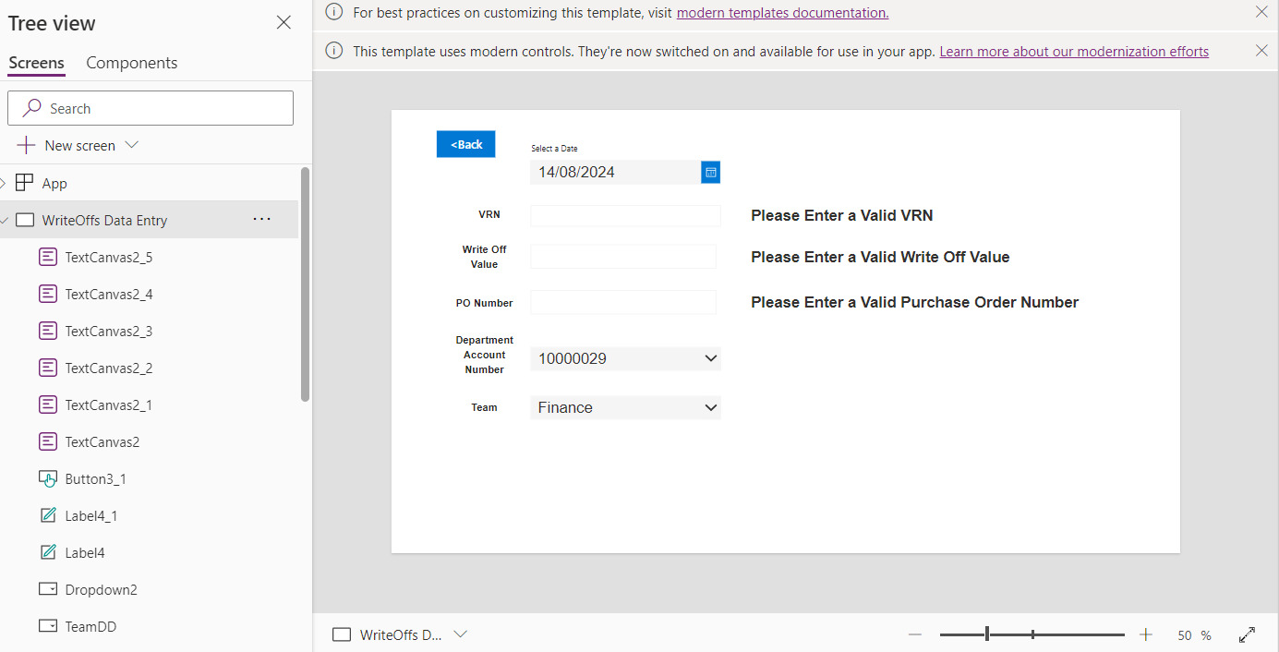

Figure 10 – Second Iteration

DVLA has its own UX lab where online services are vigorously tested with end-users and has gained a lot of positive feedback from their designs, exampled by [Figure below]
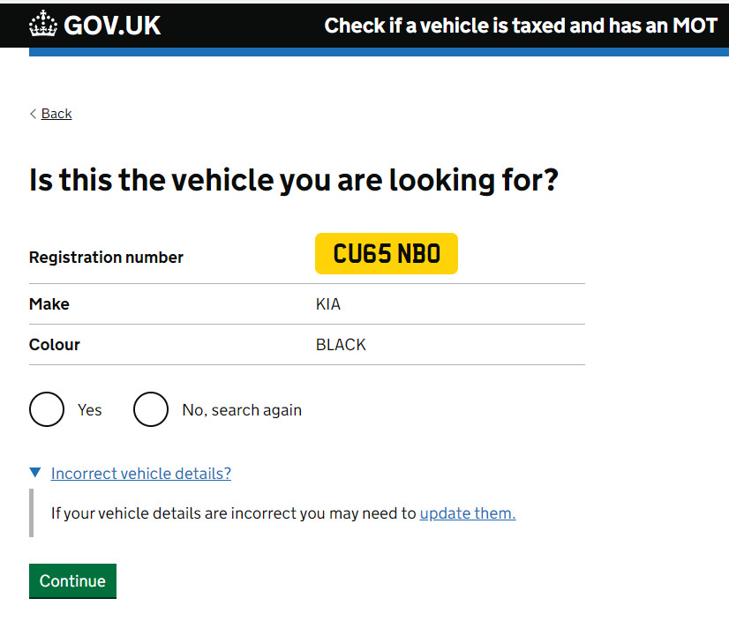

Figure 11 – Example DVLA Online Transaction Screen

In the following design phase, I aimed to emulate the appearance and functionality of a DVLA online service. Given that DfT and the Government have invested substantial resources in usability engineering design to optimize component accuracy, my intention was to replicate, utilising button styles and alignment to foster a consistent user experience across DVLA services. This strategy garnered positive feedback from end-users, with the implementation of validation processes, users expressed satisfaction with the application design, as they ultimately desired assurance that they were accurately completing the application, with conspicuous errors being flagged to assist them in this endeavour.
The DVLA has thoroughly analysed these investigations and integrated the findings into the button components; thus, I deem it appropriate to extend this implementation across all application screens to ensure uniformity [Appendix A].

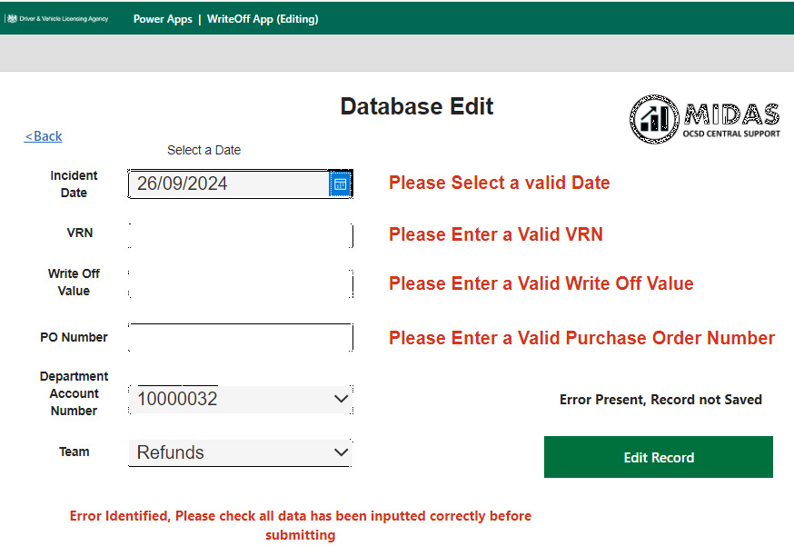

Figure 12 – Final Edit Screen with Validation

Each element was rigorously evaluated with end-users, encompassing aspects such as button placement and user interface conventions. This perspective is corroborated by Wroblewski, L., in his examination of eye-tracking behaviours during the assessment of application efficiency. The findings indicated that when buttons were strategically located directly beneath the last user input field, performance improved due to reduced eye fixations, resulting in users completing forms with greater efficiency [46].
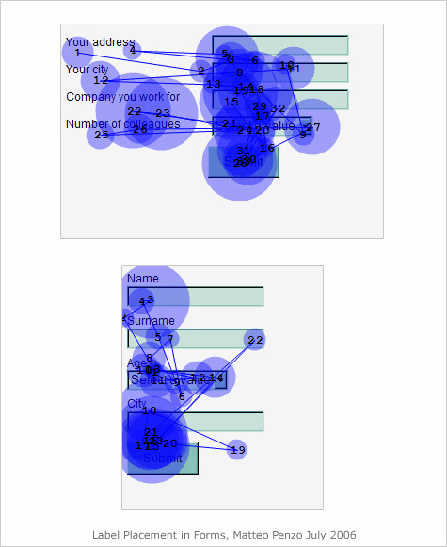

Figure 13 – Wroblewski.L’s Eye Movement [46]]

4.5 Error Handling and Application Data
Throughout the design process, it has been essential to adopt a pragmatic strategy towards error management, addressing numerous issues within the user interface prior to committing data to the database. This approach aims to enhance the quality of data collected compared to the existing Excel and SharePoint methodology aligned to the project Objectives. This principle is illustrated by the landing screen [Figure 14], where a global variable function is employed to capture the name and email of the staff member interacting with the application, subsequently stored in the Dataverse table upon data commitment within the Data Entry page [Figure 16].

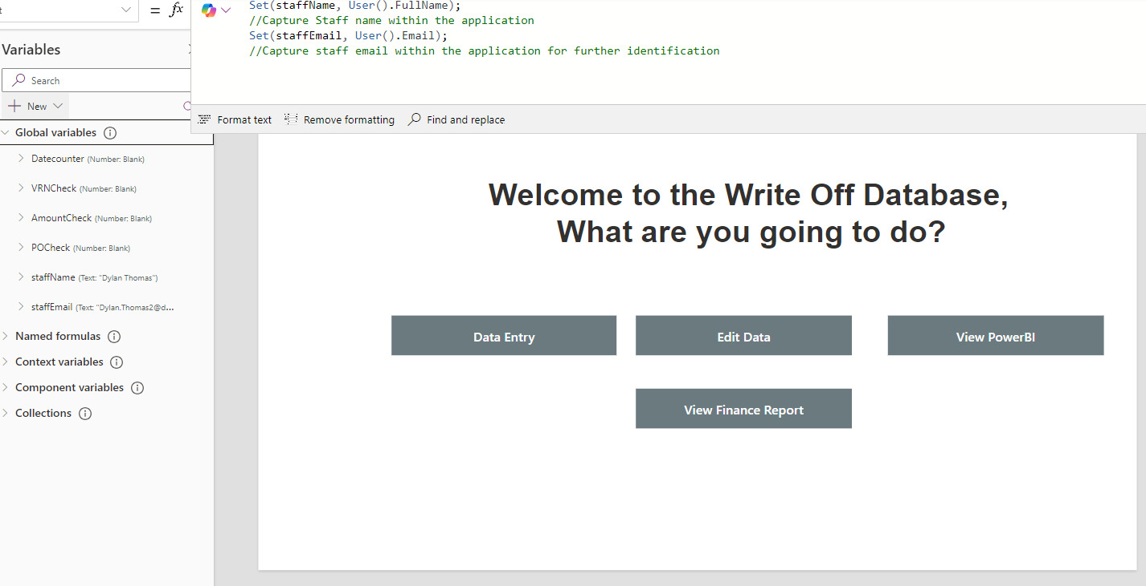

Figure 14 – Homepage Global variables
To organize the data into an appropriate structure within the staging area, PowerApps employs ‘Collect’ functions to generate a data collection [47]. Prior to the development of the application, the PowerApp platform prompts the developer to establish a connection with one or more data sources, removing the necessity of performing the task manually within the code.
[Figure below] shows the ‘WriteOffs’ Microsoft Dataverse database is connected within the application, the only storage option for this data for simplicity. This does however allow further integration with other data sources if integration with the workflow service is desired in the future. The conventional functionalities within PowerApps enable the developer to effortlessly specify data sources and connectors through specifying their respective names.

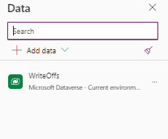

Figure 15 – Dataverse Table

In addition to the staff data collection discussed previously, another strategy for error management employed was the incorporation of a counter variable within the Data Input and Database Edit interfaces. [Figure] illustrate the management of date-related errors through the implementation of a ‘counter’ variable. Upon starting the application, a function assigns the variable a value of ‘0’; however, if the user selects a date that exceeds the current date or is more than two days prior, the variable is updated to ‘1’. This modification causes the date input field to change colour to red, alerting the user to the error, alongside a text notification that provides corrective guidance. PowerApps facilitates the utilization of ‘If’ statements, enabling the regulation of application behaviour by stipulating ‘If Counter = ‘1’ Then display errors’. This logical framework was similarly applied to button functionalities by articulating ‘if Counter = ‘1’, do nothing; otherwise, proceed’.
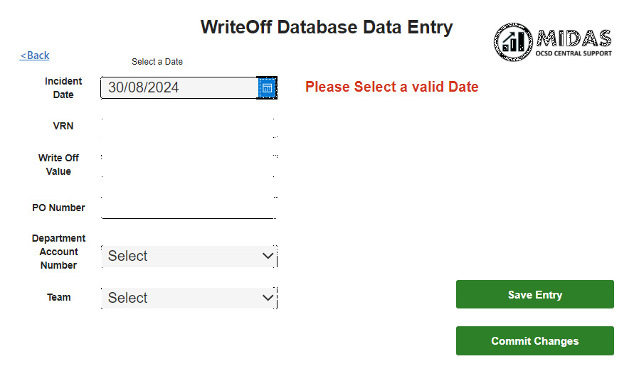

Figure 16 – Invalid Date Error

To authenticate the validity of received entries, the application component properties within PowerApps permit developers to specify the required data format, thereby restricting input to that format. For instance, by designating a component format as ‘Number’, end-users are prevented from entering textual or special characters; however, during testing, decimal numbers were deemed acceptable entries. The recorded value may encompass decimal numbers, yet the Purchase Order must always consist of whole numbers. Although it is improbable for an end-user to input a decimal value, this scenario still required consideration.

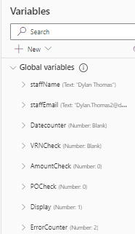
Figure 17 – Application Variables Snippet

To address this, similar logic was applied to the input field, where an 'If' statement verifies that only matching values from "0-9" are present in the entry box, thereby regulating the error counter variable for comprehensive validation, which inhibits any further actions within the application, ultimately triggering an alert for end-users regarding entry errors and their rectification.
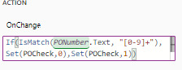

Figure 18 – PO Number Validation
The below ‘If’ statement will present an error message within the UI to alert the user that an error has occurred and a ‘Record not Saved’ message displays, which is linked back to the overall error counter implemented within the Save button. Only when the ErrorCounter has a value of 0 and all data entries are a valid input, and dropdowns have an appropriate selection will the record be successfully saved to the SingleCollection and confirmed into the Database with the Commit Changes button.
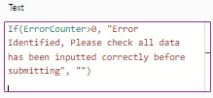

Figure 19 – Action statement for Error counter within PowerApps

Design and Implementation of PowerBI Dashboard
The objective of the preliminary wireframe is to ascertain that the end users are satisfied with the proposed Management Information (MI) visuals along with the dashboard layout. This layout should resonate with DVLA business users, since the MIDAS team provides MI from the Business Intelligence Lakehouse utilizing a comparable PowerBI format. This format was developed with user experience considerations and has undergone rigorous testing during previous dashboard developments.
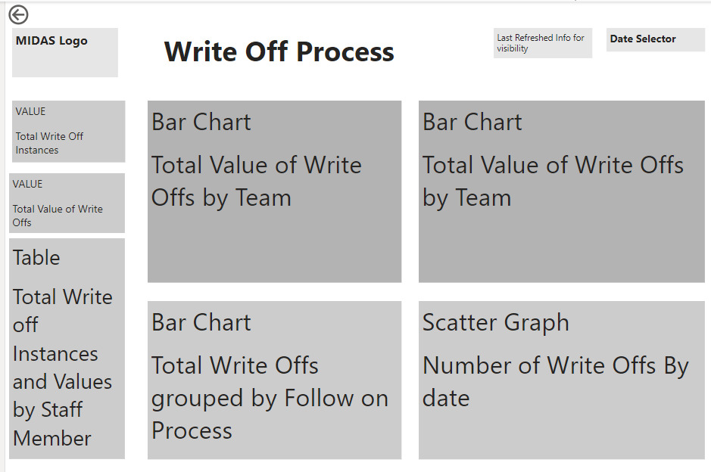

Figure 20 – Initial PowerBI Wireframe

Importing the data from Dataverse to PowerBI proved more problematic than anticipated. Initial error appearing when attempting to connect, this error persisted when attempting to implement a power query [Figure 21].

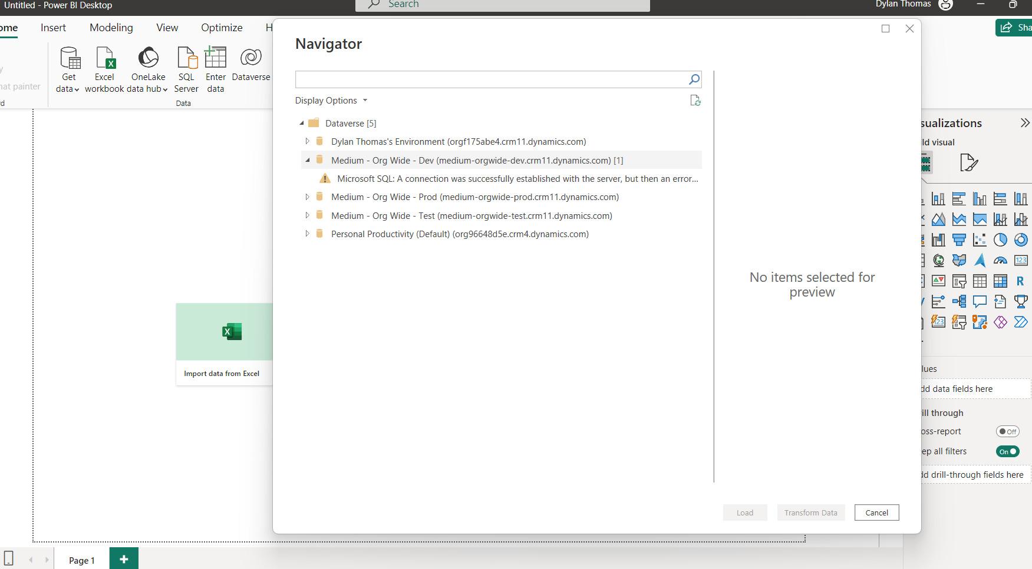

Figure 21 – Connecting to Dataverse Data

This situation arose due to the configuration of active directory permissions established within the agency, which restricted access to select members of the MIDAS team and Data Engineering division. This issue was subsequently resolved by raising a ServiceNow change to modify my active directory group assignment, along with the reconfiguration of network protocols in response to adjustments in layers 3 and 7, thereby facilitating the data source connection to PowerBI. This highlights the comprehensive firewall and security protocols implemented at the DVLA, with a significant proportion of the cybersecurity measures being informed by NCSC guidelines [48]. On resolution of the access permissions, I was able to successfully link the table in PowerApps to PowerBI [Figure below].
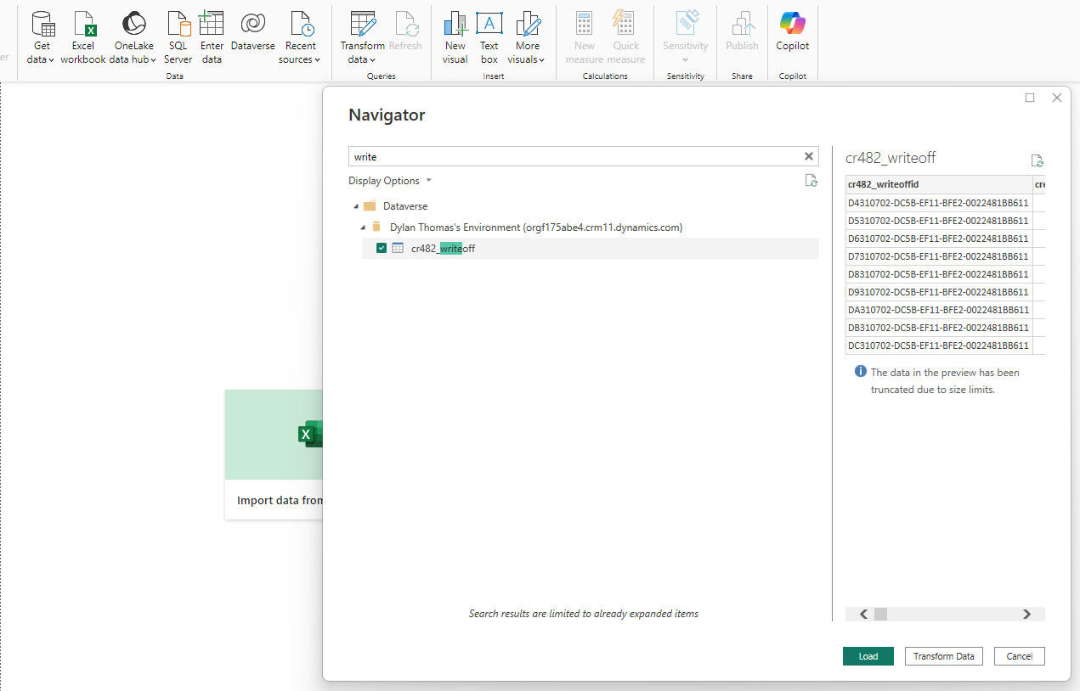

Figure 22 – Secure Connection Made

After gaining access to the data and importing via the Get Data function, the next step involved developing the PowerBI Dashboard to generate MI for the Write-Off Process. A variety of fields were incorporated, many of which were delineated within the Data Verse table, along with numerous generic data fields that provided little value, leading to these fields being removed, resulting in the data table displayed below to facilitate the visualizations. Additional data cleansing operations were necessary, including the elimination of timing discrepancies in the date columns and the conversion of the value column from numerical figures to currency for enhanced reporting accuracy.
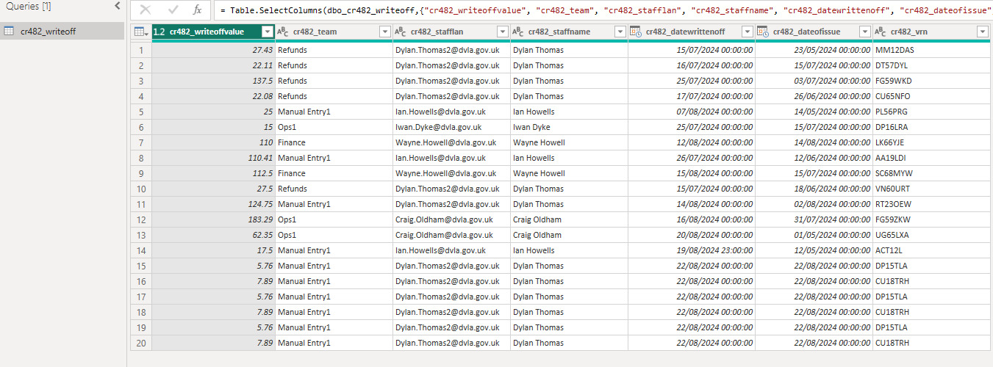

Figure 23 – Dashboard underlying Dataset
The below value grouping is an additional reporting requirement requested, showing how many write offs per each value grouping occur. This requirement is due to each grouping requiring a different subsequent process. This metric could benefit future resourcing decision making to allow the provision of resource to where it is most required.
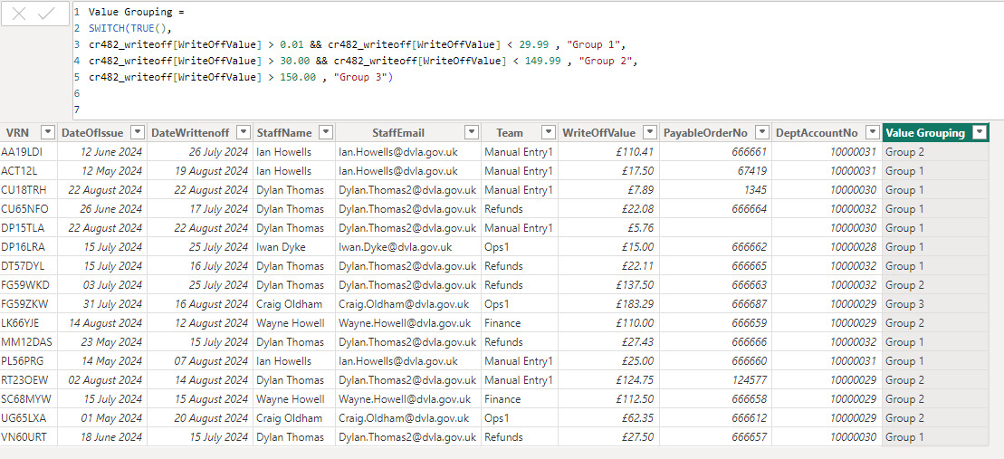

Figure 24 – Value Groupings for Follow On process

An additional Date table was necessary to operate in the background. This table encompassed a decomposition of dates into subcategories, such as Week Commencing, Month, Quarter, and Year. The table is essential for facilitating more comprehensive financial reporting as the transaction volume, while concurrently serving as a critical data table for the Finance Reporting Requirement [Figure 32].
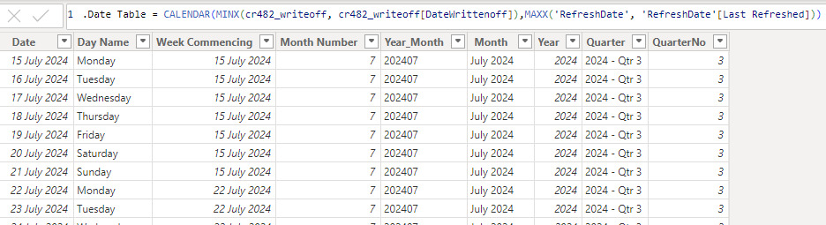

Figure 25 – Date Table

The establishment of this supplementary table necessitated the creation of a Entity Relationship, which required the connection of the Date attribute to the DateWrittenOff attribute from the cr482_writeoff database table. This connection will enable a more detailed analysis of dates for prospective financial requirements, including the currently established monthly report, while a quarterly report may also be necessitated in accordance with other finance reporting requirements.
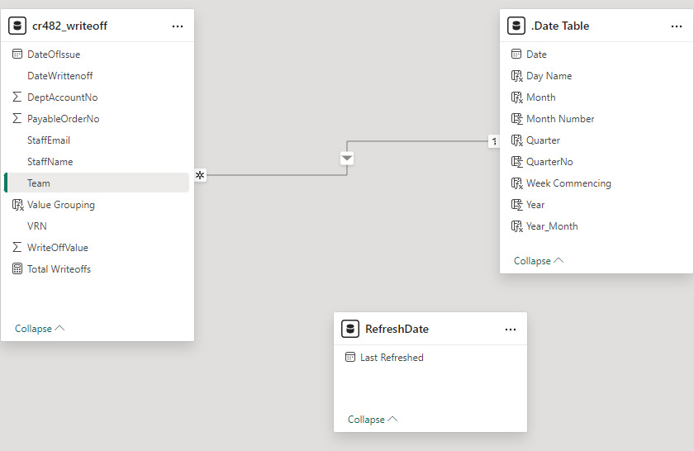

Figure 26 – Basic ERD within PowerBI
After compiling the requirements [Refer to Appendix B] in collaboration with the Service Manager and the End users, the subsequent step involved developing the visual components. By designing a preliminary interface featuring few visual elements, I successfully published the dashboard, which enabled me to evaluate the functionality of the navigation button linking the PowerApps to the Dashboard. Additional continuous improvement efforts could be pursued to integrate the dashboard directly into the PowerApps interface, thereby eliminating the necessity to switch to PowerBI for navigation.
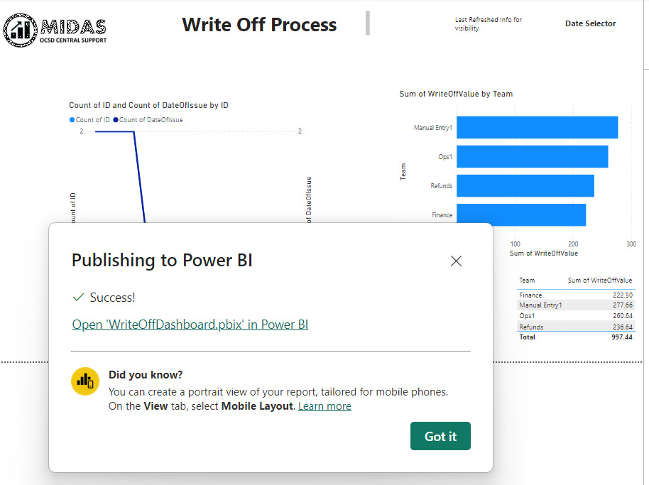

Figure 27 – Publish Testing of Dashboard for PowerApps navigation Testing
The Report can be accessed as frequently throughout the day as necessary; however, based on my findings, Power Flows will only undergo refreshment eight times per day. Should the business necessitate additional refreshes beyond this limit, Microsoft premium license will need to be acquired. Nonetheless, the dataset can be refreshed multiple times daily directly within PowerBI.
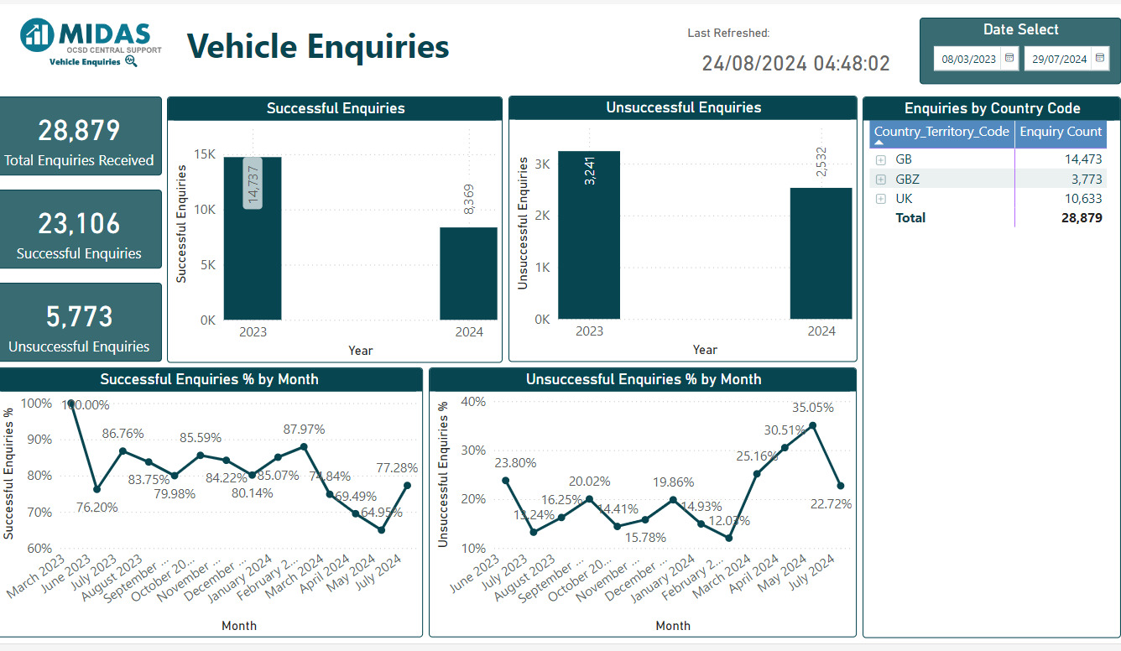

Figure 28 – Example MIDAS PowerBI Dashboard
A significant portion of the dashboard's design has been shaped by the reporting standards that MIDAS adheres to concerning the Production PowerBI Reporting [Figure Above]. The inclusion of a Last Refreshed icon serves as an additional feature; however, it informs the user of the last time the dashboard underwent a refresh. If a refresh has not taken place within a specified timeframe, it enables the user to raise an incident. The implementation of a date slicer for user convenience allows for the simultaneous adjustment of dates across all visuals when the slicer is modified, eliminating the necessity for the user to alter each metric individually.
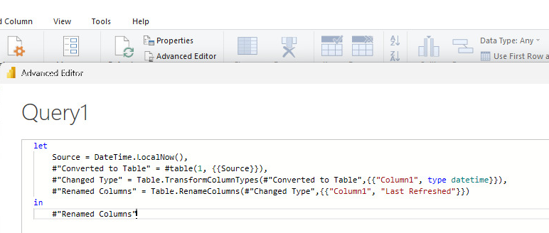

Figure 29 – Data refresh Query
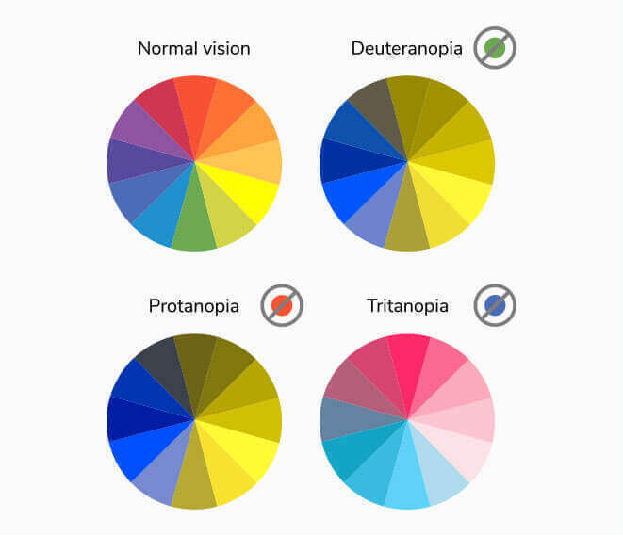
The chromatic scheme is based on a design that is considerate of individuals with colour vision deficiencies, having been through extensive user experience evaluations involving participants with a range of colour deficiencies. This design complies with the colour contrast standards set forth by the (WCAG 2.1) guidelines [49]. The spectrum of colour blindness, reflecting varying degrees of impairment, indicates that the dominant colour occupies contrasting positions on the colour wheel across all deficiencies, effectively reducing visual fatigue.

Figure 30– Colour Wheel Deficiency
Given the pre-existing reporting provided to the organization through MIDAS, along with an established and validated colour scheme and layout, the necessity for extensive wireframing iterations and testing for this dashboard was significantly reduced. After conducting a thorough assessment of the reporting requirements and the visual arrangements, I was able to commence the creation of the visuals. Utilizing insights gained from prior usability modules and existing exemplary dashboards, I developed the customized reporting for the write-off data. By employing a colour-compatible theme, I produced the visuals as per the organization's specifications and focused on enhancing the dashboard's aesthetic appeal by modifying the labels to more user-friendly terms rather than camel casing, incorporating outlines with rounded edges to the metrics for improved visual comfort, and integrating the MIDAS logo.
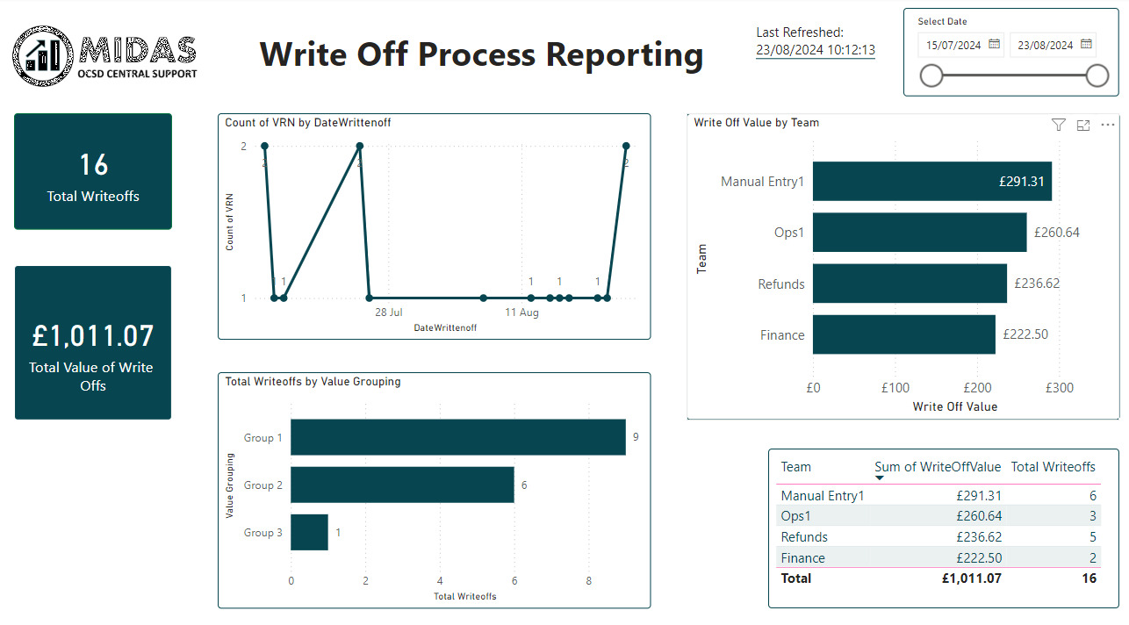

Figure 31 – Final Dashboard Design
Upon the completion of the development phase, user testing yielded favourable outcomes, as evidenced by the positive results from the System Usability Scale (see Appendix). Considering that the reporting for this process remains in its infancy and that the transaction volumes are relatively low in comparison to other DVLA transactions, it is probable that the organization will seek additional reporting requirements in the future. Most significant usability feedback was collected during the preliminary wireframe creation, with much of the feedback concentrating on enhancements to the user interface, such as the implementation of borders, user-friendly labels, and potential continuous improvements that could be executed.
User testing proved to be a versatile approach for participants; moderated testing effectively facilitated the collection of immediate feedback, enabling the capture of both positive and negative reactions in real-time as users navigated through various screen flows, from general navigation tasks to the processes of adding entries and editing previous entries. Indeed, one participant engaged in moderated testing via Teams, sharing their screen with the moderator while navigating through the prompts. The option for unmoderated testing was also made available to those staff members who possessed confidence in utilizing Power BI, granting them autonomy while still allowing for feedback provision where necessary.

4.6.1 Finance Report
Along with the creation of the PowerBI dashboard to provide the business with further MI on transaction volumes and further breakdowns there was also the requirement to replicate the Monthly report which is provided to Finance. The previous report was generated within a view on Excel, that was then printable and exportable.
The new solution PowerBI Finance report is Exportable via a CSV format, so if Finance need to export the data for their reporting purposes or to feed data cubes this is possible. Another Ci could be to automate that process if there’s a desire moving forward.
The Report has a similar colour-blind friendly colour scheme and sleek minimalistic design as was implemented for the Reporting Dashboard. This was done to promote familiarisation and uniformity for the staff when navigating the screens as the tool itself is still new to the Agency. To aid with the navigation an OI document has been created to assist staff when navigating the screens, along with making myself available when further user testing will occur if the product moves on from a POC to a live Production Solution.
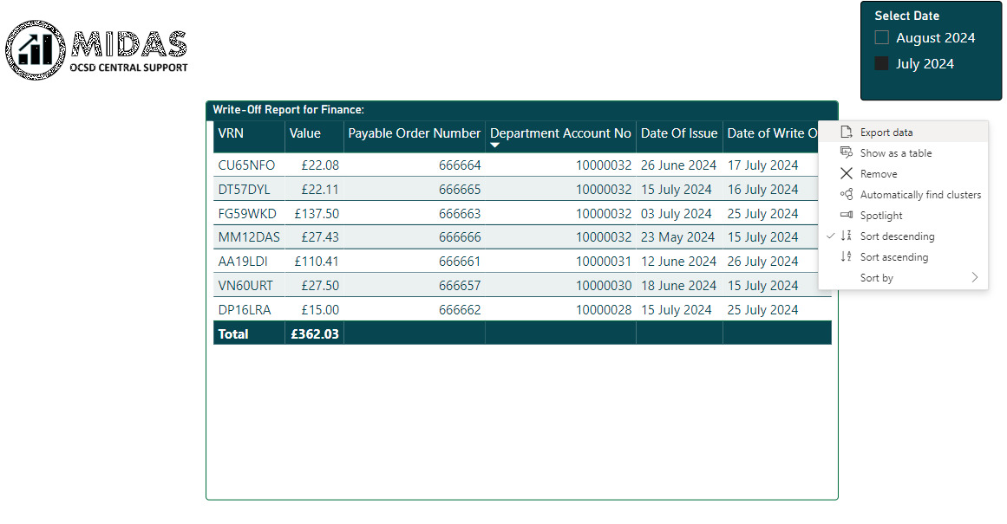

Figure 32 – Final Finance Report View

The overall feedback garnered was positive, with the overall colour palette being in accordance with the DVLA colour scheme while simultaneously satisfying the criteria for readability for individuals with colour vision deficiencies and impairments. The Data Input interfaces exhibited a sense of familiarity due to the usage of commonly utilized Gov.uk buttons. The integration of icons within the User Interface could be considered if necessary; however, given the uncomplicated nature of the navigation, this is unlikely to be essential unless it is integrated with other systems.
In response to commentary from the preceding prototype, a variety of supplementary screens have been incorporated into the PowerApps journey, including landing, confirmation and redirect screens designed to validate modifications and enhance the overall user experience.

4.7 Surveys

The findings from the survey suggest that the deployment of the PowerApps solution has been predominantly effective in satisfying user expectations. Participants noted considerable enhancements in the precision and efficiency of data entry, emphasizing the intuitive and user-centric interface as a critical element in minimizing errors and optimizing the data collection process. The feedback gathered demonstrates a substantial degree of user contentment, especially regarding the design components that conform to recognized best practices in usability. Although the overall feedback was favourable, the survey also yielded valuable insights into areas where additional enhancements could be implemented, indicating that the system possesses the capacity for further optimization in subsequent versions.
The evaluation of the System Usability Scale (SUS) and Data Input Survey outcomes from the project illustrates that the PowerApps solution and Power BI dashboard were positively received, successfully achieving the project's goals. Elevated SUS scores reflect robust usability and user satisfaction, validating the effectiveness of the user-centred design and iterative development methodologies employed.
The Data Input Survey corroborates these results, revealing advancements in data accuracy and efficiency, accompanied by favourable remarks regarding the interface. These observations are in accordance with the theoretical frameworks established in the literature review, emphasizing the significance of effective UX design in improving data integrity and user satisfaction. Aspects for potential enhancement identified in the survey propose avenues for future development, ensuring ongoing alignment with user requirements.

Evaluation

5.1 Evaluation Criteria

5.1.1 Relating to Literature Review
The results derived from the project strongly corroborated the research presented in the literature review. For instance, the enhanced user experience UX within the PowerApps was consistent with the findings of Akram and Shams (2017) and Resnick et al. (2009), who highlighted the significance of UX in improving data accuracy and user satisfaction.
Additionally, the application of Power BI for data visualization was substantiated by the literature, with Ponce (2020) and Russo and Ferrari (2016) demonstrating the tool's efficiency in producing actionable insights. The iterative methodology adopted during the development process, adhering to the principles of FDD, also reflected the success narratives documented by Firdaus et al. (2013) [28] in the existing literature.

5.1.2 Relating to the Objectives
All objectives outlined in the introduction were effectively accomplished. The project established a proof of concept aimed at enhancing the current data capture methodology through a contemporary approach (PowerApps Solution). The integration with Dataverse guaranteed a scalable and secure repository for the accumulated data, while the Power BI solution provided augmented management information (MI) to support decision-making. Comprehensive testing and validation were executed, and the creation of operational instructions (OIs) ensured that the solution could be efficiently utilized by end-users and stakeholders. The project's alignment with its original objectives is evident, signifying a successful result.

5.1.3 Relating to the Research Questions
Upon examining the results of the project, it is evident that the initial research questions were addressed through the structured design, execution, and evaluation of the proposed solution.
How effective is the usage of a PowerApps data capture solution in improving data accuracy and quality compared to other methods?
This research question was comprehensively resolved. The deployment of the PowerApps solution exhibited a significant enhancement in the precision and quality of data when compared with the prior Excel-based framework. The incorporation of functionalities such as error management, validation protocols, and optimized data entry methods markedly diminished the frequency of data entry inaccuracies. The analysis of project data indicated that these advancements resulted in more dependable and superior quality data, thereby corroborating the hypothesis that contemporary data acquisition solutions, such as PowerApps, can enhance data integrity.
How does the newly designed UI of the PowerApps solution affect user satisfaction?
User satisfaction constituted a pivotal metric for evaluating the project’s success, and the feedback gathered from users suggests that the newly developed user interface exerted a positive influence. The PowerApps interface was crafted with an emphasis on usability, integrating best practices from user UX design and Agency principles. The use of familiar design components, explicit navigation pathways, and user-centred features resulted in elevated levels of user satisfaction. Surveys and usability assessments substantiated that user perceived the new system as more intuitive and accessible, effectively addressing this question.
How effective is Power BI in providing improved MI to enhance decision-making processes?
The project successfully illustrated the efficiency of Power BI in enhancing MI and facilitating decision-making processes. The dashboard generated by Power BI offered dynamic, real-time data visualization, enabling decision-makers to derive insights rapidly and accurately. The findings of the project are consistent with the literature review, affirming Power BI’s potential to convert raw data into actionable insights.
What role does iterative feedback and application of Agile methodologies like FDD play in influencing the success of a project?
The iterative feedback process and use of FDD were crucial to the success of the project. Consistent feedback loops with stakeholders facilitated ongoing enhancement of the PowerApps and Power BI solutions. This iterative methodology ensured that the final product was closely aligned with user requirements. The project’s achievement in delivering a functional and user-approved solution substantiates the effectiveness of Agile methodologies, particularly FDD, for providing user-centric outcomes.

5.1.4 Results Expectation
The data amassed through the implementation of the PowerApps and Power BI dashboard exhibited substantial advancements in both data accuracy and reporting efficiency. The use of contemporary data capture and visualization tooling provided the organization with a robust solution that not only fulfilled the objectives but can improve decision-making processes. User feedback was overwhelmingly positive, indicating that the new system is more user-friendly and reliable in comparison to the previous Excel-based solution. The project successfully exemplified the advantages of transitioning from a manual, error-prone methodology to an automated and scalable solution.

5.2 Project Management and Time Management
In relation to Project and Time management, the following strategies were implemented to aid in achieving the project as set out,

5.2.1 Project Management
Feature Driven Development (FDD)
The Fundamental component of FDD is breaking down a project into small manageable chunks, splitting the timelines into sprints, and the features of work into manageable user stories to where possible produce shippable product at the conclusion of each sprint. The method is flexible, and where I to encounter issues, it allows pivoting and re-adjusting the project to continue the correct path. Regular feedback received from the wireframes played a part in keeping the project aligned. Employing this methodology-maintained focus, eliminated scope creep, and concentrated on delivering value or quality improvements.
Work Breakdown Structures
Story Mapping is a work breakdown structure technique I have used during my time as a Business Analyst, allowing me to break the project into smaller more manageable work packages. Personally, I see the value of this technique on every project I have been allocated, the breakdown of features into stories makes estimating easier and the resource allocation more effective, and thus monitoring of deliverables against timescales more effective. This was also the case with this project; by identifying areas of weakness, I was able to allocate more time and effort to getting these tasks correct in comparison to tasks I’m comfortable with taking less time/effort.
Alongside Story Mapping the use of a Gantt Chart was useful. It’s a tool that helps task scheduling and progression, giving a visual aid to the start, end dates and potential dependencies. By keeping the chart regularly updated it allows the identification of possible delays, and the re-assessment of priorities. It was a useful visual timeline to work to in conjunction with the story mapping and decomposition of large work packages.

5.2.2 Time Management
Regular Reviews (Catch Ups)
Conducting reviews and retrospectives at the conclusion of each sprint or project phase enables the "team" (in this instance being myself, project sponsor and internal business contacts) to critically assess elements that were effective, and areas for enhancement and shortcomings. These sessions serve as platforms to acknowledge achievements, confront challenges, and facilitate informed changes to the project strategy in subsequent sprints
Frequent reviews aid in preserving project coherence to objectives, promoting ongoing improvement, and cultivating a culture of openness and responsibility.
Timeboxing and estimation
Timeboxing involves setting fixed boundaries for tasks or activities. This allows the concentration on critical tasks while keeping aligned to a fixed timescale, meaning the right amount of time and effort is invested relating to the scope of the task. Like the work breakdown structures timeboxing is a technique used in Agile methodologies, to maintain momentum and keep the delivery of all tasks within the sprint on track.

5.3 Tools and Technologies Used
Considering that the DVLA operates predominantly within the Microsoft suite, and the Office 365 Suite is provided by the University, it's not unexpected that most software utilized is based on Microsoft products. In my capacity as a Business Analyst, I have employed Atlassian tools, specifically Jira and Confluence, for the purposes of requirements gathering and workflow monitoring. The choice of tools adopted by the agency significantly influenced the software used, for instance, Power BI is one of several data visualization solutions that could have been utilized, Tableau and Weka, among others. The possession of appropriate tools greatly contributed to the successful outcomes of this project.
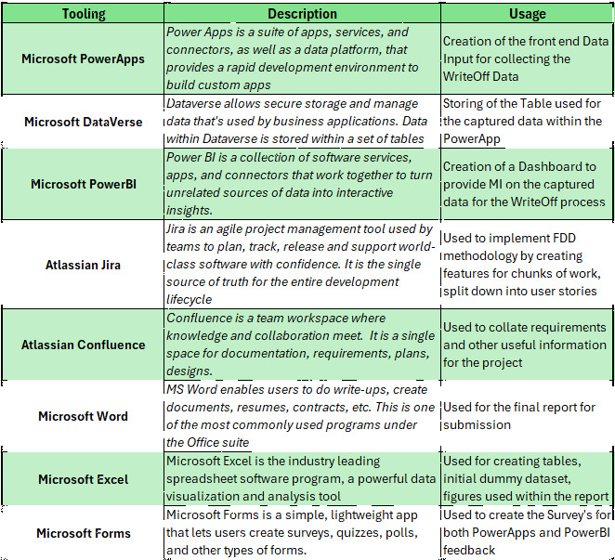

Figure 33 – Project Tooling

Conclusions and Recommendations

Upon successful replication of the daily write-off procedure for payment discrepancies using PowerApps, I have developed a strong conviction regarding its efficiency as a superior alternative to Excel, recommending for its immediate and comprehensive application. Additionally, the further enhancement of Power-Automate functionalities has the potential to replace monotonous and repetitive tasks, saving both time and resources, while PowerApps provides enhanced oversight over data integrity. The introduction of Dataverse is equally paramount, as Excel was never intended to function as a database; circumventing the constraints inherent in Excel will facilitate efficient report generation.

6.1 Summary of Findings
The literature review underscored the significance of comprehensive data collection and visualization within business intelligence systems, informing the project's design and execution stages. The design stage emphasized the development of a user-centric interface for PowerApps, integrating stakeholder feedback to ensure an intuitive and error-minimizing interaction. The implementation encompassed the construction of the PowerApps solution and integrating the Power BI dashboard, featuring critical features such as data validation, error management, and real-time analytics. A thorough evaluation through methodical testing validated the system's usability and efficiency, with favourable feedback highlighting the triumph of the FDD approach in steering the project.
The project delivered considerable advantages, including improved data precision and user experience. The PowerApps solution mitigated data entry inaccuracies, resulting in more dependable data, while the intuitive interface enhanced user satisfaction and engagement. The Power BI dashboard facilitated real-time data visualization, enhancing decision-making proficiency. Furthermore, the integration with Dataverse assures scalability and security, in alignment with GDPR regulations and government standards. The automation of data capture and reporting workflows bolstered operational productivity, enabling staff to concentrate on strategic tasks. Overall, the project established a robust basis for prospective improvements, with opportunities for additional system integration and automation.

6.2 Limitations of the Study
The principal limitation of the study was that my existing access rights and stringent networking protocols prevented the implementation of some advanced features I had envisioned. One instance is the potential integration of the PowerApps with the CASP workflow system. Such an integration would enable the automatic generation of a CASP numbers alongside other data, thereby linking a write-off instance to a casework item. Additional integration with the DVLA’s organizational database could facilitate enhanced staff-related reporting; for instance, the Team dropdown could be omitted, with Team and Area data harvested within the user interface as is currently done for Staff attributes.
Another limitation stems from my employment at the DVLA, a substantial government entity with established regulations. For instance, any software needs are restricted to currently available; any new software must be solicited, accompanied by comprehensive requirements and a business justification, adhering to an approval’s framework, followed by the establishment of a commercial contract. This process can extend beyond 12 months, thereby limiting my software options predominantly to Windows applications.
Linked to the limitation of my role at the DVLA, there's a heightened emphasis on cybersecurity and networking safeguards, owing to the persistent threats posed by cybercriminals attempting to breach the network for the PII we maintain for both customers and vehicles. This study was executed within the personal environments for both PowerApps and Power BI. The proof of concept has demonstrated considerable success within this context however, additional efforts may be required when transitioning to a live Pre-Production and subsequently Production Environment, necessitating further user testing.

6.3 Recommendations for Future Work

If I were to undertake this project again, I would implement further strategies to optimize both process and maximise results. Initially, I would engage the IT and security teams at an earlier stage to guarantee that all permissions and configurations are established from the off, mitigating delays suffered associated with networking and access authorizations. Prioritizing an expansion of user testing to encompass a wider and more diverse group would also be essential, as this would yield more extensive feedback and confirm the solution's resilience across diverse user profiles. Additionally, I would investigate the incorporation of more sophisticated features, such as the linkage of the PowerApps with external systems like the CASP workflow, to further streamline processes and augment the user experience.
Incorporating additional feedback loops with stakeholders would facilitate a closer alignment of the project with user requirements, permitting timely modifications and enhancements. Additionally, I would emphasize greater the importance of documentation throughout the project to aid knowledge transfer and future development endeavours.
Finally, although Microsoft tools represented the logical option for this initiative, evaluating alternative tools might provide additional functionalities and efficiencies. These modifications would not only optimize the development process but also ensure that the ultimate product is even more effective and user centric.

Reflection

7.1 Personal Learning and Development
The progression of my academic studies over the four years dedicated to the BSc in Data and Information Systems has equipped me with the knowledge and self-assurance to implement this project. Without the learning covered, the implementation of this project would’ve been extremely difficult. Although not all the previously completed modules were utilised in my project, some provided me with pivotal knowledge to complete this project, Data Analysis, Data Visualisation, Usability Engineering, Data security and Governance. Even Changemakers and the Industrial Based Research Module have also played their part in providing me with the knowledge of how to complete this document to an agreed standard.
Without the knowledge gained during the Usability Testing Module it would’ve been a struggle to provide the business with a fit for purpose solution. The knowledge from the module provided me with an appropriate way of working, along with standards and processes to follow. The Wireframes, the usability testing was pivotal to the suitability of the product.
I have always been an advocate of continuous improvement, not just within the workplace by following the Agile methodologies applied by the DVLA, but personally I’ve always looked for ways to improve and employ continuous professional development. Initially completing the 4 years was seen as a tick box exercise, however as I’ve worked through my time with UWTSD I’ve changed my mind set to exploring new topics and trialling them as potential new avenues for me to explore from a professional sense after the completion of this course. It has been invaluable to me as there were certain modules I found less enjoyable; thus, I can rule out that sector as a potential career pathway in the future.

7.2 Overcoming Challenges and Obstacles
The experience gained in the degree gave me the confidence to try different online learning courses when trying to overcome difficulties or knowledge gaps. For the duration of my studies and again when implementing commands within PowerApps for validations W3Schools [50] to assist with my solutions. PowerApps is a software I had never used prior to completing this project, although there is guidance within the app, I found the Microsoft Free training package [51] to be very useful in improving my knowledge and confidence of navigating and creating what was required. The Power platform community troubleshooting spaces [52] were also useful along with using experienced colleagues as sounding board for an error when attempting to save the data from my PowerApps to the Dataverse table. Rather than giving up as I would’ve prior to my degree learnings, I persevered and attempted multiple troubleshooting attempts, and eventually solved the issue by saving logical table names as can be seen in the code snippet in the appendix.
Completing this project has taught me the importance of not being complacent, not just from the requirements gathering stage, but throughout the change/project lifecycle to design, implementation and importantly to continuous improvement.
Challenges arose with the solutions element of the project, for example what solutions to implement for all aspects of the project, input, storage and visualisations. Using secondary data for researching and consulting with colleagues, along with the knowledge that the organisation is pro Microsoft helped alleviate those doubts. The knowledge gained over the previous 4 years empowered me to request a PowerBI Pro licence and further PowerApps features to deliver this POC, without this confidence and trust from the agency the project would’ve been a non-starter.
The obvious challenge with this project was timing, due to extenuating circumstances I started this project months after my peers so achieving the outcomes relied on my transferrable Business Analysis skills of working in a fast-paced environment to meet the aggressive deadlines. As mentioned previously, the Project and Time management strategies I applied, along with the Business Analysis skills, familiarisation of Requirements Engineering and working in a fast-paced agile environment made the delivery smoother than what others in the same situation would’ve experienced.

8. References

Bibliography

[1] | D. A. Keim, J. Kohlhammer, G. Ellis and F. Mansmann, “Solving Problems with Visual Analysis.,” Mastering the Information Age, Eurographics Association, 2010. [Online]. Available: https://www.vismaster.eu/wp-content/uploads/2010/11/VisMaster-book-lowres.pdf. [Accessed 24 August 2024].
[2] | S. J, D. F. J and N. C, “The Value of Information Visualization,” July 2008. [Online]. Available: https://www.researchgate.net/publication/226601772_The_Value_of_Information_Visualization. [Accessed 24 August 2024].
[3] | D. A. Keim and e. al., “Visual Analytics: Definition, Process, and Challenges.,” Springer, 2008. [Online]. Available: https://link.springer.com/chapter/10.1007/978-3-540-70956-5_7. [Accessed 24 August 2024].
[4] | B. H. Wixom and H. J. Watson, “The BI-based organization,” International Journal of Business Intelligence Research (IJBIR), 1(1), 13-28, January 2010. [Online]. Available: https://www.researchgate.net/publication/220673059_The_BI-based_organization. [Accessed 24 August 2024].
[5] | H. Chen, R. H. Chiang and V. C. Storey, “Business Intelligence and Analytics: From Big Data to Big Impact.,” MIS Quarterly, 36(4), 1165-1188, December 2012. [Online]. Available: https://www.jstor.org/stable/41703503. [Accessed 24 August 2024].
[6] | S. Eio, J. Y. Kuo, C. H. Chen and P. Zheng, “Design of Data Collection and Analysis Method for a Pleasant and Safe User Experience of Personal Mobility Device,” (pp. 224-233). IO, 2019. [Online]. Available: https://ebooks.iospress.nl/doi/10.3233/ATDE190127. [Accessed 24 August 2024].
[7] | B. Shneiderman, “Designing User Interfaces for Data Entry Systems,” 1987. [Online]. Available: http://seu1.org/files/level5/IT201/Book%20-%20Ben%20Shneiderman-Designing%20the%20User%20Interface-4th%20Edition.pdf. [Accessed 24 August 2024].
[8] | W. Fan, F. Geerts and X. Jia, “Improving data quality: Consistency and accuracy. ACM.,” ACM, January 2007. [Online]. Available: https://documentserver.uhasselt.be/handle/1942/7912. [Accessed 24 August 2024].
[9] | D. A. Norman, “The Design of Everyday Things,” Basic Books Expanded Edition, February 2013. [Online]. Available: https://ia902800.us.archive.org/3/items/thedesignofeverydaythingsbydonnorman/The%20Design%20of%20Everyday%20Things%20by%20Don%20Norman.pdf. [Accessed 25 August 2024].
[10] | J. Johnson, “Designing with the Mind in Mind,” Simple guide to understanding user interface design rules, Elseiver, 2020. [Online]. Available: https://ia801409.us.archive.org/19/items/DesigningWithTheMindInMind/DesigningWithTheMindInMindSimple-Johnson-Kaufmann2010.pdf. [Accessed 24 August 2024].
[11] | C. T. Gonçalves, M. J. A. Gonçalves and M. I. Campante, “Developing Integrated Performance Dashboards Visualisations Using Power BI as a Platform,” October 2023. [Online]. Available: https://doi.org/10.3390/info14110614. [Accessed 24 August 2024].
[12] | K. d. Jonge, “The Absolute Guide to Dashboarding and Reporting with Power BI: How to Design and Create a Financial Dashboard with Power BI–End to End,” Tickling Keys, Inc., January 2018. [Online]. Available: https://books.google.co.uk/books?hl=en&lr=&id=ChWGDwAAQBAJ&oi=fnd&pg=PP5&dq=De+Jonge,+K.+(2016).+Microsoft+Power+BI:+A+Comprehensive+Guide+to+Data+Modeling+and+Visualization&ots=lMjpdSnkxW&sig=pZzPMW9PSlSC3mlfwLaElw8iCCU#v=onepage&q&f=false. [Accessed 24 August 2024].
[13] | A. Ferrari and M. Russo, “Introducing Microsoft Power BI.,” Microsoft Press., January 2016. [Online]. Available: https://books.google.co.uk/books?hl=en&lr=&id=U1qsDAAAQBAJ&oi=fnd&pg=PT8&dq=Russo+and+Ferrari&ots=pBN_U5mXNv&sig=kYHERCf3hT8VAoX-yIVuoaA1AmA#v=onepage&q=Russo%20and%20Ferrari&f=false. [Accessed 24 August 2024].
[14] | S. Few, “Information Dashboard Design: Displaying Data for At-a-Glance Monitoring.,” O'Reilly, January 2013. [Online]. Available: http://public.magendanz.com/Temp/Information%20Dashboard%20Design.pdf. [Accessed 24 August 2024].
[15] | A. Rind, T. D. Wang, W. Aigner, S. Miksch and K. Wongsuphasawat, “Interactive Information Visualization to Explore and Query Electronic Health Records.,” Foundations and Trends in Human–Computer Interaction, 5(3), 207-298. , 2018. [Online]. Available: https://publik.tuwien.ac.at/files/PubDat_214284.pdf. [Accessed 24 August 2024].
[16] | J. Laaksonen, “Best Practices for Microsoft Power Apps Implementation.,” Turku AMK, 2024. [Online]. Available: https://www.theseus.fi/bitstream/handle/10024/865294/Laaksonen_Jens.pdf?sequence=2&isAllowed=y. [Accessed 24 August 2024].
[17] | M. G, “Digitalization of Quality Key Performance Indicators.,” Technische Hochschule Ingolstadt, February 2020. [Online]. Available: https://opus4.kobv.de/opus4-haw/frontdoor/index/index/year/2023/docId/3360. [Accessed 24 August 2024].
[18] | A. Rajaram and e. al., “An Integrated Virtual Pathology Education Platform Developed Using Microsoft Power Apps and Microsoft Teams.,” Elsevier, 2019. [Online]. Available: https://www.sciencedirect.com/science/article/pii/S2153353922007118. [Accessed 24 August 2024].
[19] | R. Y. Wang and D. M. Strong, “Beyond Accuracy: What Data Quality Means to Data Consumers,” Journal of Management Information Systems, vol. 12, no. 4, pp. 5-33, , December 2015. [Online]. Available: https://doi.org/10.1080/07421222.1996.11518099. [Accessed 24 August 2024].
[20] | C. Batini, M. Scannapieco and and G. Viscusi, “Data and Information Quality: Dimensions, Principles and Techniques,” Springer Publishings, March 2016. [Online]. Available: https://dl.acm.org/doi/10.5555/2967127. [Accessed 24 August 2024].
[21] | T. C. Redman, “The impact of poor data quality on the typical enterprise,” Communications of the ACM, vol.41 no. 2, pp. 79-82 , February 1998. [Online]. Available: https://dl.acm.org/doi/abs/10.1145/269012.269025. [Accessed 24 August 2024].
[22] | R. Anderson, C. Barton, R. Böhme and e. al., “"Measuring the Cost of Cybercrime," *Journal of Computer Security*,,” vol. 30, no. 2, pp. 97-123,, 2022. [Online]. Available: https://doi.org/10.3233/JCS-210027. [Accessed 20 August 2024].
[23] | G. Zissis and D. Lekkas, “Addressing cloud computing security issues,,” "Future Generation Computer Systems", Mar 2012. [Online]. Available: https://doi.org/10.1016/j.future.2010.12.006. [Accessed 25 August 2024].
[24] | W. Stallings, “Cryptography and Network Security: Principles and Practice,” 7th ed., Pearson,, 2017. [Online]. Available: https://www.cs.vsb.cz/ochodkova/courses/kpb/cryptography-and-network-security_-principles-and-practice-7th-global-edition.pdf. [Accessed 25 August 2024].
[25] | Anonymous, “UK GDPR Guidance and Resources,” Information Commissioner's Office, January 2024. [Online]. Available: https://ico.org.uk/for-organisations/uk-gdpr-guidance-and-resources/. [Accessed 25 August 2024].
[26] | J. P. Albrecht and e. al, “How the GDPR Will Change the World, European Data Protection Law Review,” vol. 2, no. 3, pp. 287-289,, 2016. [Online]. Available: https://doi.org/10.21552/edpl/2016/3/9 . [Accessed 25 August 2024].
[27] | T. Zarsky, “Incompatible: The GDPR in the Age of Big Data, Seton Hall Law Review,” vol. 47, pp. 995-1020, 2017. [Online]. Available: https://scholarship.shu.edu/shlr/vol47/iss4/1. [Accessed 25 August 2024].
[28] | A. Firdaus and e. al., “Developing Secure Websites Using Feature Driven Development (FDD): A Case Study.,” Jocet, October 2013. [Online]. Available: https://www.jocet.org/index.php?m=content&c=index&a=show&catid=29&id=340. [Accessed 24 August 2024].
[29] | L. Fuentes and e. al., “Feature-Oriented Model-Driven Software Product Lines: The TENTE Approach.,” January 2009. [Online]. Available: https://www.researchgate.net/profile/Pablo-Sanchez-51/publication/228905588_Feature-oriented_model-driven_software_product. [Accessed 24 August 2024].
[30] | Anonymous, “Seven Things You Need to Know About Feature Driven Development,” Lvivity, June 2020. [Online]. Available: https://lvivity.com/7-things-about-feature-driven-development. [Accessed 25 August 2024].
[31] | A.Tashakkori and C. Teddlie, “Mixed Methodology: Combining Qualitative and Quantitative Approaches,” SAGE Publications, EdTech Hub, June 1998. [Online]. Available: https://docs.edtechhub.org/lib/8DCXRQBX. [Accessed 25 August 2024].
[32] | D. L. Morgan, “Paradigms Lost and Pragmatism Regained: Methodological Implications of Combining Qualitative and Quantitative Methods,,” Journal of Mixed Methods Research, vol. 1, no. 1, pp. 48-76,, January 2007. [Online]. Available: https://www.researchgate.net/publication/240730449_Paradigms_Lost_and_Pragmatism_Regained_Methodological_Implications_of_Combining_Qualitative_and_Quantitative_Methods. [Accessed 25 August 2024].
[33] | J. W. Creswell and V. L. P. Clark, “Designing and Conducting Mixed Methods Research,” 2nd ed., SAGE Publications, , August 2007. [Online]. Available: https://onlinelibrary.wiley.com/doi/10.1111/j.1753-6405.2007.00096.x. [Accessed 25 August 2024].
[34] | T. D. Jick, “Mixing Qualitative and Quantitative Methods: Triangulation in Action,” Administrative Science Quarterly, vol. 24, no. 4, pp. 602-611, December 1979. [Online]. Available: https://www.jstor.org/stable/2392366. [Accessed 25 August 2024].
[35] | M. Chen, S. Mao and Y. Liu, “Big Data: A Survey,” *Mobile Networks and Applications, vol. 19, no. 2, pp. 171-209, January 2014. [Online]. Available: https://link.springer.com/article/10.1007/s11036-013-0489-0. [Accessed 25 August 2024].
[36] | N. K. Denzin and Y. S. Lincoln, “The SAGE Handbook of Qualitative Research*,,” 4th ed., SAGE Publication, April 2011. [Online]. Available: https://books.google.co.uk/books/about/The_SAGE_Handbook_of_Qualitative_Researc.html?id=qEiC-_ELYgIC. [Accessed 25 August 2024].
[37] | G. Filippou, “A qualitative research around the data interpretation processes SMEs follow for their digital marketing performance,” ResearchGate, June 2022. [Online]. Available: https://www.researchgate.net/publication/361533453_A_qualitative_research_around_the_data_interpretation_processes_SMEs_follow_for_their_digital_marketing_performancedocx. [Accessed 25 August 2024].
[38] | M. Saunders, P. Lewis and A. Thornhill, “Research Methods for Business Students,,” Research Gate, 8th ed. Pearson,, March 2019. [Online]. Available: https://www.researchgate.net/publication/330760964_Research_Methods_for_Business_Students_Chapter_4_Understanding_research_philosophy_and_approaches_to_theory_development. [Accessed 25 August 2024].
[39] | V. Clarke and V. Braun, “Thematic Analysis,” vol. 12, no. 3, pp. 297–298, May 2017, May 2017. [Online]. Available: https://doi.org/10.1080/17439760.2016.1262613. [Accessed 25 August 2024].
[40] | K. R and R. M, “The Data Warehouse Toolkit, Third Edition,” Kimball Group, Chapter 3. Data Modeling for Analytics, January 2013. [Online]. Available: https://www.kimballgroup.com/data-warehouse-business-intelligence-resources/books/data-warehouse-dw-toolkit/. [Accessed 25 August 2024].
[41] | A. Bryman, “Integrating quantitative and qualitative research: how is it done?,” vol. 6, no. 1, pp. 97-113, February 2006. [Online]. Available: https://journals.sagepub.com/doi/10.1177/1468794106058877. [Accessed 25 August 2024].
[42] | K. Beck and e. al, “Manifesto for Agile Software Development,” agilemanifesto, January 2001. [Online]. Available: https://agilemanifesto.org/. [Accessed 25 August 2024].
[43] | J. Rubin and D. Chisnell, “Handbook of Usability Testing: How to Plan, Design, and Conduct Effective Tests,” Second Edition, January 2008. [Online]. Available: https://www.proquest.com/docview/2131038532/$N?sourcetype=Books. [Accessed 25 August 2024].
[44] | A. Verma, “Requirements analysis phase reengineering,” Doctoral dissertation, School of Computer Science and Software Engineering, The University of Western Australia, 2010. [Online]. Available: https://citeseerx.ist.psu.edu/document?repid=rep1&type=pdf&doi=7b3cfec9e19a8229b4bcee5395217872ed4217c4. [Accessed 24 August 2024].
[45] | A. Silver, “Better Form Design: One Thing Per Page,” Smashing Magazine, May 2017. [Online]. Available: https://www.smashingmagazine.com/2017/05/better-form-design-one-thing-per-page/. [Accessed 25 August 2024].
[46] | L. Wroblewski, “Row Highlights in Web Forms,” LukeW Ideation + Design, April 2007. [Online]. Available: https://www.lukew.com/ff/entry.asp?508. [Accessed 25 August 2024].
[47] | J. Daly and e. al, “Collect, Clear, and ClearCollect functions in Power Apps,” Learn.Microsoft, April 2024. [Online]. Available: https://learn.microsoft.com/en-us/power-platform/power-fx/reference/function-clear-collect-clearcollect. [Accessed 25 August 2024].
[48] | Anonymous, “Ten Steps to Cyber Security, Identity and access management,” National Cyber Security Centre, January 2023. [Online]. Available: https://www.ncsc.gov.uk/collection/10-steps/identity-and-access-management. [Accessed 25 August 2024].
[49] | Anonymous, “Web Content Accessibility Guidelines (WCAG) 2.2,” W3C Recommendations, October 2023. [Online]. Available: https://www.w3.org/TR/WCAG22/#contrast-minimum. [Accessed 25 August 2024].
[50] | Anonymous, “Learn to Code,” W3Schools, August 2024. [Online]. Available: https://www.w3schools.com/. [Accessed 25 August 2024].
[51] | Anonymous, “Describe how to build applications with Microsoft Power Apps,” Microsoft Learn, July 2024. [Online]. Available: https://learn.microsoft.com/en-us/training/modules/introduction-power-apps/. [Accessed 25 August 2024].
[52] | Anonymous, “Help with "Column ... Does Not Exist Error",” Microsoft Community, January 2020. [Online]. Available: https://community.powerplatform.com/forums/thread/details/?threadid=a36b266f-fc13-46c3-86eb-025c1c413c5e. [Accessed 25 August 2024].
[53] | “SQL,” CodeAcademy, 2024. [Online]. Available: https://www.codecademy.com/catalog/language/sql?--&utm_id=t_kwd-302542717817:ag_165596033644:cp_21420007862:n_g:d_c&utm_source=google&utm_medium=paid-search&utm_term=learn%20basic%20sql&utm_campaign=ESC_Language:_Basic_-_Broad&utm_content=704109622984&g_a. [Accessed 21st June 2024].
[54] | “SQL Tutorial,” W3Schools, 2024. [Online]. Available: https://www.w3schools.com/sql/. [Accessed 18th June 2024].

9. Appendix A – Screenshots

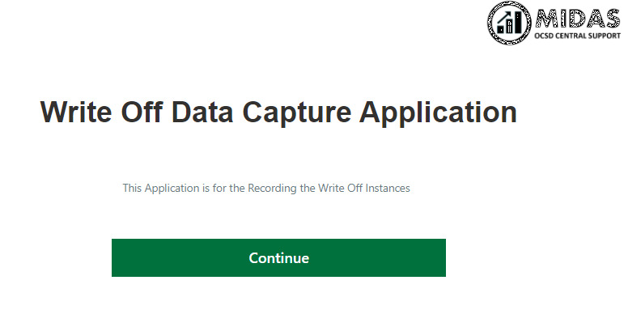
Figure 34 – Landing Screen
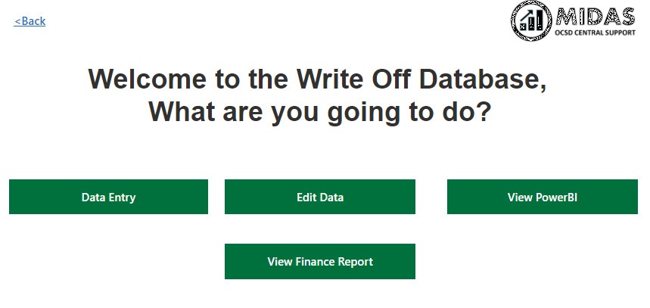

Figure 35 – Homepage

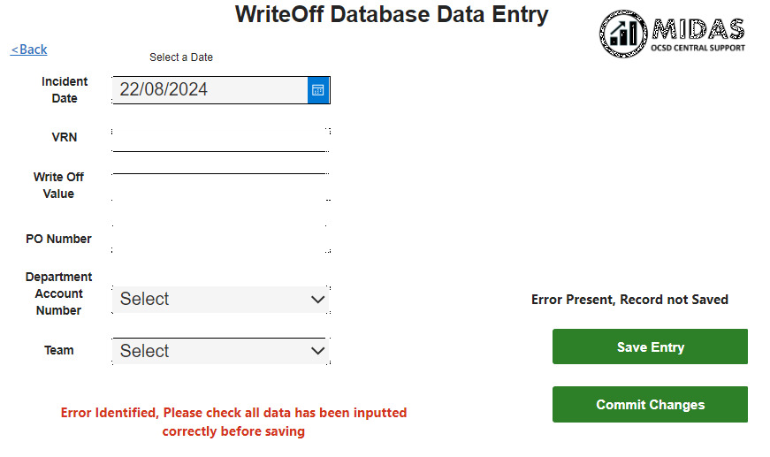

Figure 36 – Data Entry

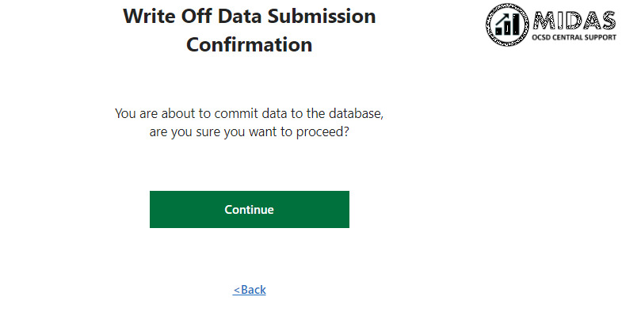

Figure 37 – Data Submission Confirmation



Figure 38 – Complete Confirmation

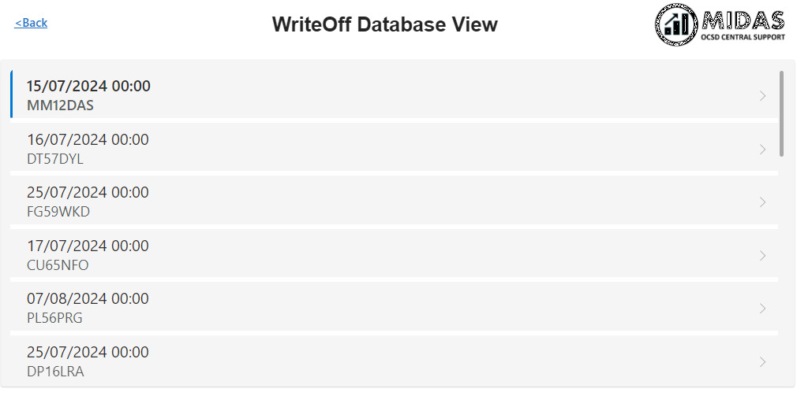

Figure 39 – Database View

Figure 40 – Database Edit

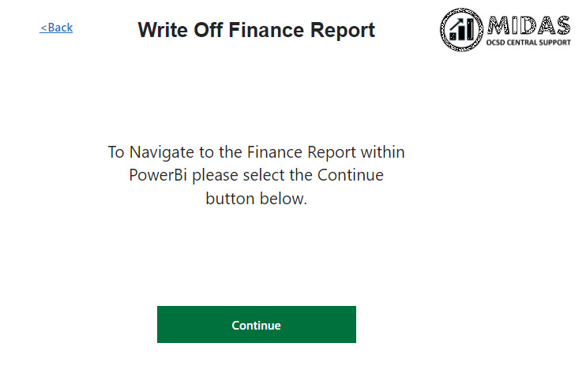

Figure 41 – Finance Reporting View

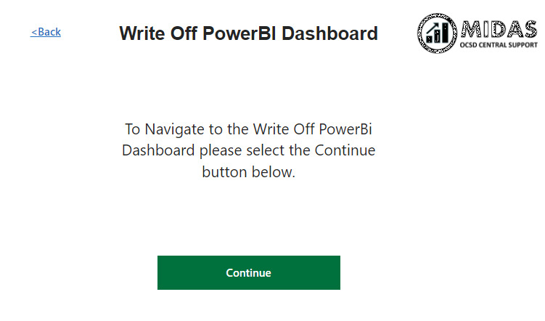

Figure 42 – PowerBI Redirect

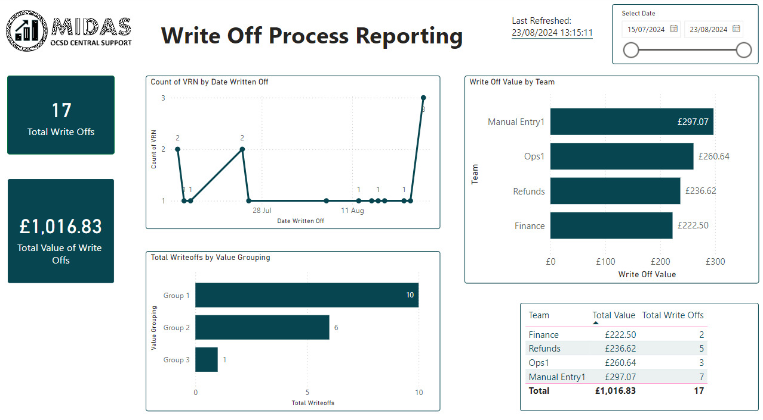

Figure 43 – Final PowerBI Dashboard

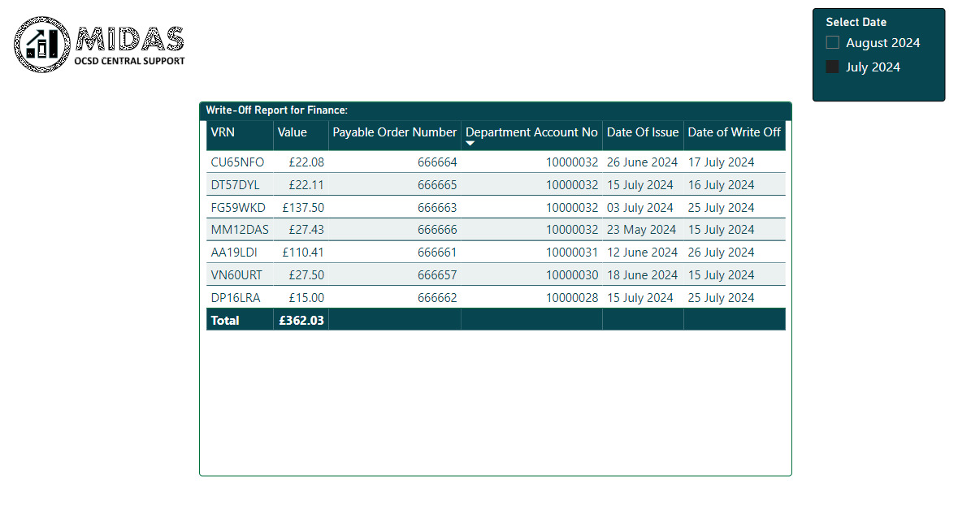

Figure 44 – Final Finance Report

10. Appendix B – Requirements

10.1 Non Functional Requirements
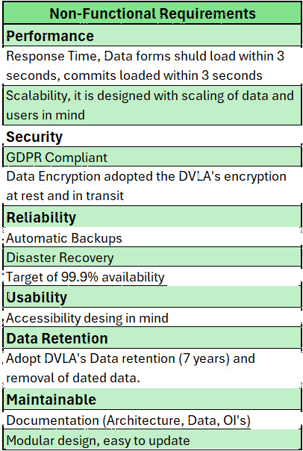

10.2 Functional Requirements
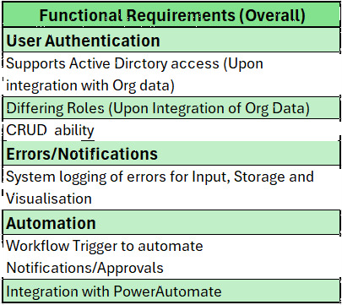
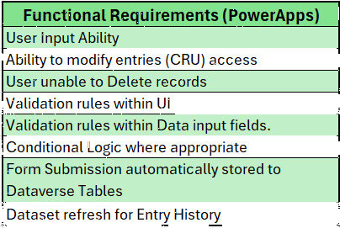
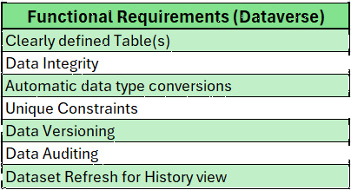
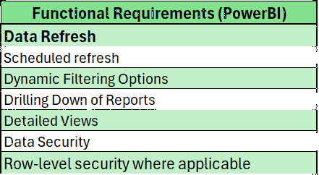

10.3 Reporting Requirements PowerBI
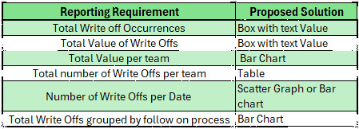

11. Appendix C – SUS + Questionnaire

11.1 System Usability Scale
Link (Accessible to DVLA staff ONLY) - https://forms.office.com/Pages/ResponsePage.aspx?id=LQ3SmSOJ2EW5rVA4yXWC4_JdIQHV5b1HmX7BglFfWK1UQjlCRjcwWVpQR1JPSkpPNEU1REUzQlJXUC4u
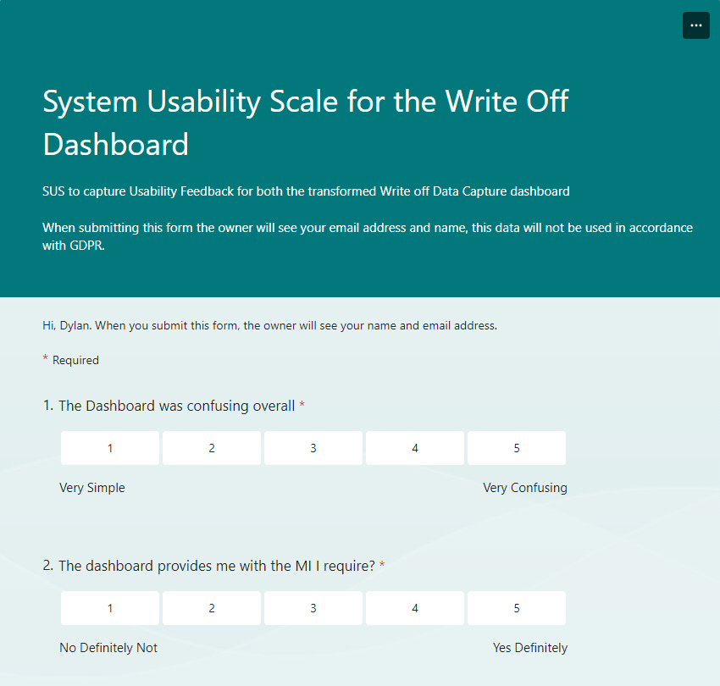
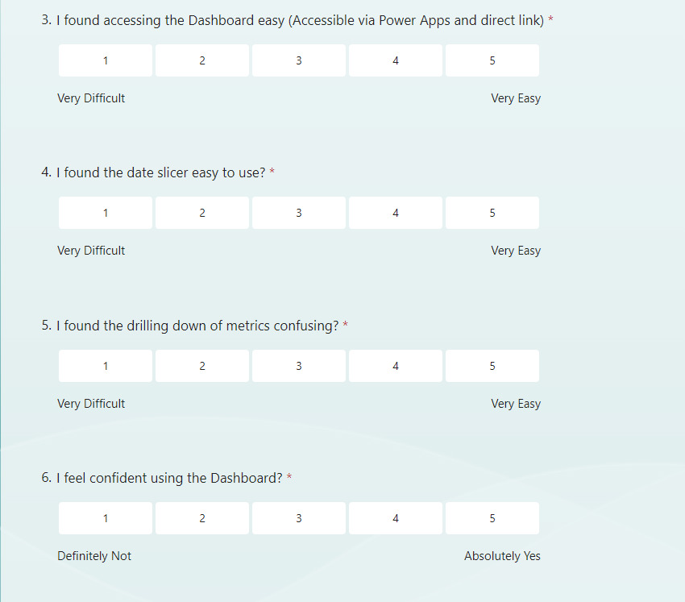
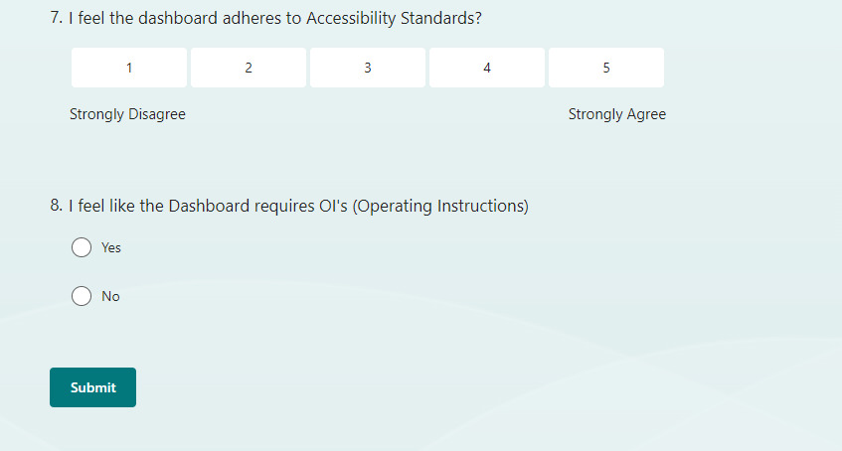

11.2 System Usability Scale Results

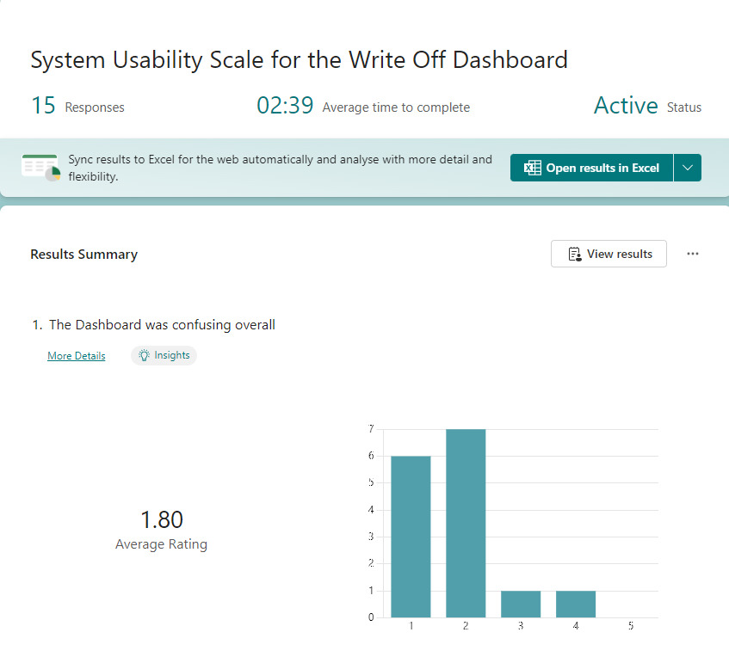

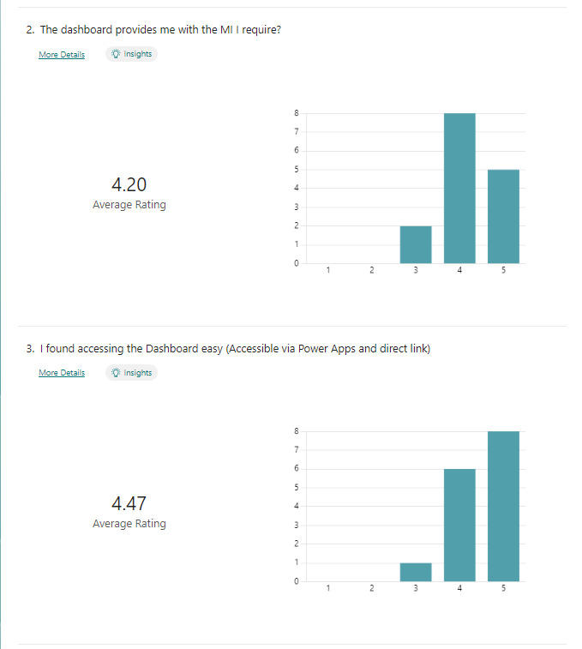
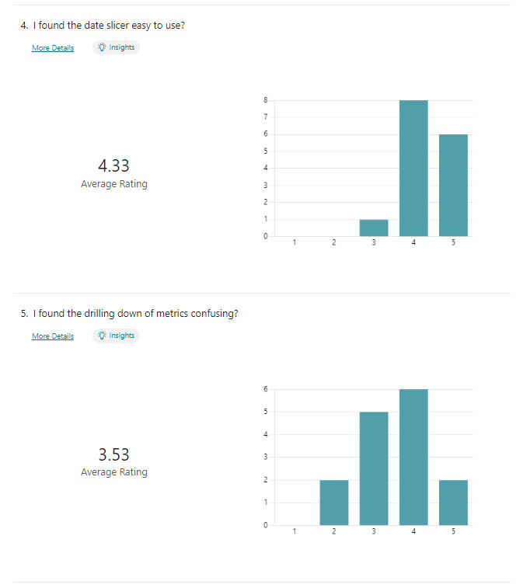
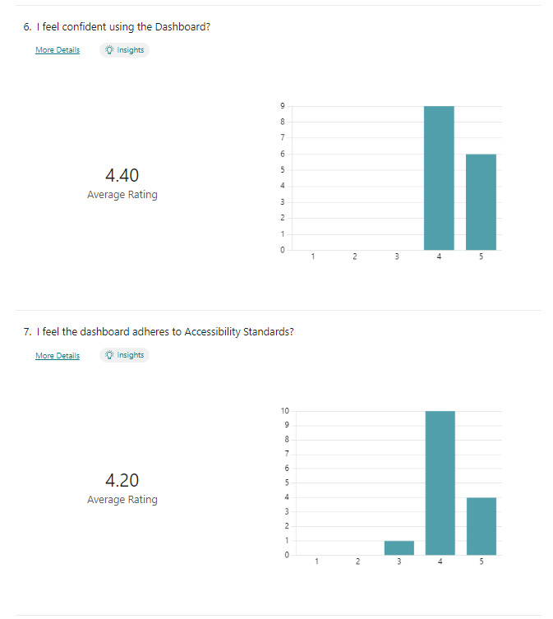
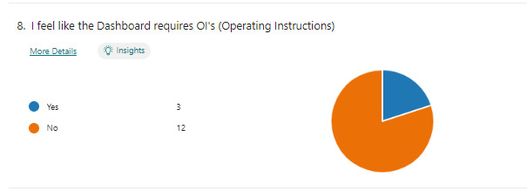

11.3 Data Input Survey
Link (Accessible to DVLA staff ONLY) - https://forms.office.com/Pages/ResponsePage.aspx?id=LQ3SmSOJ2EW5rVA4yXWC4_JdIQHV5b1HmX7BglFfWK1UQUZHSDBLSFlKQ0E2NlBWQU5IWEtYVUY0Vi4u
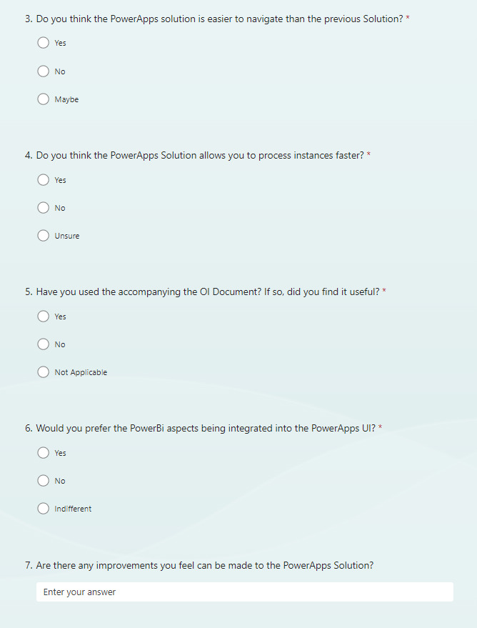

11.4 Data Input Survey Results


