

Programme Name: Master of Business Administration

Name and Code of the Module: International Marketing Principles & Practices LCMB7026

Title: Report- Starbucks

Lecturer’s Name: Tushara Balendran

Student Name: Harshil Mukeshbhai Korat
Student ID: 2430624

Term 2
Submission Date: 19 DECEMBER, 2025
Table of Contents
1. Introduction 4
2. Brand and Country Overview of Starbucks 4
3. Comparison of the socio-cultural context of the US and China (PESTEL) 5
3.1. PESTEL framework 5
3.1.1 Cultural factors based on Hofstede’s six dimensions:- 7
3.1.2 Advantage and disadvantages of Hofstede Model 9
3.1.3 Similarity and Differences of Hofstede Model 9
3.2 Comparison of similarities and differences of PESTEL:- 11
4. Comparison of Brand’s STP strategies in the US and China 12
4.1. Segmentation:- 12
4.2. Targeting:- 13
4.3. Positioning 14
4.4. Similarities and differences:- 15
5. Comparison of Marketing Mix Strategies in the US and China 16
5.1. Marketing mix comparison:- 16
5.2. Similarities/ differences:- 24
6. Evaluation of the performance of marketing strategies 25
6.1. US performance 25
6.2. China’s performance 26
6.3. Similarity and Dissimilarity 27
7. Evaluation of marketing ethics practice 28
7.1. Ethical issues in adaptation, pricing, advertising and treatment of local employees 28
7.2. Overall ethical judgement 30
8. Recommendation & Conclusion 31
8.1. Recommendations 31
8.2. Conclusion:- 32
Reference:- 33
Appendices:- 39
Appendix 1: Hofstede’s cultural dimensions:- 39
Appendix 2: Stores of both countries 40

1. Introduction:-
Marketing and promotional activities are among the most crucial parts of business organizations’ operations because effective marketing management is necessary to build a strong brand. Marketing strategy ensures taking right and appropriately influential tactics to create positive experiences and perceived impressions in consumers. This particular report analyses the marketing strategies of the US-based coffee and beverage giant, i.e. Starbucks in US and China. In spite of operating successfully in both the markets with thousands of stores and in e-commerce fields, Starbucks had faced the issue of declined sales and performance along with decreased market share, mainly in China. Through different macro-environmental forces, Starbucks applies specific STP and marketing mix strategies in the US and China. This report defines a critical analysis of its marketing strategy for both markets by evaluating success strategy and recommending actionable steps to progress further with its international marketing strategies in US and China.
The reason behind selecting Starbucks since it represents an influential global brand and analyses how MNCs can negotiate in different markets. However, the company’s strong presence in US and China is a valuable case to understand market strategies in different cultural, social and economic settings. The US indicates a stable, mature and digitally developed coffee culture whereas China represents a competitive market where Starbucks is pressured by its local competitors. Thus, these variations offer a perfect basis of analysing adaptation, consumer behaviour and strategic decision-making within the international business environments.

2. Brand and Country Overview of Starbucks:-
Starbucks is an eminent US-based coffeehouse and roastery company operating in multinational level, which began as a single store in Seattle in 1971, selling whole bean coffee, tea and spices. It shows that Starbucks followed a traditional internationalisation pathway, and not a born-global model. Starbuck’s core mission is to be the premier purveyor of the finest coffee in the world by inspiring and nurturing human spirit. However, its global growth increased only after 1980s, which is supported by strong brand building and store expansion (Musonera, 2021). At present, the company has over 40,000 operational stores working in 88 markets around the world. Based on the Uppsala model, Starbucks expanded to China using cultural adaptation, gradual learning and increased investment with time. As Uppsala model is not applicable in the US as it is home market of Starbucks.

3. Comparison of the socio-cultural context of the US and China (PESTEL):-

3.1. PESTEL framework:-
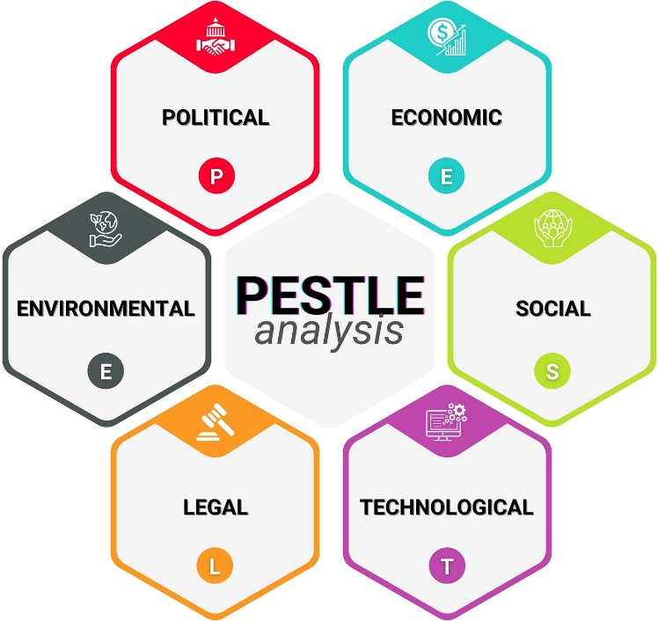
Figure 1: Pestle
(Source: Iqbal, 2025)
Pestle of US and China:-
Political:
US: The political climate in US is predictable and favourable to MNCs. There is stable democratic environment with predictable business regulation.
China: Chinese government is more closely regulated in terms of political environment. The foreign companies are obligated to adhere to laws regarding licensing of stores, under Personal Information Protection Law, 2021. It is politically stable, although China has a more interventionist regulatory environment.
Favourable and Unfavourable
Based on political environment assessment, it is evident that political stability is favourable for Starbucks as it can help the business to make long-term investments and reduce risk in operations. However, more interventionist regulatory environment is unfavourable as it can result to higher operational complexity and costs.
Economic:
US: There is a strong divergence in economic context. In 2023, the US was registered a GDP growth of 2.5%, which underlies increased consumer spending (Torry, 2025).
China: In China, GDP growth was 5.2% in 2023, although the price competition caused a reduction in market share of Starbucks that was 34% in 2019 and about 14% in 2024 (Hall, 2025). Luckin and other domestic rivals reached more than 10,000 locations in 2023, which put more economic pressure on the company.
Favourable and Unfavourable
The growing GDP is favourable for the organisation as it can help in manufacturing premium cars and can attract customers who can afford luxury vehicles. On the other hand, intense price competition is unfavourable as customers can switch to cheaper alternatives, which can pressurise Starbucks to decrease price or face risk of losing market share.
Social:
US: In 2023, 47% of the US consumers pre-ordered beverage digitally while one-third of the consumers prefer online coffee subscription instead of paying in-store. For instance, US-based coffee chain Panera Bread’s over half of $2 billion sales came from e-commerce channels in 2024 (Worldcoffeeportal.com, 2022). The US consumers are showing a cultural shift to increasing sensitivity to high-quality specialty coffee with unique flavours, leading to rising demand for premium and artisanal coffee products. Figure 1 depicts steady increase of ready-to-drink (RTD) based nitro and cold brew coffee market in the US with $47.8 billion market size in 2024 and projected 9.5% CAGR during 2025-2030 (Grand View Research, 2025).
China: Companies like Starbucks faces a strong and deep-rooted tea culture in China while coffee culture was almost non-existent until 1999 when it opened its first store in China. Therefore, the beverage companies align to this social factor by spinning out new flavours of tea and coffee every week, at lower prices, creating ferocious competition. This type of strategic steps adopted by Starbuck’s Chinese competitors caused 14% plunge in its store sales in the country.
Favourable and Unfavourable
Cultural shift toward high-quality and premium products is favourable for the company as it can support to gain a strong market for premium cars as customers would pay more for high status and superior experience. However, slower cultural adaptation can be unfavourable for Starbucks as it can create challenge for the organisation to build brand affinity.

3.1.1 Cultural factors based on Hofstede’s six dimensions:-
Hofstede' scores highlight cultural differences between US and China that determine how Starbucks should design its service and communication. From the figure below, the US scores 40 in power distance that offers a preference of equality and informal relation whereas the score of 80 in China means acceptance of hierarchy and role differences (Culture Factor Group, 2023). In Starbucks, it implies that conversational service is more relaxed and suited to US culture, but an organised and respectful link is expected in China. When US style informality is replicated directly in China, it would work against perceived professionalism, but high levels of hierarchy in the US would be unfriendly. The contrast is even more acute in individualism, as US has a score of 60 while China has a score of 43, which intends that US is highly collectivistic (Culture Factor Group, 2023). This offers Starbucks a cultural benefit in US, since individual customisation, drink identity and personal loyalty cards resonate with consumer values. In China, group norms and social experiences play a superior role in influencing the purchase decisions. This collectivist trend is applicable to large stores of Starbucks since they serve as a social meeting place, but pure customisation has lesser persuasive power.
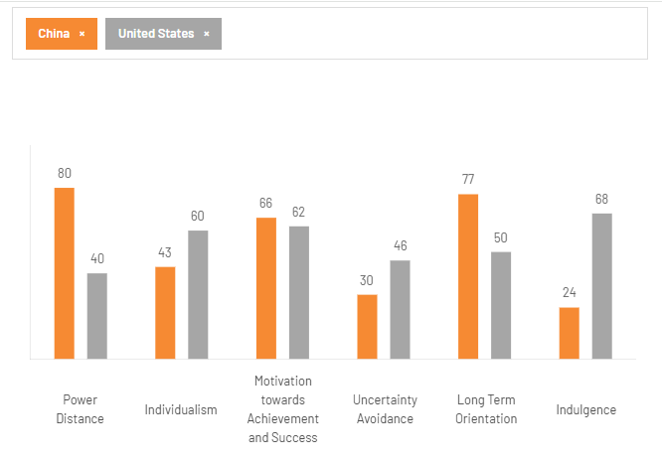
Figure 2: Hofstede’s Cultural factors of US and China
(Source: Culture Factor Group, 2023)
On masculinity, the score is relatively same as US scored 62 and China scored 66. This implies that success and achievement do count in both societies. Starbucks will be able to establish itself as an aspirational and high-end brand in every market. While in China, competitive orientation integrates with price sensitivity and existence of motivated domestic competitors that makes masculinity a source of pressure than opportunity. The uncertainty avoidance scores are lower in 2 nations, where China scores 30 and US with 46 (Culture Factor Group, 2023). This implies that Chinese customers are relatively less sensitive when it comes to playful flavours and new store format. This is likely to help Starbucks to introduce limited edition or seasonal beverages in China, whereas US customers would respond well when innovations do not disrupt the core favourites.
Moreover, the strategic implications are found more on long-term orientation and indulgence. The long-term orientation of China is 77 in contrast to US with 50, which offers greater emphasis on continuity, relations and future rewards (Culture Factor Group, 2023).
(refer to appendix 1)

3.1.2 Advantage and disadvantages of Hofstede Model
In terms of advantages, Starbucks can leverage on cultural aspects by focusing on long-term community work and permanent localization in Chinese cities, rather than short-term campaigns. On the contrary, the US market responds strongly to value and newness, which pushes Starbucks to update menus and promotional offers with a short interval. This helps to explain popularity of rich and sweet drinks in US but makes such products lesser aligned to daily preferences of China, where social norms facilitate restrained consumption. In terms of disadvantages, indulgence is a source of growth in domestic environment but a source of risk in China as long as drinks are perceived to be sugary, unhealthy or excessive. One key disadvantage of Starbucks in the US market is that not all customers may switch to Starbucks coffee, as there are many optional coffee chains in key cities of the nation, in which customers may opt for due to taste.

3.1.3 Similarity and Differences of Hofstede Model
It is found that both countries are digitally developed and have high adoption of smartphones and online payment systems. Further, both show rising interest towards premium beverages but motivation behind this interest deviates. In US, the high-quality coffee is suitable to deep-rooted coffee culture and it is positioned as a personal indulgence in an individualistic and hedonistic lifestyle. In China, the aspect of status display and group identity of premium drinks is linked to an objective to participate in Western-like urban lifestyle.
However, the differences define why the strategies of Starbucks cannot be easily transferred to other countries. In US, the low power distance combined with high individualism and high indulgence supports the strategy towards customisation, personal identity and rich flavour profiles (Culture Factor Group, 2023). However, this offers Starbucks to justify higher prices and margins but it also increases exposure to health debates and shifting attitudes towards sugar and calories. In China, the emphasis is different due to collectivism, high power distance, and long-term orientation. The stores should function as social spaces that promise quality and stability while marketing should show respect towards the local norms.
Technological:
US: The US market has a favourable technological environment. The smartphone penetration is 81.6% in the US. The society in the US shows rapid shift towards contactless and app-based payment technology for coffee ordering and shopping as customers are increasingly preferring pre-ordering and shorted waiting time without compromising on quality.
China: Chinese market has a favourable technological environment. The smartphone penetration is 64.8% in China, although Chinese users are more reliant on WeChat and Alipay ecosystems, as digital integration is necessary (Gill, 2025). China being a global leader in advanced technology, the Chinese consumers increasingly rely on digital apps and social media-based shopping and thus rapidly shifting digital culture has important social value and meanings for them (Liu and Bunnag, 2025). Therefore, beverage brands like Starbucks are obliged highly to integrate with local tech partners.
Favourable and Unfavourable
High smartphone penetration is favourable for Starbucks as it will help the company to leverage its mobile app, which can conveniently allow customers to place orders, make payments and earn loyalty points. However, reliance on third-party ecosystems can be unfavourable to Starbucks as it can reduce the control of the company over customer experience and customer data.
Environmental:
US: The coffee culture in the US firmly encompasses critical sustainability considerations as ethical sourcing, reusable packaging and water conservation. Also, in the US, the recycling packaging is in higher demand.
China: There is an increase in environmental expectations. The 2025 plastic-reduction regulations in China limit single-use plastics. Recycling and material restrictions are enforced, which are required to be followed by companies like Starbucks.
Favourable and Unfavourable
Strong sustainability focus is favourable for Starbucks as it can help the company to build a positive brand image amongst customers and also attract eco-friendly conscious customers. However, complying to strict environmental regulations can be unfavourable to certain extent as it will need redesigning supply chains and packaging for meeting recycling standards.
Legal:
US: On legal grounds, Starbucks focuses to adhere to US labour regulations. Predictable labour, food-safety and privacy laws govern operations. Also, compliance is stable that allow companies to function within legal boundaries.
China: It is important for companies to adhere to emerging standards of labour law in China, which affects store operations and data processing in China. In addition, personal information protection law, 2021 requires strict data handling in order to protect customer information and ensure security.
Favourable and Unfavourable
Predictable and stable legal environment is favourable for Starbucks as it can support in reducing compliance risks and legal uncertainty. However, compliance with stringent data handling can be challenge for the company as it increases operational complexity and costs.

3.2 Comparison of similarities and differences of PESTEL:-
Both the US and China are digitalised, with smartphone adoption that depends on heavy reliance on mobile payments, which offers Starbucks with advantage of digital ordering systems. The urban lifestyles of two countries also play a part in encouraging frequent visits to cafes, while demand in high quality drinks is rising in both markets. These similarities enable emphasis that Starbucks has made in case of convenience, digital loyalty programmes and contemporary café experience.
The differences, nevertheless, are impactful. For instance, the US has a well-developed coffee culture with consumers making coffee a regular habit. In China, tea is still central while coffee consumption is still in developing phase with influence of group identity and aspiring lifestyle values. The US market is consumer-led whereby China’s social patterns favour collective experiences and value-driven choices.

4. Comparison of Brand’s STP strategies in the US and China:-

4.1. Segmentation:-
Segmentation in US:-
Demographic
Starbucks generally target consumers of all ages (18-60) with diverse income level and life stages and targets those seeking healthy and sustainable beverages. For instance, its demographic segmentation involves Gen Z and Millennials to larger extent constituting over half of the US consumers (Lichtenberg, 2025).
Behavioural
On the behavioural level, repeat users, who utilise mobile app extensively, loyalty programme and seasonal offerings are a valuable segment.
Psychographic
Starbucks is heavily focusing on millennial moms also for their heavy mobile well-informed nature in daily lifestyle (Retail Dive, 2025).
Geographic
It is focused on key cities in US like New York, Washington DC, Florida, Las Vegas, and more where Coffee culture is premium.
Segmentation in China :-
Demographic
In China also, Starbucks targets educated, high-income, coffee enthusiasts and those seeking new flavours or trying to have a new unique experience with beverages. Demographically, it targets younger, educated and higher-income urban customers (Liu, 2023).
Behavioural
The behavioural segmentation reflects high-mobile use and preference for digitally enabled service routines. Starbucks also launched ready-to-drink juice in redesigned bottle to focus on emotional resonance of the Gen Z consumers in China (Packaging Europe, 2025).
Psychographic
Psychographically, its essence is associated with aspirational consumption and social experiences.
Geographic
The geographical segmentation has grown at a fast pace starting at Tier 1 cities like Shanghai and Beijing to emerging markets of China (Al Jazeera, 2025).

4.2. Targeting:-
In the US, Starbucks applied the tactic of targeting the consumers with middle to upper income level who appreciate high-quality coffee and are willing to pay high for higher standards, while keeping the health-conscious consumers and those seeking nutritional benefits at the second target level. For example, it had introduced protein cold foam with 15 gm protein, coconut-water based beverage, vegan spicy items with eliminated sugar in the US market to target health-conscious people (About Starbucks, 2025). In addition, lifestyle targeting was a particularly vital strategy involving targeting the ‘hard-core loyalists’ and those using stores regularly for socializing or relaxing.
On the contrary, in Chinese market, it specifically targets those feel attracted to adjusted store types and localization-based models addressing needs of Chinese consumers from different regions (Xia, 2024). This is why Starbucks strategically remained more focused on constant innovation and localization of store, service experience and products for appealing to Chinese consumers. Thus, the company was able in creating a unique cultural fit with the regional markets in China. Apart from this, Starbucks took particular care in targeting digital perceptive consumers in China by digitally engaging them (Liu and Bunnag, 2025).
In US, Starbucks uses a differentiated targeting strategy that aims at several consumer groups like health-conscious buyers, mobile-app users and premium coffee drinkers. The diversity of US lifestyles and strong individual preferences make differentiated targeting effective (Zhang, 2025). In China, Starbucks uses a concentrated targeting strategy by focusing on narrow and influential segment of urban, aspirational and digitally experienced middle-class consumers. Thus, focusing on such a strategy helps Starbucks to solidify a high-end and lifestyle-based identity, where price-conscious local rivals control the mass market. Overall, it is believed that they can focus on differentiated strategy that can be beneficial for the company over long-term.

4.3. Positioning:-
Starbucks markets itself as a quality and premium coffee brand in 2 countries, which offers a third-place experience in terms of customisation, community, and convenience. Below figures represent positioning maps of Starbucks in respect to the competitors of China and US respectively, as Starbucks in US leads well with their high price and high-quality segment, in contrast to Dunkin and Pret’s Coffee.
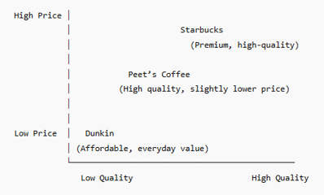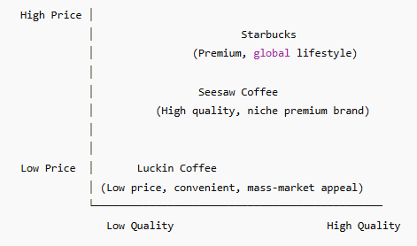
Figure 3: Positioning Map of Starbucks in US and Chinese market
(Source: Self-created)
In case of positioning, nearly similar strategies are applied by Starbucks in US and China. In both cases, a strategic combination of functional positioning (enhanced quality, range) and symbolic positioning (higher focus on values and aspirations of customers) is applied. For instance, in US and North American market, the brand is positioned as premium quality and high-standard coffee made from Arabic beans with wide variety of customizable drinks to suit different tastes (Gao et al., 2021). In addition, a symbolic positioning of experience is used by upholding the brand as a ‘third place’ between work and home to offer a relaxing and comfortable atmosphere for positive consumer experience.
In similar way, the ‘third place’ and ‘premium brand’ concept is also applied in China as the key positioning strategy in China. For instance, apart from introducing a tea-based drink brand and content to the desired target consumer base along with several cultural adaptations, Starbucks also positioned itself as the third place to capture 70% of the market share in China coffee market (Liu et al. 2021). Similarly, in both markets, Starbucks was positioned as a socially responsible and sustainable coffee brand. A noteworthy difference in this case is its localised experience-based positioning in China, which was typical to this particular market and not applied to the US market.

4.4. Similarities and differences of STP:-
Similarities:-
In both countries, Starbucks uses a premium positioning and uses a multi-dimensional segmentation that is focused on digitally active consumers. Segmentation and targeting in the US is varied, which implies an individualistic market with customisation and seasonal flavours. In contrast, the Chinese approach is more focused on middle-class customers, with stronger localisation, like tea-based drinks and culturally themed packaging.

Differences:-
The US strategy is however broad and differentiated, which links with mature market while Chinese strategy is defined by stiff price competition. The positioning in US is more focused on individual lifestyle and customisation, while it conveys modernity, social experience and international status in China. Besides, US market suites well due to the natural alignment of customer preferences and personalised positioning of Starbucks.

5. Comparison of Marketing Mix Strategies in the US and China:-

5.1. Marketing mix comparison:-
According to Juhaidi (2024), the marketing mix is considered as a set of marketing tool/ tactics for a company, which is used to promote product/ service in order to attain the business objectives.
Product :-
Starbucks in the US targets a broad variety of products, which include functional drinks, cold beverages and bespoke drinks. The US labelling system is beneficial, as it promotes nutritional transparency, which is consistent with health consumer behaviour towards standardization. In US, Starbucks uses a premium lifestyle branding strategy based on seasonal storytelling, customisation, and functional beverages. Personal identity and lifestyle-led consumption is also improved by seasonal packaging and limited-edition designs. For example, new innovative items introduced include protein lattes, cold foam drinks and Starbucks Hello Kitty Collection.
Product Width:
It is to be further pointed out that product mix width of Starbucks in the US include coffee beverages, bakery items, teas and refreshers, seasonal items, ready-to-drink products, seasonal items and merchandise.
Product Depth:
Furthermore, product line depth comprises coffee beverages with more 30 variations, bakery around 10-15 items, more than 15 teas options and more than 20+ packaged goods.
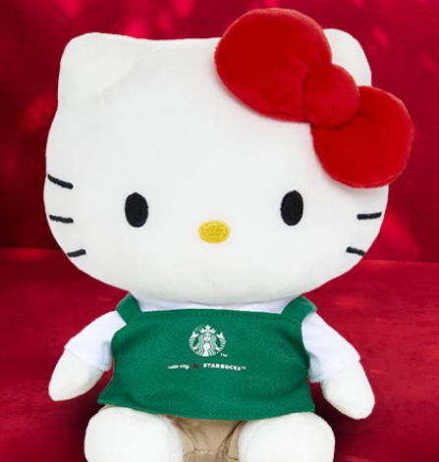
Figure 4: Starbucks Hello Kitty products in the US
(Source: Starbucks.com, 2025)
Starbucks in China is more standardised in labelling and packaging, which adheres to national food-safety regulations and consumers requirements. In China, Starbucks applies a cultural localisation branding strategy, which offers jasmine lattes, red-bean drinks and tea-coffee blends. The product strategy is based on localisation as tea-based beverages and designs, like Lunar New Year cups. Such balance between local flavour modification and standardisation of labels helps in brand confidence and adherence to regulated market. In addition, exiting range of Oleato™ beverages (Starbucks coffee innovation) is its latest product in Chinese market.

Product Width:
It can be pointed out that product mix width of Starbucks in China comprises coffee beverages, localised food items, digital products, packaged goods, teas and traditional Chinese infusions, digital products through Starbucks China app and merchandise.
Product Depth:
Apart from product width, product line depth covers teas having more than 10 options, coffee beverages include above 20 options with localised flavours, 8-12 tailored food items and merchandise including seasonal collections.
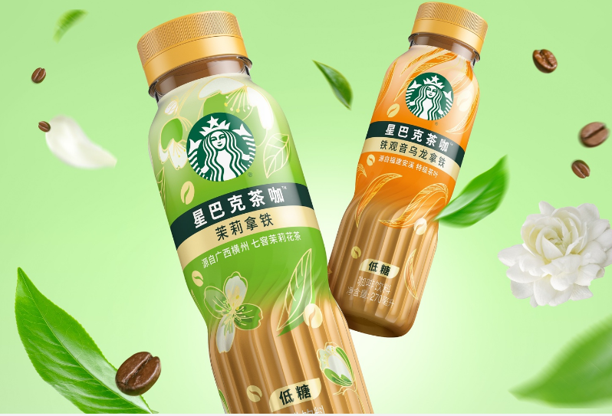
Figure 5: Starbucks ready-to-drink (RTD) coffee line-up for Chinese market
(Source: Worldbranddesign.com, 2025)
Price:-
Premium pricing is the key strategy used that reflects its lifestyle brand positioning and superior consumer experience. This specific pricing is often influenced by its value-based pricing and psychological pricing strategy also. In addition, loyalty programs, seasonal or limited-time offering and rewarding regular customers also constitute its pricing tactics in the US. It is found that for a standard tall latte, customers are charged around $3-$5 and for Frappuccinos, customers in the US are required to pay $4-$7. In China also, premium-pricing strategy is adapted but with higher competition level, prices are lowered to revive sales. For instance, in 2025, price of products like 20 Frappuccinos, iced shaken teas, and tea latte beverages were reduced by 2-6 yuan ($0.28 to $0.84) to attract more customers.
Place:-
Strategic physical locations in the US include high-visibility and high-traffic areas. For example, 100 new community stores were initiated in 2025 in high profile locations as Milwaukee, White Centre, WA, Queens, NY and Ferguson along with planning more stores in n Los Angeles, CA; Anacostia, D.C.; and Prince George’s County, MD. Apart from this, online ordering is also offered through mobile apps. Considering the direct channels of Starbucks in the US, the company follows company-operated stores and digital platforms like Starbucks app, delivery through DoorDash and Uber Eats. On the other hand, indirect channels comprise licensed stores, hotel partnerships and consumer packaged goods comprises K-Cups, Starbucks VIA.
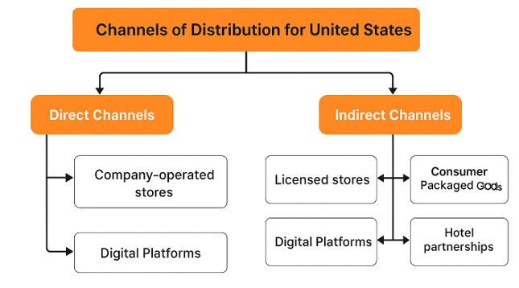
Figure 6: Channels of Distribution, Starbucks, US
(Source: Author’s Creation)
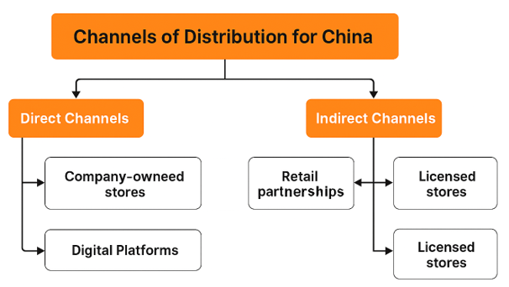
Figure 7: Channels of Distribution, Starbucks, China
(Source: Author’s Creation)

Similar to the US market, high-traffic areas, large cities, offices, and industrial locations are the main places of Starbucks stores in China. For instance, Starbucks set new records by opening 790 net new stores and entering 166 new county-level markets on the Chinese mainland by September 2024. Such important locations include places like Riverside 66 in Tianjin, Jiangsu (Coffee Innovation Park), Tier 1cities (Beijing, Shanghai) and other Tier 3 and 4 cities. The direct channels of Starbucks in China emphasises on company-owned stores and delivery platforms such as Ele.me and Meituan whereas indirect channels include licensed stores and retail partnerships.
Market Entry Method:-
It seems that licensing model of US would be effective in terms of market entry, as it will be beneficial for the company. It is due to high demand for the brand products. In addition, the licensing market entry method enabled the company to functions in different places such as airports, hospitals, universities and supermarkets in the US, as a key advantage. In addition, it risks increases brand visibility and lower capital investment due to regional differences (Singh, 2025). This method reduces control over consumer experiences.
Promotion:-
In US, the primary objective is to increase personal involvement, increase loyalty utilisation and favour a repeat procurement. Starbucks attains it by using personalised mobile rewards, app-based offers, seasonal campaigns and effective storytelling on Instagram, TikTok and YouTube. Moreover, Starbucks Rewards is the company’s highly successful loyalty program integrated with Starbucks app that enables its personalized engagement with audiences. The promotional focus is highly individualised and experience-led. Its IMC approach integrates Starbucks App, personalised email offers, Instagram and TikTok storytelling, seasonal in-store displays and national advertising.
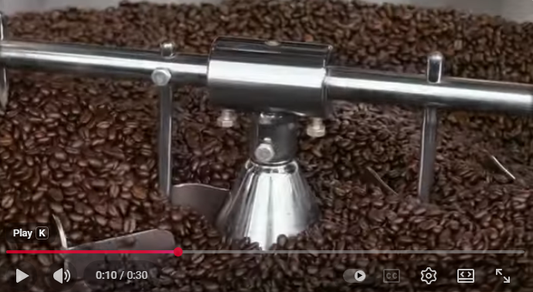
Figure 8: Starbucks Coffee Commercial, 2024-25
(Source: Youtube.com. 2024)
Similar to the US market, digital, social media, app-based marketing and loyalty programs are the key promotional strategies used in Chinese market towards its adaptation. Starbucks uses an IMC strategy focused on WeChat and Alipay Mini-Programs, personalised digital coupons, in-store events, festival campaigns, and collaborations with Chinese influencers. In addition, Starbucks adopted some unique promotional tactics to revive its image in China. For example, it opened Starbucks Reserve Stores in Tianjin to preserve heritage sites. The promotion objective in China is to create social involvement, increase brand relevancy in-group contexts and contribute cultural-led consumption.
People:-
In US, the key people involve well trained, knowledgeable and friendly baristas offering excellent customer service and creating personalize environment for guests. Further, there is no specific breakdown of Starbucks employees in the US. However, it is assumed that there would be more than 200,000 workers in the US as it holds high number of Starbucks stores. On the other hand, it is identified that Starbucks, US use different training programs such as Coffee Master Certification/Programs, collaborate networks and quarterly check-ins to develop knowledge and leadership quality. In addition, the company provides motivation by using different strategies like flexible scheduling and benefits, bean stock program and recognition culture.
In China, trained and experienced staffs with the opportunity of career development are employed by Starbucks to foster standardised experience. Apart from that, it is projected that there can be increase in employee number to 95000+ (Starbucks China, 2025). It is to be further indicated that Starbucks in China uses various training programs for mentoring and training its employees such as localised learning and development, youth career development initiatives, Starbucks China Coffee Academy and digital learning platforms. For motivating employees, the organisation emphasises on giving respect and promotes belongingness to provide localised incentives and rapid career pathways.
Process:-
Starbucks in US follows the process of using advanced technology as AI and data-analytics driven information to cater products and services to personal needs. Thus, AI and data leadership is a key to standardized process of maintaining quality and standard. Based on such data the process of ordering, barista training customization, supply chain and quality control is managed. On the other hand, for resolving complaints or issues, customers can file complaints by accessing Starbucks contact page and through using Starbucks app and live chat (Starbucks, 2025). In addition, in-store escalation helps in resolving complaints quickly.
In China, similar processes are emphasized on with particular focus on maintaining a seamless and efficient customer journey through effective technology integration. However, in both the markets, the operations are highly dependent on customer feedbacks and accordingly continuous improvement in service delivery and product offerings. On the other hand, customers in China can use hotline number such as 0571-26883310 to file complaint and use WeChat and Alipay integration (Starbucks China, 2025).
Physical evidence:-
The physical evidence in US includes Starbuck’s website that feature personalised menu recommendation, and seasonal campaigns that match its identity. In US, the key focus is on designing a welcoming coffeehouse with finest handicrafts organised by skilled baristas. For instance, newly introduced Green Apron Service with ceramic cups is aimed at higher relaxing experience in the outlets and condiment bars.
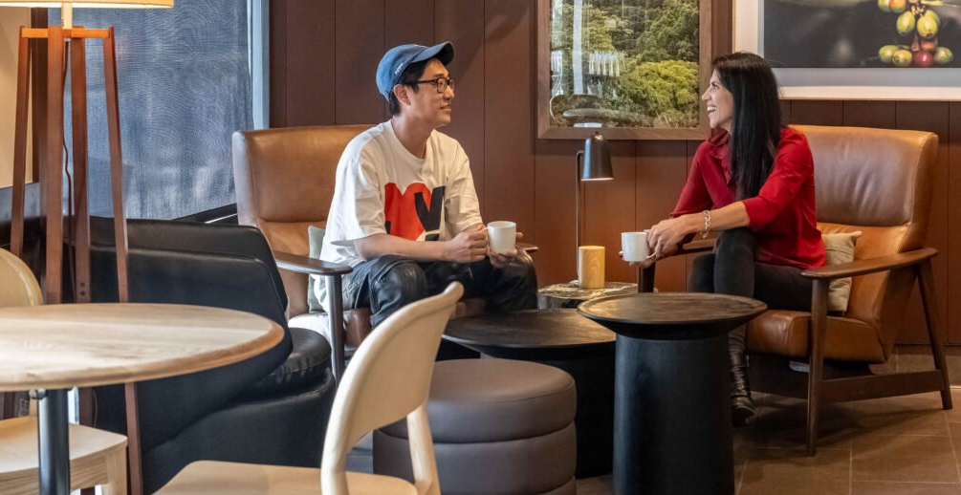
Figure 9: New Era of Design, Green Apron Service in US Starbucks stores
(Source: Starbucks.com, 2025)
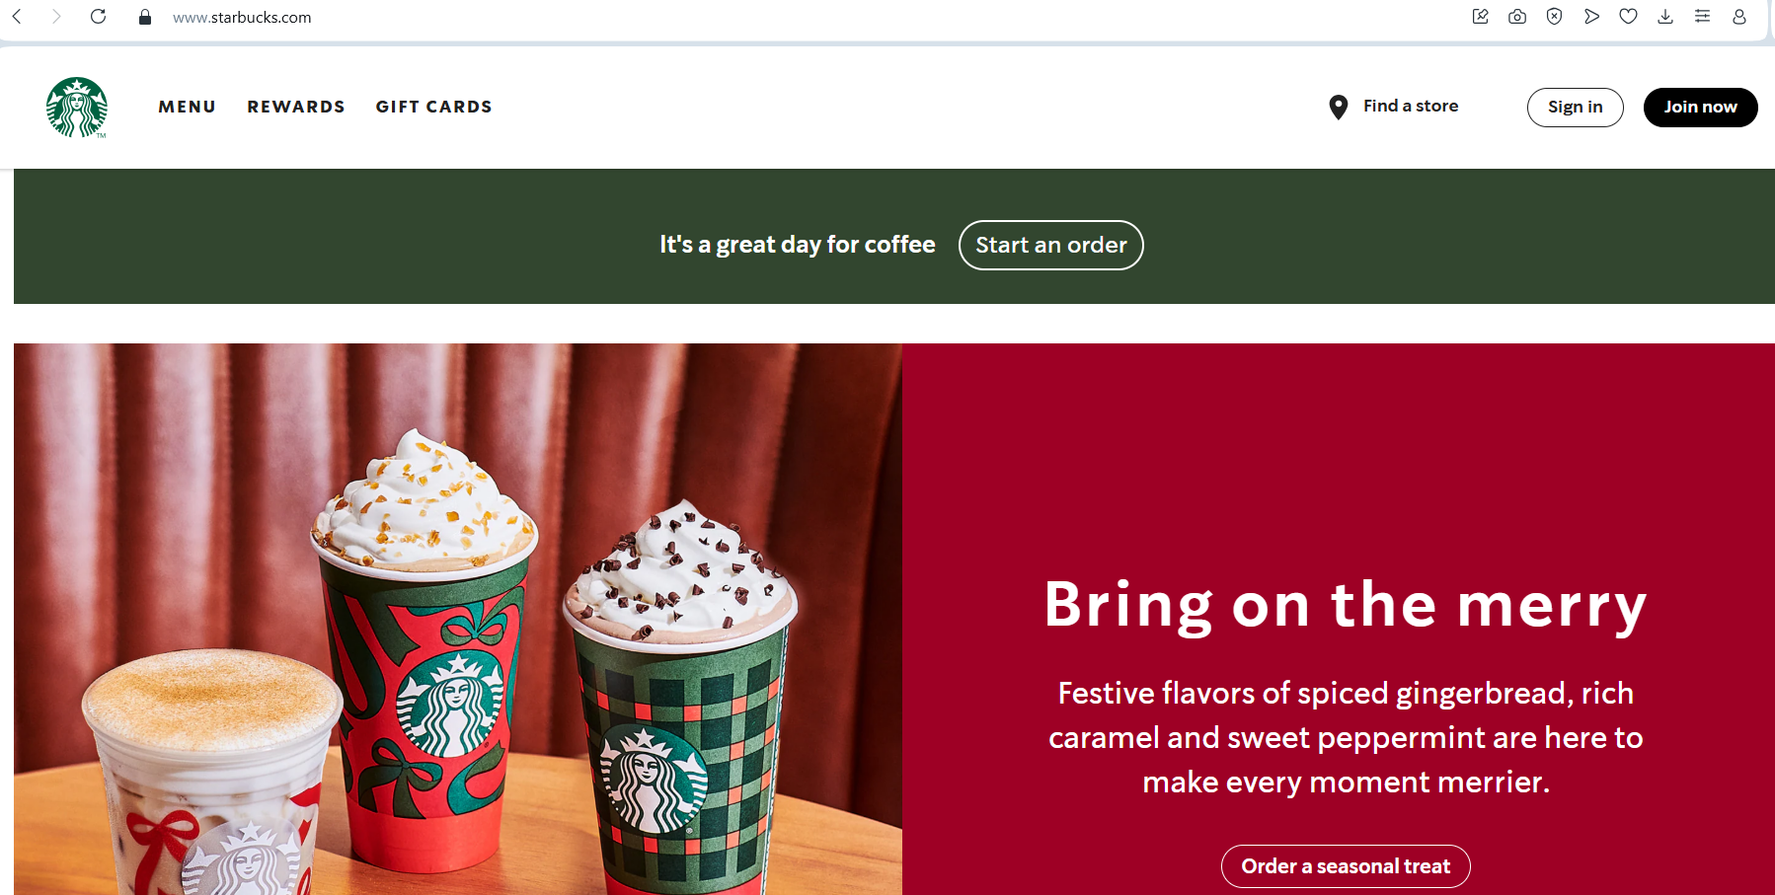
Figure 10: Website of Starbucks, US
(Source: Starbucks, 2025)
In China, designing store with specific, consistent and aesthetic creates a premium and comfortable atmosphere receives importance towards its standardization. Further, the WeChat pages and website highlight the cultural events, community initiatives, and local beverages. The consistency of brand design is maintained with tangible elements as iconic green logo. Both the markets shows that staff uniformly follows recognisable green apron, though China uses seasonal or festival-themed apron variations in order to support localisation.
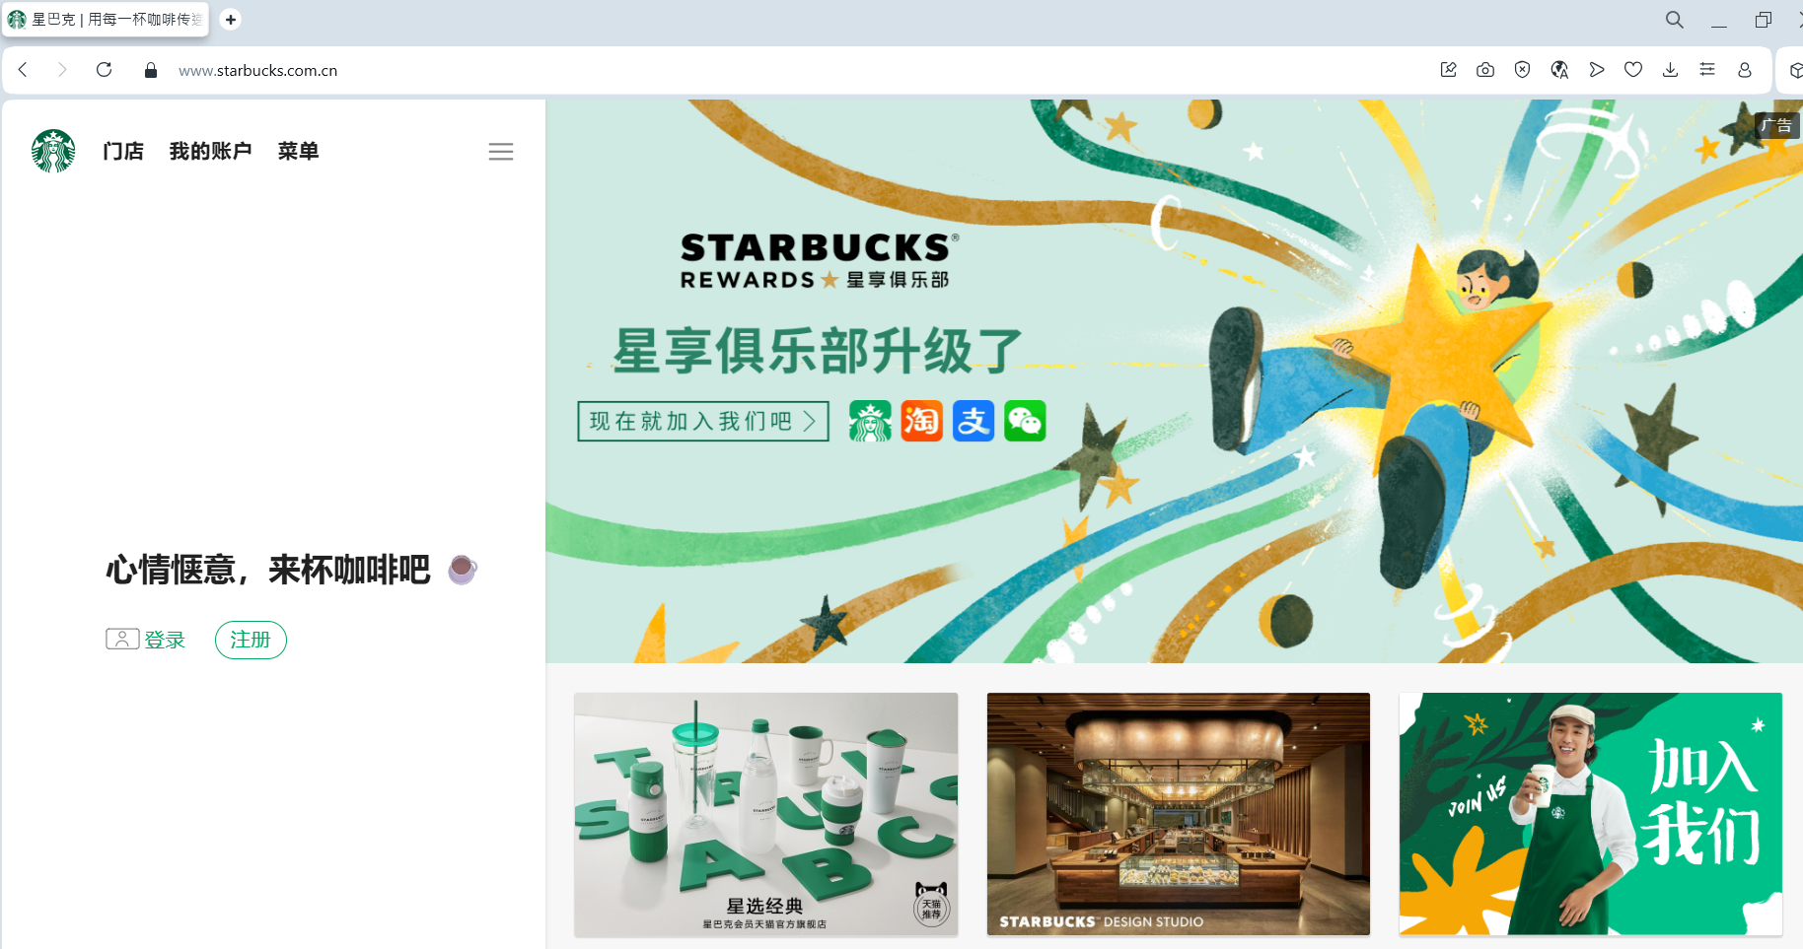
Figure 11: Website of Starbucks, China
(Source: Starbucks China, 2025)
(refer to appendix 2)

5.2. Similarities/ differences:-
Similarities:-
The similarity between both countries lies in general premium positioning of Starbucks and its digital promotion, but the application of every component of the marketing mix is different. In case of product, the US relies on extensive customisation, functional ingredients and seasonal flavours, while China relies on stronger localisation, such as tea-based beverages and local-themed packaging. The same can be reflected in case of pricing, as US can sustain its premium pricing due to stable demand, whereas in China, Starbucks will need to adjust to competition with Luckin and Manner.
Differences:-
The favourable situations within US include strong desire to pay, high acceptance of customised drinks and developed digital culture that supports Starbucks strategy as a premium brand. Nevertheless, the slow level of traffic and increased health-related issues affect negative pressures. In China, favourable conditions are provided by rapid digital inclusion, and strong desire to follow modern lifestyle brands, which positively support fast promotional reach.

6. Evaluation of the performance of marketing strategies:-

6.1. US performance:-
Starbucks in its home market has a modest and pressured revenue growth. The company recorded a revenue of about $37.2 billion in FY’ 25 globally which was a y-o-y increase by 3% (Starbucks Investor Report, 2025). In North America, similar store selling in 2025 was 2% lower due to a 4% reduction in sales but compensated by a 2% rise in average ticket size (Starbucks Investor Report, 2025).
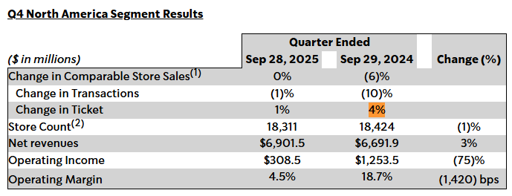
Table 1: Starbucks Q7 Segment result’ 2024 in US
(Source: Starbucks Investor Report, 2025)
Starbucks reported closing of net stores Q4 2025, where it had closed 627 stores globally, of which over 90% were in the US. This reduced the number of stores in the US to 16,864 (Starbucks Investor Report, 2025). On market share, Starbucks remains a key leader in the US in premium coffee segment, although specific US-based share information is not publicly reported but estimates suggest over 30% share in specialty chains. Presently, Starbucks is operating in the US with 17,286 stores (by September 2025) with 18% (3184 stores) of its stores being in California alone. Its US operations are supported by 5 manufacturing, roasting and distribution partners in the market (as Chicago, Seattle, New York City, etc.), while other key network channels and partners are located in China (Shanghai, Beijing, Chengdu), India and Milan. In its North America segment, Starbucks registered 1% year-on-year drop in revenue to reach $7.1 billion during last quarter of 2024 (Tahir, 2025). Currently, Starbucks decided to reduce its weekly production day from 7 to 5 in the US due to weakened demand because of its pricey beverage (Reuters, 2025).
The use of social media in the US is still high, with Starbucks boasting millions of app users, tens of millions of loyalty members, and active Instagram campaigns. Canham-Clyne (2025) acclaimed that the feeling of customer review in US has improved in 2025 when Starbucks implemented its “Back to Starbucks” programme that focused on service, experience and store redesign. Although Starbucks still has a strong brand awareness, the levelling of transactions and closures reflect a challenge of maturity in the US market. However, customers in the US also complain about Starbucks for slow service and inconsistent drink preparation across different stores.

6.2. China’s performance:-
The situation of Starbucks is more complicated in China. By the end of Q4 2025, the company recorded 8,011 stores in China, which accounted 61% of its global portfolio, along with US. Nonetheless, its share in China has declined drastically by 34% in 2019 to about 14% in 2024. Similar increases in store sales of 2% did occur in Starbucks China in the quarter ended September 2025.
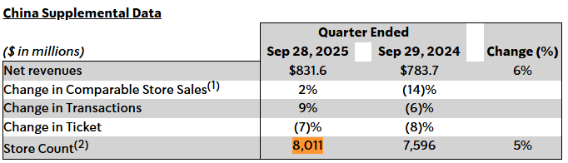
Table 2: Starbucks supplemental data of China
(Source: Starbucks Investor Report, 2025)

This was a result of a 9% increase in transactions but a 7% decrease in average ticket size (Starbucks Investor Report, 2025). In China, Starbucks’ present operations are facing declined market share in the face of lower-priced Chinese rivals in spite of opening its 1.5-billion-yuan ($209 million) Coffee Innovation Park in Kunshan during 2023 with capacity of supplying to its all-Chinese stores with its 80,000-square-meter roasting plant (Wuand Hall, 2025). Starbucks has over 7750 stores in China generating almost $740 million revenue, which made China the second largest market of the company (Cao, Baigorri and Li, 2025).
Starbucks China extensively applies WeChat, Weibo and Alipay mini-programmes on social media, along with scholarly reviews, where the brand relies on social digital lifestyle communication in China (Cao, 2022). According to customer reviews, there is an increasing pressure on local chains like Luckin Coffee and Manner Coffee due to its value pricing and faster service to attract younger population. Moreover, the store growth has also decreased, with Starbucks declaring various models to re-invest and re-organise its operations in China. On the other hand, it is also identified that customers in China praise Starbucks for providing variety of drinks and place to work or relax.

6.3. Similarity and Dissimilarity:-
In comparison to both markets, Starbucks obviously is strong in its domestic market in US but it is operating under expansion boundaries of a mature market in terms of decreased transaction rates, flat store counts, and small growth in revenues. In contrast, the Chinese market had a growth potential but rather offers strategic pressure, ticket size drop and strong local competition. Further, social media and online interaction endure to be a powerful tool in both markets, but the situation is different in US, where it is based on familiarity of the brand. However, in China, it has to compete with local challengers and shifting customer behaviour. The contrast in store growth is dramatic as US is experiencing net store closure and consolidation, while China is experiencing rapid expansion, but revising its speed. In case of Starbucks, success in US is about refining experience, whereas success in China is about value perception, and share in fast-evolving market. This uneven performance indicates that Starbucks’ global market strategy should be more market specific, which may leverage home market strength by innovating heavily and adapting rapidly in China.

7. Evaluation of marketing ethics practice:-

7.1. Ethical issues in adaptation, pricing, advertising and treatment of local employees:-
Österman (2021) stated that the concept of cultural relativism would help to assess marketing ethics of Starbucks in China based on expectations, norms and values of local culture rather than the Western standards. The social structure of China is different, which has strong collectivist habits, better hierarchy, and well-defined expectations in terms of price equity, respectful advertising and consistent employment. Starbucks has adapted to Chinese preferences, which support ethical practice from a cultural relativist view. Besides, Chinese shoppers value brands that pay attention to local taste, like eating and drinking habits aligns to identity and family culture. The sensitivity to these expectations is reflected with tea-like drinks, jasmine-based beverages, pink peach lattes and regional snacks introduced by Starbucks. It also creates special Lunar New Year cups and Mid-Autumn Festival packets, which most customers view as respectful identity. These measures are ethically upright, as it indicates that Starbucks is not trying to force an American coffee culture in a highly tea-centric society. Rather, it understands that the Chinese consumers value symbolism, colour and seasonal customs. However, adaptation should not be on an apparent level of decoration. If cultural symbols are used for marketing profit without further involvement, it might appear to some consumers as a cultural exploitation of a particular culture. Gu (2024) acclaimed that there are indications that Starbucks aims to work with Chinese designers by utilising local narratives in branding, which aligns with cultural authenticity.
One of the debates around ethics in China is the pricing. Starbucks is perceived as a high-quality brand, whereas young consumer population in China is highly price sensitive. Luckin Coffee and Manner sell their beverages at 30-50% lower prices, which have led Starbucks to lose its market share that was 34% in 2019 to about 14% in 2024 (Kale, 2025). According to the cultural relativism by Österman (2021), premium pricing does not necessarily imply that pricing is unethical. In China, the higher the price of an imported brand, the better status, quality and modern lifestyle it reflects. Nonetheless, when pricing becomes too high with local incomes, or customers might think that they do not get real value but receive foreign label, the strategy turns out to be ethically uncertain. Starbucks, in response provided discounts of 2-6 yuan on their favourite beverages in 2025 due to affordability. This action is ethically responsive, as younger generation of Chinese consumers demand fairness and transparency.
According to Cao (2022), Starbucks uses WeChat, Weibo and Alipay mini-programmes to reach out to Chinese customers, which are prevalent and reliable in China. The advertisement style used by Starbucks in China focuses on community, togetherness, social experience and modern lifestyle, which is suitable to collectivist culture where people tend to visit cafes in groups. Cultural relativism embraces advertisement, which aligns with social values of the local area (Österman, 2021). Further, local imagery and community-based campaigns done using Chinese festivals are considered culturally respectful. Starbucks does not engage in aggressive advertisement and false health claims that strengthen its ethical position. However, the key ethical issues are evident in online advertisements. For instance, younger consumers, aged 18-25 can be affected by the limited-offers or online badges. As these tools are normal in Chinese competitive beverage market, Starbucks should avoid forcing overconsumption of its product under the pressure-driven reward structures.
In China, Starbucks shows ethical practice by adapting local products by introducing Jade Citrus Tea Latte and Red Bean Frappuccino, which respects local tastes and does not impose Western tastes. The other ethical example is the Starbucks model of Community Store in Chengdu where part of the profits finance local youth programmes.
Nevertheless, there are ethical issues regarding certain actions. The high prices of Starbucks, where a simple latte is usually priced at 25-32 yuan may be considered unfair in case of the local vendors who provide the same drinks at less than 15 yuan. The other unethical incidence is the pressure applied by workers during the peak seasons, where Chinese baristas report working long shifts with no rest during holiday campaigns.
Employee treatment is a core ethical area due to China’s emphasis on professionalism, respect, and long-term stability. Starbucks spends in training programmes, promotion and partnership benefits opportunities, which match to Chinese expectations. Further, most Chinese baristas value organised career development through respectable training culture. With opening of new store formats, delivery models, and increased digital ordering, the employees state that they are occasionally experiencing increased workloads at peak hours. The high-power distance of China analyses that workers might not be willing to question the stressful schedules or voice any concerns. Under culture relativism, an ethical employer should know this reluctance and establish secure means through which the feedback can be established (Österman, 2021).

7.2. Overall ethical judgement:-
Depending on cultural relativism prism by Österman (2021), the marketing strategies of Starbucks in China can be considered as ethical, without any certain issues. Its strong adaptation strategies, its respect towards seasonal practices and formation of community-based stores align with the Chinese culture. However, the adjustments in pricing are sensitive to affordability and equity. Advertising usually suits a collectivist setting and does not propagate negative stereotypes. It is analysed that ethical success need not just good pay and training but systems that permit Chinese workers to express issues without fear of losing status. If Starbucks reinforces this aspect and keeps transparent pricing and accurate cultural adaptation, its ethical stance in China will be solid and relevant to local demands.

8. Recommendation & Conclusion:-

8.1. Recommendations:-
Recommendations for USA:-
- In US, the organisation can focus on reinforcing its digital ecosystem. It means improving personalisation through Starbucks App, and refining loyalty offers to respond to rising health awareness and increasing price sensitivity.
- In US, Starbucks should target the functional, low sugary and wellness beverages as health concerns since health concerns were identified as an unfavourable social factor.
- Starbucks can sustain its premium prices by increasing perceived value by developing in-store experience
Recommendations for China:-
- Starbucks can also strengthen its digital ecosystem in China as well. More integration with WeChat and Alipay is also necessary in China, as Starbucks needs to come up with store-level digital experiences that promote group visit, shared ordering and social experiences to align with local cultural behaviours.
- The product innovation in China will continue to feature tea flavours, regionally inspired drinks and cultural symbolic designs to reinforce relevance of the brand in a market where local competitors increase rapidly.
- China, the company will have to use an adaptive pricing system, with selective price reductions and value packages to compete with low-cost brands. Thus, this strategy fits the differentiated targeting in US and more concentrated targeting in China, as revealed in STP analysis.

8.2. Conclusion:-
It could be concluded that success of Starbucks hinges on ability to match global brand positioning with the local cultural and market realities. However, the report analyses PESTEL, STP, and 7Psanalysis, which shows that digital innovation, product adaptation on cultural context, flexible pricing, and strong employee engagement forms the basis of effective cross-market strategy. By adjusting the way, Starbucks can develop its leadership in the US and re-build competitive strength in China as well. Starbucks also needs to integrate its global brand strengths with local understanding, specifically in pricing, local product customisation and employee response. In China, the success in future is linked to re-establishing value perception and making cultural choices relevant whereas in US, preserving quality of service and developing healthier products will be suitable in defending market leadership. Moreover, through dynamic and evidence-based marketing strategies, Starbucks will attain long-term sustainability in the US and renewed momentum in China.

Reference:-
About Starbucks (2025) Starbucks Goes all in on Protein: Announces Arrival of New Protein Lattes and Protein Cold Foam to the Menu on Sept. 29, About Starbucks. Available at: https://about.starbucks.com/press/2025/starbucks-goes-all-in-on-protein-announces-arrival-of-new-protein-lattes-and-protein-cold-foam-to-the-menu/ (Accessed: 9 December 2025).
Al Jazeera (2025) Starbucks sells majority stake in China business as it eyes expansion, Al Jazeera. Available at: https://www.aljazeera.com/news/2025/11/4/starbucks-sells-majority-stake-in-china-business-as-it-eyes-expansion (Accessed: 9 December 2025).
Butch (2016) How Does Starbucks Succeed in China? https://thediplomat.com/2016/07/how-does-starbucks-succeed-in-china/ The Diplomat. (Accessed: November 25, 2025).
Canham-Clyne, A. (2025) Starbucks stanches the same-store sales bleeding, Restaurant Dive. Available at: https://www.restaurantdive.com/news/starbucks-stanches-the-same-store-sales-bleeding/803927/? (Accessed: 19 November 2025).
Cao, D., Baigorri. M., and Li, P. 2025. Starbucks Is Said to Start Process to Revamp Vast China Business. https://www.bloomberg.com/news/articles/2025-05-15/starbucks-is-said-to-kick-off-process-to-sell-stake-in-sprawling-china-business (Accessed: 20 November 2025).
Cao, Y. (2022) ‘The Influence of Social Media on Customer Behavior: Case Study from Starbucks’, Highlights in Business, Economics and Management, 2, pp. 154–158. Available at: https://doi.org/10.54097/hbem.v2i.2354.
Charles, S. (2025). Coffee’s “wellness wave” is underway. https://intelligence.coffee/2025/03/coffees-wellness-wave-is-underway/
Culture Factor Group (2023) Country comparison tool, Theculturefactor.com. Available at: https://www.theculturefactor.com/country-comparison-tool?countries=china%2Cunited+states (Accessed: 20 November 2025).
Gao, J., Zhao, J., Chen, J. and Zhuge, T. (2021) Starbucks’Customer Brand Strategy, www.atlantis-press.com. Atlantis Press. Available at: https://doi.org/10.2991/aebmr.k.210601.040.
Gill, S. (2025) How Many People Own Smartphones in the World? (2024-2029), Priori Data. Available at: https://prioridata.com/data/smartphone-stats/ (Accessed: 20 November 2025).
Grand View Research. (2025). U.S. Specialty Coffee Market (2025 - 2030). Available at: https://www.grandviewresearch.com/industry-analysis/us-specialty-coffee-market-report (Accessed: 20 November 2025).
Gu, X. (2024) ‘How a brand works globally: a multimodal study of Starbucks on Douyin’, Cogent Arts and Humanities, 11(1), pp. 1–8. Available at: https://doi.org/10.1080/23311983.2024.2435166.
Hall, C. (2025) ‘Starbucks’s China comeback relies on right partner, brewing back the vibe’, Reuters, 5 March. Available at: https://www.reuters.com/business/retail-consumer/starbuckss-china-comeback-relies-right-partner-brewing-back-vibe-2025-03-05/ (Accessed: 20 November 2025).
IMARC Group (2024) China Coffee Market Size, Share and Analysis Report 2033, Imarcgroup.com. Available at: https://www.imarcgroup.com/china-coffee-market? (Accessed: 20 November 2025).
Iqbal, A. (2025). PESTLE Analysis: The CEO’s Guide to Future-Proofing a Business. Available at: https://medium.com/techno-preneurship/pestle-analysis-the-ceos-guide-to-future-proofing-a-business-877e6c4e20ea (Accessed 1 December 2025).
Juhaidi, A., (2024). Social media marketing of Islamic higher education institution in Indonesia: a marketing mix perspective. Cogent Business & Management, 11(1), p.2374864. https://www.tandfonline.com/doi/pdf/10.1080/23311975.2024.2374864
Kale, N.J. (2025) Starbucks’ China sales is facing headwinds due to rapid expansion by local competitors like Luckin Coffee., Linkedin.com. LinkedIn News. Available at: https://www.linkedin.com/news/story/starbucks-faces-china-slump-6447340/ (Accessed: 19 November 2025).
Lichtenberg, N. (2025) Starbucks ends 6-year Gen Z experiment after finding proof that human connection is better, Fortune. Available at: https://fortune.com/2025/07/30/starbucks-gen-z-mobile-only-pickup-stores-closing-earnings/ (Accessed: 9 December 2025).
Liu, B. (2023) ‘A Study of Starbucks (China) Cross-Cultural Marketing Strategy’, BCP Business & Management, 38, pp. 1699–1705. Available at: https://doi.org/10.54691/bcpbm.v38i.3954.
Liu, T. and Bunnag, C., (2025). The Influence of Chinese cultural elements on Digital Cultural and Creative Products towards the Consumption of the Millennial Generation in China: A Case of a Digital Game. MUT Journal of Business Administration, 22(1), pp.162-197. https://so04.tci-thaijo.org/index.php/journalmbsmut/article/download/281614/188458
Liu, X., Wang, X., Zhou, X., He, X., Pan, D. and Feng, L. (2021). Analysis of Starbucks' “Third Place” Cultural Experience Marketing Mode. Advances in Economics, Business and Management Research, 178, pp. 30-37.
Musonera, E. (2021) ‘Strategic marketing case analysis: Starbucks’, Journal of Business and Social Science Review Issue, 2(11), pp. 12–22. Available at: https://jbssrnet.com/wp-content/uploads/2021/12/2.pdf (Accessed: 20 November 2025).
NCA USA (2024) Daily coffee consumption at 20-year high, up nearly 40%, Ncausa.org. Available at: https://www.ncausa.org/Newsroom/Daily-coffee-consumption-at-20-year-high-up-nearly-40? (Accessed: 20 November 2025).
Nosike, R.D.C.J., Ojobor, O.S.N. and Nwosu, C.K. (2024). International Business Expansion Strategies. Estaga Journal Of Philosophy, Arts and Humanities, 1(1). https://acjol.org/index.php/ejopah/article/download/5885/5703
Österman, T. (2021) ‘Cultural relativism and understanding difference’, Language & Communication, 80(80), pp. 124–135. Available at: https://doi.org/10.1016/j.langcom.2021.06.004 (Accessed: 20 November 2025).
Packagingeurope.com. (2025). Redesigned Starbucks bottles cater new shape and graphics to Gen Z in China. https://packagingeurope.com/news/redesigned-starbucks-bottles-cater-new-shape-and-graphics-to-gen-z-in-china/12690.article
Retail Dive (2025) How Starbucks, Target are getting millennial mom marketing right – Mobile Marketer, Retaildive.com. Available at: https://www.retaildive.com/ex/mobilecommercedaily/how-starbucks-target-are-getting-millennial-mom-marketing-right-mobile-marketer (Accessed: 9 December 2025).
Reuters, (2025). Starbucks to cut production to five-day schedule at US coffee plants, Bloomberg News reports. https://www.reuters.com/business/starbucks-cut-production-five-day-schedule-us-coffee-plants-bloomberg-news-2025-08-22/
Singh, P.K. (2025). Market Entry Strategies: Selecting the Right Approach for Global Expansion. International Business Strategies, p.91. https://www.researchgate.net/profile/Veena-Hada/publication/396147003_International_Business_Strategies_A_Comprehensive_Guide_for_Global_Leaders_A_Comprehensive_Guide_for_Global_Leaders/links/68df7dd702d6215259b8f16f/International-Business-Strategies-A-Comprehensive-Guide-for-Global-Leaders-A-Comprehensive-Guide-for-Global-Leaders.pdf#page=97
Starbucks (2025). Bring on the merry. Available at: https://www.starbucks.com (Accessed 1 December 2025).
Starbucks (2025). Customer Service. Available at: https://www.starbucks.com/contact/ (Accessed 1 December 2025).
Starbucks China (2025). Contact us. Available at: https://www.starbucks.com.cn/en/about/contact/ (Accessed 1 December 2025).
Starbucks China (2025). Feeling comfortable, come for a cup of coffee. Available at: https://www.starbucks.com.cn (Accessed 1 December 2025).
Starbucks China (2025). Starbucks China unveils its 2025 strategic vision, invests heavily to accelerate development, and launches a new growth plan with six value-driven engines working in synergy. Available at: https://www.starbucks.com.cn/en/about/news/starbucks-strategic-vision/ (Accessed 1 December 2025).
Starbucks Investor Report (2025) Starbucks Reports Q4 and Full Fiscal Year 2025 Results, Starbucks.com. Available at: https://investor.starbucks.com/news/financial-releases/news-details/2025/Starbucks-Reports-Q4-and-Full-Fiscal-Year-2025-Results/default.aspx? (Accessed: 20 November 2025).
Tahir, S. (2025). Starbucks Reports $9.4B In Net Revenues For First Quarter. https://www.forbesmiddleeast.com/consumer/food-and-drink/starbucks-reports-%2494b-in-net-revenues-for-q1-of-fiscal-2025
Torry, H. (2025) U.S. GDP Grew 2.5% in 2024, but Slowed Slightly in Final Quarter, WSJ. The Wall Street Journal. Available at: https://www.wsj.com/economy/us-gdp-economy-fourth-quarter-2024-9ccb1816 (Accessed: 20 November 2025).
Worldcoffeeportal.com. (2022). Digital sales growth continues as US coffee shop consumers seek convenience. https://www.worldcoffeeportal.com/news/digital-sales-growth-continues-as-us-coffee-shop-consumers-seek-convenience/
Wu, Kane. And Hall, C. (2025). Starbucks says it is not currently considering a full sale of its China operations. https://www.reuters.com/business/retail-consumer/starbucks-says-it-is-not-currently-considering-full-sale-its-china-operations-2025-06-24/
Xia, Y. (2024) ‘A Review of Localization Marketing Strategy of Starbucks in China’, Advances in Economics Management and Political Sciences, 66(1), pp. 291–295. Available at: https://doi.org/10.54254/2754-1169/66/20241247.
Youtube.com. (2024). Starbucks Coffee Commercial (2024-2025). https://www.youtube.com/watch?v=lsAgZw1udpw
Zahn, M. (2025) Starbucks to lay off 900 workers, close stores in North America. ABC newshttps://abcnews.go.com/Business/starbucks-lay-off-900-workers-close-stores/story?id=125922894. (Accessed: November 25, 2025).
Zhang, J. (2025) ‘Analysis of Starbucks’ Differentiated Marketing Strategy’, Advances in Economics, Management and Political Sciences, 218(1), pp. 222–226. Available at: https://doi.org/10.54254/2754-1169/2025.cau27575.

Appendices:-

Appendix 1: Hofstede’s cultural dimensions:-
Cultural Dimensions | United States | China
Power Distance | 40 (low hierarchy, informal service expectations) | 80(high hierarchy, structured service roles)
Individualism | 60(strong individual identity and personal choice) | 43(collectivist, group-oriented behaviour)
Masculinity | 62 (competitive, achievement-driven) | 66 (similar competitiveness and performance focus)
Uncertainty Avoidance | 46 (prefers familiar but open to change) | 30 (comfortable with experimentation and new products)
Long-Term Orientation | 50(short-term, outcome-focused) | 77(long-term, relationship and stability focused)
Indulgence | 68 (indulgent culture, sweet flavours appealing) | 24 (prefers lighter, less sugary drinks)

Table 3: Hofstede’s cultural dimensions
(Source: Self-created)

Appendix 2: Stores of both countries
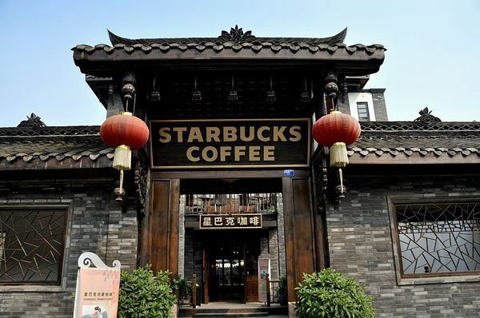
Figure 12: Starbucks store in China
(Source: Butch, 2016)

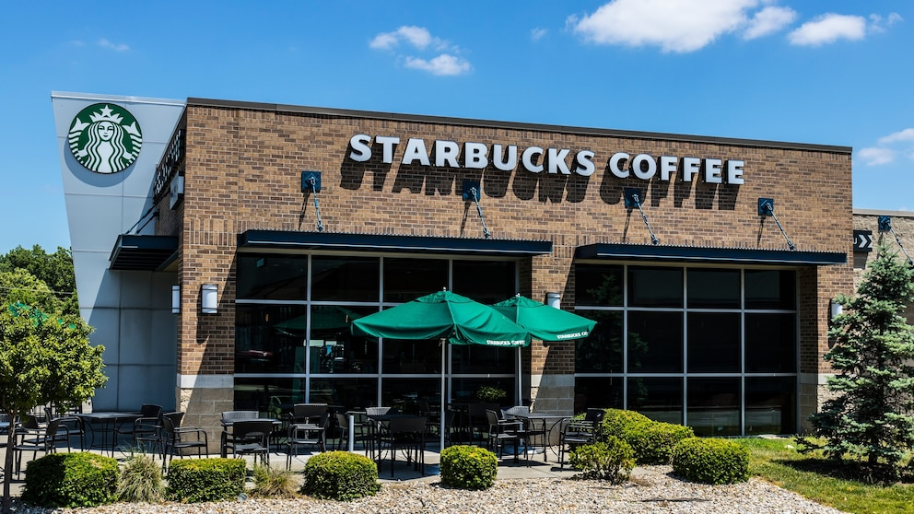
Figure 13: Starbucks store in the US
(Source: Zahn, 2025)

