International
Business
Communications LCBB6001

Asesment-2 PRESENTATION
LECTURER –DR Charles Nwaogwugwu
STUDENT Lilia Triboi SIN 2027089

Introduction

Unilever's Germany Management Office Expansion:
- Examines the significance of a management office in Germany.
- Explores intercultural communication and its impact on Unilever's operations.
- Highlights the importance of cultural issues in global operations.
- Provides insight into the effects of different cultures on Unilever's business
environment. (consultgenics.com)

Company Overview
Unilever: A Global Diversified Company:
- The joint venture of Britain and the Netherlands.
- The company Unilever operates in over 190 countries (Unilever PLC, 2024).
- Strategic management focuses on healthier, fuller lives through sustainable products and innovations.
- Current business scope includes food and beverages, personal care, and home care markets.

(https://www.unilever.co.uk)

Reasons for Expansions

Establishing a Management Office in Germany:
- Increase market coverage.
- Develop customer relationships and rely on available human resources.
- The EU market is credible due to economic turnover and consumer market (Held et al., 2021).
- Improve company operations and align with EU regulatory procedures.
(leadwayconsult.com)

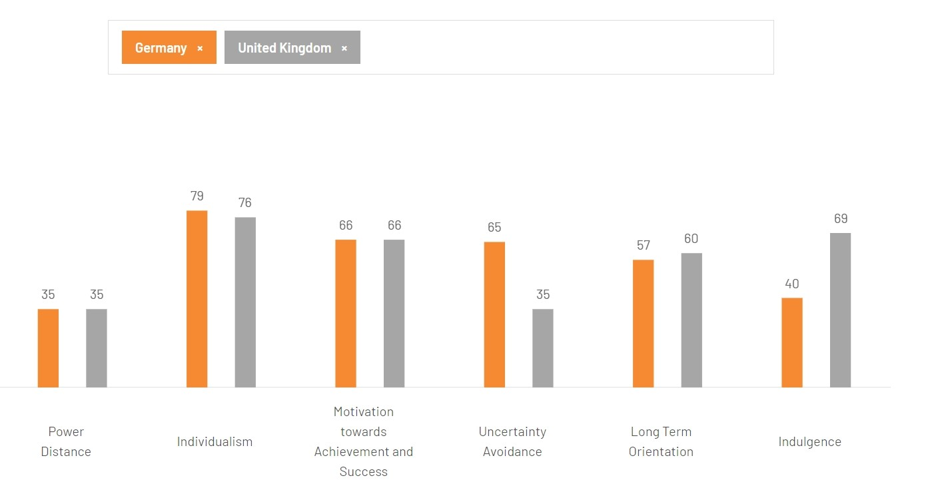
Cultural differences Germany vs. UK
- Germany is lower on indulgence and higher on uncertainty avoidance.
- The UK values order and future orientation.
- Understanding these cultural dimensions aids Unilever in managing and communicating effectively.

(hofstede-insights.com)

Cultural differences Germany vs. UK
- Road Traffic Regulations.

- Tea/coffee time and the time difference.
- The British are more polite - Germans are more direct.
- Birthday Cards.

Language and Communication Styles
UK-German Business Communication
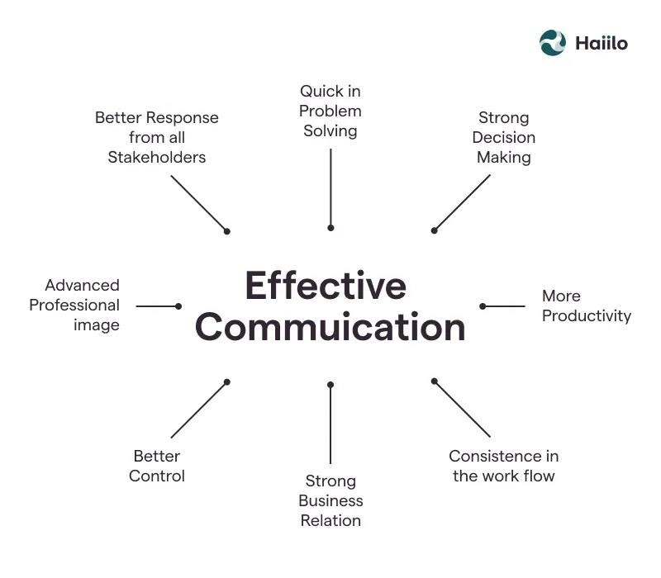
- Cultural and language policies influence UK-German business interactions.
- Unilever understands these differences to avoid misunderstandings.
- Effective communication strategies are crucial for productive collaboration and operation in new management offices (Ali et al., 2021).
Social Structures and Values
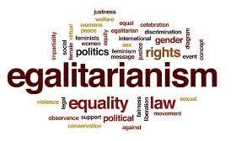
- Accordingly, the ability of social power dynamics and primary axiological orientations have significant influences on business organisations.
- In particular, German culture elevates egalitarianism and less specifically defined gender issues (Begall et al., 2023).
- For Germans, punctuality, precision, and reliability run in the blood.
(Amazon.co.uk : egalitarianism)

Work-related Attitudes
Comparing UK and German work Cultures:
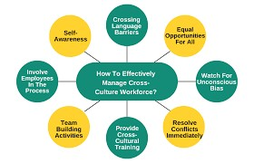
- The culture, expectations, and attitudes toward work differ in different countries.
- Moreover, Germany is valued for its good work quality, discipline, and comparatively less imbalance in work and life.
- German management practices are different from the British ones in autocratic leadership versus democratic management (Helms, 2020).
- If Unilever wants to create an enabling work environment within Germany, one of the first prerequisites will be dealing with these differences.
(Cross Culture Management: What Is It and Why Is It Important? - Edureka )

Challenges and Difficulties
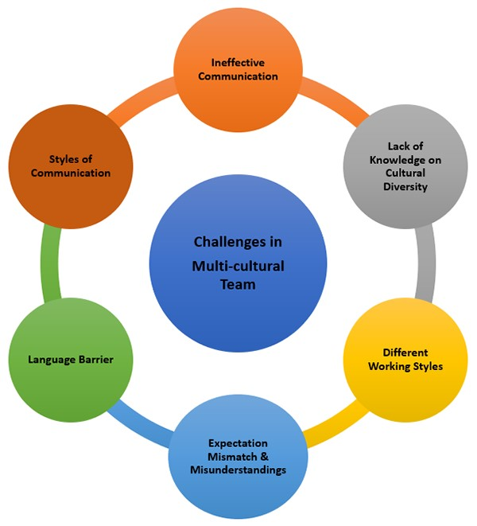
Challenges in Setting Up Management Office:
- Communication and management cultures differences among diverse businesses.
- Misunderstandings of meeting etiquette and decision-making processes.
- Culturally measured misunderstandings complicate organisational communication (Aririguzoh, 2022).
- Unilever must adapt to cultural differences and unite employees in Germany.

( Multi-cultural Team Challenges and Solutions | NTT DATA INTELLILINK Corporation​ )

Recommendations
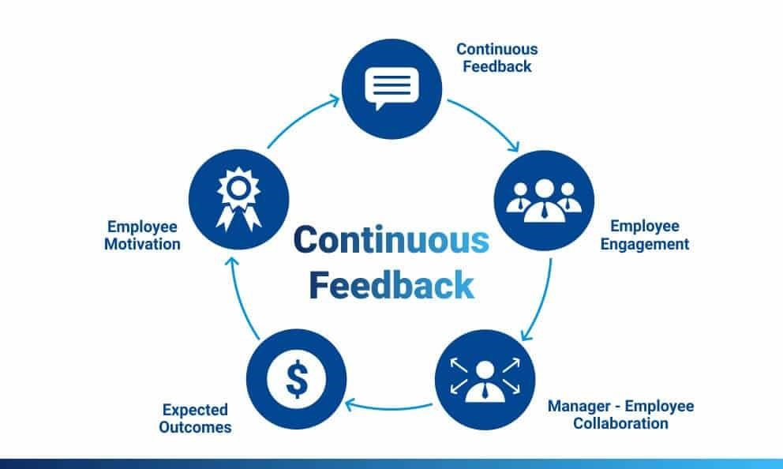
Unilever's Germany Management Office
Establishment:
- Planning includes location, hiring key local talent, and establishing necessary structures (Orel et al., 2022).
- Proposed events outline the project's progression from idea to operation.
- Supervision, evaluation, developmental, and feedback systems ensure proper implementation processes.
- These gears enhance adaptability and ensure successful establishment.

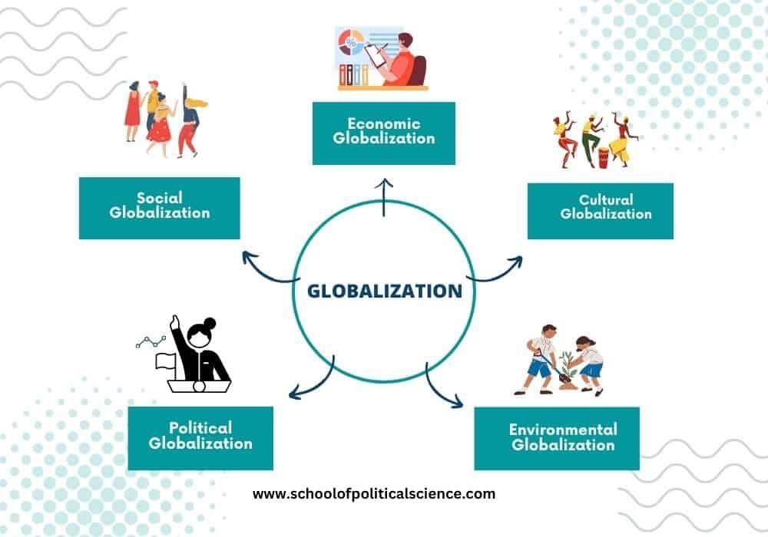
Conclusion
Unilever's Globalisation and Cultural Management:
- Respect and management of cultures are crucial for globalisation.
- Intercultural communication and opposite approaches are essential for strategic vision and competitive edge improvement.
- Cultural factors foster long-term success and sustainability in various European cultures.

Any Question?

Thank you

References
- Ali, B.J., Anwar, G., Gardi, B., Jabbar Othman, B., Mahmood Aziz, H., Ali Ahmed, S., Abdalla Hamza, P., Burhan Ismael, N., Sorguli, S. and Sabir, B.Y., (2021). Business communication strategies: Analysis of internal communication processes. Ali, BJ, Anwar, G., Gardi, B., Othman, BJ, Aziz, HM, Ahmed, SA, Hamza, PA, Ismael, NB, Sorguli, S., Sabir, BY (2021). Business Communication Strategies: Analysis of Internal Communication Processes. Journal of Humanities and Education Development, 3(3), pp.16-38.
- Aririguzoh, S., (2022). Communication competencies, culture and SDGs: effective processes to cross-cultural communication. Humanities and Social Sciences Communications, 9(1), pp.1-11.
- Begall, K., Grunow, D. and Buchler, S., (2023). Multidimensional gender ideologies across Europe: Evidence from 36 countries. Gender & society, 37(2), pp.177-207.
- Bluszcz, M. and Quan, S., 2016. Cultural comparison between china and Germany based on hofstede and globe. International Journal of Marketing, Financial Services & Management Research, 5(10), pp.58-68.
- Finken, L., & Pilz, M. (2023). Intercultural sensitivity of expatriate human resource managers towards training practices in their host countries. Human Resource Development International, 27(1), 8–35.
https://doi.org/10.1080/13678868.2023.2193808
- Held, M., Rosat, N., Georges, G., Pengg, H. and Boulouchos, K., (2021). Lifespans of passenger cars in Europe: empirical modelling of fleet turnover dynamics. European Transport Research Review, 13, pp.1-13.
- Helms, L., (2020). Leadership succession in politics: The democracy/autocracy divide revisited. The British Journal of Politics and International Relations, 22(2), pp.328-346.
- News Hofstede Insights(2024)The Culture Factor Group. Available at:https://www.hofstede-insights.com/product/compare-countries (Accessed:24.July 2024)
- Orel, M., Mayerhoffer, M., Fratricova, J., Pilkova, A., Starnawska, M. and Horvath, D., (2022). Coworking spaces as talent hubs: The imperative for community building in the changing context of new work. Review of Managerial Science, 16(5), pp.1503-1531.
- Richwien, M., (200)2. Cross-Cultural Differences-Japanese and German Management Styles from the German Perspective: Hofstede's Dimensions applied on German and Japanese Managers' Leadership Styles. p18 • Schmidt, H., & Wagner, K. (2017). Effective communication strategies in German manufacturing companies. Journal of Business Communication, 62(4), 412-427. https://doi.org/10.1177/0021943617710979
- Smith, C., (2020). The role of organizational change management in successful strategic enrollment management implementation. Strategic Enrollment Management Quarterly, 8(2), p.31.
- Taras, V., Steel, P. and Stackhouse, M., (2023). A comparative evaluation of seven instruments for measuring values comprising Hofstede's model of culture. Journal of World Business, 58(1), p.101386.
- Unilever PLC (2024) Our company, Unilever. Available at: https://www.unilever.com/our-company/ (Accessed: 10 July 2024).
- Voevoda, E.V., (2020). Intercultural communication in multicultural education space. Training, Language and Culture, 4(2), pp.11-20.
•

