

University of Wales Trinity Saint David
School of Engineering

CFD Ahmed Body
Advanced Computation Methods
M6X00408
Ainsley Martin
P149894
27/01/2020

Contents
1. Introduction 5
2. Methodology 6
2.1 Initial Run 6
2.2 Baseline Settings 6
3. Domain 7
3.1 Research 7
3.2 Full vs Half Model 7
3.3 Domain Size 8
4. Mesh 10
4.1 Research 10
4.2 Mesh Quality 10
4.3 Global Mesh Size 11
4.4 Part Size 12
4.5 Density Box Element Size 13
4.6 Density Box Size 17
4.7 Second Density Box 18
4.8 Prism Layers 19
4.9 Edge Criterion 20
4.10 Mesh Type 21
5. Solver 23
5.1 Research 23
5.2 Reynolds Number 23
5.3 Bernoulli’s Principle 23
5.4 Navier-Stokes Equations 23
5.5 Y Plus 23
5.6 Boundary Layer 24
5.7 Initialisation 24
5.8 Polyhedral 25
5.9 Turbulence Models 25
5.9.1 Laminar 25
5.9.2 K Epsilon 26
5.9.3 K Omega 27
5.9.4 Transitional SST 28
5.9.5 Reynolds Stress 28
6. Post Processor 30
7. Extra Work 31
7.1. 35 Degrees 31
7.2 Using Multiple Computers for the Same Case 33
8. Conclusion 34
9. References 35
10. Appendix 38

Figure 1 - Domain Example 7
Figure 2 - Domain Size Comparison 9
Figure 3 - Example of orthogonal quality 10
Figure 4 - Example of skewness 10
Figure 5 - Comparison of global mesh size 11
Figure 6 - Skewness Comparison 13
Figure 7 - Density box mesh size comparison 14
Figure 8 - Second density box around the slant 14
Figure 9 - Comparison of velocity contours with different density box meshes 15
Figure 10 - Vectors behind the slant with different density box mesh sizes 15
Figure 11 - Octree Mesh 21
Figure 12 - Delaunay Mesh 22
Figure 13 - Example of Y Plus 24
Figure 14 - K Epsilon Vorticies 26
Figure 15 - Flow Structures Behind Trailing Edge K Omega Comparison 27
Figure 16 - K Omega Vortices Comparison 28
Figure 19 - Pressure Distribution Over the Ahmed Body 30
Figure 17 - 35 Degree, K Epsilon NEWF 31
Figure 18 - 35 Degree, K Omega Standard 31
Figure 20 - Residuals 38

Graph 1 - Full vs Half Model 7
Graph 2 - Domain Study 9
Graph 3 - Global mesh size 11
Graph 4 - Part mesh size 12
Graph 5 - Density box element size 16
Graph 6 - Density box size 17
Graph 7 - Addition of a second density box 18
Graph 8 - Prism layers 19
Graph 9 - Edge criterion 20

Table 1 - Provided Data 5
Table 2 - Table of settings used for initial run# 6
Table 3 - Table of domain settings 8
Table 4 - Octree vs Delaunay 22
Table 5 - Standard vs hybrid initialisation 24
Table 6 - Tetrahrdra vs polyhedral 25
Table 7 - Laminar turbulence model 25
Table 8 - Turbulence Model Results 29
Table 9 - 35 Degree Results 31
Table 10 - Different Computer Comparison 33
Table 11 - Domain Study Results 38
Table 12 - Global Mesh Study Results 39
Table 13 - Density Box Mesh Size Results 39
Table 14 - Density Box Size Results 39
Table 15 - Part Size Results 39
Table 16 - Prism Layer Results 40
Table 17 - Edge Criterion Results 40

Introduction
This report will investigate different settings within an Ahmed Body study by utilising numerical modelling methods (computational fluid dynamics) to correlate against real world Windtunnel data. Bluff bodies like the Ahmed body are used to correlate wind tunnels(Kasim and Al Zaidee, 2015). The main investigation will be done using the 25 ° slant model, the settings for this will then be used with the 35° slant to validate the settings.
Ansys simulation software will be utilised to carry out all the individual studies. It is considered to be a “parent software” to the needed required subsystems, which are, Design Modeller to create the domain, ICEM to create the build grid and Fluent to solve the defining fluid investigation.
Four main areas will be investigated, the domain, meshing strategy, solver and the post processor. The size of the domain will be examined to see its impact on the produced results. The meshing strategy study will analyse the global mesh size, density box size and density, part size, prism layers, edge criterion. Within the solver, different turbulence models will be evaluated as well as other settings, such as initialisation and polyhedral mesh conversion. The post processor will be used to visualise the results.
The aim of the report is to get the computational fluid dynamics (CFD) results as close to the real world data as possible while still being realistic to use. This will depend on the user’s preference, such as the time available to get results and the accuracy of the results required.
The results to match can be seen in table 1
Table 1 - Provided Data
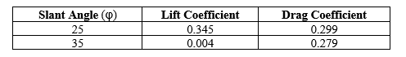

Methodology

2.1 Initial Run
The first run was done mainly using the given settings in ICEM and Fluent. This was done just to get an initial result as the provided settings should produce a mesh that will run in the solver; however, it might not end up being entirely accurate. A symmetrical model was run to try and reduce the meshing and solving time while learning the software. This can be done since the geometry is symmetrical.
Table 2 - Table of settings used for initial run#
Setting | Value
Global Mesh Size | 1
Part Size | 0.05
Shell Mesh parameters | All Tri, Patch Independent
Mesh Method | Robust Octree

The case was run at 40 m/s as this was the velocity the Windtunnel data was run at. The case was run using a K Epsilon, non-equilibrium wall functions turbulence model.

2.2 Baseline Settings
Due to the inaccuracies in the first run a closer baseline run was created to try and not skew the results too much. The domain was edited to match the domain size recommended by Lanfrit. (Lanfrit, 2005). As with the initial run, the baseline run was done using a half model. This was done again to reduce computing time while allowing a direct comparison between the baseline run and the initial run and also comparing the results to the provided data.
The global mesh size was too large and therefore was not capturing enough detail, this was reduced to try and capture more detail thus improving the accuracy of the results. As with the global mesh size the part size was far too large to capture the geometry of the Ahmed body. This was modified so it could accurately capture the geometry although this would be properly investigated later on. Prism layers were also added to the mesh to try and create a more refined mesh around the geometry.
For the solver a K Epsilon realizable turbulence model with non-equilibrium wall functions was chosen.(Banga and Zunaid, 2017). The momentum, turbulent kinetic energy and turbulent dissipation rate were all changed to second order to help improve the accuracy of the results. Moreover, the relaxation factors were also adjusted to help improve the accuracy of the results. (SiriusCFD, 2012). This test and all further tests will be run to 1500 iterations to ensure the results have fully converged. By setting each run for the same amount of iterations this removes one possible cause of error. Its possible that some of the runs might not converge in the 1500 iterations but they have all been run to this amount to try and optimise the time taken for each case.

Domain

3.1 Research
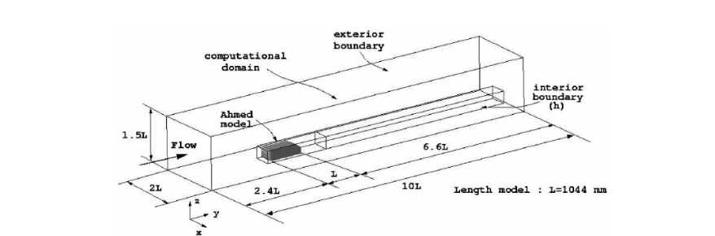
Design Modeller is where the CAD model will be imported. If the model needs some refinement it can also be done here. Such as removing holes from the model or fixing lines on the model. A domain will be created around the model. This creates a ‘virtual wind tunnel’ around the model and is where the simulation will be carried out. The dimensions of the domain are set in this stage as is the option to use a full or half model. If half model is being used a symmetry plane has to be added through the middle of the model.
Figure 1 - Domain Example
(Franck, et al., 2009)

3.2 Full vs Half Model
Initially a study was done to see if a full model would be needed or if a half model could be used. Both cases were run with the same settings, the only difference being the width of the domain which was halved for the half model run.

Graph 1 - Full vs Half Model
From graph 1 it can be seen that both cases produce similar results and since the difference in results are so marginal it could be due to other factors such as the computer being used to run the simulation can have slightly varied results even with the same settings. As the difference in results in marginal, this means the half model can be used for all the future iterations, this will help reduce computing time or allow more elements to be used for the same processing time. This in theory should produce more accurate results as the greater element count should capture more detail. Once all the case studies have been completed the final settings can be used to again compare a full model vs half model simulation.

3.3 Domain Size
6 Extra studies were undertaken in addition to the full and half model baselines. These studies were all done as a percentage difference from Lanfrits recommended settings. This was chosen to understand when Lanfrits chose the settings he did and see how the results are affected if the settings are scaled up and down.
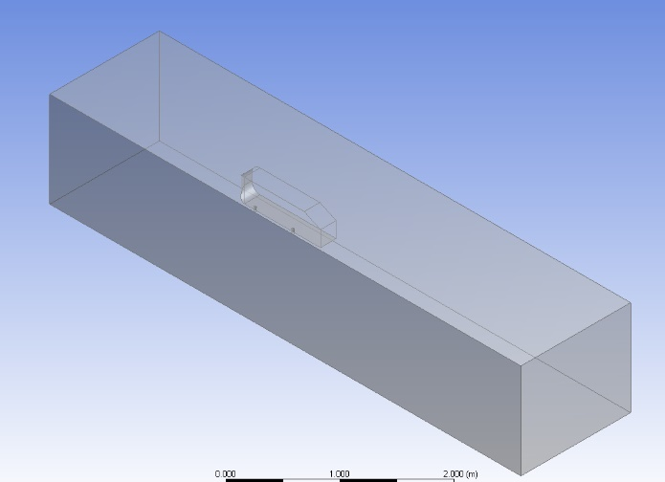
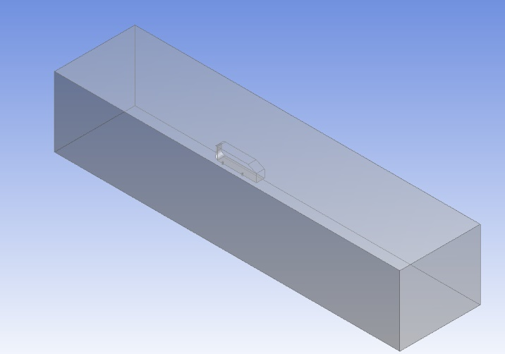
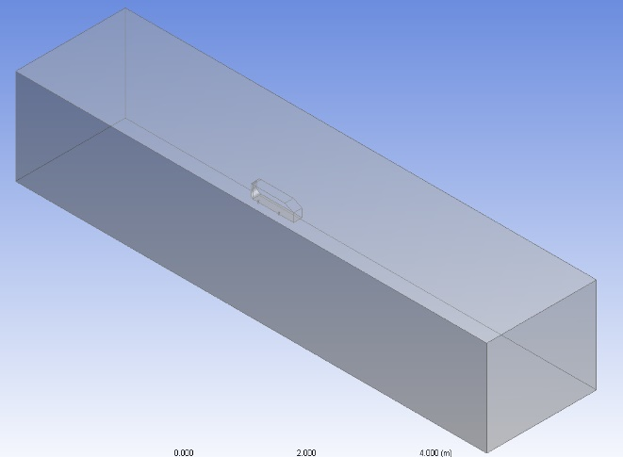
Table 3 - Table of domain settings
A
B
C
Domain Size | Total X Size (m) | X behind model (m) | Y Size (m) | Z Size (m)
30% Less | 5.846 | 3.654 | 1.183 | 1.362
20% Less | 6.682 | 4.176 | 1.352 | 1.556
10% Less | 7.517 | 4.698 | 1.521 | 1.751
Lanfrit Half Model | 8.352 | 5.22 | 1.69 | 1.945
10% More | 9.187 | 5.742 | 1.859 | 2.14
20% More | 10.022 | 6.264 | 2.028 | 2.334
30% More | 10.858 | 6.786 | 2.197 | 2.529

Figure 2 - Domain Size Comparison
Figure X shows the comparison between 3 different domain sizes. ‘A’ shows Lanfrits recommended settings, ‘B’ shows a domain 30% less than Lanfrits recommended settings and ‘C’ shows a domain 30% larger than Lanfrits recommended settings. For a future investigation different proven domain sizes could be tested and compared against the following settings.

Graph 2 - Domain Study
When the domain is less than Lanfrits settings the percentage difference for the cl fluctuates, while the cd drops closer to the datum value. This could possibly be due to the boundary walls being too close to the model, this could have an impact with the resulting flow structure effecting the final cl and cd values.(Revuz, Hargreaves and Owen, 2012). The model being investigated will also have a big impact on how small or large the domain needs to be. A lamppost will only require a small domain as it is a small, simple shape typically with low velocities. Whereas a plane will require a large domain as it is a larger model that can possibly go supersonic.
At the 30% more value the values are beginning to level out, this would suggest that after this point the domain will have a negligible impact on the resulting values. Lanfrits recommended settings were chosen as it produced the closest overall results and doesn’t require an extensive amount of computing time.

Mesh

4.1 Research
ICEM mesher was used to produce the build grid (mesh). There many settings inside ICEM that can be used to create and fine tune a mesh. For these studies only a few of these settings will be fully investigated as these settings have the most dramatic impact on the result. The reason the settings that were used were chosen was due to the user guide of ICEM.(Ansys, 2013)

4.2 Mesh Quality
There are 2 main qualities looked at when analysing the mesh quality. These are the orthogonal quality and skew. Skewness is the ‘difference between the shape of the cell and the shape of an equilateral cell of equivalent volume’. (Ansys, 2009). Therefore, the more skewed a cell is the more it’s had to modify its shape to fit into the mesh. A large skew value can make the solution hard to converge or can produce inaccurate results as the equations being used to calculate the results assume the cells are equiangular. (Adariani, 2019). Typically, the lower the skew value the better. An example of how cells are skewed can be seen in figure 4
Orthogonal quality is how much the tetra has been modified which increases the angle between the centre of one node to the centre of the next node.
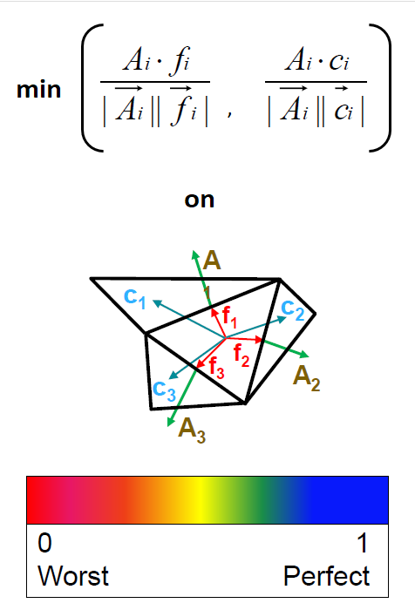
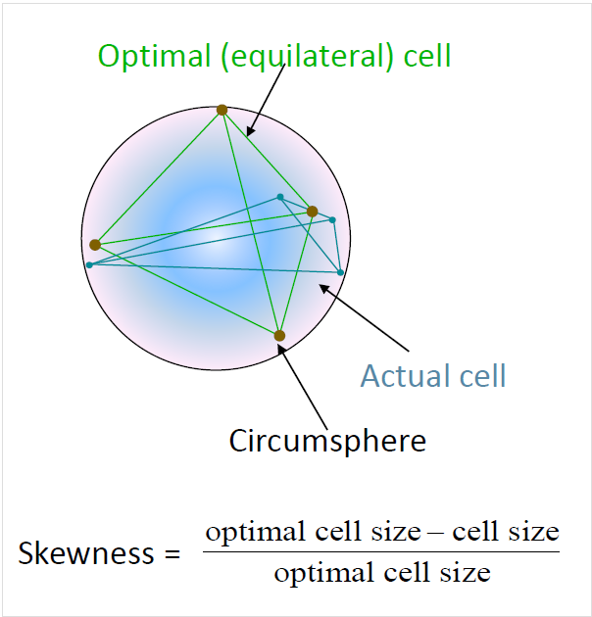
Figure 3 - Example of orthogonal quality
Figure 4 - Example of skewness
(Avraham, 2019) (Avraham, 2019)

4.3 Global Mesh Size
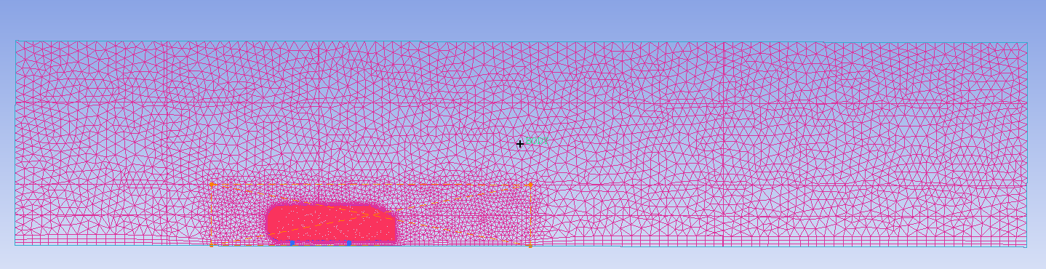
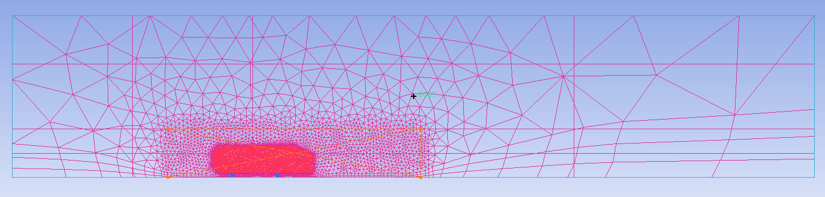
The global mesh size defines the size of the elements in the free stream volume. The smaller the number the smaller the elements will be, thus increasing the overall element count. The largest element size cannot exceed this number.
Figure 5 - Comparison of global mesh size
Figure 5 shows the differences between a fine mesh (top) and a coarse mesh (bottom). The top mesh is a global size of 0.1m and the bottom mesh is a global size of 1.7m.
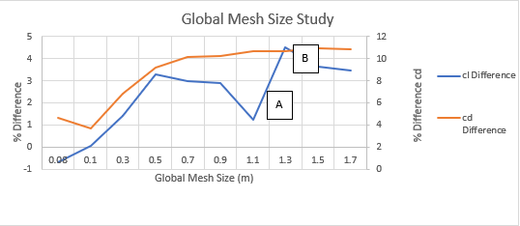
Graph 3 - Global mesh size

When looking at graph 3 it can be seen that the cd difference increases from 0.1m to 0.7m and begins to balance out after that. This suggests that for the Ahmed body any global mesh size above 0.7 m will have a negligible impact on the overall result. A global mesh size of 0.1m was chosen as it produced the closest results to the datum.
With the cl difference there is a large dip and point A before returning to a large percentage difference at point B. This has been assumed to be an anomaly as the other variables follow a similar trend, since this point currently isn’t as close as a global mesh size of 0.1m and would be expected to get worse if this was an anomaly, it was decided to accept the result and not re-test it.
Further testing could be conducted on a global element size smaller than 0.08m to see its impact on the results. However, due to the extra computing power required for the extra elements these tests were not done as the computing time would become too large for these cases.

4.4 Part Size
The part size can set independent element sizes on selected parts. This can be good to help mesh complex geometries that require a finer mesh to capture all the detail. If the value is left to 0m the global mesh size will be used. The model was split into two sections the stalks (feet) and the main body.

Graph 4 - Part mesh size
From graph 4 it can be seen that making the part sizes too small can skew the elements and cause inaccuracies in the results as seen in figure 6, this shows that the 0.005m Ahmed body case has more skewed elements (top) when compared with the 0.01m Ahmed body case (bottom). This is possibly why the smallest element size doesn’t produce the closest results. The closest results occur when the model is set to 10mm and the feet are set to 5mm as seen in graph 4. After that, as the part sizes are increased the results become more inaccurate.

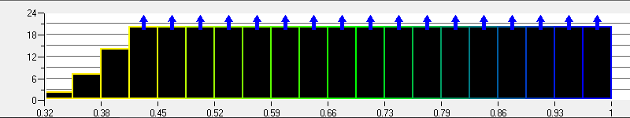
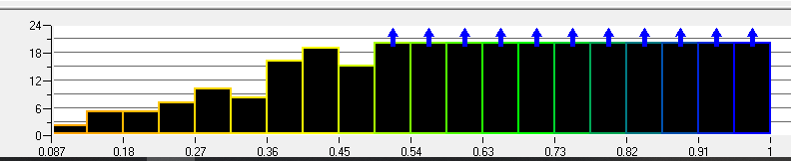
Figure 6 - Skewness Comparison

4.5 Density Box Element Size
Density boxes can be used to create a finer mesh around a certain area, allowing more detail to be captured. Typically, density boxes are placed in two main areas. The first is around the entire model to try to create a more refined mesh around the model, allowing the flow structures to be predicted more accurately. The second is to have a smaller density box around areas of separation. Such as the slant on the Ahmed body as seen in figure 8
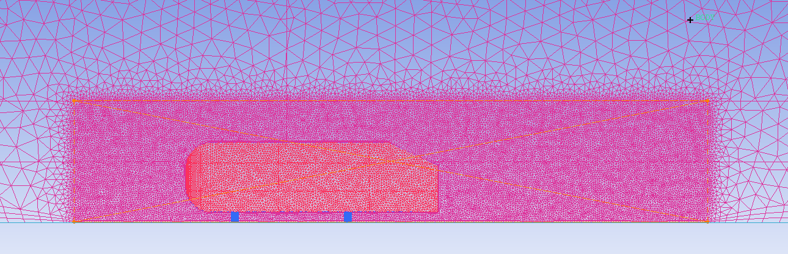
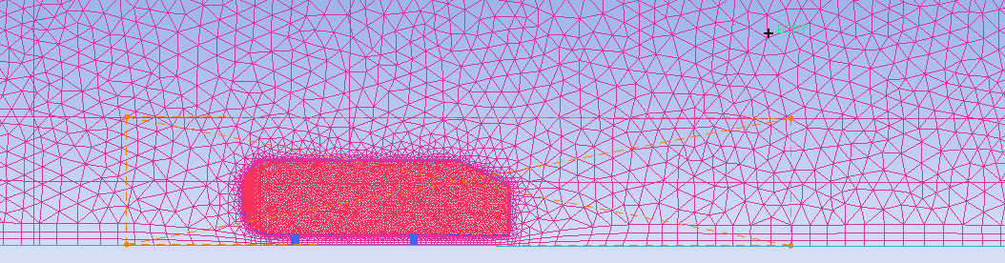
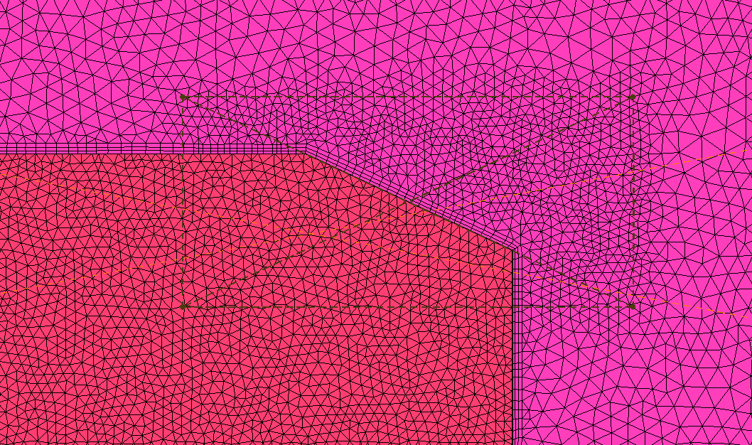
Figure 7 shows the difference between a density box of 0.13m (top) and 0.01m (bottom). As the density box of 0.13m is greater than the global mesh size of 0.1m it has no impact on the mesh sizing. This effectively acts as if there is no density box.
Figure 7 - Density box mesh size comparison
Figure 8 - Second density box around the slant
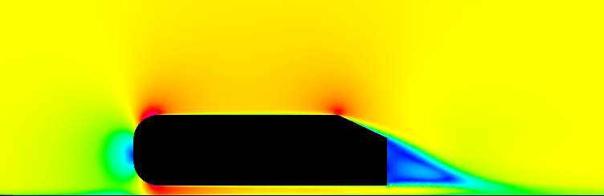
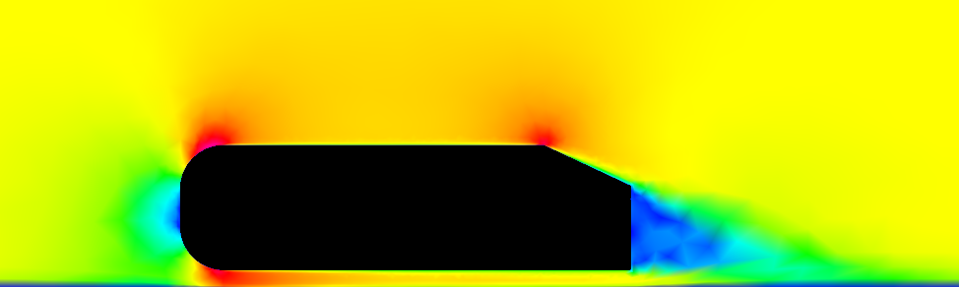
Figure 9 shows the difference in velocity contours between a coarse density box mesh (top) and a fine density box mesh (bottom). The flow structures are more streamlined when the mesh is finer. When there’s no density box the flow structures have a lower resolution, although they follow similar trends. There are a few main differences, one being the build-up of low velocity on the floor when there’s no density box. This would be due to the larger prism layers incorrectly predicting the boundary layer build up on the floor. The second main difference is the flow structure after the slant. The flow is a lot more unstructured when there is no density box.
Figure 9 - Comparison of velocity contours with different density box meshes
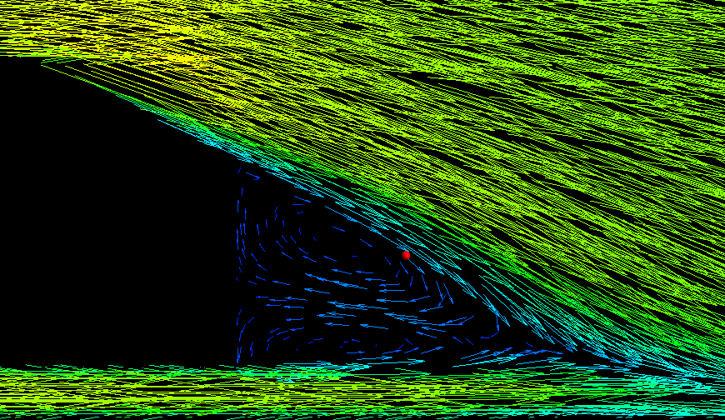
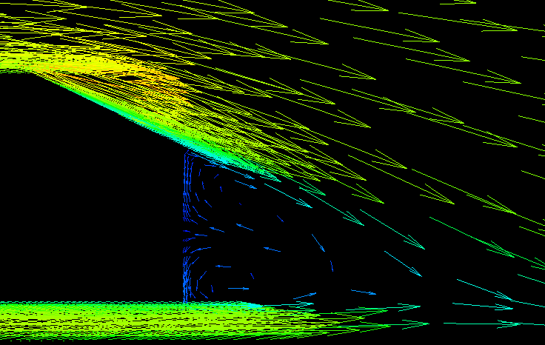
Figure 10 - Vectors behind the slant with different density box mesh sizes
Figure 10 shows the recirculation that occurs behind the Ahmed body. The left is with a coarse density box and the right shows a fine density box. Both pictures show similar flow structures, however the it’s much easier to see the complete flow structure with the finer mesh as it is able to capture more detail. This would make analysing the results in a real world investigation easier as more detail can be seen and therefore any small changes to the flow structure around a model could be captured and analysed.
Graph 5 - Density box element size
From graph 5 it can be seen that increasing the element size of the density box decreases the accuracy of the results. An element size of 0.03m was chosen to carry on with future tests, this was chosen as it produces results closest to the datum. When the element size was dropped to 0.01m the calculation time started increasing and the results diverged away from the datum results.

4.6 Density Box Size
As with the domain, the size and positioning of the density box are very important to try and capture as much detail as possible. If the density size is too small it might not capture enough detail, if it is too large it can increase the meshing and solving time without providing much extra detail.
The original density box size was 2.5x the length of the model and 1.5x the height and width of the model.
Graph 6 - Density box size
From graph 6 it can be seen that the size of the density box only has a marginal impact on the percentage difference of the cd. It does however have a larger impact on the percentage difference of cl. The shape of the graph is unusual as it does not seem to follow a trend. This could be due to an anomalous result, although since the questionable result was using the settings that had been used in previous studies it was decided not to repeat the test and continue using these settings.

4.7 Second Density Box
A small investigation was done to see the impact of adding a second density box around the kick point of the Ahmed body as seen in figure 8.

Graph 7 - Addition of a second density box
A decision was made to only use one density box around the model. This was chosen as the second density box wasn’t improving the accuracy of the results. By only using one density box the computing time is also reduced.

4.8 Prism Layers
Prism layers are placed on the surface of the model to try and simulate a boundary layer acting on the surface.(Dixon et al., 2008)

Graph 8 - Prism layers
3 prism layers was chosen to be used for the rest of the tests as it produced the closest results to the datum. After 3 prism layers the percentage difference cd levels out, this shows that after 3 layers the amount for layers has very little impact on the cd. Although it still has a big impact on the cl difference. This could occur since the prism layers help simulate the boundary layer, therefore by increasing the number of prisms it is effectively increasing the size of the boundary layer.(Sakamoto and Haniu, 1988). This could cause the solver to over or under predict the flow separation which can have large impacts on the cl value.
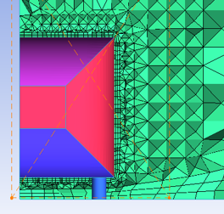
The circles show an example of prism layers applied to the road and the model.

4.9 Edge Criterion
The edge criterion is set to help improve meshing thing walls. The smaller this value is set the better it is at capturing thin geometry, however, to capture this geometry ICEM skews the cells.(ANSYS, 2012) Therefore, if this value is set too low it can increase computing time or reduce the accuracy of the results.

Graph 9 - Edge criterion
As with the domain size the results are a bit sporadic, since there are no sharp edges on the model its unexpected that the edge criterion would have major impacts. Again, the edge criterion only has a minor impact on the difference of cd but has a more significant impact on the difference of cl. Although the results are questionable an edge criterion of 0.1m was chosen as it did provide the closest results.

4.10 Mesh Type
Two mesh types will be investigated. These are Robust Octree and Quick Delaunay. A Robust Octree mesh is a tetra mesh that is created using a top down method. This method creates a surface mesh after the volume mesh has been created.
Quick Delaunay creates a tetra mesh using a bottom up method. This creates a surface mesh before the volume mesh has been created.

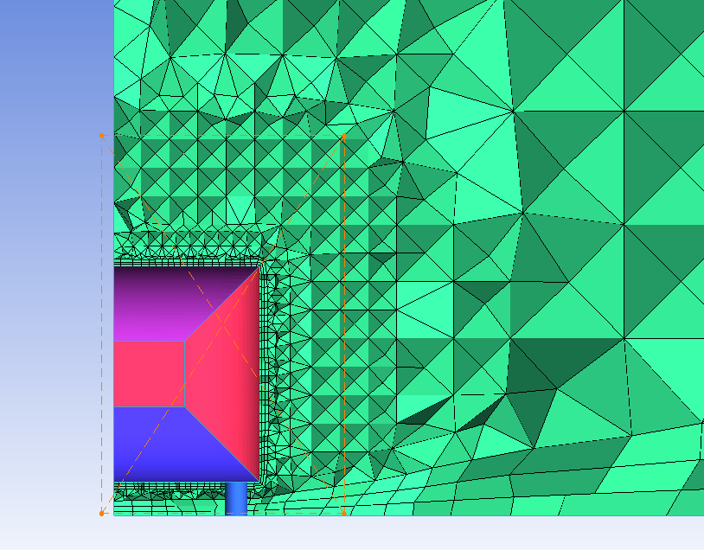
Figure 11 - Octree Mesh
Figure 11 shows an example of an octree mesh
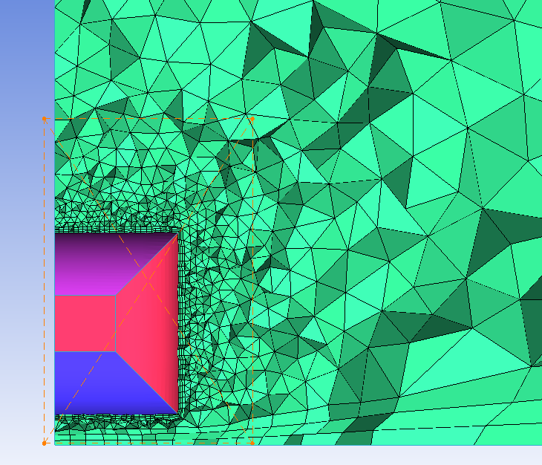
Figure 12 - Delaunay Mesh
Figure 12 shows an example of a Delaunay mesh.
Table 4 - Octree vs Delaunay
Test | cl | cd | Efficiency | % Difference cl | % Difference cd | %Difference efficiency
Octree | 0.34427 | 0.29861 | 1.152908476 | -0.211594203 | -0.130434783 | -0.081265419
Delaunay | 0.30345 | 0.30762 | 0.986444314 | -12.04347826 | 2.882943144 | -14.50815942

From table 4 it can be seen that the octree mesh provides results closer to the datum, this could be due to the mesh being developed for the octree setting. Therefore, it’s possible the Delaunay mesh could yield better results if the previous mesh strategies were developed for it.

Solver

5.1 Research
Fluent was used to solve the mesh. Inside fluent there are many settings that can be changed, although for these studies only the turbulence models will be fully investigated as these can have major impacts on the results and also the resulting flow structures over the model. One reason for this is fluent can be used to solve lots of different scenarios which makes lots of the settings redundant for external vehicle aerodynamics the main area of investigation inside fluent will be the different turbulence models and their impact on the results and flow structures over the Ahmed body.(Demuren and Trehan, 2006).

5.2 Reynolds Number
The Reynolds number (Re) is a ratio of the inertial force against the viscous force of a fluid. The Reynolds number dictates is fluid flow is laminar or turbulent. If the Re is less than$1 ×{10}^{5}$ then the flow will be laminar, if the Re is greater than $1 ×{10}^{5}$ the flow will be turbulent.(Tientcheu-Nsiewe et al., 2016) (McBeath, 2006).

5.3 Bernoulli’s Principle
Bernoulli’s principle states that as the velocity of a fluid increases this will result in a decrease in pressure (Katz, 1995). When air flows from high pressure to low pressure the air accelerates and vice versa.
$P+0.5ρV^{2}=Constant$ Equation 1 - Bernoulli’s equation

5.4 Navier-Stokes Equations
The Navier-Stokes equations are a set of equations that govern fluid dynamics. There are 3 main parts to these equations. The first being a continuity equation for the conservation of mass, the second is the three equations relating to the conservation of momentum.(Carnarius et al., 2009) Finally, there is a conservation of energy equation that is time related (NASA, 2011). The first part of these equations was developed by Euler, these work fine for linear solutions. However, when turbulence is introduced the full Navier-Stokes must be used to calculate the turbulence (SimScale, 2017).
Examples of these equations being used can be found in figure 17.

5.5 Y Plus
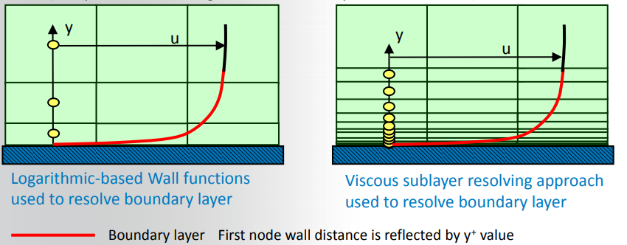
Y plus is a dimensionless value and is used to help model the boundary layer close to the surface. (Schlichting, 1979). The y plus is used to ensure the first cell is inside the log law region. (Simscale, 2018). Typically, this value should be greater than 30 but less than 300, however this is a guideline and can change depending on the Re. (Ansys, 2012).
Figure 13 - Example of Y Plus

5.6 Boundary Layer
A boundary layer is a layer that forms on a surface as air passes over it. As the air passes further along the surface the boundary layer starts to increase. At first it will start off laminar and this applies as long as the Re is less than $1 ×{10}^{5}$. At this point the layer is thin with very little skin friction. However, the shear stresses can no longer keep the flow laminar which causes the air to begin to rotate (Schuetz, n.d.). This is described as the transitional phase between laminar and turbulent flow. The freestream air begins to mix with this rotating air which causes the boundary layer to become turbulent. This occurs as the air in the transitional phase has lost some of its energy and it becomes reenergised by the freestream air. Inside the turbulent layer a viscous laminar sublayer begins to form as the shear forces become great enough to maintain laminar flow close to the surface. These are the horizontal layers.(Le Roux, 2004)
There are also vertical layers. These are the viscous sublayer, the buffer layer and the overlap layer.

5.7 Initialisation
There are two ways to initialise a run inside fluent, standard or hybrid. With a standard initialisation the user sets all the variables such as the pressure, velocity and kinetic energy. Fluent then uses this data to produce an initial guess at the result. Hybrid is slightly different as fluent guesses the setting for you. It then tries to solve the problem with 10 iterations using a linear solution to provide an initial guess for the result.(Keating, 2011)

Table 5 - Standard vs hybrid initialisation
Test | cl | cd | Efficiency | % Difference cl | % Difference cd | %Difference efficiency
Standard | 0.34427 | 0.29861 | 1.152908476 | -0.211594203 | -0.130434783 | -0.081265419
Hybrid | 0.34327 | 0.29923 | 1.147177756 | -0.501449275 | 0.076923077 | -0.577927792

From table 5 it can be seen that the standard initialisation produces results closer to the provided data. However, in theory both results should be identical given enough iterations. Since the difference between the two results is relatively small the difference in the two results could be due to different computers being used for the two tests as they were run in parallel to allow more runs to be completed in a smaller amount of time.
Since the difference can’t be proven, standard initialisation will be used for all the future runs as it did produce the closest result to the datum.

5.8 Polyhedral
Polyhedral meshes are a way to simplify a complicated mesh. This mesh type is based on a premade tetrahedral mesh. The tetra mesh is then converted into a poly, this reduces the amount of cells compared with a tetra mesh (Southampton University, 2016), it also can solve quicker. (Symscape, 2013). While there is some evidence to suggest that a polyhedral mesh can be more accurate and solve quicker than a tetra mesh (Peric & Ferguson, 2014), this can be true with a dedicated poly mesher. This can be true since there are more points of contact with a poly mesh compared to a tetra mesh. However, since Fluent converts a tetra mesh into a poly mesh some issues can occur. Some accuracy can be lost due to the conversion as the new poly cells have to try and match the tetra mesh.
Table 6 - Tetrahrdra vs polyhedral
Test | cl | cd | Efficiency | % Difference cl | % Difference cd | %Difference efficiency
Tetrahedra | 0.34427 | 0.29861 | 1.152908476 | -0.211594203 | -0.130434783 | -0.081265419
Polyhedral | 0.34997 | 0.31425 | 1.113667462 | 1.44057971 | 5.100334448 | -3.482153275

From table 6 it can be seen that the tetrahedra mesh produces a more accurate results compared with the polyhedral. Therefore, for the remaining cases the tetra mesh will not be converted into a poly mesh. However, the poly mesh solved in under half the time that the tetra mesh did. If time was a concern the final cases could be converted into a poly mesh as the results would still be within tolerance.

5.9 Turbulence Models
One important point to consider before looking at the turbulence models is that all the previous tests have been done using a K Epsilon, Realisable with non-equilibrium wall functions turbulence model. This means the mesh has been modified to help suit this turbulence model. It’s possible that one of the other models could produce better results if the mesh had been modified for it.

5.9.1 Laminar
A laminar turbulence model can only model the flow when it’s in a linear state, therefore it cannot model turbulent flow or flow separation. The linear model is a one equation model. This is acceptable in certain scenarios when the user knows that separation won’t occur and the Re won’t reach a value great enough for the flow to become turbulent.
Table 7 - Laminar turbulence model
Test | cl | cd | Efficiency | % Difference cl | % Difference cd | %Difference efficiency
Laminar | -0.08972 | 0.19988 | -0.448879328 | -126.0063768 | -33.15050167 | -138.9028751
Given | 0.345 | 0.299 | 1.153846154

Since the Ahmed body has a 25° slant, there will be some separation and some turbulent flow will occur. Therefore, a linear turbulence model won’t properly simulate the flow structures occurring around the model. As can be seen from table 7 the linear models results are dramatically different than the given data. It was not expected that a linear model would be able to solve the problem correctly however it was tested just to see the impact of using it since it could be used by accident.

5.9.2 K Epsilon
K Epsilon is one of the standard models used for vehicle aerodynamics. This is because its good at modelling flow when are small adverse pressure gradients(Singh et al., 1983), meaning its good at modelling flow structures behind a model. It predicts flow far from the walls. However, since K Epsilon doesn’t work very well with large adverse pressure gradients (Wilcox, 1993) other models should be considered when looking at the point that separation occurs and near wall boundaries. This model is a two equation model, the K models the turbulent kinetic energy and the epsilon models the rate of dissipation of kinetic energy.
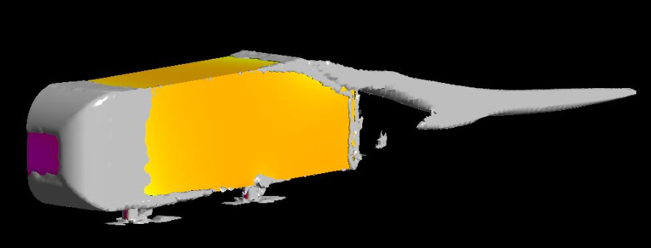
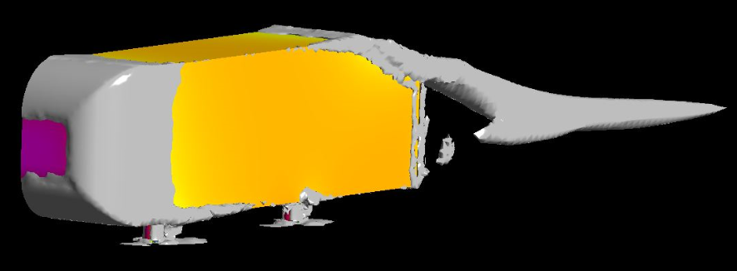
There are two main differences between the standard and realizable K Epsilon models. The first is that the viscosity coefficient in the turbulent viscosity equation is constant with the standard model, in the realisable model this becomes a variable. The second is the realisable model has a more accurate equation for the rate of dissipation of kinetic energy. This means the realisable model should be better at predicting separation and recirculation.(ANSYS FLUENT, no date a). The RNG model has an additional term in the epsilon equation which is used to improve the accuracy for ‘rapidly strained flows’. The accuracy of recirculation is also improved.
Figure 14 - K Epsilon Vorticies
Figure 14 is showing the vortices on EWT (top) and NEWF (bottom). From this it can be seen that the vortex structures are near identical between the two models. Although the EWT does produce a larger vortex coming off the trailing edge.

5.9.3 K Omega
K Omega is also used for road vehicle aerodynamics as it is good at modelling near wall conditions. As with K Epsilon the “K” term models the turbulent kinetic energy, the “omega” term models the specific dissipation of kinetic energy. Due to its ability to predict near wall interaction, K Omega is superior at predicting the point where separation will occur. However it does require the mesh resolution close to the wall to be more refined, otherwise it can over or underpredict the point of separation.(Menter, 1993)
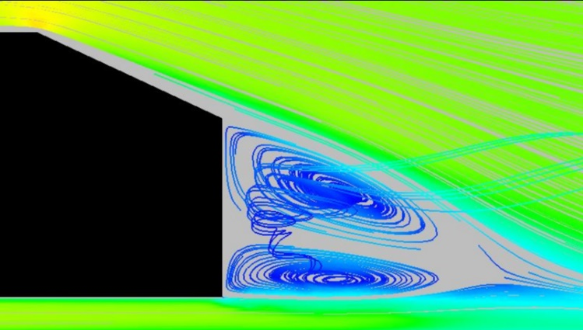
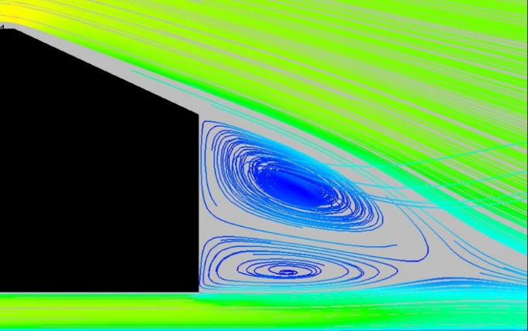
The way the turbulent viscosity is modelled for the turbulent shear stress transport equation is different for the SST model compared with the standard model. SST model acts as mixture of the K Omega and K Epsilon models. This means the model has the close to wall functions of the K Omega model and away from wall functions of the K Epsilon model, while still only having two transport equations. This means the SST model is able to predict a greater range of flow structures and pressure gradients than the standard model.
Figure 15 - Flow Structures Behind Trailing Edge K Omega Comparison
From figure 15 the difference of flow structures from standard (left) and SST (right) K Omega can be seen. Both of the flow structures behind the notch are similar however, the standard model has a larger vortex forming at the trailing edge. This then bleads into the recirculation occurring near the base of the model, giving it more energy.

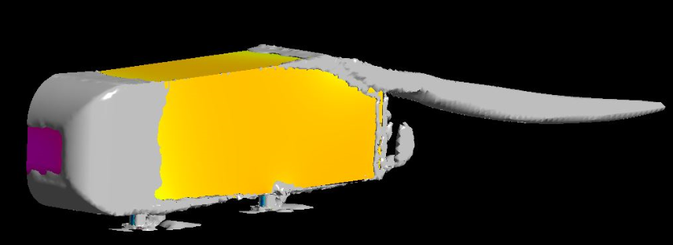
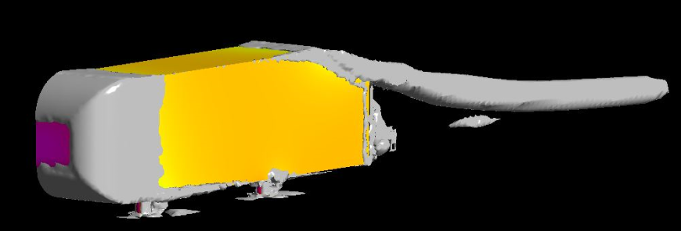
Figure 16 - K Omega Vortices Comparison
Figure 16 shows the vortices occurring on the model. The top shows the standard model and the bottom shows SST. The leading edge of the model shows very similar trends as does the point of separation occurring at the slant. The main difference occurs at the rear of the model in the circled section. This is most likely due to the different turbulent viscosity equation with the SST model.

5.9.4 Transitional SST
The transitional SST model is based on the k omega SST model. It contains an extra an extra two transport equations. One is the intermittency and the other is for transition onset criteria.(ANSYS FLUENT, 2012).

5.9.5 Reynolds Stress
Reynolds Stress is one of the most complex models in fluent. It has 7 transport equations to solve. It tries to solve the Reynolds averaged Navier-Stokes equations by solving the Reynolds stress along with an equation for dissipation rate. In theory this model should have the closest accuracy however it requires the best mesh to solve.

Table 8 - Turbulence Model Results
Test | cl | cd | Efficiency | % Difference cl | % Difference cd | %Difference efficiency
K-epsilon Standard | 0.35981 | 0.32494 | 1.107312119 | 4.292753623 | 8.675585284 | -4.032949673
K-epsilon RNG | 0.33664 | 0.28875 | 1.165852814 | -2.423188406 | -3.428093645 | 1.040577201
K-epsilon Realizable NEWF | 0.34427 | 0.29861 | 1.152908476 | -0.211594203 | -0.130434783 | -0.081265419
K-epsilon Realizable EWT | 0.3504 | 0.30776 | 1.138549519 | 1.565217391 | 2.929765886 | -1.325708344
K-Omega Standard | 0.34226 | 0.29061 | 1.177729603 | -0.794202899 | -2.806020067 | 2.069898948
K-Omega SST | 0.31926 | 0.29454 | 1.08392748 | -7.460869565 | -1.491638796 | -6.059618388
Transitional SST | 0.3161 | 0.29486 | 1.072034186 | -8.376811594 | -1.384615385 | -7.090370571
Reynolds Stress | 0.33183 | 0.29248 | 1.134539114 | -3.817391304 | -2.180602007 | -1.673276805

From table 8 it can be seen that most turbulence models would produce results accurate enough for most basic cases. However, it is clear that the choice of turbulence model will have an impact on the results and therefore they do have to carefully be considered depending on each individual case.

Post Processor
The post processor is used to visualise the results produced from the solver. This is the best place to analyse the results. (Toet, 2019). There are a few main ways the results can be analysed. The first is using contours, these can be applied to any surface and used to view pressures, velocities etc as seen in some of the previous figures. Flow structures can also be visualised using streamlines and/or vectors. Graphs and tables can also be produced to show data such as the pressure distribution over the model. Such as the graph seen in figure 19
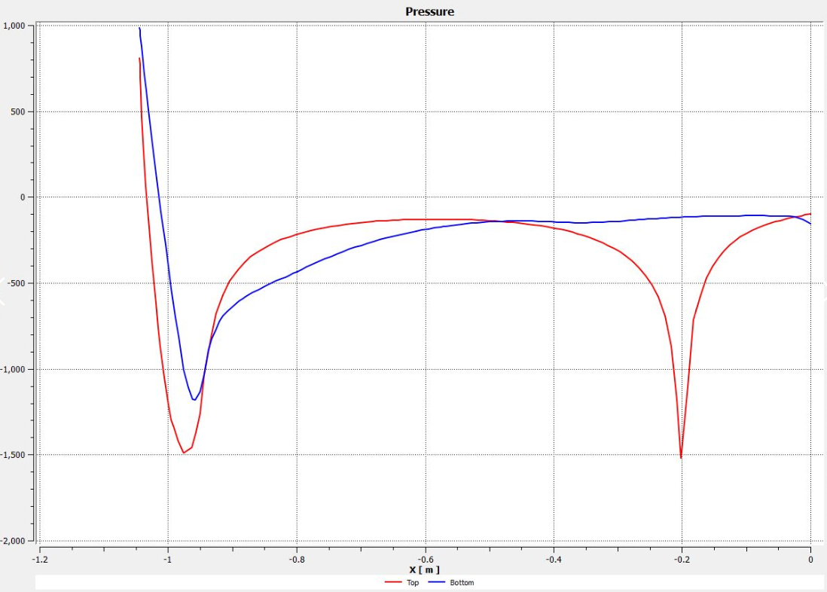
Figure 19 - Pressure Distribution Over the Ahmed Body
Figure 19 shows the pressure distribution over the top and bottom surface of the Ahmed body. Pressure distribution graphs can be very useful for looking at areas of separation and to see how the top and bottom surfaces of a body are being acted on. This is especially important when investigating aerofoils.(Allen, 1945)

Extra Work

7.1. 35 Degrees
Using the build grid settings found in the previous studies, different turbulence models were explored using the Ahmed body with a 35° slant. This was conducted to see if the same build grid settings can be used to produce accurate results with different models.
Table 9 - 35 Degree Results
Test | cl | cd | Efficiency | % Difference cl | % Difference cd | %Difference efficiency
K-epsilon Standard | 0.42431 | 0.3577 | 1.186217501 | 10507.75 | 28.2078853 | 8173.867067
K-epsilon RNG | 0.062201 | 0.27312 | 0.227742384 | 1455.025 | -2.107526882 | 1488.50313
K-epsilon Realizable NEWF | 0.5593 | 0.44607 | 1.253839084 | 13882.5 | 59.88172043 | 8645.527608
K-epsilon Realizable EWT | 0.26641 | 0.32095 | 0.830066989 | 6560.25 | 15.03584229 | 5689.717246
K-Omega Standard | 0.13583 | 0.29133 | 0.466241033 | 3295.75 | 4.419354839 | 3152.031202
K-Omega SST | 0.96079 | 0.30225 | 3.17879239 | 23919.75 | 8.333333333 | 22072.07692
Transitional SST | 0.127 | 0.30402 | 0.417735675 | 3075 | 8.967741935 | 2813.706335
Reynolds Stress | 0.15108 | 0.29895 | 0.505368791 | 3677 | 7.150537634 | 3424.947316

By looking at the results in table 9 its clear that the previous settings are not able to produce results anywhere close to the provided data.
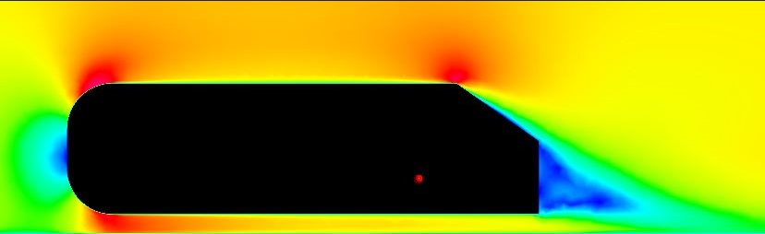
Figure 17 - 35 Degree, K Epsilon NEWF
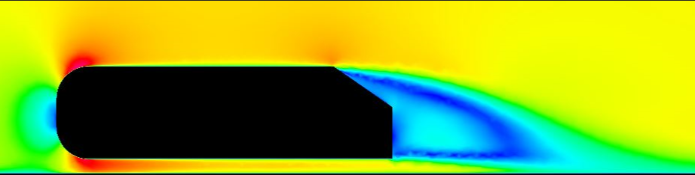
Figure 18 - 35 Degree, K Omega Standard
By looking at figures 17 and 18 the difference in the velocity’s contours can be seen when using different turbulence models. This explain why the choice of turbulence model is so important, especially when areas of large separation are being investigated as the resulting flow structures are completely different.

Using Multiple Computers for the Same Case
A mini investigation was done by running the same case across multiple computers. This was done to see if there are any inaccuracies by using different computers.
Table 10 - Different Computer Comparison
Test | cl | cd | Efficiency
PC 1 | 0.35536 | 0.32937 | 1.078908219
PC 2 | 0.35998 | 0.32965 | 1.092006674
PC 3 | 0.3506 | 0.32898 | 1.065718281

From table 10 it can be seen that using different computers for the same case can produce slightly different results. The difference in overall efficiency ends up being 2.407% between three computers. This shows that not all results can be fully trusted especially if they are run on different machines.

Conclusion
From this report it can be seen that CFD can be a very powerful tool when looking at external fluid dynamics. It allows data to be gathered quickly and fairly accurately when compared with real world testing. (McBeath, 2004). However, the setting must have some validation to them otherwise the results can be inaccurate without the user knowing. To gather accurate results from the CFD package there must be some sort of real world correlation, whether that is from a wind tunnel or from on track testing.
This report has also shown that just because a mesh works for one model, it doesn’t mean it will correlate when applied to a different model. Thus, it is important to establish accurate baseline setting for each induvial model, especially if the end goal is to create an iterative design. This will allow each iteration of the design to have a good initial setting with results that have been proven to correlate. Therefore, the user can have a stronger backing for their results with each iteration.
As these settings were testing on a bluff body it is unlikely they would be able to be used on a more complicated geometry such as a full car model. Especially since the settings couldn’t be transferred onto the same geometry where the only modification was the angle of the slant.
.

References
Adariani, M. R., 2019. How can I understand mesh quality and simulation results in CFD?. [Online]
Available at: https://www.researchgate.net/post/How_can_I_understand_mesh_quality_and_simulation_results_in_CFD
[Accessed 12 January 2020].
Ansys, 2009. Mesh Quality. [Online]
Available at: https://www.afs.enea.it/project/neptunius/docs/fluent/html/ug/node167.htm
[Accessed 12 January 2020].
Ansys, 2012. Wall modeling strategies, Canonsburg: Ansys.
Avraham, T., 2019. Know Thy Mesh - Mesh Quality Part 1. [Online]
Available at: https://allaboutcfdtomers.blog/2019/02/01/know-thy-mesh-mesh-quality-part-i/
[Accessed 12 January 2020].
Franck, G., Nigro, N., Storti, M. & D'Elia, J., 2009. NUMERICAL SIMULATION OF THE FLOW AROUND THE AHMED. Latin American Applied Research , Issue 39, pp. 295-306.
Katz, J., 1995. Race Car Aerodynamics. 1st ed. Cambridge: Bentley Publishing.
Lanfrit, M., 2005. Best practice guidelines for handling Automotive External Aerodynamics with FLUENT, Southampton: Fluent.
McBeath, S., 2004. Aerobytes. Racecar Engineering, Volume December, pp. 91-94.
McBeath, S., 2006. Competition Car Aerodynamics. 3rd ed. s.l.:Veloce.
NASA, 2011. Navier-Stokes Equations. [Online]
Available at: https://www.grc.nasa.gov/WWW/k-12/airplane/nseqs.html
[Accessed 29 December 2019].
Peric, M. & Ferguson, S., 2014. The advantage of polyhedral meshes, Melvile: CD-adapco.
Schlichting, H., 1979. Boundary Layer Theory. 3rd ed. Braunschweig: McGraw-Hill.
Schuetz, T., n.d. Aerodynamics of Road Vehicles. 5th ed. Warrendale: SAE.
SimScale, 2017. What are the Navier-Stokes Equations?. [Online]
Available at: https://www.simscale.com/docs/content/simwiki/numerics/what-are-the-navier-stokes-equations.html
[Accessed 29 December 2019].
Simscale, 2018. What is y+ (plus). [Online]
Available at: https://www.simscale.com/forum/t/what-is-y-yplus/82394
[Accessed 14 January 2020].
SiriusCFD, 2012. Part 1a - DesignModeler for Vehicle Aerodynamics. [Online]
Available at: https://www.youtube.com/watch?v=dZR7Wi70Vec
[Accessed 19 October 2018].
Southampton University, 2016. What is the polyhedral meshing model. [Online]
Available at: http://www.southampton.ac.uk/~zxie/SESS6021/CCMP/online1/071-workingWithCoreMesh-03.html
[Accessed 12 January 2020].
Symscape, 2013. Polyhedral, Tetrahedral, and Hexahedral Mesh Comparison. [Online]
Available at: https://www.symscape.com/polyhedral-tetrahedral-hexahedral-mesh-comparison
[Accessed 12 January 2020].
Toet, W., 2019. Willem Toet explains…CFD Post Processing. [Online]
Available at: https://www.racetechmag.com/2019/02/willem-toet-explains-cfd-post-processing/
[Accessed 12 January 2020].

Allen, H. J. (1945) General theory of airfoil sections having arbitrary shape or pressure distribution, NACA Report.
Ansys (2013) ICEM User Manual.
ANSYS FLUENT (no date a) ANSYS FLUENT 12.0 Theory Guide - 4.4.3 Realizable - Model. Available at: http://www.afs.enea.it/project/neptunius/docs/fluent/html/th/node60.htm (Accessed: 17 January 2020).
ANSYS FLUENT (no date b) ANSYS FLUENT 12.0 Theory Guide - 4.5.2 Shear-Stress Transport (SST) - Model. Available at: https://www.afs.enea.it/project/neptunius/docs/fluent/html/th/node67.htm (Accessed: 17 January 2020).
ANSYS FLUENT 12.0 Theory Guide - 4.7.1 Overview (no date). Available at: https://www.afs.enea.it/project/neptunius/docs/fluent/html/th/node73.htm (Accessed: 19 January 2020).
Banga, S. and Zunaid, M. (2017) ‘CFD Simulation of Flow around External Vehicle: Ahmed Body’, IOSR Journal of Mechanical and Civil Engineering, 12(04), pp. 87–94. doi: 10.9790/1684-1204038794.
Carnarius, A. et al. (2009) ‘Numerical study of the controlled flow around a tandem Ahmed body configuration’, in 47th AIAA Aerospace Sciences Meeting including the New Horizons Forum and Aerospace Exposition. doi: 10.2514/6.2009-1079.
Demuren, A. and Trehan, R. (2006) ‘Computational aerodynamics of the Ahmed model car body’, in Proceedings of ASME Fluids Engineering Division Summer Meeting 2006, FEDSM2006, pp. 401–408. doi: 10.1115/fedsm2006-98285.
Dixon, A. G. et al. (2008) ‘Wall-to-particle heat transfer in steam reformer tubes: CFD comparison of catalyst particles’, Chemical Engineering Science, 63(8), pp. 2219–2224. doi: 10.1016/j.ces.2008.01.017.
Kasim, A. B. and Al Zaidee, S. R. (2015) ‘Validation of Computational Fluid Dynamics Technique for Turbulent Wind Flow Approach, Bluff Two-Dimensional Body’, International Journal of Science and Research, 6, pp. 2319–7064. doi: 10.21275/ART20172706.
Keating, M. (2011) Accelerating CFD Solutions Several recent enhancements in ANSYS Fluent solver capabilities accelerate convergence and reduce solution time, ANSYS Advantage. Available at: http://resource.ansys.com/staticassets/ANSYS/staticassets/resourcelibrary/article/AA-V5-I1-Accelerating-CFD-Solutions.pdf (Accessed: 27 January 2020).
Menter, F. R. (1993) ‘Zonal two equation κ-ω turbulence models for aerodynamic flows’, in AIAA 23rd Fluid Dynamics, Plasmadynamics, and Lasers Conference, 1993. American Institute of Aeronautics and Astronautics Inc, AIAA. doi: 10.2514/6.1993-2906.
Revuz, J., Hargreaves, D. M. and Owen, J. S. (2012) ‘On the domain size for the steady-state CFD modelling of a tall building’, Wind and Structures, An International Journal, 15(4), pp. 313–329. doi: 10.12989/was.2012.15.4.313.
Le Roux, J. P. (2004) ‘An integrated law of the wall for hydrodynamically transitional flow over plane beds’, Sedimentary Geology. Elsevier B.V., 163(3–4), pp. 311–321. doi: 10.1016/j.sedgeo.2003.07.005.
Sakamoto, H. and Haniu, H. (1988) ‘Aerodynamic forces acting on two square prisms placed vertically in a turbulent boundary layer’, Journal of Wind Engineering and Industrial Aerodynamics, 31(1), pp. 41–66. doi: 10.1016/0167-6105(88)90187-0.
Singh, B. J. et al. (1983) NASA Technical Memorandum, Nasa Technical Memorandum. Available at: https://ntrs.nasa.gov/search.jsp?R=19900019424 (Accessed: 15 January 2020).
Tientcheu-Nsiewe, M. et al. (2016) ‘Ahmed body, Wake, Velocity field, Turbulent flow, CFD; Ahmed body, Wake, Velocity field, Turbulent flow, CFD’, American Journal of Environmental Engineering, 6(6), pp. 157–163. doi: 10.5923/j.ajee.20160606.01.
Wilcox, D. C. (1993) Turbulence modeling for CFD. 3rd edn, Aiaa. 3rd edn. D C W Industries. doi: 0963605151.

Appendix
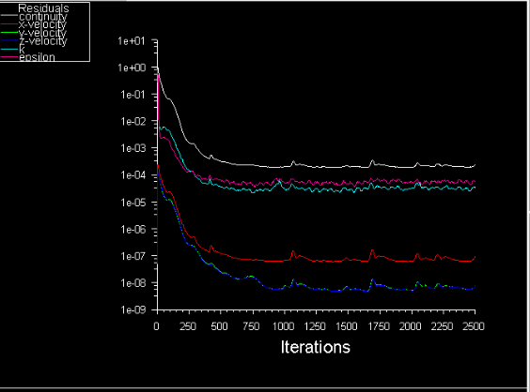
Figure 20 - Residuals

Table 11 - Domain Study Results
Test | cl | cd | Efficiency | % Difference cl | % Difference cd | %Difference efficiency
Given Data | 0.345 | 0.299 | 1.153846154
30% Less | 0.35722 | 0.34436 | 1.037344639 | 3.542028986 | 15.17056856 | -10.09679792
20% Less | 0.34975 | 0.3372 | 1.037218268 | 1.376811594 | 12.77591973 | -10.1077501
10% Less | 0.36401 | 0.3341 | 1.089524095 | 5.510144928 | 11.73913043 | -5.57457847
Lanfrit Full Car | 0.3585 | 0.3264 | 1.098345588 | 3.913043478 | 9.163879599 | -4.81004902
Lanfrit Half Car | 0.35633 | 0.32656 | 1.09116242 | 3.284057971 | 9.217391304 | -5.432590234
10% More | 0.35604 | 0.32993 | 1.079137999 | 3.2 | 10.34448161 | -6.474706756
20% More | 0.3624 | 0.334 | 1.08502994 | 5.043478261 | 11.70568562 | -5.964071856
30% More | 0.36564 | 0.33409 | 1.094435631 | 5.982608696 | 11.73578595 | -5.14891197

Table 12 - Global Mesh Study Results
Test | cl | cd | Efficiency | % Difference cl | % Difference cd | %Difference efficiency
0.08 | 0.34266 | 0.31282 | 1.09539032 | -0.67826087 | 4.622073579 | -5.06617224
0.1 | 0.345223 | 0.310158 | 1.113055282 | 0.064637681 | 3.731772575 | -3.535208937
0.3 | 0.34992 | 0.31948 | 1.09527983 | 1.426086957 | 6.849498328 | -5.075748091
0.5 | 0.35633 | 0.32656 | 1.09116242 | 3.284057971 | 9.217391304 | -5.432590234
0.7 | 0.35536 | 0.32937 | 1.078908219 | 3.002898551 | 10.15719064 | -6.494621044
0.9 | 0.35495 | 0.32949 | 1.077270934 | 2.884057971 | 10.19732441 | -6.636519065
1.1 | 0.349211 | 0.33102 | 1.054954383 | 1.22057971 | 10.7090301 | -8.570620104
1.3 | 0.36061 | 0.33093 | 1.089686641 | 4.524637681 | 10.67892977 | -5.560491141
1.5 | 0.35753 | 0.33166 | 1.078001568 | 3.631884058 | 10.92307692 | -6.573197451
1.7 | 0.3569 | 0.33143 | 1.076848807 | 3.449275362 | 10.84615385 | -6.673103421

Table 13 - Density Box Mesh Size Results
Test | cl | cd | Efficiency | % Difference cl | % Difference cd | %Difference efficiency
0.01 | 0.34341 | 0.29377 | 1.168975729 | -0.460869565 | -1.74916388 | 1.311229874
0.03 | 0.34324 | 0.29928 | 1.146885859 | -0.510144928 | 0.093645485 | -0.603225519
0.05 | 0.34864 | 0.30978 | 1.125443863 | 1.055072464 | 3.605351171 | -2.46153184
0.07 | 0.34489 | 0.30993 | 1.112799664 | -0.031884058 | 3.655518395 | -3.557362415
0.09 | 0.32675 | 0.32351 | 1.010015146 | -5.289855072 | 8.197324415 | -12.46535398
0.11 | 0.31813 | 0.317 | 1.003564669 | -7.788405797 | 6.02006689 | -13.02439537
0.13 | 0.31866 | 0.32216 | 0.989135833 | -7.634782609 | 7.745819398 | -14.27489446

Table 14 - Density Box Size Results
Test | cl | cd | Efficiency | % Difference cl | % Difference cd | %Difference efficiency
2nd box by notch 0.01 | 0.34095 | 0.29987 | 1.136992697 | -1.173913043 | 0.2909699 | -1.460632941
2nd box by notch 0.005 | 0.35749 | 0.29897 | 1.195738703 | 3.620289855 | -0.010033445 | 3.630687583
0.75x size | 0.35459 | 0.30059 | 1.179646695 | 2.779710145 | 0.531772575 | 2.236046886
1x size | 0.34324 | 0.29928 | 1.146885859 | -0.510144928 | 0.093645485 | -0.603225519
1.25x size | 0.35179 | 0.29867 | 1.177855158 | 1.968115942 | -0.110367893 | 2.080780348
1.5x size | 0.34815 | 0.29979 | 1.161312919 | 0.913043478 | 0.264214047 | 0.64711965
2x size | 0.3411 | 0.29866 | 1.142101386 | -1.130434783 | -0.113712375 | -1.017879863
Table 15 - Part Size Results
Test | cl | cd | Efficiency | % Difference cl | % Difference cd | %Difference efficiency
0.005 ahmed, 0.0025 feet | 0.35223 | 0.28731 | 1.225958024 | 2.095652174 | -3.909698997 | 6.249695451
0.01 ahmed 0.005 feet | 0.34324 | 0.29928 | 1.146885859 | -0.510144928 | 0.093645485 | -0.603225519
0.15 ahmed, 0.01 feet | 0.35463 | 0.31185 | 1.137181337 | 2.791304348 | 4.297658863 | -1.444284111
0.2 ahmed 0.015 feet | 0.37063 | 0.33454 | 1.107879476 | 7.428985507 | 11.88628763 | -3.983778721

Table 16 - Prism Layer Results
Test | cl | cd | Efficiency | % Difference cl | % Difference cd | %Difference efficiency
0 | 0.32913 | 0.28989 | 1.135361689 | -4.6 | -3.046822742 | -1.601986961
1 | 0.34475 | 0.30954 | 1.113749435 | -0.072463768 | 3.525083612 | -3.475048997
2 | 0.35595 | 0.30777 | 1.156545472 | 3.173913043 | 2.933110368 | 0.23394093
3 | 0.34324 | 0.29928 | 1.146885859 | -0.510144928 | 0.093645485 | -0.603225519
4 | 0.34252 | 0.299 | 1.145551839 | -0.71884058 | 0 | -0.71884058
5 | 0.35252 | 0.29834 | 1.18160488 | 2.179710145 | -0.220735786 | 2.405756296
6 | 0.35211 | 0.29813 | 1.181061953 | 2.060869565 | -0.2909699 | 2.358702579
7 | 0.37085 | 0.29767 | 1.245842712 | 7.492753623 | -0.444816054 | 7.973035016
3 on Car none on Road | 0.33936 | 0.29701 | 1.142587792 | -1.634782609 | -0.665551839 | -0.975724723

Table 17 - Edge Criterion Results
Test | cl | cd | Efficiency | % Difference cl | % Difference cd | %Difference efficiency
0.05 | 0.33788 | 0.2998 | 1.127018012 | -2.063768116 | 0.267558528 | -2.325105626
0.1 | 0.34427 | 0.29861 | 1.152908476 | -0.211594203 | -0.130434783 | -0.081265419
0.15 | 0.33555 | 0.29879 | 1.123029553 | -2.739130435 | -0.070234114 | -2.670772114
0.2 | 0.34324 | 0.29928 | 1.146885859 | -0.510144928 | 0.093645485 | -0.603225519
0.25 | 0.34538 | 0.29884 | 1.155735511 | 0.110144928 | -0.053511706 | 0.163744256

