
Student NAME: | Student ID:
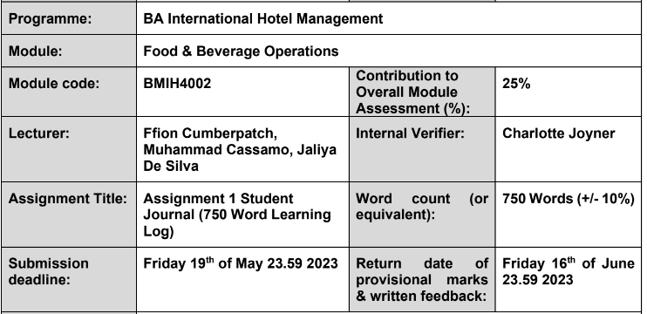

Learning Log: How Different Restaurant Concepts and Services Affect the Skills Their Employees Need to Succeed
According to a survey that was published by World Tourism, the restaurant business is responsible for 57.3 percent of the entire economic contribution that the hotel sector makes (Laudicina, 2019). As a result, the functions and duties that constitute a member of a restaurant's staff play an essential part in determining the level of success that an establishment has. Fast food joints coexist with more refined eateries, as well as caterers and other food service providers. The decor, food, and service at various dining establishments vary widely (Hayes et al., 2021). Therefore, the qualifications needed for a given job in the F&B industry may vary depending on the nature of the company and the service it provides. The purpose of this introspective essay is to examine whether or not an F&B worker's expected skill set varies with the degree of service provided by the restaurant.
Job Role: Restaurants are places where consumers may get ready-to-eat food and drinks, either on-site or via take-out and delivery (Ninemeier, 2019). The selected occupation for this work is that of a server. A server's duties include collecting orders, preparing and serving food and beverages, and interacting with customers.
Restaurant Types: The restaurant business is an important component of the hospitality sector, creating jobs and contributing considerably to the economy (Kivela, 2019). Furthermore, restaurants play an important role in the tourism industry by providing appealing food varieties that highlight local history and culture, which can attract foreign visitors (Farrell et al, 2021). Fast food restaurants and Dining restaurants were picked as the two sorts of restaurants to compare and contrast in this essay.
Necessary Skillset for the chosen role: A server must have exceptional skills in customer service, understanding of the item, the ability to perform multiple tasks at once, interpersonal ability, problem-solving talents, excellent scheduling abilities, and the capacity to collaborate with others (Gibson, 2021). They are responsible for directing the work of the workforce as a whole, supervising the kitchen, checking on food quality and safety, dealing with complaints from customers, and enhancing profits (Kotschevar, 2020). Furthermore, they are accountable for managing the restaurant's quality standards, making schedules, vetting requests for time off, determining staffing needs, promoting employees, and dealing with any legal or administrative issues that may arise (Walker, 2020).
Skills Needed by Servers at Various Restaurant: The ability to rapidly and effectively assist people is essential for a server in a fast food establishment (Kotler et al., 2020). The server's product expertise is essential for providing diners with up-to-date recommendations. Restaurant employees' duties and responsibilities are critical in providing a great customer experience and developing long-term connections with customers (Sing, 2021). Quick food servers need to be adept in multitasking, time management, and problem solving to keep up with the quick pace of the restaurant. Teamwork is also crucial in a fast food establishment since customers want prompt service.
Excellent customer service abilities are essential for a server at a fine-dining establishment in order to provide an unforgettable dining experience for each diner. Also, they check the food's quality before it has served and keep the kitchen's equipment in good working order (Grosz et al., 2020). The server's ability to provide informed suggestions to patrons depends on their depth of product knowledge, which includes the ability to combine foods and drinks. Because of the more personal atmosphere of fine dining establishments, the server's ability to read the table and anticipate diners' wants is crucial (Davis et al., 2020). A server's ability to multitask and keep track of many tables at once is crucial to providing prompt service to diners. Teamwork between the front-of-house (including the waiters) and back-of-house (including the chefs) is also essential in a fine dining establishment. Their expertise is crucial to the restaurant and catering sectors' profitability and development (Devine, 2020).
As someone who has worked in restaurants before, both as a server and as a kitchen assistant, I have first-hand experience with the many jobs and duties that are necessary for successfully operating a restaurant (Guilding, 2020). As a server, it was my job to take orders from guests, provide information in response to questions they had about the menu, and provide suggestions. I am knowledgeable about a wide range of cuisines and beverages, and I guaranteed that all of the clients' requests were fulfilled in a timely manner. In addition to serving, I was responsible for a variety of other tasks, including the handling of customer complaints, the compilation of invoices, and the processing of payments. Servers at quick food establishments and those in fine dining establishments need quite different sets of expertise.

Reference
Davis, B., Lockwood, A., Alcott, P. and Pantelidis, I.S., 2020. Food and beverage management. 6th edition, London: Routledge.
Devine, J., 2020. The Handbook of Contemporary Hospitality Management. 2nd edition, Abingdon: Routledge.
Farrell, B., Rennie, C. and Robinson, R., 2020. Food and Beverage Cost Control. 6th edition, Hoboken, NJ: Wiley.
Gibson, H.J. 2021. Food and Beverage Service: A Training Manual. 4th edition, Abingdon: Routledge.
Grosz, S., Hemphill, T.A. and Zahn, M., 2020. Modern Hospitality: Simple Recipes with Southern Charm. 1st edition, New York: Stewart, Tabori & Chang.
Guilding, C., 2020. Financial Management in the Hospitality Industry: An Introductory Guide. 3rd edition, Abingdon: Routledge.
Hayes, D.K., Ninemeier, J.D. and Miller, A.I., 2021. The Restaurant: From Concept to Operation. 8th edition, Hoboken, NJ: Wiley.
Kivela, J. 2019. Handbook of Hospitality Marketing Management. 2nd edition, Abingdon: Routledge.
Kotler, P., Bowen, J.T., Makens, J.C. and Baloglu, S., 2020. Marketing for Hospitality and Tourism. 8th edition, London: Pearson.
Kotschevar, L. 2020. Management by Menu. 6th edition, Hoboken, NJ: Wiley.
Laudicina, P.A., 2019. World Class: Thriving Locally in the Global Economy. 3rd edition, New York: McGraw Hill.
Ninemeier, J.D. 2019. Managing Food and Beverage Operations: A Handbook for Hospitality Professionals. 6th edition, New York: Pearson.
Singh, H. 2021. Food Safety Management System in Food Processing Industry: A Comprehensive Review. Critical Reviews in Food Science and Nutrition, 61(4), pp.611-628.
Walker, M.D., 2020. The Hospitality Industry Handbook on Hygiene and Safety: A Practical Approach. 2nd edition, Abingdon: Routledge.

