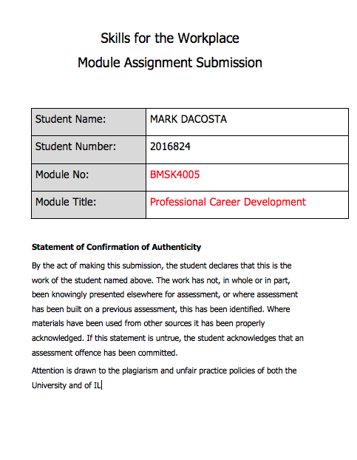
Table of Contents
Introduction 4
Section 1 Professional Career Development 5
Know how to identify development needs 5
Self-assessment 6
VARK assessment 6
Analyze learning/development options to meet needs of another. 8
Comparing learning styles 9
Honey and Mumford assessment 11
Assessment conclusions 12
Section 2 Strengths and Weaknesses 15
SWOT analysis for my colleague 19
SMART objective 22
Stephen Covey’s Matrix 23
Johari Window 24
Personal development Plan 25
Section 3 The Recruitment Process 27
Reflection models 28
The Experiential Learning Cycle 28
Conclusion 31
References 32
Appendix A 33
Appendix B 39
39
40
Appendix C 41

Introduction

In this assignment we will look at how to identify development needs through self-assesment and learn techniques we can use to resolve barriers to learning.

Also, we deal with strengths and weaknesses and use good tools to help turn weaknesses into strengths.

Finally, we will reflect on the recruitment process and how I would recruit myself based on these reflections.

Section 1 Professional Career Development

Know how to identify development needs

In a competitive world that is constantly changing, it is important that you strive to be the best that you can be. Great employers are always looking to employ the best candidates for a job, so you need to be one of the best to be employed by them. This often requires development, which only you are responsible for.

The first step to self-development is self-awareness. You really need to know yourself, your preferences, needs and desires. To develop you need to know where you need to develop and how best to develop and also what methods of development you are going to use. You can only know these things by knowing yourself and being aware of your strengths and weaknesses.

You also need to have a clear perception of your personality, attitudes and behaviours.

Your personality will dictate what you like and dislike. Would you be motivated to pursue something you disliked for example? If you tried to develop in an area you disliked, you would probably lose motivation when it became difficult.

Your attitude is also important to assess and be aware of. Do you have negative attitude towards change? This would need addressing before you start to develop yourself for example. Your attitude has a huge impact on how you apply yourself to any given task, so to be aware if you have the right attitude to succeed is vital.

You must also be aware of your behaviours as these can detract from your progression in development. Do you like to party? Or do you procrastinate? These behaviours and many others would stifle your development if they are dominant in your day to day life.

Self-assessment

Self-assessment is the basis for good development because it tells you what tools you have to work with and what potential pitfalls lye ahead.

Based on a Harvard business review article in 2015, there are 5 ways to improve self-awareness.

- Meditate
- Write down your key plans and priorities
- Undertake psychometric tests and profiling
- Ask trusted friends
- Get regular feedback at work

I will be focusing on option 3 for my self-awareness assessment.

We will look at two models that help you to assess your learning style for both a colleague and me.

I will use these two assessments to identify areas of development and create a personal development plan based on the findings.

VARK assessment

VARK (Fleming, 1987) is a recognised model for identifying your learning style.
There are four categories in the VARK model, which are Visual, Auditory, Read/Write and Kinaesthetic.

After completing the VARK questionnaire my personal results are shown below:

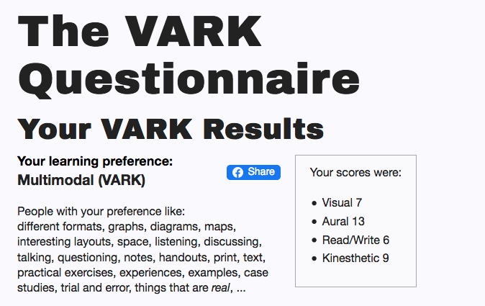

As shown above I am classified as a Multimodal learner, which I perceive as fairly accurate. It breaks me down as high auditory learning at 13 points but also 9 for kinaesthetic, 6 for Read/Write and 7 for visual.

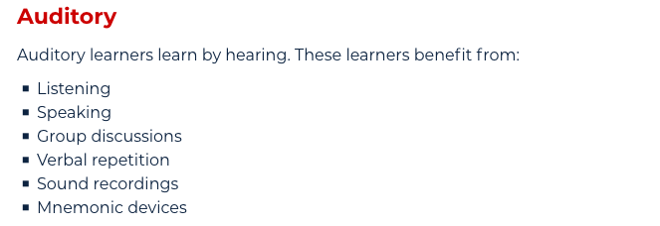

From the Auditory category I agree that I learn well from speaking, listening and group discussions. For example, I like doing work meetings on teams as I often find others ask questions you are thinking or questions you didn’t think of. This helps you get a fuller understanding of what is being discussed.

I also learn a lot from sound recordings like podcasts. I often listen to debates and talks on subjects I want to learn more about and audio books for novels I want to read.

Analyze learning/development options to meet needs of another.

Now that I have analysed my learning styles for myself, it is important to do the same for another person to help them learn and de
velop too.

I asked a colleague to complete the VARK questionnaire to assess their learning styles, which yielded the following results.

- Visual 1
- Aural 8
- Read/Write 5
- Kinesthetics 9

Looking at the results I think it is fair to say that the results are pretty much spot on with the Kinesthetics and aural evaluation. My colleague is very hands on and very vocal when in a learning situation.

She likes to participate in physical activities and is always one of the first to get involved if volunteers are requested. She is very vocal and always asks if she doesn’t understand things or gives an example of a given subject to check if her understanding is correct.

I would have thought her visual score would be higher though as she does seem to take information in better visually than she does from written instructions.

However, she is fairly adept at written instruction also, so I don’t think the Read/Write score is low in any way.

Comparing learning styles

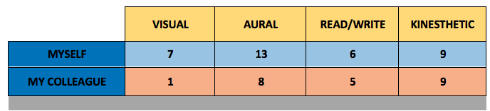

Comparing to my colleague, statistically I would have put her aural learning higher than mine and would not have my kinaesthetic score as high as her.

In reality she is a lot more vocal when learning and a lot more interactive than me too. An example of this is whenever we are training together she always asks more questions and is has more physical interaction in sessions. I am more reserved and think more deeply about information.

This matches my assessment of the scores being individually inaccurate in her visual and aural area’s being a little low. The comparison highlights this fact when the statistics are put side by side.

Honey and Mumford assessment

Honey and Mumford is the second self-awareness assessment that I completed.

My results are shown in the table below:

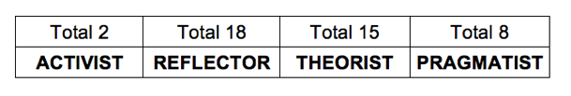

Reflector
- Students think deeply about what they are hearing
- They like things to be tried and tested
- Tend to be reserved

I scored 18 as a reflector, which again is fairly accurate, as I do tend to think deeply about information, and I can tend to be a little reserved. I do tend to read reviews a lot before I make any purchases so in that sense I do like things to be tried and tested. Again, I do feel the score is slightly high as these characters are not my dominant characteristics, but they are definitely correct.

In summary my learning styles are varied, and I don’t learn by any single method individually. This means that I have a wide range of learning opportunities that gives me a good basis for learning new skills and subjects.

My colleagues’ results are shown below:

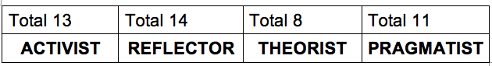

My colleague also gave a reflector result. Knowing my colleague well, I would say this is not very accurate. She is not reserved, nor does she need things tried and tested. She tends to learn vocally and likes to try new things.

In a lot of ways, she is the complete opposite to a reflector. I don’t think she would agree with the assessment either.

Finally, I completed the Dantec questionnaire which gave me a result relating to a visual learner.

Again, being a multimodal learner, visual learning is something I do learn from quite well.

Assessment conclusions

I primarily learn from auditory and kinaesthetic means, but I like to take time to digest information before applying it. Discussing new idea’s and projects is my preferred learning technique when it is backed up with written documentation.

As a union rep I often discuss changes and updates to company policies in hour weekly meeting, and we are able to ask what the changes mean in practice. I find learning this way useful as people often ask questions you did not think of giving you a fuller rounded knowledge of how the change will impact you. These policy changes are backed up with written documentation, which gives an opportunity to recap what was learnt, and reference it later on.

I find this way of learning easy to absorb and useful especially for organisational changes as it allows me to investigate the implications of the changes before they happen which helps me learn what is expected before hand.

I do also learn visually as confirmed by the Dantec assessment and I also scored 7 in visual on the VARK assessment.

Visual learning, I find more useful for things like learning new systems and more practical tasks. The visual picture it paints is important for my mind to be able to reproduce what I have learnt moving forward. If I have instructions in word form I can struggle to visualise them in a practical sense.

I believe I was classed as multimodal on VARK as I learn differently based on what I am learning, be it academic or practical. In certain situations, I would prefer auditory learning but in other situations visual learning. I generally agree with this assessment.

On the Honey and Mumford, I was highest as a reflector, which is characteristically accurate, as I do think deeply about things and I am reserved, but I feel these reflect my personality rather than my learning style.

It is important to be self aware of your learning styles as it will help you identify the best way to learn new skills. If you can match your learning style with any training programme you have to undertake, it will increase your ability to gain new skills which is important to your continual progression.

The VARK results for my colleague was fairly accurate but a little low on the aural score but her Honey and Munford score of a reflector I feel was inaccurate and the opposite to how she would actually learn.

However, these are good forms of self-assessment and gives the individual some data to work with.

Having a written profile of your learning style is important as the documentation of your attributes provides a good basis for making changes.

It is also very important for a manager to know their staff and what learning style each one would find most beneficial. This is important to get the most out of each individual and give everyone the best opportunity to pick up what is being trained.

Another important self-awareness technique is to assess your strengths and weaknesses. I have also looked at these in detail in order to improve my skills and also the skills of my colleague.

In the following section we will look at strengths and weaknesses and how they affect our development.

Section 2 Strengths and Weaknesses

Identifying your strengths and weaknesses is an important step to improvement.
You need to have a clear perception of your personality attitudes and behaviours, which allow you to better understand yourself and others around you.

SWOT can be used for a person, project or even organisation to understand what you need to address to achieve success.

I will use SWOT analysis to better understand what I do well and what areas may need improvement, so in this instant I have completed a SWOT analysis on myself to help identify improvement areas.

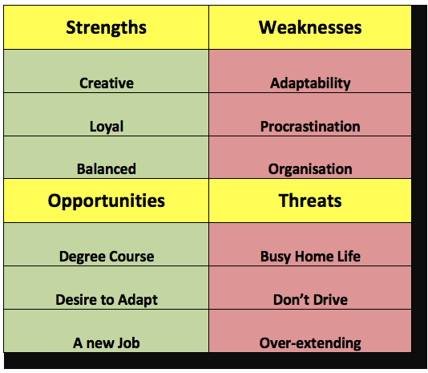

Strengths

Strengths are important as they can give you advantages over others.

By identifying things, you can do which others can’t, not only helps you personally to be a step ahead of your rivals in a competitive environment, but also helps in a team environment as it will, based on those individual strengths, identify who to give specific tasks to.

You may have access to persona resources that others may not. One of my strengths which is creativity would give me an advantage in producing new material, whether this be artistic ideas or new ways of looking at a situation.

In a project for example this would be a valuable asset.

How others see your strengths is also important. Your boss for example may approach you based on your strengths. For example, my loyalty strength means I am approached to help resolve sensitive problems in my workplace.

When a matter requires confidentiality a loyal member who can be trusted would be used to gain a resolution rather than someone who is likely to divulge sensitive information.

Also, that person would need to be balanced and not promote ideas that are based on self-interest or bias. Again, with one of my strengths is me being balanced and fairly objective with situations, I am often approached for an impartial opinion or position.

Weaknesses

Weaknesses are also important, as they are potential areas of improvement. The best way to handle weaknesses is place them into your opportunities box and work on an action plan that will turn them into strengths

My weaknesses I have listed are all interlinked and therefore gives me a good opportunity to resolve them together. My adaptability, procrastination and organisation shortcomings are mainly all due to a lack of organisation. Therefore, my goal is to resolve my poor organisational skills that would help me adapt to new things by having a structure to help new ideas/projects bed in.

Also, being organised would help with procrastination that is generally due to being un-organised and relying on spur of the moment decisions.

In another section I will go through a plan to implement these changes.

Opportunities

Opportunities are potential avenues to improving your current situation by focusing on areas you can develop as mentioned previously as weaknesses.

Opportunities are not only restricted to developing weaknesses, you may also have opportunities to develop in other areas like furthering your skills through education and training.

I have started a degree course focusing on skills for the workplace as I see this as an ideal opportunity to develop my existing skills and gain new skills to help my development.

I also have a strong desire to adapt to a different job role than the one I currently occupy. I see this as an opportunity as my current job has changed over time and has become a different job that does not suit my skillset. As a result, I have developed a strong desire to learn new skills that will allow me to change to a new role that is more suitable.

Threats

Threats are internal and external pressures that could hinder your progress and development.

My main threat I see as family commitments, due to having a large family. This often leads to little spare time to study and develop. A fast-paced home life may stop assignments being completed on time. This often leads to procrastination as mentioned in my weaknesses as it is very easy to put off study and development when there are a lot of people needing your attention all of the time.

Also, this could lead to over extending myself if I make to many commitments in too many areas. It is important to be organised to maximize my time. Not doing this would make it feel like there is not enough time to do everything. I will look at prioritizing time in another section.

Not having a driving license is another potential threat as it could limit job opportunities that require me to travel. An obvious solution is to pass my test, but this would also need to be time managed so as not to over book myself and leave me short of time.

SWOT analysis for my colleague

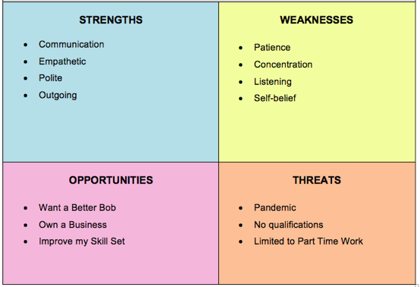

I have asked my colleague to do a SWOT analysis also yielding the results shown above.

Strengths

On analysis I have identified that the strengths of my colleague do lend themselves to a leadership role. She has good communication skills which is important in a leader, but she is also empathetic and polite, which is also important when communicating with colleagues especially in difficult conversations.
Being outgoing she is also able assert herself in a leadership position, and actually her weakness of impatience could become a strength if she uses it to drive results and hold high expectations.

Weaknesses

Being impatient can also be a detriment if it turns to frustration or expresses itself as petulance and would need to be worked on. Concentration and listening are both related I believe. Not concentrating on someone else’s dialog leads to not listening. I don’t think her weakness in listening is a lack of ability but more down to her love of speaking.

The lack of self-belief maybe more complicated to remedy as it could be due to subconscious and historical issues. My colleague always second guesses herself even though she knows what she is saying.

Opportunities

My colleagues’ opportunities of a better job and to own a business are certainly achievable. Working on her weaknesses and improving her skill set will go a long way to achieving these opportunities.

Threats

Her threats of pandemic and part time work limitations will dissipate with time. As the pandemic passes and her children get older she will naturally gain freedom from these constraints.

Her lack of qualifications will also be remedied over time but through hard work on her current academic qualifications.

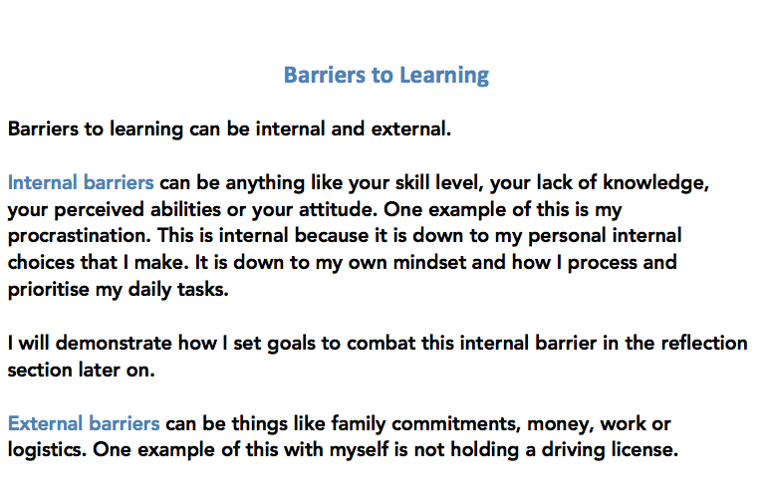
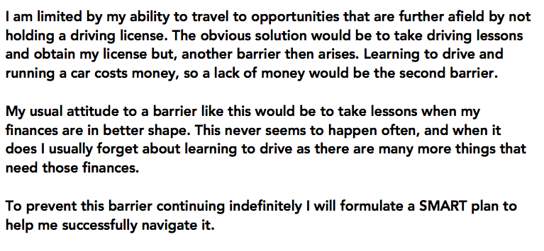

SMART objective

My plan needs another development tool namely the SMART objective, which would yield some clear definitive goals.

Specific – I must be clear about the objective, for example I need to save money to fund my driving lessons.

Measurable – I will need £800 to pay for my lessons, theory and driving tests. I plan to start these lessons in February by which time I will need £600 to cover my lessons which means saving £300 per month.

Agreed – I need to agree with family members that this is the right time to save and that it won’t put us in financial difficulty as this is a potential barrier that could stop my plans before they complete.

Realistic – I need to ensure that it is a realistic goal and the timescale to save the money isn’t unrealistic with Christmas around the corner. My grant will help me support the family whilst I make these savings.

Time-bound – There must be a time limit, so I can measure my progress and give some pressure to the delivery of this task. I want to be driving in 8 months’ time.

In order to develop, whether it be turning a weakness into an opportunity or identifying a threat to nullify its potential impact, or overcoming barriers, you must have a strategy you can implement in order to produce the desired results.

You need to reflect on any given situation to assess what is happening and what you need to about it.

Stephen Covey’s Matrix

A useful tool for reflection is Stephen Covey’s Matrix as it highlights where your time is spent.

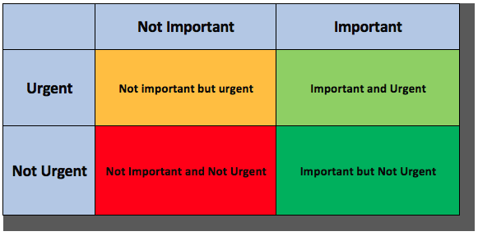

With one of my weaknesses being procrastination, this tool is very useful to me. It allows me to categorise what I am doing with my time by placing all my daily activities in the correct category.

Once I have ordered my activities into the appropriate priority, it is then easier to shave off unnecessary activities giving me more time.

This is important for me as my procrastination is not from sitting around doing nothing but by putting things off when I have a lot of other things to do. It tends to be the important but non-urgent things that I end up putting off as they are often difficult or time consuming. This then means they end up shifting to the important and urgent category later, but then important/urgent things become rushed and less thought out and therefore suffer as a consequence.

The matrix gives more balance to my tasks and I find even the non-important non-urgent tasks are more enjoyable as they are done with less guilt and dread.

Johari Window

Another important skill for self-reflection is to be honest with yourself and this should involve gaining others opinion of you. A helpful tool for this is called the Johari Window created by physiologists Joseph Luft and Harrington Ingham (1955).

It gives you a four-pain window (shown below) for you to place your characteristics in and allows you to view potential blind spots.

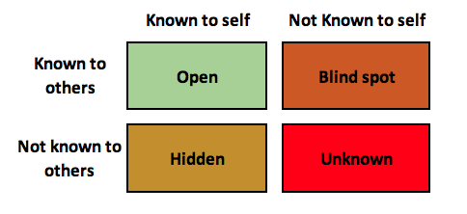
By placing things about yourself in the different boxes you can have a platform by which to open up to others and ask questions about how they view you.

This way you can identify any blind spots you may have that others can see but you cannot. It also helps you identify hidden characteristics, things you know that others don’t. If you have problems in these areas, then you may need to open up about them and gain help.

Personal development Plan

Now we have done a comprehensive assessment of our learning styles, strengths and weaknesses and self-awareness, we need to create a personal development plan or PDP to have an action plan for development.

I have chosen two areas for myself and two areas for my colleague to target for improvement. The action plan will give concrete steps to better our development in these areas.

My PDP is shown below.

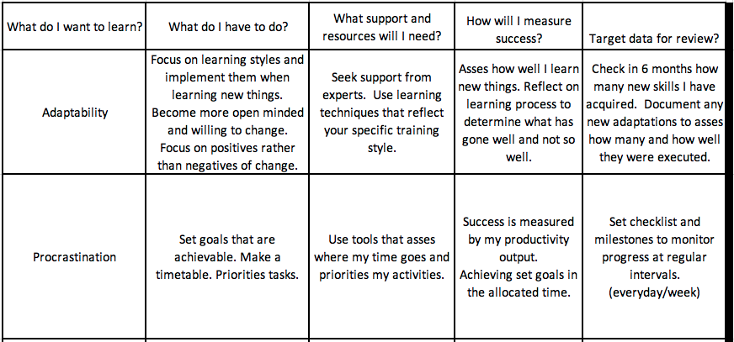

It is important to you highlight what you need to change, what you need to do to change it, what support and resources you need and how you will measure success and review the process. The plan is important as it gives you structure to your goal as it is difficult to make improvements without steps to success.

I have created a PDP for my colleague which is shown below.

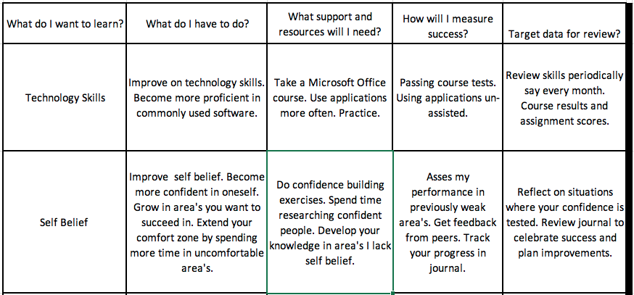

In both PDP’s I have taken the learning style of the individual into consideration when deciding what steps are needed.

An example of this is in my colleague’s PDP to increase self-belief. I have specifically used confidence building exercises and getting feedback from peers as these are kinaesthetic exercises.

I also made sure the plans were positioned to bring the best out of the individual.

For example, in my plan to combat procrastination I have made a point of goals being achievable and to use tools that map time usage. An unrealistic goal for someone who procrastinates is extremely off putting but giving more time by eliminating time wastage would encourage task completion.

Section 3 The Recruitment Process

Reflection models

To conduct a good recruitment process it is important to reflect on previous processes you have gone through and use those experiences to shape a process you would like to go through yourself.

A reflection model is a useful tool in this situation. It allows you to assess what has happened, what you need to change and what you need to do moving forward.

Or as highlighted by Terry Barton (1970) What? So, what? Now what?

The Experiential Learning Cycle

One such reflection model called “The Experiential Learning Cycle” (David Kolb and Ron Fry 1975) is shown below:

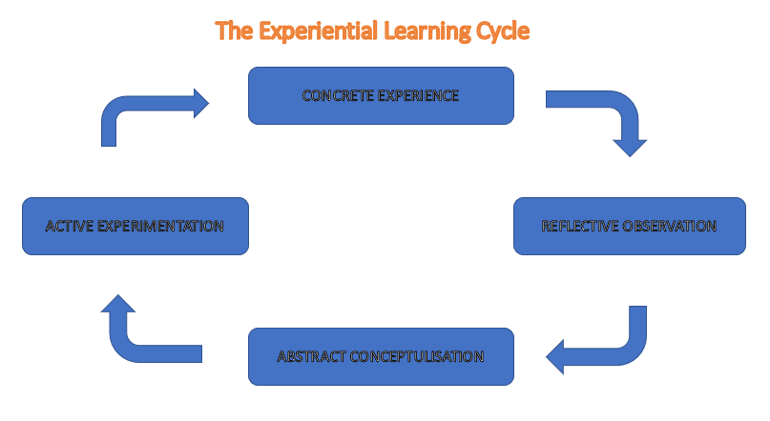

I have used this reflection model to asses a recruitment process I went through to try to discover what a good recruitment process would look like.

Concrete experience

I went for an interview for a sales role in a large organisation. I firstly went through an employment agency and had to have typing, arithmetic and English tests there. On successfully completing those tests I was offered an interview at the business itself.

At the interview I was sat in a room with other applicants and we were called in one by one to have an interview.

The interview was in a glass room with two managers. One interviewing the other taking notes.

I was advised after the interview that I did well and would receive a call in 24 hours if the position was to be offered to me, which it was.

Reflective Observation

I found the employment agency process tedious as it was almost an interview before the interview with a set time to travel and do tests which were not for the actual role itself.

The interview process was drawn out as it resembled a doctor’s waiting room, like watching other patients going in and coming out of the doctor’s surgery before you were called. This gave me an odd feeling that didn’t feel like I was applying for a job.

The interviewer was pleasant and made feel comfortable and relaxed however I felt like I was in a gold fish bowl with the room being glass and current employees staring in as they walked passed. This was uncomfortable and distracting.

Abstract Conceptualisation

Even though I appreciate the employer had reasons for doing the interview process the way they did, I think I would change a few things so as to improve the experience of the employee.

Firstly, I would do away with the employment agency that caused extra hoops to be jumped through. I understand this is to ensure a certain standard of applicant and weeds out a lot of vetting for the employer, but it doesn’t seem to produce the calibre of applicant that they were seeking.

I would allow applicants to apply direct and use tests or scenario’s that relate directly to the job if aptitude tests were required.

Secondly, I would revert to more conventional interviewing process with allotted time slots for each applicant to improve the experience. I think waiting around for extremely long periods causes anxiety and frustration.

It also shows that the employer does not value the applicants time which could lead to applicants choosing another job offer from a company that gave them a better experience.

Active Experimentation

I would oversee the process changes to ensure they were implemented properly and monitor successful applicants to see if they met the criteria the employer was looking for.

I would look at early attrition statistics and get feedback from management about the competency of the applicants. I would then use this information to re-asses the recruitment process.

If applicants were not competent for example I would adjust the job description to insist on previous experience for example. Or if there was high attrition I would instruct interviewers to probe more on long term aspirations of applicants to try and identify applicants who saw their future with the company.

Conclusion

I have discovered the learning styles of myself and a colleague and the looked at weaknesses in us both. Using a PDP, I have addressed those weaknesses and set up a documented strategy to improve on them or even turn them into strengths.

I have used the Johari Window and the Stephen Covey Matrix to address my procrastination and have a clear plan to avoid this moving forward.

I have reflected on a recruitment process and highlighted areas where I feel the process could be better.

I think the recruitment process in general should be as simple as possible, unless you wish to weed out applicants who are not prepared to go through a complicated process as part of the recruitment process.

Also, I think the company should be as punctual as possible and provide individual interview times again unless having multiple applicants in at the same time serves a purpose in the application process.

Finally, I feel any tests or assessments that the applicant has to undertake should be relevant to the job or at least relevant to the company and not generic or undertaken by a third party. This should save costs and make recruitment more efficient.

References

Anthony K. Tjan, Harvard business review 2015
Stephen Covey, The Seven Habits of Highly Effective People
Joseph Luft and Harrington Ingham (1955).
Honey, P., and Mumford, A.(1982) ‘Manual of learning styles’ London: P Honey
Fleming, N. (1987) ‘Vark’ New Zealand
Dante’s, C., Diouri, M., Goodchild, L. (2006)’Dantec’ Southampton: University of Southampton.
Humphrey, A. (1960) ‘SWOT Analysis’ California: Stanford University
Morgan, P.(2017) ‘The Business Students Guide to Study and Employability’ London: SAGE (PDP, SMART)
Kolb. D. A. And Fry, R. (1975) ‘Toward an applied theory of experiential learning’,in C. Cooper (ed.), Theories of Group Process, London: John Wiley

Appendix A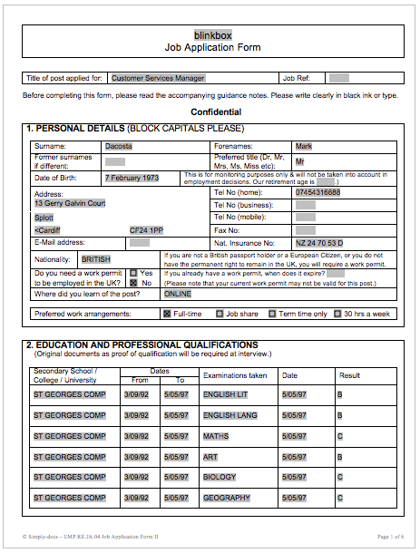

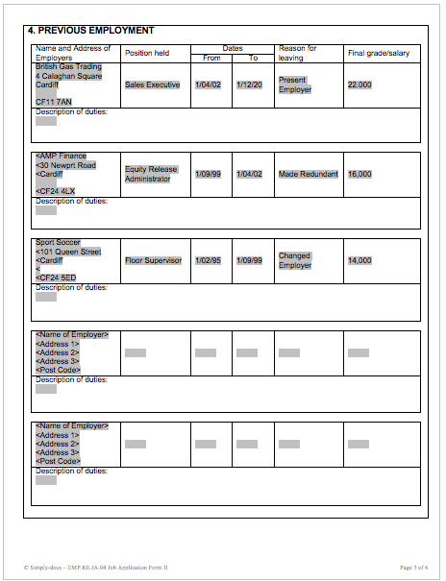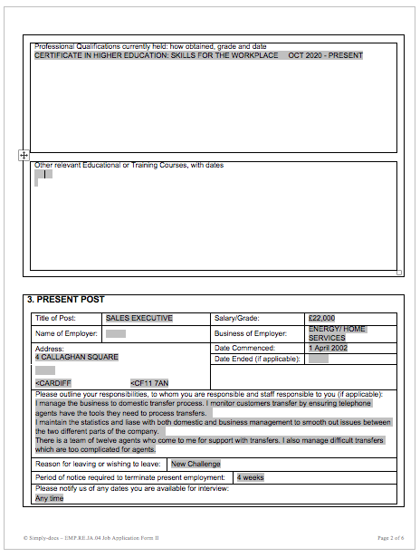

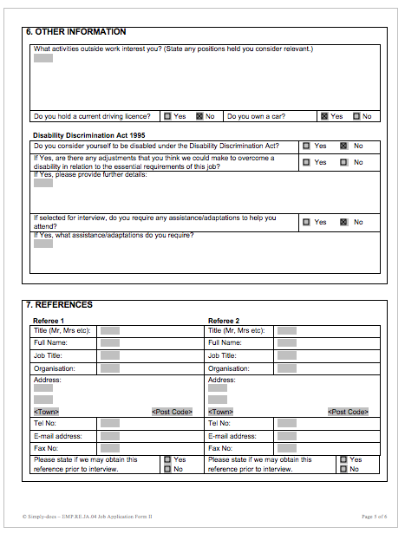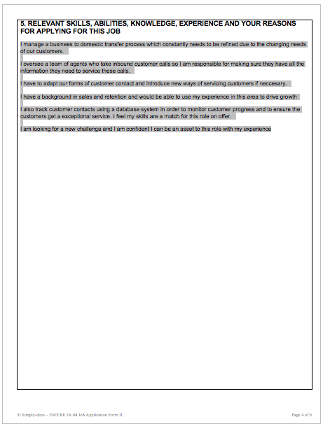

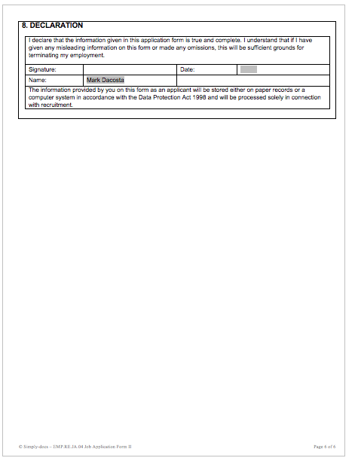

Appendix B

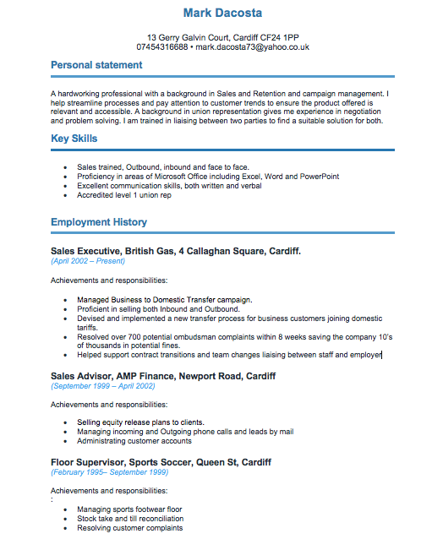

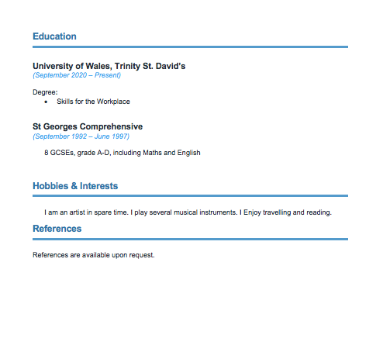

Appendix C



