University of Wales Trinity Saint David London
Design and Prototype Development of a Mobile Application for Comparing UK Supermarket Grocery Prices:
Smart Shop

Md Gulam Hafiz (2232603)
[Date]

Table of Contents
Abstract: 3
Introduction: 4
1.1 Problem statement: 6
1.2 Aim: 6
1.3 Objectives: 7
1.4 Research Question: 7
2. Research Background and Logic: 8
2.1 Proposed contribution: 9
3: literature Review & context: 9
3.1 Pressure of UK grocery cost: 9
3.2 Price comparison & Unit Pricing: 9
3.3 Mobile commerce & consumer behaviour: 10
3.4 Product identification using GTIN or Barcode: 10
3.5 Usability & User Experience: 11
3.6 Accessibility and Inclusive design: 12
3.7 Privacy, Security & Trust: 12
4. Methodology: 13
4.1 Research Methods [6],[8],[10]. 14
4.2 Ethical Method: 15
5.Requirement Analysis: 15
5.1 Stakeholders: 16
5.2 Functional Requirements: 16
5.3 Non-Functional Requirements: 17
5.4 MoSCoW Prioritisation: 19
Software Development Life cycle (SDLC): 20
Fig: Waterfall Model 20
Fig: Iterative Agile Model: 21
6.1 SDLC Phases: 21
6.2 Why Iterative Prototyping is suitable for this project: 22
6.3 User Stories: 23
7.Proposed Gantt Chart: 24
Figure 1: Project Gantt chart. 24
8. System Design & Architecture: 24
Figure 2: Proposed Smartshop system architecture. 25
8.1 Architecture Explanation: 25
8.2 Data Model 26
Figure 3: Product, retailer, price record, shopping list & budget entities prototype data model. 26
8.3 Data Integration Strategy: 27
9. User Experience Design and Wireframes: 27
9.1 Designing Tools: 28
9.2 Design Principles: 28
9.3 User Personas: 28
9.4 Wireframes: 29
9.5 User Flow 34

Abstract:
By the name of Smart Shop this project investigates how to design, develop and implement a prototype mobile application. The aim is to help UK consumers those who do not like visit multiple retailers’ website or app to compare the price of their desire groceries. The proposal pointed the real issues that customer face. It is very hard and time consuming especially in this time of high cost of living crisis when you need to take make quick decision to plan your grocery budget. Smart shop offers the solution of this problem by a single mobile first interface where product search is based on barcode or GTIN, price comparison, making shopping list, budget tracking, showing offers and suggestion for an alternative cheaper option are also included [1]-[4].
This project follows an iterative software development life cycle (SDLC) where requirement analysis, human-centred design, wireframing, prototype implementation and evaluation has been integrated. In this report secondary research, observation-based reasoning, competitor analysis, privacy-by-design principles, accessibility guidance and mobile usability heuristics has been used. The protype has been implemented as a progressive web App (PWA) because this technic supports iOS and Aneroids’ modern smartphone brewers where user can install in their suitable devise [4].
It is supported and can work in offline condition after loading first time. For the academic demonstration this prototype uses mock supermarket data because to use the retailers live you need to have authorised data feeds, contracts or approved APIs [4], [10].
The result is an effective cross-platform prototype with full design specification. The report provides the logic that a grocery-specific app can help create awareness, reducing the time, and making household budget if data quality, retailer compliance, accessibility, security and transparent privacy control are not put as an option but a mandatory design requirement [1], [4], [7]-[8].

Introduction:
It has become one of the concerning issues among the UK resident, increase in cost of grocery shopping. Food, household products and personal-care items are bought more frequently, for this reason weekly/monthly price differences can be very important facts. The main proposal of this project has already been accepted that consumers can compare the prices among the major supermarkets [1],[2],[5]-[6] but the way is difficult because every retailer has their own app, website, offers and loyalty system. For this reason, the proposed project is a smart mobile application centred which brings together grocery price comparison-shopping-list creation and budgeting [1]-[4].
price comparison is not a something new digital concept in the market, consumers are already used with the comparison app for electronics, insurance, travel and household services but grocery price comparison is more critical because products are sold in perishable, frequently promoted, different pack sizes, loyalty schemes influence the prices and usually substitutes the products by own-label alternatives, so a grocery comparison app should not only show the price of the products but it need to be more than that, it need to be able to make the user understand that whether the products are really comparable, unit price is authentic and cheaper option are real substitute and finally all the products and prices are under the consumers weekly or monthly budget [1]-[3],[5].
The project is consisting of research, design and software implementation as it is an undergraduate project, and the practical deliverable is the prototype named Smart Shop.
This prototype has not been developed in the interest of commercial perspectives rather than to check the feasibility of the project with realistic mock data and mobile-first Progressive Web App. It explains the foundation of desirable academic research, problem analysis, requirements, system architecture, user interface design, software development life cycle, testing strategy and evaluation plan [1],[4],[6],[10].
The report also reflects the limitation of the prototype. In the production environment, authorise sources are needed for live data, robust update mechanisms, retailer agreements, legal review and quality controls. For this reason, prototype design is kept separated from the retailer integration which is a necessity for the academic projects, ethical and legal distinction [1]-[2],[9]-[10]

1.1 Problem statement:
In this project the main highlighted issue is that in UK consumers do not have such a simple grocery-focused, mobile-first tool where in one place more than one retailer’s product price can be compare for common products. Currently to check or compare the product price among the retailer’s customer need to open individual apps for each store and search repeatedly for the similar products and to check which shop is cheaper they need to go physically to that store. It is inefficient and specially for families with low household income, students and busy workers those need clear and fast information before their shopping trip [1],[3]-[5].
The second part of this problem is product matching. Same product may be sold by different retailers but due to brand size, packaging unit, loyalty price and difference in availability may also mislead the comparison. Therefore, a valid digital solution needs to be supported by GTIN, barcode data, pack size and for example product identifier such as unit price. The project offers a matching approach where, if possible, to use GTIN and for alternative a normalised product attribute will be used combinedly [5].

1.2 Aim:
The aim of this project is to design a prototype smart mobile application and develop which will help the users to compare the grocery products among the UK major supermarkets, creating shopping lists, budget tracking, and with using a simple mobile interface can identify the cheaper alternatives [1]-[2], [4], [6].

1.3 Objectives:
- Review the existing grocery shopping price comparison and mobile commerce literature [1]-[2],[4]-[5]
- Identify user needs, functional requirements and non-functional requirements for a grocery price comparison app [1]-[2],[5].
- Using free design tools and accessible design principle design a mobile-first user experience [1],[4],[6]-[7].
- Creating a realistic development plan for wireframe, system architecture and data model [1]-[2],[6],[10].
- Develop a cross-smartphone prototype using free and open web technologies [1]-[2],[4],[10].
- Evaluate the prototype by usability test, test cases and future participant-testing plans [1]-[2],[6],[10].
- Discuss about privacy, ethics, UK GDPR, data minimisation, security and limitations [1]-[2],[8]-[9].

1.4 Research Question:
Guiding research question: How to design a smart mobile application and a prototype that will help to compare the price of grocery across the major UK supermarkets and for everyday grocery shopping it will indicate the low-cost alternative for the consumers [1]-[2],[4],[10]?

2. Research Background and Logic:
Grocery shopping is a regular financial significant activity for the consumers. Grocery shopping usually repeats weekly or monthly rather than occasional purchase that accumulate small saving with the time. Due to inflation and high cost of leaving user may change retailer, products pack size and brand to manage their household budget [1]. A digital tool can have a high practical impact on finding the cheaper option in less effort & time [1]-[2],[6],[10].
Mobile solution is more logical because shopping decision usually come to mind when the consumer is away from desktop. Some user may on their way to shopping, standing on the aisle, time of checking promotional leaflet or to update the shopping list at home. A mobile first application is relevant with this context. It should have support minimum typing, search and barcode entry. Clear presentation of price, no unnecessary account creation and should also have plain language. Interface should not assume that all users are technically smart to handle the app [3]-[6].
The project has also academic logic. It allows software engineering, user centred design, database design, privacy and security principles application. This is a realistic case study of grocery price comparison app because it has multiple stakeholders, uncertain data source, legal consideration, usability challenges and measurable output. For all of these reason it is really a suitable undergraduate project where to show the research understanding and development capabilities [2],[6],[8]-[9].
Another rational is that the gap between general price comparison website and grocery price comparison app. Generally other comparison website or app deal with electronics good, insurance brokers and holiday planning but grocery app is different because products prices depend on variety of criteria, like pack size, unit price, loyalty scheme ams substitute etc. The smart Shop app focussed on practical problem domain [1]-[3],[6].

2.1 Proposed contribution:
This project is not something new pricing algorithm rather than for grocery price comparison application a practical design and prototype framework. Among the contribution, structured requirements specification, mobile-first UX design, for future real data integration a system architecture, prototype PWA and evaluation plan. By maintaining the clear difference between mock data and production data collection this project contributes ethical development approach [1],[4],[6] [10].

3: literature Review & context:

3.1 Pressure of UK grocery cost:
It is still one of the great concerns among the public in UK is cost of food price. Recent official inflation statistics and food price monitoring show that after the severe cost -of-living period food and alcoholic beverage price are same and did not change in some cases that has increase little bit [1]. The key point of this project is not a single monthly rate rather a transparent price information for running consumer need. When consumers feel the pressure of financial difficulties, they look for own-Lebel alternatives, loyalty offers and switching the retailer strategies [1],[3].

3.2 Price comparison & Unit Pricing:
Consumers decision improved if the displayed information is accurate, comparable and understandable. In grocery shopping unit price very important because pack seems expensive but by unit price it is cheaper than a single unit [2],[3]. In grocery sectors Unit price has been considered by Competition and Market authority because it helps the consumers to compare between unit pricing and different packet sizes and it also support the project requirements that Smart shop will display both item price and unit price. In prototype unit price is simplified but in design, future unit price is kept as normalisation service [2],[3].

3.3 Mobile commerce & consumer behaviour:
Mobile commerce has changed the way of shopping, how to search, compare and purchase.
Smart mobile phone is not only a payment or browsing machine it is a decision support tool also. Users can change the shopping list context while checking the price, reviews and store availability. A grocery price app should support a short goal decision making instead of long browsing session in a app. User may be want to where the price is cheaper of product [4],[6]?
Proposed app should support recognition rather than recall. User can search by entering everyday term or GTIN scan & can see the familiar retailer names. Complex menus should avoid in the app, and every page should have a primary action button should be presented for example Add cheaper to list it will help the elderly customer, busy parents and for limited digital confidence consumers [6].

3.4 Product identification using GTIN or Barcode:
The centre point of reliability of a product search is GTIN or global trading item number it can uniquely identify the trade item and hugely used in retail supply chain [5]. For smart shop it very important because it reduce the ambiguity to match the same branded products. GTIN alone cannot solve all problems because for own-label products and there may not be the common identifier among the alternative retailers [5]. For this reason, in design uses 2 level matching. If GTIN and bar code is available, then uses exact matching. Alternative matching is used when the customer wants cheaper substitute rather than branded products. Alternative matching should include transparency, pack size, category, dietary requirements and unit price comparison [2],[5].

3.5 Usability & User Experience:
Usability is very important because if the price comparison tool increase the effort than reducing then it will fail. Nielsen’s usability heuristics foundation helps in visibility of system status, match between the system and the real world, user control, consistency, error prevention, recognition rather than recall, minimalist design and recovery from errors [6].
This principle has been reflected in Smart Shop design by clear search feedback, simple price cards, visible list totals and editable quantities [6].
Usability evaluation should not be kept at the end of the development. This project has taken an iterative approach where wireframe design, prototype screen and user flows can be tested earlier. Small participant group and confusing labels, unclear buttons or missing information can be exposed.
In this project instead of large scale testing a structural usability test and heuristics evaluation realistic can be done [6],[10].

3.6 Accessibility and Inclusive design:
Accessibility is a designing requirement not a separate finishing touch. The web content Accessibility guidelines explain that how a digital content can access across devices including mobile devices [7]. In Smart Shop accessible design readable text, sufficient contrast, if relevant keyboard support, clear labels, large touch targets, meaningful headings and colour -only communication should be avoided [6]-[7].
Prototype uses semantic HTML elements, readable system fonts and responsive layout.
In the future version a lighthouse. Axe DevTools and using manual screen-reader check tools would be needed for formal accessibility testing. Accessibility is also linked to social value. In a money-saving app, customer with disabilities and assistive technologies user should not be excluded [7]

3.7 Privacy, Security & Trust:
A grocery comparing app seems to be less risky but if store shopping habits, dietary needs, location or household budgets then it can expose sensitive patterns. Data minimisation, purpose limitation and privacy design is relevant with UK GDPR principles [8]. A safe academic prototype store only local browsers data and cannot transfer data to personal data server [8]-[9].
Trust can be affected by price transparency. Users want to that price is live, cached, estimated, promotional. Loyalty-based or manually entered. In production version, update timestamps, source notes, retailer attribution and error-reporting should be added. Like QWASP mobile security principles, security guidance authentication, secure storage, communication security and dependency management should be informed if the system is production app [9].

4. Methodology:
This project uses design-and-development methodology. It integrates secondary research, requirement analysis, user-centred design, prototype implementation and evaluation planning.
This methodology is appropriate because it not only discuss the problems but also to create a problem solution artefact [6],[8],[10].
Secondary research provides academic and professional background. Official statistics, consumer protection material, usability guidance, accessibility standards, mobile web documentation, data protection guidance and security standard included in it [1],[2], [6]-[9].
All of these inform the sources requirements and design decision [4],[6]-[7],[9].
In commercial scale primary data collection is complete rather than is a proposed. Original proposal indicates shopping behaviour observation, prototype usability testing and existing applications analysis. In project plan these methods will be applied ethically appropriate participant consent, anonymised notes and without unnecessary personal data collection [6],[8],[10].
Development Method is iterative. The project defines a minimum viable prototype instead of complete commercial system. First iteration shows the core user value: search. Compare, add to list, track budget and suggest saving. Later iteration live data, integration, account synchronisation, location-based availability and more advanced recommendation engine can add [1],[6],[8],[10].

4.1 Research Methods [6],[8],[10].
Method | Implementation | Result
Secondary research [1]-[2], [6], [8] | Official statistics, standards, guidance & academic/professional literature review [1]-[2], [6], [8] | Justify design decisions justify and identify constraints. [1]-[2], [6], [8]
Competitor analysis [1]-[2], [6], [8] | Review supermarket apps & general comparison platforms [1]-[2], [6], [8] | Identify the gap of grocery-specific comparison- [1]-[2], [6], [8]
Observation [1]-[2], [6], [8] | Observing how users do grocery purchases plan & compare [1]-[2], [6], [8] | Find out the real shopping pain points [1]-[2], [6], [8]
Prototype usability testing [1]-[2], [6], [10] | Tell the participants-to perform task in prototype. [1]-[2], [6], [10] | Measure Search, comparison & list use- [1]-[2], [6], [8]
Heuristic evaluation [1]-[2], [6], [10] | Evaluate against recognised UI heuristics [1]-[2], [6], [8] | Identify design issue before Full deployment [1]-[2], [6], [10]

4.2 Ethical Method:

The need of Ethical practice is important because this project is related to household shopping behaviour and probable budget stress. Any participant observation or usability test informed consent, voluntary participation, anonymised notes and right to withdraw should be used. In prototype login personal identity is not necessary. During the test the entered values should be treated as test value not as personal financial information. Institutional ethics approval is needed before the data collection if real user is involved in [1],[6],[8],[10].

5.Requirement Analysis:
Requirement analysis considers the proposal as implementable function and a set of quality attributes. Application should have support quick search, reliable comparison and easy list building. It should be useful if the user has limited time, limited technical knowledge or small screen. Requirement is divided into functional requirements, nonfunctional
requirements and data requirements and constraints [4],[6],[8],[10]

5.1 Stakeholders:

Stakeholders | Interest
Primary users [1]-[2], [6], [8] | UK grocery shoppers who want to reduce comparison time and want to manage spending [1]-[2], [6], [8]
Families and budget-conscious households [1]-[2], [6], [8] | Cheaper alternatives is required to do weekly basket planning [1]-[2], [6], [10]
Students & young workers [1]-[2], [6], [8] | Fast comparison and simple budgeting needed.[1]-[2], [6], [8]
Retailers [1]-[2], [6], [8] | Potential data providers; correct attribution need fair use [1]-[2], [6], [8]
Developers & administrators [1]-[2], [6], [8] | Need data quality, application updates & security controls maintain [1]-[2], [6], [9]
Regulators & institutions [1]-[2], [6], [8] | Consumer are concern regarding transparency, privacy & accessibility [1]-[2], [7]-[8]

5.2 Functional Requirements:
- .FR1Searching products by name, category, brand or GTIN [4]-[6], [8]
- FR2: Compare price of same or similar product across multiple UK supermarkets [2], [4]-[6]
- FR3: For every product, should display cheapest retailer clearly [4], [6], [8]-[9]
- FR4: If data is available then loyalty price, rollback, nectar price or offer of general promotion- offer labels should show [3]-[4], [6]-[7]
- FR5: User should be given power to add select product-retailer combination shopping list [4], [6], [8]-[9]
- FR6: u ser should be given the opportunity to quantities edit &remove items from shopping list [4], [6], [8]-[9]
- FR7: Calculate estimated total basket cost [4], [6], [8]-[9]
- FR8: User-should be given the option to set weekly budget set and compare that with basket total Basket [1]-[2], [4], [6]
- FR9 If there are meaningful saving then cheaper alternatives should suggest [1], [4], [6], [8]
- FR10: App should be installed if there is modern smartphone browsers & PWA support [4]
- FR11: Core assets are cached so that prototype still can work after first time loading [4]
- FR12: In academic prototype mock data is used but live prices are not guaranteed that is clearly state [4], [6], [8], [10]

5.3 Non-Functional Requirements:
- NFR1: Usability: common tasks should be finished by a limited number of tasks. [4], [6], [8]-[9]
- NFR2: Accessibility: text readable, controls labelled & layout should be responsive [7]
- NFR3: Performance: search & comparison in mid-range phones should load quickly.[4], [6], [8]-[9]
- NFR4: Privacy: If not necessary for defined purpose, personal data should not be collected [8]
- NFR5: Security: If future server version HTTPS, secure authentication & safe storage should be used. [9]
- NFR6: Maintainability: product data, price records & UI logic should be separable [4]-[6], [8]
- NFR7: Scalability: architecture should support additional retailers & products s [4], [6], [8]-[9]
- NFR8: Reliability: In production version source, last-checked information should be included with price [4], [6], [8]-[9]
- NFR9: Portability: prototype should run in iOS, Android & desktop browsers [4], [6], [8], [10]
- NFR10: Transparency: If data estimated, mocked or promotional users should be informed [3]-[4], [6], [8]

5.4 MoSCoW Prioritisation:
Priority | Features
Must have [2], [4], [6], [8] | Search, compare prices, add to list, show total, responsive mobile layout [2], [4], [6], [8]
Should have [2], [4], [6], [8] | Budget tracker, GTIN entry, offer labels, cheaper alternative suggestion [1], [3], [5], [7]
Could have [2], [4], [6], [8] | Account sync, location-based stock availability, receipt scanning, price alerts [2], [4], [6], [8]
Not be in Prototype [2], [4], [6], [10] | Live retailer scraping, payment, delivery ordering, personal profiles [2], [4], [6], [8]

Software Development Life cycle (SDLC):
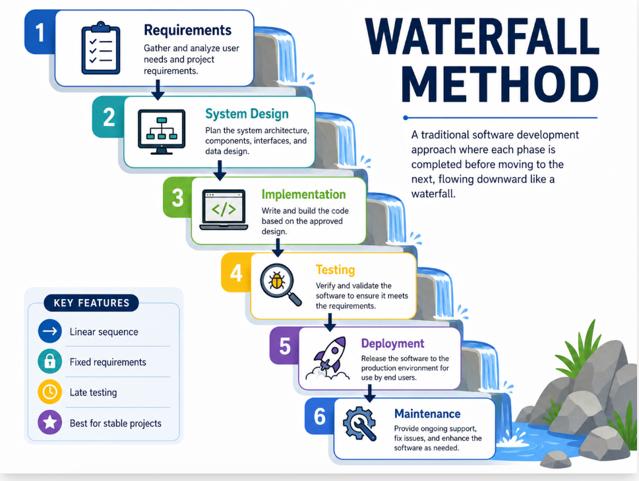

Fig: Waterfall Model

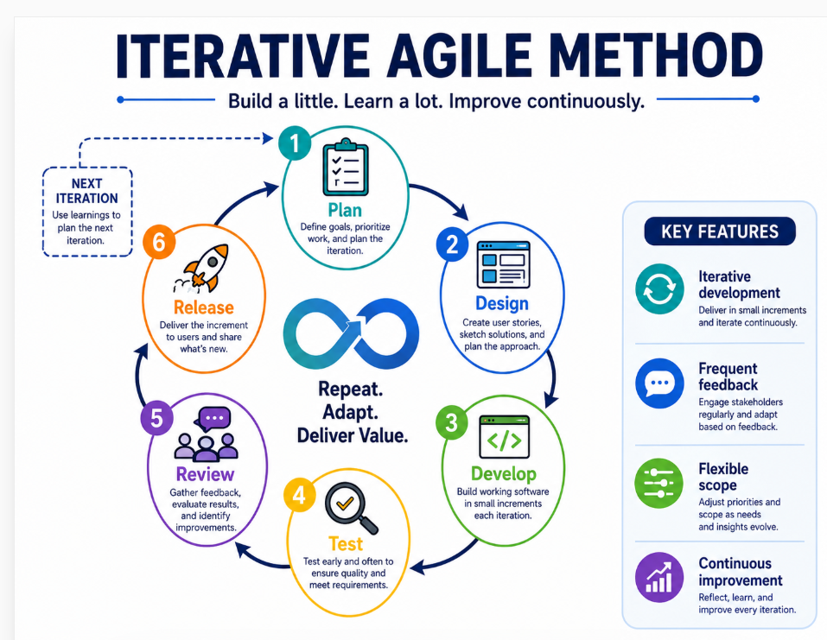

Fig: Iterative Agile Model:

Selected software development life cycle is a prototype supported iterative Agile inspired model. Purely Waterfall model is very rigid because it will be difficult to customer to deidentify users interface problems before getting interact with the screens. Purely ad hoc approach is not suitable for academic project because it will not do structural analysis, design, implementation and demonstrate evaluation. Chosen approach combines staged documentation, iterative design and development [10].

6.1 SDLC Phases:
Phases | Actions | Outcome
Planning [10] | Define Aim, objectives, scope, risks & schedule define [10] | Proposal, Gantt chart, feasibility statement [10]
Analysis [10] | Research users, competitors, data needs & requirements [10] | Requirements specification & user stories [6], [10]
Design [10] | Create architecture, data model, user flows & wireframes [6], [10] | Design specification & wireframe assets [6], [10]
Implementation [10] | Using HTML, CSS Python build PWA prototype [4], [10] | Working prototype package [10]
Testing [10] | Running the functional, usability, accessibility & compatibility [6]-[7], [10] | Test cases & evaluation notes [10]
 | checks [10]
Deployment [10] | Package the files for local or static hosting demonstration [10] | Zip package & installation guide [10]
Maintenance [10] | identify improvements & future development roadmap [10] | Future work & limitation section [10]

6.2 Why Iterative Prototyping is suitable for this project?
Iterative prototype is suitable because project heavily depends on users’ knowledge. Central challenge is not only to store the price rather clearly present comparison results. Early wireframe can reveal users item price, unit price, offer price and whether understand the different retailer’s difference, after that to attempt the more complex data integration prototype can be adjusted [2]-[3],[6],[10].
Project gets benefit from incremental risk reduction. First risk is usability; users may not understand the interface. Second is Data quality; product may not be correctly match. Third risk is compliance; retailer data and customer data need to be handled legally. Mock-data building prototype first demonstrates the project concept, live data avoid the premature dependence on sources [6],[8]-,[10].

Agile principles are seen on user stories, prioritised backlog items & iterative testing, but academic report also give formal documentation so that project can be assessed on undergraduate learning outcomes. This balance is appropriate for independent project where student need to demonstrate both practical development & reflective analysis [6], [10].

6.3 User Stories:
- As a shopper I want to search a product, and I also want to know where it is cheaper [10].
- I want to enter a barcode or GTIN so that I can compare the same product [5],[10].
- As a budget conscious user, I want to add a product in my list so that I can estimate the cost in my shopping basket [1],[10].
- As a fixed budget user, I would like to set a weekly budget limit to avoid overspending [1],[10].
- As a busy parent I would like to have cheaper alternatives so that I can quickly substitute that [10].
- To trust the information as a cautious user I want to know that the price is mocked, live or promotional [3],[9],[10].

7.Proposed Gantt Chart:
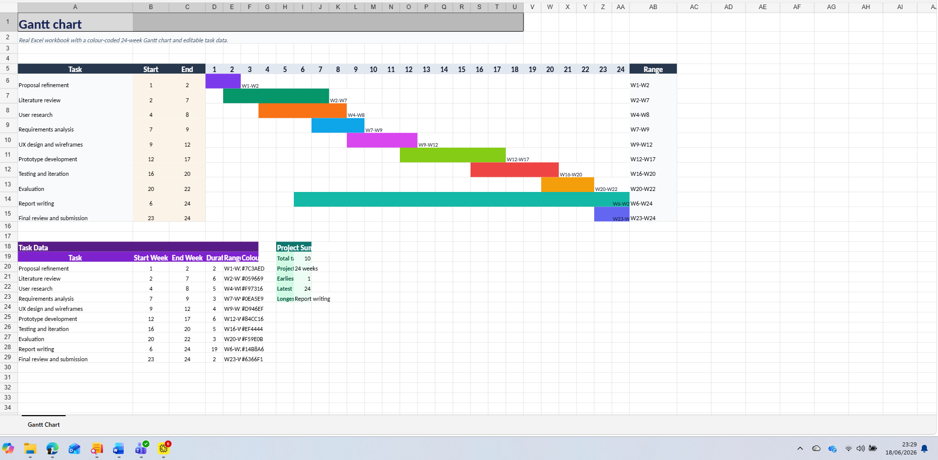

Figure 1: Project Gantt chart.

8. System Design & Architecture:
Proposed architecture separates mobile user interface from back-end services and data sources. It is important because in production grocery system regular data updates, product normalisation, retailer attribution and audit control will be needed.
Using mock data in Prototype major part of client-side JavaScript behaviour implemented, but architecture section shows how design can be grown in complete system [4], [6], [9]-[10].

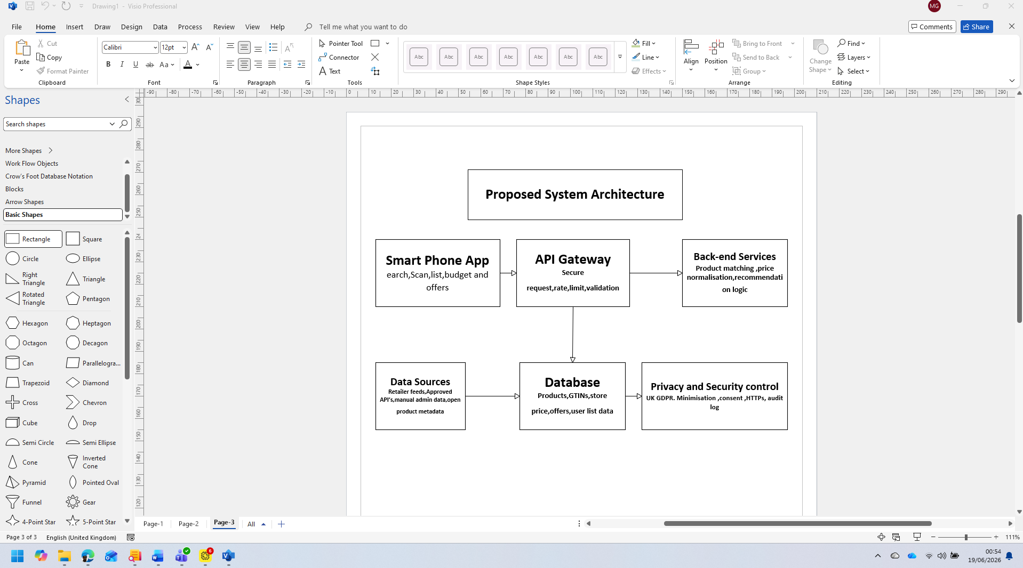

Figure 2: Proposed Smartshop system architecture.

8.1 Architecture Explanation:
Mobile application layer provides user interface that helps to product search, barcode entry, comparison, list management and budget tracking. In prototype it is a PWA that run in the browser. In the future production version, performance, camera scanning, push notification and requirement of the app-store same design native app, hybrid app or as PWA can be implemented [4].
API gateway layer will handle authenticated and unauthenticated request, validate input, and apply rate limits. It will prevent the mobile application directly access to internal services. This separation improves security and supports future scaling [9].
Back-end services will perform product matching, price normalisation & recommendation logic. For Product matching exact matches will use GTIN and for alternatives will use controlled similarity process. Price normalisation will calculate unit prices and identify offer types. Basis of recommendation logic suggestion without hiding lower-cost alternatives will suggest [2]
Data layer product records, GTINs, retailer records, price records, offer information and shopping-list data store where user can choice cloud synchronisation. In Privacy-first version personal lists can stay in device. In future account-based version, explicit consent, secure authentication, and data-retention policy will be needed [8], [9]

8.2 Data Model
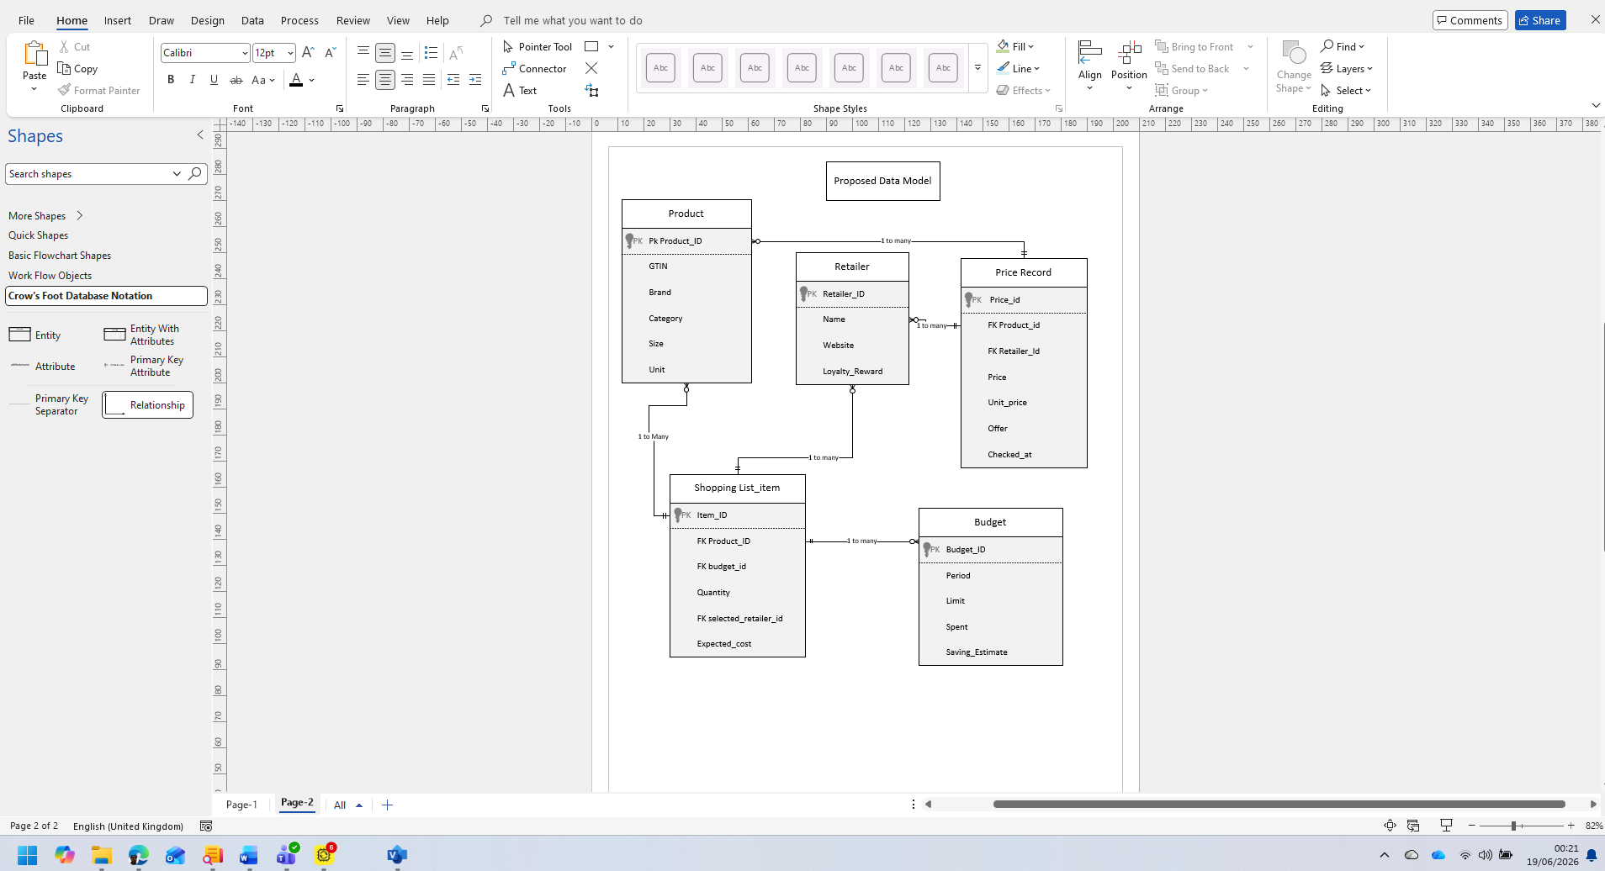Figure 3: Product, retailer, price record, shopping list & budget entities prototype data model.
For data model prototype deliberately need a simple product central entity and it will have product identifier, GTIN, name, brand, category, size and such as unit product identity field.
By storing the retailer identity, later it can include website, store coverage & loyalty scheme information. Price Record connect; products, retailers and unit price, offer text contain last -checked timestamp. Shopping list item user-selected product, quantity and record selected retailer. Budget user-defined spending limit store calculated spending [1]-[3],[5].

8.3 Data Integration Strategy:
Production system needs to use lawful and reliable data integration. Among the possible sources authorised retailer APIs, commercial data providers, retailer partnerships, product information services, manual administration and if licencing give permission, then open product material related. Without permission web scraping website may breach the terms. Create reliability problems and can give misleading results. For this reason, it is based on recommended production strategy authorised feeds and clear governance agreements [4]-[5],[8]-[9].
Prices versioned should be timestamped. User should be informed that price has been checked and is its online price, store price, loyalty price or delivery price. Prices may vary from customer to customer so it should tell that price is not available for all location [3]-[5],[8].
Product matching should follow conservative approach. Label may be by exact GTIN matches. Different-size comparison unit price should be included. User should be warned if similarity is uncertain without pretending [2],[4]-[5],[7].

9. User Experience Design and Wireframes:
User experience design follows the mobile-first approach. Main interaction is possible to do in one hand and should be readable and without training understandable in a small screen.
App uses bottom navigation structure because it is familiar to mobile apps and provide quick movement among comparison, list, and budget. Interface cards give opportunity to every product comparison to clear group of visual units [1],[4],[6]-[7].

9.1 Designing Tools:
Project uses free or free-tier modern tools and recommend and that. For collaboration and interface design penpot open source can be used. Figma can be used for wireframe and clickable prototyping. For diagram drawing, appenate, forms on fire, Monday.com, airtable etc can be used. Visio Studio code can be used for code editing. Chrome DevTools, safari responsive design mode, lighthouse, and axe DevTools can be used for testing. For version control GitHub can be used. Canva can be used for design and prototype [4],[6]-[7],[10].

9.2 Design Principles:
- Clarity: application cheapest option, for retailers’ name and price visually show in a prominent way. For Simple decision, no need to do users dense tables interpretation [6]-[7].
- Consistency: product cards, brings consistency between buttons and navigation screens. It supports learning support and errors reduce [6]-[7]
- Minimalism: prototype accounts, avoids unnecessary features like adverts and checkout. Core task is comparison & planning [6]-[7], [10]
- Transparency: prototype notes explain that data is mocked. Production version will show update timestamps and source information [6]-[7], [10]
- Accessibility: does not depend only text high contrast, controls labels, responsive layout and does not communicate alone with information colour [7].
- Budget awareness: shopping list and budget screen individual product decisions links with total basket cost [1], [6]-[7]

9.3 User Personas:

N/B: All data are Mock and only used for academic purposes.
Persona | Context | Design need
Aisha, 34, parent [6]-[7] | Wants to reduce spending weekly family shopping plan without visiting several apps [1], [6]-[7] | Quick search, basket total, cheaper alternatives [2], [6]-[7]
Tom, 21, student [6]-[7] | Limited budget and do shopping at discount supermarkets and larger retailers [1], [3], [6]-[7] | Budget tracker, own-label suggestions, simple list [1], [6]-[7]
Margaret, 68, retired [6]-[7] | Like Clear price information and dislike complicated apps [6]-[7] | Readable interface, minimal typing, clear buttons [6]-[7]
Ravi, 29, commuter [6]-[7] | Compare price when travel back to home from work [2], [6]-[7] | Fast mobile search, barcode entry, saved list [4]-[7]

9.4 Wireframes:

LFI:
Logo | Home | Date & time
 | Shop Smartly
Log in
Search …………………….
Product Quantity
Asda Price £
Sainsbury’s Price £
Tesco Price £
Morrisons Price £
Lidl Price £
Total Saving £

MF: Wireframe.
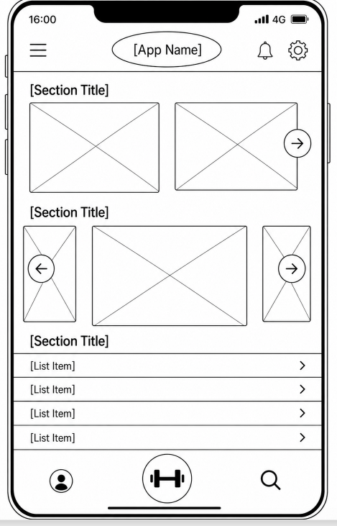

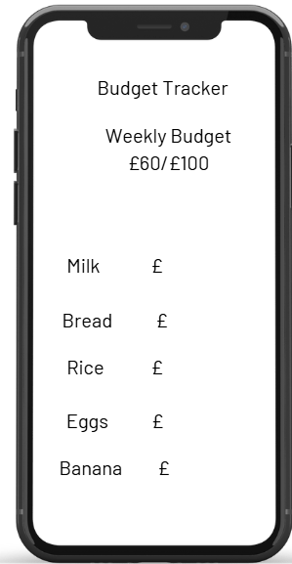

Figure 4: barcode entry and with quick product cards home and search wireframe.
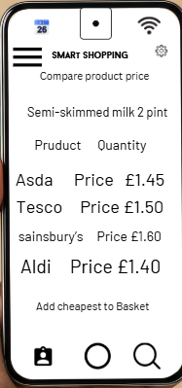
Figure 5: shows retailers, offer labels and cheapest option product comparison wireframe.
Link: https://canva.link/0klgqppv3yxk6yb

9.5 User Flow:
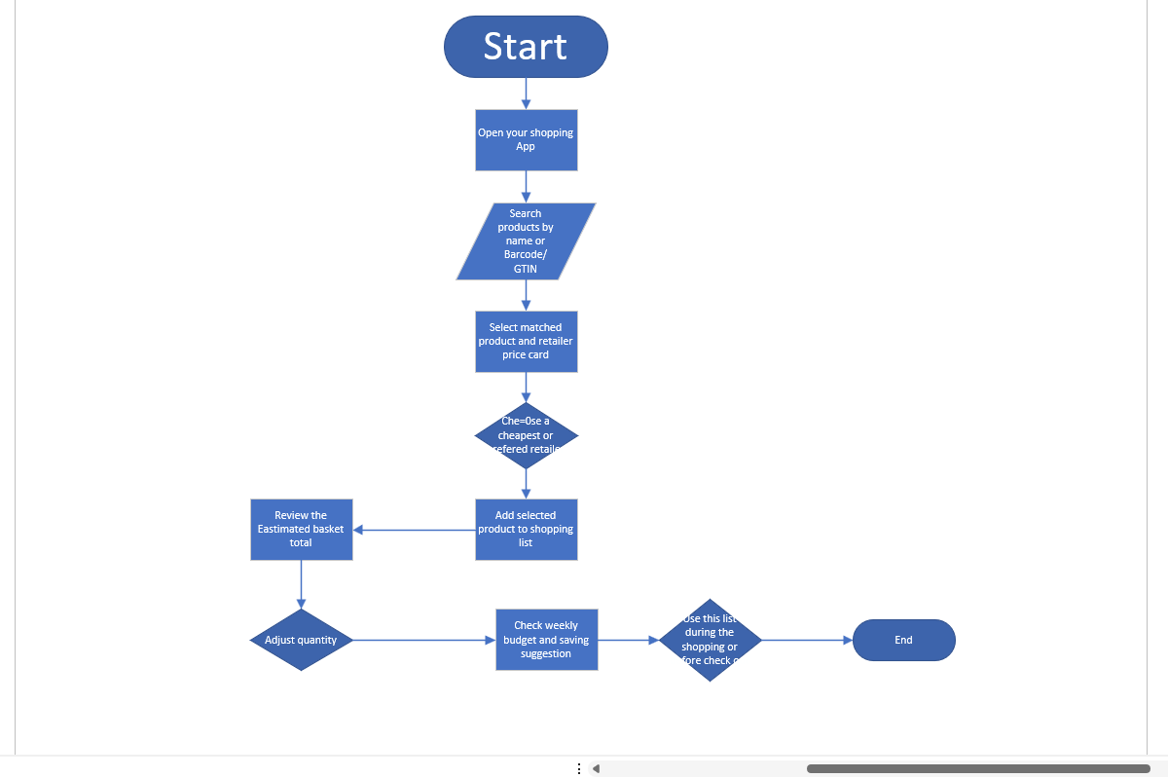
Fig 6: Flowchart of the proposed prototype.

HF wireframe by Figma.
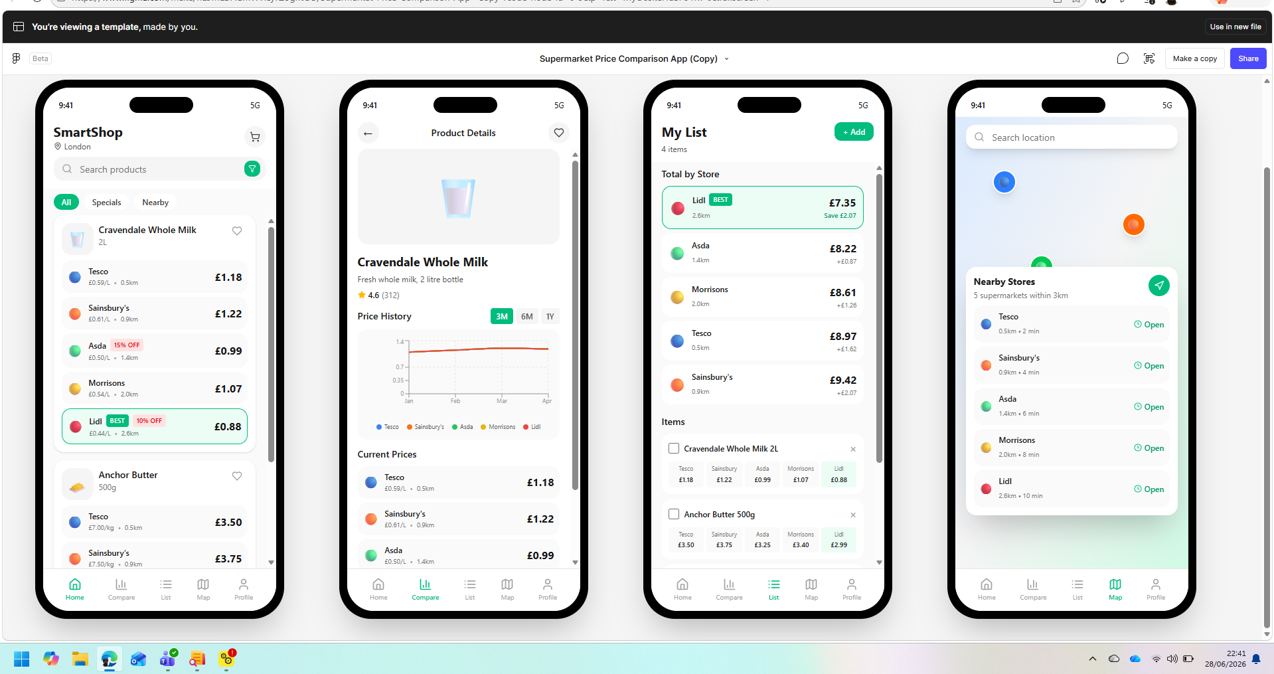
Fig 7: Design Template. Of Smartshop.

Interactive prototype Design:
Interactive proto
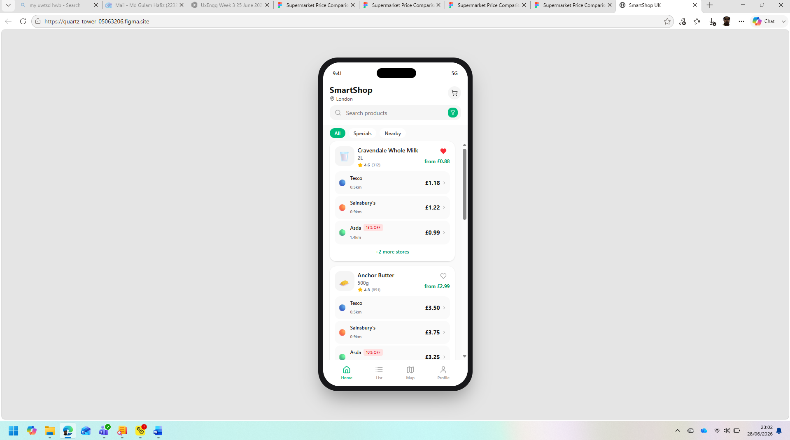
Fig 8: Interactive Prototype by Figma.
https://www.figma.com/make/9T5v2q9NWqTOiV7HhcMX3r/Supermarket-Price-Comparison-App?t=mROxFACa8rU23eAe-1
https://www.figma.com/make/Mo1ugyAdxTgPZngcUyteZh/Supermarket-Price-Comparison-App?t=TT5fMQ4lyHpx9E5Z-1
https://github.com/Hafiz2232603/Supermarket-price-comparison-app.git

10.Prototype Development and Implementation:
After completing the wireframe design and users follow the next steps was to convert the Smart Shop design into an effective prototype. The proposed application has been created as a mobile first website using PHP, MySQL, HTML and CSS. Loragon has been used as a local windows development environment. Loragon is suitable for this project work because from the same local interface Apache, PHP and MySQL can be run. The intention of this development was to create a commercial supermarket platform rather by a realistic end-to-end user journey all the requirements together can actively work or not was to show [10]
Using the implemented prototype a user can search a product by name, brand, category or Barcode/GTIN, can compare the price across the supermarket by the mock super price, can check the lowest price, alternatives and can add any option to the shopping list/basket, also can basket total and weekly budget and can delete any product from the basket or clear the basket. All these functions are directly support with the previous requirements & user stories, but all price data is mock, and it cannot be presented as alive retailer information because for that need authorised feed, retailer agreement, updated schedule and quality control [2],[3],[10]. The file of this application is saved in C:\laragon\www\Smart_Shop. The main files are database. SQL, db.php, index.php, compare.php, add to cart.php, cart.php, clear_cart.php & styles.css. these files’ separate structure database script, connection settings, search page, comparison page, session action & presentation rule. Comparing with complete Model-View-Controller framework though this structure is easy but for prototype it is understandable and supports iterative debugging [10]. Outside of a production system, reusable template, public directory, configuration file, central validation function and presentation, application logic and between database access-need more clear separation [9], [10].

10.1. Technical architecture & Development Environment.
In this prototype a small three-layer architecture has been used. The browser in the presentation layer has HTML form, product card, navigation link, and CSS rule. PHP script in application layer that by receiving GET or POST request implement the business rule, runs database queries and make response. Data layer is as smart shop.db MYSQL database. This layered is suitable for interpretation because it shows how any action in the interface added with the application process and store data though the layers are not still independent software component [10]
Laragon runs locally Apache and MYSQL and the prototype is used htto://localhost/smart_shop. Localhost is an ideal environment for development and demonstration because the researcher can check incomplete software, database record, page reload and can change the code before publishing it in the internet [20]. But it is guaranteed that it is ready for public deployment. It necessary to have a secure hosting environment, HTTPS, protected secret, least-privilege database account, monitoring, backup, and formal maintenance procedure [9],[14]. PHP has been selected for server-side processing because to take the form value, can run the session and communicate with MYSQL using PHP data object.
In Database connection, utf8mb4 character set has been used so that in product description different type of character can be supported. PDO exception mode helps to make database fault visible during development. Production environment [9], [11].
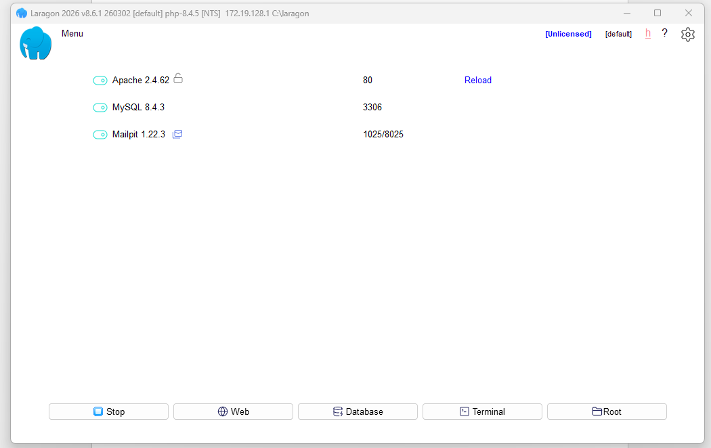
Fig 9. For running the Smart Shop prototype used Laragon development environment.

10.2 Database implementation:
In the database there are two relational table, products, and prices. In a product table-internal product identifier, GTIN. Name, brand and pack size text are stored. In a price table, for every linked product retailer, price, offer description and checked data are stored. price.product_id. Foreign key in the product.id prevent the detachment the price record from its’ parent product logically, support referential integrity. For the foreign-key enforcement need a MySQL compatible key type and index which support relationship check [12].
This structure prevents repetition of product description for every retailer and is suitable for showing one-to-one relationship. Current schema is still very simple, repetition of retailer name is stored as a text, offer rule is not normalised and size-text is not normalised mathematically rather than a human readable. In more dependable model there should have a separate retailer, product, offer, price-source ana a unit table.
Pack size needs to be divided into numeric quantity, measurement unit, and multipack count so that unit price can be counted continuously [2],[3],[12].
GTIN can separate different size or packaging products from the same description [5].
For the own ladled prototype accept blank GTIN value that reflects the realistic product matching reality, if there is no shared identifier. In a big database-known GTIN validated index usually should make unique and instead of unknown identifier empty string should be stored as NULL after those who do not share the same product code for them exact GTIN matching normalised brand; category, quantity and unit information can be added [5]
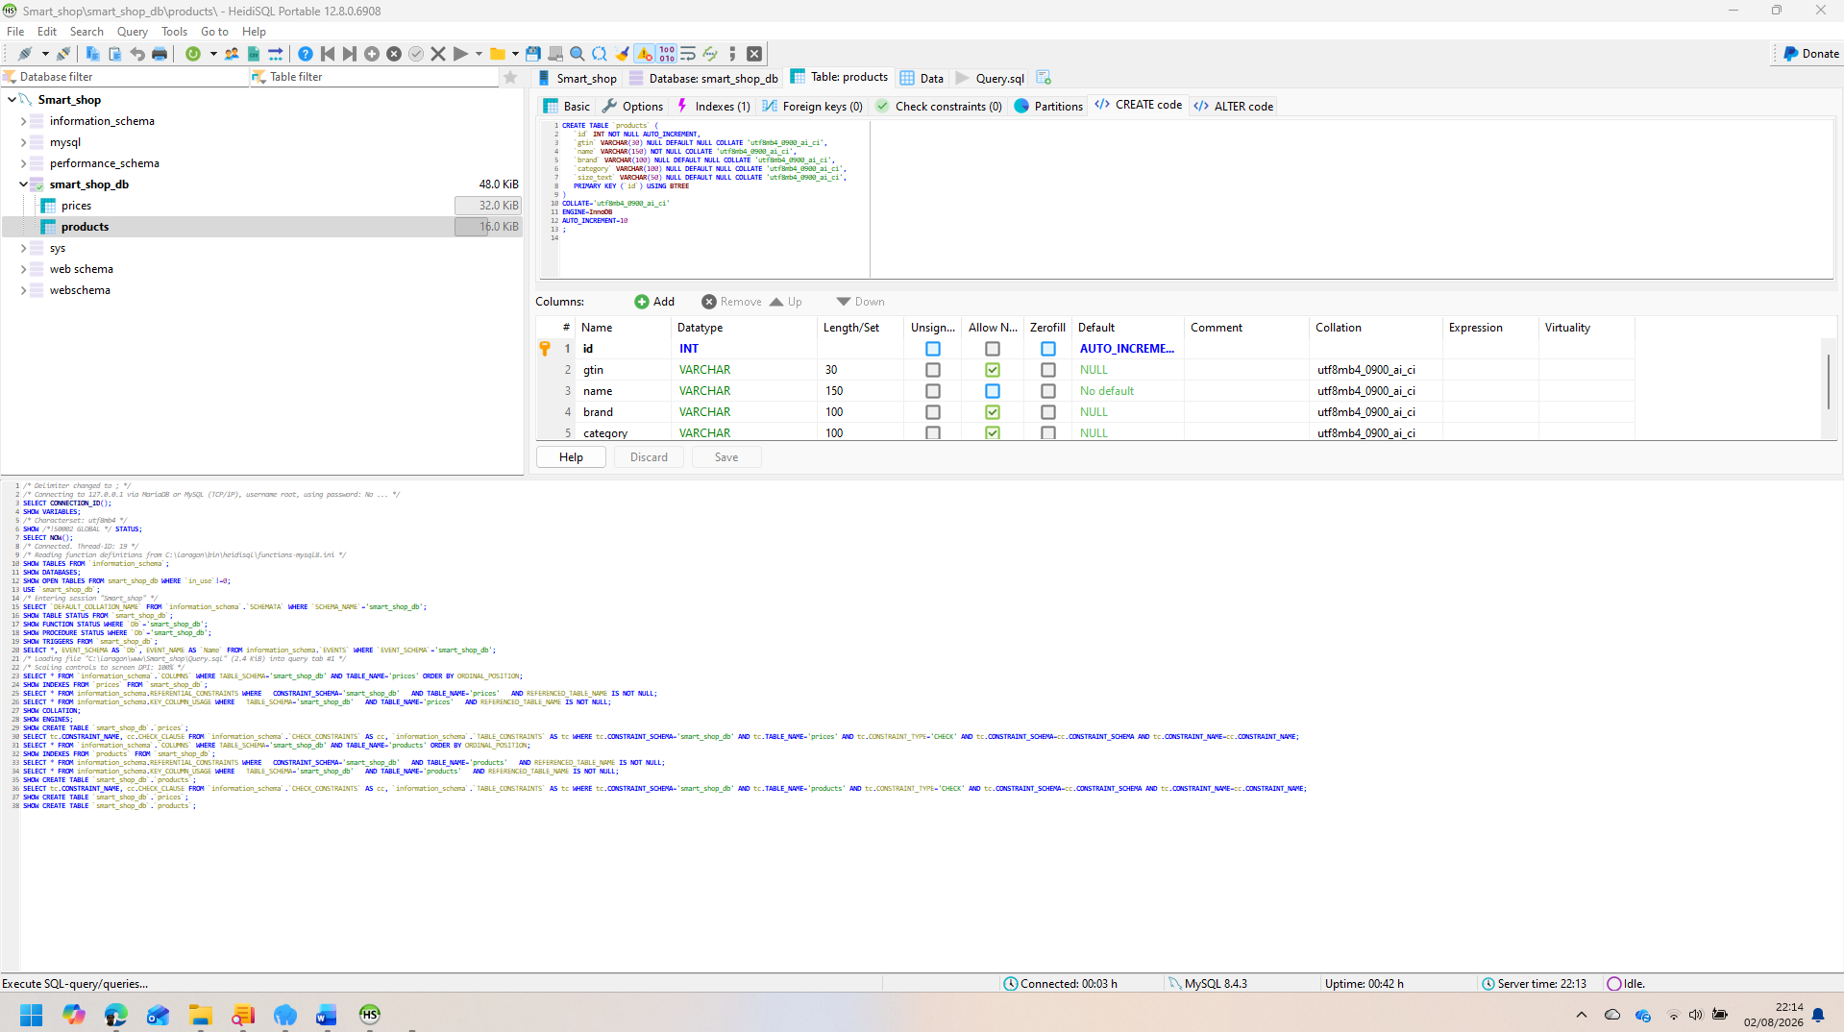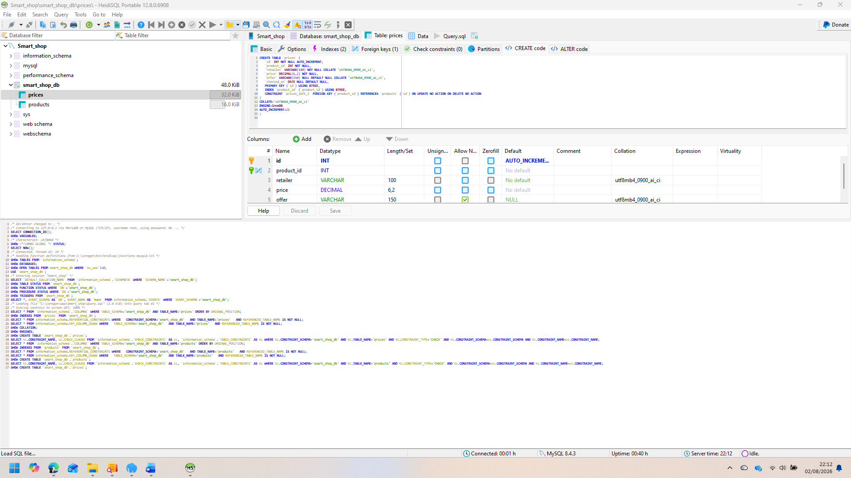
Fig 10: Implemented MYSQL database table and relationship. (Laragon HeidiSQL)

10.3 Secured database query and output handling:
In the search and comparison page, prepared PDO statements have been used. According to PHP guidance, user-supplied value without directly adding to SQL should bind by parameter marker; prepared execution manual reduces the need for quoting [11]. It is an important development of directly adding SQL string to raw search text to create a query. It supports the safe search of product name, brand, category, & GTIN value [11],[13].
In the search statement a technical limitation has been detected because the same named place holder has been repeated in couple of condition. PHP manuals explain that if the emulated preparation is not enabled for each value named marker should be unique [11], for this reason in developed query name search, brand search, category search a separate place holder should be used like, GTIN search though each of these will receive same search value. Enabled native preparation to avoid the dependency on the driver emulation [11].
Main product & field’s dynamic output has been sent by html special characters (). Output encoding is important because text collected from data base may have special meaning character in HTML [16], but security cannot depend on encoding only. Before processing input need to be validated in server because client-side control can be bypassed [13]. So that search length, GTIN format, product identifier, quantity & budget value should be justified with clear allow-list rule and acceptable numeric range [13].

10.4 Product search and price comparison:
In the Index page, a search field has been given so that before starting the user need not select search type. PHP examines the query product name, brand, category, and GTIN field then show matching product, brand, category, size & barcode. A single visible metrics support recognition instead of search route recall and reduce number of necessary decisions of a new user.[6]. No message shows to the customer if it does not match with the database though in future version-spelling correction or related category should be suggested.[6].
After selecting product; compare.php collect price records and organise in ascending order. The first record is highlighted as the least saved option. It gives instant visual feedback and supports the main price-comparison task [6]. In the page offer text is also shown, because least price product does not depend on loyalty scheme or promotion. CMA has emphasized that for meaningful comparison unit-pricing and loyalty-pricing information should be clear enough to the users [2], [3].
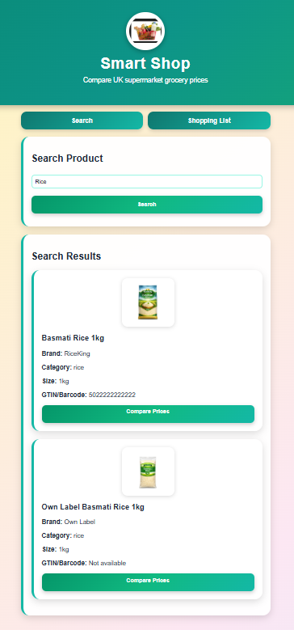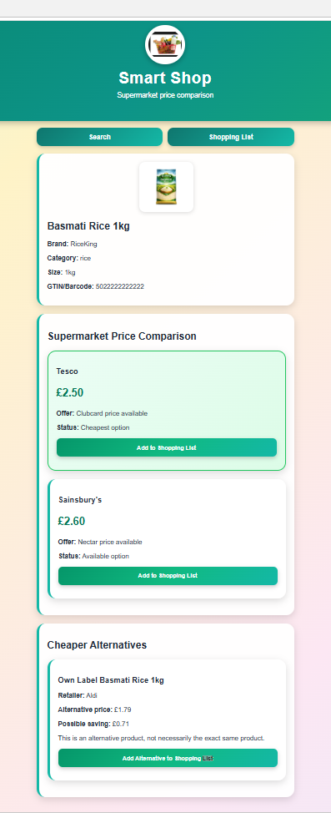
Fig 11-12: Search result and supermarket price comparison.

10.5 Shopping List & Budget Tracker:
When a user selects retailer option add to cart.php save that item in PHP session. Session key brings together product ID & retailer so that same product taken from different retailers indicate separately if the same combination is added again then quantity increased. Shopping-list page by multiplying price with quantity, calculate every line as total and later adding subline fixed the basket total. It supports directly weekly planning and separate decision add with the completed list cost [1],[6].
Budget tracker takes a weekly grocery budget and compares with basket total. If total is below the budget, then shows the remaining amount and if the total is more, shows over-budget warning. This feedback supports visibility of the user the consequences of selection. system status [6]. In invalid non-positive budget, a validation message shown and if quantity is shown zero then item remove. In the future version should have a clear labelled remove button and undo option Undo option because user can mistakenly change the list or clear the list [6].
As a result of using session, without collecting academic prototype name address or account credential can show shopping list. It follows data minimisation principle where personal information should be kept enough relevant and within necessary limit. The problem is that list is temporary and cannot be synchronised in the device. In the future if the account added, lawful basis, transparent privacy information, retention rule, access control and secure account recovery should be needed.[8],[9].
Session security should be stronger before the deployment, suggested attribute like OWASP secure HTTP Only Same Site to keep session cookie protected and for secure attribute needs an encrypted HTTPS transport [14]. URL should not be in Session identifier. URL and identifier should be generated in appropriate security boundary [14]. In localhost prototype this control are not shown completely, so that there is difference in report functional session use & production-level session assurance [14].

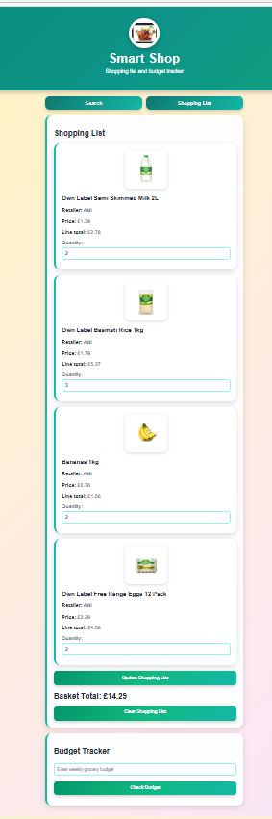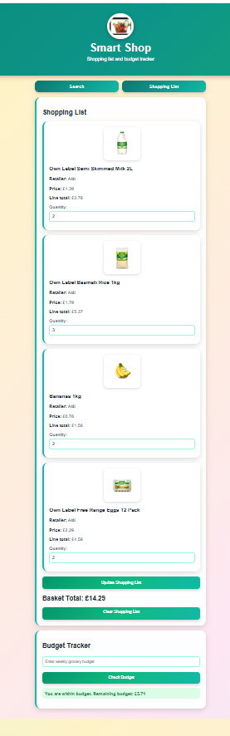
Fig 12-13: Shopping list with quantity, basket total and budget Tracking

10.6 Interface, Accessibility and PWA Status:
In interface a consistent card, heading, button, and navigation link has been used. During the price comparison by the user's product details satay visible and for success or failure warning message is shown in detail and with colour. All this decision support consistency visibility, and error recovery [6].
Accessibility demands more than a visually clear layout. According to WCAG 2.2, content needs to be perceivable, operable, understandable, and robust [7].
In the previous design a progressive Web App was proposed implemented Laragon version should be correctly describe as mobile-first PHP web prototype. For the installable PWA name icon, start URL and as display mode, with information web-app manifest needed [18]. For offline and background behaviour usually use service Worke [19]. In the current file there is no manifest or service Worke so that install ability and offline operation completely function these have been kept as future development [18], [19].
Use of offline price information need to be extra cautious. Static interface file can be cached safely but cached grocery price can be confusing. In the future service worker, a last-checked time show, make difference between fresh and cached record and if the device current data is brought should give warning [2], [19]. It shows that there should have been a balance between technical convenience and consumer transparency [2].[3].

11. Testing strategy and results:
Does the implemented function work according to requirements! and testing has been done to find out the fault before greater usability evaluation. In this stage evidence is based on developer –led testing at local Laragon environment. Formal participant result has not been demanded because completion rate, timing or present creating satisfaction score will weaken the project reliability. Software testing should have traceable evidence and test environment and limitation should indicate clearly [10].
In the test approach, functional, integration, boundary, usability-inspection, accessibility a d security-oriented check was included. Functional test has examined individual feature and integration test retrieve the database from the search and comparison, session storage and follows up to budget calculation journey fully. In boundary testing empty search, unknown barcode, zero quantity and invalid budget have been used. Heuristic inspection has considered feedback, consistency, user control, and error prevention [6]. Accessibility security check has been run by WCAG and OWASP [7], [9], [13]-[15].

11.1 Functional Test Record
Home page has been loaded successfully when Apache and MYSQL were active. relevant product record has been found when milk was search. And entering GTIN 5000159484695 expected semi-skimmed milk item has come back. Entering the unknown term no product found message has been shown. All these result shows that for supplied mock dataset-database connection, prepared search statement and output loop has worked perfectly together [5], [11],[12].
When Compare Prices is selected, linked retailer record been shown in ascending price order and first opinion has been highlighted. Offer information was visible and cheaper category items have been shown in cheaper alternative area. Product session goes to shopping list when a price option was added. If same action is repeated quantity has been increased and if quantity is changed line and basket total calculated again and when quantity was zero item has been removed. These results prove successful integration of compare.php, add_to_cart.php and cart.php [10], [14].
In budget testing, more/less and equal value has been used than the basket total. Budget is more than Total shows remaining amount, less budget exceeded amount and for non-positive value validation warning has been shown. Clear Shopping List action has emptied the session. Multiplying Price by quantity and adding all line calculations has been tested manually. In monetary formatting two decimal places have been shown though in production system for all financial value, consistent decimal handling and server-side limit should enforce [3],[13]. Prototype development has passed all of actions like opening applications, search, use of GTIN or barcode, unknown search, compare prices, cheapest result, adding and removing item, basket total, budget. Shopping list, etc.
11.2 Security and Negative Testing:
In code inspection an important data-integrity weakness has been identified that add to cart.php takes product name, retailer, and price from hidden form field. Hidden field, client-control and developer tool or by crafted request can be changed. OWASP says validation must be done in server because client-side control bypass is possible [13]. In Secure design should only submit price-record identifier and quantity, after that before updating the session from MySQL authoritative product, retailer, and price need to retrieve [12],[13].
In state-changing request also need protection. Lists add, update and to make clear should use with session-bound Cross-Site Request Forgery token POST request. For the OWASP state-changing request suggest CSRF token and for state changing suggest not to use GET [15]. Currently use clear-cart link GET that is acceptable only for local demonstration and before the deployment should be replaced by protected POST form [15].
Local database connection uses Laragon development configuration. Public version root account should not connect with a blank password. Restricted application account; environment-held secret and generic error message should be used, and details should be recorded in fault protected log [9],[20]. Very long search input should be rejected; is identifier in expected range or not need to be examined and without publishing detail invalid request application need to give controlled response [13].

11.3 Usability & Accessibility Evaluation Plan:
Heuristic review indicates that application gives a brief and understandable task flow. Search, Shopping list and Compare prices in known language and cheapest and budget message gives instant feedback [6]. In the improvement plan, visible list count, item add confirmation, after separate remove control, clear, undo option, loyalty price more clear explanation and price record age explanatory help text can be included [2], [3],[6].
Formal usability testing should only be done after ethical approval. Participants can do realistic tasks by name and by GTIN search milk, saved least price options identify adding 2 units and checking budget and select alternative options. In alternative measure task completion, time, error, assistance request comment should be included. Usability works in specific context of use, effectiveness, and efficiency satisfaction so that only developer observation alone cannot establish user satisfaction [17].
In an accessibility evaluation, with the automated check manual keyboard, zoom and screen-reader testing do together. Automated software missing label or can identify contrast problem but instruction is understandable or not or alternative recommendation has clearly explained or not cannot notice clearly [7]. So that before the complete audit the prototype should not be presented as WCAG-conformant rather it should be presented as accessibility informed [7].

11.4 Requirements Traceability and Test Limitations:
Requirement traceability has been used to add main design intention with implemented function and test evidence. Search requirement name category is supported GTIN test case, comparison requirement, order, retailer record and lowest price supported by highlight planning requirement session storage, quantity, update are supported by basket total and budget requirement within budget, equal budget and over-budget are supported by input. Traceability is important because it save testing from being saved with detached demonstration and make possible to identify incomplete requirement [10]. In this project, live authorised price complete PWA installation kept outside of completed test set because the related function has not been implemented yet [18],[19].
Testing evidence has clear limitation. As mock database is small; large catalogue, simultaneous user or for the reason of frequent price update-performance problem do not show. Local environment mobile-network interruption, server failure or public internet attack do not re-generate so that beside current Chrome, Edge, Firefox and Safari version Android and iOS in screen size browser compatibility test should be done again [7], [18]. In future performance test exact GTIN search and in broad product name search response time, database query time and failure rate should be rerecorded [5],[10].
At last functional test pass means in a specific environment, observed output has similarity with expected output, it does not prove complete correctness. Search, comparison, session or in budget logic regression test should run after every change because correction journey in one page can interfere another page [10]. Automated test will increase repeatability but for unexpected input, accessibility behaviour and misleading comparison result, manual exploratory testing will be still needed [2], [7],[10].

12. Evaluation and Discussion:
Prototype search, comparison, alternative, list management budget feedback fulfils academic requirement. It provides effective connection between user interface, PHP application logic, MySQL record and session state. It shows the technical feasibility of the Smart Shop concept in a prototype scale [10]. Development shows more that grocery comparison system and selected quantity’s by influencing on weekly budget helps to take decision beyond single item decision making [1]-[3]
Research question was how a smart mobile application can compare UK supermarket grocery price and can help customer to choose cheapest alternative. Project shows that for the solution need a mobile-first search interface, reliable product identification, structured retailer-price record, clear comparison feedback and list-level budget function [2], [5]-[7]. GTIN can improve exact matching and own-label and for substitute product need descriptive attribute [5].
Project shows more that in general view the simple cheapest word got some data-quality problem. Cheap items may not be cheap y unit price, can depend on membership, pack size or may not be available [2],[3]. So that in a trustworthy comparison; source, pack quantity, unit price, eligibility condition and checked time need to be shown. This is one of the main findings because interface value is not only attractive presentation rather on the reliability of data and explanation [2], [3],[6].
Use of Mock data; limitation and ethical control perform two types of roles it prevents prototype to claim unauthorised or potentially outdated retailer price again let evaluate database user journey [2],[3], but cannot show small dataset, market coverage, high-volume search performance or real product matching accuracy. Local response speed cannot be generalised in huge user and frequent updated cloud service [10].
Security review gives another result. Prepared statement and output encoding supports safer database interaction but cannot prove functional success client value trustworthy [11],[13],[16]. Hidden-price issue and missing CSRF protection shows why adversarial testing is needed for primarily simple shopping-list [3]-[5]. These weaknesses do not create any obstacle for prototypes, feasibility demonstration but before the public release these need to be fixed [9].
Privacy risk comparatively very less because current system does not want system registration, payment data, delivery address or location. It supports data minimisation [8], but in the future account-based service may create elaborated information regarding household purchase, dietary preference & financial behaviour for this reason optional account, limited retention, but, if necessary, by clear consent and strict access control should keep privacy-by-design [8],[9].

12.1 limitations:
Project has some limitations. Firstly, supermarket price is not live authorised information; this is manually created mock record. Secondly, a comparison is made instead of normalised unit value based on item price. Thirdly, category-based alternative does not ensure equivalent size, ingredient or dietary suitability and fourth application is not complete installable PWA; this is a responsive local website. Fifth developer-led test cannot be an alternative to participant usability evidence or independent security assessment [2],[7],[9],[17]-[19].
Even Codebase is procedural and small business logic & HTML are on the same page. Though for the Prototype it is manageable but if the feature increase it would be hard to maintain. In the future architecture; model, service, controller, reusable view, automated test and version-controlled database migration should be included [10]. So that project should not judge as finished commercial product, rather should understand as validated concept and learning artefact [10].

13. Future Development:
First development priority is security and data integrity. Client-supplied price field server-side database should be replaced by lookup, for all state-changing action protected POST request session cookie need to be harden and database credential least-privilege principle need to be followed [13]-[13]. Error handling needs to be centralised, and application secret need to keep outside public directory [9].
Second priority is trustworthy data. In authorised retailer feed; should have product, price, offer, availability and timestamp information. In the Schema; unit price needs to be calculated after normalising the unit, in product matching, GTIN, brand, quantity, category and confidence scoring needs to do together [2], [3],[5]. Data-quality rule duplicate identifier, missing unit, stale price and unusual change will be flagged [2],[12].
Third priority is to complete the PWA design. For instal lability needs manifest, icon, HTTPS deployment and appropriate display setting [18]. Service worker static asset needs to be cached and can give offline fallback but in cached price record need to show freshness warning [19]. In further work should include camera barcode scanning, retailer filter, dietary information, accessible label, keyboard testing and with representative user, ethically approved usability testing [5]-[7], [17].

14. Reflective Review:
This project research has improved my understanding of how design and implementation need to be integrated with each other. Firstly, wireframe thought the that the shopping journey straight forward but during database and comparison logic code identifier, pack size, loyalty condition, stale data and alternative-product suitability related practical problem revealed [2], [3],[5]. It has been understood that useful application is also depends on quality of the data and explanation like coding. I have gain PHP, PDO, MySQL, session, form processing and in CSS practical skill. More importantly security review has taught me the differences between honest browser interaction and untrusted request. Hidden field is not secure though it does not show on the page; client-side validation can improve usability, but server-side validation cannot be compromised [13]. So that this project has made my technical ability and critical evaluation skill stronger.
Iterative method was appropriate because the application has been made on an effective stage; database creation, connection, search, comparison, alternative, shopping list, quantity control and budget feedback. Every stage has created testable output and has published the future iteration requirement [10]. Like live data and full PWA operation, some ambitious functions intentionally have been transferred in the future work so that final submission without clamming incomplete feature can be presented as completed function with honesty [10], [18], [19].

15. Conclusion:
Smart Shop has been designed as mobile friendly PHP/MySQL grocery price-comparison prototype and implemented. Completed application product and GTIN search, multi-retailer mock price comparison, lowest-recorded-price highlighting, cheaper alternative, session shopping list, quantity calculation and shows weekly budget feedback. Developer-led testing has ensured that core journey works locally by Laragon [5], [10],[20].
Project research question give answer by showing that a useful grocery comparison application needs to integrate dependable product identification, transparent price condition, structured data and with budget support accessible mobile interaction together [2], [3], [5]-[8]. It also shows that for production readiness need server-side validation, CSRF protection, secure session, authorised data, unit pricing complete usability accessibility testing [7], [9], [13]-[19].
Overall, this prototype is not a finished commercial service, rather provide a realistic foundation. The most important contribution is that in a simple user flow- comparison, alternative and budget planning integration and at the same time related with live version-legal, ethical, accessibility, security and data-quality responsibility’s critical recognition [2], [3], [7]-[10].

16.References:
[1] S. Bowler and S. Price, "Heterogeneity in Public Understanding of the Causes of Inflation in the United Kingdom and the United States," vol. 107, no. 2, pp. e70143, 2026,
[2] H. Chen, J. Li, G. Liu and J. Shao, "Termination amounts and the enforcement gap in the Contracts for Difference scheme: Insights from offshore wind project finance in the United Kingdom," vol. 2, no. 2, pp.9400034, 2026,
[3] D. Mohiuddin, A. A. Zaveri, I. Ahmed and M. Umar, "A systematic literature review of multi-channel analytics linked to POS and connected to food businesses in the UK", in 2026 International Conference on AI Innovations and Industry (ICAIII), pp. 1–6.
[4] M. Wang, J. Huang and G. Gu, "Demystifying Progressive Web Application Permission Systems", in 2026 56th Annual IEEE International Conference on Dependable Systems and Networks (DSN), pp. 173–184.
[5] U. F. Saeed, R. Kamil and K. O. Appiah, "Leveraging green technological innovation for corporate value creation: The mediating role of environmental performance in the Japanese manufacturing sector," vol. 17, no. 3, pp.7182–7205, 2026,
[6] C. Wellhausen, L. Reinhardt and K. Schneider, "User Reviews as a Source for Usability Requirements: A Precursor Study on Using Large Language Models," 2026,
[7] I. Loaiza-Ramírez and B. A. González-Beltrán, "Digital accessibility guidelines for deaf and hard of hearing persons: a state-of-the-art review article," vol. 25, no. 1, pp.4, 2026,
[8] P. Taylor, K. Bishop, J. M. Davies and F. Murtagh, "Data-based research in UK palliative care: guidance, challenges, opportunities," 2026,
[9] Z. Wu, L. Lei, P. Wang, Y. Wang, X. Feng and H. Zhang, "Cross-Application Key Abuse Attack against Hardware-backed Android Keystore", in ICC 2026-IEEE International Conference on Communications, pp. 1–6.
[10] A. A. Nubatonis and M. Iskandar, "Enhancing Prototype Development of Facility Damage Reporting and Repair System using Waterfall Model," vol. 8, no. 2, pp.691–700, 2026,
[11] J. Korkiakoski, "Development of a CRM Membership System Using PHP and the Laravel Framework," 2026,
[12] D. Rousidis, E. Garoufallou, P. Koukaras, I. Nitsos and C. Tjortjis, "The Use of Social Media as Bibliographic Citations in Open Access Education Journals," vol. 16, no. 6, pp.3095, 2026,
[13] D. Kim, J. Choi and J. Lee, "Trust Boundary Semantic Gaps: A Multi-dimensional Analysis and Mitigation for Security-by-Design," 2026,
[14] S. S. Nathan and R. Marimuthu, "Hybrid Security Framework Integrating Firewall and VPN Technologies," 2026,
[15] E. Pienimaa, S. Rauti and V. Leppänen, "Secure Token Management in Hybrid Applications," 2026,
[16] D. Xu, M. Liu, X. Wang, J. Zhong and Z. Zheng, "RepoDoc: A Knowledge Graph-Based Framework to Automatic Documentation Generation and Incremental Updates," 2026,
[17] M. Cescon and M. Peruzzini, "Evaluating UX and Usability in Automotive Human–Machine Interfaces: A Systematic Review," vol. 16, no. 7, pp.3437, 2026,
[18] M. Wang, J. Huang and G. Gu, "Demystifying Progressive Web Application Permission Systems", in 2026 56th Annual IEEE International Conference on Dependable Systems and Networks (DSN), pp. 173–184.
[19] C. Chinchilla and I. Akrap, "Front-End Development," in Building the Sustainable Web: How to Create Web Products That Respect People and the Planet, Springer, 2026. pp. 161–208.
[20] A. P. Dzulfiga, A. Prasetyawan and S. M. Shuhidan, "DEVELOPMENT OF A WEB-BASED GROUP VISIT RESERVATION SERVICE AT THE ARCHIVES AND LIBRARY OFFICE OF MAGETAN REGENCY," vol. 11, no. 1, pp.185–200, 2026,

17.Appendix:

