Assignment 1: E-Portfolio



Nathan Evans
Electronic & Electrical Engineering / Changemakers
Submitted to:
UWTSD – Waterfront Campus 09/11/23

Contents Page:

 | Page Number
- Task 1 | Found on E-Portfolio
- Task 2 | 3-4
- Task 3 | 5-6
- Appendix Proof of Participation | 7-9
- Reference List | 10

Links :
- Mind Map - https://mm.tt/app/map/3002093912?t=y5z47zms4e
- E-portfolio - https://sites.google.com/view/nathan-evans/home?authuser=0

The work of this report completed under the supervision of (Gareth Jones). I declare that this report is the product of my own work and is not being submitted for any other degree etc.
N. Evans
Task 2
Q1: For the task in hand, the student would first need to identify what kind of philosophy suited them best. This led to the student researching the different kinds of philosophies and analysing the differences between them, then finally matching the philosophy with their personal beliefs.
There are 5 kinds of research philosophies, being:
- Positivism – Scientific Evidence is essential, empirical observation.
- Critical Realism – Scientific Evidence is preferred, empirical observation can be inconclusive (optical illusions)
- Interpretivism – Social constructions, Science cannot be used to understand how people function, qualitative methods.
- Postmodernism - Challenge established thinking, research through their own experiences.
- Pragmatism – Open to ideas if it supports the end goal, one point of view cannot give an entire picture. [1] Goes into detail about the philosophy of Pragmatism.
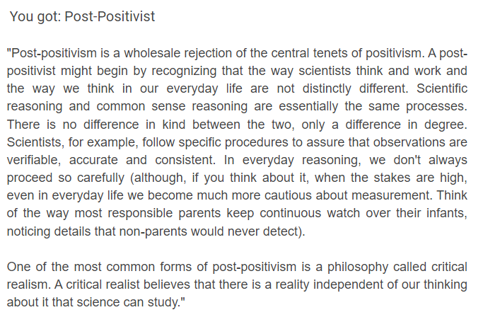
To identify which philosophy the student was suited to, he undertook an online test. This was considered the best way to pinpoint their beliefs as the questions are professionally written which helps the student understand more about the topic.

[2] Shows Epistemology test results.
Though this is the students personal research philosophy. The student decided to use Positivism for this project as an eye tracking effects pedal board would be created purely based off scientific evidence and research.

Task 2
Q2: The research methods the student has adopted is mostly through online sources. The study contains the following online research methods: search engines (google), online library’s and google scholar. While conducting research, the student demonstrated the use of multiple research strategies to assist their report. These being:
- Use of keywords (Guitar effects & Eye tracking) [5] Explains the importance of key words in research.
- Boolean Operators (AND,OR,NOT) [3]
- Phrase searching (Use of quotation marks to search an exact phrase)
- Limiters (Filters to limit search results)

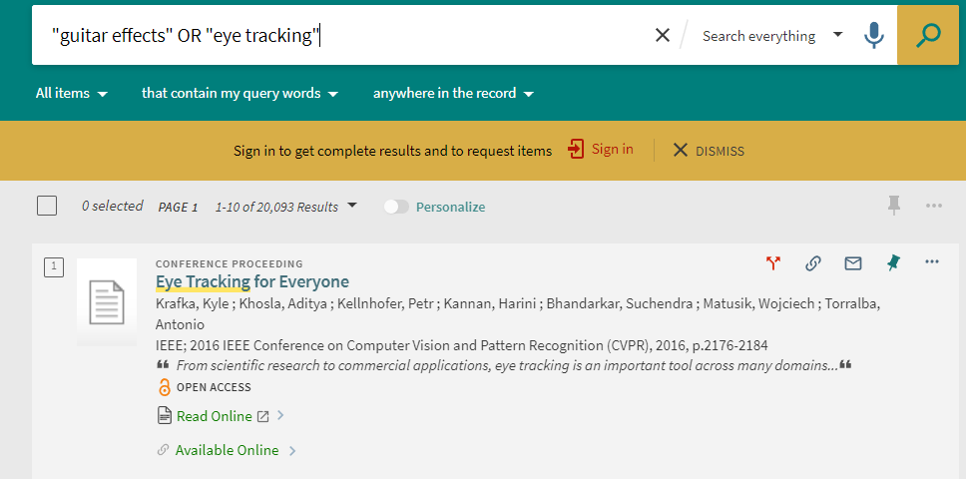

[4] Figure [] &[] Use of Research Methods
The figures above display the use of research methods. The left shows the use of limiters, and the right shows the use of keywords, Boolean operators and phrase searching.

Q3: The research strategy the student has decided to use for feedback on the project is a questionnaire. It was decided that a questionnaire would be the most suitable method of obtaining feedback as you the student was able to ask qualitative and quantitative questions to gather relevant opinions on the project.
The questionnaire will be tailored to assist the development of the eye tracking effects board, meaning that is a predevelopment research strategy. Once completed, the student concluded that the best way to obtain feedback would be through, Observations and Experiments. These methods would be conducted under supervision in controlled environments. The student plans on giving free handouts to local musicians and then gathering all their opinions on things such as, the sensitivity of the tracking, meaning, is the eye tracking operating when not intended by the user.

Task 3:
Q1: The two research methods the student chose for the project were:
- Qualitative Research – Focus’ on the users’ opinions and experiences
- Quantitative Research – Focus’ on surveys, experiments & observations
[1] Explains what Qualitative and quantitative research is in developmental science.
The student began to research qualitative and quantitative research strategies that could be used to gather information. It was quickly decided that quantitative methods would be more suitable for the project. The student came to this conclusion because the main concern was gathering information on whether the board functioned in the way it was intended. To gather this information quantitative research was essential. Though Qualitative methods seemed to dominate the research methods, the student decided to design a questionnaire which would gather crucial information prior to building the pedalboard.
Q2: The student understood that if the questionnaire was to be a success, he would have to identify strategies to ensure that the data received from the questionnaire was going to be sound. He concluded that three variables would have to be fined tuned for success.
- Validity
- Reliability
- Generalizability
[2] Explains the validity and reliability of research.
To enhance validity, the student brainstormed methods prior to the design of the questionnaire. He concluded that, clearly defining the variables, pilot testing and local expert reviews would be the correct approach.
To then enhance reliability, the student concluded that data from validity could be used to strengthen the reliability from the questionnaire. For example, pilot testing would show any inconsistencies or misunderstandings of the questions. Furthermore, the student knew that clear and simple language would be essential for reliable feedback and consistent formatting would be essential to avoid confusion with the participants.
Finally, the student examined the generalizability of the questionnaire. The student concluded that the project was very much targeted for a specific group of people, thus being guitarists at an intermediate level at minimum. So, attempting to generalise the questionnaire would be almost an obsolete process.

Q3: Questionnaire [3]
To access the online Questionnaire please Either paste the link into your search bare or simply scan the QR code

LINK: https://t4ciq46q9g7.typeform.com/to/fC5c6dkt

Appendix Proof of participation
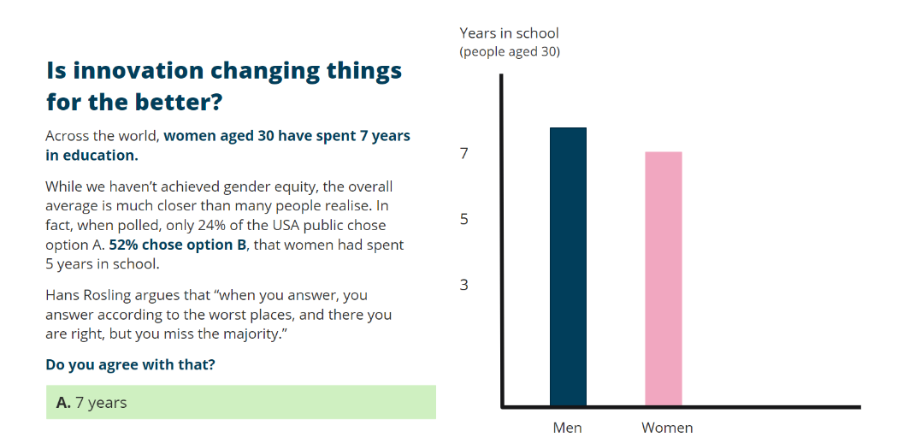
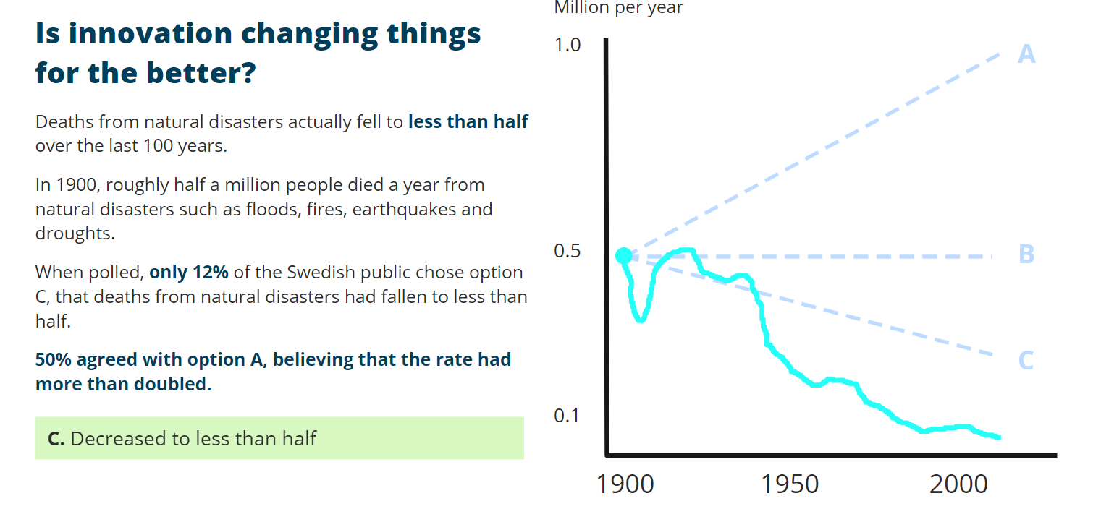

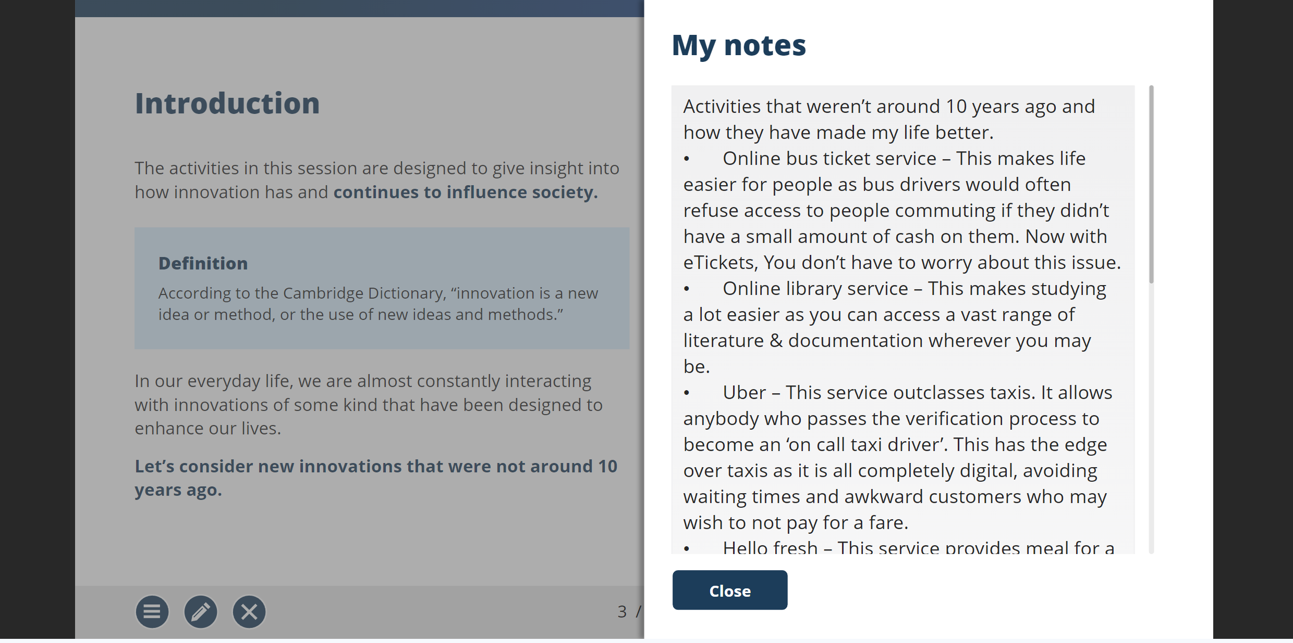

Appendix Proof of participation
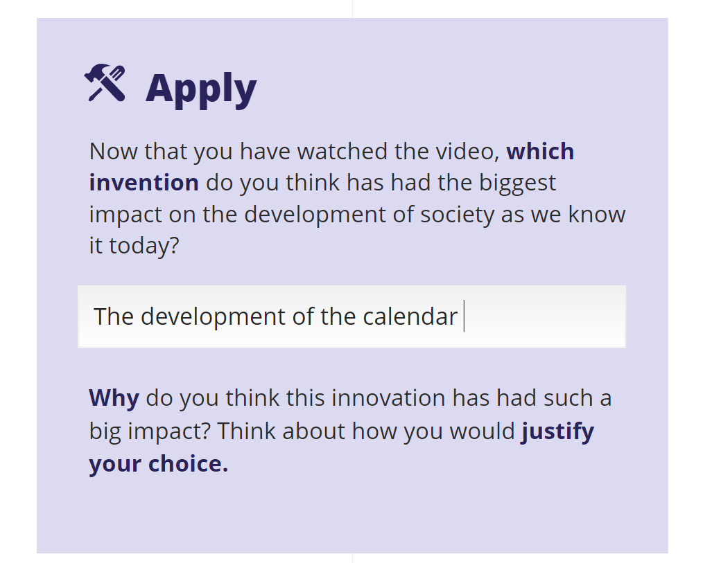

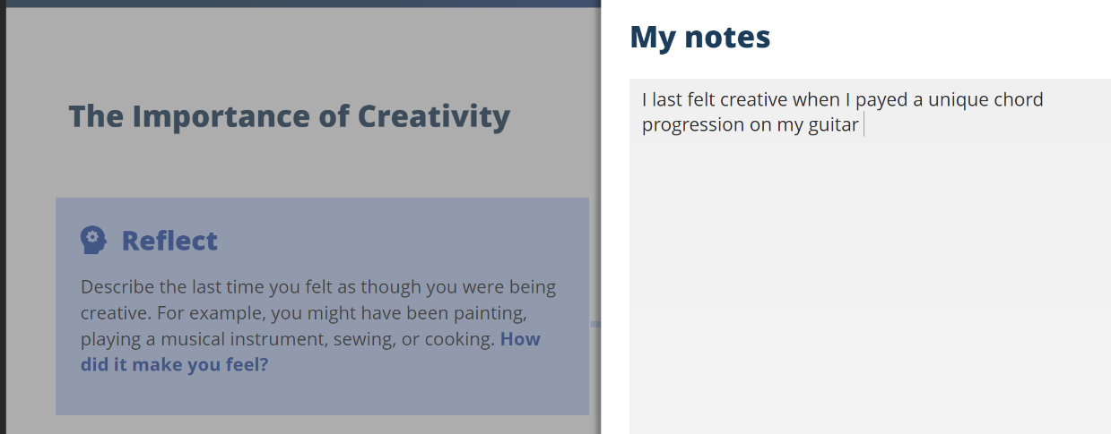

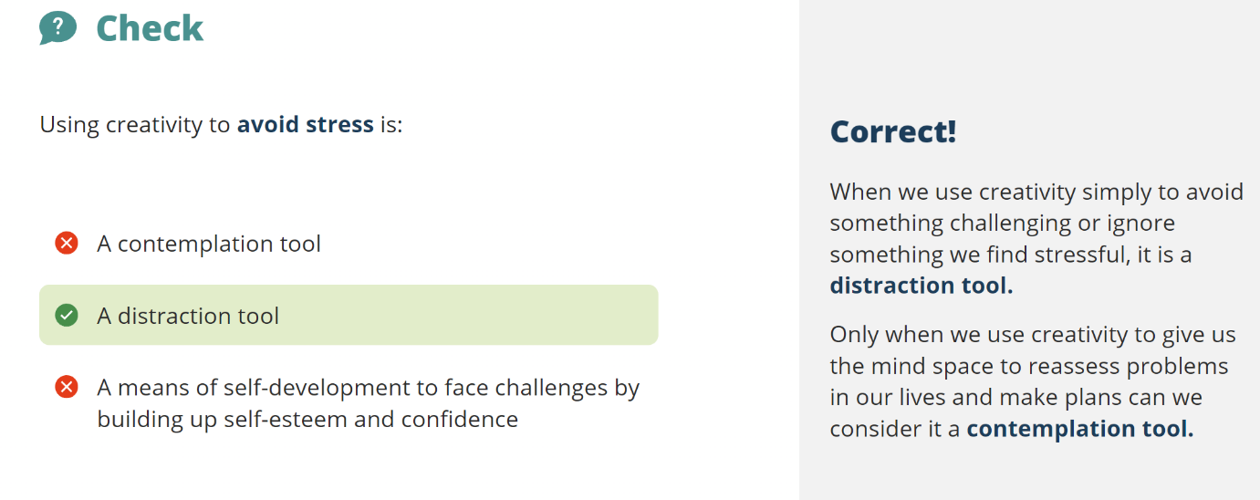

Appendix Proof of participation
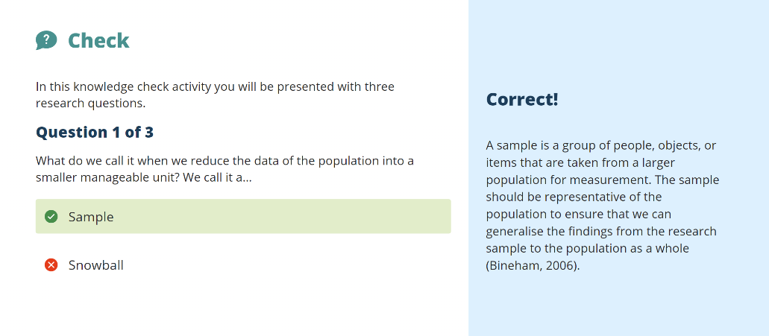

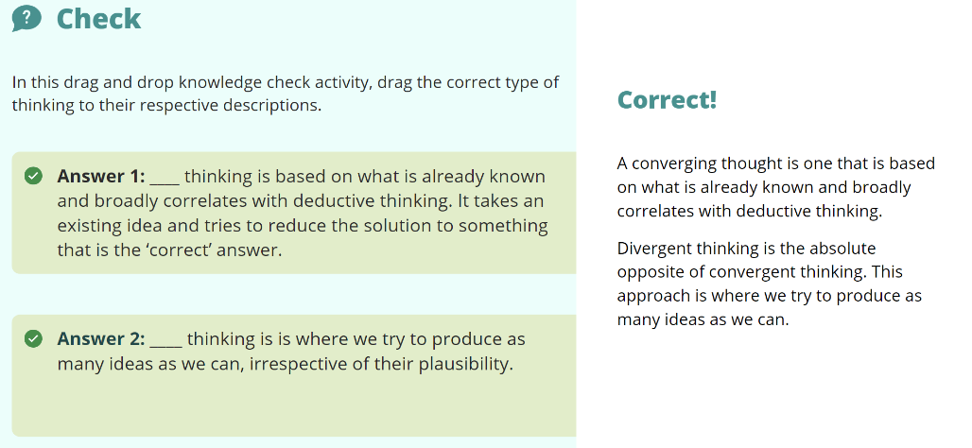
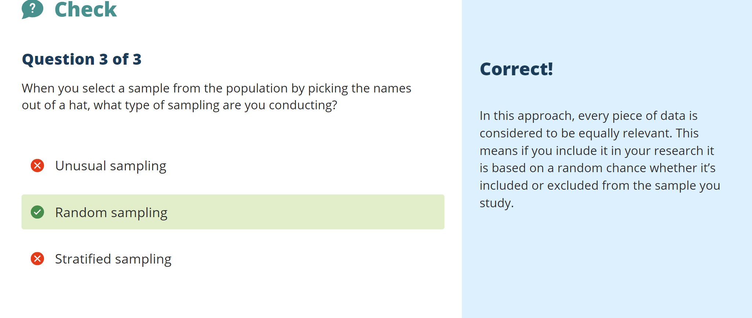

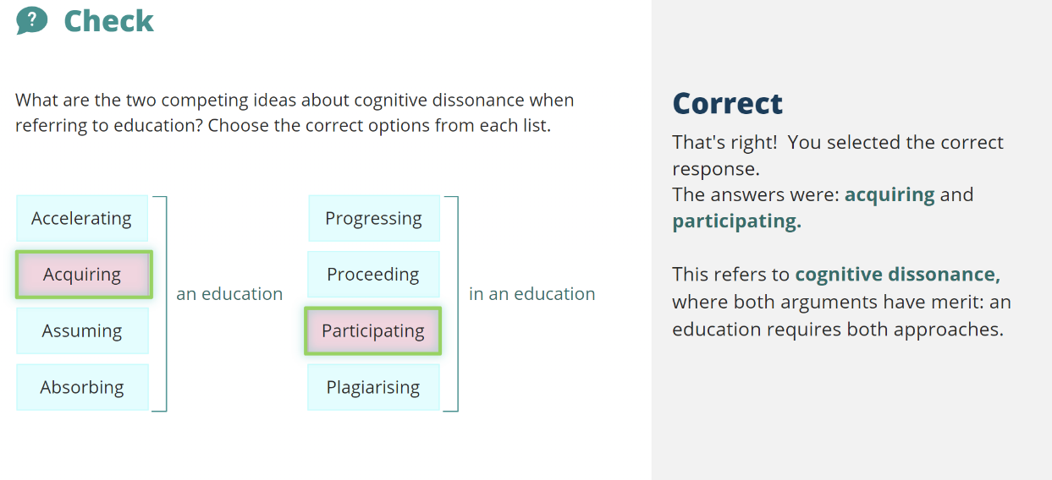

Reference List:

TASK 1:
References found on mind map. Link to mind map on E-portfolio Task 1

TASK 2:
[1] “Quiz: What’s your epistemology? let’s find out!,” ProProfs, https://www.proprofs.com/quiz-school/personality/quizreport.php?title=epistemology-and-you&sid=MjE1NjA2NTA3
[2] C. Legg and C. Hookway, “Pragmatism,” Stanford Encyclopedia of Philosophy, https://plato.stanford.edu/entries/pragmatism/
[3]Miralles-Dolz, E., Gray, A., Patelli, E., & Ferson, S. (2022). Correlated Boolean Operators for Uncertainty Logic. In arXiv.org. Cornell University Library, arXiv.org. https://doi.org/10.1007/978-3-031-08971-8_64
[4] Librarysearch.uwtsd.ac.uk, https://librarysearch.uwtsd.ac.uk/discovery/search?vid=44WHELF_UWTSD%3A44WHELF_UWTSD_VU1
[5] Key words and their role in Information Retrieval - Wiley Online Library, https://onlinelibrary.wiley.com/doi/full/10.1111/j.1471-1842.2010.00904.x

Task 3:
[1] H. Yoshikawa, T. S. Weisner, A. Kalil, and N. Way, “Mixing Qualitative and Quantitative Research in Developmental Science: Uses and Methodological Choices,” Developmental psychology, vol. 44, no. 2, pp. 344–354, 2008, doi: 10.1037/0012-1649.44.2.344.
[2] “The bera/sage handbook of educational research,” Google Books, https://books.google.co.uk/books?hl=en&lr=&id=NaPUDAAAQBAJ&oi=fnd&pg=PT178&dq=what%2Bis%2Bvalidity%2Band%2Breliability%2Bin%2Bresearch&ots=teEArlL3ju&sig=YlIgiBl5cgQn4swbEcf-DCYdyFI#v=onepage&q=what%20is%20validity%20and%20reliability%20in%20research&f=false
[3] “Easy Online Questionnaire Maker,” Typeform, https://www.typeform.com/try/questionnaire-builder/?gclsrc=aw.ds&&tf_campaign=UK-Generic-Questionnaire-English-Desktop_18008307830&tf_source=google&tf_medium=paid&tf_content=154232250628_646768504754&tf_term=questionnaire+design&tf_dv=c&tf_matchtype=e&tf_adposition=&tf_location=1007460&gad_source=1&gclid=CjwKCAiA3aeqBhBzEiwAxFiOBqbL6MDyv7ebiwIVDFjzk4wOpNPejki_8QtQtTKxb4-AzjfUSQB6rxoCKyEQAvD_BwE

