

CO2 dosing system to regulate the acidity of water leaving the plant

By
FERAN KANDA

Lecturer: Stephen Mosey

Programme: Meng Power and Water Engineering

Module: Instrumentation and Control
Module code: M7X11115

20th March 2018

Table of Contents

Tables of Figures 4
Tables of Tables 1
Abstract 2
Introduction 3
Advantages of Control System 4
Open-Loop control system 4
Close-Loop control system 5
Control Modes 6
Differential action 6
Proportional Control (P) 7
Proportional plus derivative (PD) 7
Proportional plus Integral (PI) 8
Proportional plus Integral and derivative (PID) 8
PID electronic controller 9
Method 10
The Concept of PH measurement and control 11
List of PH Sensors 12
List of CO2 Valves 13
Transducer selection 14
PH sensor 14
Operation 14
CO2 Valve Controller 15
Operation 15
PH sensor Transfer function 16
PH sensor transfer function 16
Response time 16
Calculation 16
Transfer function development in MATLAB 17
PID Controller Design Specifications 18
PID Tuner 19
Transfer functions in MATLAB 20
Results 22
Stability In control system 0
Pole-zero plot 0
Nyquist Diagram 1
Bode Diagram 2
Conclusion 4
References 5
Appendices 6

Tables of Figures

Figure 1- A simple description of a control system, Source [1] 3
Figure 2 - Open-loop, Source [3] 5
Figure 3- Close-loop, Source [4] 5
Figure 4 - (a) A simple ON/OFF action of a room heating system, (b) differential ON/OFF action, Source [4]. 6
Figure 5 - (a) and (b) shows the examples of both the derivative action and the effect of PD action on the correction time, Source [4]. 7
Figure 6 - Effect of proportional and integral action on a variable, Source [4] 8
Figure 7 - Waveforms for proportional plus integral action and waveforms for proportional plus derivative and integral action, Source [4] 9
Figure 8 - Waveforms for proportional plus integral action and waveforms for proportional plus derivative and integral action, Source [4]. 9
Figure 9 - Task block diagram 10
Figure 10 - Control system – closed-loop 10
Figure 11 - PH Scale, source [11] 11
Figure 12 - PH electrode parts, source [11] 11
Figure 13 - (PH - BTA), Source 14
Figure 14 - Specifications, Source [12] 14
Figure 15 - Flow Control Valve, Proportional Solenoid – Model 001, Source [13] 15
Figure 16 - MATLAB system design 17
Figure 17 - PID Controller 18
Figure 18 - Step Plot Tuned and block response 18
Figure 19 - Performance and Robustness 19
Figure 20 - Controller Parameters 19
Figure 21 - PID Transfer function 20
Figure 22 - The plant Transfer function 20
Figure 23 - PH sensor Transfer function 20
Figure 24 - System Transfer function 21
Figure 25 - PH sensor Scope Reading (a) 22
Figure 26 - PH sensor Scope Reading (b) 22
Figure 27 - PH sensor Scope Reading (c) 22
Figure 28 - Pole – Zero 0
Figure 29 - Nyquist Diagram 1
Figure 30 - Bode Diagram (a) 2
Figure 31 - Bode Diagram (b) 2
Figure 32 - PH sensor Scope Final Reading (d) 4

Tables of Tables

Table 1 - List of PH sensors 12
Table 2 - List of CO2 Valves 13

Abstract

The aim of this report was to design a CO2 dosing system that can regulate the acidity of water leaving a plant. The system was to be fitted just before the treated water leaves the plant to control its acidity. The role of a control system in the CO2 dosing system was to reduce the pH value of the water that was measured around 8.5 –13 and reduce it between pH 6.5 – 7.5. Thus, Minimising and reducing the risk to human health and also save the environment.
The pH sensor was a major component of the control system because the measurements provide from the sensor was feedback into the system, so the control system can take the appropriate actions. In this paper a method was proposed into to complete the main objective and the entire control system was designed and implemented using MATLAB. The stability of the system was also analysed from a series of output response time diagrams to determine if it was stable or unstable.

Introduction

Control systems are important part of our modern society. Control systems is a vital concept that is include in numerous of applications surrounding our everyday life. The operation that are associated with control have always existed in nature. There are some control systems even within a human body, such as the pancreas, which regulates the blood sugar. Another example, is the adrenaline rush that occurs in time of fight or flight. The adrenaline increases along with the heart rate causing more oxygen to flow through the cell. The human eyes can track or follow a moving object to keep it in view. In addition, the hands can grab or pick up an object and place it precisely at a predetermined location. [1]
A control system, is a system of integrated elements and processes (or plants) assembled for the aim to obtain a desired output within a desired range of values, given a specified input. An example of a control system is an elevator in a building. When the fourth-floor button is pressed on the first floor, the elevator rises to the fourth floor with a speed and floor-levelling accuracy designed for passenger comfort. [1]
The two terms which help define a control system are input and output. A control system’s input is the stimulus applied to a control system from an external source to produce a specified response from the control system. In the elevator example the push button of the fourth floor is an input that represents the desired output. Control system output is the actual response obtained from a control system. In the elevator example, the elevator rising to the top floor is the actual response. [1]
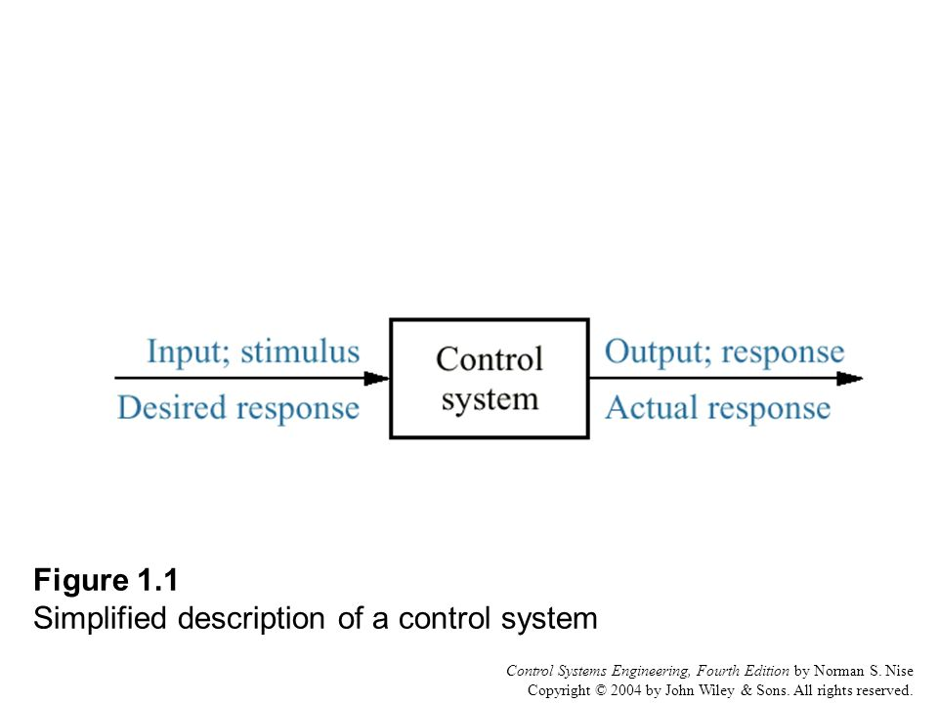

Figure 1- A simple description of a control system, Source [1]

Advantages of Control System

Control systems allows us to move large equipment’s with precision that would otherwise be impossible to move. Control system are designed for four primary reasons:

- Power amplification
- Remote control
- Convenience of input form
- Compensation for disturbances

An example of power amplification would be a radar antenna that is positioned by the low-power rotation of a knob at the input. This system requires a large amount of power for its output rotation and yet with a control system this rotation can be achieved with a turn of a knob at the input. Control systems can also be useful in remote or dangerous location, such as radioactive environments. A robotic arm can be used to pick up materials or even move items, without placing any human life in danger. [1]
Control systems can also be used to provide convenience by changing the form of the input. An example of this is, in a temperature control system. The input is a position on a thermostat and the output is the heat. Another advantage of a control system is the ability to compensate for disturbances, especially when dealing with variables such as temperature in a thermal system. [1]

Fundamentally, there are two types of approaches to a control loop and these are, an open-loop and closed-loop systems.[2]

Open-Loop control system
In an open-loop system, the product variable is not compared to or with any references/ desired value. One of the advantages of an open-loop system is that the system is simple to construct, and it is also easy to maintain and generally have no stability problems. As a result, most of the open-loop systems has limited use. The block diagrammatic representation of a typical open-loop system is shown in figure 2. [2]
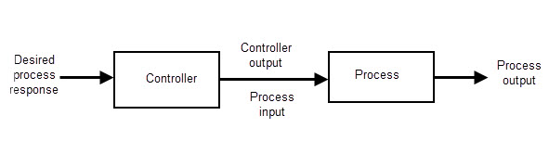
Figure 2 - Open-loop, Source [3]

Closed-Loop control system

Close-Loop control system

A close-loop system is similar to an open-loop system, but it includes a feedback path. This feedback path is through which the measured controlled variable is transmitted to a comparator for comparison, and the error so generated is used for operating a controller whose output actuates an actuator/control valve for proper functioning of the process. The block diagrammatic representation of a typical close-loop system is shown in figure 3. [2]
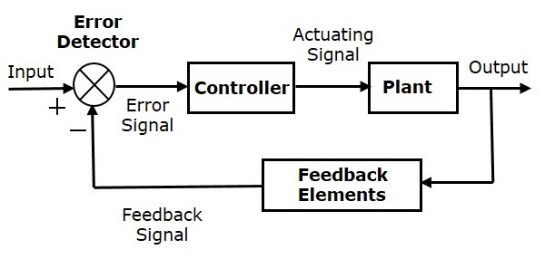
Figure 3- Close-loop, Source [4]

In figure 3, the system’s output is improved with the feedback path because the output is monitored and compared with the desired output value, and if the difference between the two (the error) is used as a signal to develop corrective action to reduce the error. Examples of close-loop systems are found in many industrial processes where position or velocity at some point must be altered in a certain way. [3]

Control Modes

There are two basic modes of process control which are ON/OFF action and continuous control action. The purpose of the control is to hold the measured variable output from a process within set limits by varying the controlled input variable to the process. [4]

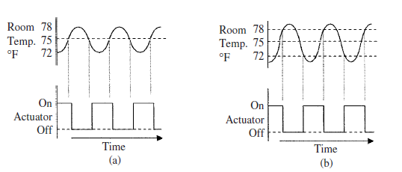
Figure 4 - (a) A simple ON/OFF action of a room heating system, (b) differential ON/OFF action, Source [4].

Figure 4, shows an example of a simple room heating system. In figure 4 (a) the top graph shows the room temperature (measured variable) and the bottom graph shows the actuator signal. The set point in this example for the room temperature is set at 75 degrees. However, when the air is being heated, the temperatures in the middle of the room would reach 77 degrees before the temperature at the sensor reaches the reference temperature of 75 degrees. Similarly, as the room cools down, the temperature in the room will drop to 73 degrees before the temperature at the sensor reaches 75 degrees. The room temperature will go from about 72 – 78 degrees due to the inertia in the system. [4]

Differential action
As it can be seen in the top graph in figure 4 (b), the thermostat which acts as the sensor in the system is supposed to switch on and off at the set reference of 75 degree but the switching point are delayed by +/- 3 degrees. This system has a built-in hysteresis or a dead-band operation. As a result, the thermostat turns OFF the actuator when the room temperature reaches 78 degrees and doesn’t switch back ON until the room temperature falls to 72 degrees, giving a built-in hysteresis of 6 degrees. [4]

Proportional Control (P)
Proportional control is the most common of all continuous industrial process control action. The control initiates a corrective action to a value that is in some proportion to the change in error or deviation of the process variable from set point. The input signal is compared to a set point and any difference in amplitude between the two (error signal) is amplified and fed to a control valve (actuator) as a correction signal. The control valve controls one of the inputs to the process and by changing the input to the control, will result in a change in the output amplitude until it equals the set point or the error signal is zero. [4]

Proportional plus derivative (PD)
In order to reduce the correction time that would have occurred using proportional action, proportional plus derivative was created to achieve this. This control action senses the rate of change of the measured variable and applies a correction signal that is proportional to the rate of change. [4]
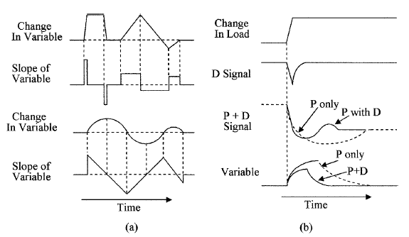
In figure 5 (a), a derivative output is obtained only when the load is changing. However, figure (b) shows the effect of PD action on the correction time, when a change in loading is sensed both the proportional and derivative signals are generated and added together. Once these signals are combined it produces a signal that speeds up the actuator’s control signal. The faster reaction time of the control signal reduces the time to implement corrective action. [4]
Figure 5 - (a) and (b) shows the examples of both the derivative action and the effect of PD action on the correction time, Source [4].

Proportional plus Integral (PI)
Proportional plus Integral action is known as the reset action which was developed to correct for long term loads and applies a correction proportional to the area under the change in the variable curve. Figure 6, shows that the Integral action gives a slower response to changes in the measured variable to avoid overshoot. However, it normally has a high gain so that with long term load changes it takes over control of the manipulated variable and it applies the correction signal to actuator. [4]

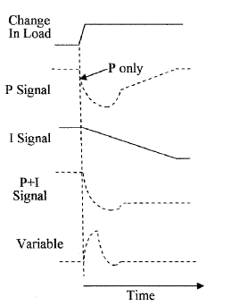

Figure 6 - Effect of proportional and integral action on a variable, Source [4]

Proportional plus Integral and derivative (PID)
All three actions described above can be combined to form a PID action. Figure 7, below shows the waveforms of PID action which is the most often used corrective action for process control. [4]
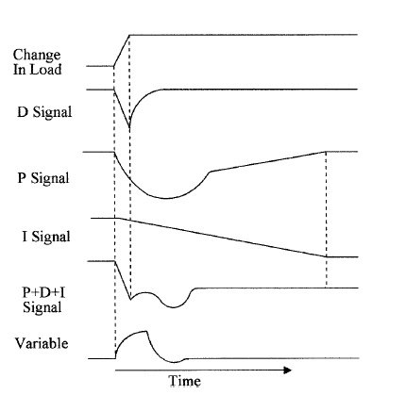

Figure 7 - Waveforms for proportional plus integral action and waveforms for proportional plus derivative and integral action, Source [4]

PID electronic controller

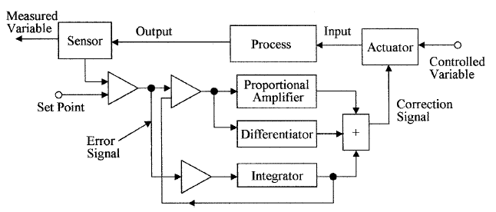
Figure 8, shows a block schematic of a PID electronic controller. The PID electronic uses the sensors to measure the variable and compare it with the set point in the first unity gain comparator. Its output is the error signal which is fed to the integrator with an inverting unity gain buffer and to the proportional amplifier and differentiator via a second inverting unity gain. These signals are compared to the integrator output and if there is a change in the measured variable, the error signal passes through the second comparator which is the proportional amplifier, added to the differential signal in a summing circuit and fed to the actuator to change the input variable. [4]
Figure 8 - Waveforms for proportional plus integral action and waveforms for proportional plus derivative and integral action, Source [4].

Method

Figure 9 - Task block diagram
Water Treatment
Water In
CO2 Dosing System
Water Out

Figure 9 above, shows a block schematic diagram of the task that would need to be completed to treat the water with pH 8.5-13 and reduce it to a pH level between 6 -7.

Figure 10 - Control system – closed-loop

Controller
G(s) = $\frac{K}{S}$
PH Sensor
H(s) = $\frac{1}{1+2s}$

Plant + Tank
G2(s) = $\frac{1}{1+s}$

Amplifier
Error

Figure 10, shows the block diagrams with the transfer function. In this control system, there are four individual transfer functions:
- Controller
- CO2 Valve
- Plant + Tank
- pH sensor
G = controller * CO2 Valve * Diffuser + Tank
H = pH sensor * (Signal conditioning)
$$System= \frac{G}{1+GH}$$

The Concept of PH measurement and control

There are a wide range of applications from high-purity pharmaceutical processing to wastewater treatment. These applications can pose some challenges to PH measurement, including high-temperature and otherwise harsh measurement environments, stability, low conductivity and more-stringent PH control. [5]
PH is a measure of hydrogen ion concentration in an aqueous (water) solution. The PH scale range from 0 -14. A low PH value indicates acidity, a PH=7 is neutral, and a high PH value indicates alkalinity. The aim of the PH value is to tell you whether you’re dealing with an acid or base, but it offers limited value indicating the true strength of the acid of base. [6]

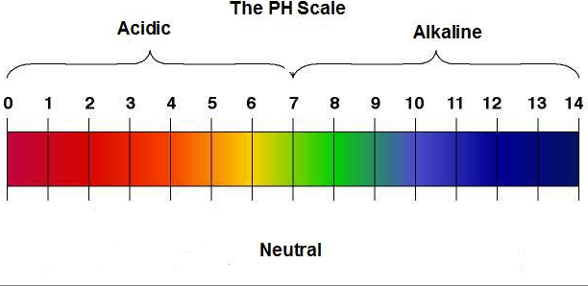

Figure 11 - PH Scale, source [11]

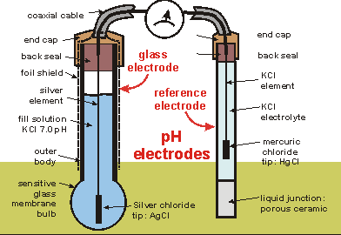

Figure 12 - PH electrode parts, source [11]

List of PH Sensors

Types | Temperature range | Accuracy | Sensitivity | Range | Response time | Linearity
  Vernier pH sensor  (PH-BTA) | 5 to 80°C | +/- 0.2 pH units | N/A | pH  0–14 | 90% of final reading in 1 second | N/A
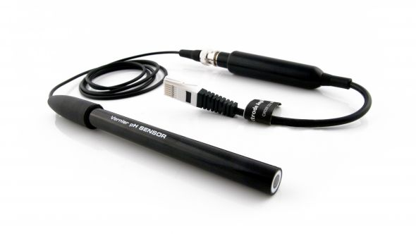  Vernier pH sensor  (FPH-BTA) | 0 – 100ºC | +/- 0.2 pH units | N/A | pH  0–14 | 98% of full response in 30 s at 25ºC | N/A
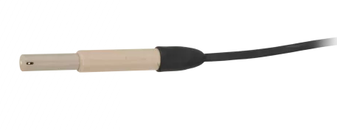  (CS526L) | 10° to 40°C | ±0.2 pH (over 10° to 40°C) | N/A | pH  2 –14 | N/A | N/A
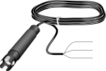  (CSIM11-L) | 0° to 80°C | ±0.1%(over full range) | N/A | pH  0 to 14 | 95% of reading (in 10 s) | N/A

Table 1 - List of PH sensors

List of CO2 Valves

Types | Flow rate | Proportional | Temperature | Pressure Bar
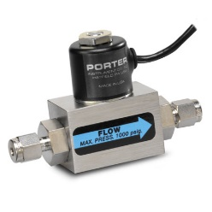  Proportional Solenoid Model 001 | 0-5 SCCM to 0-10 SLPM | proportional solenoid control valves | Range: -10 to 70 °C (±14 to 158 °F) | 1000 PSIG
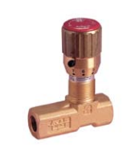  Flow Control Needle Valves reverse flow | 20 LPM | N/A | Range: -20 to 100 °C | 0 - 210
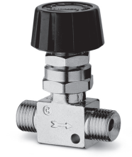  Series 28 flow control valves | 590 NI/min | N/A | Range: 0°C + 80 °C (with dry air 20°) | 0+10
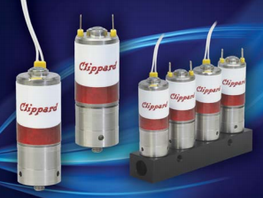  DVP High Flow Proportional Control valve | 70 L\min | proportional solenoid control valves | Range: 32 to 120 °F | Vac to 100psig
Table 2 - List of CO2 Valves

Transducer selection

PH sensor
Figure 13 - (PH - BTA), Source

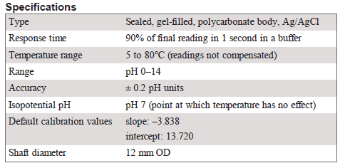
Figure 14 - Specifications, Source [12]

The PH-BTA sensor would be considered for this project because the pH sensor is designed to make measurements in the pH range of 0 to 14. In addition, the pH sensor types meet the specification for the project such as response time, temperature range, range and accuracy.

Operation
This pH sensor is designed to produce a voltage of approximately 1.75 volts in a pH 7 buffer and the voltage increases by about 0.25 volts for every pH number decrease. The voltage decreases by about 0.25 volts/pH number as the pH number increases. [7]

CO2 Valve Controller
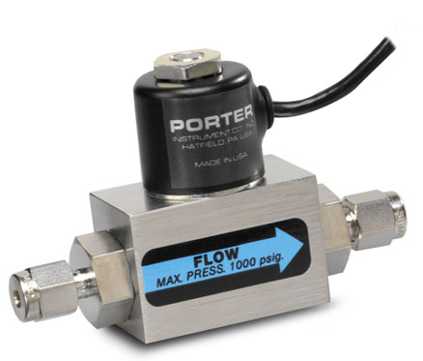
Figure 15 - Flow Control Valve, Proportional Solenoid – Model 001, Source [13]

The mass flow control valve would be considered for this project because the control valve is designed to operate in temperature range of -10 to 70$℃$ ( $±14 to 158℉$). Flow capacity of 0-5 SCCM to 0-10 SLPM. Operating voltage of 4-11 VDC (24Vdc maximum) and operating current nominal 150mAdc (275mAdc). [8]

Operation
The model 001 is a mass flow control valve which is normally closed, proportional solenoid control valve. This model consists of a valve body, valve sleeve, DC coil, which creates a magnetic field lifting the internal valve assembly from the orifice to allow the gas flow control. [8]

PH sensor Transfer function

For the pH sensor transfer function, the two-main specification type that mattered were sensitivity and response time. The sensitivity of the pH sensor was not included in the specification. However, the pH voltage increases and decreases by about 0.25 volts/pH number. Thus, this voltage was used as the sensitivity of the pH sensor.
The response time was calculated because in the pH sensor specification it stated that 90% of final reading in 1 second in a buffer. Thus, the response time was calculated using the following equations:

PH sensor transfer function
$$\frac{sensitivity}{1+ τs}$$

Response time
$$90\%÷100=0.9$$
$$0.9=1-e \frac{-1}{τ}$$
$$0.9-1=-e \frac{-1}{τ}$$
$$- 0.1=-e \frac{-1}{τ}$$
$$0.1=e \frac{-1}{τ}$$
$$\ln{0.1}=\frac{-1}{τ}$$
$$-2.3= \frac{-1}{τ}$$
$$\frac{-1}{-2.30} =τ$$
$$τ=0.43$$

Calculation: Response time equation

Transfer function development in MATLAB
Plant - Tank
Flow rate
Carbon dioxide
Transfer Function 0.5s + 1 relative flow of water and CO2 – speed of the reaction
7 Constant is added to the PH neutral at 7

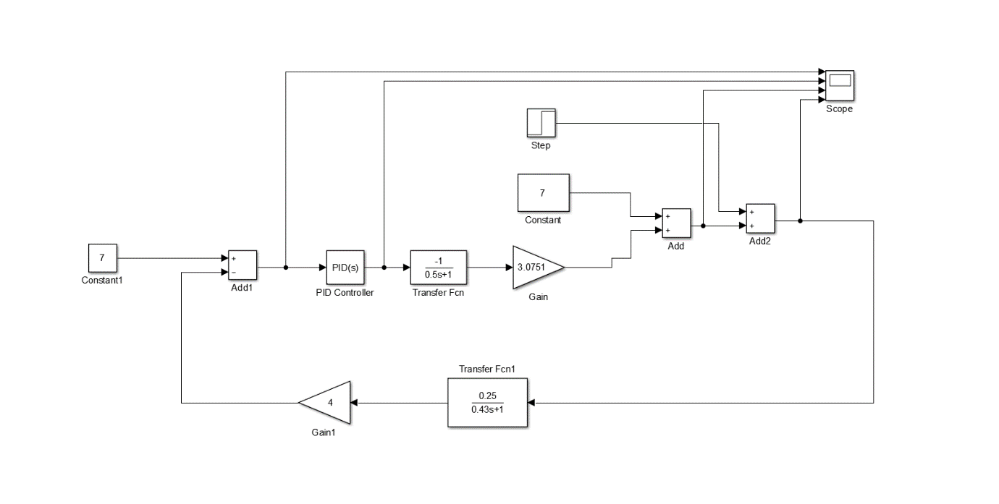
Error detection

Figure 16 - MATLAB system design

Transfer Fcn1 is the transfer function for the PH sensor. The top part of the transfer function relates to the sensitivity, while the denominator is the response time. An amplifier with is added to the system to amplify the signal from the sensor. The amplifier also has a gain of 4 which is multiplied by the numerator to get the PH in volts. Finally, the step is added as the disturbance in the system. The PID controller also has a transfer function with a low pass filter inside to slow and smooth out the response.
Figure MATLAB block diagram

PID Controller Design Specifications

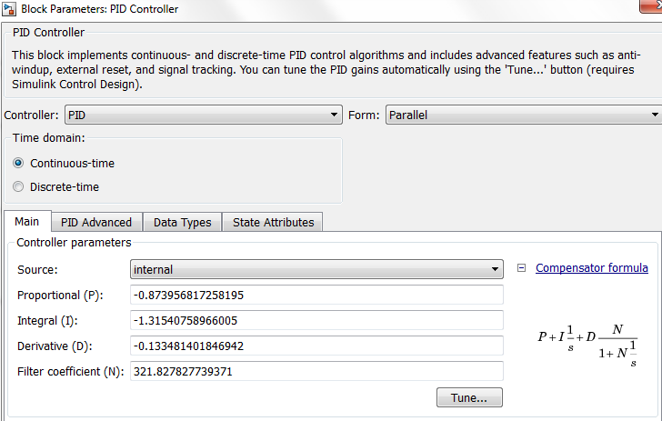
KP= -0.874 KI= -1.32 and KD= -0.133
Figure 17 - PID Controller
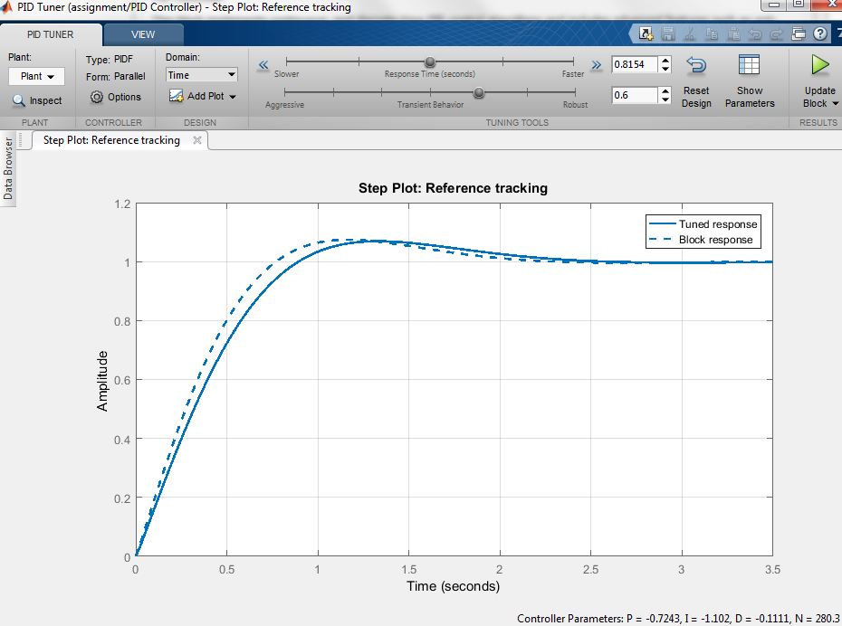
Figure 18 - Step Plot Tuned and block response

PID Tuner

Settling time less (min) than 3 seconds, Percent overshoot (%) less than 8 seconds and Closed-loop stability = stable.

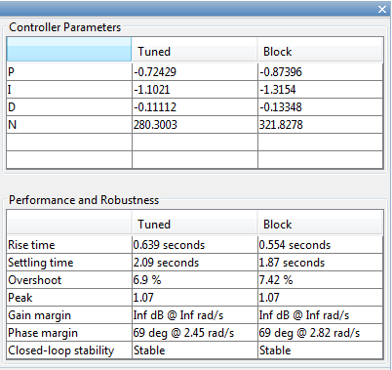
Figure 19 - Performance and Robustness

Figure 20 - Controller Parameters

Transfer functions in MATLAB
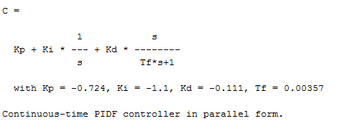
Figure 21 - PID Transfer function

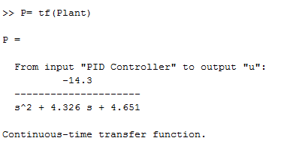
Figure 22 - The plant Transfer function

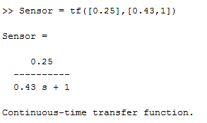
Figure 23 - PH sensor Transfer function

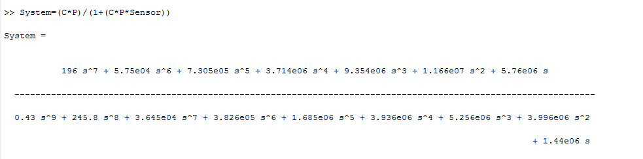
Figure 24 - System Transfer function

Results
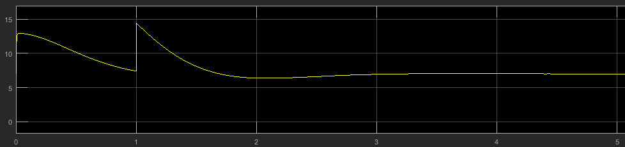

Figure 25 - PH sensor Scope Reading (a)
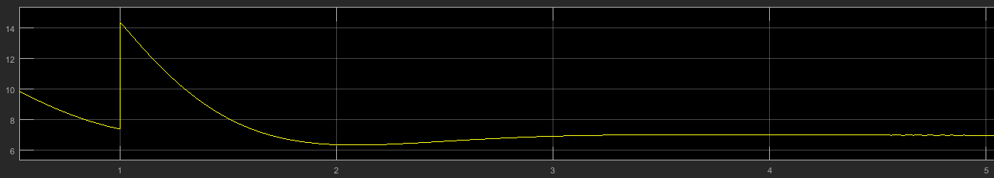

Figure 26 - PH sensor Scope Reading (b)
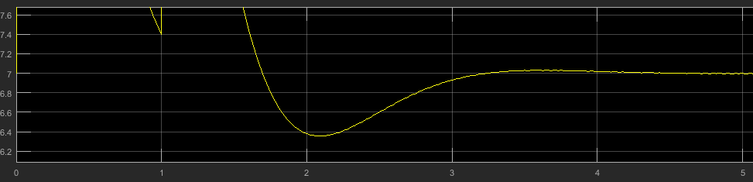
Figure 27 - PH sensor Scope Reading (c)

Stability In control system

Stability analysis is the nature of the response of a system to transient disturbance. The analysis determine whether or not the system is stable, if a control system is designed to meet a time domain specification using empirical frequency response data. Then it is necessary to be able to predict how the closed loop system will behave in the time domain. In addition, small changes in the characteristics of the controller or the system can determine how robust the design is in term of the sensitivity of the control system performance. [5]

Pole-zero plot
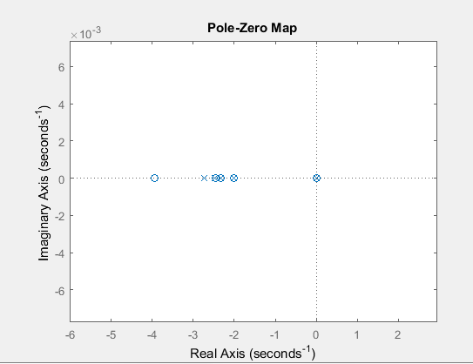
Figure 28 - Pole – Zero

Figure 26, shows the pole-zero output response which is fundamental to the analysis of the system. The zeros and poles generate the amplitude for both the forced and natural responses. Thus the farther to the left a pole is on the negative real axis, the faster the exponential transient response will decay to zero. This is known as the effect of a real-axis pole upon transient response. [9]

Nyquist Diagram
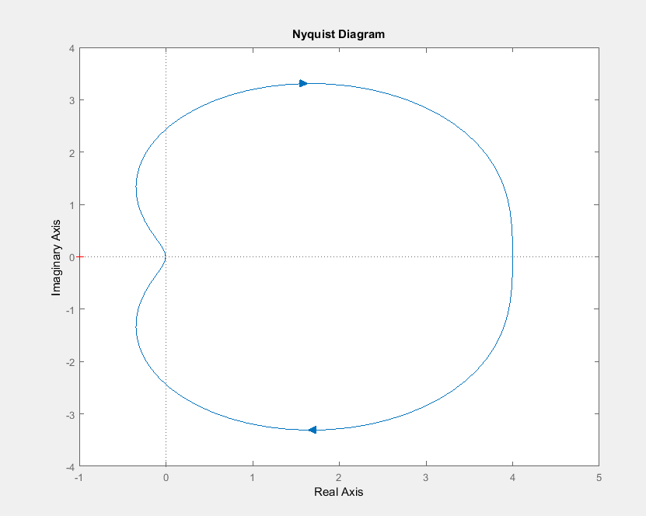
Figure 29 - Nyquist Diagram

Figure 27, shows the systems output response in a Nyquist diagram. The diagram defines two quantitative measures of how a system is. The two quantities are called gain and phase margin. If a system has greater gain, this means the phase margin can withstand greater changes in the system parameters before becoming unstable. Thus, the Nyquist diagram above shows that the system is stable. As previously explained in a system whose poles are farther from the imaginary axis have a greater degree of stability. [9]

Bode Diagram
Figure 30 - Bode Diagram (a)
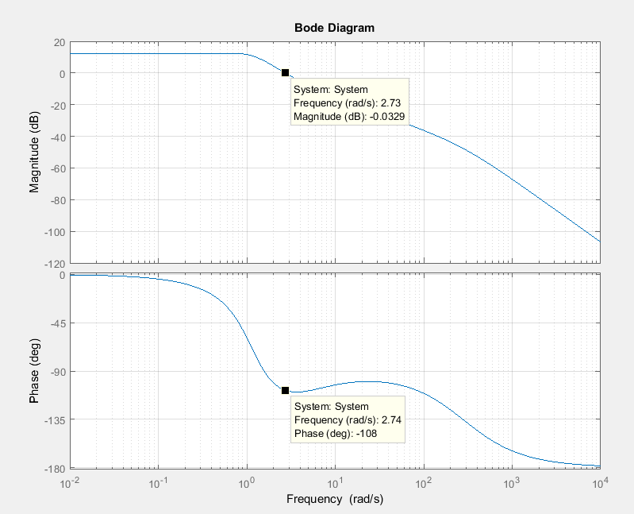

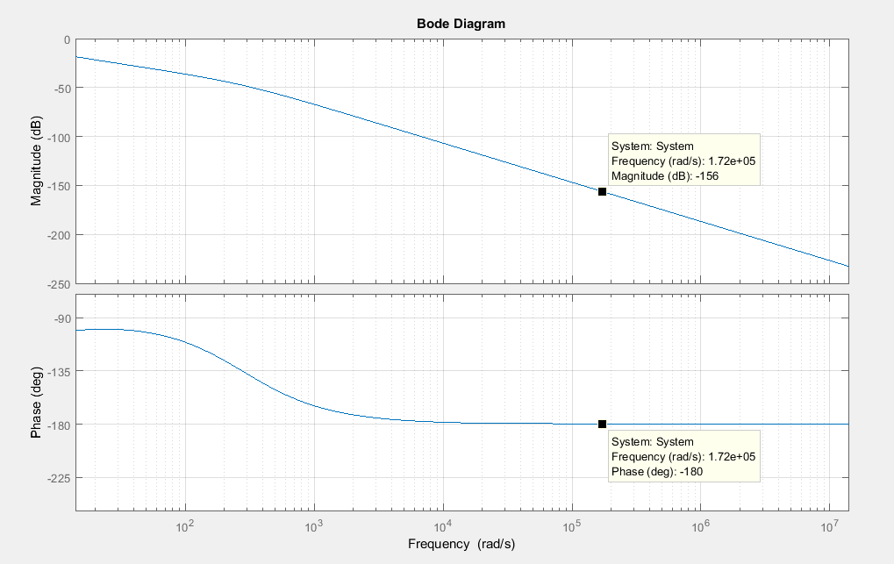
Figure 31 - Bode Diagram (b)

Both Figure 28 (a) and (b), shows the systems output response in a Bode diagram. Bode plots are subsets of the complete Nyquist diagram but just in another form. The Bode plots are an alternate ways of visualising and implementing the theoretical concepts of the system. Thus, all the calculations still applied to stability can also be derived from the Nyquist stability criterion. [9]
The gain margin is determined by looking at the phase plot and finding the frequency where the phase is 180 degree. At this frequency, we determine from the magnitude plot how much the gain can be increased before reaching 0dB. Figure, the phase angle is 180 at approximately 1.72e+0.5 rad/s.
The phase margin can be determined by looking at the phase plot of the diagram and finding out the frequency where the phase is 180 degrees. At this frequency, we look on the phase plot to find the difference between the phase and 180 degrees. This difference is the phase margin, figure (b) shows that the difference between the two is:
$-108-\left(-180\right)=72°$.

Conclusion

Based on the results, the system managed to regulate the acidity of the water leaving the plant to a safe level. Thus, the pH value of the water was also reduced from 13pH to 7ph.
The system was designed to incorporate any possible disturbance that could have an effect on its performance. Possible disturbances, such as changes in plant o/p pH, changes in plant o/p flow, changes in temperature o/p and any temperature changes of the incoming CO2 gas. Figure 29, below shows the pH value of the water decreasing and a sudden spike in the system which represents any possible disturbances. Although, the pH value increases for a short period of time it, the system is acknowledges this and deals with it and pH value continues to decrease shortly after the spike.
Figure 32 - PH sensor Scope Final Reading (d)

References

[1] | N. NISE, Control Systems Engineering, California: Polytechnic University, 2009.
[2] | D.Patranabis, Instrumentation and Control, New Delhi: PHI Learning, 2011.
[3] | J.Schwarzenbach, Essentials of Control, London: British Library Cataloguing in Publication Data, 1996.
[4] | W. C.Dunn, Fundamentals of Industrial Instrumentation and Process Control, United States of America: McGraw-Hill, 2005.
[5] | J. G. a. A. Verwer, Control System Design and Simulation, Berkshire: McGRAW-HILL, 1991.
[6] | HACH, “HACH,” 18 January 2018. [Online]. Available: PH is a measure of hydrogen ion concentration in an aqueous (water) solution.. [Accessed 19 March 2018].
[7] | “Vernier,” [Online]. Available: https://www.vernier.com/products/sensors/ph-sensors/ph-bta/. [Accessed 18 February 2018].
[8] | Porterinstrument, “Parker,” [Online]. Available: http://www.porterinstrument.com/product/industrial/001. [Accessed 18 February 2018].
[9] | N. S.Nise, Control systems Engineering, California: Courier Kendallvile, 2015.
[10] | Adminstrator, “Electronics HUB,” 15 July 2015. [Online]. Available: https://www.electronicshub.org/open-loop-system/. [Accessed 18 February 2018].
[11] | “Tutorialspoint,” [Online]. Available: https://www.tutorialspoint.com/control_systems/control_systems_introduction.htm. [Accessed 18 February 2018].
[12] | G. McMillian and R. Baril, “pH Measurement and Control,” Access Intelligence LLC, New York, 2010.
[13] | E. 360, “Globalspec,” [Online]. Available: https://www.globalspec.com/learnmore/sensors_transducers_detectors/analytical_sensors/ph_orp_electrodes. [Accessed 19 March 2018].

Appendices

The fact that the CO2 dosing system consist a tank of carbon dioxide gas, several calculation were done to determine the correct PH sensor, Co2 in the water and gas diffuser for the project. However, at the end of these calculation it was proven that difficult to achieve, because the logarithms equations were not satisfied.

$$CO2+H2O=HCO3+H^{+}$$
$$K=\left(\left[H^{+}\right]\left[HCO3\right]\right)÷\left[CO2\right]$$
$$pH=\frac{1}{2} \left(pK+pCO2\right)$$
$$Pk=\log\left(k\right)PCO2=\log\left[CO2\right]$$
$$\left[CO2\right]=\frac{20mol}{dm^{3}}$$
$$\left[H20\right]=\frac{55.5mol}{dm^{3}}$$

$$75\% of CO2 which 20mol=15mol$$
$$75\% of 20mol=15mol/dm^{3}+15mol/L$$
$$=CO2+H20=HCO3+H^{+}$$

$55.5-15=40.5mol/L$Pure water (Unreacted water)
$20-15=5mol/L$CO2 (Unreacted CO2)
$15+15=30mol/L$CO2 $\left[H^{+}\right][HCO3]$

$$K=\frac{30}{5}=6$$

$$pK=-\log\left(6\right)=-0.778$$

$KW=\left[H^{+}\right]\left[{OH}^{-1}\right]=1×{10}^{-14 }at 25℃$
$$pKw=-\log\left(kw\right)=14$$

$CO2+2H_{2}0→H_{2}Co3+H20→HCO3+H3O$

Carbon acid
P Ka = 6.367 Ka = ${10}^{-6.367}$
[CO2] = 44.01g/mol

Solubility of CO2 14 H2O 15 1.45g/L (which will change with pressure)

1.45g (Co2) $\frac{1mol}{44.01g}=0.03297 mol Co2$

$$Ka\frac{\left[H^{+}\right][HCo3]}{[Co2 \left(aq\right)]}→ {10}^{-6.367}=\frac{x x}{0.03297}$$
$${10}^{-6.367}=\frac{x^{2}}{0.03297}$$
$$x^{2}={10}^{-6.367}×0.03297=1.41317×{10}^{-8 }$$
$$=\sqrt{1.41317×{10}^{-8}}$$
$$=1.18877×{10}^{-4} [H^{+}]$$

$$pH=-\log{(\sqrt{{10}^{-6.367}}×\frac{Sol}{44.01})}$$

$Co2 in water = 392×{10}^{-4}Mol/L.atm$ Henry’s law

Rearrange the equation to get pressure

$$pH=-\log{(\sqrt{{10}^{-6.367}}×392×{10}^{-4}×Pressure)}$$

$$Log \left(ABC\right)=logA+logB+logC$$

$$\sqrt{ABC}=\sqrt{A}×\sqrt{B}×\sqrt{C}$$

$$- pH=\log{(\sqrt{{10}^{-6.367}}×\sqrt{392×{10}^{-4}}×\sqrt{Pressure})}$$

$$- pH=\log\left(\sqrt{{10}^{-6.367}}×\sqrt{392×{10}^{-4}} \right)+log\sqrt{Pressure})$$

$$- pH=\log{-3.89+log\sqrt{Pressure})}$$

