

Programme: MBA Master of Business Administration
Student name: Alina Jubea
Student number: 2023149
Lecturer name: Dr Hoang Nguyen
Module name: Strategic Management
Module code: LCMB7003

Individual Assignment: “Virtual Organisations” and how the concept of virtual management is practised within Shopify.com

Table of Contents
Introduction 3
Virtual Organisations 3
Shopify 4
Opportunities of virtual management 5
Planning 5
Challenges 5
Opportunities 5
Design 5
Challenges 5
Opportunities 6
Leading 6
Challenges 6
Opportunities 7
Conclusion 7
Recommendations 8
List of References: 9

Introduction

This report critically examines the rise of online businesses using Shopify as an example. Shopify is a well-known online business that is run more smoothly with the help of digital tools. This gives us a good look at the pros and cons of making plans, creating things, and leading people in a virtual place. There are communication gaps; keeping teams together and ensuring that teams working in different places all make the same high-quality goods are all things the study looks at. It also shows how businesses can change by using up-to-date digital technology and collecting data in real-time. The study also talks about the great things about virtual organisations, like being able to hire people from all over the world, fostering innovation through different cultural views, and making the workplace flexible and focused on results. Shopify has become a model for virtual businesses because it encourages people to work from home, especially during the COVID-19 pandemic. It has proven that digital management can be a strong force for progress and (Sanjeev Sularia, 2021; Shopify.com, no date; Ferguson et al., 2022; Dwivedi, 2022; Bulgarella, 2023), and this study all talk about how important it is for online businesses like Shopify to have plans, good leadership, and the newest technology in order to grow to their full potential.

Virtual Organisations

A virtual organisation, also called a virtual firm, is a cooperative network of autonomous entities, such as companies or individuals, that simultaneously accomplish specific objectives by utilising advanced information and communication technology. This notion, which has undergone development since the early 1990s with input from researchers such as Jan Hopland, Nagel Dove, Davidow and Malone, highlights the importance of being flexible and adaptable in dynamic market contexts. VOs, although lacking a broadly accepted definition, are distinguished by their capacity to function without the limitations of a conventional, centralised physical presence. Small and medium-sized firms can enhance their competitiveness by collaborating and sharing resources (Camarinha-Matos, L. M. et al).

Shopify

Shopify is one of the best e-commerce platforms because it lets businesses of all kinds make, customise, and run their online stores. Shopify lets business owners sell their goods on many platforms, such as websites, social media, and stores. It has an easy-to-use interface and many useful tools. The site has many useful features for businesses that want to start or grow their online presence. These include safe ways to process payments, keep track of inventory, and connect to marketing tools. Shopify is the platform of choice for millions of sellers worldwide because it is dedicated to new ideas and easy expansion (Shopify.com, no date).

Shopify is an example of a virtual organisation because it fits the criteria set by experts such as Jan Hopland, Nagel Dove, Davidow, and Malone that virtual organisations are networks of separate, self-governing groups that work together to complete specific tasks using cutting edge computer and communication technology. Because these groups do not have a standard, centralised physical presence, they stress being flexible and able to adapt, especially in constantly changing markets. Shopify does not have to be limited by a traditional office structure because it has a mindset of working from home first. Its workers and partners worldwide can work together efficiently, which shows how well digital tools help it stay efficient and come up with new ideas. Forbes says that Shopify's move to a fully remote model during the COVID-19 pandemic has made the company a star in e-commerce and changed how the market works (Sanjeev Sularia, 2021)

Shopify practices virtual organisation by using many digital tools and letting employees work from home. This enables the company to run smoothly without having a central office. According to Shopify (Shopify.com, no date), their platform is made to help businesses worldwide run their entire operations online, from designing products and keeping track of their goods to marketing and sales. The company's use of cloud-based technology and distributed teams is an excellent example of a virtual organisation because it allows for planning, creating, and running business operations from different places and time zones (Martinez et al., 2001). This method makes things more efficient and lets Shopify quickly respond to changes in the market and expand its services to meet the needs of a wide range of customers worldwide.

Opportunities of virtual management

Planning

Challenges
It is harder to plan for a virtual company like Shopify because it takes longer to keep track of workers who work from home. It can be hard to talk to each other, match up on goals, and work as a team in different time zones. It is easier to keep everyone on the same page and build a sense of unity when there is a real office. This is because online talks don't always feel as accurate or nuanced as in-person talks. Also, because the digital market moves so quickly, companies have to change and decide things rapidly, which makes planning for the long run harder. Market trends and evolving customer behaviour must always be considered, meaning plans must be flexible and changed often. This makes strategic planning even harder in a different room (Dwivedi 2012). To deal with these problems in this setting, good communication plans and digital tools that work well will be needed. This contrasts with the competitor WooCommerce, which also has to deal with these issues. However, WooCommerce's reliance on third-party plugins and decentralised support structure can make planning even harder, especially when users need to coordinate across tools and services that may need to be fully integrated (Watts, 2023).

Opportunities
Managing a staff that is spread out can be challenging, but Shopify's virtual organisation lets them be more creative and get more done. The business can see data in real time and make plans quickly thanks to cutting-edge digital tools. This enables it to quickly adapt to changes in people's lives and how the market moves. These digital tools make it easy to make big choices and let people keep trying new ways to run their businesses. This creates an adaptable environment that can quickly adapt to new events. By adding cutting-edge marketing tools, Shopify can better target customers and connect with them on a deeper level (Haan, 2024), making its place in the market even more important. Customisation-wise, WooCommerce is more open than Shopify. This can be a good thing because it lets users create their stores to fit the needs of different markets. However, this can also lead to complexity and slower reaction times compared to Shopify's more streamlined, integrated method (Watts, 2023).

Design

Challenges
Shopify needs help keeping the brand style and product quality across a team that works in different places. Creative projects often require a lot of teamwork, which is tough when people do not see each other. This could confuse or hold up the process. Virtual teams may not always be able to agree on design ideas, and not being able to see each other in person can make the creative process less smooth. A big logistical issue is ensuring everyone on the team can access the materials and tools they need, especially when people are spread out in different places and use different tech systems. Even more challenging is the need for constant communication to keep the design process running smoothly and avoid problems that could affect the quality and consistency of the end product (Ferguson et al., 2022). WooCommerce, its main rival, also needs help keeping quality and branding consistent because it uses a lot of plugins from different developers, which can cause problems with compatibility and a jumbled user experience (WooCommerce, n.d.).

Opportunities
Virtual corporations are hard to design. Although designing online is difficult, Shopify's digital nature gives many design alternatives. The company's global reach allows it acquire diverse talent and absorb fresh ideas from other cultures, making creativity more fun. Innovation and more inclusive products for a wider audience cause this variation. Virtual collaboration tools like digital whiteboards and project management software accelerate creativity. These tools let teams discuss ideas, get rapid feedback, and stay on course even when members are scattered. Shopify's robust digital platform enables designers create and improve items in real time with Google Cloud and rapid prototyping and testing. This feature speeds design and makes product creation more versatile and adaptive, meeting consumer needs (Shopify, 2024). Its main competitor, WooCommerce, is open-source, letting clients generate custom designs that match their brand. It involves more technical knowledge and may take longer than Shopify's integrated and user-friendly technologies (WooCommerce, n.d.).

Leading

Challenges
Leading a virtual company like Shopify is difficult since it's hard to maintain teamwork and culture without seeing each other. Digital communication is fast and convenient but lacks the human touch that encourages workers. Building strong team ties and belonging is difficult. Managing remote workers requires balancing trust, choice, monitoring, and accountability. It's hard to do well, yet it can boost output and creativity. Leading various teams in different areas with varied cultural and operational peculiarities is harder. Leaders must understand and adapt to culture. Virtual leadership is made more complicated by logistical issues including time zone coordination and resource distribution. Leadership in these contexts involves excellent digital communication, emotional awareness, and a plan to inspire, unite, and motivate a team despite these issues (Efimov et al., 2022). WooCommerce customers confront comparable leadership issues, especially when dealing with developers and service providers who extend website capabilities. The decentralised nature of WooCommerce forces leaders to handle these relationships more manually than Shopify's integrated, centralised support system, which is meant to help manage these complications (Shopify, 2023).

Opportunities
Virtual leadership gives Shopify many opportunities to improve the firm. Because executives may work from home, Shopify can hire diverse abilities and perspectives. This boosts the company's creativity and innovation. Digital tools simplify communication and idea sharing. This helps CEOs persuade their people to support company goals. These tools can help remote teams stay in sync. Because of their flexibility, telecommuters may be happier and more loyal. Leaders can let employees choose their hours and work from home. This flexibility improves work-life balance and attracts top talent. It fosters a results-driven culture that values results over office time. Instead of task time, results may make workers more productive. People will have more freedom to work and focus on results (Bulgarella, 2023). WooCommerce's decentralised infrastructure allows for a varied and global talent pool, but it takes more coordination and management to attain Shopify's efficiency and innovation. Influential WooCommerce leaders must manage a variety of contributors to ensure consistency and success (Shopify, 2023).

Conclusion

Being successful as a virtual business like Shopify shows how important it is to use cutting-edge digital tools to get more done, develop new ideas, and stay ahead of the competition. Some planning challenges include creating and leading in a virtual setting, like keeping the team together and fixing communication issues. However, Shopify shows that setting up a virtual solid organisation structure can quickly deal with these. Thanks to its "remote-first" approach, the company can quickly adapt to changes in the market, hire people from all over the world, and keep its working flexibility. These strengths show that online companies can change and make the most of the opportunities. The story of Shopify shows how using cutting-edge technology and encouraging an open work environment can strengthen a business and help it grow. Other companies that want to do well in a world that is becoming more digital can learn from it (Shopify.com, no date; Sanjeev Sularia, 2021; Dwivedi, 2022; Ferguson et al., 2022).

Recommendations

A look at Shopify's virtual management structure can lead to several ideas for improving its
operations and strategic planning. First, Shopify should keep putting money into high-tech
tools and platforms for digital contact that let people in different places and time zones easily
talk to each other. This would make it easier for people who work from home to speak to
each other (Dwivedi, 2022). Regular virtual meetups and team-building events can build a
stronger sense of unity and company culture (Efimov et al., 2022). This helps with the
disconnect that comes with working in a decentralised environment. Finally, Shopify's built-in
tools are helpful but must be constantly updated and improved to stay ahead of the
competition. This is important because WooCommerce and its competitors give you options
through open-source customisation (Shopify, 2023; WooCommerce, n.d.). Shopify can keep
strengthening the market and developing helpful new ideas for the digital world by focusing
on these areas.

List of References:

Bulgarella, C. (2023). In Shopify Support, Effective Managers Act As Mission Enablers. [online] Forbes. Available at: https://www.forbes.com/sites/caterinabulgarella/2023/04/26/in-shopify-support-effective-managers-act-as-mission-enablers/ [Accessed 18 Aug. 2024].
Camarinha-Matos, L. M. et al. (2006) Virtual Organizations. Springer Science & Business
Media.

Dwivedi, Y.K. (2022). Metaverse beyond the hype: Multidisciplinary Perspectives on Emerging challenges, opportunities, and Agenda for research, Practice and Policy. International Journal of Information Management, [online] 66(66), p.102542. doi:https://doi.org/10.1016/j.ijinfomgt.2022.102542.

Efimov, I., Rohwer, E., Harth, V. and Mache, S. (2022). Virtual leadership in relation to employees’ mental health, job satisfaction and perceptions of isolation: A scoping review. Frontiers in Psychology, [online] 13. doi:https://doi.org/10.3389/fpsyg.2022.960955.
Ferguson, S., Lai, K., Chen, J., Faidi, S., Leonardo, K. and Olechowski, A. (2022). ‘Why couldn’t we do this more often?’: exploring the feasibility of virtual and distributed work in product design engineering. Research in Engineering Design. doi:https://doi.org/10.1007/s00163-022-00391-2.
Haan, K. (2024). Best Marketing Software Of 2024. Forbes. [online] 22 Aug. Available at: https://www.forbes.com/uk/advisor/business/software/best-marketing-software/ [Accessed 17 Aug. 2024].

Martinez, M.T., Fouletier, P., Park, K.H. and Favrel, J. (2001). Virtual enterprise – organisation, evolution and control. International Journal of Production Economics, 74(1-3), pp.225–238. doi:https://doi.org/10.1016/s0925-5273(01)00129-3.

Sanjeev Sularia (2021). Council Post: How Shopify Is Shifting The E-Commerce Landscape. Forbes. [online] 22 Jan. Available at: https://www.forbes.com/councils/forbestechcouncil/2021/01/22/how-shopify-is-shifting-the-e-commerce-landscape/ [Accessed 15 Aug. 2024].

Shopify. (2020). Working Remotely for the Planet. [online] Available at: https://www.shopify.com/uk/blog/working-remotely-for-the-planet [Accessed 21 Aug. 2024]

Shopify. (2023). Shopify vs. Woocommerce 2023: Which Platform Is Better? [online] Available at: https://www.shopify.com/uk/compare/shopify-vs-woocommerce.

Shopify (2024). Empowering Innovation: Shopify and Google Cloud Partner to Transform Customer Experience (2024) - Shopify UK. [online] Shopify. Available at: https://www.shopify.com/uk/partners/blog/empowering-innovation-shopify-and-google-cloud-partner-to-meet-customer-needs [Accessed: 18 Aug. 2024].

Shopify.com (no date) Create your online store today with Shopify, Shopify. Available at: https://www.shopify.com/uk/free-trial?term=shopify&adid=642171117993&campaignid=15439902872&branded_enterprise=1&BOID=brand&utm_medium=cpc&utm_source=google&gad_source=1&gbraid=0AAAAAC3Mv8_PtPpiaiYk6E_-Re1u2VqaT&gclid=Cj0KCQjww5u2BhDeARIsALBuLnMYS9Pjaqzg8SckDiLPvSD9yqD2jEZC5zotmkWIBwraaYYb68xaBP4aAnVrEALw_wcB&cmadid=516586848;cmadvertiserid=10730501;cmcampaignid=26990768;cmplacementid=324286430;cmcreativeid=163722649;cmsiteid=5500011 [Accessed: 18 August. 2024].

Watts, R. (2023). WooCommerce Vs. Shopify (2023 Comparison). [online] Forbes Advisor UK. Available at: https://www.forbes.com/uk/advisor/business/software/woocommerce-vs-shopify/ [Accessed 17 Aug. 2024].

WooCommerce. (n.d.). WooCommerce vs Shopify. [online] Available at: https://woocommerce.com/woocommerce-vs-shopify/ [Accessed 18 Aug. 2024].

Student name: Alina Jubea
Student number: 2023149
Lecturer name: Dr Hoang Nguyen
Module name: Strategic Management
Module code: LCMB7003

1000 words Report for the Journal Article: Why enterprise resource planning initiatives do succeed in the long run: A case-based causal network.

The study looked at ERP implementations in industrial companies that had finished the project phase. It only looked at companies with at least 250 system users involved in big ERP projects. Vanilla implementations were included because they only had a small group of users and a limited reach. Four European cases were chosen because they were close to each other and showed ERP projects at different times. Two cases were in the later stages of implementing ERP, and the other two were at the beginning. The study continued for over two years after "normal operations" resumed. The goal of this method was to achieve both theory and actual replication in the study.

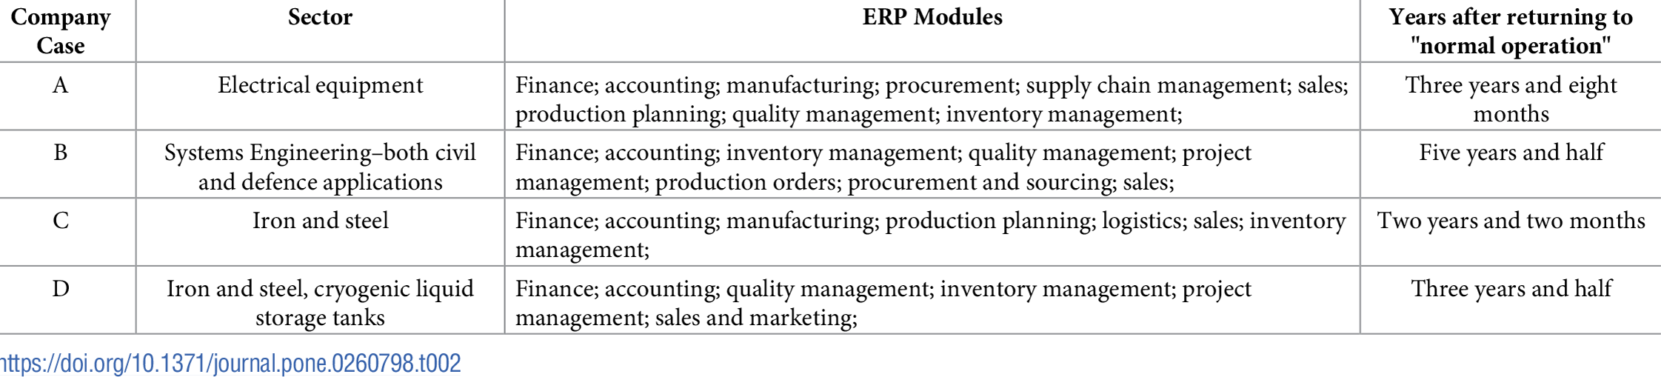
Table 2
Case Selection and the Power of Analysis
The study looked at ERP implementations in industrial companies that had finished the project phase. It only looked at companies with at least 250 system users involved in big ERP projects. Vanilla implementations were included because they only had a small group of users and a limited reach. Four European cases were chosen because they were close to each other and showed ERP projects at different times. Two cases were in the later stages of implementing ERP, and the other two were at the beginning. The study continued for over two years after "normal operations" resumed. The goal of this method was to achieve both theory and actual replication in the study.

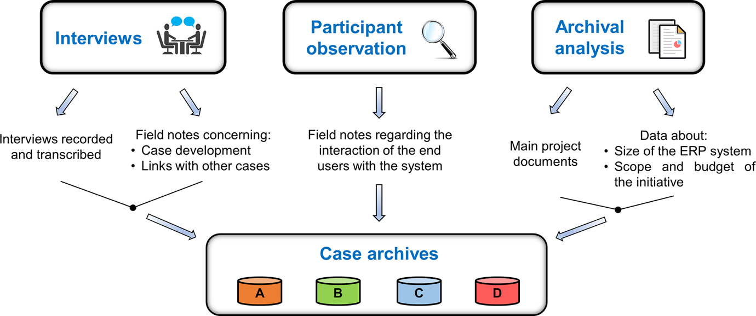

Figure 2, Data collection.

An organised, standardised case study method was used to ensure that data collection was correct. The technique started with a meeting on the first day of each case study. Critical people like the Project Sponsor, the ICT Manager, and the ERP Project Manager were at this meeting, which was very important for getting people to join and commit to the study. It set a helpful tone right from the start. After the first meeting, it was easier to plan follow-up trips and come up with a way to collect data that worked well and was specific to each case. This organised way helped the researchers collect much data over five years, from April 2015 to October 2020. This gave them a deep understanding of how ERP systems change and affect people over time. The research got deeper by sticking to a clear and consistent method and ensuring that all the subjects understood the study's goals. It became more reliable and valid, leading to solid and complete results. This organised and thorough method made it clear how critical strategic planning and clear communication are for carrying out a long-term research project well.

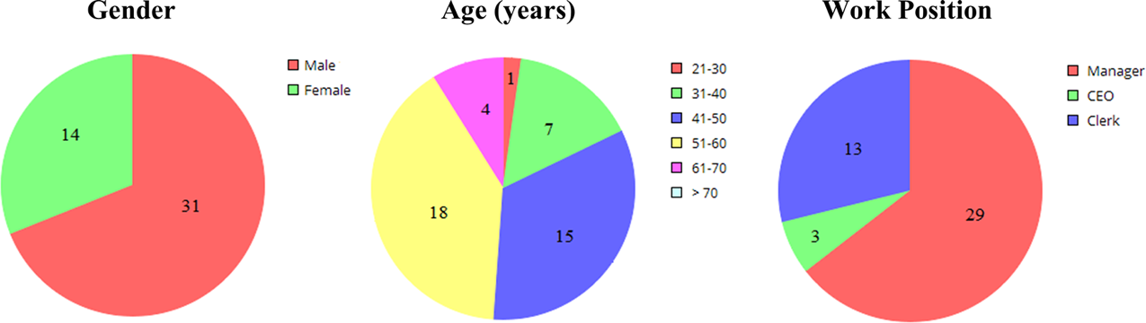
Figure 3
The profiles of the subjects provide a comprehensive view of the sample group's gender, age, and job title distribution. Notably, the group is predominantly male (31 men vs. 14 women), underscoring the necessity for future studies to strive for a more balanced gender representation. The age range is diverse, with the 40–50 age group being the largest at 18 individuals. This is followed by the 31 to 40 years old group (15), 51 to 60 years old group (7), 61 to 70 years old group (4), and 21 to 30 years old group (12). There is also one participant over 70 years old, highlighting the need for age diversity in future studies.

The sample is mainly made up of managers. The group has 29 managers, 13 workers, and 3 CEOs. Usually, these groups prefer people who have a lot of power in their groups. Most participants were middle-aged, senior, and in management positions. Given this, it is possible that the ideas came from more experienced and influential staff members, leaving out the thoughts of younger, less experienced staff. Routine changes may come from having more managers than lower-level workers. These changes are mainly about the company's big-picture and strategic views.

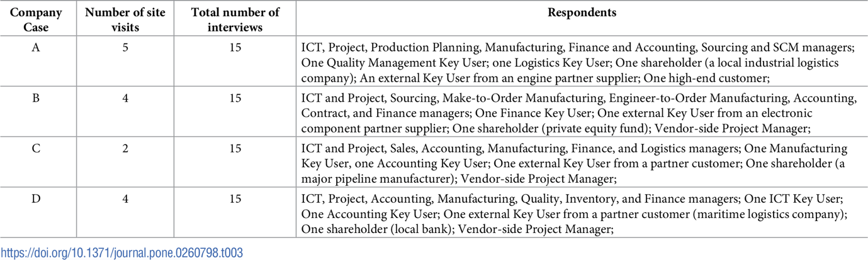
Table 3
The study's summary discusses how four companies (A, B, C, and D) worked with different partners on their enterprise resource planning (ERP) projects through site visits and interviews. Company A had 15 interviews and five site visits with a wide range of internal and external stakeholders, such as customers and people in charge of IT and finance. Four site trips and fifteen interviews were part of Company B's work. These mainly were with private equity shareholders and people with a stake in make-to-order and engineer-to-order manufacturing. Company C did two site visits and fifteen interviews with people in jobs ranging from sales to logistics and with critical stakeholders from major manufacturing sectors outside the company. Lastly, Company D, like Company B, set up 4 site trips and 15 interviews with people from different departments, such as ICT, manufacturing, finance, and maritime logistics and banking partners from outside the company. This broad involvement of stakeholders across the companies shows how well the method of understanding the specifics of ERP implementation success in various business settings is working.
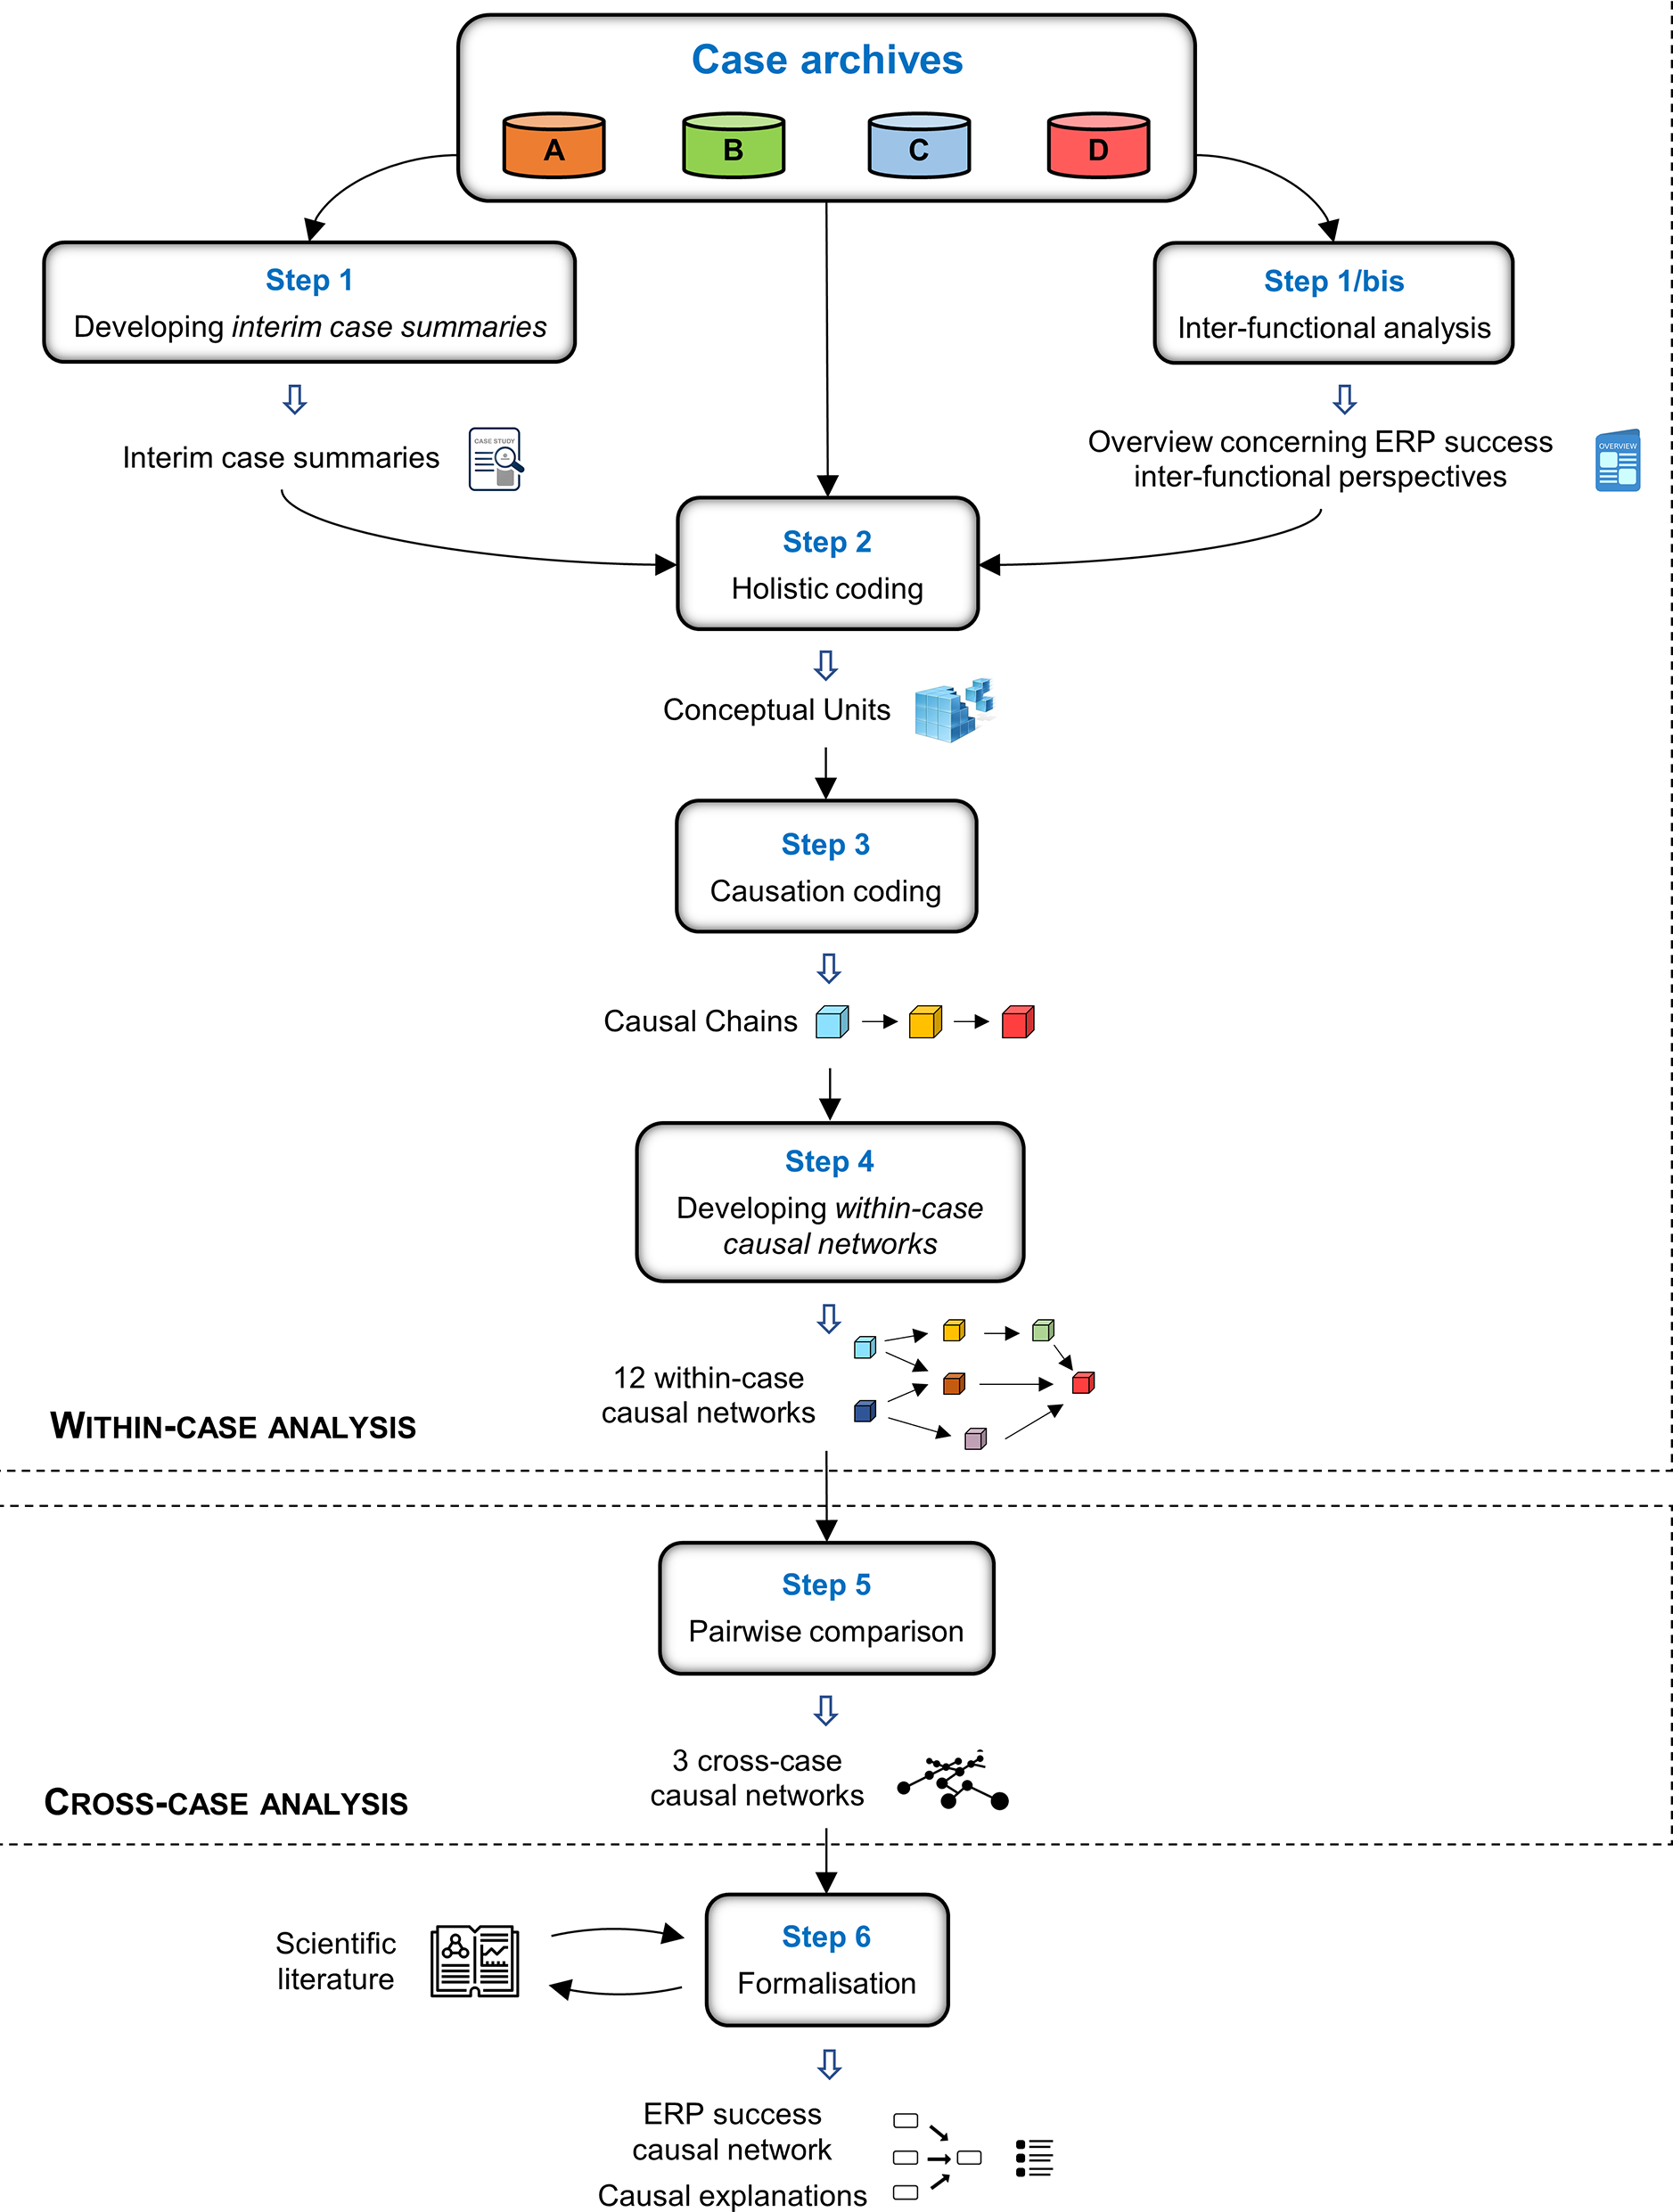
Figure 4
The picture shows a flowchart that shows a step-by-step process for creating a case-based cause network to look at the success of enterprise resource planning (ERP) projects. The process is split into two main parts: within-case analysis and cross-case analysis. The first step is to make intermediate summaries for each case study (A, B, C, and D). These give a first look at the data. The next step is an inter-functional analysis, which looks at ERP success from the point of view of different organisational roles and how they work together. The following steps are to holistically code these summaries to find the main ideas and to causally code them to create chains of events that show how the factors in each case are connected. These causal chains are set up into twelve within-case causal networks to make the cause-and-effect connections more accessible to see. The next step is to compare these networks across cases pairwise to find patterns and differences. This creates three cross-case causal networks. The last step is to make these results official by adding academic insights. This will create official solid ERP success causal networks and reasons. This organised method ensures that ERP projects are looked at in detail, using detailed case studies and more extensive cross-case analyses to find the most critical success factors.

The study looked at ERP implementations in manufacturing companies with at least 250 system users. It did not look at smaller Vanilla implementations. It focused on four European companies in different stages of ERP implementation, with the goal of achieving both theory and real replication two years after implementation. This all-around method looked at the long-term effects and helped come up with strategies for integrating ERP successfully. This improved understanding and got people ready for future technological investments in a variety of organisational settings.

References:

Zerbino, P. et al. (2021) Why enterprise resource planning initiatives do succeed in the long run: A case-based causal network. PloS One. [Online] 16 (12), e0260798. [online]. Available from: https://doi.org/10.1371/journal.pone.0260798.

Precís
Programme: MBA- Masters of Business Administration
Module: Strategic Management
Module code: LCMB7003
Lecturer: Hoang Dang Nguyen
Title: “Why Enterprise Resource Planning Initiatives Do Succeed in the Long Run: A Case-Based Causal Network.”
Students:
Marie Jandova 2020984
Alina Jubea 2023149
Bikash Roy 2010168

The paper "Why Enterprise Resource Planning Initiatives Do Succeed in the Long Run: A Case-Based Causal Network" explores the reasons behind the high failure rates (40%-90%) of enterprise resource planning systems despite significant investments. The research points out that while many studies focus on the initial implementation of these systems, there's little information on how to sustain their success over time. By taking into account the viewpoints of all stakeholders, including workers, managers, suppliers, and customers, this study is trying to reduce that gap.

The goal of the study is to provide clarification by demonstrating the complex connections between numerous elements. They want to understand what really makes these systems work in the long run. By looking at multiple real-life examples, the researchers hope to give practical advice that companies can use to avoid common problems. The goal is to help businesses get the most out of their enterprise resource planning systems, avoid wasting money, and keep everyone happy and productive.

Utilising an inductive, positivist case study methodology, the study identified and elucidated the success factors of ERP installations in order to develop theory in IS research. Vanilla implementations were not considered in the selection; manufacturing companies with 250 system users and completed ERP programmes were. Four companies in Europe that are geographically close were selected for data gathering and analysis.
Comprehensive ERP implementation insights were obtained through participant observation, open-ended and semi-structured interviews, kick-off meetings with important stakeholders, and archival records analysis.
Data analysis was done in two steps. Using case data, holistic coding, causality coding, and inter-functional analysis, within-case analysis produced causal explanations. Cross-case study compared within-case causal networks for generalisation.
According to the report, ERP systems assisted all firms in resolving their first operational problems. A functional ERP system required ongoing review and revision of the specifications. Gains after adoption were reliant on knowledge-driven user-system interaction and user awareness. ERP benefits were indirectly increased by directly including stakeholders in the requirement elicitation process. Furthermore, there was a causal relationship between ERP benefits flow and indirect stakeholder expectations.

Conclusion: Over the past 20 years, the exceptional work of scholars and professionals has made the ERP phenomenon a well-known and developed reality. However, the ERP acronym continues to be linked to both enduring overall advantages and instances of recurring setbacks, a financial collapse, and well-known legal actions. Despite a few noteworthy additions.

Long-term success of ERP initiatives is mainly neglected. The absence of the context-specific "multi-stakeholder perspective" boundary condition in addressing ERP success may be one of the primary causes of this gap. This may indicate theoretical inconsistency and deepens the gap between any theoretical explanation of ERP success and the empirical occurrence of such a phenomenon. Utilise AI to anticipate maintenance requirements, optimise inventory, and forecast demand. Automate repetitive activities with machine learning algorithms to increase productivity and accuracy.

To explain why ERP success may occur, in this article they used several qualitative data analysis methodologies in conjunction with the inductive case-based theory-building methodology. As a result, they created an ERP success causal network that incorporates the boundary condition that many stakeholders overlook. Subsequent research endeavours ought to investigate ERP performance in a variety of situations and industries, scrutinising the impact of cultural and organisational disparities on the discerned causal mechanisms.

