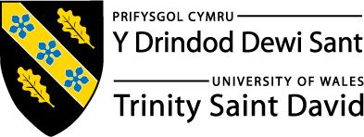
Skills for the Workplace
Module Assignment Submission
Student Name: | Mahmuda Begum
Student Number: | 1811540
Module No: | BMSK4003
Module Title: | Digital Skills and Research Methods

Statement of Confirmation of Authenticity
By the act of making this submission, the student declares that this is the work of the student named above. The work has not, in whole or in part, been knowingly presented elsewhere for assessment, or where assessment has been built on a previous assessment, this has been identified. Where materials have been used from other sources it has been properly acknowledged. If this statement is untrue, the student acknowledges that an assessment offence has been committed.
Attention is drawn to the plagiarism and unfair practice policies of both the University and of ILM.
Permission for ILM to use this script
ILM uses learners’ submissions – on an anonymous basis – for assessment standardisation. By submitting, both the centre and the learner agree that ILM may use this script on condition that identifying information is removed. However, if you are unwilling to allow ILM use this script, please refuse by ticking the box: □

Table of Contents
Introduction 1
An Overview of the 21st Century Workplace 3
An in-depth look at technologies used in own workplace 3
Part 2 4
An exploration of the use of social media in the workplace generally 4
An in-depth look at the use of social media in own workplace 4
The use of social media to enhance networking and career prospects 4
LinkedIn Profile 4
Conclusion 5
References 6

Introduction

In this assignment I will look at how modern technology affects the workplace and the type of modern technology that is influencing my own workplace. For this I will carry out secondary research. I will also look at the impact social media has for businesses and the type of social media that is used in my own workplace.

The impact of 21st Century Technologies in the modern workplace

Over the last few years Modern Technology has become highly advanced. There are different forms of technology that are used. Things such as Microsoft Outlook can be used by employers to advertise and interact with suitable candidates for a job application. Individuals and businesses benefit from modern technology as it is a way to communicate, expand the network and promote the company. Modern technology is a form for learning, improvement and development.
Technology can be used to collect and gain data and present it in a report if necessary quickly and efficiently. There would be certain criteria’s in place for example if a business use a form of web chat to communicate with customer queries they may have a certain wait time for a customer response before, where there may be two warning messages for no response before ending a chat. By sticking to the criteria’s it will benefit the overall customer wait and also the business. There can also be a survey at the end where the customer would provide feedback on the web chat experience with the adviser, this is a really good way to review and improve customer satisfaction and the business quality.
The technology has changed over the years, in previous years there would be people reading books to do their training for work but now audio books, slideshows and videos are available to help them learn. This would be a good way for staff to learn as some people may learn quicker by listening and watching videos, so it gives more options on ways to develop and learn in the workplace. By using technology you do not need many resources and it reduces the workload of the staff and makes the task easier to complete.
Using technology in the workplace can also be cheaper and less time consuming. For example if you needed to send a important document to a colleague and they are not at work you can easily attach it to an email and send it straight away, that way they can access it even at home instead of sending a letter out and waiting a few days for the post.
Some businesses have staff located all over the world so not everyone would be able to attend a team meeting or discussion physically, so using things like video call or a conference call will help the costs of employee’s travelling and also build a connection with each other in the business.
Even though technology is a positive change for the new generations it can also have a negative impact for the older generations as not everyone has access to the digital services such as computer or smart phone. Some people also prefer to speak to someone directly as they are worried that they may become a victim of scams. So businesses would usually have a specific target audience.
I did a small survey to check how many people thought technology made a positive or negative impact the workplace. Out of the seven people only one said it made a negative impact and the rest said it was positive.

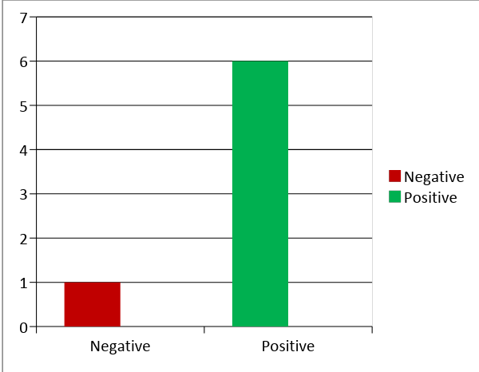

An in-depth look at technologies used in own workplace

Since working with Her Majesty’s Revenue and Customs, I was able to identify the Modern technology that has made an impact in my workplace. Modern Technology has made it efficient and effective to carry out my job role as an Administrative Officer. For my daily duties I use a desktop computer which uses Wi-Fi and I use a printer to complete letters and print out documents for colleagues and tax payers. There is also a central print system where I just send the document or letter for print and it will automatically be printed and posted by a computer. This reduces the time spent on going back and forth to the printers and also is a good back up in a case where the printers are not working.
I also use Microsoft Email to communicate with my colleagues which makes it very easy to transfer information. By using Email I am able to know which colleagues are available and it is very quick and easy to access. On the email we receive notifications to remind us of any important tasks, meetings and important dates.
We use Webchat to communicate with the taxpayer queries; this again is a very fast way of taxpayer’s queries being dealt with and gives a wider range of options to contact us. We have a personal tax account that is available for taxpayer’s and holds limited information, on this account taxpayer’s can view a range of things from their employment records to their benefits. On this they can apply for refunds and update their personal details themselves which helps reduce the phone calls and fewer resources are needed.
When taxpayers contact us on the phone we use the Data Protection Act to pass security so that we can access records and save time going through it with us while they are waiting in the queue. We also use the voice recognition system which remembers the taxpayer’s voice and automatically passes security and directs them through to us.
Due to security and high confidentiality for the taxpayers we use a voice recording system to record the calls for any training and quality purposes. We have CMA system which tells us why the taxpayer is calling and brings up the security records so that we can be ready.
To accept and make outbound phone calls to customers we have a Jabber and Cisco Finesse system. These systems have logs of the contact numbers and record calls. We also have an automated system which takes the taxpayer through security while waiting in the queue and also directs them to the correct department so that we can deal with their query. So that we can speak and listen to taxpayer’s we are provided with a headset and microphone that we connect to the computer.
I use Microsoft Excel to complete forms and send out documents requested by taxpayers; these have templates ready and save time. We also have our employee human resources system online, this provides easy access to our personal information such as payslip and P60’s, we are also able to view time off availability and also request any leave.
All the staffs have mobile phones to communicate with each other. Some managers are provided with smartphones, this technology keeps managers connected with the staff for example if someone needs to ring in and inform of absence due to sickness. We also do video calling and conference calls at work during meetings so that we can communicate with colleagues around the country. We communicate with employers through the real time system where employers send in the electronic payslip and P14 information; we also send electronic tax code notices to their payroll. Lastly we also have a fax machine where we can send and receive faxes if there was a problem with the employer’ electronic system.

Interrogation of Secondary source of research

Sarah Blakeslee created the CRAAP test so that individuals are able to recognise and to assess sources before believing them with a blind eye. It is a way to find out if the sources are coming from a reliable and relevant source since the media and news can portray fake news and stories.

I will use the CRAAP test (Blakeslee, 2004) to evaluate my secondary sources.
C | Currency – how old is this source or when was it published?
R | Relevance – is this information related to your topic?
A | Accuracy – how reliable is this source?
A | Authority - what do you know about the author?
P | Purpose – What is the reason for this?

‘’Technology is such an integral part of the 21st-century workplace that any business without some level of technical savvy will likely fail. It is that critical.’’, (Emma,2018)
After coming across this article the first thing that is noticed is the quote above, this is suggesting how important technology is for the 21st-century in the workplace. It also is implying that businesses benefit from the technology and it shows that businesses can be dependent on technology. She is very informative and presents ideas and examples on how to improve your business without gaining anything herself. This article was written in the year 2018 which shows that it is a current and up to date article. This was published on the Houston Chronicle which is a recognised newspaper website and has around 825,000 regular readers in a day. It was written by Linda Emma who was a previous business owner and is now a digital marketing strategist and gives marketing advice to people. Since she was a business owner and works in the digital industry she understands how technology benefits the business and she is talking from experience. Based on her intellectual background she is a reliable source and knows what she is talking about. The article is well structured, written in the suitable academic style and is relevant. The purpose of this article was to advise other people about how to use technology in the workplace, there is no purpose to sell anything and I do not think it is biased. This source passes the CRAAP test as it meets all the criteria.

‘’Technology in today is a must to enable people to be more productive, efficient and innovative; stay connected internally and externally’’. (Efron, 2017)
In this article (Efron,2017) speaks about how technology can be a positive influence in the workplace. He mentions how it is resourceful and how it can be useful in helping people. The article was published in the year 2017 which is quite recent so it will be relating to the modern technology in the 21st century and is also up to date. Louis Efron is an internationally known writer. He is an author to four books and he has an Advanced Leadership qualification which he studied at Harvard Business School. Since he studied in a business school he would have gained knowledge in the business industry and learned the advantages and disadvantages that technology has in the workplace industry. This article was published on the Forbes website which is a very well-known website for publishing, has up to a million readers in a month and is a reliable source. The purpose for this article was to inform people of the benefits of technology in the workplace and try look away from the negatives. It is just giving an insight of the technology influences, I do not think that this article is biased since (Efron,2017) speaks about both the positives and negatives and is just giving his opinion and being informative so that others can also learn from it. I believe he is trying to change the bad judgment people have on technology in the workplace and make them aware. He also supports his arguments by providing examples and uses high-quality spelling and grammar. The whole article is well structured and is relevant to the title of the article, throughout the article is aware of what audience is he trying to attract. This has passed the CRAAP test.

DATA

Data is a collection of information and it can be stored on videos, texts, sounds, images and patterns. It is used in the workplace and businesses.
The general data protection regulation (GDPR) is a process of protecting and having control over personal data. It was created in 2016. The GDPR rules apply to a majority of organisations and the regulator must process the data while complying with the data protection laws. There are fines for companies which are up to 4% the business or organisations yearly earnings. Businesses that do not abide by the rules and fail to protect people’s personal data will be fined for a breach of personal data. Below are the 6 data protection principles that need to be followed when processing, storing and collecting personal data and information.
Principles of the GDPR
- Purpose – Personal data should be collect for a specific reason and should declare the purpose for the data collection.
- Accuracy- Data must be correct and complete
- Data Minimisation- keeping the data amount limited so that it is easy to store and access.
- Fairness, Lawfulness and Transparency – Organisations must comply within the laws when collecting and storing data and they must be aware of the GDPR rules and regulations.
- Confidentiality and Integrity – Making sure that the correct and appropriate security is used when handling data.
- Storage limitations – Knowing when to delete personal data when you no longer need it.

In my own workplace we always have to take the taxpayer through security through a recorded system so that we know that we are speaking to the taxpayer before disclosing or accessing personal information. We record all the calls so that if there was an issue we can always relate back to it and managers are able to carry out quality checks so that we are not breaching personal data. There is also a disclosure matrix which advises us on what we can and what we cannot disclose to the taxpayer. For any agents, third parties, power of attorney and so on we make sure that we have a valid document signed by the taxpayer to say that they are giving us permission to disclose any information or make any claims on their behalf. The emails we send to each other are also security protected so that we know it has sensitive information related to a taxpayer. We don’t send links or emails to taxpayers as these can make them a victim of scams. We have our own work email and this is to protect the safety of the taxpayer information that we pass around. We use USB’s to store and transfer data. We are able to view who last accessed the taxpayer’s record and we need to always write notes. Any staff that work at HM Revenue and Customs or any government department have got their tax records locked so that other colleagues are not able to access and they would need to speak to a specific team. We are also not allowed to speak or handle a tax record of a family member or someone we may know.

An in-depth look at the use of social media in the workplace

To communicate and advertise the company we use social media platforms such as Facebook and Twitter. On Facebook we do daily updates and post status’s to keep the taxpayer’s informed for example if we are facing any technical issues we would post this to make them aware. We use Twitter to promote and try and get as many people to use the online services that we provide, such as the Personal Tax account and webchat so that we can reduce phone calls.Even just discussing social media in conversations can build a relationship with colleagues. By using social media we can build a good connection with the public and be aware of the things going on in the world. Sometimes if we want to advertise for a job role we would upload a status on facebook, as this is a way for people to share it amongst themselves and it will help the recruiting process.
Social media is very good way of creating a larger network and connecting with people. Some individuals with online businesses will promote the product and advertise the offers on social media. Some people will also post vacancies as this helps to recruit quicker. Social Media is also a good way of finding the audience you are looking for. It is a fast and cheap way of recruiting staff and you do not need many resources. If a job advert was posted on Facebook, it can be liked and shared by friends to build a network. Research shows that media and technology is used in everyday talk and reports show that from 10.5% to half a conversation include media content (Alberts, Yoshimura, Rabby and Loschiavo,2005).

There are many different types of social media such as
- Twitter where you can post photos, share tweets and exchange messages.
- Facebook where you can upload photos, videos, write status, make video, phone calls and also exchange messages.
- Instagram where you can upload photos, videos, make video calls and exchange messages.
- Snapchat is where you can take pictures and videos which will disappear in a few hours. You can also send messages and make phone calls on this.

If I owned my own business and needed to use one of the social media to advertise and communicate, I would choose Facebook as you have many options. I would be able to update status’s to keep the customer/clients updated and informed, I’d be able to post photos and pictures of the business and people would be able to comment on them so I can get feedback. This is also cheap and free, easily accessible and would also be a way to get an audience.

LinkedIn Profile

Linked in is a social networking site which is used to build a profile that can be helpful when you are looking to apply for a job application or if employers are looking for suitable candidates to fit a required job role. It can be used to promote oneself and the qualities, almost like a online CV. It is a platform of personal branding and a unique selling point.

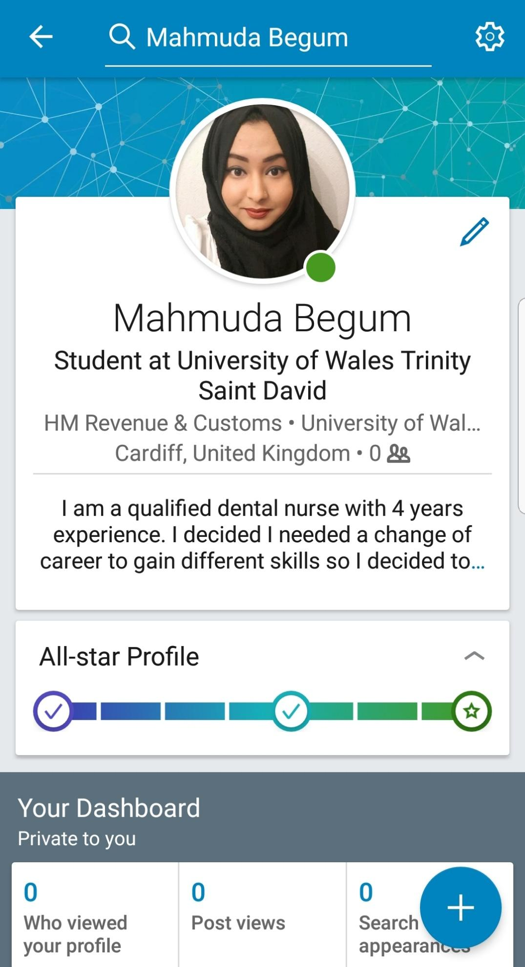
I used this photo as it looks professional and suitable. I look well presented and it also shows my identity as a Muslim woman due to my headscarf. I think this photo of me smiling looks approachable. I used this background since it is neutral but still colourful so that my profile looks appealing to look at. I wanted to keep my personal statement short and simple so that it does not become boring, I just wanted to give a brie overview about my work experience. I also mentioned where I currently work and study so that this will show how I am able to balanced my studies and work life.

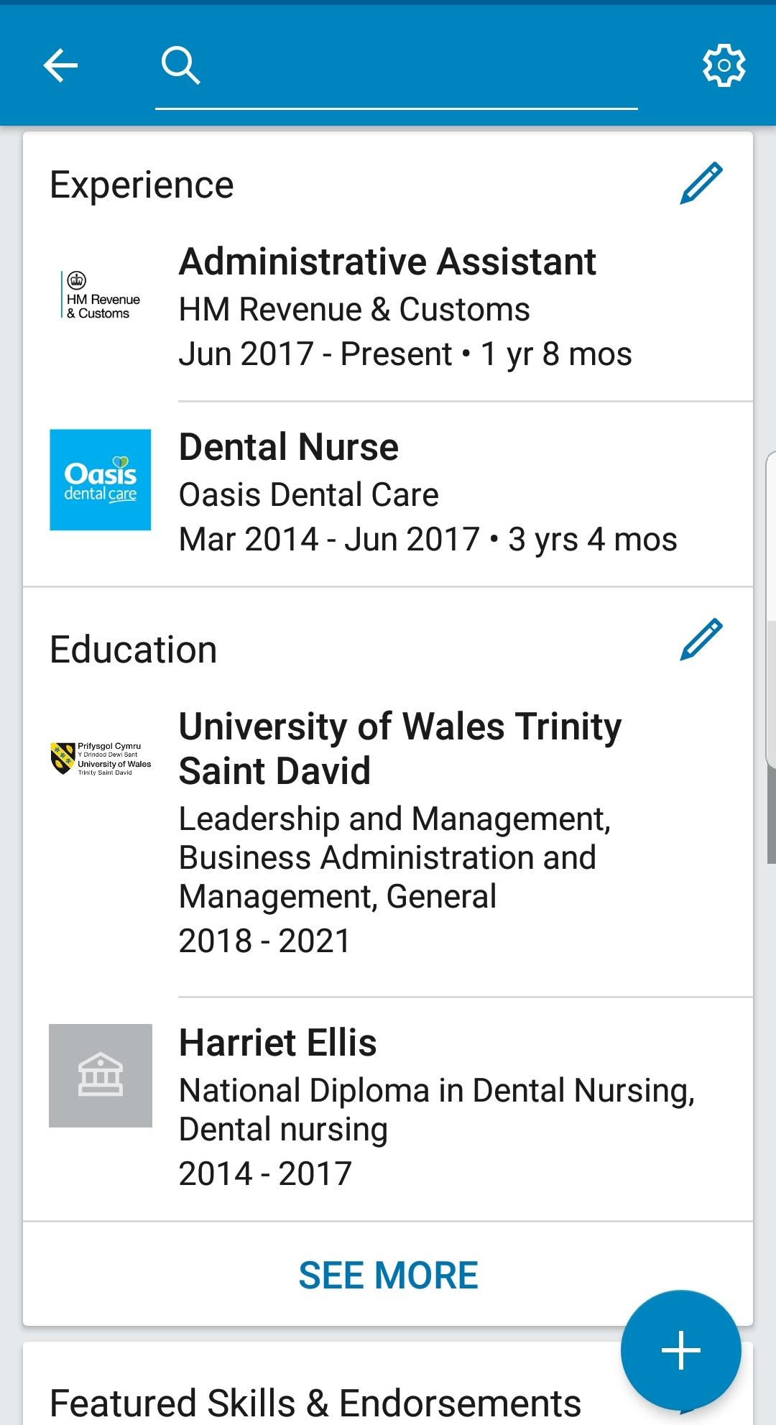
On this part of my Linked In profile I have included the previous and current employment experience I have. This also includes my employment details. I have done this so that if they need to do a background check they can. I have also state what education I am currently studying.

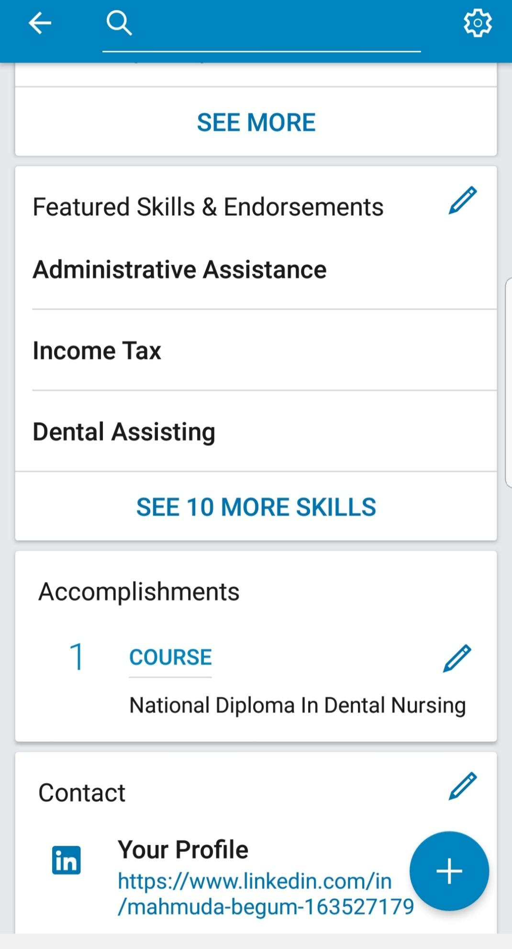
In this section I inserted the skills I have and they are relevant to two industries and I have included my accomplishments. I have also included the link for the profile and an email so that any employers can contact me.

Conclusion

I identified the digital skills I use in the workplace and how it helps me carry out my job role. I did research on technology in the 21st century workplace and I found that technology is really useful for the business and people. I also learned how social media impacts the workplace and how it can be used to advertise the business.

References

Emma L.(2018) - Importance of Technology in the Workplace. Available at https://smallbusiness.chron.com/importance-technology-workplace-10607.html. (accessed 26/01/2019)

Louis.E(2017) How Technology Can Transform Workplace Humanity. Available at https://www.forbes.com/sites/louisefron/2017/12/03/how-technology-can-transform-workplace-humanity/#5e4223cc2f00(accessed 26/01/2019)

(Alberts, Yoshimura, Rabby and Loschiavo,2005) - Technology and Media are used in everyday talk. Available at Certificate in Higher Education: Skills for the workplace Student yearbook. (Accessed 19/12/2018)

