

Student Name: Abdul Hakim

Student ID: 2505488

Module Name: Marketing Management

Module Code: LCMB7024

Assessment 2: Marketing Strategies Portfolio

Lecturer’s Name: Dr Mohammed Tariq

Topic – Tesla GridNest: Modular Residential Energy Pod for Urban Microgrids

Word Count: 2743

AI use acknowledgement
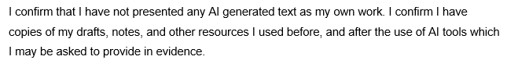

Table of Contents
Introduction 4
Element 1: Brand Extension Poster Presentation 5
Element 2: Segmentation, Targeting, Differentiation, and Positioning (STDP) Analysis 5
2.1 Market Segmentation 5
2.2 Targeting Strategy 6
2.3 Differentiation Strategy 8
2.4 Positioning Strategy 9
Element 3: Marketing Mix (4Ps) 10
3.1 Product Strategy 11
3.2 Pricing Strategy 12
3.3 Place (Distribution) Strategy 12
3.4 Promotion Strategy 13
Conclusion 15
Element 4: Reflection (Gibbs Reflective Cycle) 16
4.1 Description 16
4.2 Feelings 16
4.3 Evaluation 17
4.4 Analysis 17
4.5 Conclusion 17
4.6 Action Plan 18
References 19
Appendix: Brand Extension Poster 22

Introduction
Marketing management is defined as the planning, implementing and controlling of marketing strategies with the aim of realising the customer needs, as well as the organisational goals (Wilson and Gilligan, 2022). It entails market analysis, value creation and establishing good brand relations. The portfolio aims at building a brand extension strategy of Tesla grid nest, STDP analysis and application of marketing mix. The objective is to evaluate how Tesla can expand into urban energy markets while strengthening brand equity and achieving sustainable business growth.

Element 1: Brand Extension Poster Presentation
Please refer to the appnedix part.

Element 2: Segmentation, Targeting, Differentiation, and Positioning (STDP) Analysis
STDP is segmentation, targeting, differentiation, and positioning (Fachri Dwi Putra, 2023). This part establishes the essential market segments, target audience, competitive advantages, and how Tesla GridNest will be positioned in the energy market of the city.

2.1 Market Segmentation
Market segmentation entails separating a large market into smaller segments that share common attributes so as to be able to serve customer needs better. The detailed market segmentation of Tesla GridNest is provided below:
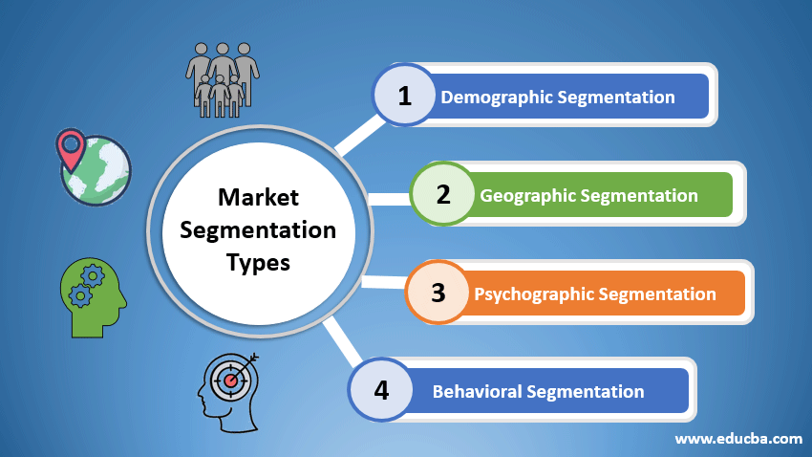
Figure 1: Types of Market Segmentation
Source: (EDUCBA, 2020)
Geographic Segmentation: Tesla GridNest is focused on highly urbanised markets like North America, Western Europe and Asia-Pacific. The United Nations (2022) estimates that currently, 56 per cent of the world's population resides in cities, which is expected to increase to 68 per cent by 2050, bringing more than 2.5 billion people to urban areas. London, New York and Shanghai are some of the cities that are given priority because of high population density and apartment living.
Demographic Segmentation: The main target population consists of urban-dwelling residents aged 25-55 who are middle- to high-income earners. These people will tend to embrace new technologies and ecological solutions. According to Deloitte (2023), more than three-quarters of millennials and Gen Z consumers are willing to pay a premium on sustainable products. Moreover, the world population of middle-income citizens will amount to 5.3 billion by 2030, which will put pressure on the consumption of intelligent energy solutions.
Psychographic Segmentation: Psychographically, GridNest will focus on the consumers who are environmentally friendly and innovators. Engao (2025), 73% of consumers worldwide are open to altering their consumption behaviour to achieve a lower environmental impact, and 81% of consumers think that companies should do more to solve environmental issues.
Behavioural Segmentation: Behavioural segmentation targets consumers who use a lot of energy, care about renewable energy, and buy EVs. According to Cui and Zhao (2024), the sales of EVs worldwide reached more than 14 million units in 2023, about 18% of the total car sales. Yet, the absence of charging infrastructure is also a major obstacle to city residents.

2.2 Targeting Strategy
The targeting strategy is where the most attractive segments are picked, and marketing is flown towards the segments in order to maximise the impact (Dibb and Simkin, 2020). The targeting strategy of Tesla GridNest is as follows:
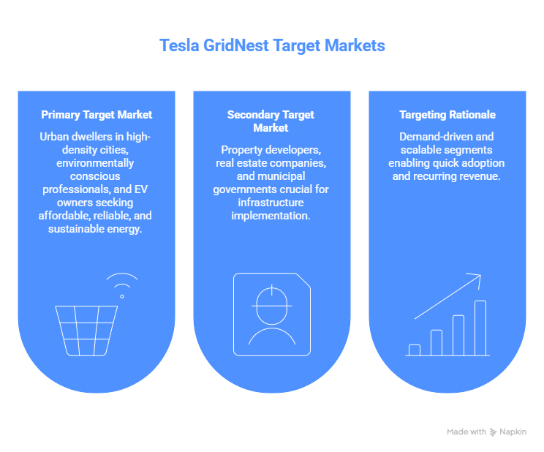
Figure 2: Targeting Strategy of Tesla GirdNest
Source: (Self-Made)

Primary Target Market:
Tesla GridNest is mainly aimed at the urban dwellers of high-density cities who live in apartments. This group is highly responsive to collective solutions as they have some serious obstacles to the implementation of their own renewable systems. The target also consists of the environmentally conscious professionals and EV owners who want affordable, reliable, and sustainable energy (Almansour, 2022).
Secondary Target Market:
The secondary target market comprises property developers, real estate companies, and municipal governments (Theurillat and Rérat, 2024). These are stakeholders who are vital in implementing infrastructure. By 2030, the smart building market will be over 150 billion globally due to the need for energy-efficient and sustainable buildings.
Targeting Rationale:
The chosen segments are very demand-driven and scalable. Urban dwellers are a big underserved market, and developers allow quicker implementation in various buildings (Theurillat and Rérat, 2024). This two-fold targeting strategy enables quick adoption and returns recurring revenue with energy services and software platforms.

2.3 Differentiation Strategy
Differentiation strategy is about establishing a value that is unique and that will make a brand stand out among others (Suharto, 2024). The differentiation strategy of Tesla GridNest is provided below:
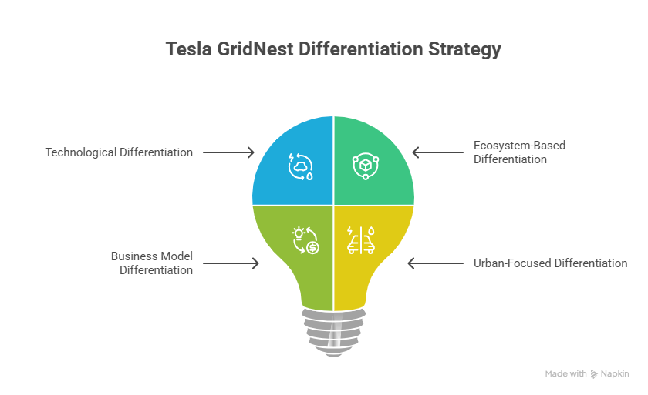
Figure 3: Differentiation Strategy of Tesla GirdNes (Self-Made)

Technological Differentiation: Tesla GridNest stands out as a fully integrated technical solution, a mixture of solar energy, battery storage, EV charging, and AI optimisation. Tesla has a complete system when competitors only offer partial solutions. According to Karpenko (2024), smart energy systems have the potential to lower the costs of energy by 20-30 per cent, which underscores the cost-efficiency of AI-based optimisation.
Ecosystem-Based Differentiation: One of the strong points of Tesla is the integration of the ecosystem. GridNest is integrated with Tesla vehicles, Powerwall, and software, resulting in a single user experience (Zheng and Chen, 2025). This integration enhances switching costs as well as customer loyalty. The result of the ecosystem approach is already high customer retention rates, as Tesla users report more than 90% brand loyalty.
Business Model Differentiation: The shared consumption model proposed by gridNest decreases initial expenditure and allows access via subscriptions (Nguyen, 2022). This model gives the users access to renewable energy without ownership restrictions and can generate recurring revenue for Tesla.
Urban-Focused Differentiation: Unlike conventional residential energy solutions, GridNest is specifically created to meet the requirements of urban apartments. In urban centres, more than half the world population occupies multi-unit housing, but the majority of energy solutions are built towards detached homes (Friedman, 2025).

2.4 Positioning Strategy
Positioning strategy describes the way a brand is viewed in the minds of customers as compared to that of the competition (Cotler, 2025). The positioning strategy of Tesla GridNest is as follows:

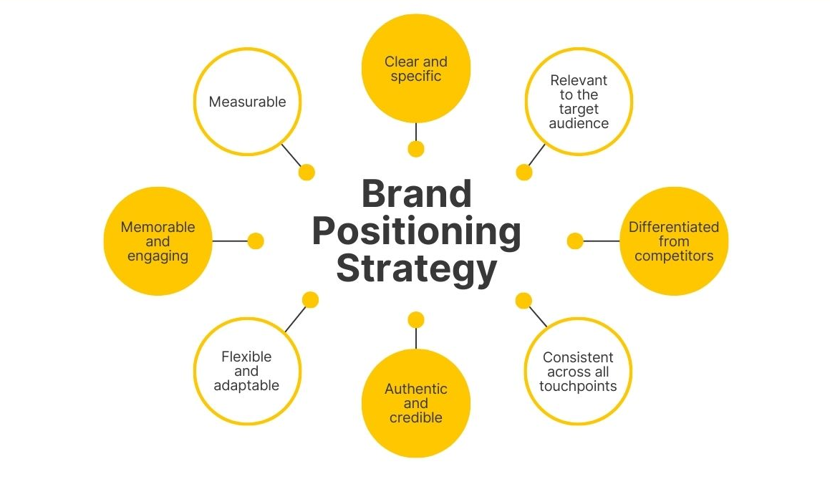
Figure 4: Brand Positioning Strategy
Source: (Cotler, 2025)
Positioning Statement:
Tesla GridNest is positioned as a high-end, intelligent, and sustainable energy system in city communities, which provides AI-controlled renewable energy and in-built EV charging via a system of shared microgrids (Pin, 2024).
Perceptual Map:
The perceptual map is founded on two aspects: level of integration and urban suitability.
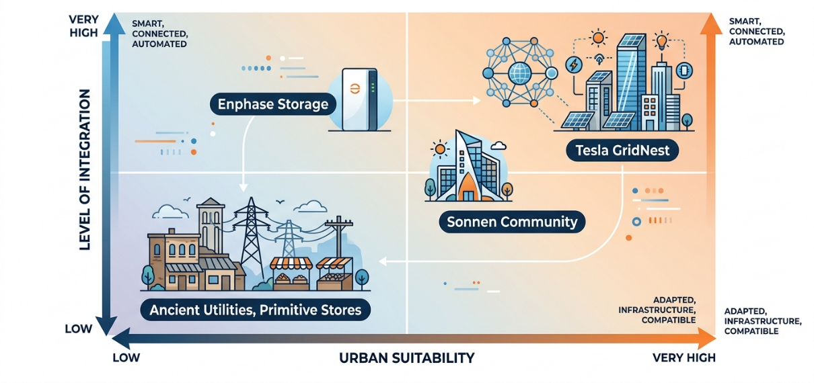
Figure 5: Perceptual Map of Tesla GirdNest
Source: (Self-Made)
The map of Tesla’s new brand and product positions Ancient Utilities and Primitive Stores at low integration and urban suitability (Pin, 2024), Sonnen Community at moderate levels, Enphase Storage with medium integration, while Tesla GridNest leads with very high integration and urban compatibility.

Competitive Positioning Advantage:
The reason why GridNest is on the top-right is that it is highly integrated and urban-oriented. Its AI and shared infrastructure, coupled with EV compatibility, make it have a better value proposition (Mishra and Dash, 2025). This positioning reinforces Tesla's image as a leader in innovation and sustainable technology while addressing unmet needs in urban energy markets.

Element 3: Marketing Mix (4Ps)
Product, Price, Place and Promotion are known as the marketing mix (4Ps). This section discusses the application of each of these elements to the Tesla grid nest and its contribution to the overall brand extension strategy in the urban energy markets.
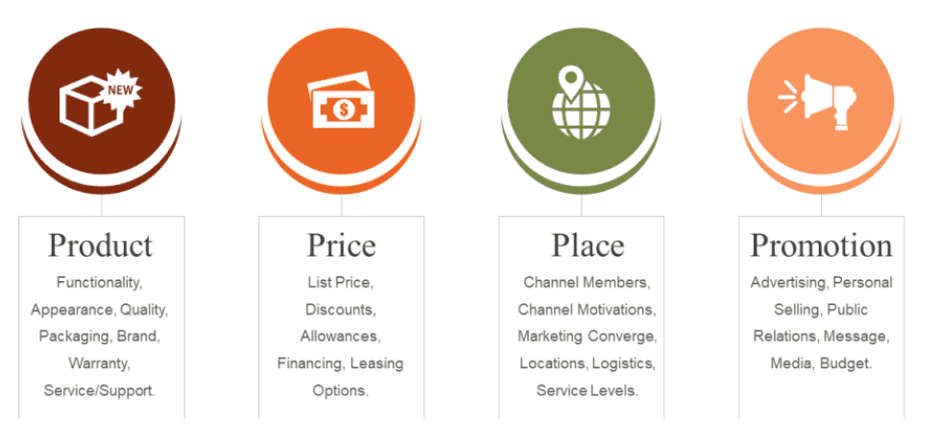
Figure 6: 4Ps of Marketing Mix
Source: (Mehta, 2023)

3.1 Product Strategy
Core Product Concept: Tesla GirdNest is a solar-powered, battery-powered, EV-charged, AI-controlled, modular, shared energy pod designed to power apartment buildings (Tesla, 2024). Its main advantage is that it offers affordable and reliable clean energy without the need to install it individually. This is extremely topical since urban households constitute almost 70 per cent of the worldwide energy consumption. Furthermore, in the future, by 2040, distributed energy resources will provide more than 40 per cent of the global electricity, which will support the need to have decentralised solutions (Siemens-energy, 2024). The lack of access to renewable energy in high-density housing is directly tackled through GridNest.
Augmented Product and Ecosystem Integration: The augmented product consists of the Tesla software ecosystem that will enable real-time monitoring, predictive analytics, and automated energy optimisation via a mobile application. Connecting to Tesla cars and energy infrastructure makes users experience seamless integration. Integrated ecosystems help companies to enhance customer retention by up to 30 per cent (Ullah, Aimin and Ahmed, 2023). This enhances customer loyalty and switching costs and helps in long-term brand value.
Product Differentiation and Innovation: The distinctive characteristics of the GirdNest include the urban design and the shared consumption model. Since it is not a detached home solution, unlike traditional ones, it is a multi-unit housing solution, in which more than 55% of the world population lives. It can be scaled and is cost-effective due to its modular structure. Such innovations have a high growth potential as the global smart energy market is expected to reach $600 billion by 2030 (Mordor Intelligence, 2025).

3.2 Pricing Strategy
Value-Based and Subscription Pricing:
Tesla GridNest is priced with value-based and subscription packages. For example, Tesla solutions already in place, like Powerwall, have value-based pricing, which is long-term savings and energy efficiency. Likewise, a company such as BYD and Volkswagen are incorporating subscription-based power and EV ecosystem (Ramkumar, 2021). This proves the fact that the model used by GridNest correlates with the established competitor approaches, which makes it more credible and emphasizes cost-effectiveness, the incorporation of renewable resources, and user-friendliness.
Cost Efficiency through Shared Model:
Cost efficiency in shared infrastructure can be supported through evidence from community solar and microgrid projects, where economies of scale reduce per-user costs. Research conducted by utility-led shared renewable systems and Tesla Energy pilot microgrids suggests that savings are approximately 25-30 per cent as compared to single home installations because of shared storage, maintenance, and distribution expenses (Microgirds, 2025).
Competitive Pricing and Long-Term Value: Tesla is a competitive but high-end pricing company. Competitors provide partial solutions, whereas GridNest provides complete services, which warrants the value. Furthermore, government subsidies and incentives for renewable energy may decrease the cost of adoption (Tesla, 2024). The worldwide renewable energy market will expand at a rate of more than 8 per cent every year until the year 2030, which will sustain the long-term affordability and demand.

3.3 Place (Distribution) Strategy
Direct and Partnership-Based Distribution: Tesla GridNest has adopted a hybrid distribution approach that involves direct sales and strategic partnerships (Pin, 2024). The hybrid distribution approach will be compatible with the current direct-to-consumer approach employed by Tesla to distribute products such as Powerwall and Solar Roof, with the help of real estate developers. In the case of electricity distribution in smart cities, research of the industry demonstrates that other companies like BYD and Volkswagen also cooperate with residential developments to make urban renewable faster, eliminating obstacles to installation in crowded cities.
Digital Platform Integration: Over three-quarters of customers are inclined to use digital platforms to manage services (Tesla, 2025). Following this pattern, Tesla GridNest unites the digital control with the usage of the app whereby users can monitor the energy, billing, and system performance. This is in line with the current Tesla ecosystem strategy, which enhances convenience and cost of operation and customer service.
Global Expansion Strategy: The first markets that GridNest will be launched in are the developed markets, such as in the US, UK and Germany, where renewable policies and infrastructure are robust. The growth opportunities are huge because the energy demand in urban areas is projected to rise by 50% in 2040 (Mordor Intelligence, 2025). The international nature of Tesla allows it to scale effectively to new markets in the long run.

3.4 Promotion Strategy
Integrated Marketing Communications: Tesla will employ an integrated marketing communications strategy that will incorporate digital marketing, PR and direct interaction. The use of digital channels is essential, as more than 65% of consumers now rely on online platforms for product research and decision-making (Tesla, 2024). This guarantees uniformity in messaging and wide coverage.
Brand Messaging and Sustainability Focus:
The marketing communication will focus on saving money, sustainability, and smart living. More than 73 per cent of consumers are drawn to environmentally responsible brands (Engao, 2025). By facilitating urban decarbonisation and energy autonomy, which is the trend, and building on the brand image of Tesla, GridNest fits the trend.
Strategic Partnerships and Public Policy Support: It will be promoted using partnerships with governments and environmental organisations. Up to 40% of renewable energy investments are driven by policy incentives, so it is critical to engage in partnerships in order to adopt them. Smart cities demonstration projects will further increase credibility (Engao, 2025).
Experiential and Community Marketing:
Tesla will be able to market GridNest using pilot projects and community activities (Tesla, 2025). Experiential marketing enables the consumer to experience the benefits in practice. Community-based promotion is very effective, and 70% of consumers trust peer recommendations.

Conclusion
In conclusion, this portfolio has demonstrated how Tesla GridNest can successfully expand Tesla's brand into urban energy markets. The strategy helps to identify a high-growth urban segment by using effective segmentation, targeting, differentiation, and positioning. This is also supported by the marketing mix, which makes the product innovation, pricing, distribution and promotion to meet the needs of customers. Altogether, the portfolio illuminates the role the portfolio can play in improving the competitive edge of Tesla and sustainable urban development and success in the long term.

Element 4: Reflection (Gibbs Reflective Cycle)
The Gibbs Reflective Cycle is a systematic model that facilitates experience-based learning by helping people take six steps: description, feelings, evaluation, analysis, conclusion and action plan (Vecteezy, 2025).
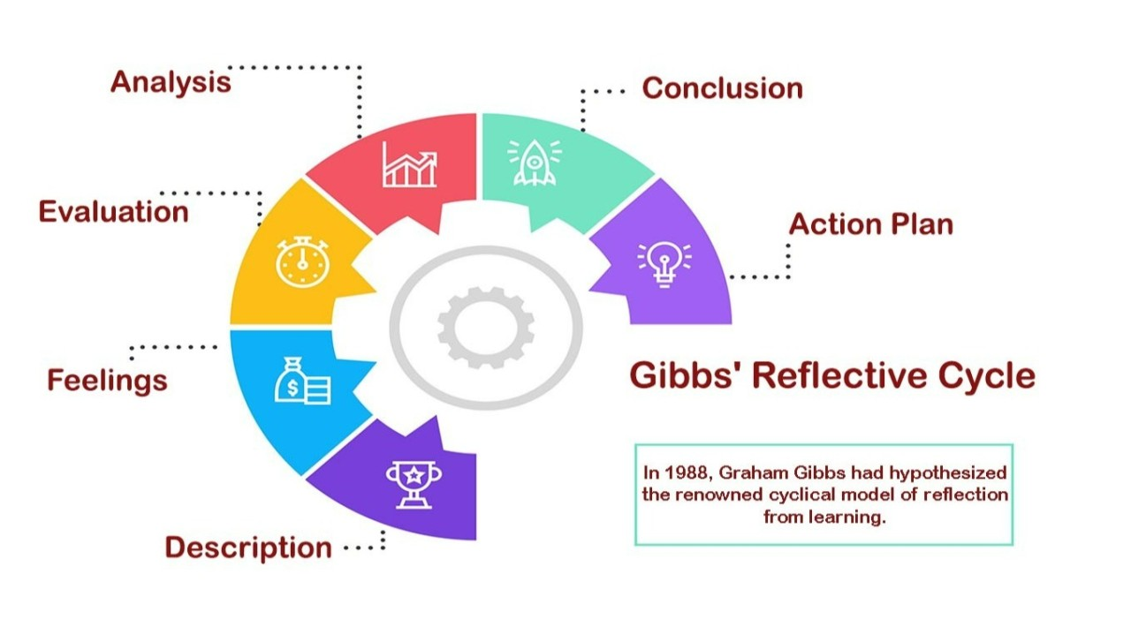
Figure 7: Gibbs Reflective Cycle
Source: (Vecteezy, 2025)

4.1 Description
At the beginning of my portfolio, I designed and presented a poster on Tesla’s new brand “GridNest”, organising key ideas like target market, strategy, and sustainability into a clear visual format.This was an initiative to create a brand extension of Tesla GridNest, whose target market is urban energy solutions. I did market research, used STDP analysis, and created a marketing mix strategy. The job demanded a combination of theoretical marketing with a practical use, especially in the sustainability and technology-oriented markets.

4.2 Feelings
The initial stage was challenging for me because of the issue of integrating brand development and technical energy concepts. As I advanced, however, I was more assured in the application of the marketing theories of segmentation and positioning. I initially felt uncertain about presenting visually, but gained confidence while explaining my poster to others. According to Mandler (2023), learning to identify emotions in the learning process aids in comprehending the development of an individual, and this is what I encountered in the process of undertaking this project.

4.3 Evaluation
Another strength of my work was the possibility to combine the appropriate data and statistics to prove the arguments, which contributed to the increase in the academic quality of the portfolio. I was also able to match the existing brand strengths of Tesla with the suggested extension to provide strategic fit. A drawback, however, was the problem of time management, namely, the balance between in-depth research and short writing. My poster effectively communicated the concept, though some areas lacked strong visual impact and clarity. Daudelin (2024) suggests that experience and reflection have to be balanced when learning, and I also realised that I had to spend more time reviewing and refining my work.

4.4 Analysis
This project improved my knowledge of the application of marketing theories in practice. I was able to acquire critical thinking by examining the market trends like urbanisation and renewable energy demand. My competitive positioning evaluation and value proposition ability were also enhanced. According to Cole (2025), reflective practice is crucial to professional learning, and the project enabled me to reflect on my decision-making process, especially when choosing the right strategies to use in Tesla GridNest. Furthermore, developed skills in simplifying complex information and presenting the poster in an engaging, structured visual way.

4.5 Conclusion
In conclusion, this experience helped me develop academically and professionally considerably. I had some hands-on experience in brand extension, strategic marketing, and innovation with a sustainability approach. Other transferable skills that I acquired include research, analysis, and presentation. Nevertheless, I understand that I should improve my time management and visual communication to perform better in the future. Moreover, the poster presentation experience strengthened my presentation and visual communication abilities.

4.6 Action Plan
Area for Improvement | Action Steps | Timeline | Expected Outcome
Time Management | Use structured planning tools such as Gantt charts and weekly schedules | Short-term | Improved efficiency and timely completion
Research Skills | Engage with more academic journals and industry reports | Ongoing | Stronger evidence-based analysis
Visual Communication | Practice using design tools (e.g., Canva, PowerPoint) for presentations | Short-term | More effective and engaging presentations
Critical Thinking | Apply more theoretical frameworks in analysis | Long-term | Deeper and more critical evaluation
Presentation Confidence | Participate in more presentations and seek feedback | Ongoing | Increased confidence and communication skills

References
Almansour, M. (2022). Electric vehicles (EV) and sustainability: Consumer response to twin transition, the role of e-businesses and digital marketing. Technology in Society, [online] 71(6), p.102135. doi:https://doi.org/10.1016/j.techsoc.2022.102135.
Cole, M. (2025). Learning through reflective practice: a professional approach to effective continuing professional development among healthcare professionals. Research in Post-Compulsory Education, [online] 5(1), pp.23–38. doi:https://doi.org/10.1080/13596740000200067.
Cotler, G. (2025). Unstop - Competitions, Quizzes, Hackathons, Scholarships and Internships for Students and Corporates. [online] unstop.com. Available at: https://unstop.com/blog/brand-positioning-definition-and-strategy [Accessed 16 Apr. 2026].
Cui, S. and Zhao, N. (2024). A Study on the Current Status and Future Prospects of EV Automotive Market. Journal of Social Science and Cultural Development, [online] 1(2). doi:https://doi.org/10.70767/jsscd.v1i2.296.
Daudelin, M.W. (2024). Learning from Experience through Reflection. Organizational Dynamics, [online] 24(3), pp.36–48. doi:https://doi.org/10.1016/s0090-2616(96)90004-2.
Deloitte (2023). Deloitte’s 2024 Gen Z and Millennial Survey finds these generations stay true to their values as they navigate a rapidly changing world. [online] Deloitte. Available at: https://www.deloitte.com/southeast-asia/en/about/press-room/gen-z-millennial-survey-finds-generations-stay-true-to-their-values.html [Accessed 16 Apr. 2026].
Dibb, S. and Simkin, L., (2020). Target segment strategy. Marketing theory: a student text. Sage Publications: London, pp.237-260.
EDUCBA (2020). Market Segmentation Types | Top 4 Key Types of Market Segmentation. [online] EDUCBA. Available at: https://www.educba.com/market-segmentation-types/ [Accessed 18 Apr. 2026].
Engao, E.L. (2025). How Consumer Demand Is Fueling the Sustainability Shift. [online] Plastic Bank. Available at: https://plasticbank.com/blog/how-consumer-demand-is-fueling-the-sustainability-shift/ [Accessed 17 Apr. 2026].
Fachri Dwi Putra (2023). Segmenting, Targeting, Differentiation, dan Positioning pada Digital Campaign Instagram @sebarkankebersihan. Jurnal Penelitian Inovatif, 3(2), pp.311–320. doi:https://doi.org/10.54082/jupin.160.
Karpenko, D. (2024). An integrated AI-based approach to transforming energy systems for sustainability and efficiency. System Research in Energy, 2025(3), pp.41–55. doi:https://doi.org/10.15407/srenergy2025.03.041.
Mandler, G. (2023). Affect and Learning: Causes and Consequences of Emotional Interactions. Affect and Mathematical Problem Solving, 6(3), pp.3–19. doi:https://doi.org/10.1007/978-1-4612-3614-6_1.
Mehta, L. (2023). ALL about Marketing Mix | The 4Ps - 12manage. [online] 12manage.com. Available at: https://www.12manage.com/methods_marketing_mix.html [Accessed 18 Apr. 2026].
Mishra, D.P. and Dash, A. (2025). AI-Driven Innovations in Electric Vehicle Energy Management: Challenges and Opportunities. Lecture notes in electrical engineering, 6(3), pp.309–334. doi:https://doi.org/10.1007/978-3-031-94276-1_14.
Mordor Intelligence (2025). Smart Energy Market Size, Share & 2030 Growth Trends Report. [online] Mordor Intelligence. Available at: https://www.mordorintelligence.com/industry-reports/smart-energy-market [Accessed 15 Apr. 2026].
Nguyen, G.T. (2022). Exploring collaborative consumption business models - case peer-to-peer digital platforms. aaltodoc.aalto.fi, [online] 4(3). Available at: https://aaltodoc.aalto.fi/items/2795c148-9284-4a67-8277-3fe909dc3ee5 [Accessed 18 Apr. 2026].
Pin, D. (2024). How Tesla integrates Shared Value principles with Ecosystem Innovation to build sustainable competitive advantage. Cineca.it, [online] 6(2). doi:https://hdl.handle.net/20.500.14247/16836.
Ramkumar, B. (2021). Modeling consumers’ intention to use fashion and beauty subscription-based online services (SOS). Fashion and Textiles, 5(1). doi:https://doi.org/10.1186/s40691-018-0137-1.
Suharto, S. (2024). Differentiation strategy: an easy way to make your business stand out in the market. Journal of Economics and Business (JECOMBI), [online] 4(02), pp.74–81. doi:https://doi.org/10.58471/jecombi.v4i02.77.
Tesla (2024). Solar Panels | Tesla. [online] Tesla.com. Available at: https://www.tesla.com/solarpanels [Accessed 18 Apr. 2026].
Tesla (2025). Tesla App for Energy | Tesla Support. [online] Tesla. Available at: https://www.tesla.com/support/energy/powerwall/mobile-app/tesla-app-for-energy [Accessed 16 Apr. 2026].
The United Nations (2022). 68% of the world population projected to live in urban areas by 2050, says UN | Nações Unidas. [online] United Nations. Available at: https://www.un.org/pt/desa/68-world-population-projected-live-urban-areas-2050-says-un [Accessed 18 Apr. 2026].
Theurillat, T. and Rérat, P. (2024). The real estate markets: Players, institutions and territories. Urban Studies, 52(8), pp.1414–1433. doi:https://doi.org/10.1177/0042098014536238.
Ullah, A., Aimin, W. and Ahmed, M. (2023). Smart Automation, Customer Experience and Customer Engagement in Electric Vehicles. Sustainability, 10(5), p.1350.
Vecteezy, D. (2025). Gibbs’ Reflective Cycle is a structured framework for reflecting on experiences, developed by Graham Gibbs in 1988. [online] Linkedin.com. Available at: https://www.linkedin.com/pulse/guide-gibbs-reflective-cycle-professional-growth-assignment-help-xmipe/ [Accessed 18 Apr. 2026].
Wilson, R.M. and Gilligan, C., (2022). Strategic marketing management. Routledge.
Zheng, K. and Chen, Q. (2025). Cyber-Physical Virtual Power Plants: Modeling, Operation, and Control. Power Systems. Singapore: Springer Nature Singapore. doi:https://doi.org/10.1007/978-981-96-5358-4.

Appendix: Brand Extension Poster


