Task 1: Summary of Essential Academic and Employment Skills
Employers are placing a greater emphasis on transferable skills that support technical competence in today's labour market. Five essential employability skills - professionalism, flexibility, collaboration, dependability, and communication - are highlighted in recent worldwide research by Tushar et al. (2023). Each of these abilities contributes to a lifetime of achievement in the job. These results are consistent with research conducted by the Skills Builder Partnership (2023), research found that 92% of UK workers value critical skills like problem-solving and cooperation more than formal degrees.
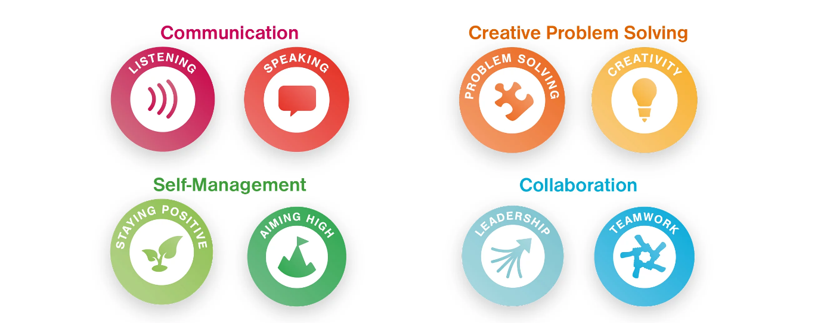
All professional jobs are based on communication abilities, which allow people to express themselves clearly, negotiate successfully, and forge lasting bonds. As hybrid as well as cross-functional teams become the standard in post-pandemic settings, cooperation and teamwork are equally important (Skills Builder Partnership, 2023). Furthermore, digital literacy is becoming a basic prerequisite for employment. Workers must swiftly learn and apply technology with confidence due to the growing adoption of automation along with artificial intelligence (Bone, Ehlinger, and Stephany, 2023).
Last but not least, managing oneself and reflective learning enable workers to manage stress, adjust to change, and constantly improve their skills - qualities essential for career resilience. Gaining these skills while in school guarantees that graduates can move seamlessly into changing workplaces. In the end, these fundamental abilities enable people to lead, create, and stay relevant across their careers in addition to performing well.

Reflection

References
• Bone, M., Ehlinger, E. and Stephany, F. (2023) ‘Skills or Degree? The Rise of Skill-Based Hiring for AI and Green Jobs’, arXiv pre-print. Available at: https://arxiv.org/abs/2312.11942 (Accessed: 9 November 2025).
• Skills Builder Partnership (2023) Essential Skills Tracker 2023: The Impact of Essential Skills on Employability and Productivity. London: Skills Builder. Available at: https://www.skillsbuilder.org/global/blog/soft-skills-transferable-skills-employability-skills-or-essential-skills (Accessed: 9 November 2025).
• Tushar, H. et al. (2023) ‘Global Employability Skills in the 21st Century Workplace’, Journal of Education and Work. Available at: https://doi.org/10.1016/j.jedw.2023.102308 (Accessed: 9 November 2025).

