Chapter 1 Introduction

1. Aims of Research
The overall aim of this research is to investigate the feasibility of various energy efficiency strategies and to provide a systematic approach towards the reduction of carbon dioxide emissions for heritage buildings in the UK. This will be established through a review of the wider current literature, and primary research surveys through on-line questionnaires and telephone interviews with industry professionals. The literature highlights the potential of technological solutions in assisting the government to meet targets on greenhouse gas (GHG) emissions and renewable energy production. The study will also consider how to balance issues surrounding the application of technology across the historic built environment.

There is currently no universal agreement as to how to improve energy efficiency and reduce greenhouse gas (GHG) emissions of heritage buildings. Presently, the focus has mainly been centred around heritage building`s in the domestic sector, while the non-domestic sector has only received little attention. In order to understand the reasons behind this, the study considers a number of incentives and barriers on re-using and adapting traditional buildings for public use. A range of examples from the UK and European traditional building sector are discussed to present a case for the various options and innovative solutions for the long-term sustainability of heritage buildings.

The key objectives include to:
(I) Understand the concepts of sustainable development and its implication`s within
the historic built environment;

(II) Investigate the causes of energy consumption in listed heritage buildings;

(III) Examine the effectiveness of existing energy reduction measures for heritage
Buildings (behavioural solutions, technological solutions, and building fabric
Improvement`s);

(IV) Make recommendations on how heritage building projects (HBP`s) can bridge
the gap in operational performance.

1.1 Structure of thesis
A review of literature in Chapter 2 will establish the main sources of published and on-going research, including literature relating to existing solutions to reduce energy consumption and carbon emissions and their feasibility in the historic built environment. These solutions vary from technological, such as heating systems to the potential of passive cooling and heating techniques. Chapter 3 introduces research methodologies and different approaches to research design and data collection techniques used for both quantitative and qualitative research to gather information relating to industry practitioner`s perception of the key benefits and barriers associated to improving energy efficiency in heritage building conversion projects. Chapter 4 presents the results from on-line questionnaires and interviews with industry practitioners. In Chapter 5 the results are discussed from the research findings and linkages made against the
reviewed literature. Chapter 6 This thesis will conclude by the researcher drawing conclusions and making recommendations for areas of further research.

1.2 Background to the Study
Increased competition for energy, land and materials in modern economies has forced many institutional and commercial organisation`s to seek out and develop viable alternatives which strike a balance between energy efficiency and architectural value in heritage buildings. This increasingly growing practice to promote the active use and care of heritage buildings has been adopted by many developers and architects around the world, where in many instances the existing façade of usually a historic valued building is retained, whilst the interior structure is demolished and rebuilt afresh with new energy efficiency technologies and materials. This urge by industry professionals to renovate the existing building stock and to produce more energy efficient buildings to meet – The European Commission`s set energy targets of reducing greenhouse gas emissions by 80% by 2050, has also led many cities and countries around the world to adopt a number of climate - friendly strategies within their development`s, (Commission of the European Communities, 2007). Furthermore, given the issue of rising energy costs and impaired purchasing power, building adaptive reuse has also become the preferred method to demolition and replacement as it entails less energy and waste, and can have a direct economic effect on decreasing energy bills, (Itard, Klunder, & Visscher, 2006). However, as Verheof (2007) saliently points out that many of these historic building envelops seldom meet the present standards and demands, which in turn can often lead to heavy maintenance and energy costs. In this regard and given that estimates by the Carbon Trust for older non-domestic buildings in the UK account for approximately 20% of all carbon emissions, has in turn also led to an acceleration of resource efficiency measures to reduce energy consumption in non-domestic buildings, (Kelly, 2010).

Therefore, it has become apparent that in tackling the case of energy efficiency in heritage buildings, one of the primary concerns is how to understand the tight connections between the current energy performance, climatic conditions and existing building fabric. One noteworthy viewpoint examined by Fournier & Zimnicki (2004), who`s work into the adapted re-use of heritage buildings also highlighted the importance of adopting sustainable design principals, which encourage the maximum re-use of the buildings existing components, incorporates passive aspects of the buildings original design, and to preserve the heritage value of the building in a way that enhances the built environment. Moreover, and in-line with the above Pearce (2003) also states that this act of retaining existing elements of construction in old buildings and seeking to enhance their thermal performance, rather than replacing them, has also become part of the heritage conservation principal. As Jackson (2005), points out that if a replacement building is energy efficient, it would take decades before the savings in operating energy could outweigh the embodied energy in the old building. This notion was further alluded to by the English Heritage (2004), who also indicate that in terms of materials, transport and construction the replacement of an existing building with a new one is the equivalent to between five and ten years of energy consumption for heating and lighting the building, (see Fig I)
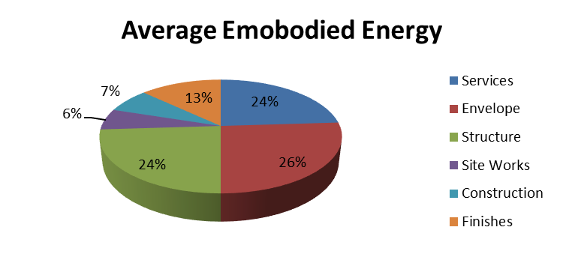
Figure I: Average Embodied Energy.
Source: Cole & Kernan (pp.307-317, 1996).

Moreover, Power (2008) also lists the following additional benefits of renovating/heritage buildings:
- Renovation saves the structure of the property and retains the existing infrastructure
- It attracts investment as it sends the signal that the neighbourhood is worth investing in
- It involves a shorter and more continuous building process
- It has a wider positive social impact on the neighbourhood.
Hence, the adaption of existing buildings to achieve a more efficient use of resources, reduce energy consumption and greenhouse gas emissions, is starting to be seen as a more environmentally friendly and sustainable option (Itard & Klunder, pp. 252-267, 2007).

However, many of the existing heritage building stock fail to meet current-day heating and cooling standards, and that the global challenge of coping with climate change, whilst trying to maximize energy efficiency without sacrificing the special character of these buildings has also become one of the key barriers to achieving major reductions in CO₂ emissions, (see Fig .II )
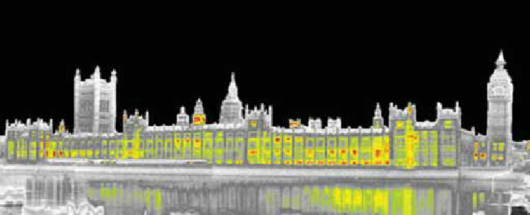
Figure II: Infrared image of heat loss in the Houses of Parliament.
Source: Thermal Cities (n.d.).

Furthermore, and as mentioned above while there has been an array of design approaches and solutions in existence for decades, there is still a lack of consensus as to what design criteria would best maximise the adaptive reuse potential of existing heritage buildings. For example, Kohler (1999, pp.309-320) states that the objective to improving the functionality and durability of existing building`s should be centred around the development of techniques which reduce energy consumption and carbon emissions.

This point was also interestingly observed by Clark et al (2008, pp. 4605-4609) who summarises these actions as:
- Increasing public awareness on the significance of energy saving
- Using new efficient domestic appliances
- Implementing modern building techniques in various areas such as heating
- Legislation which quantifies building plant performance
- Improvement of building regulations on installed plant
- Adaption of small scale renewable technologies
- Flexibility in legislation and energy saving initiative.
Therefore, and as a prelude to answering the questions raised earlier in this section, it could be argued that historic structures provide an opportunity to reduce energy and carbon emissions consumption. However, Kua & Lee (2002) opined that modern living standards which can be achieved by intelligent technologies may not always be compatible with historic structures and that achieving sustainability can be a complex process due to the inherent differences of such structures with modern buildings. Thus, and as indicated by Kikira & Gigliarelli (2010), if the goal of reducing greenhouse gas emissions by 80% by 2050 is to be realized, then more scientific research into sustainability and energy efficiency in heritage buildings is needed. Hence, from what has preceded it may be deduced that achieving a sustainable energy strategy for heritage buildings in the UK is a complex process which requires a thorough examination of existing energy reduction measures.

1.2.1 Defining Energy Performance in Buildings
The European Energy Performance Building Directive (EPBD) defines energy performance in buildings as:
"The calculated or actual annual energy that is consumed in order to meet the different needs associated with its typical use and shall reflect the heating energy needs and cooling needs (energy needed to avoid overheating to maintain the envisaged temperature conditions of the building and domestic hot water needs".
Source: (EPBD, 2010).
At a macro level this includes the optimisation of energy production, distribution and consumption processes which minimizes losses and achieves lower levels of CO₂ emissions, (Irrek et al, 2008). The approach shown in Figure Ill is based on achieving a balance between energy consumption and production, with the goal of creating `Net Zero-Energy Building`s (NZED), which is the objective of the current EPBD recast. Under this framework two phases are outlined: An improvement in building performance (system efficiency) and the introduction of on-site energy generation from renewable energy sources.
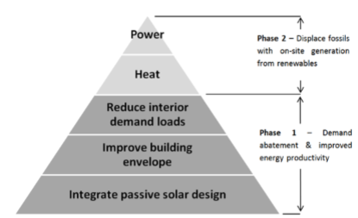
Figure III Net Zero-Energy Buildings (NZEB) step approach for the existing stock.
Source: Ayoub (2011, p.9).
Moreover, this framework can also be extended to form a broader approach by integrating supplementary passive design techniques, e.g. natural ventilation and lighting as proposed in Figure lV below. This framework will be the base for approaching the energy efficiency in heritage buildings in the current research.
Figure IV – Proposed buildings energy efficiency framework.
Source: Author (2017).
The methodology defined in Figure. IV identifies a building`s thermal performance by balancing the heat transfer (through the envelop, thermal bridges and air renovation) to acquire useful heat gains with building elements, (e.g. floor, walls and roof).

1.2.2 Factors Influencing Energy Efficiency in Heritage Buildings
The Buildings Performance Institute Europe (BPIE, 2011), analysis of existing building envelops showed that there were low levels of insulation and high levels of air leakage within the oldest building stock and that these two factors may explain why European countries consume relatively high levels of energy for heating, despite their lower heating needs due to milder winters. Furthermore, the BPIE (2011, p.100) study also goes onto highlight the most effective measures for energy refurbishment of existing buildings:
- Improving the thermal performance of the building fabric through insulation of the walls, floors and roofs, and replacement and tightening of windows and doors.
- Improving the energy performance of heating, ventilation, air-conditioning (HVAC) and lighting systems.
- Installations of renewable technologies, such as photovoltaic panels, solar thermal collectors, biomass boilers and heat pumps.

This approach fits into the general scheme of Figure. IV and is confirmed by other studies which are supported by fieldwork and case studies analysis (Energy Saving Trust, 2010b; HFWG, 2009; Richarz et al., 2007).

1.2.3 Building Physics Parameters
Determining a building`s thermal performance depends directly on the physics of materials and construction systems. Identified in Fourier`s Law for heat conduction, the basic principles for heat transfer in buildings are associated with two physical characteristics of materials: thermal conductivity (k) and specific thermal resistance (R). Deriving from these parameters are the overall thermal transmittance (U) and the total thermal resistance (RT), which express the total values for the building`s fabric elements, e.g. the total material thickness or the sum of their diverse layers of materials (Hall & Allinson, 2010). The last two parameters are commonly named as the `U-value` and `R-value`, and are conventionally the reference for the thermal performance of the building`s fabric and apply to the glazed elements of the buildings envelop to sustain the indoor thermal environment for occupants with optimal energy usage (Portugal, 2006a; Santos & Rodrigues, 2009; and Santos & Matias, 2007). Furthermore, (ASHRAE, 2009; Washington State University, 2008) also point out that apart from direct `conduction` of energy, heat transfer through fluid `convection` and electromagnetic waves `radiation` also need addressing. Another relevant factor which influences the fabric`s heat transfer is thermal mass. According, to the (The Concrete Centre, 2012) this process is determined by the following parameters: the specific heat capacity (amount of heat required to change the temperature of a substance`s mass – J/kg/K), the mass density (mass of the material per unit of volume – kg/m²), the thermal conductivity and surface resistance (m²K/W). In addition, Wheatley (2008) also points out that heritage buildings usually possess a high thermal mass and where designed can take advantage of the building`s physical characteristics and local weather conditions (e.g. natural lighting/ventilation, solar gains and thermal mass heat storage) to improve energy efficiency. Moreover, literature relating to these building parameters, also affirm that an increase in insulation is an effective way of improving the energy performance of existing buildings and can reduce typical heat losses in walls by (35%), roofs (25%), floors (15%) and windows (10-15%), (Department for Communities and Local Government, 2006; Livesey et al; 2013).

1.2.4 Building Systems
The main drivers of energy optimisation in building systems include all types of devices used in building operations, e.g. lighting appliances, domestic hot water (DHW) production and heating and cooling services. From this perspective, the policies mainly address the technological framework.

1.2.5 Occupancy Behaviour
Occupancy behaviour can be divided into choice and pattern of use. The first relates to the selection of the most efficient equipment and building services, (EURECO, 2002). The second deals with the efficient and conscientious use of equipment, with special relevance given to stand-by mode reduction, e.g. the lighting operation, the thermal environment and the efficient use of appliances. In addition, Almedia et al (2011) also stressed that a combination of behavioural and technological approaches can lead to potential electricity savings in the commercial sector of up to 48%. Moreover, a field study by Gas Natural Fenosa (2012) also revealed that it was possible to reduce energy consumption in buildings by 20% through smart – metering.

1.2.6 Indoor Thermal Comfort
Thermal comfort refers to a level of “satisfaction with the thermal environment and is directly associated with the occupants” (ASHRAE, 2010, p.2). Several factors are condensed in the ASHRAE thermal comfort standard under two categories: environmental (temperature, thermal radiation, humidity and air speed) and personal (level of activity and clothing). The combination of these two parameters provides a temperature range, in which the sensation of human comfort lies. The models and methods developed by Olgyay (1963), Givoni (1969), Fanger (1972) and Dear et al. (1997), represent a wide variety of approaches for the determination of the thermal comfort zone. The first approach is based on a fixed all year round comfort zone. The method developed by Fanger (1972), establishes the “Predicted Mean Vote” (PMV) and the “Predicted Percentage of Dissatisfied” (PPD), which are based on a person`s thermal sensation scale in a climatic chamber. In a similar vein ASHRAE (2010), also adopted this method for establishing certain indoor thermal comfort standards (metabolic clothing and air speed), which must be met in order to determine the comfort zone. Further research by (Brager and Dear, 2001; Dear et al. 1997; Dear and Brager, 2002) also introduced the `adaptive model` which was subsequently integrated into the ASHRAE`s standard. This model adds outdoor weather parameters, which influence the human capacity to tolerate and adapt to different thermal conditions, e.g. “where the thermal conditions of the space is primarily regulated by the occupants through opening and closing of windows” (ASHRAE, 2010, p.9). The Comite Europeen de Normalisation or (CEN, 2007) EN 15251 Revised Standard of the adaptive model for Europe, also extended the scope of indoor comfort by incorporating thermal air quality, and visual and acoustic dimensions. These two adaptive approaches were also discussed in a number research projects (Guedes et al. 2009a; Halawa and van Hoof, 2012; Olesen, 2012; Roetzel et al. 2011). The main differences pointed out in the research resided in the calculation of the outdoor temperature (mean outdoor temperature in ASHRAE 55 and mean outdoor temperature in the EN 15251) and in the comfort acceptability grades: Predicted Mean Vote (PMV) 80% to 90% in the ASHRAE 55 and categories I to IV in the EN 15251. `Category III` was pointed out as the most suitable European standard for complying with the thermal expectations of occupants of existing buildings. However, Nicol and Mike (2011) critical review of the of the European standard, also pointed out that the comfort perceived by the occupants often differed from the standard, and led them to concluded that there was a necessity for revising these limits in the ASHRAE method. Moreover, Roetzel et al. (2011) also argues` that in free – running buildings (i.e. naturally ventilated) that the standards have an inability to conform to acceptable human comfort levels. Furthermore, Guedes et al (2009b) also affirms that traditional architecture depends on high thermal mass and other passive design techniques to achieve the best possible indoor comfort. Despite the incertitude of these adaptive models, and due to the complexity of the human response to the environment, they are conceptually the best approach to determine the indoor comfort of existing buildings. As stated by Nicol and Humphreys (2009), this methodology relies on the interaction between building, occupants and environment and avoids a closed building approach, e.g. the use of heating, ventilation and air-conditioning (HVAC) equipment. In addition, Nicol (2011) also goes onto say that this approach has also become part of the mainstream and can play an important role in the design strategy for low-energy buildings. Thus, the approach to adaptive comfort in traditional heritage buildings should be based on natural ventilation, passive design technologies and the human capacity to adapt.

This chapter argued for the reuse of heritage buildings and energy efficiency upgrades under the urban sustainability strategies. From the general overview of the literature it is possible to conclude that the role of Renewable Energy Sources (RES) and Passive Design Techniques (PDT) are fundamental in obtaining the most optimised and cost efficient buildings. Based on this context, it is necessary to identify measures which address cultural issues with the technical and behavioural approaches of the energy efficiency framework.

Chapter 2 Literature Review
2 Key Sources of Literature
This chapter aims to identify the measures and solutions which have been developed to specifically address energy efficiency upgrades of heritage buildings. This was performed through the analysis and revision of the literature and available case studies, which focuses on key mechanisms and incentives to improving energy efficiency in heritage buildings.
To achieve the research aims and objectives it was necessary to consider literature from a wide range of sources. The energy efficiency framework for heritage buildings and the specific measures to address it are discussed, with special focus being put on the constraints posed by this type of building. This includes connecting several aspects of this field of research, namely the economic and social framework involving these typologies, the thermal performance of heritage buildings, their construction systems and the current developments in technical research which deal with the energy efficiency of buildings. In the academic arena prominent research into energy efficiency upgrades of heritage buildings has emanated from Durham and Cambridge Universities, led by Dr Kalliopi Fouseki and Professor May Cassar. In the energy efficiency context there is an expanding and evolving body of literature which has also been consulted in order to reveal current research, trends and industry developments. Literature obtained from EU information sources, detailed topics such as renewable energy technologies and passive design techniques. A review of these resources also emphasised lessons to be learned from other EU countries, particularly in relation to the building`s fabric.

2.1 Overview of Sustainability in the Historic Built Environment
Generally, the historic built environment is viewed as a unique and invaluable resource from which a large section of the nation derives inspiration, enjoyment and instruction (English Heritage, 2006). Whilst, current perceptions towards sustainable development may appear to be a postmodern reaction to accommodate change, the altering of historic buildings for new functions is not a new phenomenon. As Linters (2006, p. 4-12), points out that during the Renaissance period religious buildings were also transformed for new industrial or military uses. However, it wasn’t until the late 19th Century when Violett-le-Duc (1814 – 1879) recognised adaptive re-use as a way of preserving historic buildings. He argued that “the best way to preserve a building is to find a use for it, and then satisfy so well the need dictated by that use that there will never be any further need to make any further changes to the building”. Although, in comparison John Ruskin (1819-1900) and William Morris (1834-1896) who were strongly opposed to Violett-le-Duc`s approach and found it “impossible, as impossible as to raise the dead, to restore anything that has ever been great or beautiful in architecture” and instead of restoration they favoured regular care and maintenance to ensure the preservation of historic buildings. In addition, this concept of adopting sustainable practices in the built environment was also considered as part of a response towards the exploitation of natural resources during the industrial revolution. Moreover, and in an effort to break with traditional building, new architectural styles were also created following the post war era. However, as Cantacuzino (1989) points out in his documented paper new uses for old buildings, that as a reaction to the increased demolishment of existing buildings and development of new construction, a growing interest has emerged in the conservation of old buildings of every kind. As a result, since the mid 1970`s the fundamental focus has been about `how, when and what to conserve`. In light of these debate`s a number of different `schools of thought` have emerged. For example, Forsyth (2008) proposes that all structural interventions for heritage buildings should be governed by The Society for Protection of Ancient Buildings (SPAB) four maxims of conservation, which consists of:
- Conserve as found
- Minimum intervention
- Like for like repairs
- Reversibility of interventions.
In addition to SPAB`s four maxims, another well documented theme that came to the fore was the significant shift in research towards understanding the composition and dynamic behaviour of heritage buildings in relation to enhancing their energy efficiency. Generally, enhancing energy efficiency in heritage buildings can be achieved through a range of sustainable options such as, building fabric improvements (glazing, insulation), enhanced heating regimes, and the application of low carbon and renewable technologies. Although, the extent to which these measures can be applied within the historic built environment also depends heavily on the type of structure, listing status, function and compliance with existing laws and legislation. In this regard and following the UK governments acquired commitments of the now famous Kyoto Protocol of 1997, the first regulation of reference on energy efficiency in buildings was approved in 2002, namely the Energy Performance of Buildings Directive (EPBD). This was further revised in 2010, and expanded on the issue of improving energy efficiency in historic buildings through the implementation of the following requirements (English Heritage, 2010):
- The application of minimum requirements on the energy performance of new buildings;
- The application of minimum requirements on the energy performance of large existing buildings that are subject to major renovation;
- Energy performance certification of buildings;
- Regular inspections of boilers and air-conditioning systems in buildings.
According, to Harrison & Oades (1997) a ` historic building` is a structure which has special architectural or historic significance and is registered on a statutory list.
Generally, regarded as structures built before 1919 from a limited palette of largely natural materials which are more or less vapour permeable and commonly perceived as energy inefficient, these buildings are classified into grades to show their relative importance, (Boardman, 2007). For instance, in terms of age and rarity the following general principals are applied:
- Before 1700: All the buildings constructed prior to 1700 and still contain a significant proportion of their original fabric are listed
- From 1700 to 1840: Most of the buildings constructed in this period are listed
- After 1840: Given the high number of buildings erected which have survived to date, a progressively greater selection is required
- After 1945: Careful selection is required
- Past 30 years: Only buildings of outstanding quality or under threat.

Source: (DCMS, 2010).

Figure: V illustrates the age range of listed buildings in the UK.
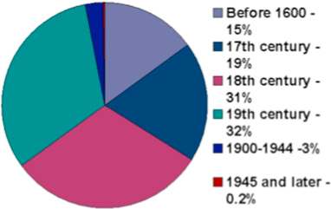
Figure V: Age Range of Listed Buildings in the UK.
Source: English Heritage (2011).

Based on the DCMS (2010) principals summarised above, each listed building falls into one of the following three categories:
1. Grade I buildings: is the highest category and are of exceptional interest. Only 2.5% of the UK`s listed buildings fall into this category
2. Grade II* buildings: are buildings of more than special interest. They account for 5.5% of the UK`s listed buildings
3. Grade II: are of special interest and are of national importance. They account for 92% of the UK`s listed buildings.
Current, English Heritage figures for traditional individual listed buildings stand at approximately 500,000 or 1.5 % of the total number of dwellings in the UK, although the exact numbers are still not yet known due to increasing numbers in listing. However, it may be inferred from these figures and assuming the same rate of carbon emissions for both listed and unlisted buildings that designated historic buildings contribute to 0.25% of all carbon dioxide emissions, (English Heritage, 2008). Furthermore, while heritage buildings represent only a small proportion of the building stock, they are nevertheless significant in terms of contributing to improving energy efficiency and reducing greenhouse gas emissions, (Judson, et al. 2010). In addition, Gors & Highfield (2009) also point out that while the driving force behind the adaptive reuse of traditional buildings from the 1970`s onwards was mainly centred around the functional, technical or economic aspects of the building, very little emphasis was given to energy refurbishment upgrades at this time. Associated terms of refurbishment as defined by Riley & Cotgrave (2011), is a process of modifications and alterations to extend the useful lifespan of the original structure. However, Ashworth (1996) defines refurbishment as a term that originates from a combination of obsolescence and deterioration. Therefore, and most importantly while there are a variety of reasons why refurbishment is undertaken in the UK, such as to preserve a sense of attachment to a place which safeguard`s community heritage, it is also imperative that all principles of sustainable energy efficient building design are explored, (Sodagar, 2013). Further concepts of sustainability are discussed by Forster (2010b, pp. 165-188), who also indicates that within the building conservation philosophy there are two meanings of sustainability, namely a `green` agenda and a perpetuation of a building`s utility. The author also goes onto say that `it is essential that a building is in continuous use for its survival` and that ` changes made to a building are managed sensitively`. In a similar vein, this aspect was also discussed in the ICOMOS Venice Charter (1964, Article.5), which states that `the conservation of monuments is always facilitated by making use of them for some socially useful purpose`. Furthermore, studies by Mithraratne & Vale (2004) also show that there has been a significant shift towards research in understanding how existing buildings behave in relation to their operation, maintenance and refurbishment. Whilst, the author`s findings revealed the significance of operational energy as an important component within the life cycle (LC) and energy use of a building, it also highlighted that an essential step to reducing the impact of carbon emissions on the environment, was to make substantial improvements to the level of insulation within the building. Moreover, Boardman (2007) reported findings on a housing project, also revealed that through the application of low and zero carbon technologies located in and around a building, that a 33% reduction in energy usage could be achieved.
Although, Lowe (2007) in contrast to the recommendations of Boardman (2007), also suggests that if delivered energy is reduced by 20% a 60% reduction in CO² emissions could also be achieved. In this regard, Levine et al (2007) viewed a wide range of literature on energy efficiency and concluded that buildings house a significant amount of energy efficiency potential, which in turn can be harnessed through existing energy efficiency technologies. Hence, the adaptive reuse of heritage buildings should be undertaken to extend the buildings life and to make better use of available technologies to capture energy savings.

2.2. Sustainability
In their review of operational and environmental management Jimenez and Lorente (2001), state that concerns nowadays are over climatic change, biodiversity, air, and water pollution. This fact in turn has led to the establishment of sustainable development strategies within organisations aiming to restructure their social and environmental responsibilities. According to Putman and Price (2004), sustainable development involves the reduction of energy consumption and makes improvements in the working environment. In addition, Ding (2008), also asserts that the construction industry is accused of negatively impacting on the environment due to large resource use. Moreover, Kibert (2008) also adds weight to this argument by stating that the construction industry affects the environment in matters related to climate change, ozone depletion, desertification, and a number of other negative effects. Furthermore, Ofori-Boadu et al (2012) also discusses the methodological frameworks resulting from the efforts made in terms of promoting sustainability.
One measurement framework developed by the United States Green Building Council (USGBC) is the LEED (Leadership in Energy and Environmental Design) program. LEED offers technical assistance, accredited systems for professionals and modern strategies for attaining water efficiency, suitable energy and material usage and appropriate in-door air quality (Paumgartten, 2003).
Another tool for addressing sustainability is the BRE Environmental Assessment Method (BREEAM). BREEAM puts standards for best practice in sustainable design, construction and operation and is currently well recognised in measuring the environmental performance of buildings (BREEAM, 2012).
Ding (2008), also states that sustainable activities in construction should encompass the efficient location of resources, reduce energy consumption, minimise embodied energy, increase the use of re-cycled materials, which in turn could ensure the sustainability of natural resources in the short and long term. Additionally, Putnam and Price (2004) also emphasise that the green building concept encourages possibilities for lower operating costs and enhance worker comfort and productivity through providing an appropriate in-door environment. Castro-Lacouture et al (2009), also mentions that green buildings can alleviate the impact of carbon emissions on the environment. As many organisations nowadays are faced with the challenges of reducing energy costs, the green building concept seems more popular than ever. Speaking of the importance of design to promote sustainability Clevenger and Haymaker (2012), also affirms that designers are faced with a higher demand from owners and users to maximise the value of their facilities through implementing sustainable measures. Supplementing these measures further Castro-Lacouture et al (2009) also believes that following a vigilant design scheme accompanied by a proper material selection process, instead of spending on technology, could be sufficient to realise environmental targets at minimum costs.
However, Olatunji and Sher (2009) declare that while design sufficiency, constructability, operability and cultural value are significantly correlated with profitability, the attention towards sustainability and climatic implications remains insufficient.

2.3 Energy Efficiency
Concerns have been surfacing around the high use of energy demand, which in turn has led to the establishment of energy conservation regulations in many countries. According to the (ORNL Review, 2007, pp. 6-7; Quoted in Umstattd, 2009) energy efficiency can be increased by using the following technologies:
A. Solar Panels
B. Geothermal Energy
C. Structural Insulated Panels
D. Controlled Ventilation
E. Consolidated Utility Walls.

Moreover, Hartungi and Jiang (2012) also discuss the use of energy – efficient lighting as an example for saving both energy and cost. Hartungi and Jiang (2012), also go onto discuss various provisions for conserving fuel and power, which is found in Part L2 of the building regulations set by the UK Government strategy for reducing greenhouse gas emissions to address global warming issues. Such provisions include:

A. Limit heat loss in the building fabric (hot water piping, hot air ducting and
hot water tanks)

B. Implement heating and hot water systems that are energy efficiency

C. Implement lighting systems that are energy efficiency

D. Limit the building`s exposure to solar overheating

E. Implement reasonable air-conditioning and ventilation systems that do
not use energy than what is needed

F. Limit heat gains by chilled water piping, refrigerant systems and air ducts

G. Ensure that the operation and maintenance of buildings do not consume
more energy than is required in reasonable conditions.

The above mentioned provisions require modifications to be made to the building design in order to reduce the losses and gains which affect energy consumption. The buildings fabric, water piping, air-conditioning ducts, lighting systems, ventilation and chiller systems are all elements of a building`s design. According to ACEEE (2013), in order achieve high efficiency systems, proper design, installation and operation should occur. Jewell et al (2010), also states that failing to incorporate the future design decisions could lead to low levels of energy performance in the long term. Moreover, a study conducted by Georgiadou and Hacking (2012) also highlighted that various design considerations can affect the overall energy performance of facilities throughout their life cycle. These considerations included architectural features such as exposure to natural sunlight, external shading, natural ventilation, insulation and glazing. Other electro-mechanical considerations include low energy lighting, BMS, solar thermal and photovoltaic panels. Furthermore, Umstattd (2009) also identifies different barriers which prevents the use of energy tools to increase efficiency; barriers such as insufficient energy storage, whereby energy supply and energy demand cannot be dealt with independently. Another barrier mentioned by the author is the missing data about energy consumption due to the unavailability of individual meters, which can help to maintain performance and increase facility efficiency. Again, the use of smart meters as proposed by ACEEE (2013) is seen as one of the consumer products which have the potential to save energy.
2.4 Energy Efficiency Improvements in Heritage Buildings
The English Heritage (2011) has developed a toolkit which identifies the gradual measures based on the cost and easiness of their implementation in the heritage sector. These stages range from easy savings (`soft measures`) to long term planning (`hard measures`) and is shown in table l below. The first type is based mainly on occupancy behaviour and by using more efficient equipment. The second level, proposes general draught-proofing and insulation of some of the building elements. In addition, the maintenance and improvement of traditional windows and doors is also encouraged in order to maintain the character and appearance of the heritage buildings. According to Cartwright et al., 2011; Changeworks, 2008; Drewe and Dobie, 2008; Ferguson, 2011; Pickles et al., 2012; Rye et al., 2012; Yates, 2006; this framework of solutions seems consensual in the literature and summaries the research promoted by BRE, English Heritage, Historic Scotland and SPAB, and is based on UK case studies from pre-1919 building stock, covering Georgian, Victorian and Edwardian properties.
Level | Category | Measures
Easy Savings  (`Soft Measures`)  Long Term Planning (`Hard Measures`) | Occupancy Enhancements | Appliance Standby Nulling
 | Occupancy Enhancements | Lights Turned Off
 | Occupancy Enhancements | Lower Heating Temperature
 | Appliance Upgrades | Less Boiling of Water
 | Appliance Upgrades | Higher Efficiency
 | Appliance Upgrades | Lower Temperatures
 | Heating Controls and Energy Metering | Intelligent Thermostats
 | Heating Controls and Energy Metering | Controls for Radiators
 | Heating Controls and Energy Metering | Smart Metering
 | Improved Lighting | Low Energy Lamps
 | Improved Lighting | Motion Detectors
 | Improved Lighting | Standby Mode
 | Energy Efficient Heating | Fuel Efficient Boiler
 | Energy Efficient Heating | Boiler Maintenance
 | Energy Efficient Heating | Biomass Heating
 | Draught-Proofing of Doors and Windows | Insulation of Secondary Glazing
 | Draught-Proofing of Doors and Windows | Frame Draught-Proofing
 | Insulation of Some Building Elements | Floors and Chimneys
 | Insulation of Some Building Elements | Roof and Loft
 | Insulation of Some Building Elements | Hot Water Tank and Piping
 | Insulation of the Building Envelop | Roofs and Walls
 | Insulation of the Building Envelop | Suspended or Solid
 | Insulation of the Building Envelop | Floors
 | Introduction of Renewables | Solar Thermal
 | Introduction of Renewables | Photovoltaic
 | Introduction of Renewables | Micro-Wind
 | Introduction of Renewables | Hydro Power
 | Introduction of Renewables | Air/Ground Source Heat Pump

Table l: Heritage buildings energy efficiency toolkit.
Source: English Heritage (2011).

By crossing the framework for the improvement of heritage buildings presented in table I, and with specific solutions identified in the literature review, it was possible to produce the following measures. These solutions highlighted envelop insulation, glazing upgrades and the introduction of renewables as the most effective way for improving energy efficiency of heritage buildings.

2.5 Building Fabric Improvements
2.5.1 Thermal Insulation
According to Ferguson (2011) and Richarz et al (2007), the use of external insulation is acknowledged to be the most effective solution, as it takes advantage of the high thermal mass usually found in heritage buildings. However, its use in the building envelop is considered to be a major challenge, due to technical and heritage constraints posed. As Yates (2006), points out that the BRE conducted research on several Victorian houses and found that the insulation of solid walls posed many problems. Although, improvements were made by addressing the building envelope`s insulation at several scales (roof, walls and glazing) and by paying careful attention to the consequences this had on the building`s authenticity. A `case-by-case` basis is the most commonly applied approach for assessing the visual impact of the solutions on the buildings fabric.

Changeworks (2008), Curtis (2008), Drew and Dobie (2008), English Heritage (2011) and Yates (2012) also discuss natural insulation, such as mineral and natural fibres or hemp batts to be more adequate than petro-chemical materials for heritage buildings, as they absorb and let out moisture which in turn allows the traditional construction to breath. Moreover, the same authors reviewed the same type of insulation available for each approach, stating that flexible materials (e.g. mineral or natural fibres), are more suitable for inner insulation than rigid boards, as they can be inserted in the construction voids. Additionally, it is also important to stress that due to reduced interior dimensions of spaces or by the limited available thickness on the main façade, natural or flexible insulation seems to be the most viable option. Furthermore, the use of dry-lining insulation is also limited by the existing walls, which must be preserved. Hence, it is possible to consider the use of two recent materials: aerogel insulation and phase change materials (PCM).The silica aerogel insulation is produced from one of two silica containing precursors, tetram-ethoxysilane, (TMOS, Si (OCH₃)₄) or tetraethoxylane (TESO,Si (OCH₂H₅)₄). It relies on enclosed air gaps for its insulating power and is placed between two enclosed panes of glass that are hermetically sealed to minimise unwanted heat gain, (Kaushika and Sumathy, 2003). In addition, the transmission of solar radiation through transparent insulation can also off set the heat loss through the insulation, leading to effective seasonal mean U-values. Hastings (1994) presents data on effective U-values for a wide range of conditions. For equator-ward-facing walls with transparent insulation, effective U-values are negative for locations as far north as the Shetland Islands (latitude 60.5⁰N).
Part L1A of the Building Regulations which came into force in October 2010 has listed the limiting U-values for different building components and Table ll illustrates the new acceptable levels in comparison with the 2006 version of the Building Regulations.
Table: ll Acceptable U-Values of Different Building Components
Element 2006 2010
Roof 0.25 0.20
External Wall 0.35 0.30
Party Wall N/a 0.20
Floor 0.25 0.25
Windows 2.20 2.00
Air Permeability 10 10

Source: Part L1A of Building Regulations (2006 & 2010).

However, due to the traditional construction, the thermal characteristics of heritage buildings are generally poorer than their modern counterparts.
The typical U-values for heritage buildings are resented in Table lll below:

Table: lll Typical U-Values for Heritage Buildings
Building Element | U-Value W/m² K
600mm solid brick wall with limestone facing | 1.00
600mm solid brick wall | 0.88
900mm limestone wall with lime plaster | 1.22 – 1.88
Uninsulated pitched roof with slate | 2.6
Stone Floor  Uninsulated 30m x 10m  Uninsulated 60m x 20m | 0.45  0.25

Source: Carbon Trust (2011).

In addition, the Carbon Trust (2011) also point out that, depending on the level of access, the roof is the most practical area to improve the insulation standard of a heritage building. Moreover, while it is possible to achieve a high level of insulation, achieving a U-value of 20 W/m² K (Part L1A of the Building Regulations 2010) for the roof of a heritage building, it could be especially challenging if there are constraints regarding the thickness of insulation in the rafters.

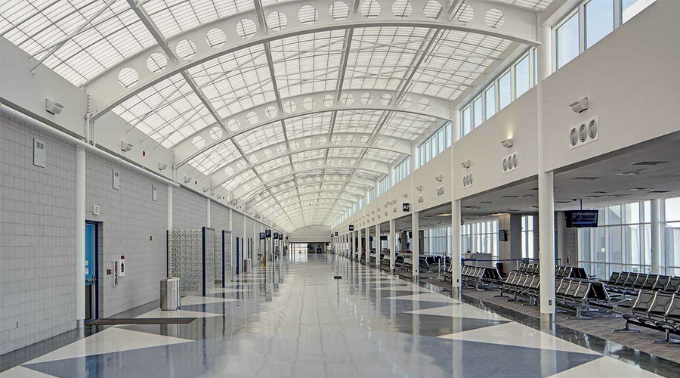
Figure: lV Example of aerogel skylights: University of Central Fllorida
Source: Kalwall Corporation, www.kalwall.com

Companies producing transparent insulation include the Canadian firm Advanced Glazings (www.advancedg-lazings.com), the German firms Wacotech (www.wacotech.de) and Okalux (www.okalux.de), and the US firm Kalwall (www.kalwall.com).
The phase change material (PCM) store and release heat when changing their phase (solid to liquid and vice versa) are classified as latent heat storage (LHS) units. In addition, Silva et al (2008) and Monteiro et al (2005) who studied microencapsulation in plaster, also point out its potential for energy efficiency. In their experiments 25% of PCM¹ was incorporated in the final layer of plaster covering the inner face of exterior walls. The results revealed that the room maximum temperature was reduced by 28% and the room minimum temperature was increased by 6%, without using any heating or cooling equipment. This 1 mm thick PCM layer improved the wall thermal mass significantly and, with an additional 1€ per square meter of the total render cost, it seems to be a high potential solution to be used in the upgrade of the thermal performance of heritage buildings. Furthermore, the study also highlighted that a reduced amount of energy was used to achieve the thermal temperature. Additionally, the work undertaken by Zamolloa et al (2008) also showed that the use of PCM insulation increased the thermal inertia of a wall, and reduced the cooling demand by up to 30%. Thus these results have shown that PCM insulation can play a relevant role in the passive cooling of buildings, increase comfort and save energy.
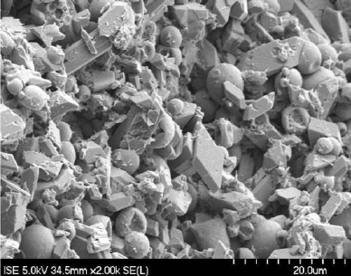
Figure: Vll shows electron microscope image PCM in gypsum plaster
Source: Schossig et al (2005).
In addition, Changeworks (2008), Drewe and Dobie (2008), English Heritage (2011), Richarz et al (2007) and Yates (2006), also highlight that the approach towards roof insulation is also consensual in the literature, and is considered in conjunction with the loft space. For example, if the space under the roof is not inhabited the insulation is placed on the floor which permits cross ventilation of this space (cold roof). However, if it is used for living, the insulation is then placed directly in the roof, by incorporating it between the rafters (warm roof).
¹ –This ratio proved to be the best in terms of balancing the mechanical stability of the plaster with their thermal improvement.

2.5.2 Glazing
A major contribution to the character of heritage buildings are the windows, which illustrates the history of the structure, the craft skills, building economics and changes in architectural styles. However, as the English Heritage (2010) point out that older windows can be draughty and suffer from excessive air-leakage, which in turn can affect heating regimes. A number of non – intrusive approaches which have proven to be the most successful are based on up-grading the glass (by inserting double glazing or by introducing secondary glazing, (Changeworks, 2008; Curtis, 2008; and Yates, 2006). From these examples, Changeworks (2008) highlights the Slimeline secondary glazing applied to a Scottish pilot study. Figure Vlll below: shows secondary glazing with the original window design.
Figure: Vlll Slimeline Secondary Glazing
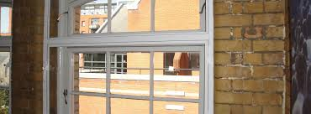
Source: Secondary Glazing.co.uk.
In addition, Askar et al (2001) also highlights that in a double glazed window, a layer of motionless air is created between two glazings, thereby increasing the thermal resistance. Moreover, studies by MaCrae (1997 and Muneer et al (2000) into the thermal conductivity (W/m/K) of different gases which can be used to optimize windows are compared in Table lV below:

Table: lV Thermal conductivity (W/m/K) and other properties of different gases that can be used in windows; the optimal thickness of the gas layer is for an average inside to outside temperature difference of 20K
Gas | Conductivity | Molecular mass | Percentage in air | Optimal thickness of gas layer | Gas-separation energy for a 1.1 m² glazed area
Air | 0.0250 | 28.96 |  | 20mm
Argon | 0.0161 | 39.95 | 0.9 | 16mm | 12KJ
Krypton | 0.0096 | 83.8 | 0.00014 | 12mm | 508MJ
Xenon | 0.0055 | 131.3 | 0.0000087 | 8mm | 4.5 GJ
Source: McCrae (1997) for thermal conductivity, Muneer et al (2000) for properties.
Argon filled windows are commercially available in many countries, while krypton-filled windows have been introduced commercially in the US and Switzerland and xenon-filled windows in Germany. Argon has a thermal conductivity two-thirds that of air, while krypton and xenon have thermal conductivities just over one-third and one-fifth that of air respectively. As a result, the optimum size of the gap between the two panes of glass is smaller the heavier the enclosed gas, as shown in Table lV. In addition, Muneer et al (2000) also points out that due to the fact that argon constitutes almost 1 percent of the atmosphere, the separation energy is quite small compared to krypton and xenon and that these separation energies can reduce heat loss over the lifetime of the window.
Furthermore, the literature stresses that the use of low –emissivity coatings to reduce heat loss of the glazing. Such windows are said to be `low-e` or `heat mirror` windows. Lowe-e coatings serve`s to keep the infrared radiation (heat) inside the room and are produced using the pyrolytic technique, (Holland et al 2001). In the pyrolytic technique an aerosol is sprayed from a nozzle above hot (600ºC) glass, vapourizing and reacting before reaching the glass. The impact of the low-e films can also be engineered to have a negligible effect on light transmission, solar gains and light transmittance, (Restart Project, 2000).
Quotes of the additional costs of high-performance windows are highly erratic, and reflect an immature market in many places and the perception among window manufacturers is that those seeking high – performance windows are prepared to pay a high price for environmental reasons. However, there is an opportunity with high-performance windows to offset part of the extra cost through avoiding perimeter heating units and downsizing heating and cooling equipment at peak times.
2.5.3 Double – Skin Facades
A double-skin façade is a façade with an inner and outer wall separated by an air space that is not actively heated or cooled. The outer façade consists of a single – or double glazed glass wall with fixed or adjustable openings, and the inner façade may also consist of a single-or double glazed glass wall with operable windows. Oesterle et al (2001) identifies the following types of double-skin facades:
- Box Windows
- Shaft-Box Facades
- Corridor Facades
- Multi-Storey Facades
Box windows consist of a frame with inward-opening-casements. Airflow from one box window to another (i.e. from floor to floor or laterally from room to room) does not occur, thereby inhibiting the transmission of sound and smell. Shaft-box facades have columns of box windows which alternate with vertical shafts and are linked through lateral openings at the top of each box window. The stack effect draws external air into the bottom of each box window, through the adjacent room if the windows are open, and into and up the shaft. Figure lX below: shows a box window.
Figure: lX Construction of a box window type double-skin façade.
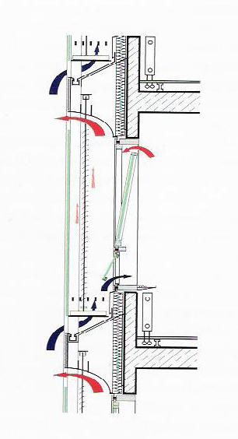
Source: Oesterle et al (2001).

Corridor facades separate a given floor from the floors above and below by a partition, but extends without interruption from one side of the façade to the other. Air intakes and outlets occur near the floor and ceiling of each floor, but to prevent exhaust air from entering the intake of the floor above, they are staggered from one floor to another. This in turn will also reduce the spread of smoke in the event of a fire. Figure lX below: shows a double-skin façade at the Centre for Cellular and Biomolecular Research at the University of Toronto.

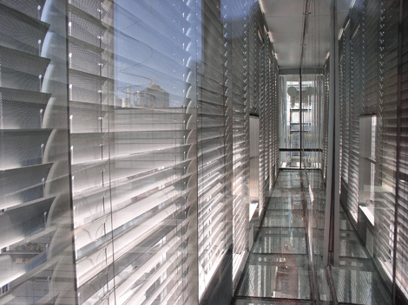
Figure: lX shows a Double-Skin Corridor Facade
Source: Kiang (n.d).

Multi-storey facades are useful when external noise levels are high, as they require few openings and can be used as supply duct rooms behind the façade that need to be mechanically ventilated. The temperature in the façade gap increases with height, thereby increasing summer cooling loads in the upper floors. In addition, motorised lourves are usually placed just inside the outer façade. These in turn will reflect but also absorb the sunlight during the summer that would otherwise cause overheating in the building. The motorized lourves can also be programmed to optimize the balance between day-lighting (when the adjacent room is occupied, as determined by occupancy sensors) and reduce the cooling requirements when unoccupied during the summer months. During the winter months, heated air between the facades can be directed to the inside of the building. However, condensation on the inner surface of the of the outer skin can be a problem if (l) the building air is humid and the inner windows are open, and (ll) if the outer skin is closed and the outside temperatures are low. To overcome this problem oesterlie eta al (2001), states that the inner windows should be closed when outside conditions dictates. One traditional example of a double - skinned building can be found in the heart of Kings Cross in London. The flatiron lighthouse building which dates back to 1875 has been renovated with a double skin façade and the resulting measures has significantly improved natural ventilation, heat gains and reduced noise levels to within BRE guidance levels of 46-48 dBA and is illustrated in Figure: Xl below:

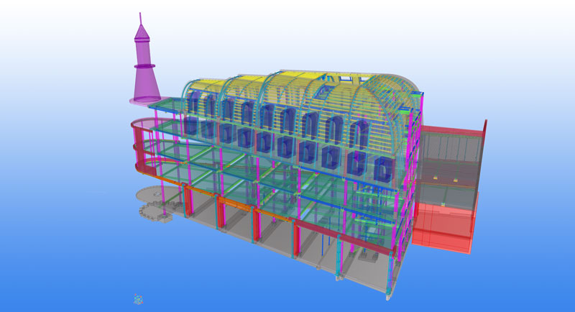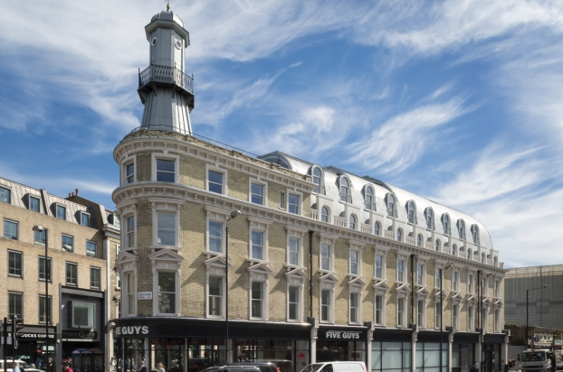

Figure: lX The Lighthouse Building at King`s Cross London.
Source: www.ramboll.com/projects/ruk/lighthouse-building (n.d.)

The direct economic cost of double-skin facades depends on a number of factors. Oesterle et al (2001), indicates that an overall cost of double-skin facades, including sun-shading devices ranges from 650 to 1500€/m² of the façade area. In addition, Lang and Herzog (2000) also state that double-skin facades cost about twice as much as single-skin facades in central European, where there is a good level of experience with this technique. According to Grut (2003) the double-skin façade on the Daimler Chrysler Building in Berlin cost only 20% more than a normal façade (and the façade constituted only a 9% of the total building). However, as with high – performance windows and curtain walls, part of the extra capital cost of double – skin facades can be offset through savings in HVAC (heating, ventilation and air conditioning) equipment due to the downsizing of equipment.

2.5.4 Air Leakage
According to ASHRAE (2001b, Chapter 24), airflow barriers in buildings are often-poorly designed and executed. Air leakage in buildings with brick masonry can be significant, due to the fact that upward airflow in the cavities are not always` sealed. A selected sample is shown in Figure Xl below:

Figure: Xl Air Leakage In Masonry Brickwork
Source: Insulating old brick buildings (2011).
In addition, Bahnfleth et al (1999) also states that two methods have been used to measure leakage in buildings. One method is a floor-by-floor blower door test, which is installed in a door leading to a stairwell shaft and used to pressurize a given floor. The second method uses the ventilation fans to pressurize the building in increments, which need to measure the total envelop leakage. Furthermore, Fennell and Haehnel (2005) also highlight the following ranges for typical Air Changes Per Hour (ACH) in buildings, based on documented studies in Canada 1.1 – 1.6, in the US 4.9 – 7.5, and in the UK 6.0 – 9.1. From this there is a factor of 6-8 difference between modestly good practice and the typical practice of some countries. However, this procedure is rarely followed except in major public buildings, e.g. (hospitals, museums, theatres).

2.6 Heating Solutions
2.6.1 Passive Solar Heating
Passive solar heating occurs when the building is heated by direct absorption of sunlight. Techniques include the use of solar collectors, solar walls, and integrated PV- solar collector systems. Solar air collectors can be mounted on a roof or on walls and integrated into the structure of the roof or wall as part of the building envelop. Hastings and Morck (2000) discuss solar hot water systems, used for both space heating and domestic hot water. Outside air is drawn through a roof top or wall – mounted solar collector, heated then circulated directly into the space to be ventilated and heated. Figure Xll below: illustrates DHW solar thermal collector on the roof of a traditional building.
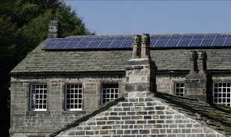
Figure: Xll Solar Thermal Collector on a Traditional Roof
Source: Gibson Mill (2012).
Hastings and Morck (2000), also go onto point out that solar collector efficiencies range from about 30-70% which is sufficient to meet 80% or more of the annual heating load for well-insulated buildings with a collector area equal to 16% of the floor area. Solar collectors cost in the region of 200-400€/m². However, this again can be offset against the annual energy savings made through feed-in-tariffs.
Another early passive solar heating system with thermal storage is the Trombe wall. The traditional Trombe wall consists of a massive wall behind a glass pane, typically with a 1m air gap. The idea of the Trombe wall is to collect solar heat that can be re-supplied after sunset, while reducing the risk of overheating. Zalewski et al (2002), has analysed the heat budget of a traditional Trombe wall and found that with insulation they save between 30-40% of energy usage. Furthermore, Zalewski et al (2002) also points out that instead of using rock or concrete as the thermal mass, the Trombe wall can be constructed with a suitable phase-changing material (PCM), as a means of improving the performance of the existing walls, as discussed early in this chapter. Figure Xlll below: illustrates the air flow in a vented Trombe wall.
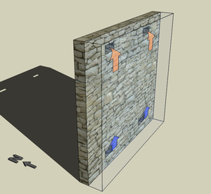
Figure: Xlll Vented Trombe Wall
Source: Drukpa Trust (2008).

2.6.2 Heating, Ventilation and Air Conditioning (HVAC) Systems
A variety of methods have been used to ventilate and heat or cool commercial or public buildings. In an all-air system, air of sufficient coldness is circulated through the building to remove heat. This can be done using either a constant flow rate, or a variable flow rate – referred to as a constant air volume (CAV) and variable air volume (VAV) systems. In some buildings, there may only be two pipes, with the system switching from cooling to heating in the winter and from heating to cooling in the summer. According to Durkin and Kinney (2002), due to the inflexibility of switching between heating and cooling only twice per year, the two-pipe systems fell out of favour and new methods allowed daily switching between heating and cooling needs. Lian et al (2005) highlighted that many buildings` now favour water-to-air heat pumps with one heat exchanger connected to a common building system, which in turn can redistribute cooling and heating needs to different parts of the building, thereby improving overall efficiency. Another alternative discussed by Behne (1999), is ceiling radiant cooling which has been used in Europe since the mid-1970`s. In Germany during the 1990s, 10% of retrofitted buildings used CC panel cooling. Of these 10% relied on natural ventilation, 45% used conventional ventilation and 45% relied on displacement ventilation. In addition, Hodder et al (1998) also points out that this in turn also allows the air temperature to be 2K warmer in CC systems than in water to air systems. Figure XlV below: illustrates chilled ceiling cooling panels within a traditional building.
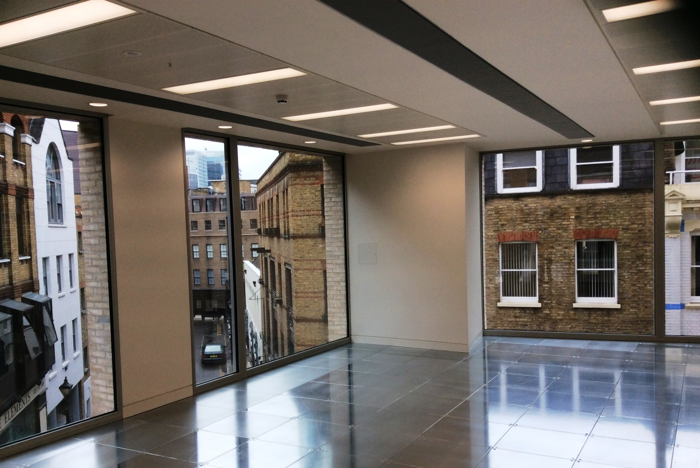
Figure: XlV shows Chilled Ceiling Coolant Panels
Source: Steward Building (2014).
MaDonell (2003) also presents data on the cost and energy use of a chilled-ceiling system in a traditional building in Vancouver (Canada), and found that with a high – performance envelop heating and cooling cost approximately 10% less and used 45% less energy per unit of floor area.

2.6.3 Lighting
Lam (1986) provides a well – illustrated general discussion of conventional techniques for daylighting using skylights, atria, clerestories, and light wells. Particular attention is given to aesthetic and lighting-quality issues. In addition, Hastings (1994) quantitative analysis of buildings has also provided a number of effective daylighting strategies. Moreover, Leslie (2003) also discusses the use of dimmable lighting systems, occupancy sensors and zone controlling, so that each zone can be automatically adjusted up or down as the availability of sunlight changes, and turned off when rooms are not occupied. Buildings with the provision of an atrium can increase daylighting with minimal impact on heating and cooling energy use. Calcagni and Paroncini (2004), reviewed tool`s for predicting the distribution of daylighting in buildings with an atria. This daylighting potential of an inner atrium was also fully exploited by Sim-Darby Associates on the new £9 billion pound renovation project of the Battersea Power Station in London. The use of roof mounted sun-tracking heliostat and reflecting mirrors, where used to directed sunlight down onto the atrium. In addition, (glazed vertical steps in the roof) were also used to distribute natural light throughout a building as illustrated in Figure XV below:
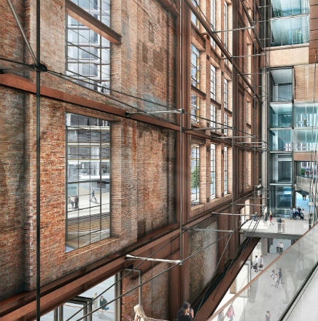
Figure: XV shows the use of natural daylighting at Battersea Power Station (Grade ll) listed building.
Source: https://www.simdarbyproperty.com

2.6.4 Domestic Hot Water (DHW)
Reducing the use of both cold and hot municipal water can save energy by reducing the consumption of the embodied energy associated with that water. The consumption of unheated municipal water can be reduce (l) by recycling `greywater`; (ll) by collecting and sorting rainwater for use where treatment is not required; and (lll) through the use of water efficient measures. According to Dixon et al (1999), 80% of toilet flush water can be provided in this way. In addition, there are up to four kinds of integrated space and hot-water heating systems which are commercially viable. In one, the hot-water tank is connected by pipes to one or more fan coil air handlers, and the hot water circulates through the fan coil when space heating is needed. A second type of system consists of a boiler and two heat exchanger coils, where water or gycol is circulated to the space-heating or water-heating coil, as needed. A third option circulates hot water from the hot water tank through hot-water radiators located in each room for space heating, with domestic hot water being drawn from the same tank. The fourth option is where a tank-less water heater feeds a radiant space-heating system as well as supplying DHW. According to Jones and Bicker (2004), energy factors based on water heating range from 0.51 to 0.83. Moreover, studies by Proskiw (1998) also indicate that simultaneous flows account for 30 – 40% of the total hot-water load in a single building. In addition, Vasile (1997) also discusses the gravity falling film method, which enables a high rate of heat transfer. This is where the cold incoming water passes through a coil that is tightly wrapped around the vertical downpipe and is warmed as it flows, see Figure XX below.
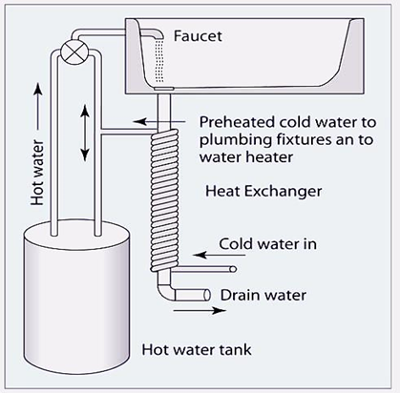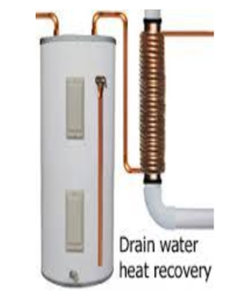

Source: Vasile (1997).
Vasile (1997) also goes onto say that this system can recover between 45-65% of the available heat in wastewater.

2.6.5 Energy Efficiency Lighting
The main lighting technologies and key principals by which electricity is converted into light are summarized as follows: Incandescent lamps have a tungsten filament which serves as an electric resistant and as such can be heated to a temperature of 2100-2800º C and have a lamp lifespan of 750-1000 hours. A fluorescent lamp consists of a tube filled with argon at each end and the inner tube is covered with a phosphors coating which emits lights at various wavelengths. They are used in commercial buildings and often referred to as (T12, T8 and T5) accordingly. High intensity lighting or (HID) lamps are restricted to outside lighting (street-lighting, stadiums, schools). Light-emitting diode or (LED) lamps are like photovoltaic (PV) cells running in reverse. Light is converted to electricity using a pair of semi-conductors that form a junction. AC electricity must be converted into DC electricity. According to the National Association of Home Builders technical information website (www.toolbase.org), a 5W desk LED lamp can replace a 60W incandescent lamp for around $90 and have an energy saving of over 90%. LEDS also have a 100,000-hour lifespan which makes them worthwhile. In addition, Rubinstein et al (1998) findings of lighting energy savings over a six month period in a San Francisco office building using LEDS with light sensors and dimmable ballasts in one entire floor, calculated energy savings of 41%. Moreover, Atif and Galasiu (2003) also measured a 45% annual saving with LEDS in a large atrium in Canada (the atrium itself was unchanged and therefore not optimized for daylighting). Figure XXl below shows LEDs illuminating the façade of the Grand Palace in Brussels, Belgium.


Figure: XXI LED Lighting Illuminating the Façade of the Grand Palace in Brussels Belgium.
Source: www.ledlight-lamp.com/article₋206.html.

2.7 Grants and Tax Incentives
One of the main factors for applying for low carbon energy supply technologies are the government grants and tax incentives which aim to promote the uptake of these technologies. Types of incentives which have emerged in the UK are Feed-in-Tariffs or (FIT`s), EDF`s Green Energy Fund, The Energy Saving Trust and the Renewable Heat Incentive (RHI).
2.7.1 Feed-In-Tariffs (FITS)
The Feed-in-Tariff scheme or (FITs) is an environmental programme introduced by the government in 2010 to promote the widespread uptake of a range of small-scale renewable and low-carbon electricity generation technologies.
Source: Ofgem, (2011).
Specially aimed to incentivize small scale low carbon electricity producers, the tariffs offer guaranteed rates per KWh produced, which in turn has the effect of reducing the variable costs when in the process of developing energy efficiency projects. However, Bywater (2011) noted the disappointment in the rates allocated to the UK`s FITs in meeting its targeted producers, when compared to the incentives being offered to suppliers of small-scale PVs (Photovoltaics).

2.7.2 EDF`s Green Energy Fund
Customers on EDF`s Green Tariff pay a premium that is matched by the EDF and then is re-distributed through the Green Energy Fund as grants to the community or for non-profiting organisations for renewable energy projects, (Carbon Trust, 2011).

2.7.3 The Energy Saving Trust
The Energy Saving Trust offers grants from their sustainable development fund to provide grants for the installation of PV panels. According to the Carbon Trust (2011), these grants are also available for other efficiency measures, such as insulation and heating systems. In addition, these grants are also available for organisations who intend to explore models of best practice for sustainable living through innovative ideas which support or involve local communities.

2.7.4 Renewable Heat Incentive (RHI)
The Renewable Heat Incentive (RHI) is another government scheme to incentivize the uptake of a range of renewable heat generating technologies, where a payment is made for heat generated by eligible technologies. In addition, Kelly and Pollitt (2011) research into RHI indicated that the world`s first renewable heat incentive opened for applications in 2011, providing payments for heat generated from renewable technologies. The authors also go onto identify that RHI can potentially provide a cost effective way of reducing GHG emissions in energy production.

2.8 Regulations
The European Commission`s Energy Performance Building Directive (EPBD) 2002/91/EC requires all member states to set minimum energy performance standards for new and existing buildings. In addition, the UK government is legally committed to an 80% cut greenhouse gas (GHG) emissions by 2050 (Climate Act, 2008). Approved document L1B and L2B (2013, edition) of the building regulations contains the requirements for the conservation of fuel and power for existing new and existing buildings.
Schedule L1: States that reasonable provisions should be made for the conservation of fuel and power in buildings by-

(a) Limiting heat gains and losses through the thermal elements and other parts
of the building fabric; i.e. pipes, and ducts used for space heating, space
cooling and hot water services.

(b) Providing fixed building services which are energy efficient, have effective
Controls and are commissioned and tested to regulatory guidelines.

Also noted for the UK are specifications that are consistent with a 25% improvement in building energy performance in response to the EPBD (ODPM, 2004). Moreover, surrounding these regulations is the issue of `what, when and how` to conserve heritage buildings. Highfield (1996) also noted that considerable work is required to balance legislation and regulations, which do not inhibit the progress of heritage sustainability.

Chapter 3 Methodology
The principle aim of this research is to establish the opinions of targeted industry practitioners to the benefits of adopting energy efficiency measures within heritage buildings. To achieve this, a survey of industry practitioners was undertaken, comprising of an online self-completion questionnaire (see Appendix l) and semi – structured telephone interviews to obtain and generate accurate results. The following section describes and justifies these approaches, as well as the ethical considerations and limitations of these methods.

3. Approaches to Research
According to Lee (1989), research falls under three categories:
1. Subjective: The researcher`s personal perception of the research participants
2. Interpretive: The researcher`s perception of research participants` subjective views
3. Positivist: The objective perception of the facts within a certain situation.
In addition, Thietart et al (2001) also states that the knowledge types sought by the researcher can differ according to whether the epistemological suppositions are made based on a positivist, interpretive or constructivist view. The positivism view aims at explaining reality, the interpretativism view mainly focuses on understanding it and the constructivism view how to construct it. However, there is a slight difference between the two aforementioned sets of categories. For instance, Lee (1989) tends to use the researcher`s participation level as a criterion for classification, whereas Thietart et al (2001) refers to the nature of the work done in the research. Another viewpoint presented by McNeill and Chapman (2005), also describes different philosophical models, taken during the research process about the different aspects of the world. As a result McNeill and Chapman (2005), handle both positivism and interpretative sociology as follows: Positivism – generates quantitative data used in statistical analysis to generate correlations, patterns or trends to aid in arriving at conclusions. Interpretativism – introduces ethnographic studies and is consequently a qualitative practice, describing life instead of producing statistical outcomes.

3.1 Qualitative versus Quantitative Data
Research is either an investigation (qualitative) or theoretical (quantitative). However, Lee (1991) differentiates between interpretative (qualitative) and positivist (quantitative) methodologies by stating that qualitative researchers seek to investigate not only the objective issues related to people and their behaviour, but also the people`s subjective views concerning their own behaviour. In addition, Silverman (1998), also points out that qualitative research is concerned with analysis methods, which relies on words not statistics or numbers. Furthermore, Lee (1991) also argues that the quantitative approach is based on objective data gathering and analysis, and that their natural science methods are the only true methods of research. Although, Tashakkori & Teddlie (1998) claim that qualitative researchers, requires methods which are distant from natural science methods.

3.2 Types of Research Methods
3.2.1 Surveys
According to Oppenheim (1992), there are generally two different types of survey; the descriptive survey which deals with census-type data and the analytical survey. The rationale for using descriptive surveys is to ask the question of “how many”. However, when the purpose of the research shifts from counting and describing to answering the question of “why”, the analytical survey is then used to perform an analysis of the causality. Moreover, Cohen, Manion and Morrison (2000) also list instruments used to gather data under the survey methods of research and include the following:
(a) Structured or semi-structured interviews
(b) Self-completion or postal questionnaires
(c) Standardized tests of attainment or performance
(d) Attitude scales.

3.2.2. Case Studies
Yin (2003, p.13) defines a case study as an `empirical inquiry` which examines an event `within its real life context`. Moreover, Flyvbjerg (2006) also states that being close to real life situations, renders case studies essential for a number of reasons, i.e. understanding human behaviour through forming a certain perception of reality which cannot be achieved through theories is one reason and a second reason would be that case studies enhance a researchers` learning practice in favour of producing high-quality research. Furthermore, Cepeda and Martin (2005) also suggest that case study research is considered practical for two main reasons. The first reason is that case studies provide the opportunity of studying object in their natural environment in order to produce theoretical outcomes from practical data. The second reason regarding case studies is that it enables the researcher to understand the complex processes taking place in a certain environment and the reasons behind their occurrence.
3.2.2 Choosing a Suitable Methodology
Referring back to the research problem and the nature of the investigation, the researcher is required to investigate energy efficiency in heritage buildings. Therefore the investigation should involve industry practitioners operating within a certain context. In order to attain a research output that could be generally applied to heritage buildings within a define context, the survey approach method is utilised. In addition, and based on the analysis made in Section 3.2 qualitative data about people`s experiences and opinions is found to be the required data collection type.
Qualitative survey methods began to gain popularity during the 1980`s in an effort to respond to the short-comings of surveys which predominately relied on questionnaires. This divergence between the traditional quantitative and qualitative techniques resulted in unsatisfactory findings and conclusions. However, Marsland et al (2000) also identified that qualitative survey types enable`s qualitative and quantitative tools and attitudes to be merged. Due to this merging of both tools, the researcher is able to collect data obtained from open-ended questions, which in turn can be coded to develop categories as well as attain statistical outputs such as frequency tables.

3.2.3 Data Collection Methods
Following selection of a research methodology, data collection techniques should then be considered depending on the type of methodology used.
Three important issues need to be considered when deciding on data collection techniques; to be in-line with the selected research methodology and result in obtaining the right data needed for a successful outcome. McNeill and Chapman (2005), highlight the following:
(a) Reliability
A method is considered reliable whenever other researchers use it or the same
researcher uses it again, and the obtained results turn out to be the same.

(b) Validity
Whenever the collected data reflects truly what is being studied, then this data
is considered to be valid

(c) Representativeness

If the results achieved are relevant to the group of people or the situation under
study, are also relevant to other people outside the group.

Data collection techniques include: Questionnaires, interviews and observations.
Figure XVl below: depicts an example on the range of methods used in data collection.

Numbers
Involved
Many
Social surveys

Structured interviews

Unstructured interviews

Observation

Participant observation

Few
Low High
Personal involvement of researcher

Source: (McNeill & Chapman, 2005).

3.2.4 Questionnaires
According to Wilson & Mclean (1994), questionnaires are a commonly used technique for gathering numerical data. In addition, Oppenheim (1993) & Sapsford (1999) both quoted in Boynton & Greenhalgh (2004), opinion that questionnaires give researchers the option of collecting objective data about people, their behaviour, attitudes and knowledge they possess. Moreover, and as reported by Cohen, Manion & Morrison (2000), questionnaires are of three types:

1. Structured Questionnaires: Involve closed questions which can help in the
analysis of statistical data due to the generation of response frequencies.

2. Semi – Structured Questionnaires: Involve open-ended questions framed
within a certain structure ad sequence which enables the respondents to
focus their answers in certain required ways, whilst responding in their own
words.

3. Unstructured Questionnaires: Involve completely open – ended questions
which allows respondents to write whatever they want, whilst being guided by
minimal structuring.

3.2.5 Interviews
According to Kvale (1996), the interview is a technique which deals with information generated between people through contact and dialogue rather than just regarding individuals as entities subject to manipulation. Additionally, the author also goes onto discuss that an interview, has common interests in a certain issue, promotes knowledge creation through human relations and reflects the social characteristics of data gathering. Other contributors to the philosophical aspects of the interview was found in Alvesson (2003) who whilst referring back to Baker (2003), states that the purpose of an interview is “in order that the respondent speaks openly, authentically or truthfully, to produce a valid report on some interior or exterior state of affairs. Further support was also found with other authors such, as (Cohen, Manion and Morrison, 2000), who also state that there are various purposes for interviews, which include:
(a) Appraising people in some way
(b) Choosing employees or for promotion purposes
(c) Inducing healing affect, as in psychiatry
(d) Developing and testing hypotheses
(e) Gathering data for research purposes
(f) Collecting people`s thoughts and opinions about specific topics.
Moreover, Ely et al (1991) also highlights that through in-depth ethnographic interviews, researchers are able to understand aspects of the world as viewed by interviewees who in turn inform researchers about their own behavioural characteristics.

3.2.6 Choosing an Appropriate Data Collection Technique
The work by Oppenheim (1992) suggests that data collection techniques are linked to survey research, namely standardized interviews and questionnaires. The author also goes onto describe attitude scales as tools for measuring opinions or beliefs of “for or against” concerning certain issues. However, this study is not concerned about measuring whether people are for or against energy efficiency upgrades in heritage buildings, but rather more towards an investigation. Therefore, attitude scales are not a suitable tool for gathering information for this type of research.

3.2.6.1 Questionnaire
The literature review shows that questionnaires are often used to gather numerical data that is easy to examine. A self-completion questionnaire was considered to be an unobtrusive method of obtaining specific information from industry practitioners during the busy summer months, as opposed to telephone enquiries. Wilson & McLean, as cited in Cohen (2007), also emphasise that questionnaires are a widely used instrument for collecting survey information and is a way of gathering information from a large number of people relatively quickly, which in turn can be straightforward to analyse. In addition, Fowler (2009, p.82) also highlights the key advantage of the questionnaire is that, the respondent does not have to share responses with the interviewer and that the collection of sensitive data is more valid. However, a number of potential disadvantages of a self-completion questionnaire have also been identified. According to Bryman (2004), one of the disadvantages of the self-completion questionnaire is that the respondent is unable to provide fuller information on areas that may require further probing. Moreover, Oppenheim (1992, p.102), also states that even though questionnaires involve low cost data collection/processing and a greater ability to reach people at scattered and far locations, the questionnaire suffers from a low response rate and absence of control over the order of questions being asked. However, because of the qualitative nature of the research, and with so many variables in heritage buildings situations and circumstances, it is hoped that a straight forward and concise questionnaire will elicit a positive reaction to the request and that telephone interviews at a later stage of the enquiries will help mitigate any disadvantages.
A list of heritage buildings was compiled using details obtained from the literature search and from the historic England website (https://historicengland.org.uk/images-books/publications/energy-efficiency-historic-buildings-ptl/) which lists current energy efficiency strategies of heritage buildings. A total of 100 industry practitioners were chosen to receive the survey. A pilot questionnaire was sent to 3 firms then excluded from the main study.

3.2.6.2 The Questionnaire Pilot
In order to carry out the data collection exercise and gather participant experiences and opinions, it was essential to first decide on the population pertaining to the previously mentioned context that this research targets. Following the pilot study, a few minor changes were made to the questionnaire and a brief letter constructed outlining the scope of the study and timescales for respondents` responses.
Moreover, Oppenheim also suggests that:
a larger probability sample will give a better estimate of population
parameters than a smaller one, but will also be more costly. Yet the size of
a sample is, of itself, not very important: a national sample of many
thousands might still be very poor… A sample`s accuracy is more important
than its size.
Source: Oppenheim, 1992, p.43.
One questionnaire was returned during the pilot work from a government-funded research facility in Ireland. However, while research facilities were not the primary targeted area for the survey, it was subsequently realised that many of the organisations were either research or educational establishments. Following discussions with Mr Ian Standen, director of architecture at UWTSD, suggestions for amendments to the questionnaire was made before distribution of the main survey. Additional amendments were also included following recommendations from Mr Trevor Francis and Mrs Linda Rudd at UWSTD. The introductory letter was edited to draw attention to changes in government legislation to improve the energy efficiency of buildings. The telephone interview with Mr Stefan Morgan of Morgan & Horowskyj architects along with other industry practitioners also illustrated that questions about design disciplines and the nature of their integration should also be included in the questionnaire. This question was therefore included in the study. In addition, while it was initially considered relevant in terms of establishing government funding bodies, Q.12 was omitted from the survey to reduce the questionnaire to 20 questions. The premise of Q.15 was to establish whether energy efficient data techniques were being adopted by individual organisations. However, it was considered that this question added unnecessary bulk the survey. The question was omitted from the survey questionnaire. While certification of the buildings energy rating through the Energy Performance Certificate (EPC), is of a high point of interest it was felt that this would be of value in the survey during the second telephone interview phase. The question was omitted from the survey questionnaire with the anticipation of inclusion during the interview questioning. The format on the main survey was amended to keep it to two A4 pages – the tick box formula was adapted to keep the survey relatively simple. Q.18 on the survey was designed to establish the participants overall knowledge of energy efficiency in buildings. A number of industry practitioners throughout the course of the survey revealed that had some knowledge of certain areas of energy efficiency in buildings. It was anticipated that the group that this applied to would respond to `minimal` and the question was therefore designed to establish if any industry practitioners would consider their knowledge to be good or bad. On reflection it was considered that any industry practitioners regularly reviewing building energy efficiency publications would be well versed in the implications to their businesses or organisations and as such would be particularly useful in a follow up telephone interview.

3.2.6.3 Design and Structure
Oppenhiem (1992), states that shorter questionnaires generally receive higher response rates than longer questionnaires. The questionnaire was designed by incorporating factors obtained from the literature review and was based on earlier research undertaken by Fouseki & Cassar (2014). It is divided into four sections of direct questions on industry practitioner`s experiences of and perceptions towards heritage buildings and energy efficiency.
Section A. - is designed to establish the building uses and characteristics. There is a certain criteria identified in the literature review, for which energy efficiency can be considered to be more economically viable than others. Furthermore, The Society for Protection of Ancient Buildings (SPAB), recommend that all energy efficiency improves to heritage buildings, should be carried out in a sympathetic manner.
Part B. - is designed to provide an indication of what current energy using equipment and systems are employed, while also looking for indicators towards environmental issues.
Part C. - is simply to establish current investment in and attitude towards energy efficiency. Using the five-point Likert scale to investigate attitudes – Strongly Agree (SA =5); Agree (A =4); Neither (N =3); Disagree (D =2); to Strongly Disagree (SD =1) is more appropriate than a four-point scale and allows results to be analysed with more precision and accuracy. According to Hair et al (2006), the Likert scale is the best – suited response format to derive accurate responses by means of self –administered questionnaires. Furthermore, McCelland (1994) also points out that Likert scale also saves a great deal of time and effort and increases the likelihood of responses being formulated.
Part D. – is for personal information. This section is crucial to the analysis of the questionnaire and as such, it could be argued that some of the respondents may consider it to be impertinent and act as a barrier to the respondent making any contribution to the survey. The closed nature of the questionnaire gives very little opportunity for the respondents to elaborate. Therefore, it is hoped that the text box at the end of the questionnaire for `other information` will produce additional detail and opportunity for further lines of questioning, should the respondent agree to take part in a telephone interview.

3.2.6.4 Main Survey
Following the pilot survey, 100 questionnaires were sent via electronic means to professionals employed in the construction and facilities industry and 65 responses were received. However, due to the poor response it was decided to conduct a second selection of industry practitioners, which were more in tune with energy efficiency upgrades of heritage buildings. Open questions were used for the second phase of the research, so the questionnaire was designed to elicit answers to basic questions, although this failed to contribute anything to this part of the survey.

3.2.6.5 Analysis
Ely et al (1991), states that data analysis creates categories and sub-categories in order to determine associations between data sets and to get more acquainted with data gathering. Additionally, Yin (2003) expands further by talking about data analysis as consisting of examining, categorizing, tabulating and testing to utilize both qualitative and quantitative date to tackle the initial set of research propositions. The accumulated information from the respondent`s responses to agree/disagree with a particular statement was coded and initially collated on a Microsoft Excel spreadsheet. The charts were then created from this data to allow for easy data comparison.

3.2.6.6 Ethical Issues
The code of ethics and conduct was adhered to throughout this project. This code is based on four ethical principles, which constitute the four main domains of responsibility within which ethical issues are considered. The British Psychological Society lists these as follows:
- Respect
- Competence
- Responsibility, and
- Integrity

Source: Ethics Committee of the British Psychological Society (2009).

According to Cohen et al (2007, p317), questionnaire respondents are “subjects not objects of research” which in turn can lead to a number of ethical issues. In addition, Oppenheim (1992, p.83) also points out that “the basic ethical principal governing data collection is that no harm should come to the respondents as a result of their participation. Furthermore, Oppenheim (1992) and Fowler (2009) also acknowledge that all survey data must be treated confidentially and all efforts made to ensure that published information cannot identify individuals. The introductory paragraph preceding the questionnaire re-assures the respondents of anonymity and that all of the data collected for the purpose of the study will protected. Having decided to use telephone interviews to conduct secondary data collection required the recording of responses. Great emphasis was placed on informing the respondents that their responses were going to be recorded and that this was being done to maintain the conversation flow and once annotated, the recordings would be deleted and that notes would not be used or kept beyond the length of the study. Fowler (2009, p.167), states that the main approach of dealing with everyone in an honest way while constantly attending to the details will maximise benefits and minimise costs.

3.2.6.7 Semi –Structured Interviews
Following the return of the questionnaires and initial analysis of the qualitative data, stage two of the research will be to request respondents to undertake a further interview, either by telephone or with an on-site visit. As Holbrook et al (2003) points out that, face to face interviews allow for increased engagement of the interviewee. However Bryman (2011), points that while face to face interviews are preferable, telephone interviews are also beneficial as a time and cost-saving method. Further support was also found in Oppenheim (1992), who also states that carrying out interviews is more expensive than distributing questionnaires or conducting telephone interviews, and that the processing of the responses to open-ended questions might be time consuming as well.

3.2.6.8 Design and Structure
As with the on-line questionnaire the telephone interview structure was designed to aid in the collection of information on key areas identified in the literature review. The qualitative survey was in the form of semi-structured telephone interviews, the interview template is included as Appendix ll. The interviewee was informed that the interview would take approximately 15 minutes. Interviews commenced with an introduction and confirmation of answers received in the questionnaire. Additional points were also raised with the respondents to establish any new issues within the structure of `heritage building and energy efficiency`. Considering Bryman (2001), advice standardised prompts were used to elicit or clarify certain points, e.g. “what are your thoughts” or “is there anything else you can think of “. Notes were used during the interviews and written up in full immediately following the interview as not to become side tracked.

3.2.6.9 Advantages and Disadvantages of this Method
Bryman (2001, p.125) define the interview as “a research instrument that is used to standardise the asking and often recording of answers in order to keep the interview related errors to a minimum. In addition, Gilham (2005) presents the three main interview structures used in social research and their advantages and disadvantages. While the unstructured interview is a good exploratory tool, structured interviews on the other hand are quicker and the analysis of the collected data is rather simple, but the discussion is usually limited and the information gathered often shallow. Whereas semi-structured interview`s provide more of an equilibrium between the structure and the open discussion. Since the objective of this research was to impose a structure for investigating specific themes which was based on the information from the literature review, and collection of data that is rich enough to uncover participant experiences and views in relation to the research problem, semi-structured telephone interviews were perceived to be the way forward to perform data collection. As Bryman (2004) points out that the advantage of conducting telephone interviews is that they are cheap and are quick to administer. Further support was also found with authors Sturges and Hanrahan (2004), who also state that telephone interviews can be a successful method of reaching respondents and obtaining qualitative data with a particular benefit in gaining opinions of people who may otherwise be averse to giving face to face interviews. Interviews with the respondents who had already consented to a call-back was agreed with a suitable time to conduct the interview. The 15 calls were all conducted with industry practitioners who had previously completed the on-line questionnaire and proved to be an entirely satisfactory method of obtaining further detail and clarification on the previously mentioned points. However, the obvious failing was not having met any of the interviewees in person, which in turn may have meant that detail might have been lost by the impersonal nature of the telephone interview.

3.2.6.10 Sample Limitations of the Research
Statements extracted from the interviewees` responses were quoted in the findings with the intention of backing up the interpretation of the accumulated data. 15 telephone interviews were held representing 11.5% of questionnaire respondents. These were spread throughout the targeted area and were considered to be a fair representation of the initially targeted sample.

Chapter 4 Results
4. Data arising from the on-line questionnaire
This chapter aims to describe the survey findings, conducted with 100 industry practitioners and are presented in the sections below. Section one presents the data gathered from industry practitioners through on-line questionnaires to assess the perceived benefits and barriers for adopting energy efficient strategies in heritage buildings. The second section focuses on information and opinions arising from a series of semi-structured telephone interviews. Of the 100 on-line questionnaires distributed 25 were not returned, this in turn represents a total response rate of 75%.

4.1 About the Building
Figure: XVll below indicates how surveyed industry practitioners described their building:
Building Types Sample

Figure: XVll Types of Heritage Buildings Surveyed

The table: V below indicates energy efficiency related issues which need to be taken into considered when integrating new facilities into heritage buildings. However, when comparing the views of various industry practitioners, the common points stated from one type of concern to another, as shown in the following table (sorted by the rightmost column):

Concern Type  (No) | Industry Practitioners Response  (No) | Design Response  (No) | Common Response  (No) | Combined Response  (No) | Common to Total Response Ratio (%)
Operation & Maintenance | 14 | 16 | 10 | 20 | 50%
Space Layout | 16 | 12 | 7 | 21 | 33.33%
Client/User Satisfaction | 18 | 12 | 6 | 24 | 25%
Energy Efficiency | 6 | 6 | 2 | 10 | 20%
Sustainability | 6 | 6 | 2 | 10 | 20%
Ergonomics | 6 | 4 | 1 | 9 | 11.11%
Other Issues | 7 | 8 | 1 | 14 | 7.14%
Combined Total | 73 | 64 | 29 | 108 | 26.85%
Table: V Energy Related Issues.
Source: Author.
The surveyed table above revealed that there was a minimum of 108 occupancy related energy efficiency issues that required consideration when integrating new facilities in heritage buildings. Most of the respondents agreed on operations and maintenance issues, followed by space layout and client/user satisfaction as the main areas of concern. The individual ratios for these three types were also nearly equal to the ratio calculated (26.85%) when combining all three types of concerns.
Figure XlX below: shows that the aforementioned types constitutes the majority of energy related issues reported by industry practitioners.

Figure: XlX Combined Reponses.

Source: Author.

Moreover, the noticeable differences detected when observing the calculated ratio of combined common-to-total issues reported, also suggests a wide divergence between the points of views of industry practitioners.

4.1.1 About Energy Efficiency
This section questioned the respondents` about their experience of alternative energy efficiency techniques and resources to ascertain their propensity towards innovation solutions, compared to more conventional practices. Twenty five of the respondents indicated that they had participated during the design and upgrading of energy efficient systems in heritage buildings. Three of the respondents were also recruited on an individual basis, by a property developer to specifically work with designers from conception through to detailed design of energy efficient systems. Eight of the respondents also confirmed that they had a certain involvement after the building was handed over to the client.
The chart below indicates the number of industry practitioners which have participated in energy efficiency upgrades in heritage buildings.

Figure: XlX Percentage of respondents involved with building energy efficiency.

Source: Author.
4.1.2 About the Buildings Current Comfort Levels
Section C of the online questionnaire aimed to establish opinions about their buildings current comfort levels. This part of the research revealed one of the most significant points of the findings. Six of the respondents felt that the building was to warm and that the air movement in the building at the time was neither high nor low. In addition, eight of the respondents also commented on daylighting levels as being too bright for them. Six of the returned questionnaires also revealed that noise levels in the surrounding area`s was affecting their concentration levels and as a result they often felt disconnected with the task at hand. Moreover, several of the respondents also revealed that there was an absence of coordination between localised lighting, air-conditioning and heating levels, with a number of the respondents stating that they suffered regular headaches. Several factors have been found to be associated with Sick Building Syndrome (SBS): Mendall & Smith (1993, pp.227-236), reported that mechanical ventilation (particularly air-conditioning), lighting, noise and indoor air temperature can affect sensory perception.
Furthermore, three of the returned questionnaires were from building owners who were yet to occupy the building. While these anomalies` distorted the quantitative survey results, they did present some useful qualitative information.

4.1.3 Benefits and Barriers
The tables below set out the perceived significance of a number of benefits and barriers to energy efficiency in heritage buildings. A number of respondents completed this section, and considered all the benefits and barriers to be of equal importance. Statistically, more were inclined to cite increased profitability as of no importance. The largest number of respondents (69.5%) listed energy reduction cost`s as an important benefit and (31.3%) of the industry practitioners did not feel that economic obsolescence was of any importance.
The questionnaire respondents were asked to rank the importance of the possible benefits of adopting energy efficiency technologies in heritage buildings. These responses are summarised in Table: Vll
Potential Benefit Very Important Important Not Very Important Of No Importance
Reduced Energy Costs 6 4 1
Improved Sustainability 4 4 1
Increased Profitability 3 3 2
Creation of Renewable Energy 3 3 3
Reduced Economic Obsolescence 2 1 2
Reduction of Fossil Derived Fuels 4 4 1

Other Reasons

Table: Vl: Perceived benefits of adopting energy efficiency measures.
Source: Author.
As the figures indicate 44% of the respondent`s perceived fossil – fuel reduction as important and 69.5% cited reduced energy costs as very important. 33.3% of the respondents felt that economic obsolescence was of no importance when considering the benefits of energy efficiency in heritage buildings. The questionnaire respondents were also asked to rank the importance of possible barriers to adopting energy efficiency in heritage buildings are summarised in Table Vll below:
Potential Barrier Very Important Important Not Very Important Of No Importance
Difficulties with Planning 5 4  Insufficient Return on Investment (ROI) 4 6  Lack of Information 2 3  Up Front Costs 3 4  Government Incentives Wrongly Targeted 3 4  Lack of Knowledge & Know How 4 1  Other Reasons | 1  2  1  2  2  4

Table: Vll Perceived barriers of energy efficiency measures.

Source: Author.

As the figures indicate 89.7% of the respondents stated that insufficient ROI was very important as a barrier to energy efficiency upgrades, 79.3% of the respondents stated that difficulties in obtaining planning permission was another important barrier. Only 16.4% of the respondents stated that the lack of knowledge and know how was a very important barrier to energy efficiency measures.

4.1.4 Understanding and Awareness
In order to establish how energy efficiency may impact on heritage values, industry practitioners were asked if they had undergone any formal heritage training in the last five years. Practitioners were also asked which if any trade journals they subscribed to in order to gauge exposure to heritage information. These results were then compared with the answers given to the question about the likelihood of adopting energy efficiency measures within the next five years. From the sample, 62% of the respondents had not received any up-to-date energy efficiency literature. Only 16.4% of the respondents were favourable to subscribing to a trade journal. Four of the respondents 7% had left education in the past ten years and they considered to be well informed and also subscribed to trade journals.
These results can be interpreted as indicating that energy efficiency education needs to be more accessible for industry practitioners to access.

4.2 Data from Semi-Structured Interviews
The second qualitative approach to capture industry Practitioners` perceptions of the potential barriers and benefits to adopting energy efficiency measures was achieved through fifteen pre-arranged, semi-structured telephone interviews with industry practitioners within the heritage sector of the industry, which was undertaken over a two week period. The interviews were designed to last 10 to 15 minutes in duration. The semi-structured approach used allowed respondents to express them-selves, within a framework which prevented deviation from the main focus of the interview. This approach was selected as a valid research method based on the ease of obtaining industry practitioners perceptions in a relatively unobtrusive way.
The following sections report on the results obtained from the telephone interviews. There are two main areas of discussions – benefits and barriers. These two areas have been separated into themes that represent the general `narratives` of the interviewees.

4.2.1 Understanding Energy Efficiency
Eight of the interviewees had an understanding of energy efficiency measures in the heritage sector prior to receiving the on-line questionnaire and three of the respondents had over 15 years` experience of specifically working on energy efficiency adaptions within the heritage sector. However, seven of the interviewees explained that they had minimal knowledge of the subject, prior to receiving the self- completion questionnaire, but was now more inclined discuss the topic further.

4.2.2 Key Barriers
The main barriers according to the surveyed respondents related to a Return on Investment (RIO) and possible planning regulations.
4.2.3 Return on Investment
All 15 interviewees argued that up front energy costs were the most significant barrier given the long pay back periods of investment.
Two of the interviewees also pointed out that it should be the government`s responsibility to make it easy for industry practitioners to take on the additional financial commitments. Furthermore, two of the interviewees who had undertaken a feasibility study also explained that the capital investment was too great, given the much quicker ROI and with less risk and more predictable outlay costs.

4.2.4 Regulations
Planning was also another area which many of the respondents considered as a barrier to adopting energy efficiency measures within listed heritage buildings. This was demonstrated by (I8) who had made a significant investment in adopting energy efficiency measures within his listed building only to realise later on that these measures were unlikely to meet a return on the investment. Another Interviewee (I5) who had considered the regulations in relation to heritage buildings and was aware that this could present additional costs to an energy efficiency project was also asked whether he thought training additional staff in energy efficiency measures would be financially feasible. He replied that he probably would but committing labour during busy times would not be possible.

4.2.5 Key Benefits
The key benefits according to the surveyed respondents related to a reduction in energy costs as (very important) and a reduction in fossil fuels as (important).

4.2.5.1 Reduction in Energy Costs
Interviewee three (I3) was very well informed of the advantages on adopting energy efficiency measures within heritage buildings. When asked about passive design technique`s the interviewee replied that passive design techniques uses the thermal mass of the building to store energy gathered throughout the day and then vent them outside during the night. A number of the interviewee felt that a reduction in fossil fuels was important given the UK governments commitments to reducing CO² emissions` by 2020, Interviewee 10 (I10) stated that with ever increasing fuel prices and limited finite resources, energy efficiency techniques and resources is the only way forward if we are to realise our long term energy reduction goals.

4.2.5.2 Incentives
Many of the respondents saw the existence of FITs and RHIs as encouraging. Two of the interviewees noted that assistance with initial outlay would be the best incentive in making the decision to invest in energy efficiency technologies and that the tariffs would then incentivise going through with the project. Interviewee four (I4) had benefited from initial outlay incentive on the basis of energy efficiency residuals. Interviewee 12 (I12) had recently been involved in securing an energy development grant for his building, which in turn enabled him to invest a considerable some in planning and legal fees.
Having confirmed that all interviewees had the same background information with regard to the in service benefits of energy efficiency production from FITs and RHIs, they were asked if these incentives were enough to encourage them to adopt energy efficiency measures in their buildings. They all questioned what the RIO would be over a five year period.

4.2.6 Access to Information
All interviewees were asked the same question in relation to access to information. Did they use the internet for energy efficiency research? Interviewee one (I1) stated that he didn’t use it for energy efficiency research. Interviewee nine (I9) stated that he used the internet as his primary information tool. Interviewee thirteen (I13) stated that he did not subscribe to any energy efficiency journals.

4.2.7 Closing Comments
Out of the 15 industry practitioners interviewed, five reported as having been heavily involved in restoration projects and on a number of occasions as part of the design team. However, all but one of the respondents questioned that there was an absence of participation during the design stages of specific energy reduction projects.

Chapter 5 Discussion
The aim of this research survey was to investigate energy efficient strategies in heritage buildings, and to elicit the perceptions of industry practitioners on the benefits and barriers to adopting these measures. This chapter discusses the main findings obtained from the online questionnaire and the qualitative interviews with industry professionals working in this field of the industry, which link these findings to the research objectives and the key themes identified in the current literature in chapters 2 and 3.

5. Perceived Benefits and Barriers
Interviewees commented on the reported effectiveness of Photovoltaics (PV`s) in comparison to building fabric solutions (air-tightness, secondary glazing and energy efficient lighting). However, a number of the interviewees revealed that air-tightness with (inadequate ventilation) posed risks to health. Based on the nature of their construction, historic and traditional buildings need ventilation to preserve the fabric, to maximise evaporation of moisture and to maintain an acceptable equilibrium. Moreover, STBA (2010) study of traditional buildings concluded that suitable levels of ventilation are needed to control moisture, and that excessive levels` of air-tightness could lead to mould growth and fungi attack. In view of this Bon et al (2010, pp. 233-238) also emphasised a real need for large-scale longitudinal studies to assess the relationship between energy efficiency, ventilation, indoor air quality and health.

5.1 Financial Issues
The questionnaire and telephone interviews established feed-in-tariffs (FITs) as a significant benefit but pay-back periods as the most significant barrier given the economic competitiveness of some of the utility companies. However, six of the respondents noted that while investment in PV would potentially have lower outlay costs, there was also the potential of high costs with listed planning consent with no guarantee of approval. In addition, there was also the perception that

Chapter 6 Conclusion, Recommendations and Research Limitations

6 Main Conclusion
This dissertation `Identified energy efficiency strategies for the sustainable re-use of heritage buildings`. This included bringing together the fields of building heritage conservation. The first part of the study established the background and the literature review, concluding with the methodology. The second part of the study focused on the survey results from the research area and concluded with determining the most effective measures to improve energy efficiency in heritage buildings.

6.1 The Most Effective Measures
From the analysis of the research study questionnaire, it was possible to conclude that the majority of industry practitioners were unsatisfied with the overall comfort of their building, namely, with temperature, air quality, light and noise levels. Four of the interviewees also highlighted the role of thermal mass and the pattern of temperature variation in their buildings which could be improved upon to avoid overheating. In addition, doubts also arouse as to whether envelop improvements were effective given their high implementation costs and long pay-back periods.
However, positive results were shown in behavioural approaches towards equipment use (lighting and stand-by nulling) and the improvement of glazed elements.
The medium cost of introducing double or secondary glazing seemed the most feasible solution. In the literature similar solutions were identified, leading to affirm that these solutions are perfectly viable to implement in heritage buildings.

The use of solar thermal panels for water heating and cooling, although presented to be relatively cost effective, it has a negative impact on the significance of heritage buildings. In the literature it is pointed out that the use of other forgotten traditional solutions, like `draught excluders` could be a viable strategy to overcome the high payback periods of some retrofit solutions, (English Heritage, 2008). Moreover, the combination of behavioural and technological approaches as obtained in the results confirmed to be a critical factor to improving comfort and reducing energy levels.

6.2 Main Recommendations
- The retrofit of heritage buildings should assess insulation-orientated regulations critically, verifying their impact and feasibility for each case.
- The role of thermal mass in heritage buildings` performance renders it necessary to devise natural ventilation design strategies which help dissipate the heat accumulated in the solid walls.
The retrofit of the traditional window frames should be encouraged as it improves the inner comfort.
-The retrofit measures have to be based on design solutions that are compatible with the existing fabric; e.g. `breathability` or hygrothermal behaviour.
- The introduction of non-intrusive renewables, like the use of geothermal measures should be encouraged.
- The promotion of district heating and cooling to alternative solar systems. A heritage assessment which considers the cumulative impacts on the historic site, rather than on the individual building, should be introduced.
- Based on the most effective solutions identified, the development of awareness campaigns for behavioural changes, focusing on stand-by nulling, lighting regimes, and enhanced traditional window use, is recommended.

6.3 Research Limitations
One of the limitations was the incertitude of the data accuracy used in the study. This was related to the U-values, which was taken from existing literature. The accuracy of information reported by the interviewees regarding their perception about energy consumption and behavioural control can also be pointed out as another limitation of this research. However, whilst these limitations can provoke bias, they were unlikely to affect the comparison between the results.
This study concludes with an emphasis on the role that some emerging technologies could play an important part in the improvement of energy efficiency in heritage building. This includes the use of super-insulating materials, PCM insulation incorporated in plaster, and secondary glazing to improve air-tightness around the traditional frames

