UNIVERSITY OF WALES TRINITY SAINT DAVID
LONDON CAMPUS
Assignment 2
Learning in the Digital Era
Video Link: Present your Video Link here (Upload your video presentation on You Tube or OneDrive/any other platform of your choice and then share that link here).
Please be sure to give unrestricted access to your video presentation so that your work can be marked by the examiner.
Module Name: Learning in the Digital Era
Module Code: ACCA 4025

Student Name: Albert Boadi
Student ID:2517986
Group: 1

Lecturer’s Name: Koushik Modak

Table of Contents
Introduction 2
Main Body 2
Conclusion 9
References 9

Slide 1 COVER PAGE
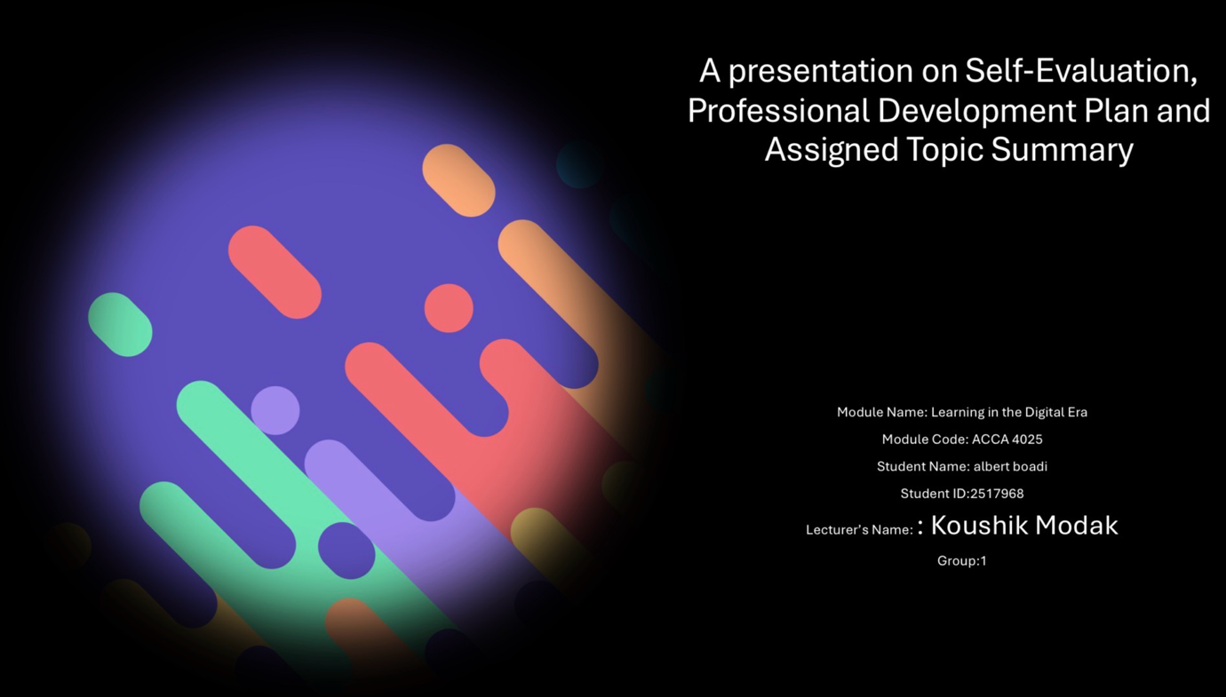

Slide 2 CONTENTS
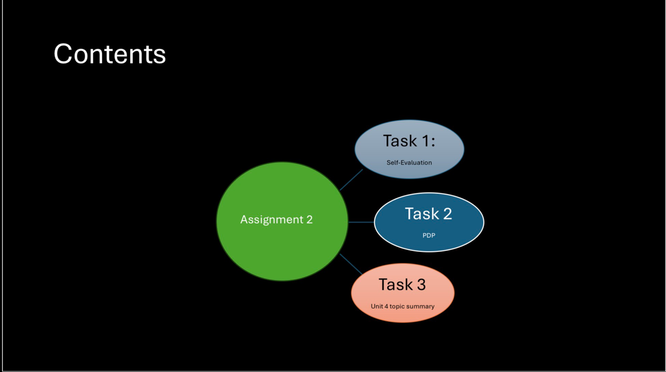

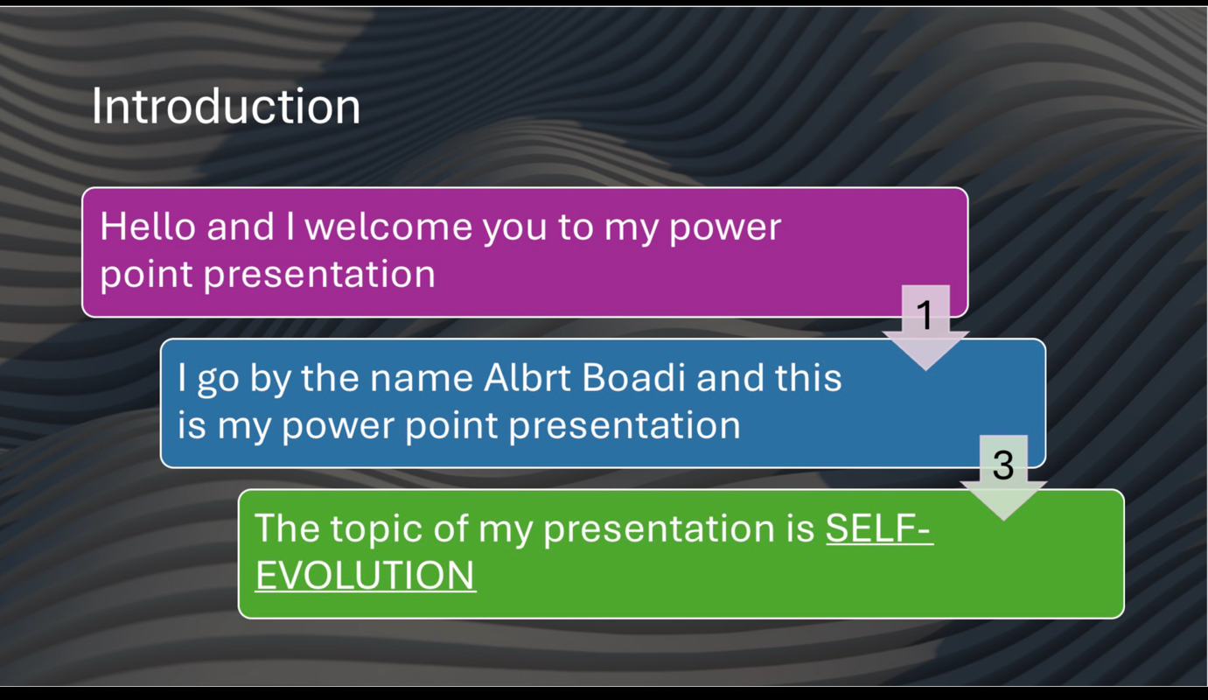
Slide 3 INTRODUCTION

Introduction
Hello everyone, and welcome to my presentation. My name is Albert Boadi, and today I will be discussing the topic of self-evaluation. This presentation will focus on reflecting on my personal strengths and weaknesses, the lessons I have learned from my experiences, and how self-reflection helps show areas for improvement and personal growth.

Slide 4: Main Body
Self-evolution is the continuous process of improving oneself through learning, self-reflection, and personal growth. In a rapidly changing world, developing skills, building confidence, and adapting to new challenges are essential for both personal and professional success. This presentation explores the concept of self-evolution, why it is important, and how individuals can actively work towards becoming better versions of themselves. By understanding self-evolution, we can make positive changes that lead to growth, resilience, and long-term success.

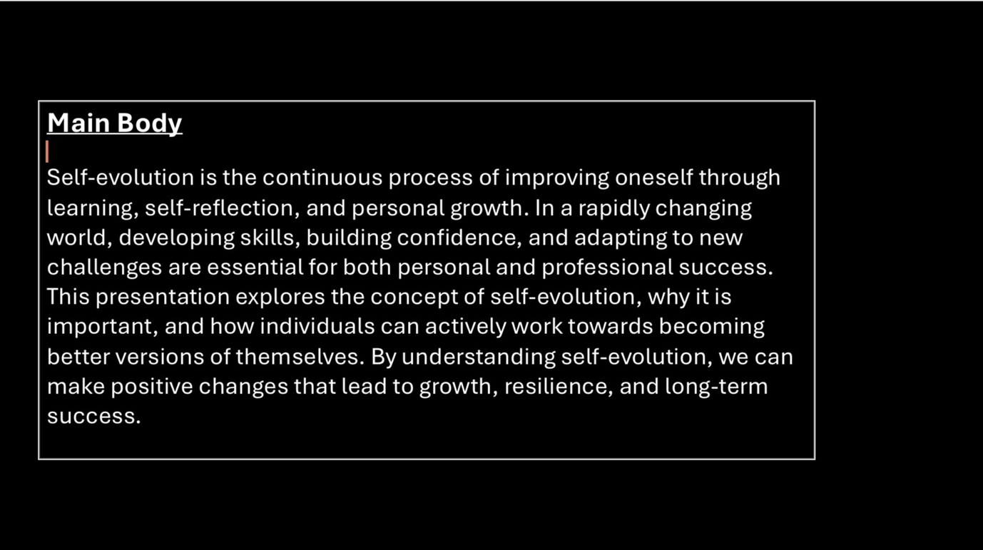
Slide 5 GIBB’s REFLECTIVE MODEL
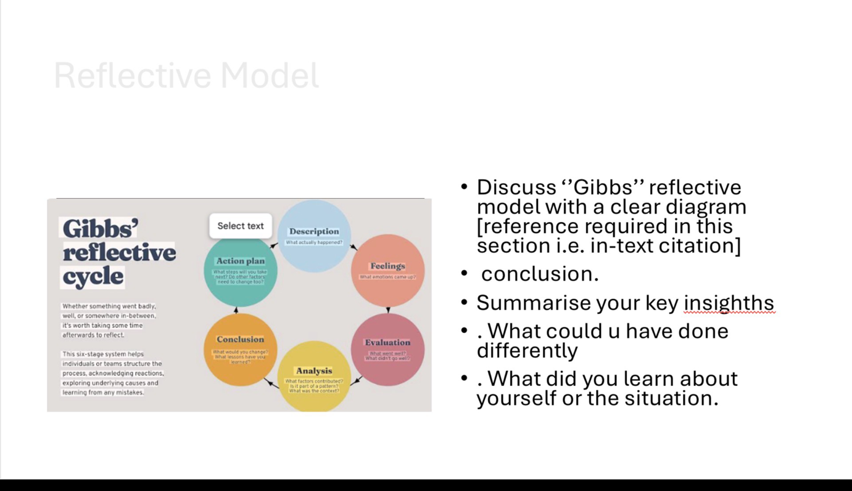
Brief explanation:
Gibbs’ Reflective Model is a structured framework that supports learning through reflection on experiences. It consists of six stages: Description (what happened), Feelings (thoughts and emotions), Evaluation (what went well or poorly), Analysis (why it happened), Conclusion (what could have been done differently), and Action Plan (how to improve in the future). This model helps individuals name key insights, understand their actions and reactions, recognise areas for improvement, and apply learning to future situations (Gibbs, 1988).

Slide 6 TASK 1: SELF EVALUATION
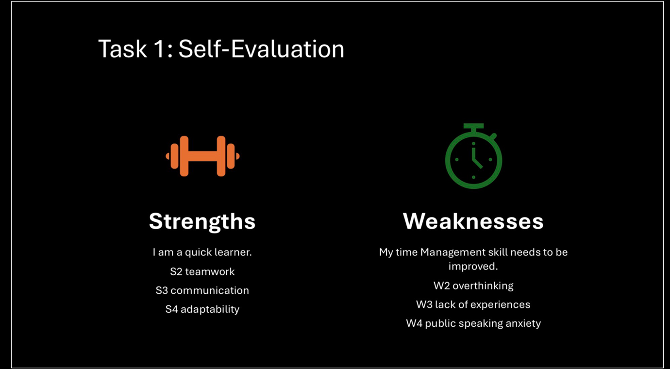

Brief explanation:
The individual is a quick learner with strong teamwork, communication, and adaptability skills, allowing them to work effectively with others and adjust to new situations. However, they need to improve time management, reduce overthinking, gain more experience, and build confidence in public speaking. Overall, the strengths show strong potential, while the weaknesses can be improved with practice and experience.

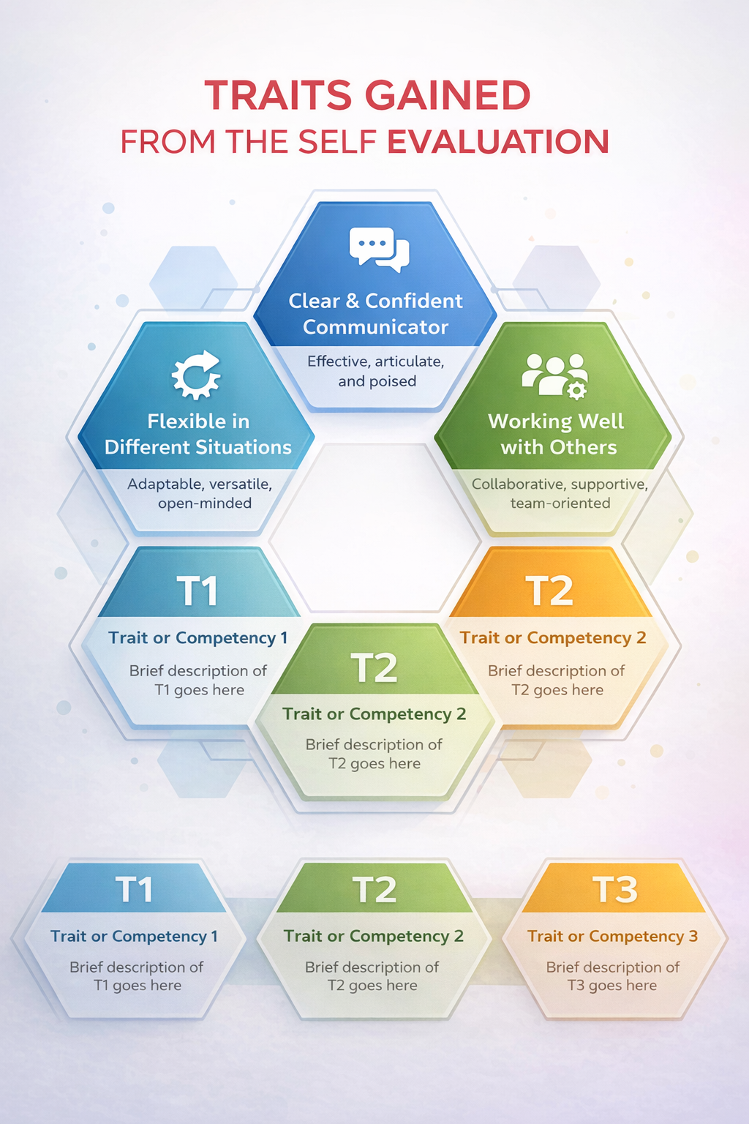
Slide 7 TRAITS GAINED FROM THE SELF EVALUATION

Brief explanation:
This image highlights key personal or professional skills using a visual hexagon layout. It emphasises strengths such as being a clear and confident communicator, working well with others, and being flexible in different situations. The sections labeled T1, T2, and T3 represent other traits or competencies, each intended to be briefly explained. Overall, the image presents a concise visual summary of important teamwork, communication, and adaptability skills.

Slide 8 PROFESSIONAL DEVELOPMENT PLAN
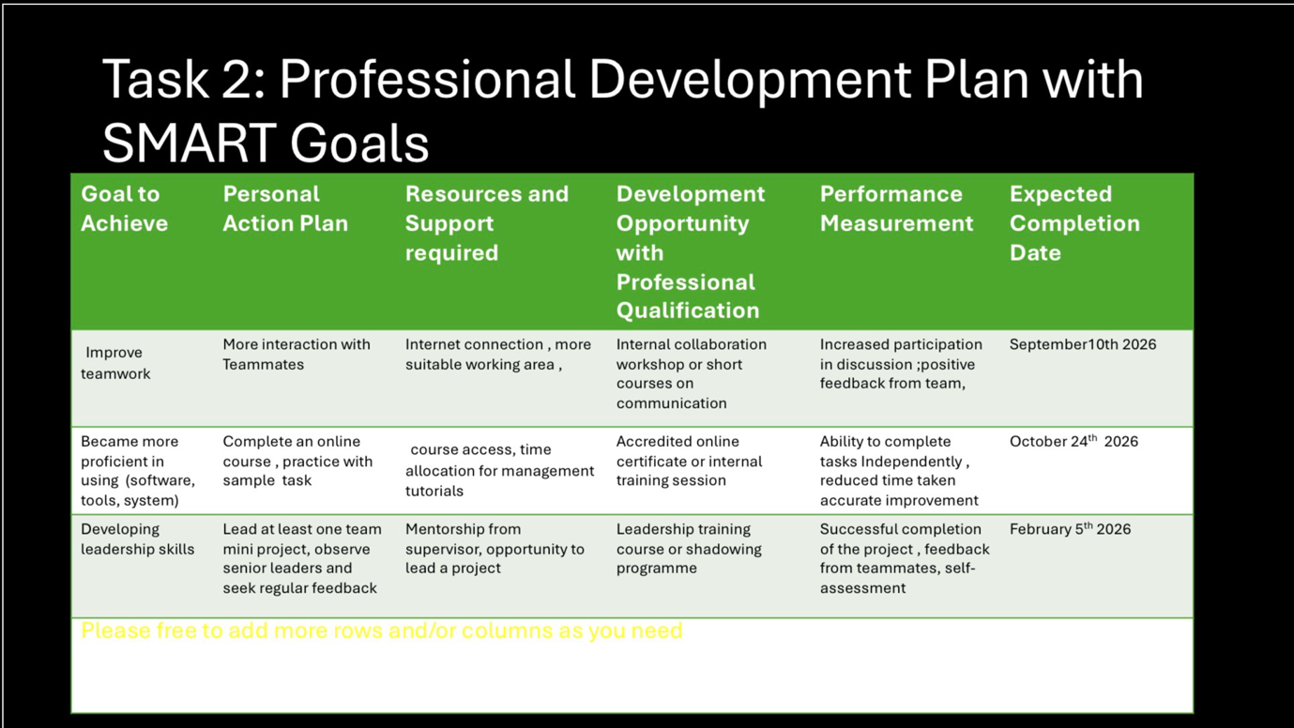

Brief explanation: The table outlines:
- Goals to achieve (e.g., improve teamwork, increase software ability, develop leadership skills)
- Personal action plans explaining what actions will be taken
- Resources and support needed to achieve each goal
- Development opportunities such as training, workshops, or certifications
- Performance measurements to evaluate success
- Expected completion dates to keep goals time-bound
Overall, it provides a clear, organised roadmap for professional growth by linking development activities to measurable outcomes and deadlines.

Slide 9 UNIT 4 TOPIC SUMMARY
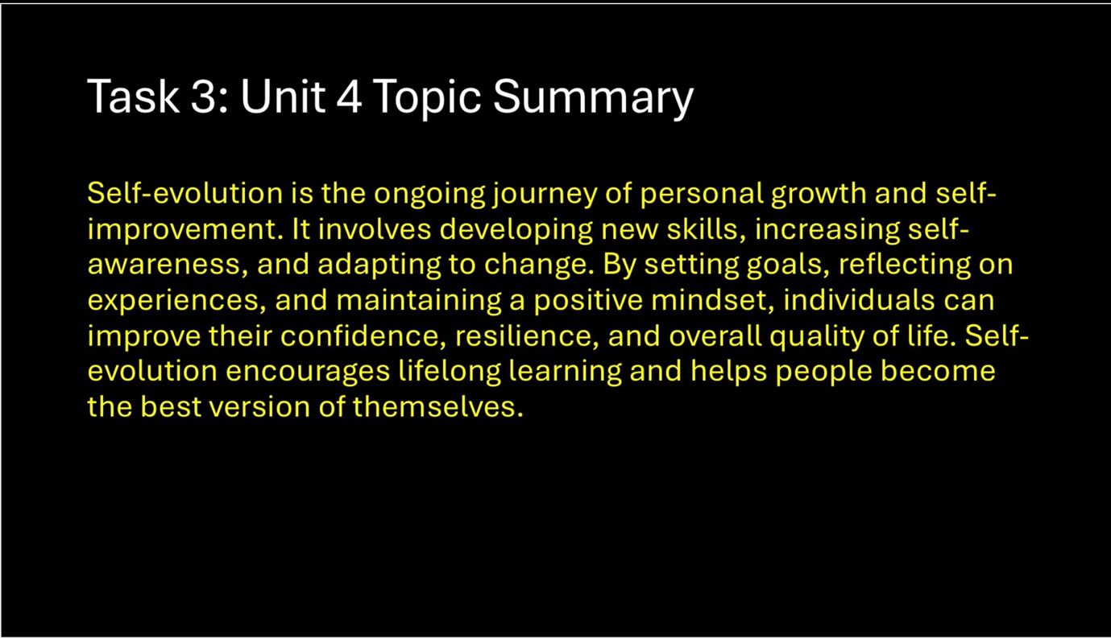

Brief explanation:
This image presents a Unit 4 topic summary focused on self-evolution. It explains that self-evolution is a continuous process of personal growth and self-improvement through developing skills, increasing self-awareness, and adapting to change. The summary highlights the importance of goal setting, reflection, and a positive mindset in building confidence, resilience, and overall quality of life, while encouraging lifelong learning and becoming the best version of oneself.

Slide 10 CONCLUSION

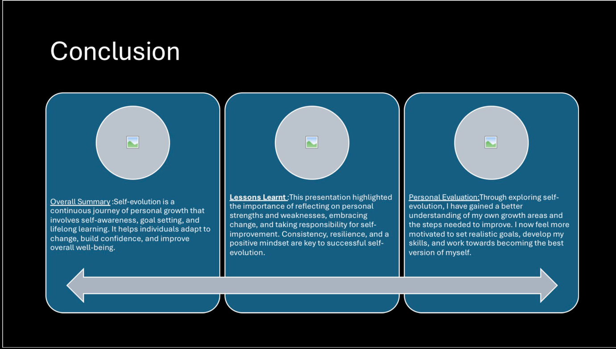

Brief explanation:
This is a brief explanation of three point I have put my conclusions into which are , Overall conclusion, lesson conclusion, and personal conclusion. Each of the ares have their own explanation and points.

Slide 11
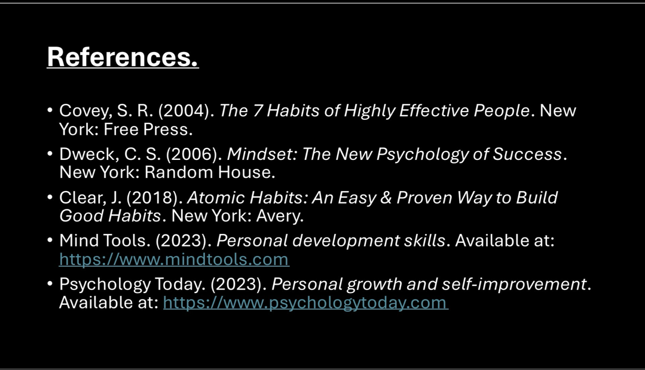

Conclusion
Self-evolution is the ongoing journey of personal growth and self-improvement. It involves developing new skills, increasing self-awareness, and adapting to change. By setting goals, reflecting on experiences, and keeping a positive mindset, individuals can improve their confidence, resilience, and overall quality of life. Self-evolution encourages lifelong learning and helps people become the best version of themselves.

References
- Covey, S. R. (2004). The 7 Habits of Highly Effective People. New York: Free Press.
- Deck, C. S. (2006). Mindset: The New Psychology of Success. New York: Random House.
- Clear, J. (2018). Atomic Habits: An Easy & Proven Way to Build Good Habits. New York: Avery.
- Mind Tools. (2023). Personal development skills. Available at: https://www.mindtools.com
- Psychology Today. (2023). Personal growth and self-improvement. Available at: https://www.psychologytoday.com

IEEE referencing style must be followed.
In-text citations need to be used in the slide as well as in brief explanation section in this report.

