


University of Wales Trinity Saint David – Swansea
B.Eng. Manufacturing Systems Engineering (Hons)
Dissertation
Martin Brophy (P151988)
May 2019
EVALUATION of additive AND SUBTRACTIVE manufacturing for the toolroom.

Could an additive manufacturing process be more cost and time effective than the existing subtractive (CNC) manufacturing process to produce functional engineering components in the Toolroom of Ford Bridgend Engine Plant?

Declaration of Authenticity
This thesis is the result of the author’s original research. It has been composed by the author and has not been previously submitted for examination which has led to the award of a degree.

Signed: Date:

Acknowledgements
I would firstly like to give a huge thanks to my project tutor Graham Howe for providing me with excellent support and guidance throughout the course of this project. His excellent knowledge and expertise gave me valuable insight that helped me steer my project in a positive direction.
A special thanks goes to Woody Darlington and Chris Austin at Mazak UK who hosted me on a visit to their manufacturing facility in Worcester. Their expertise at the cutting edge of hybrid additive manufacturing provided me with great insight to the benefits of the technology.
I would also like to thank all my colleagues at Ford Bridgend Engine Plant who helped me with my research and data collection. Particularly, I would like to thank Mark Thomas (Plant Engineering Manager) and Phil Moreton (Emerging Technologies Engineer) for all the help, support and guidance they provided to ensure my project was a success.
Finally, I would like to thank all my family for being so supportive over the course of this project. In particular, my father Peter Brophy, who was always on hand to provide extra insight to a problem; my wife Emma, who has been so supportive over the course of this degree; and my daughter Sadie, for being so understanding and providing me with my ultimate inspiration.

Abstract
This study aims to determine whether the introduction of an additive manufacturing (AM) process can be more efficient for producing components than the existing subtractive manufacturing (SM) method in the toolroom of Ford Bridgend Engine Plant (BEP). The existing SM process is firstly optimised using a value stream map (VSM) to identify and suggest improvements to make the process leaner. A suitable AM process is suggested for the toolroom according to analysis of data gathered over the previous year of work in the toolroom and data gathered on the numerous AM categories available on the market. A hybrid metal wire-arc AM (WAAM) process is suggested as most suitable for the toolroom as it scores highest according to a set of criteria which is considered relevant to the toolroom needs. Design for Additive Manufacturing (DfAM) is investigated as a method to reduce the lead time of AM which aims to reduce the volume of material whilst maintaining maximum stiffness of the structure. A topology optimisation (TO) study is used to optimise a component selected from the toolroom archive. The original and optimised parts are manufactured on an AM machine in Ford BEP to demonstrate how the DfAM process can improve lead time.
An ideal state VSM is constructed which includes the AM process. This shows that a significant reduction in lead time can be achieved by eliminating the reliance on external material suppliers, which accounts for a large proportion of lead time in the original VSM. The results reveal that the optimised SM and AM processes are more efficient than in their original conditions as lead time is improved.
Through comparison of the SM and AM processes in their optimised states, it is revealed that to achieve maximum efficiency, AM should be used if the batch quantity of parts is 3 or less whereas SM should be used if the quantity is 4 or more. The cost saving of implementing an AM process is calculated as £319,121 per annum due to a reduction of downtime. Considering this, the capital investment of a hybrid WAAM machine could be recovered within 13 months of purchase.
The study highlights that AM can be more beneficial than SM as material is used more efficiently and complex shapes can be constructed more readily. On the other hand, SM can achieve higher tolerances, finer surface finishes and increased dimensional stability. It is discovered that by combining AM and SM into a single hybrid workstation, the advantages of each process can be harnessed to provide a solution to many problems that exist in manufacturing.
Contents
1. Declaration of Authenticity 1
2. Acknowledgements 2
3. Abstract 3
4. List of Figures 7
5. List of Tables 9
6. Acronyms and Abbreviations 10
7. Project Plan 11
8. Introduction 13
8.1. Ford Motor Company 13
8.1.1. Bridgend Engine Plant (BEP) 14
8.1.2. The Toolroom 15
8.1.3. The CNC Milling Machines 18
8.2. Aims and Objectives of the Project 19
9. Literature Review 21
9.1. Lean Manufacturing 22
9.1.1. 5S 24
9.1.2. Value Stream Mapping 25
9.2. Additive Manufacturing 27
9.2.1. Hybrid Additive/Subtractive Manufacturing 30
9.2.2. Additive Manufacturing in Ford Motor Company 31
9.2.3. Design for Additive Manufacturing 32
10. Model and Methodology 33
Chapter 1: Optimisation of the Current Subtractive Manufacturing Process 34
11. Define 34
11.1. Project Charter 34
11.1.1. Problem Statement 34
11.1.2. Business Case 36
11.1.3. Project Charter Summary 37
11.2. Process Mapping 38
11.2.1. High Level Process Map (SIPOC) 38
11.2.2. Process Map 39
11.3. Project Scope 40
12. Measure 41
12.1. Data Collection Plan 41
12.1.1. Data Collection Form 1 42
12.1.2. Selecting a Product Family for VSM 44
12.1.3. Selecting a Component for VSM 45
12.1.4. AJ supercharger end-effector RH clamp jaw 46
12.1.5. Data Collection Form 2 47
13. Analyse 48
13.1. Current state Value Stream Map 48
13.2. Pareto Analysis of Process Steps 50
14. Improve 51
14.1. Future State Value Stream Map 51
Chapter 2: Additive Manufacturing Process Selection 54
15. Pareto Analysis of Toolroom CNC Archive Data 56
15.1. Identification of Waste Material Removal 59
16. Additive Manufacturing Considerations 60
16.1. AM Production Rate Comparison 60
16.2. AM Capital Cost Comparison 60
16.3. AM Material Utilisation Fraction Comparison 61
17. Additive Manufacturing Process Selection 62
17.1. Powder Bed Fusion Capabilities and Limitations 63
17.2. Hybrid Additive/Subtractive Manufacturing (Hybrid AM) 64
17.2.1. Hybrid AM Capabilities and Limitations 64
17.2.2. Hybrid AM Machines 65
17.3. AM Process Selection Considerations 67
17.4. AM Process Selection Results 68
Chapter 3: Optimisation of the Additive Manufacturing Process 70
18. Design for Additive Manufacturing (DfAM) 70
18.1. Topology Optimisation Study 70
18.2. Additive Manufacturing of Original and Optimised Parts 74
19. Chapter 4: Analysis of Results and Discussion 76
19.1. Ideal State VSM Construction 76
19.2. SM and AM Results Comparison 76
19.3. Optimised Results Comparison 78
19.4. Cost Analysis 79
19.5. Management of Change 80
Chapter 5: Conclusions and Recommendations 82
20. Conclusions 82
21. Recommendations 84
21.1. Short Term (0-3 months) 84
21.2. Medium Term (3-6 months) 84
21.3. Long Term (6+ months) 84
22. References 85
23. Appendices 92
23.1. Current State and Future State VSM examples 93
23.2. Ford Production Cost Data 94
23.3. Change Management Models 95
23.3.1. Kurt Lewin’s 3 Step Model for Change 95
23.3.2. Kotter’s 8 Step Model for Change 96
23.4. AM Process Categories 98
23.4.1. Binder Jetting 98
23.4.2. Directed Energy Deposition 99
23.4.3. Material Extrusion 100
23.4.4. Material Jetting 101
23.4.5. Powder Bed Fusion 102
23.4.6. Sheet Lamination 103
23.4.7. Vat Photopolymerisation 104
23.5. WAAM Suitability Scale (The British Standards Institution, 2019) 105
23.6. Print Results for Original and Optimised parts 106
23.7. Infill Density Settings 107

List of Figures
Figure 1 – Chart of hours assigned to each week 12
Figure 2 – Chart of hours assigned to each project task 12
Figure 3 – Ford logos from time of formation to present (Ford Motor Company, 2018) 13
Figure 4 – Bridgend Engine Plant Site (Ford Motor Company, 2018) 14
Figure 5 – The Ford BEP Toolroom 15
Figure 6 – Toolroom material stores area 16
Figure 7 – Toolroom layout 17
Figure 8 – Devlieg V4 CNC Machining Centre 18
Figure 9 – Devlieg V5 CNC Machining Centre 18
Figure 10 – 8 wastes of lean manufacturing (goleansixsigma.com) 22
Figure 11 – Five Step Lean Process (Lean Enterprise Institute, 2018) 23
Figure 12 – The 5S steps (5stoday.com) 24
Figure 13 – Material and information flow symbols (Thomas, 2018) 26
Figure 14 – Industrial metal AM sales rise ( from Wohlers report 2018) (Additive Manufacturing, 2018) 28
Figure 15 - Gartner's Hype Cycle for 3D printing (Shanler & Basiliere, 2017) 28
Figure 16 – Ford Global Rapid Manufacturing Centres (Ford Motor Company, 2018) 31
Figure 17 – Example topological design with minimum overhang angle of 45.11 degrees (Liu, et al., 2018) 32
Figure 18 – DMAIC process steps (Berardinelli, 2012) 33
Figure 19 – CNC Lead-time breakdown for various batch quantities (example) 35
Figure 20 – Project charter summary 37
Figure 21 – CNC milling operation process map 39
Figure 22 – Cause and effect diagram 40
Figure 23 – Archived CNC work 42
Figure 24 – AJ supercharger end-effector RH clamp jaw 45
Figure 25 – CNC machined component 45
Figure 26 – Component fixed to lifting frame on production line 46
Figure 27 – Component in operation on production line 46
Figure 28 – Current state VSM 49
Figure 29 – Pareto chart of process steps 50
Figure 30 – Future state VSM 53
Figure 31 – Pareto chart of component quantities 56
Figure 32 – Example component showing material removal 57
Figure 33 – Pareto chart of finished part material volume 57
Figure 34 – Pareto chart of material by priority 58
Figure 35 – Pareto chart of high priority work 58
Figure 36 – Pareto chart of material removal on CNC 59
Figure 37 – Production rate comparison of AM processes (CES Edupack, 2018) 60
Figure 38 – Capital cost comparison of AM processes (CES Edupack, 2018) 61
Figure 39 – Matl. utilisation fraction comparison of AM processes (CES Edupack, 2018) 61
Figure 40 – Relative energy use, speed and resolution of fabrication in different AM processes (Tofail, et al., 2018) 62
Figure 41 – PBF warpage 63
Figure 42 – ELB-Schliffe millGrind Hybrid AM DED (elb-schliffe.de) 65
Figure 43 – Variaxis j600AM Hybrid Wire-Arc AM (mazak.com) 66
Figure 44 – Mazak INTEGREX i-400 AM (Mazak, 2018) 66
Figure 45 – Bathtub curve (Ahmad & Kamaruddin, 2012) 68
Figure 46 – Chart of suitable AM processes 69
Figure 47 – (a) original design (b) with load and fixtures applied 71
Figure 48 – (a) topology optimisation results (b) finite element mesh 71
Figure 49 – Geometric interpretation of the topology study 72
Figure 50 – Von mises stress analysis before and after optimisation 72
Figure 51 – Mass of original and optimised designs 73
Figure 52 – AM of parts using FDM machine in Ford BEP 74
Figure 53 – (a) Original and (b) optimised parts produced using FDM AM process 75
Figure 54 – Chart of build time at various infill settings 75
Figure 55 – Ideal state VSM 77
Figure 56 – Chart of lead time to completion for various batch quantities 78
Figure 57 – Chart of optimised SM and AM processes for various part quantities 79
Figure 58 – Current state VSM example (Chen, et al., 2010) 93
Figure 59 – Future state VSM example (Chen, et al., 2010) 93
Figure 60 – Binder jetting process basic schematic (CES Edupack, 2018) 98
Figure 61 – Directed energy deposition process basic schematic (CES Edupack, 2018) 99
Figure 62 – Material extrusion process basic schematic (CES Edupack, 2018) 100
Figure 63 – Material jetting process basic schematic (CES Edupack, 2018) 101
Figure 64 – Basic schematic of powder bed fusion process using SLS or DMLS method (CES Edupack, 2018) 102
Figure 65 – Sheet lamination process using LOM method 103
Figure 66 – Basic schematic of vat photopolymerisation process using SLA method (CES Edupack, 2018) 104
Figure 67 – Infill density (all3dp.com) 107

List of Tables
Table 1 – Allocation of study hours to project tasks 11
Table 2 – Aims and Objectives Summary 20
Table 3 – Literature review summary 21
Table 4 – VSM symbols (Thomas, 2018) 26
Table 5 – High level process map (SIPOC) 38
Table 6 – Data collection plan 41
Table 7 – Data collection form 1 (archived component drawings) 43
Table 8 – Selecting a product family (Rother, 2009) 44
Table 9 – Data collection form 2 (CNC manufacturing process data) 47
Table 10 – Summary of AM Process Categories (Eyers & Potter, 2017) 55
Table 11 – Hybrid AM deposition processes (Merklein, et al., 2016) 64
Table 12 – AM process selection using significant criteria for toolroom application 69
Table 13 – AM Process selection results 69
Table 14 – Stiffness-to-weight ratio calculations 73
Table 15 – Comparison of TO results of original and optimised designs 73
Table 16 – Print time results 74

Acronyms and Abbreviations
3DP | 3D Printing
AM | Additive Manufacturing
BEP | Bridgend Engine Plant
BJ | Binder Jetting
C/O | Changeover Time
C/T | Cycle Time
CAE | Computer Aided Engineering
CNC | Computer Numerical Control
DDM | Direct Digital Manufacturing
DED | Directed Energy Deposition
DfAM | Design for Additive Manufacturing
FDM | Fused Deposition Modelling
FE | Finite Element
FPS | Ford Production System
GMAW | Gas Metal Arc Welding
GTAW | Gas Tungsten Arc Welding
ISO | International Organisation for Standardisation
JIT | Just-In-Time
L/T | Lead Time
LBM | Laser Beam Melting
LMD | Laser Metal Deposition
LPF | Laser Powder Forming
ME | Material Extrusion
MJ | Material Jetting
MJF | Multi Jet Fusion
MRF | Maintenance Request Form
NVA | Non-Value Added
PAG | Premier Automotive Group
PAW | Plasma Arc Welding
PBF | Powder Bed Fusion
SL | Sheet Lamination
SLM | Selective Laser Melting
SLS | Selective Laser Sintering
SM | Subtractive Machining
STL | Stereolithography
TO | Topology Optimisation
TPM | Total Productive Maintenance
TPS | Toyota Production System
VA | Value Added
VP | Vat Photopolymerisation
VSM | Value Stream Mapping
WAAM | Wire-Arc Additive Manufacturing

Project Plan
A study plan has been set out to ensure enough hours are allocated to complete each task of the project. Table 1 has been constructed to ensure that the workload is organised in a way so that the project is achievable within the overall time frame (Maylor, 2010).
Data from this table has been plotted to charts to assist in planning of the workload. This ensures that the project plan is carefully balanced to distribute the workload evenly. For example, in Figure 1, the workload has been reduced in January due to interference with other commitments of the author. Similarly, in Figure 2, more time has been allocated to the literature review and data collection, whereas less has been allocated to the problem statement, ensuring that each task is sufficiently resourced. The total workload that has been allocated to the project is 385 hours.
Table 1 – Allocation of study hours to project tasks
 | Project proposal | Interim viva | Literature review | Introduction | Problem statement | Aims and objectives | Process mapping | Project scope | Data collection | Current VSM | Graphical data analysis | AM process selection | Future VSM | AM implementation plan | Design for AM | Discussion | Conclusions | Recommendations | Final edit and hand in | Final oral examination | Workload
07-Nov-18 | 6 |  | 2 |  |  |  |  |  |  |  |  |  |  |  |  |  |  |  |  |  | 8
14-Nov-18 | 6 |  | 2 |  |  |  |  |  | 2 |  |  |  |  |  |  |  |  |  |  |  | 10
21-Nov-18 | 10 |  | 2 |  |  |  |  |  | 2 |  |  |  |  |  |  |  |  |  |  |  | 14
28-Nov-18 |  | 6 | 6 |  |  |  |  |  | 2 |  |  |  |  |  |  |  |  |  |  |  | 14
05-Dec-18 |  | 6 | 6 |  |  |  |  |  | 2 |  |  |  |  |  |  |  |  |  |  |  | 14
12-Dec-18 |  | 10 | 6 |  |  |  |  |  | 2 |  |  |  |  |  |  |  |  |  |  |  | 18
19-Dec-18 |  |  | 6 |  | 3 | 5 |  |  | 2 |  |  |  |  |  |  |  |  |  |  |  | 16
26-Dec-18 |  |  | 2 |  | 3 | 5 |  |  | 2 |  |  |  |  |  |  |  |  |  |  |  | 12
02-Jan-19 |  |  | 6 |  | 3 | 2 |  |  | 2 |  |  |  |  |  |  |  |  |  |  |  | 13
09-Jan-19 |  |  |  | 3 |  |  | 5 |  | 2 |  |  |  |  |  |  |  |  |  |  |  | 10
16-Jan-19 |  |  |  | 3 |  |  | 5 |  | 2 |  |  |  |  |  |  |  |  |  |  |  | 10
23-Jan-19 |  |  |  | 3 |  |  | 5 |  | 2 |  |  |  |  |  |  |  |  |  |  |  | 10
30-Jan-19 |  |  |  | 5 |  |  | 2 |  | 2 |  |  |  |  |  |  |  |  |  |  |  | 9
06-Feb-19 |  |  |  |  |  |  |  | 6 | 2 | 3 |  |  |  | 3 | 3 |  |  |  |  |  | 17
13-Feb-19 |  |  |  |  |  |  |  | 6 | 2 | 3 |  |  |  | 3 | 3 |  |  |  |  |  | 17
20-Feb-19 |  |  |  |  |  |  |  |  | 2 | 8 |  |  |  | 3 | 3 |  |  |  |  |  | 16
27-Feb-19 |  |  |  |  |  |  |  |  | 2 | 8 |  |  |  | 3 | 3 |  |  |  |  |  | 16
06-Mar-19 |  |  |  |  |  |  |  |  |  |  | 4 | 2 | 6 | 3 | 3 |  |  |  |  |  | 18
13-Mar-19 |  |  |  |  |  |  |  |  |  |  | 6 | 4 | 3 | 3 | 3 | 3 |  |  |  |  | 22
20-Mar-19 |  |  |  |  |  |  |  |  |  |  | 6 | 4 | 3 | 1 | 3 | 4 |  |  |  |  | 21
27-Mar-19 |  |  |  |  |  |  |  |  |  |  |  | 4 | 6 | 3 | 3 | 6 |  |  |  |  | 22
03-Apr-19 |  |  |  |  |  |  |  |  |  |  |  |  |  |  |  | 10 | 6 | 2 |  |  | 18
10-Apr-19 |  |  |  |  |  |  |  |  |  |  |  |  |  |  |  |  | 10 | 6 | 4 |  | 20
17-Apr-19 |  |  |  |  |  |  |  |  |  |  |  |  |  |  |  |  |  | 10 | 6 | 4 | 20
24-Apr-19 |  |  |  |  |  |  |  |  |  |  |  |  |  |  |  |  |  |  | 10 | 10 | 20
Task hours | 22 | 22 | 38 | 14 | 9 | 12 | 17 | 12 | 32 | 22 | 16 | 14 | 18 | 22 | 24 | 23 | 16 | 18 | 20 | 14 | 385
Figure 1 – Chart of hours assigned to each week
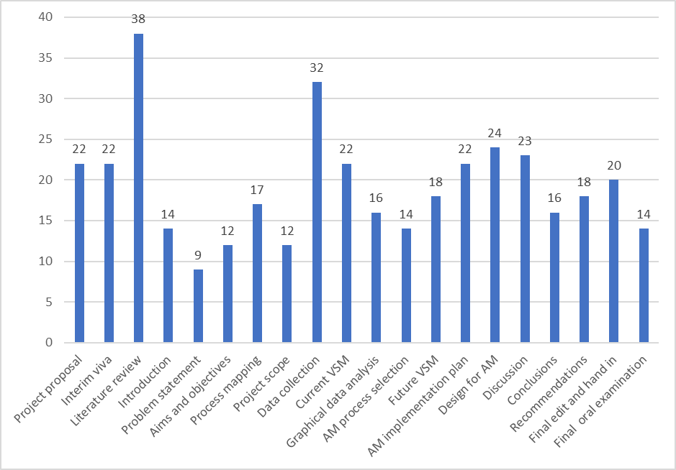
Figure 2 – Chart of hours assigned to each project task
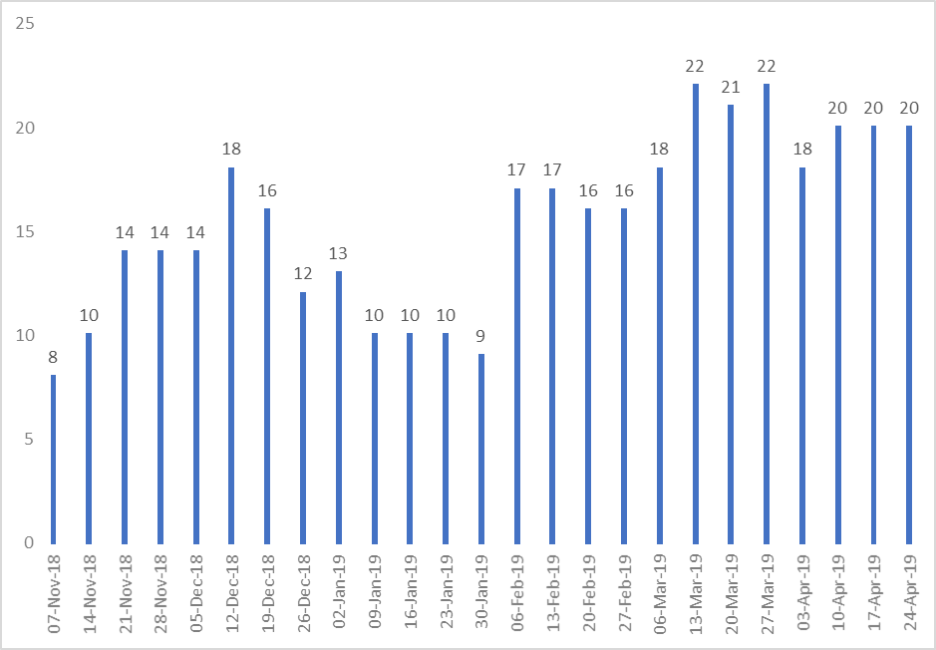

Introduction
The subject of this dissertation will be conducted within the toolroom of Ford engine plant in Bridgend. In this section, an introduction will be given to Ford Motor Company and the operation of the toolroom within the engine plant.

Ford Motor Company
Ford Motor Company is a multinational automobile manufacturer that is headquartered in Dearborn, Michigan (Ford Motor Company, 2018). The company was founded by Henry Ford in 1903. Ford was the third largest automotive manufacturer worldwide in 2017 with 6.5% of market share, behind Toyota (9.2%) and Volkswagen (7.2%) (statista, 2018).
Figure 3 – Ford logos from time of formation to present (Ford Motor Company, 2018)
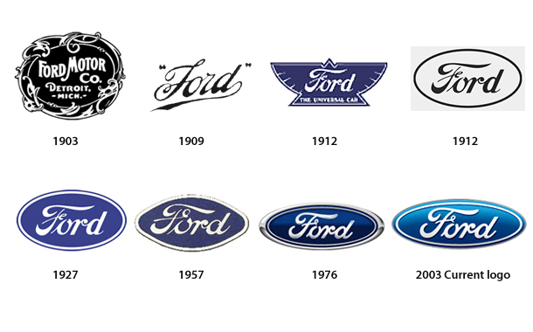
In 1995, Ford initiated the Ford Production System (FPS) which aimed to transform Ford from a mass production system to a lean production system. The FPS model uses a continuous improvement model to standardise the production process. The model aims to achieve this by stabilising the inputs, normalising the processes, and seeking change (if necessary) for the outputs (Ford Motor Company, 2018).
Previously, Ford has owned other automotive brands including Aston Martin, Jaguar, Volvo and Land Rover (Ford Motor Company, 2019). However, the ‘One Ford’ initiative introduced in 2007 reduced the vehicle portfolio to concentrate the focus on Ford branded vehicles after near collapse of the world markets (Woodall, 2012). Following this initiative, the company slogan was changed from ‘Feel the Difference’ to ‘Go Further’ to highlight that confidence in recovery was nearing completion.

Bridgend Engine Plant (BEP)
Ford Bridgend Engine Plant (BEP) was opened in 1980 and is one of Ford’s principal engine manufacturing plants in Europe (Ford Motor Company, 2018). In 1992, BEP started to manufacture 4.0 and 4.2 litre normally aspirated and supercharged engines for Jaguar after Ford took ownership of the company. In March 2001, BEP began production of new V8 and SI6 (in-line 6) engines for Premier Automotive Group (PAG), which were destined for Ford’s more prestigious Jaguar, Land Rover and Volvo models. The engines currently produced at BEP include:
- 1.6 L I4 EcoBoost Sigma Engine for Ford
- 1.5 L I3 Dragon Engine for Ford
- 5.0 L V8 AJ133 Petrol Engine for Jaguar/Land Rover, and
- 3.0 L V6 AJ126 Petrol Engine for Jaguar/Land Rover
Figure 4 shows the site of the plant which covers an area of 141,702 m² (Ford Motor Company, 2018). The plant specialises in the production of petrol engines which power vehicles such as the Focus and Fiesta. In 2015, production volumes were 750,000 engines per annum. However, this figure is expected to fall to between 125,000 and 250,000 units by 2020 as the Jaguar/Land Rover contract comes to an end, and the Sigma engine is phased out.
Figure 4 – Bridgend Engine Plant Site (Ford Motor Company, 2018)
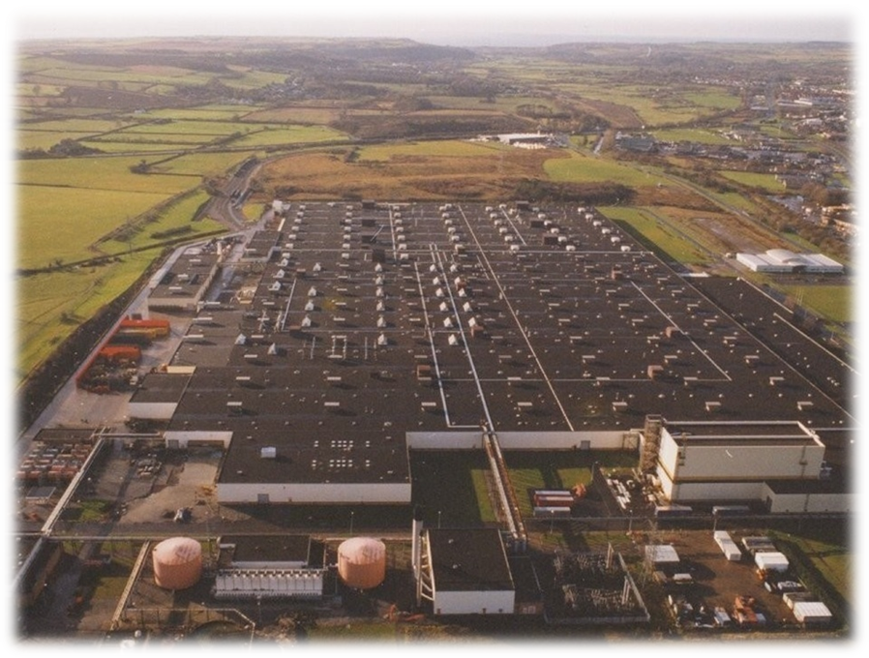

The Toolroom
The toolroom (see Figure 5) is a skilled manufacturing department within BEP in which toolmakers craft engineering components from raw materials using toolroom machinery. Within the toolroom there are currently 14 employees operating on a 4-shift 156-hour-monthly work pattern.
Figure 5 – The Ford BEP Toolroom
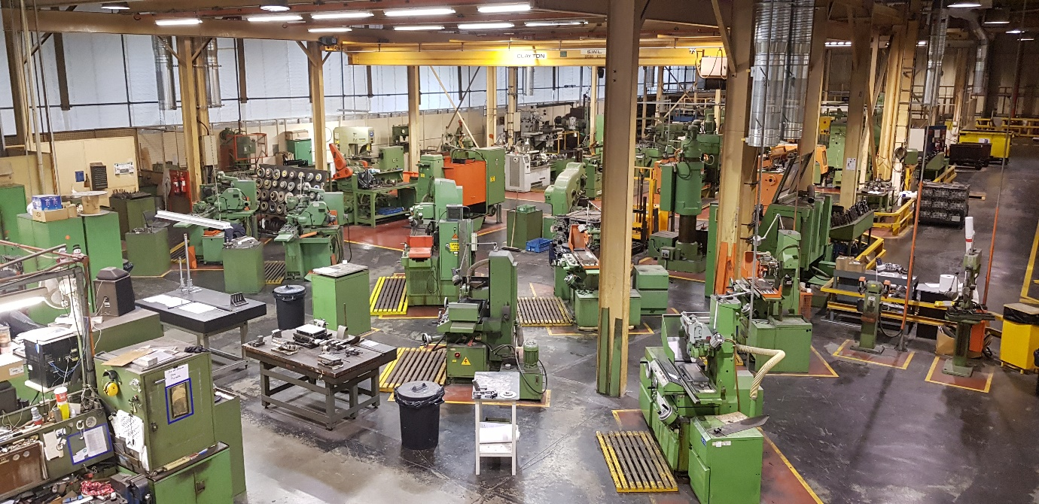
The toolroom contains the following machinery on which components are manufactured:
- Manual lathe (x5)
- Manual milling machine (x3)
- CNC lathe (x2)
- CNC milling machine (x2)
- Cylindrical grinder (x3)
- Surface grinder (x4)
- Slotting machine (x1)
- Gear hobbing machine (x1)
- Jig boring machine (x2)
There are two heat treatment furnaces and one tempering furnace that are used for heat treatment of components if any hardness is required.
Work is submitted to the toolroom by completing a maintenance request form (MRF) via the Maximo work ordering system which requires an engineering drawing to be attached to the MRF. Upon receipt of the MRF, the foreman of the toolroom department delegates the work to an available toolmaker. The foreman must prioritise the work depending on the priority specified on the MRF. For example, if a job is required to repair a breakdown of machinery on production it is high priority (3), if a breakdown is imminent but no spare parts are available it is a medium priority (2), and spare parts for routine maintenance are low priority (1).
When a toolmaker receives a job, the appropriate material must be acquired to commence manufacture of the part. Typical materials used in the toolroom include mild steel, tool steel, nylon, brass and phosphor bronze. The toolroom stores area (see Figure 6) contains a limited inventory of materials of various sizes. However, due to the variable nature of work that is received by the toolroom, materials often need to be ordered from an external supplier before manufacturing can begin.
Figure 6 – Toolroom material stores area
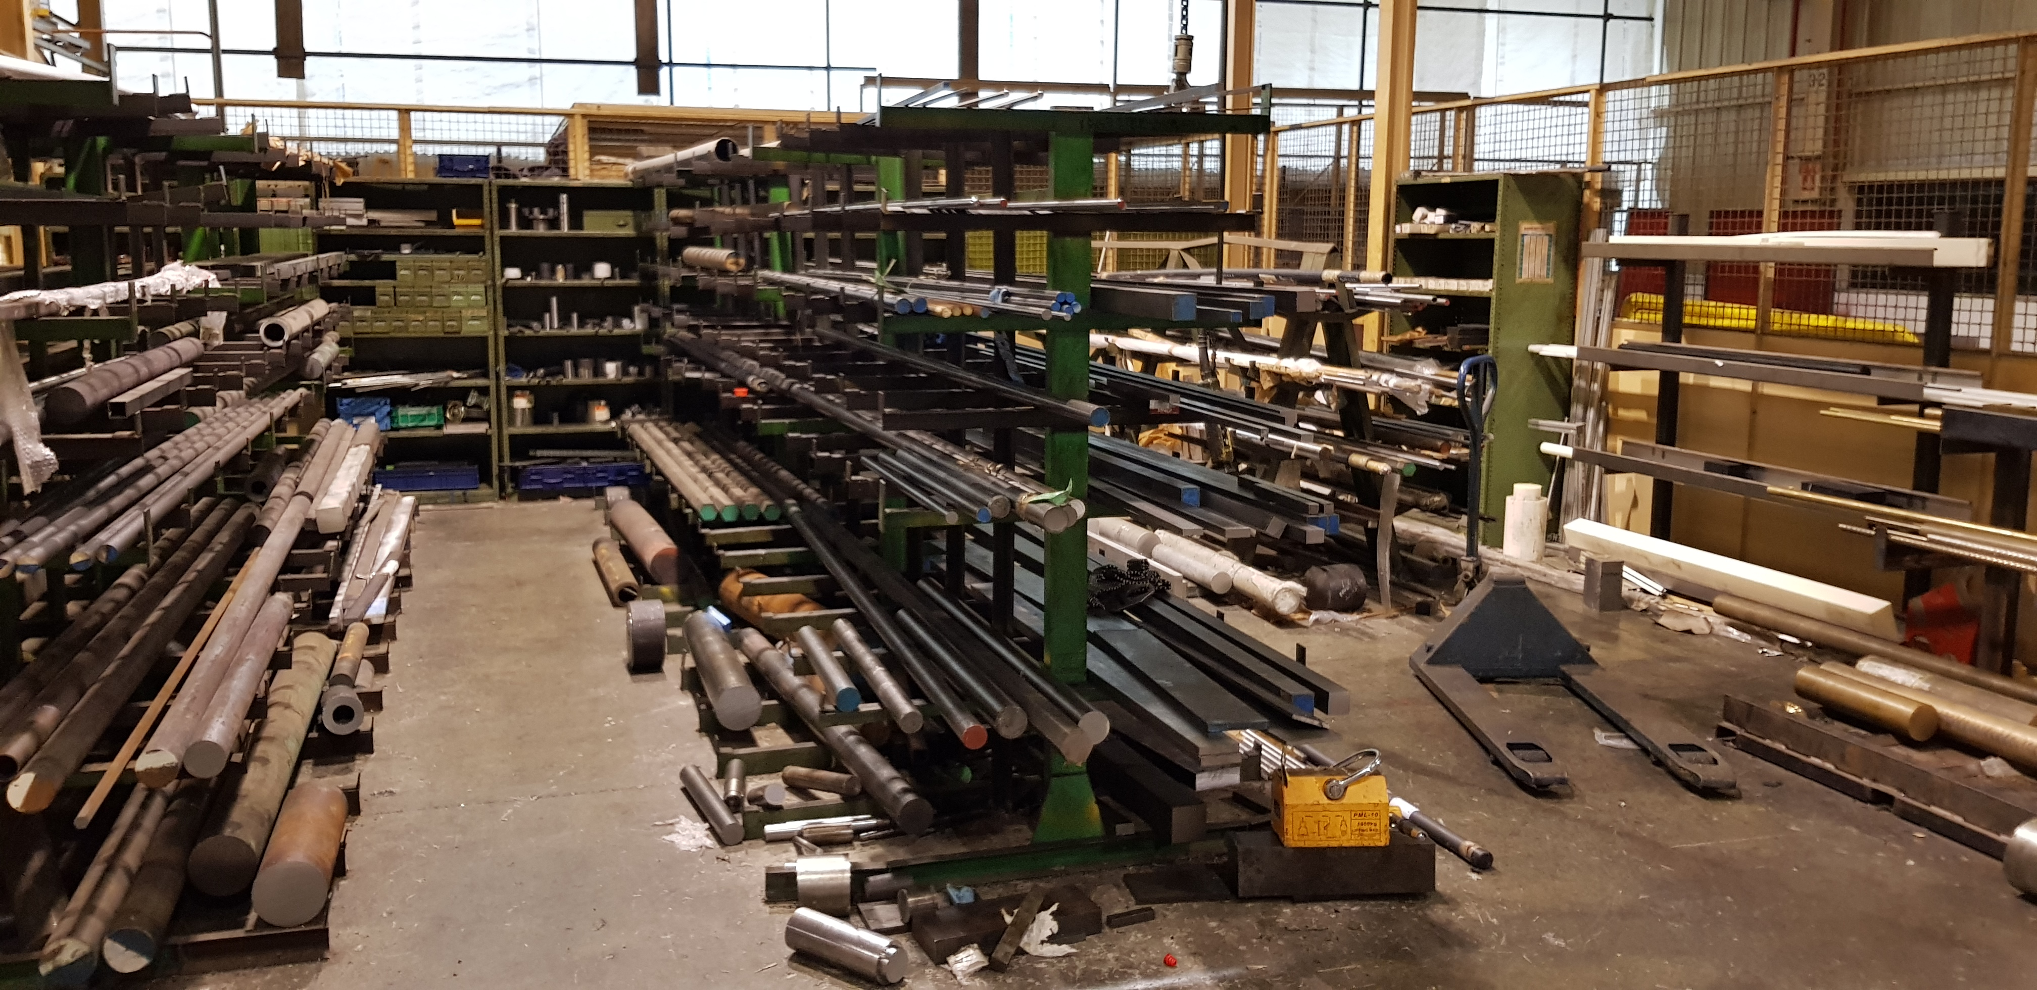
Figure 7 illustrates the layout of the toolroom. The marked aisles which are wide enough for vehicles are shown in yellow. There are four overhead gantry cranes that cover the machining areas of the toolroom. These are used to assist the lifting of heavy equipment during workpiece setups and during work holding changeovers.
Figure 7 – Toolroom layout
= Overhead gantry crane areas

The CNC Milling Machines
In the toolroom, there are two CNC milling machines – a Devlieg V4 (see Figure 8) and Devlieg V5 (see Figure 9). The V4 has a smaller bed with 500 x 400mm of travel in the x and y axes whereas the V5 is larger with 1000 x 500mm of travel in the x and y axes. Additionally, the V5 has an attachment that adds a 4th and 5th axis which adds more flexibility for machining complex parts.
Figure 8 – Devlieg V4 CNC Machining Centre
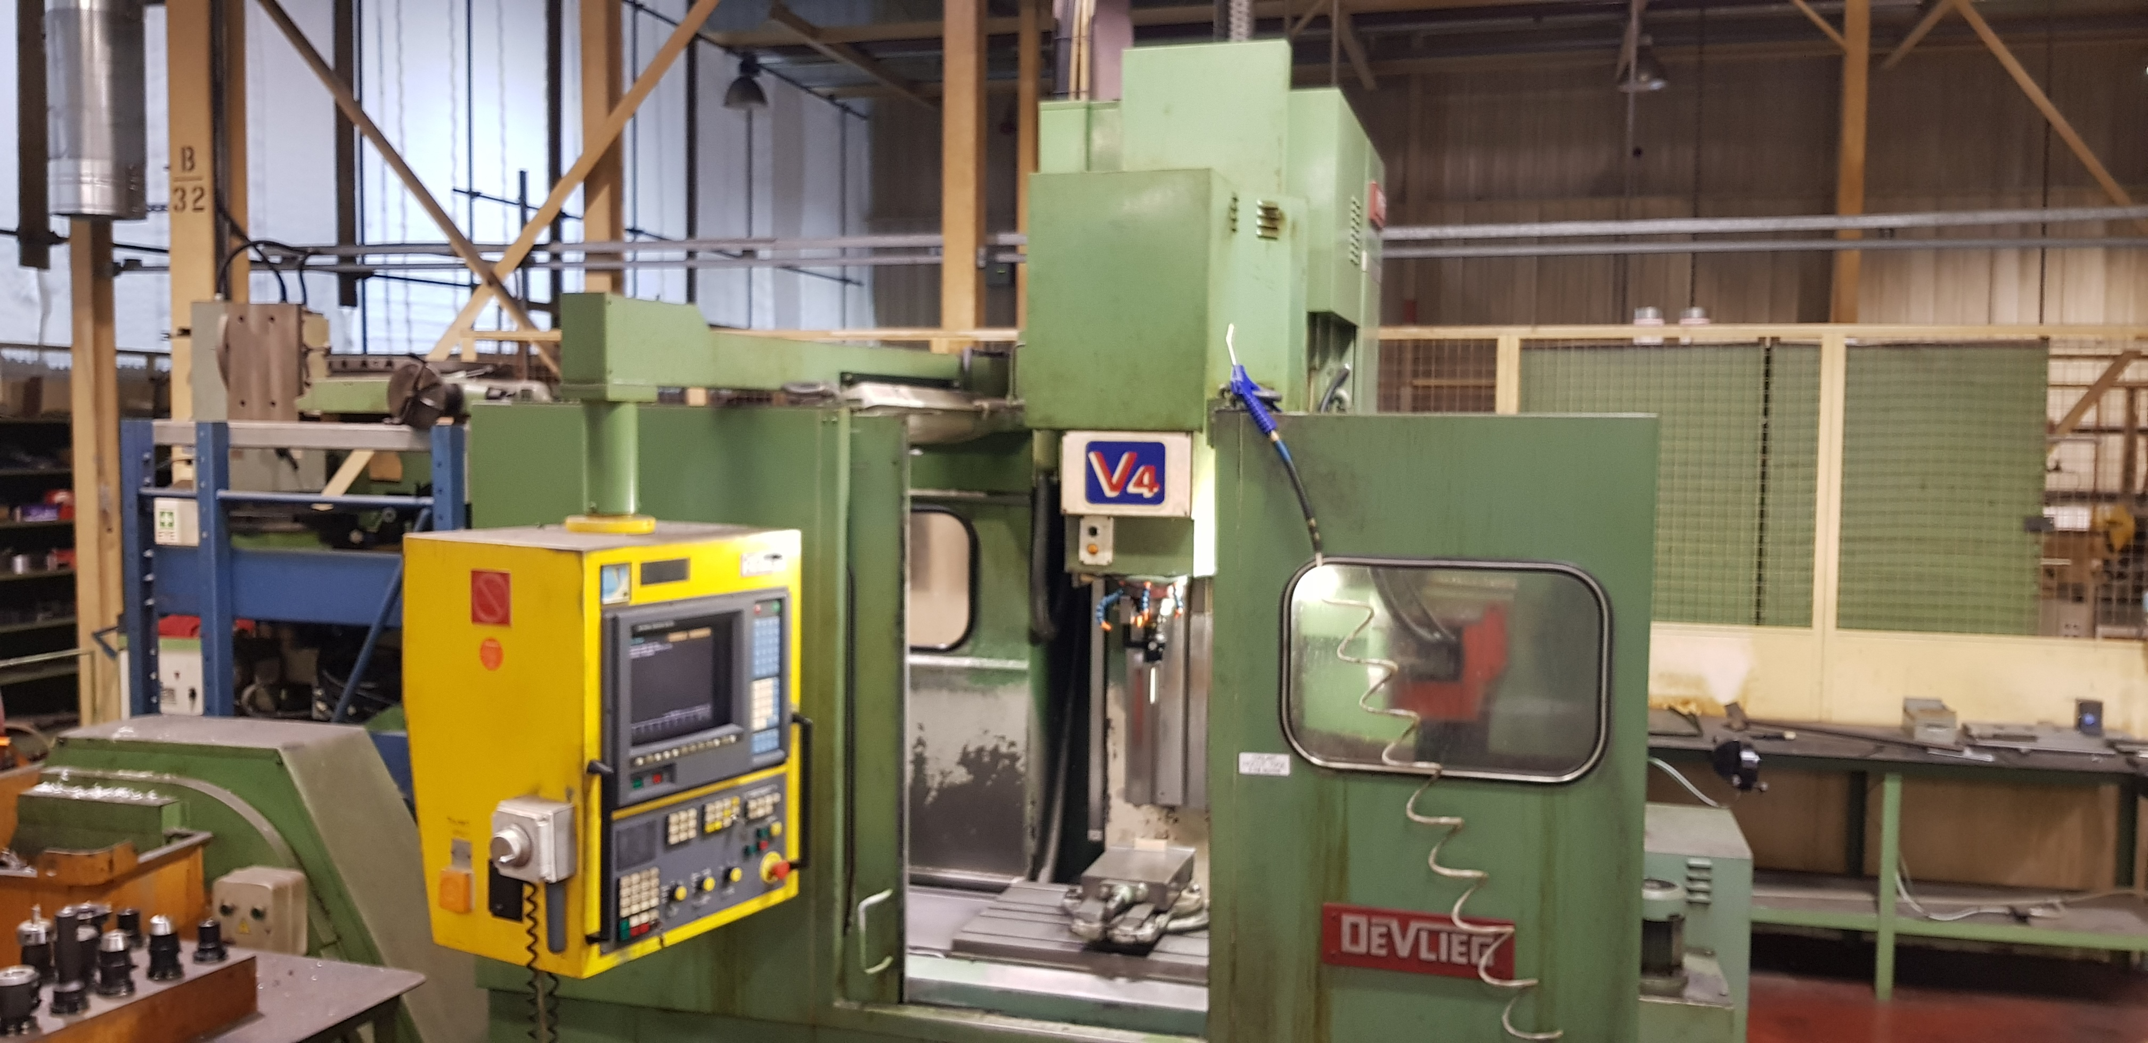
Figure 9 – Devlieg V5 CNC Machining Centre
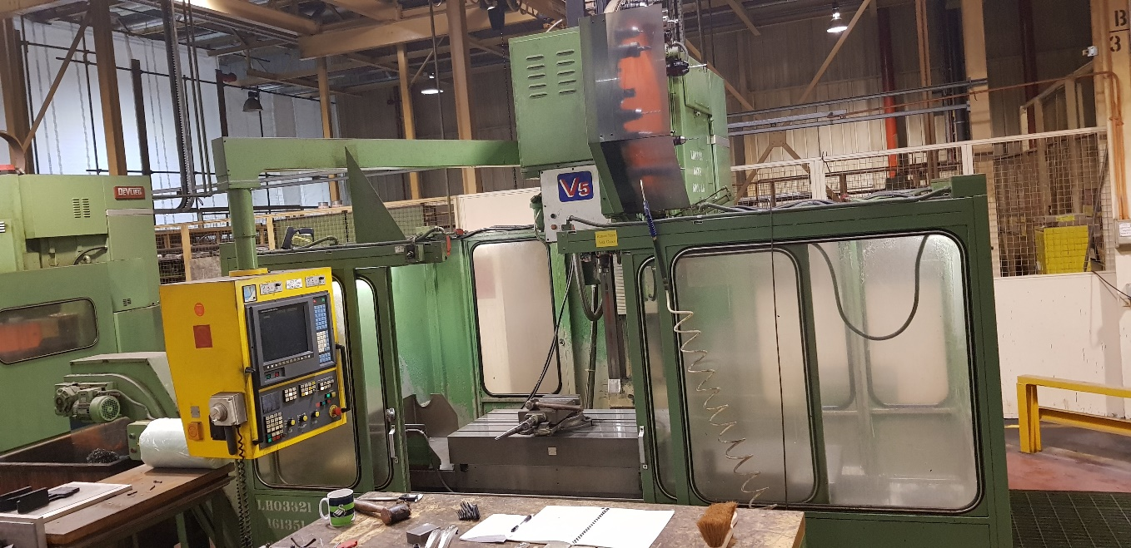

Aims and Objectives of the Project
The main aim of this project is to determine if additive manufacturing (AM) can be used in a toolroom environment to produce functional end-use components faster and more reliably than the current subtractive (CNC) manufacturing method. To achieve this aim, the current method of CNC machining will be analysed so that improvements can be made using lean principles. This will be achieved by value-stream mapping the current process to identify the value-added activities whilst also identifying the necessary and unnecessary non-value-added activities. Improvements to the current process can satisfy the lean philosophy of gathering the ‘low hanging fruit’ which involves finding solutions that are easy to implement with relatively little effort to achieve a goal for the project (Lean Enterprise Institute, 2018).
To study the CNC process, a suitable component will be selected from an archive of the previous jobs completed on the Devlieg V5 CNC milling machine in the toolroom. Once this has been achieved, a future-state value-stream-map will be designed which aims to minimise the non-value-added activities in the process. This will allow a benchmark to be set against which the proposed new AM method can be compared.
Further to optimising the current subtractive process, the proposed AM process will be optimised by considering design for AM methods. Engineering components in industry are generally designed to be suitable for subtractive manufacturing which favours minimum material removal and tool-friendly design features, for example, geometric features and radiused internal corners. However, there are fewer geometric restrictions with AM. Topology optimisation within Solidworks CAE software will be used to aid the redesign of a toolroom component to reduce the volume of material whilst minimising stress and deformation. This can be beneficial for AM as it is more efficient at building low-volume structures. A successful redesign can reduce the lead time to manufacture with AM whilst remaining within an acceptable range of mechanical performance for functional operation.
There are numerous AM technologies that are commercially available that could be suitable for toolroom application. Data will be collected from the previous year of archived MRFs and drawings to define the characteristics of typical work submitted to the toolroom. Information gathered for each component will include component description, quantity required, material, outside dimensions, priority, hardness, secondary machining requirements, set up time and cycle time. It is expected that this information can facilitate an informed decision to select an AM method that would be most suitable for toolroom application.

Table 2 – Aims and Objectives Summary
Aims | Objectives
To determine if additive manufacturing can be used in the toolroom of Ford Bridgend Engine Plant to produce functional components faster, and more economically, than the current subtractive manufacturing method. | - Optimise the current subtractive process using lean principles  - Optimise the proposed additive process using ‘design for AM’ (topology optimisation).  - Compare the performance of the optimised processes to produce a component (AJ Supercharger End Effector Unit RH Clamp Jaw)  - Research the cost and performance data of the proposed AM method to determine the potential cost benefits.
To determine the most appropriate AM method for use in the toolroom. | - Research the suitability of the various AM methods to produce functional engineering components  - Collect attribute and variable data from toolroom archives, then analyse to determine the most suitable AM method for the toolroom.
To determine if additive manufacturing can add value to toolroom operations. | - Produce a current state and future-state VSM to determine the value-added and non-value-added activities before and after implementation of AM.
To determine if the selected AM process can produce functional components to a satisfactory quality. | - Manufacture an AM optimised part (AJ Supercharger End Effector Unit RH Clamp Jaw) using an AM process  - Research the structural properties of AM manufactured parts.
To determine how organisational change can be managed to ensure a smooth transition. | - Research change management models (Lewin’s and Kotter’s models)  - Discuss and suggest a plan for change according to the selected change model.

Literature Review
A literature review is a discussion on published information about a subject and can be considered as the foundation upon which a successful project is constructed (Oliver, 2012). It allows the author of the work to gain a comprehensive understanding of the subject matter by considering knowledge attained through previous works. The review should be a summary of the arguments put forward by others and should not contribute any new arguments.
The following literature topics have been chosen to be reviewed as they are considered relevant to gain a wide-ranging understanding of the topic area:
Table 3 – Literature review summary
Topic | Project Relevance
Lean manufacturing and value stream mapping | Lean manufacturing principles will be used to optimise the current CNC process to establish a baseline against which suitable comparisons can be made with the proposed AM manufacturing methods. Value stream mapping is the tool which will be used to map the current state and design the future lean state of operation.
Additive manufacturing | The project will propose an additive manufacturing method to compare with the current CNC method to manufacture functional engineering components.
Change management  (Appendix 22.3, Page 95) | Introducing a new method of manufacturing to the toolroom will entail new methods of working for toolroom employees. Change management theory can be used to facilitate a smooth transition to a new way of working and reduce employee resistance to change.

Lean Manufacturing
Lean manufacturing is a popular methodology used by organisations to reduce waste and increase value to customers which in turn can increase profitability and help the organisation become more competitive (Lean Enterprise Institute, 2018). It is a management philosophy that was developed by the Toyota executive Taiichi Ohno, who first identified the seven types of waste by studying the Ford Model T continuous flow in final assembly (Herron & Hicks, 2008). From this, the Toyota Production System (TPS) was born, which aimed to reduce or eliminate inconsistency (mura), overburden (muri) and waste (muda) (Pieńkowski, 2014). Chahal & Narwal (2017) explain that each of the waste categories are strongly connected and their identification led to the success of the Toyota Production System. Figure 10 shows the modern interpretation of lean manufacturing that identifies eight distinct wastes: talent, inventory, motion, waiting, transportation, defects, overproduction and over-processing (Pieńkowski, 2014).
Figure 10 – 8 wastes of lean manufacturing (goleansixsigma.com)
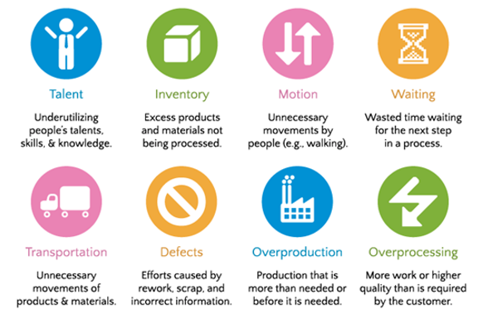
There are many resources freely available that give good instruction of how to implement lean manufacturing in an organisation. For example, Wilson (2015) uses global case studies to explain how lean principles can be used to eliminate waste, control quality and inventory. References to the Toyota Production System are made, describing how the techniques can be used to gain maximum results. Similarly, Davim (2018) provides good guidance by describing some recent case studies of lean manufacturing implementation within industry. Topics covered within this text include Just in Time (JIT), Kaizen activities and Critical metrics.

Value
Wilson (2015) explains that in lean manufacturing, value is determined by what the customer is willing to pay for. Crawford (2016) highlights the importance of defining the customer needs so that value-added (VA) activities can be determined. According to Wilson (2015), VA activities are ones which alter the function, fit or form of a product. Consequently, all remaining activities that do not alter the function, fit or form can be considered non-value-added (NVA) activities. Crawford (2016) explains that the NVAs can be divided into necessary NVAs and unnecessary NVAs. The necessary NVAs are activities which must be performed to produce a final product. However, the customer is unwilling to pay for it as it has not altered the function, fit or form of the product. It is therefore necessary to focus on reducing or eliminating the unnecessary NVAs to make the process leaner.

Flow
Figure 11 shows how lean implementation is a continuous cycle which aims to seek a perfect state in which there is no waste (Lean Enterprise Institute, 2018). Once the optimum state for a system has been achieved then the process can start again so waste is continually minimised. Wilson (2015) explains how the manufacturing process can be made leaner by creating product flow and establishing pull from the downstream activities. Similarly, Davim (2018) explains that the flow can be improved by reducing the non-value-added steps so that the value-added steps become closer together. This can help the product flow more evenly towards the customer.
Following the creation of flow in the process, it is necessary to establish pull. Wilson (2015) explains that pull is where the system is able to supply at a level that is dictated by customer demand by effectively ‘pulling’ the product through the production process as and when needed.
Figure 11 – Five Step Lean Process (Lean Enterprise Institute, 2018)
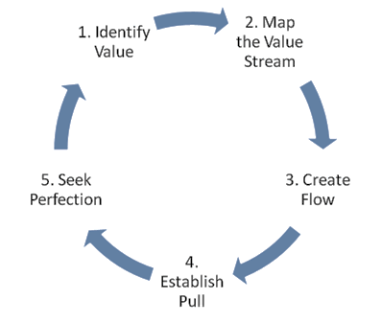

5S
5S is a program that originated from the Toyota Production System (TPS) and Total Productive Maintenance (TPM) techniques. It is structured to standardise the workplace, simplify the working environment, reduce unnecessary activities, and improve quality and safety (Dana, 2015). The technique can be used to create a lean manufacturing environment by achieving a continuous product flow and enabling continuous improvement.
Figure 12 – The 5S steps (5stoday.com)
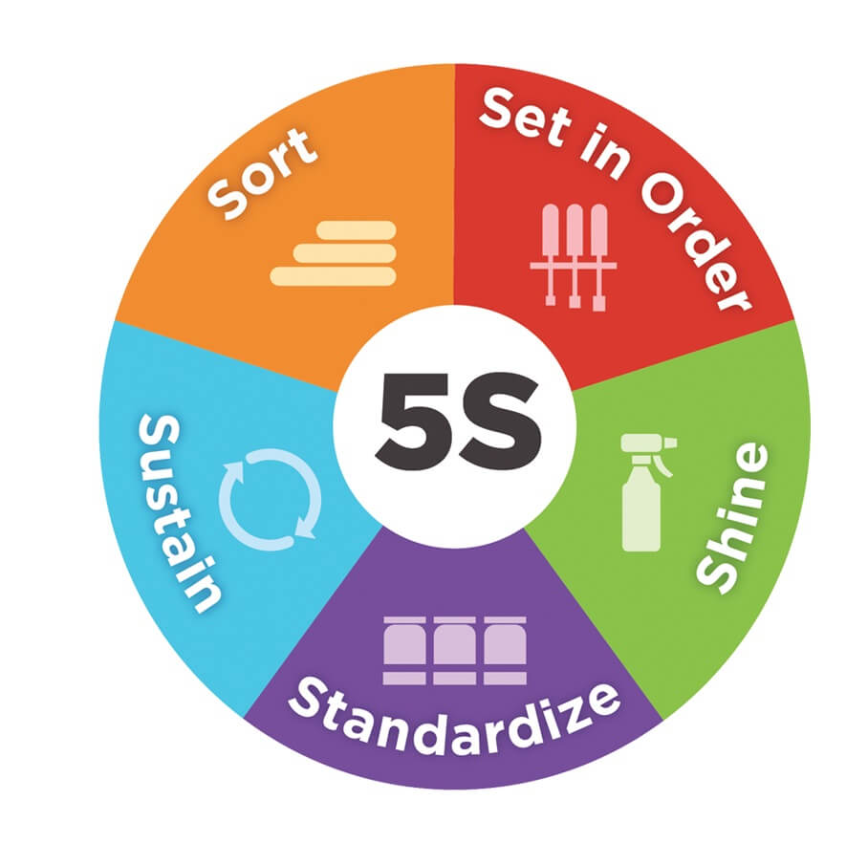
5S is an acronym for Japanese words SEIRI, SEITON, SEISO, SEIKETSU, and SHITHSUKE that translate into SORT, SET IN ORDER, SHINE, STANDARDISE and SUSTAIN (Dana, 2015). Each step of 5S can be implemented sequentially to improve product flow and reduce waste:
- Sort. This would involve sorting through all tools and fixtures in the work area and determining what is needed for the job. Further to this, all items are removed from the work station that is not required to perform the task (Imp, 2011).
- Set in order. The idea that there is a place for everything and everything in its place is important to the success of 5S. The introduction of shadow boards is important to this step so that every tool is returned to its original place after use (Kazmierski, 2016).
- Shine. The work area should be kept clean and tools and materials should be stored away. In doing so, the equipment is inspected by the employee to check it is in good working order. This step also requires regular maintenance to be performed on equipment to prevent downtime losses (Imp, 2011).
- Standardise. This involves creating schedules for employees to follow that are accessible and unobstructed. Additionally, communication boards can be utilised that should be kept up to date (Kazmierski, 2016).
- Sustain. This aims to sustain the gains made by implementing the other steps of 5S. If employees have confidence in the program, then they will be encouraged to make positive contributions. Also, participation from managers should be encouraged so that the program is established in the workplace culture (Imp, 2011).

Value Stream Mapping
Stadnicka & Litwin (2019) explain that Value Stream Mapping (VSM) is a popular lean manufacturing approach to improve performance by identifying waste. The process can be used to redesign the manufacturing system to achieve a leaner system. Chen, et al. (2010) describe how a value stream map contains all the materials and information required in a manufacturing system which graphically shows the flow of product and information. Value Stream Mapping is the act of transferring value stream information to a ‘map’, which can represent either the current state, future state and ideal state of a manufacturing system (Chen, et al., 2010).
The term ‘value stream’ was first used in the book ‘The Machine that changed the World’ (1990) by Womack, Jones and Roos, and the idea was expanded further in ‘Lean Thinking’ (1996) by Womack and Jones (Chowdhury, et al., 2016). In a later book by Martin & Osterling (2014), Value Stream Mapping is described as:
“a tool to reduce operational waste, the broader use of value stream mapping as a methodology to transform leadership thinking, define strategy and priorities, and ensure that customers are receiving high level of value is where value stream mapping earns its brightest stripes”.
There are numerous works available to gain a good understanding of the VSM concept. For example, Murugesan, et al. (2016) show how VSM can be applied to a tool shop by firstly mapping the current state of operations and then improving operations by eliminating waste and establishing continuous flow in the future state VSM. Similarly, Chen, et al. (2010) sets out the steps needed to undertake a VSM using an industrial case study.
Figure 58 and Figure 59 (Appendix 22.1, page 93) illustrate examples of how the number of process steps can be reduced to improve continuous flow and reduce lead time in the future state using a VSM (Chen, et al., 2010).

Rother (2009) explains that to map a value stream, there is a need to focus on one product family within the manufacturing process that share similar manufacturing and assembly steps and equipment. Once this has been established then the value stream can be mapped using graphical symbols.
In a VSM workshop conducted at UWTSD Swansea in 2018, Thomas (2018) explained the function of the VSM symbols as follows:
Table 4 – VSM symbols (Thomas, 2018)
Icon | Represents | Notes
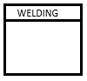 | Manufacturing Process | One box is one area of continuous flow. Can also identify departments.
 | Outside Sources | Shows customers, suppliers and external manufacturing processes.
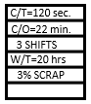 | Process Data Box | Records data concerning a department or manufacturing process etc.
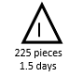 | Inventory | Count and time are noted.
 | Truck Shipment | Frequency of shipments is noted.

Figure 13 – Material and information flow symbols (Thomas, 2018)
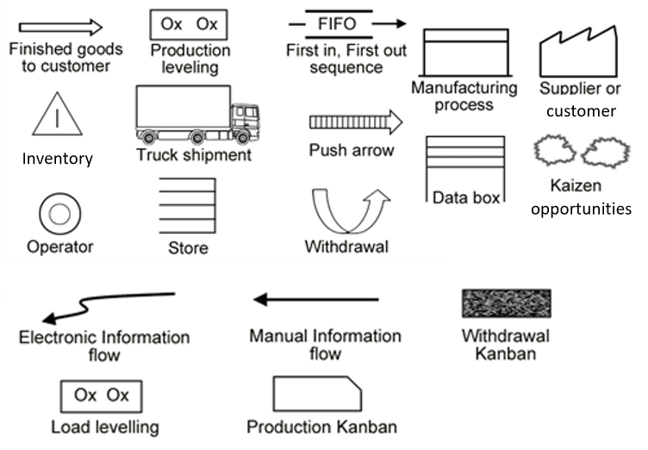

Additive Manufacturing
Additive manufacturing (AM) processes, also referred to as 3-D printing (3DP), produce physical objects layer-by-layer by placing, bonding, and/or transforming primitives or elements (voxels) of raw materials to build a final part (Thompson, et al., 2016). Gibson, et al. (2015) explain that the overall geometry of the parts is determined by projection patterns or tool paths depending on the AM method. This enables the fabrication of parts without the need for any shaping tools. The first working 3D printer was created by Charles W. Hull in 1984 while working for 3-D Systems Corporation (Attaran, 2017). Tofail, et al. (2018) explain that the International Organisation for Standardisation (ISO) classify standard AM processes into seven categories (for detail of these categories, see Appendix 22.4 on page 98):
- Binder Jetting (BJ);
- Directed Energy Deposition (DED);
- Material Extrusion (ME);
- Material Jetting (MJ);
- Powder Bed Fusion (PBF);
- Sheet Lamination (SL); and
- Vat Polymerisation (VP).
Watson & Taminger (2018) explain that AM is a fundamentally different process to subtractive manufacturing (SM) as material is built up in layers, whereas with SM, material is removed from stock material to produce the final component. Further to this, Watson & Taminger (2018) argue that an AM approach to manufacturing can improve material efficiency as parts that are built from powder, wire or vat feedstock require little more than the volume of material in the final product.
Eyers & Potter (2017) argue that AM has been identified as having the most potential to solve manufacturing problems than any other approach. Figure 14 shows how the use of AM in industry has increased substantially over the last thirty years (Additive Manufacturing, 2018). However, whereas the technology is not yet considered mainstream, it offers new opportunities in terms of manufacturing possibilities. Hider (2018) explains that whereas AM was Initially developed as a rapid prototyping tool for new products, the technology has recently been used for the direct production of functional end-use products. Eyers & Potter (2017) state that it is widely considered that AM could invoke a new industrial revolution, and it is estimated that by 2025, AM could contribute a $200bn-$600bn impact to the global economy.
Figure 14 – Industrial metal AM sales rise ( from Wohlers report 2018) (Additive Manufacturing, 2018)
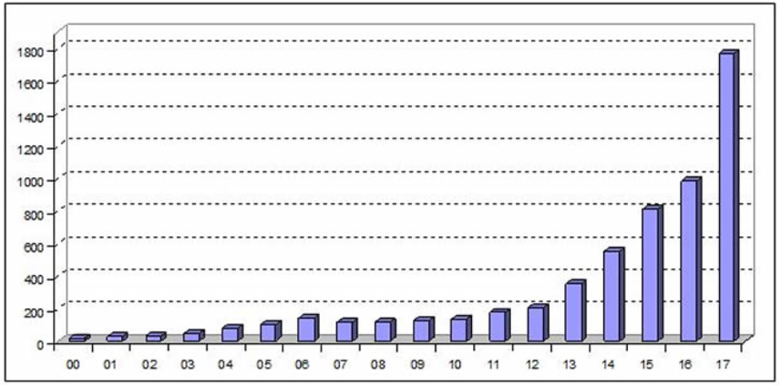
Figure 15 shows a ‘Gartner Hype Cycle’ for 3DP which graphically depicts the maturity and adoption of AM technology over time (Shanler & Basiliere, 2017). It can help an organisation distinguish between hype and commercial viability of a new technology. The Hype Cycle suggests that in 2017, expectations for 3DP in manufacturing operations were sliding into the trough of disillusionment. However, through continued investments to the satisfaction of early adopters of the technology, the next stage could witness the crystallisation of the technology as it starts to become more widely understood for its benefits.
Figure 15 - Gartner's Hype Cycle for 3D printing (Shanler & Basiliere, 2017)
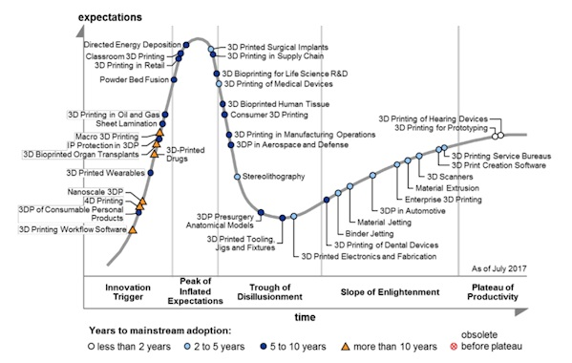
As AM is in its infancy, the technology is advancing very rapidly, therefore the literature used to support this study needs to be relatively recent to ensure that the information is current and valid. Eyers & Potter (2017) state that the range of materials suitable for use in 3D printing is increasing as the technology in industry matures. Similarly, Debroy et al. (2018) explains that as well as polymers, AM is capable of constructing metals including aluminium, steel, titanium and various alloys.
Attaran (2017) argues that there are many advantages of additive manufacturing over traditional (SM) manufacturing. These include:
- Industrial efficiency – customers printing own parts to fix purchased products
- Mass customisation – design and personalise products without lengthy delivery times
- On-demand manufacturing – shortening the supply chain to reduce lead times
- Decentralised manufacturing – reduce the need for logistics as designs can be sent electronically
- Printing complete systems – less assembly steps needed if a complete system or subsystem is printed
- Modifications without penalties – no custom tooling means that the design can be changed without incurring time or cost penalties.
- Sustainability – little material waste is generated which leaves a smaller environmental footprint.
Watson & Taminger (2018) argue that AM consumes far less energy than SM, not just in the manufacturing stage, but when considering all the processes involved to generate a final product. This is due to the excessive non-productive consumption of energy of SM compared with AM which has less processing steps.
On the other hand, Neely (2016) explains that AM is limited in the size of the objects that can be printed as well as the range of materials that can be used compared with SM. In addition to this, Gibson, et al. (2015) suggests there can be limitations to the technology in terms aniisotropy, which means the structural strength of the part is not consistent in all three dimensions. This is due to the layered structure of AM parts when compared to SM parts. This can be an important factor to consider if load-bearing engineering components are being manufactured.

Hybrid Additive/Subtractive Manufacturing
Additive and subtractive methods can be combined into a hybrid process within a single workstation so that the benefits of each process can be harnessed. Flynn, et al. (2016) explains that AM processes are limited by their ability to achieve accuracy, uniformity and surface quality. As such, to achieve the necessary quality characteristics, AM metal parts require post processing using subtractive methods. Similarly, Li, et al. (2018) argue that the limitations of AM technologies can be overcome by combining them with post processing SM to achieve a hybrid process. In this way, the dimensional and performance characteristics of AM can be improved whilst reducing the production time.
Manogharan, et al. (2016) explains that lead times can be reduced using hybrid AM systems as the process makes use of direct digital manufacturing (DDM), which is the process of making a physical product directly using a 3D CAD model. The benefits of DDM include: reduced part development time, reduced process engineering time, lower material waste, less stock material inventory and faster design-to-part lead time (Manogharan, et al., 2016). On the other hand, Liu & To (2017) explain that the hybrid process could have problems manufacturing ‘design for additive’ optimised parts using the more common 3-axis machines due to the AM and SM processes being carried out in direct sequence which requires work holding to remain constant throughout the cycle. This restricts the range of machining operations during the SM phase. However, Li, et al. (2018) explains that a 6-axis machine can add material and subtract material with much greater capability, enabling complex features to be formed in a continuous process.
Mazak (2018) explains that the two mechanisms by which Hybrid AM can be carried out are laser metal deposition (LMD) and wire-arc AM (WAAM). The difference between the two methods is that LMD can deposit material at a higher resolution but at a lower deposition rate of up to 60 cm³/hr whereas WAAM has a much lower resolution but a deposition rate of up to 600 cm³/hr. Merklein, et al. (2016) adds that the benefit of LMD is that any powder metal can be used and ceramic particles can be infused for localised hardness. However, LMD equipment can be very expensive due the high cost of the fibre laser.

Additive Manufacturing in Ford Motor Company
Figure 16 shows the global sites of Ford global rapid manufacturing centres (Ford Motor Company, 2019). There are two rapid manufacturing centres in Europe: one in Dunton, England and the other in Merkenich, Germany. The Dunton Technical Centre is one of Ford’s major research and development facilities and has been responsible for the design of the Ford Fiesta, Ford Ka and engines for Ford of Europe (Ford Motor Company, 2019). Currently, the AM capabilities in Dunton are used predominantly for rapid prototyping to assist in the design process. However, any Ford member of staff can request to build a component on one of its AM machines via the innovation portal of the Ford Intranet system.
Figure 16 – Ford Global Rapid Manufacturing Centres (Ford Motor Company, 2018)
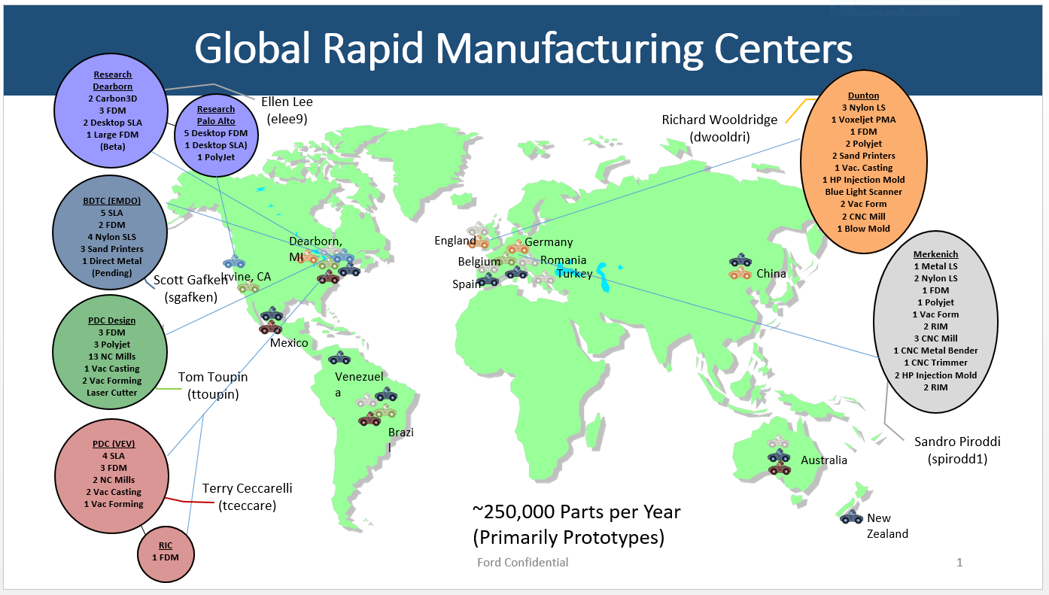
The AM machines that are currently in operation at Dunton technical centre are:
- 3 Nylon Selective Laser Sintering (SLS)
- 1 Voxeljet PMA
- 1 Fused Deposition Modelling (FDM)
- 2 Polyjet
- 2 Sand Printers
- 1 HP Multi Jet Fusion (Ford Motor Company, 2019)
Additionally, the ‘emerging technologies’ department in BEP has 3 FDM printers that are available for the author for the purpose of this study.

Design for Additive Manufacturing
Design for Additive Manufacturing (DfAM) is a practise that aims to optimise the design of AM components to reduce development time and cost thereby increasing quality, performance and profitability (Thompson, et al., 2016). Similarly, Lu, et al. (2014) argue that DfAM aims to set the techniques and guidelines to adapt a design to a given set of constraints specific to the AM process used.

Topology Optimisation
Topology optimisation (TO) is a method of computational design that can generate distributions of material within a prescribed design space that optimises according to criteria set by the designer (Langelaar, 2016). Liu, et al. (2018) support this by explaining that a maximum strength-to-weight ratio is a common criteria for designers. Rezaie, et al. (2013) state that TO can reduce the part mass by optimally distributing the material throughout the material body. On the other hand, Liu, et al. (2018) highlight that whereas freeform design can be easily created from topology optimisation, there are unique limitations to AM that should be considered during the design stage such as the need for structures to support overhanging features.
Rezaie, et al. (2013) explain that modern Computer-Aided Engineering (CAE) packages have integrated this TO approach to aid designers. However, Rezaie, et al. (2013) goes on to explain that there is a need for designers to interpret TO results by reviewing the optimised design and altering the complex areas into fully dense or fully void sections for ease of manufacture. Liu, et al. (2018) indicate that when designing for TO, consideration should be made to remove the need for support structures i.e. all overhang angles in the design are larger than the minimum self-supporting angle of the AM process used. Figure 17 illustrates a TO design that has stipulated a maximum overhang angle constraint of 45.11 degrees to enable FDM printing without support structures.
Figure 17 – Example topological design with minimum overhang angle of 45.11 degrees (Liu, et al., 2018)
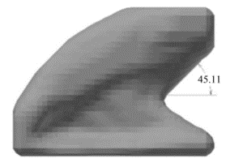

Model and Methodology
Chapter 1 of this project will aim to improve the current CNC process using a lean six sigma DMAIC methodology. The DMAIC method is a structured process whereby the problem is firstly defined, then measured, analysed, improved and finally controlled. Each phase builds on the previous phase to sequentially achieve a solution to the problem (Berardinelli, 2012). However, the final control phase will be omitted from this project as the aim is to optimise the process for comparison purposes and not maintain the solution over a time period. Figure 18 illustrates the sequential stages of the DMAIC process.
Figure 18 – DMAIC process steps (Berardinelli, 2012)
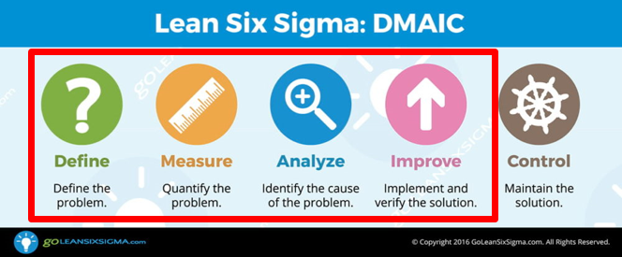
Chapter 2 is concerned with the AM selection process which is based on the process suitability to the toolroom activities, process capabilities, process limitations and cost considerations. The most suitable process is selected by considering a set of criteria relevant to the toolroom.
Chapter 3 investigates the optimisation of AM using ‘design for AM’ techniques. The part used for the VSM study in chapter 1 is optimised using topology optimisation to reduce the mass volume. The part is then manufactured using an AM machine before and after optimisation to determine the difference in build time.
Chapter 4 compares the results of the SM and AM optimisation processes and determines the cost benefits of the optimised processes. Additionally, the management of change is discussed to facilitate a smooth transition to a new way of working.

Chapter 1: Optimisation of the Current Subtractive Manufacturing Process

Define
Define is the first stage of the DMAIC model and sets out to refine the understanding of the problem to be addressed (Ford 6-Sigma, 2006).

Project Charter
The project charter is the definition of the project and serves as a focal point throughout the project (Cudney & Agustiady, 2016). This section will include the problem statement and business case.

Problem Statement
Parts manufactured on the CNC machining centres in the toolroom can involve extended lead times due to a range of non-value-added activities that are involved in the subtractive manufacturing process. These activities include material acquirement, fixture manufacture, set-up times, CNC programming, secondary machining operations, and other wastes that can be defined by the ‘mudas’ of lean manufacturing. For this reason, CNC machining can be considered as more economical for high batch quantity operations in which the economy of scale makes the process more efficient.
Figure 19 illustrates how the lead time for a job can be separated into initial set-up time and total cycle-time for various batch quantities of parts. It is shown that for a one-off component, the initial set-up time can be a large proportion of the total lead time. However, as the batch quantity increases, the cycle-time accounts for a larger proportion. This can be explained as initial set-up is only performed once regardless of the batch quantity of components.
Figure 19 – CNC Lead-time breakdown for various batch quantities (example)
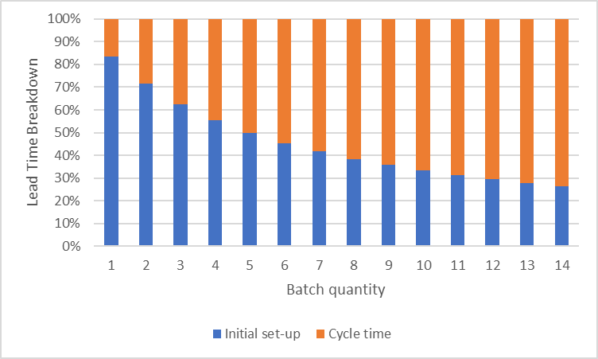
The problem that exists is that there is excessive non-value-added time due to the activities that must take place before machining can begin. In a situation where a high priority component is urgently required to repair a breakdown of machinery on production, a delay can be very costly as a result of downtime. In a breakdown situation, a 1-off component is usually required for urgent manufacture, so it would be favourable to begin manufacturing as soon as possible after receiving the MRF. However, a large proportion of the lead time is consumed by the set-up stage which is excessively high if the component is complex.
Further to this, it is considered that parts with a high complexity of features take much longer to manufacture due to multiple workpiece set-ups, custom tooling manufacture, complex tooling set-ups, and the manufacture of work-holding fixtures. It would be desirable to reduce the lead time in these instances as this would improve lead times, thereby increasing the satisfaction of the internal customers within the plant.

Business Case
When a high priority part is submitted to the toolroom, it is either to address an urgent safety concern or to repair a breakdown of machinery in plant. In each case, production can be stopped until a replacement part has been manufactured by the toolroom. Once completed, the part is fitted to the machine by mechanical fitters to resume production. Considering this, the faster the toolroom can produce a part, the minimum disruption is caused to production during a breakdown which reduces costs incurred due to downtime. The sigma assembly line employs 163 operating staff on each shift at a labour rate of £53.20, and each of these employees can be idle for the duration of a breakdown (see appendix 22.2, page 94). The labour rate is the total of the average hourly rate, fringe benefits and overheads for each employee. The total cost of labour can be calculated as:
£53.20 x 163 staff = £8,671.60 per hour.
Additionally, there is a cost of lost sales opportunity as the production of engines is reduced. Considering that each sigma engine is sold for $1,200 (£920.65) and the cycle time is 28 seconds, then the value of the engines for one hour of production can be calculated as:
£920.65 x 128 engines = £117,843 per hour.
However, there are other factors which must be considered to determine the cost of lost production. The value of the in-process stock remains a company asset which can be processed at a later date by utilising overtime. Also, there is a reduction in processing costs and materials due to the halt in production which should be factored in the calculation. Therefore, the costs due to lost sales opportunity has been given a conservative estimate of 30% of the sales value of the engines, which gives:
£117,843 x 30% = £35,352 per hour
Therefore, the total cost incurred by lost production per hour can be calculated as:
£8,671.60 + £35,352 = £44,024 per hour.
It has been estimated by the author that that 20 hours of production per annum are lost due to breakdowns which rely on the CNC mills to produce parts for production to resume. This project will aim to reduce the duration to complete a job on the CNC mills. It is considered that 25% reduction of lead time is achievable through the implementation of lean principles. Therefore, reducing the CNC lead time by 25% could reduce the incurred costs of downtime to the company by:
20 x £44,024 x 25% = £220,118 per annum.

Project Charter Summary
Figure 20 shows a summary of the project charter which contains the four critical elements: business case, problem statement, goal statement and project scope (Aboelmaged, 2010). It is important to understand that the project charter is an evolving document that should be revised as more knowledge is gained about the project.
Figure 20 – Project charter summary
Project Charter
Project Name: Improving the lead time for CNC manufactured components
Business Case: Reduce costs incurred by production downtime by £220,118 per annum
Refined Problem Statement: Lead times for parts manufactured on the CNC mills are excessive due to the non-value-added steps in the process. It would be desirable to reduce or eliminate these steps using lean principles.
Goal Statement: Achieve a 25% lead time reduction.
Project Scope: The project will focus on reducing cycle times, utilising resources efficiently, increasing efficiency of CNC programs, reducing breakage of tools, reducing variation in operator techniques, increasing productivity at different times of the shift, reducing external supplier issues and reducing or eliminating all types of waste.

Process Mapping

High Level Process Map (SIPOC)
The concept of process mapping can be easily understood by considering the acronym ‘SIPOC’ which considers the Suppliers, Inputs, Processes, Outputs and Customers of the process (Ford 6-Sigma, 2006). The model considers that inputs are taken from the suppliers, value is added through the processes and the output meets the customer needs. The output of the process should be the same as the customer expectations of the product.
Each stage of the SIPOC (Table 5) can be identified by considering the following questions:
- Suppliers – who supplies the process inputs?
- Inputs – What inputs are required?
- Processes - What are the major steps in the process?
- Outputs – What are the process outputs?
- Customers – Who receives the outputs?

Table 5 – High level process map (SIPOC)
Suppliers | Inputs | Processes | Outputs | Customers
-Plant maintenance staff  -Material suppliers  -Tooling suppliers | -Work order placed by maintenance through Maximo system | -Stock material is cut to lengths  -Work holding is set up on CNC  -Tooling is set up on CNC  -Component is machined  -Component is deburred  -Secondary processes are performed if required  -Component is inspected | -Completed components are transferred to collection area in toolroom | -Plant maintenance staff

Process Map
A process map has been constructed (Figure 21) which provides a visual representation of the toolroom CNC milling process (Ford 6-Sigma, 2006). The map helps to visualise rework loops and redundancies in the process. The ‘hidden factory’ is highlighted within the map which involves a workaround to reprocess the part when it is found to be out of specification after inspection. The hidden factory can be identified as a waste which takes up unnecessary time, space and resources and should be focused on to create a leaner working environment (Wilson, 2015).
Figure 21 – CNC milling operation process map

HIDDEN
FACTORY

Project Scope
Figure 22 shows a cause and effect diagram, also known as an Ishikawa diagram, that has been constructed to find various influences that contribute to a problem which can be used to identify the most likely causes (Ford 6-Sigma, 2006). In the manufacturing industry, the six possible causes of a problem can be attributed to the 6Ms which can be defined as: (George, et al., 2005)
- Method – are the methods consistent and established?
- Machine – are there any maintenance issues?
- Materials – are the any supply issues or material issues?
- Measurement – are there any errors or issues with measurement?
- Man – are there any inconsistencies or issues with the workforce?
- Management – are there any issues with the process management?

Figure 22 – Cause and effect diagram

Measure
In this section, the techniques for data collection will be set out to determine the current performance of the process. This allows a benchmark to be set so that any improvements to the process can be made in the appropriate areas. From this, refinements to the CNC process can enable the necessary lead time improvements to achieve the project goal.

Data Collection Plan
Two types of data can be collected from the CNC process, attribute data which involves recording the occurrence of an event and variable data which involves recording measurements (Ford 6-Sigma, 2006). Table 6 shows the data collection plan that has been compiled to construct a VSM of the current state.
Table 6 – Data collection plan
What data will be collected? | Why? | By who? | How? | When? | Where?
Archived CNC component data (variable and attribute) | For AM comparison (Chapter 2) | Observer | Data collection form 1 | Previous year archive of work | Toolroom
Archived CNC component data (variable and attribute) | To select a product family for VSM | Observer | Data collection form 1 | Previous year archive of work | Toolroom
CNC process cycle times  (variable) | To compile current state VSM | Observer | Data collection form 2 | Over 3 CNC machining cycles | V5 CNC mill
CNC process changeover times  (variable) | To compile current state VSM | Observer | Data collection form 2 | Over a full CNC manufacturing cycle | V5 CNC mill

Data Collection Form 1
A data collection form has been designed to extract information from archived work (see Figure 23) carried out on the V5 CNC milling machine over the previous year. To ensure there are no seasonal variations in the data, the first six jobs of each month have been selected. Table 7 shows the form has was used to collect variable data including part quantity, outside dimensions, priority and hardness. Additionally, the form collects attribute data including construction material and secondary processing requirements.
The form requires the observer to determine the volume of the part which is estimated as a percentage of the finished part outside dimensions. This is to estimate the volume of material required for AM (Chapter 2) and the volume of waste material produced using SM. Additionally, the material cut-off size is determined as CNC requires the material to be a size that can be considerably larger than the outside dimension of the finished part due to work holding requirements.
Figure 23 – Archived CNC work
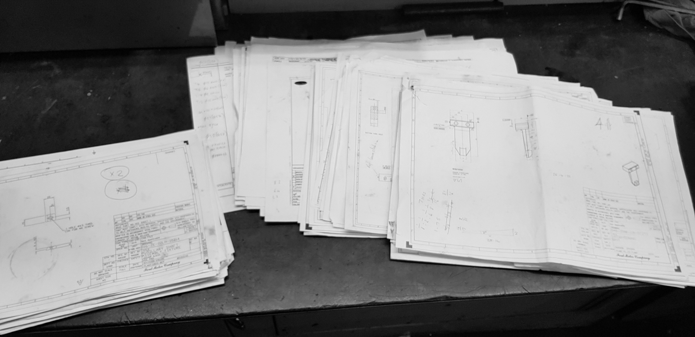

Table 7 – Data collection form 1 (archived component drawings)

Selecting a Product Family for VSM
Rother (2009) explains that to conduct a VSM, there is a need to focus on a single product family. This is necessary in the toolroom as many different types of product are produced that go through varying process steps. A product family can be defined as a group of products that pass through similar processing steps and are processed using common equipment downstream.
Table 8 shows the six different product families identified in the toolroom that share common process steps and equipment. For the purpose of this study, the ‘Angular’ product family has been chosen as it is suitable for the CNC mill and it includes a wider range of materials than the other families identified.
Table 8 – Selecting a product family (Rother, 2009)
 |  | Process Steps and Equipment
 |  | Cut-off saw | CNC mill | CNC lathe | Heat treat | Cylindrical grinding | Surface grinding | Deburring
 |  |  |  |  |  |  |  |  | Suitable materials
Product Families | Cylindrical, Hardened, Ground | X |  | X | X | X |  | X | Mild steel, tool steel
Product Families | Cylindrical, Ground | X |  | X |  | X |  | X | Mild steel, tool steel
Product Families | Cylindrical | X |  | X |  |  |  | X | Mild steel, tool steel, aluminium, bronze, brass, plastic
Product Families | Angular, Hardened, Ground | X | X |  | X |  | X | X | Mild steel, tool steel
Product Families | Angular, Ground | X | X |  |  |  | X | X | Mild steel, tool steel
Product Families | Angular | X | X |  |  |  |  | X | Mild steel, tool steel, aluminium, bronze, brass, plastic

Selecting a Component for VSM
The AJ supercharger end-effector RH clamp jaw has been selected from Table 7 as a suitable component to carry out the VSM study as it is a typical component produced in the toolroom that is part of the ‘Angular’ product family chosen in Table 8. Figure 24 shows the engineering drawing that has been selected from the archive and Figure 25 shows the completed component after manufacture on the V5 CNC mill. The component is constructed of Nylon 6/10 plastic.
Figure 24 – AJ supercharger end-effector RH clamp jaw
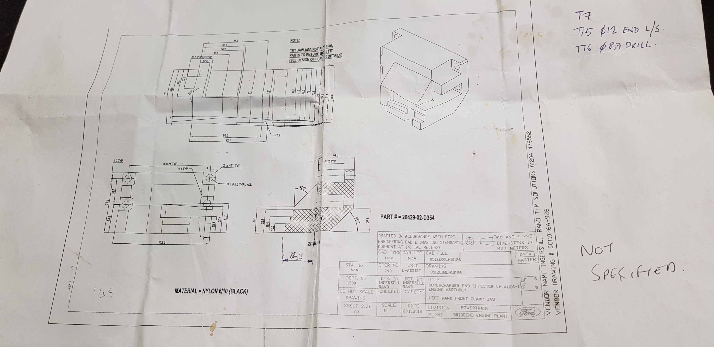
Figure 25 – CNC machined component
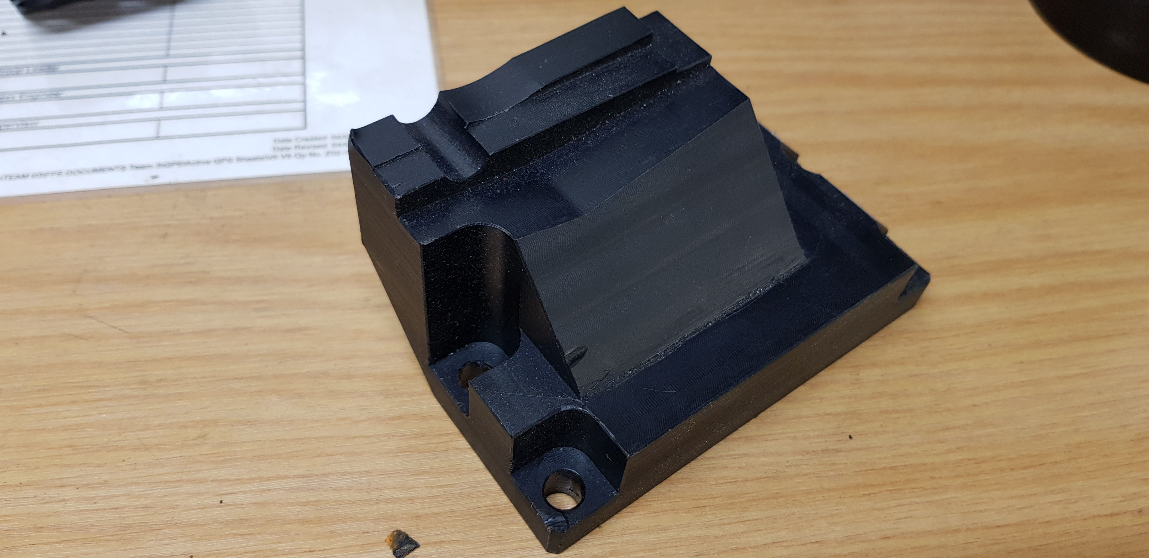

AJ supercharger end-effector RH clamp jaw
In operation, the component functions in conjunction with three similar components to clamp the AJ supercharger when performing a transfer operation. Figure 26 shows how the clamp jaw is fastened to the clamp frame using four bolts. The contoured surface on the clamping face of the part clamps on to the outside surface of the AJ supercharger. The part is made of nylon so that minimum damage is caused to the supercharger during operation. Figure 27 shows the part in operation before carrying out a lift-and-carry cycle.
On a previous occasion in the toolroom, this part has been manufactured as a high priority which signifies that it is urgently required to resume a breakdown on production. In this instance, downtime would have continued until the new part had been manufactured and fitted to resume production of engines.
Figure 26 – Component fixed to lifting frame on production line
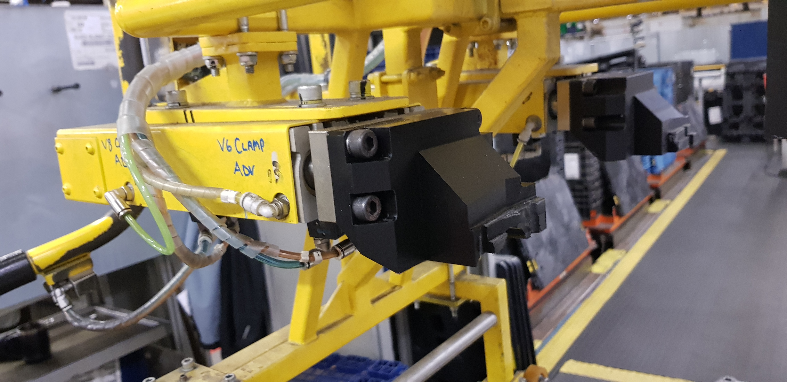
Clamping
face
Figure 27 – Component in operation on production line
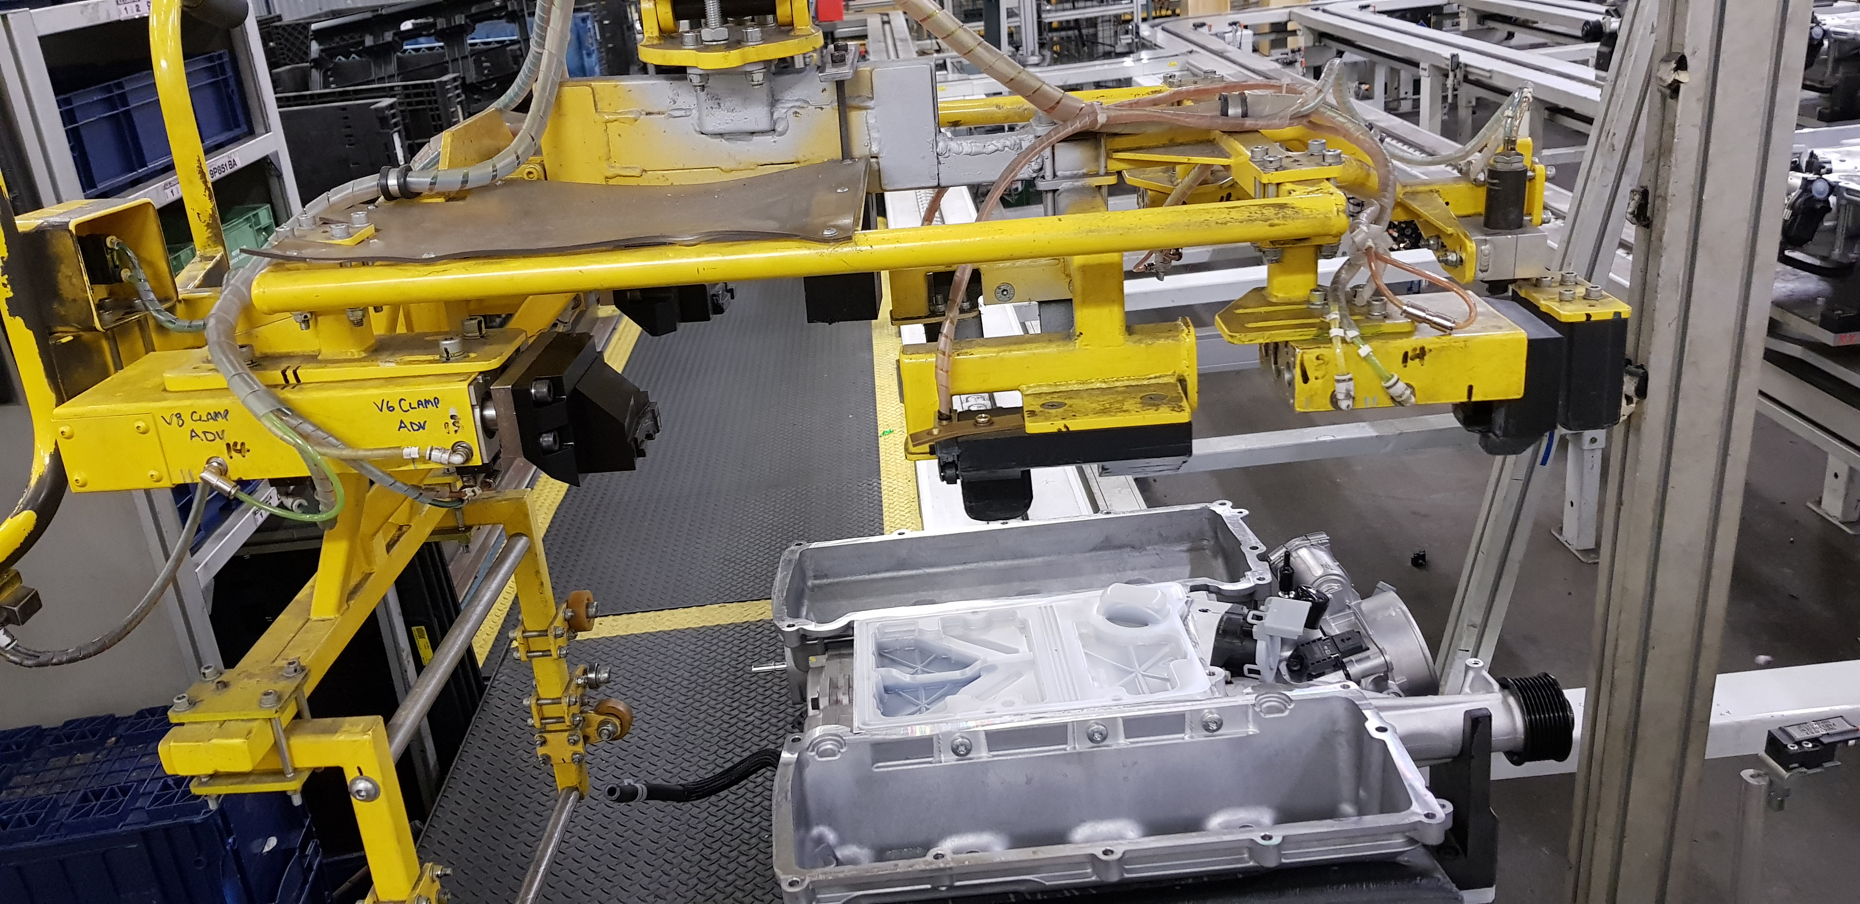

Data Collection Form 2
The AJ supercharger end-effector RH clamp jaw has been manufactured on the V5 CNC machine using a stopwatch to record each processing step of the operation. Table 9 displays the data that has been collected at each stage from job initiation through to delivery. Each process step can be described as follows:
- Material acquirement – the time from ordering the material to it arriving in the toolroom stores.
- Horizontal bandsaw – cycle time is the cutting time whereas changeover time is the material handling time.
- CNC programming – this involves compiling and verifying the CNC program.
- Tooling setup – this involves acquiring necessary tooling from the plant stores and setting up tooling in the CNC machine.
- Work-holding setup – this involves setting up work-holding fixtures and repositioning of the workpiece during manufacture.
- CNC machining – this is the duration of the CNC cycle time whereas changeover time is the loading and setting of the workpiece.
- Deburring – this involves hand deburring the part to remove sharp edges.
- Collection – this is the duration from completing the part to collection by maintenance staff.
Table 9 – Data collection form 2 (CNC manufacturing process data)
Process Step | C/T | C/O
Material acquirement | 1440 min | N/A
Horizontal bandsaw | 18 min | 15 min
CNC programming | 121 min | N/A
Tooling setup | 126 min | N/A
Work holding set-up | 122 min | N/A
CNC machining | 105 min | 26 min
Deburring | 27 min | N/A
Inspection | 24 min | N/A
Collection | 116 min | N/A

Analyse
The purpose of the analyse phase is to allow improvement opportunities to be targeted by studying the data collected (George, et al., 2005). In this case, a current state VSM is constructed which graphically represents the stream of product and information in the process.

Current State Value Stream Map
The current state map represents the existing position of the CNC manufacturing process. This stage is used to identify the critical problem areas for improvement and the various non-value-added activities (Murugesan, et al., 2016). As described by Rother (2009), the mapping of the value stream begins by considering the customer requirements, as these can identify where value is added to the final product. It is understood that inventory will accumulate before each process step if continuous flow does not exist in the process.
Figure 28 shows the current state VSM constructed for the CNC mill manufacturing process. The cycle time (C/T), which is a measure of how long it takes for a part to be completed by a process, has been entered for each process step (Rother, 2009). Additionally, the changeover time (C/O) has been included which considers all work undertaken to change between products and setups. Finally, the lead time (L/T), which is the time it takes for the product to move all the way through the process from start to finish, has been calculated. The total lead time calculated in the VSM is 34h 51m, however, the value-added time is 1h 19m, which is just 3.42% of the total lead time.
The toolroom supervisors are included in the VSM as they have overall responsibility for ensuring the schedule is met. The schedule is received electronically by the supervisor from production control and the progress of each process step is monitored through direct contact with each process step. The horizontal bandsaw and CNC machining process steps can be considered as the only steps that add value to the product as they alter the fit, form or function to satisfy the customer requirements (Davim, 2018). Consequently, all other process steps can be considered as non-value-added steps which are necessary to carry out the manufacturing process but can be reduced.

Figure 28 – Current state VSM

Pareto Analysis of Process Steps
The cycle times of each process step have been plotted on a pareto chart which shows where the most gains can be made by reducing the cycle times of the largest process steps. Figure 29 reveals that the process step with the largest duration is material acquirement which contributes 67.3% to the overall lead time. Therefore, a reduction in the duration of this activity could provide significant benefits to lead time.
Further reductions in lead time can be achieved by reducing the duration of CNC machining, tooling setup, work holding setup, CNC programming and collection, which account for a further for 28.8% of lead time. When combined with material acquirement, these activities account for 96.1% of lead time. The chart shows that deburring is 1.3% and inspection is 1.1% of lead time which indicates that any improvements to these processes would provide very little impact to an overall reduction of lead time.
Figure 29 – Pareto chart of process steps
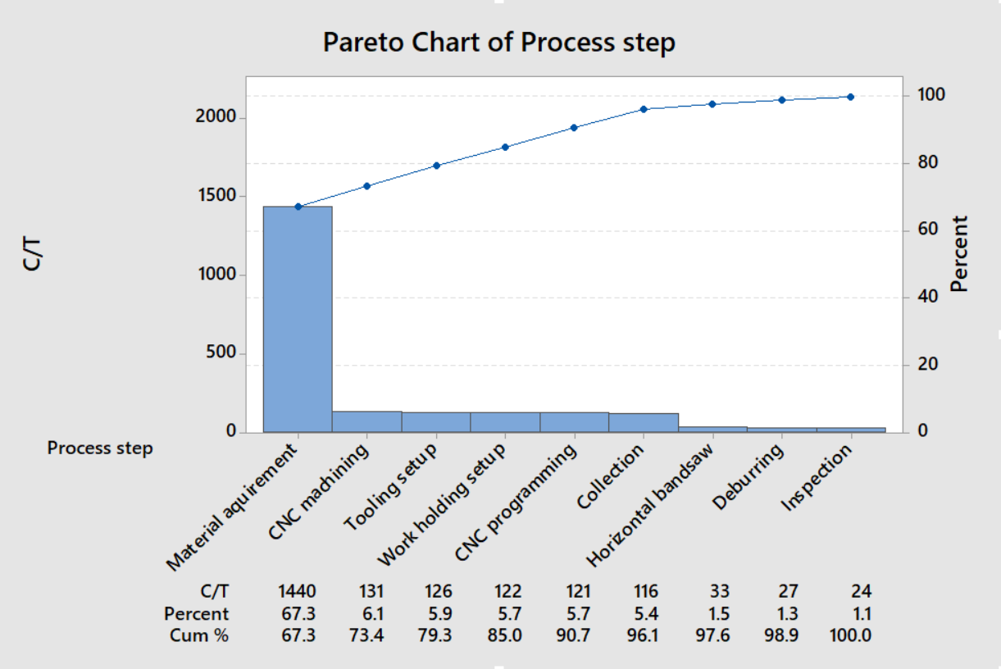

Improve
In the improve phase, improvements are developed to generate a solution to the problem set out in the define phase (Berardinelli, 2012). From studying the current state value stream map and considering the cause and effect diagram in the define phase, a set of actionable solutions are set out to try and achieve a 25% reduction in overall lead time. This is achieved by constructing a future state VSM that highlights the areas which can be improved.

Future State Value Stream Map
The future state VSM sets out the measurable target conditions that should be met to improve the current state (Rother, 2009). This can be achieved by highlighting sources of waste and eliminating them in each step of the process. The goal of the future state VSM is to construct a chain of production in which the processes are linked by continuous flow where possible and by producing only what the customer needs when they need it.
Figure 30 shows the future state VSM has been constructed whereby each stage has been highlighted using ‘Kaizen Burst’ boxes (Rother, 2009). These signify improvement needs at specific processes that are critical to achieving the future state of the value stream. Each Kaizen Burst box identifies waste that can be reduced or eliminated in the process:
- Get faster deliveries – using the current delivery service, material can be delivered within approximately 24 hours for a high priority job. However, this waiting time can be reduced by sourcing materials from a local supplier whereby the delivery can be prioritised if the job is high priority. For example, local stockholders such as ‘Dyfed Steels’ (dyfedsteels.co.uk) and ‘Metal Goods Wales’ (metalgoods.co.uk) hold a wide variety of stock materials and deliveries could be arranged on the same day. This has led to estimations that the material acquirement time could be reduced from 24 hr to 18 hr to result in a 6-hr reduction of lead time.
- Improve CNC programming efficiency – this involves being more efficient when compiling CNC programs by ensuring that the optimum speeds and feeds are used to maximise the efficiency of the program. It has been estimated that this could reduce the duration of the process from 121 min to 100 min to result in a 21 min reduction in lead time. The inefficiency that exists can be due to overly cautious speeds and feeds settings being used.
- Implement 5S – the introduction of 5S practises would increase the efficiency of tooling setup and changeovers. This can be achieved by ensuring the correct tools are readily available to the operator. This would involve implementing the sequence steps of sort, set in order, shine, standardise and sustain. In particular, the introduction of shadow boards would be beneficial as this would facilitate tools being returned to their rightful place after being used. It is estimated that 5S could reduce the duration of tooling setup from 126 min to 110 min, resulting in a 16 min reduction in lead time.
- Improve CNC machining C/T and C/O – the CNC process is where most of the necessary value-added time exists. However, there is also unnecessary non-value-added time due to over-processing. This can involve the machine performing at a level that is below its operating capacity. The cycle time can be reduced by ensuring that the optimum speeds and feeds are used when running the CNC program cycle. It is estimated that this can reduce the CNC machining cycle time from 105 min to 100 min and the changeover time can be reduced from 26 min to 22 min. In total, this could reduce the overall lead time by 9 min.
- Improve customer delivery – A ‘First-In First-Out’ mechanism has been introduced between the CNC machining process and the customer collection point so that each part is processed in turn until completion. This can improve the flow and reduce inventory, whereas normally the parts are processed in batch quantities before moving on to the next process step. Additionally, it has been estimated that the customer delivery can be improved by introducing a supermarket mechanism that signals the customer when the inventory level in the collection area reaches a value of 1. Using this process, it is estimated that the customer delivery time can be reduced from 116 min to 60 min, an improvement of 56 min to overall lead time.
The successful implementation of the future state VSM could improve the overall lead time and costs by:
Current state lead time = 34 hr 51 min (2091 min)
Future state lead time = 27 hr 9 min (1629 min)
Lead time improvement = (1 – 1629 / 2091) x 100%
= 22.1%

Cost reduction = 20 x £44,024 x 22.1%
= £194,586 per annum

This lead time improvement is 2.9% less than the target of 25% and the cost reduction is £25,532 less than the target of £220,118. However, further gains could be made by reducing the need for reworks in the hidden factory identified in Figure 21. This could be achieved by ensuring the tool wear offsets are frequently updated to reduce the occurrence of defects, which in turn would reduce the need for scrap or reworks.

Figure 30 – Future state VSM

Chapter 2: Additive Manufacturing Process Selection

In this chapter, an appropriate AM process is selected based on suitability to the toolroom needs, cost effectiveness, economy, mechanical properties of manufactured parts and sustainability.
The seven categories of AM have been researched in Appendix 22.4 (Page 98) which investigates operating sequence, suitable materials and advantages and disadvantages of each AM process. Mançanares, et al. (2015) argue that due to AM being in its infancy, little research is available for which AM method is best for producing a specific item. Similarly, Gibson (2015) suggests that the process of identifying a suitable process and materials to fabricate a specific part can be surprisingly complex. Therefore, it would be beneficial to investigate which AM technologies are currently being used in industry so that the needs of the toolroom can be best served. However, the options of which AM process to use can result in variable outcomes in terms of time, cost and surface finish of a part.
Table 10 summarises the AM process types which list the principal manufacturers of each AM process and the suitable materials (Eyers & Potter, 2017). In addition to material capability, Eyers & Potter (2017) emphasise that there are many factors to consider when selecting a suitable AM process which include:
- Cost – the expense incurred by manufacturing to satisfy product demand
- Dependability – the reliability of the AM machine to satisfy demand at the expedited time
- Flexibility – the ability to change the outputs of the system with little penalty
- Quality – the manufacture of products that conform to specification
- Speed – the time taken to respond to customer demand.
The archived data from the toolroom (Table 7) will be analysed to determine the materials that are most frequently used to manufacture components. Additionally, the significant attributes of various AM processes will be compared to assist in the selection process.

Table 10 – Summary of AM Process Categories (Eyers & Potter, 2017)
Process Type | Description | Focal AM Technologies | Principal Manufacturers | Suitable materials
Binder Jetting | Powder materials are joined using a liquid bonding agent | 3D Printing (3DP) | Z-CORP  3D Systems  ExONE | Powders including plasters, sands and composite materials  Powders including stainless steel, cobalt, aluminium, copper and sands
Direct Energy Deposition | Deposited materials are melted using focused thermal energy | -Laser Cladding  -Laser Metal Fusion  -Laser Metal Deposition | Trumpf  Optomec | Powders including stainless steel, cobalt, aluminium and copper  Titanium, nickel, tool steel, stainless steel, cobalt, aluminium, copper and composites
Material Extrusion | Material is dispensed selectively through an orifice | -Fused Deposition Modelling (FDM) | Stratasys  Raise3D  Ultimaker | Thermoplastics including ABS, ASA, polyamide, polycarbonate and polypropylene
Material Jetting | Build material is selectively deposited in droplets | -Multijet Modelling | Stratasys  3D Systems | Ceramics, liquid photopolymers and melted waxes
Powder Bed Fusion | Regions of a powder bed are selectively fused using thermal energy | -Selective Laser Sintering (plastics)  -Selective Laser Sintering (Metals)  -Selective Laser Melting  -Electron Beam  -Multi Jet Fusion (MJF) | EOS  3D Systems  Formlabs  EOS  Renishaw  ReaLizer  ARCAM  HP | Polyamide, PEEK, polystyrene and composites  Alloys including aluminium, cobalt chrome, maranging steel, nickel, stainless steel and titanium  Alloys including cobalt, chrome, titanium and steel  Polyamide (PA12)
Sheet Lamination | An object is formed by bonding sheets of material | -Laminated Object Manufacturing | MCOR  EnvisionTEC | Sheet paper  Composite Thermoplastics
Vat Photopolymer-isation | Light activated polymerisation selectively cures a liquid photopolymer | -Digital Light Processing  -Stereo-lithography (STL) | EnvisionTEC  3D Systems | Epoxy and nano-composite resins

Pareto Analysis of Toolroom CNC Archive Data
The data collected in Table 7 can be used to determine the typical components manufactured in the toolroom. The analysis will make use of the Pareto principle, also known as the 80/20 rule, which states that 20% of causes are responsible for 80% of effects (Pandey, et al., 2013). In this case, the pareto principle can be applied to make an informed decision as to which process would be more suitable, as each AM process is only suitable for a given range of materials (Eyers & Potter, 2017).
In Figure 31, a pareto chart has been constructed that plots total quantity of components by build material. The chart shows that 81 components (29.8% of total) are constructed of nylon whereas 76 components (27.9% of total) are constructed of mild steel. Both these materials account for 57.7% of the total quantity of parts manufactured on the CNC mill.
Figure 31 – Pareto chart of component quantities
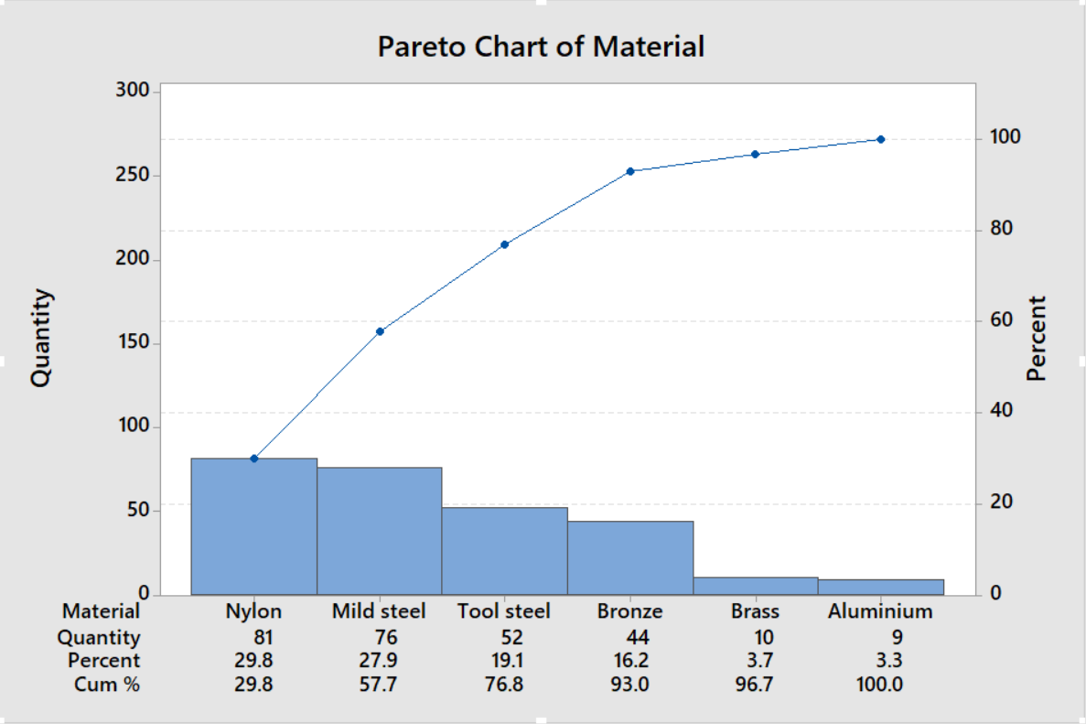
The data has been processed further to estimate the amount of material that is contained in the finished components. This has been achieved by gathering the outside dimensions of each component and multiplying the length, width and height together to give a rectangular block volume of material. Next, the volume of the finished part has been estimated as a percentage of the block volume. For example, Figure 32 shows an example component in which the blue area is the material removed. In this case, the material in the finished part is estimated as 75% of the block volume. Any inconsistencies in the estimations of this method are likely to even out over the full range of data.
Figure 32 – Example component showing material removal
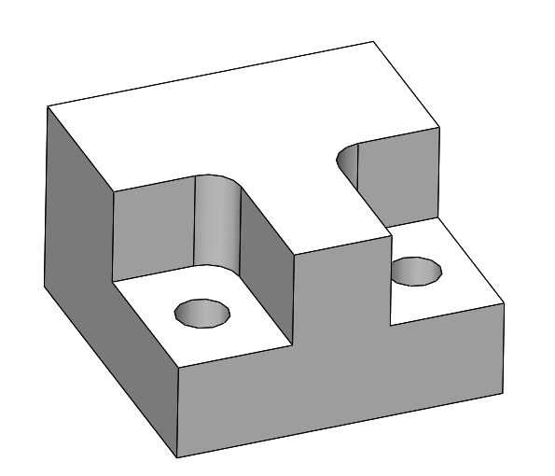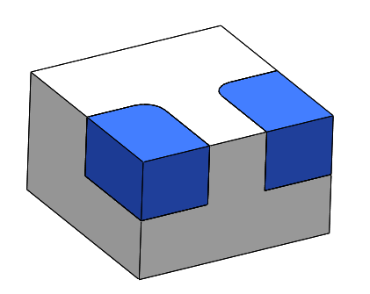
AM build time is dependent on material volume, therefore the total volume of material in the components can help to decide which AM method would be more beneficial for the toolroom. The component quantities in Figure 31 do not consider any information about volume of material as they are all various shapes and sizes. Therefore, a pareto chart has been constructed in Figure 33 which plots the total volume of material of components. It can be seen from this chart that nylon is the most voluminous material used on the CNC at 49.9% of total processed volume, whereas mild steel is second at 24.5%.
Figure 33 – Pareto chart of finished part material volume
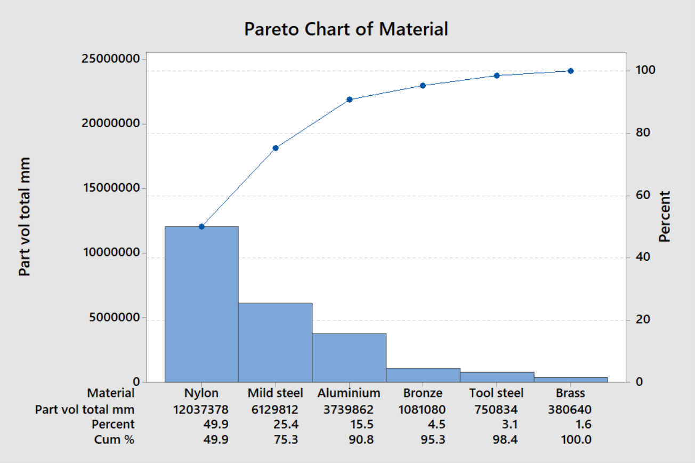

It can be perceived that AM is more beneficial for high priority jobs when a part is urgently required. AM manufacturing can commence almost immediately after receiving a work order whereas CNC involves many preparation and set-up steps which need to be carried out first. Figure 34 shows the finished part volume of each material for priority 1 (low urgency), priority 2 (medium urgency) and priority 3 (high urgency) parts. This chart shows that low and medium priority parts are mostly constructed of nylon. However, Figure 35 shows that 62.3% of high priority parts are constructed of mild steel. Therefore, it can be considered that a steel AM method is most beneficial for manufacturing breakdown parts, as reducing the lead time of high priority parts can reduce the duration of downtime instances in the plant.
Figure 34 – Pareto chart of material by priority
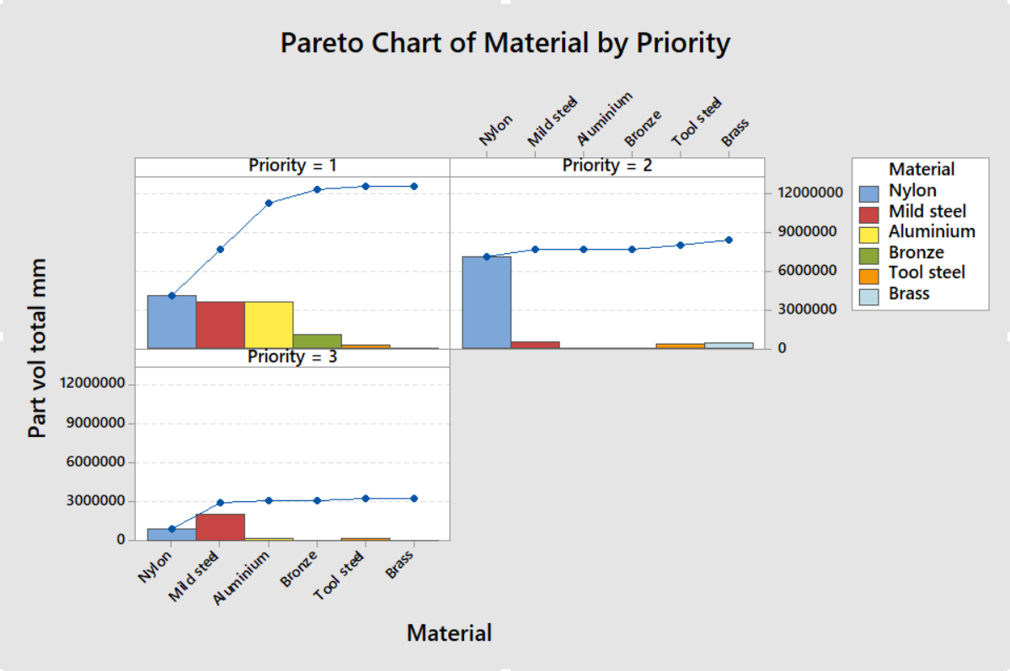
Figure 35 – Pareto chart of high priority work
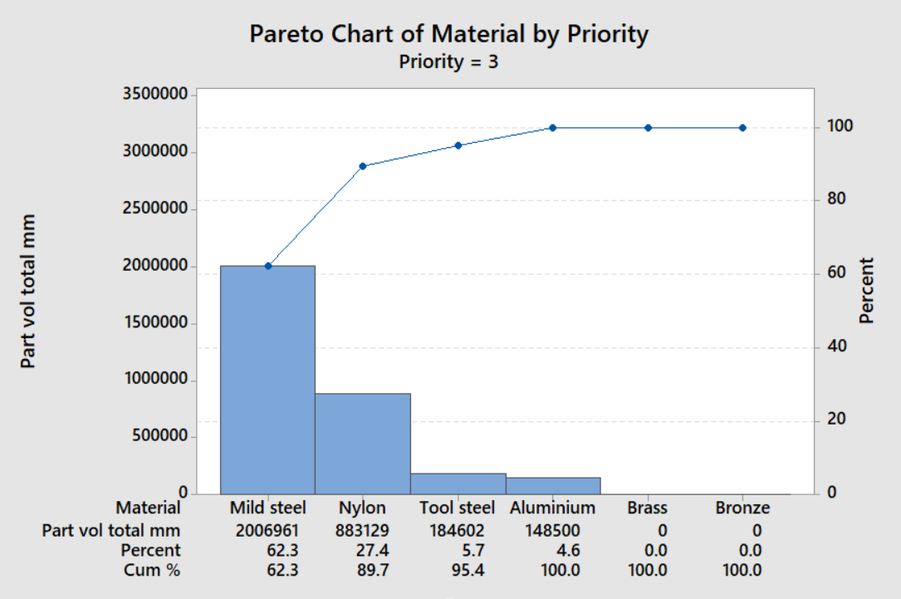

Identification of Waste Material Removal
The data in Table 7 has been processed further to determine the volume of waste material produced on the CNC mills. The method considers that the stock material cut off for subtractive machining is always larger than the finished component to provide extra material for work holding. A stock size requirement has been estimated that considers standard stock material sizes and the length of cut-off required. For example, job 14 in Table 7 has finished outside dimensions of 84 x 82 x 44mm. However, a stock size of 100 x 100mm would be selected and cut off into 50mm lengths giving a workpiece size of 100 x 100 x 50mm. By subtracting the finished part volume from the initial volume, the waste material removal produced can be calculated.
Figure 36 shows a pareto chart of the volume of material removal for each component material. The chart shows that nylon components produce the most waste with 48.8% of total, whereas mild steel is next at 26.7%. The significance of this data is that AM processes produce very little waste material, so a nylon AM process could provide the most benefits in terms of reducing the volume of waste material.
Figure 36 – Pareto chart of material removal on CNC
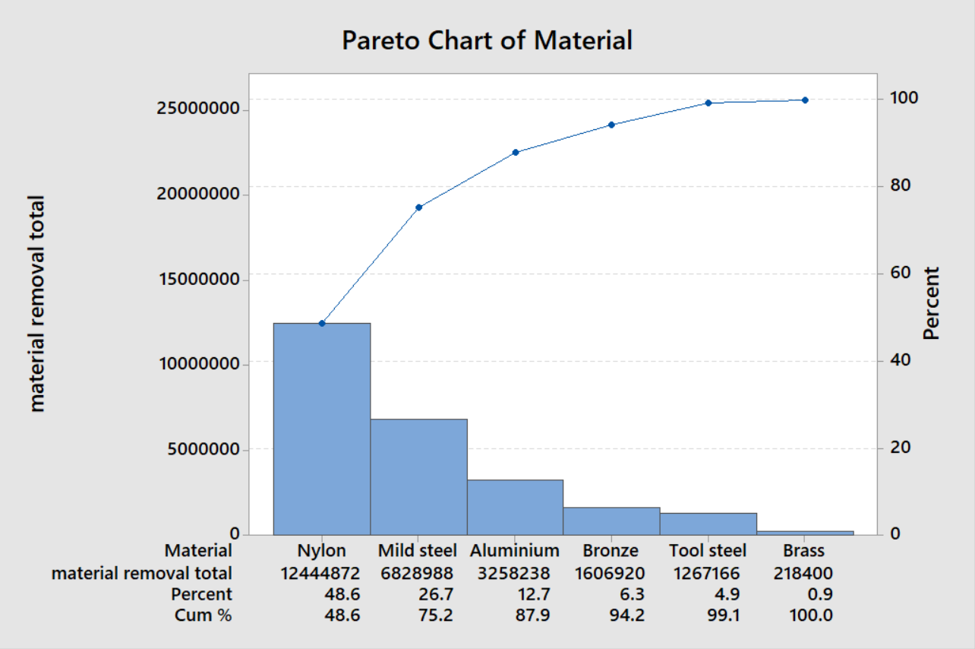

Additive Manufacturing Considerations

AM Production Rate Comparison
The production rate of each AM method has been compared in Figure 37 which shows the typical range that is achievable. The polymer processes shown in blue indicate that SLS is capable of building parts up to 400 units/hr whereas FDM can only operate at up to 1 unit/hr (CES Edupack, 2018). This demonstrates that SLS is considerably more capable of short lead times than FDM. However, Gibson (2015) explains that SLS can be more productive for larger quantities of components. This is because the build envelope must be filled with material during operation regardless of volume and quantity of parts constructed.
The metal AM processes (shown in red) are plotted to show the differences in production rate. Laser powder forming (which is a DED process) is capable of building at 25 units/hr whereas EBM, SLM and SLS (which are PBF processes) are capable of 7, 1.6 and 1 units/hr respectively. This indicates that the rate of production can be faster with DED.
Figure 37 – Production rate comparison of AM processes (CES Edupack, 2018)

AM Capital Cost Comparison
The capital cost is the total cost of all the equipment required to perform the AM process which includes tooling and equipment. Figure 38 shows that the capital cost for metal processes is generally higher than polymer processes. Industrial metal AM processes have a retail price in the range of £137,000 to £645,000 depending on the type and specification of machine (CES Edupack, 2018). Metal DED (laser powder forming) processes range from £379,000 to £607,000, whereas FDM (polymer) machines can range from £3,000 to £304,000 depending on the size and accuracy of parts required.
Figure 38 – Capital cost comparison of AM processes (CES Edupack, 2018)
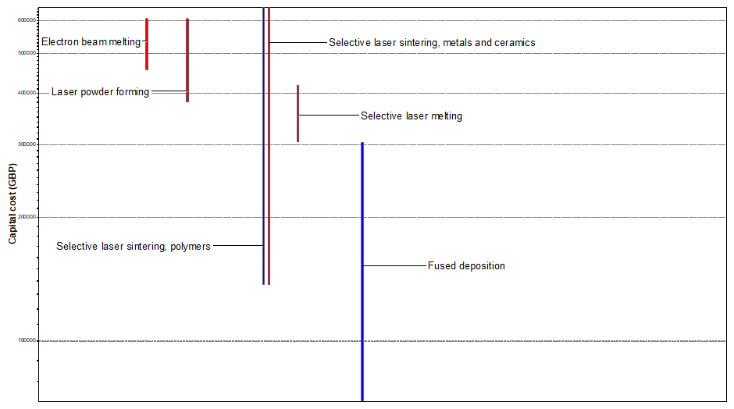

AM Material Utilisation Fraction Comparison
The material utilisation fraction is the mass fraction of the primary material entering the process which remains in the final product measured on a scale of 1-0 (CES Edupack, 2018). Figure 39 shows how sustainable the processes are in terms of material utilisation in which a higher measure means less material is wasted. For polymers, FDM is shown to utilise a higher proportion of material whereas SLS is more wasteful. For metal processes, laser powder forming utilises the most material whereas EBM uses the least. SLS for metals and polymers are shown to be in the mid-range of material utilisation with a mass fraction range of 0.5-0.7 (CES Edupack, 2018).
Figure 39 – Matl. utilisation fraction comparison of AM processes (CES Edupack, 2018)
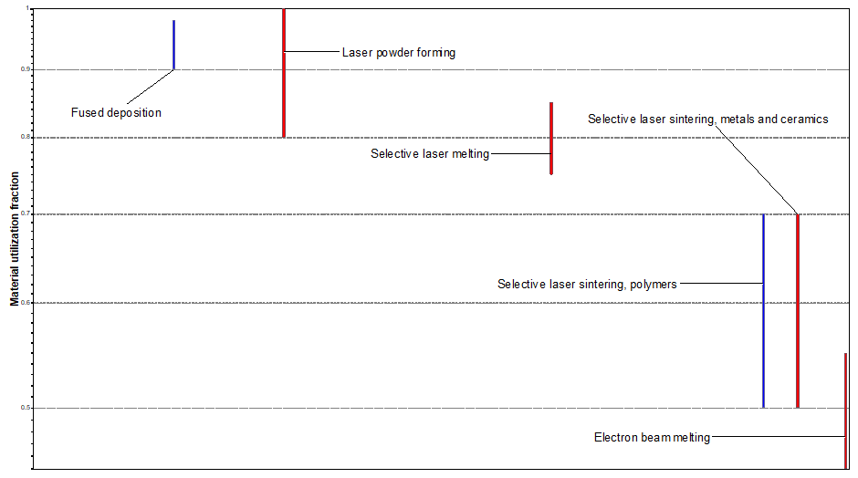

Additive Manufacturing Process Selection
Considering the analysis of data from the toolroom archives, it is evident that the most utilised material is nylon with 49.9% of the overall total volume. However, when considering the materials of high priority components, mild steel is highest with 62.3% of material volume. This suggests that there could be a requirement for both nylon and steel AM processes in the toolroom. However, whereas nylon components are generally low-priority, there is less need for a high production rate in the polymer AM process. On the other hand, mild steel components are more likely to be high-priority so a metal AM process with a high production rate would be more beneficial.
The chart shown in Figure 40 demonstrates that direct energy deposition (DED) is the metal AM technology that can provide the best build speed (Tofail, et al., 2018). However, the resolution is the lowest of the seven AM categories and the energy consumption is considerably high. It can be considered that powder bed fusion (PBF) is the most suitable process as the speed is appreciably high and the resolution is very good compared to the other AM processes. Material extrusion (ME), which includes FDM, has a comparably much lower build speed than PBF while also having a lower resolution.
Figure 40 – Relative energy use, speed and resolution of fabrication in different AM processes (Tofail, et al., 2018)
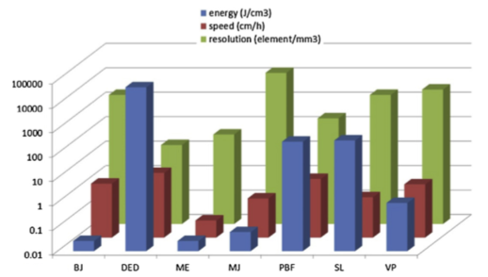
From analysis of the data, it would appear that powder bed fusion is the most suitable process for tool room application as a suitable resolution is achievable while also achieving a high build speed of 900-5000 cm³/hr, whereas laser powder forming is capable of 16-320 cm³/hr (CES Edupack, 2018). The high production rate of PBF can only be achieved however when multiple parts are produced in a single build envelope which increases the productivity of the process. Gibson (2015) also explains that the mechanical properties of SLS parts using polyamide-based powders are very good and can be similar to those of thermoplastic injection moulded parts. Additionally, any material that can be melted and re-solidified can be used in PBF processes.

Powder Bed Fusion Capabilities and Limitations
For polymer PBF, the loose powder is sufficient to act as a support material which enables advanced part geometries to be built that would require difficult post-processing using other AM methods (Gibson, et al., 2015). On the other hand, for metal processes, supports are generally required as high residual stresses mean that the supports stop the part from excessively warping due to heat. Figure 41 shows a test component that has been manufactured for Ford BEP using a titanium PBF process. Warpage has occurred due to the part peeling away from the substrate base material due to excess heat. Considering this, for the part to be manufactured reliably, a sufficient level of operator training and experience would be required to ensure that dimensional and geometric stability is achieved.
Figure 41 – PBF warpage
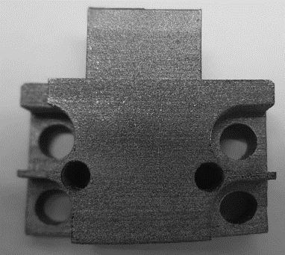
Accuracy and surface finish of PBF processes are strongly influenced by the powder particle size and the operating conditions (Eyers & Potter, 2017). Therefore, a finer particle size will produce a smoother finish and more accuracy, but the powder is more difficult to spread in layers and handle. Parts typically exhibit 3-4% shrinkage which should be compensated for in the design. Gibson (2015) explains that total construction time can be high with PBF due to pre-heat and cool-down cycles involved, though these can occur off-line which increases the machine productivity. On the other hand, when producing polymer parts, the ability to nest the components in 3-dimensions with no support structures means that many parts can be produced in a single build, greatly increasing the productivity of the process compared to processes that require support structures.

Hybrid Additive/Subtractive Manufacturing (Hybrid AM)
It could beneficial to use hybrid AM in the toolroom to manufacture components as the high deposition rates of wire-arc AM (WAAM) can be combined with the high tolerance and surface finish capabilities of CNC machining. Tabarnero et al. (2018) explains that processes such as gas metal arc welding (GMAW), gas tungsten arc welding (GTAW) or plasma arc welding (PAW) can be applied for additive manufacturing of steels, nickel superalloys, titanium alloys and aluminium. Flynn, et al. (2016) agrees that by combining AM and SM processes into a single workstation, the merits of each process can be harnessed. This process enables the manufacture of overhanging, internal and high aspect ratio component features with good surface characteristics and geometric accuracy.

Hybrid AM Capabilities and Limitations
Merklein, et al. (2016) explain that there are four AM deposition methods possible for hybrid AM. However, laser beam melting (LBM) cannot be integrated into a five-axis CNC station as the process is limited to an on-plane building platform. The three remaining AM deposition methods are listed with their main advantages and disadvantages in Table 11.
Table 11 – Hybrid AM deposition processes (Merklein, et al., 2016)
Additive Process | Advantages | Disadvantages
Laser Metal Deposition | Can be built on any freeform substrate | Risk of powder dust if the machine is opened.
Metal Powder Application | Minimal heat input so less chance of distortion | Risk of powder dust if the machine is opened
Gas Metal Arc Welding or WAAM | High build rate | Low build accuracy

Tabarnero, et al. (2018) claims that whereas selective laser melting (SLM) can deposit material at up to 0.1 kg/hr and LMD can deposit at up to 1 kg/hr, WAAM can deposit at rates up to 5-6 kg/hr. The low cost of welding equipment, the wide availability of standard wire feed stock and large part build sizes are also favourable for WAAM. On the other hand, WAAM has some limitations when compared to the powder processes including low surface resolution and high heat input, which can induce high residual stresses, leading to distortion. However, the application of subtractive machining to finish critical part features means the surface resolution is less important. A further useful capability of hybrid AM is the ability to repair components by adding material selectively and machining it back to specification. This reduces the need to produce an entire component in many instances, significantly reducing the lead time to completion.

Hybrid AM Machines
Many machine tool manufacturers including DMG MORI, ELB-Schliff, Matsuura, Mazak, Mitsui Seiki and Okuma have developed hybrid systems to integrate with their CNC offerings (Wright, 2018). Whereas hybrid add-ons can be purchased for installation onto existing CNC machines, machine tool manufacturers such as ELB-Schliff and Mazak offer Hybrid AM machines as standard integral units. The ELB-Schliff millGrind Hybrid AM machine (see Figure 42) uses a material jetting process to blow metal powder onto a substrate via an inert gas which is then melted by a laser, depositing material at a rate of 10-15 grams per minute. The secondary SM process involves CNC grinding which has an XYZ resolution of 0.1 micron. The capital cost of the machine is upwards of $250,000 (£192,000) (elb-Schliffe.de).
Figure 42 – ELB-Schliffe millGrind Hybrid AM DED (elb-schliffe.de)
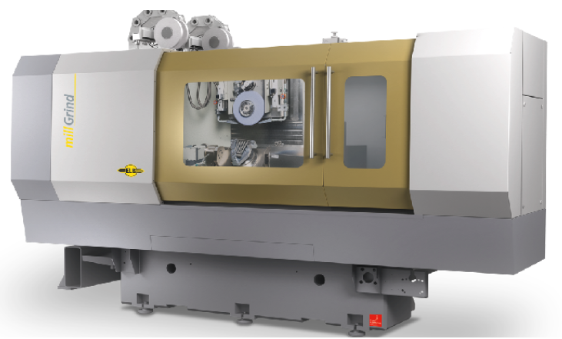
The Variaxis j600AM Hybrid Wire-Arc AM from Mazak (see Figure 43) is a 5-axis CNC machine with integrated WAAM capability that can build materials including aluminium, nickel, nickel alloys, copper, copper alloys and steel. High purity Argon is used as the inert gas for shielding the build location. Due to the infancy of WAAM technology, there is relatively little literature available and the process is not listed in the CES database. However, Appendix 22.5 shows an excerpt from the recently submitted BSI guide to WAAM that provides guidance on its capabilities (The British Standards Institution, 2019). While visiting to the manufacturing facility at Mazak in Worcester, UK (March 2019), the author was quoted a capital cost for the machine of approximately £350,000. The cost of this process is comparable to SLM and SLS in Figure 38. However, WAAM is considerably less expensive than laser powder forming (LPF) and EBM processes (CES Edupack, 2018).
Figure 43 – Variaxis j600AM Hybrid Wire-Arc AM (mazak.com)
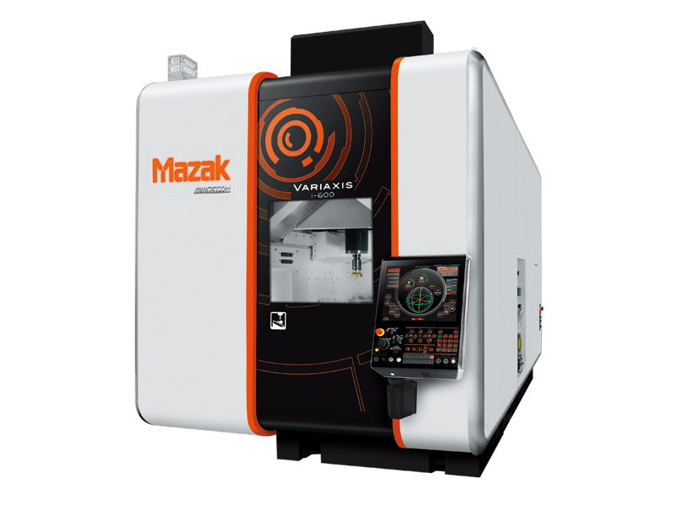
The INTEGREX i-400 AM from Mazak (see Figure 44) melts metal powder using fibre laser heat. This machine can manufacture the part to final specification with 5-axis CNC machining in a continuous operation. The capital cost of the machine is quoted as upwards of £600,000 (Mazak, 2018). According to the data in Figure 38, the capital cost of hybrid LMD is comparable to the upper price range of LPF and similar to EBM processes (CES Edupack, 2018). The high cost of hybrid LMD is primarily due to the high cost of the fibre laser as well as the cost of including CNC functionality within the process.
Figure 44 – Mazak INTEGREX i-400 AM (Mazak, 2018)
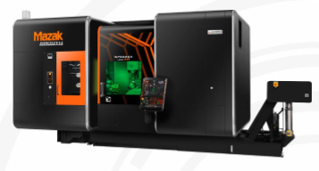

AM Process Selection Considerations
Pareto analysis of toolroom archived data (Figure 35) indicated that that the most benefit could be gained by adopting a metal AM process as the majority of high priority work (62.3%) is constructed of mild steel. Therefore, if high priority work can be manufactured significantly faster than the existing CNC method, costs incurred to the company due to downtime can be significantly reduced, improving the cost efficiency of the toolroom department. There could be a need to introduce a polymer AM method, however only 27.4% of nylon components were high priority jobs. Therefore, a polymer AM process would not improve cost efficiency to the extent of a metal AM process. On the other hand, the lower cost of polymer AM compared to metal AM can mean there is a cost benefit to be gained by adopting both technologies. For plastic AM, a SLS process appears to be the most suitable as dimensional accuracy is high and the structural properties are more suitable for engineering application, whereas FDM is probably not suitable due to inherent problems with anisotropy and delamination as a result of the layered construction (Gibson, et al., 2015).
It is evident that the greatest improvement in manufacturing lead time can be gained by reducing the reliance on material acquirement. Figure 29 showed that this activity accounted for 67.3% of lead time in the existing CNC process. AM can reduce the reliance on external material suppliers, as common feedstock material is used to construct any component shape or size. It would be necessary to only keep adequate inventory of feedstock material types that are used in the toolroom. However, for hybrid AM, part features are constructed onto a substrate base material (Mazak, 2018). Therefore, it would be beneficial to keep a small selection of rectangular material sizes on-hand for this purpose.
Considering the three process categories of hybrid AM, the high build rate of WAAM could be the most desirable as this has the most potential to significantly reduce the lead time of component manufacture in the toolroom. Adopting WAAM would require the purchase of a hybrid machine that has 5-axis CNC capability with the inclusion of AM technology. This investment could be further justified as the machine can also operate as a standard CNC milling machine. It can be considered that the existing CNC machines in the toolroom are nearing the end of their useful life and are entering the wear-out phase of their operating life. Ahmad & Kamaruddin (2012) explains that equipment experiences increasing failure rates in the wear-out phase and replacement can be necessary to increase reliability (see Figure 45). Therefore, as well as providing AM capability, the purchase of a hybrid AM machine could replace the existing worn-out CNC machine to increase the reliability of the CNC milling process.
Figure 45 – Bathtub curve (Ahmad & Kamaruddin, 2012)
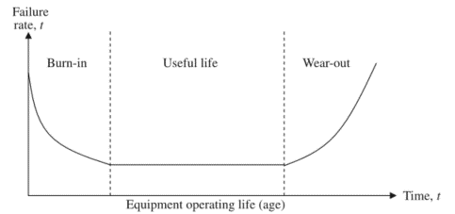

AM Process Selection Results
To determine the most appropriate AM method for toolroom application, Table 12 has been constructed that considers the significant criteria of each AM process. Five AM processes have been selected due to their apparent suitability for toolroom application. Each criterion has been assigned a rating according to the AM research conducted which ranges from 1 (not suitable) to 10 (very suitable). Further to this, each criterion has been assigned a weight value ranging from 0 (not important) to 1 (very important). The score for each of the criteria are determined by multiplying the rating by the weight. Further to this, the overall score for each AM process is determined by adding the scores of each of the process criteria together. The maximum attainable score for each process is 49, which is used to calculate the suitability of each process as a percentage in Table 13 and Figure 46.
The table reveals that the most suitable AM method for the toolroom is hybrid WAAM with a score of 83.3%. PBF metal, SLS polymer and hybrid laser powder processes scored in the range of 61 - 62.1% whereas FDM is the least suitable of the five selected processes with a score of 50.6%.

Table 12 – AM process selection using significant criteria for toolroom application
AM Process | Production rate |  |  | Surface resolution |  |  | Dimensional accuracy |  |  | Capital cost |  |  | Material utilisation |  |  | Structural strength |  |  | Material range |  |  | Overall Score
AM Process | Rating | Weight | Score | Rating | Weight | Score | Rating | Weight | Score | Rating | Weight | Score | Rating | Weight | Score | Rating | Weight | Score | Rating | Weight | Score | Overall Score
PBF metal | 6 | 0.9 | 5.4 | 7 | 0.7 | 4.9 | 6 | 0.9 | 5.4 | 5 | 0.7 | 3.5 | 5 | 0.2 | 1 | 6 | 0.9 | 5.4 | 8 | 0.6 | 4.8 | 30.4
Hybrid WAAM | 10 | 0.9 | 9 | 7 | 0.7 | 4.9 | 8 | 0.9 | 7.2 | 7 | 0.7 | 4.9 | 8 | 0.2 | 1.6 | 10 | 0.9 | 9 | 7 | 0.6 | 4.2 | 40.8
Hybrid Laser Powder | 3 | 0.9 | 2.7 | 9 | 0.7 | 6.3 | 8 | 0.9 | 7.2 | 1 | 0.7 | 0.7 | 5 | 0.2 | 1 | 8 | 0.9 | 7.2 | 8 | 0.6 | 4.8 | 29.9
SLS polymer | 7 | 0.9 | 6.3 | 8 | 0.7 | 5.6 | 6 | 0.9 | 5.4 | 4 | 0.7 | 2.8 | 5 | 0.2 | 1 | 6 | 0.9 | 5.4 | 6 | 0.6 | 3.6 | 30.1
FDM plastic | 4 | 0.9 | 3.6 | 4 | 0.7 | 2.8 | 5 | 0.9 | 4.5 | 10 | 0.7 | 7 | 9 | 0.2 | 1.8 | 3 | 0.9 | 2.7 | 4 | 0.6 | 2.4 | 24.8

Table 13 – AM Process selection results
Rank | Process | Suitability
1 (Most suitable) | Hybrid WAAM | 83.3%
2 | PBF Metal | 62.1%
3 | SLS Polymer | 61.4%
4 | Hybrid Laser Powder | 61.0%
5 (Least suitable) | FDM Plastic | 50.6%

Figure 46 – Chart of suitable AM processes

Chapter 3: Optimisation of the Additive Manufacturing Process

Design for Additive Manufacturing (DfAM)
DfAM is the practise of designing and optimising a product to reduce development time, cost or performance (Thompson, et al., 2016). The component used for the VSM study in Figure 25 will be modified using topology optimisation in Solidworks CAE software to reduce the mass of the component while maintaining maximum stiffness of the structure. Topology optimisation can be a very useful tool within CAE as material is shifted within a prescribed design space in order to obtain optimal structural efficiency (Sigmund & Maute, 2013). The TO method makes use of repeated iterations of design updates which are guided by gradient computation.
Lin, et al. (2014) explain that using powder and deposition type AM processes, the production time and cost of the resulting model is directly related to the volume of material employed in the manufacturing process. Therefore, it is preferable to design cost effective 3D components to reduce the volume of build material but maintain acceptable levels of performance. Langelaar (2016) adds that the enormous geometric freedom AM offers compared to traditional manufacturing provides many opportunities to create optimised components whereby form follows functionality. This section will investigate the opportunity to optimise the design of components to be produced more efficiently using AM.

Topology Optimisation Study
The aim of the TO study is to reduce the mass volume of the component while maximising the stiffness of the structure. To do this, the loading and constraints that the part exhibits in operation needs to be known so that the load paths can be calculated (Langelaar, 2016). Figure 47a shows the original CAD model which has been constructed from information in the engineering drawing in Figure 24. In this instance, the construction of the 3D model was necessary as the model was not accessible to the author from the Ford drawing database. However, with appropriate access rights, the 3D model can be downloaded directly, further reducing the duration of the TO process.
A static simulation study has been carried out within Solidworks to set the initial conditions for the TO study. Figure 47b shows that the bolt holes have been fixed in 6 degrees of freedom and the clamping face has been applied with a total estimated force of 100N to simulate the clamping force of the part when in operation.
Figure 47 – (a) original design (b) with load and fixtures applied
a.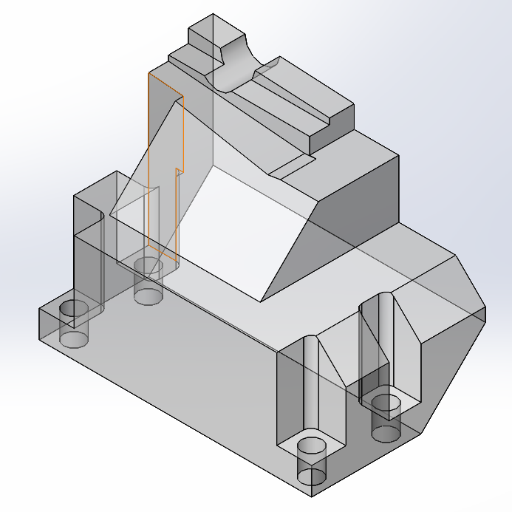b.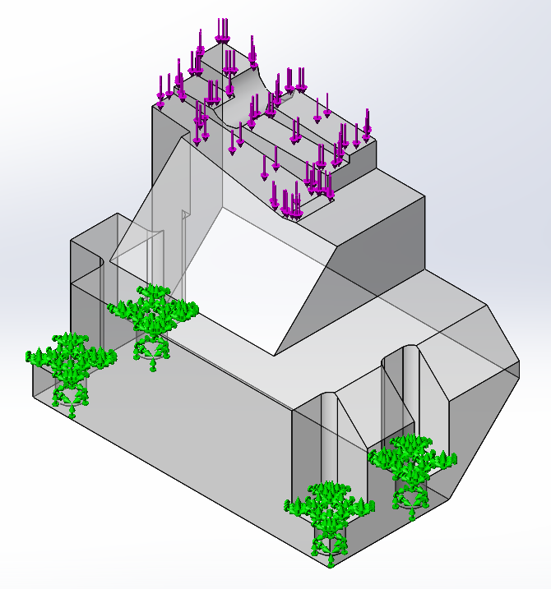
Once the loading conditions and fixtures have been set, the goals and constraints of the TO study are specified in the study. In this case, the goal is to maintain the best stiffness to weight ratio and reduce the mass of the part by 50%. Figure 48a shows the results of the topology study which has generated an organic shape whereby the material follows the load paths through the part. Similarly, Figure 48b shows the results of the FE mesh in which elements have migrated from areas of low stress to areas of high stress.
Figure 48 – (a) topology optimisation results (b) finite element mesh
a.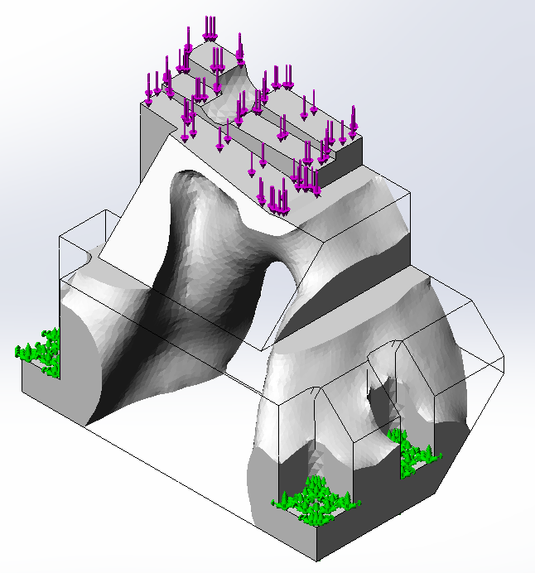b.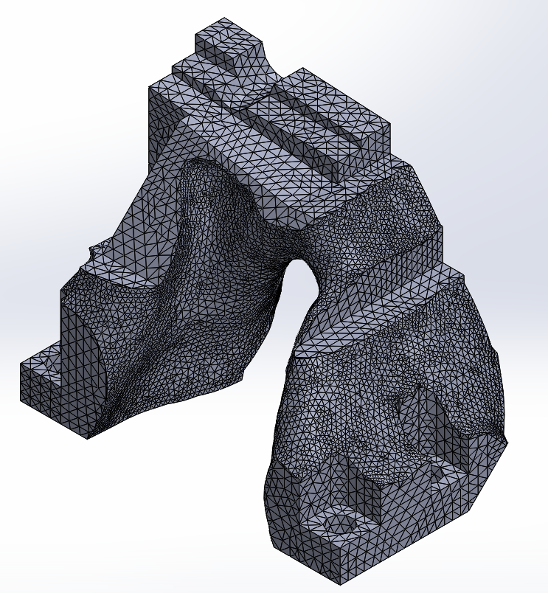
Whereas AM is capable of manufacturing organic shapes, it is more beneficial to represent the optimised part as a geometric part so that it can be presented on an engineering drawing. Also, the file size required for geometric parts can be significantly smaller than organic structures as the regular features enables more efficient file encoding (Langelaar, 2016). Figure 49 displays the geometric representation of the TO study which has been modified by extruding cuts through the part in three dimensions that closely follow the contours of the TO results. It is shown by this method that a 29% mass reduction can be achieved which could result in a significant reduction in AM build time.
Figure 49 – Geometric interpretation of the topology study
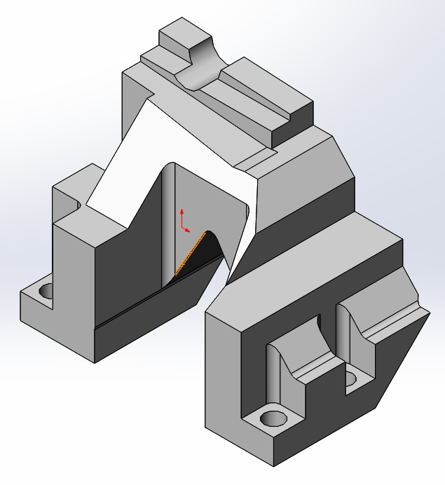
A static simulation study has been carried out on the original and optimised parts to determine the Von Mises stress distribution and maximum displacement of each part. The maximum stress in the optimised part is 3.34e+05 N/m². This is just 0.24% of the yield strength of Nylon 6/10 (1.39e+08 N/m²) (Solidworks, 2018) which demonstrates that the part is capable of withstanding forces much larger than the clamping force estimate.
Figure 50 – Von mises stress analysis before and after optimisation
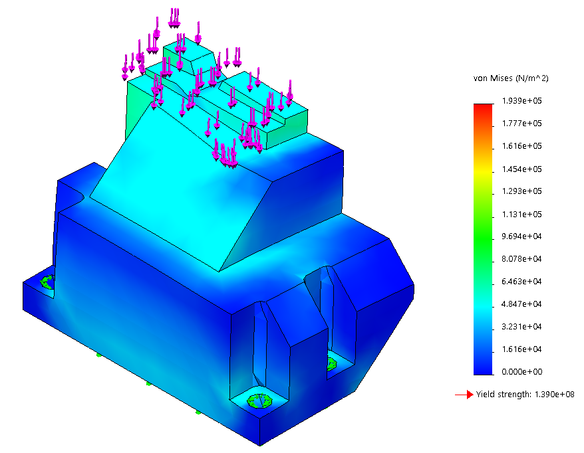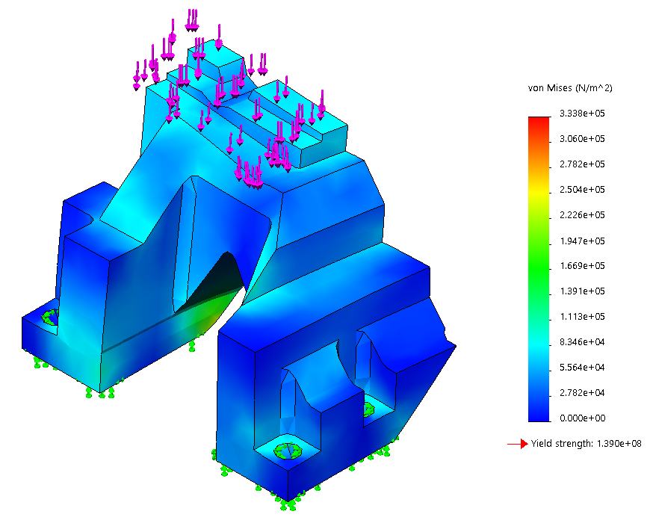
The stiffness of the structure can be determined using Hooke’s law F = k x, whereby the force, F, and the displacement, x, are proportional when the strain is within the elastic limit of the material (Oxford University Press, 2009). The weight, which is a force, is calculated by multiplying mass and gravity using Newton’s second law of motion, F = ma. The stiffness-to-weight ratio can determine how efficiently the part is utilising its construction material.
Considering this, the stiffness-to-weight ratios for the original and final design are calculated in Table 14.
Table 14 – Stiffness-to-weight ratio calculations
 | Original Design | Optimised Design
Mass | =0.52 Kg | = 0.37 Kg
Reaction force | =100 N | = 100 N
Maximum displacement | =1.619e-3 m | = 2.210e-3 m
Stiffness | =100/1.619e-3  = 61,767 N/m | = 100/2.210e-3  = 45,248 N/m
Stiffness-to-weight Ratio | 61,767/ (0.52x9.81)  = 12,108 N Kg/m | = 43,290/ (0.37x9.81)  = 12,466 N Kg/m

Figure 51 – Mass of original and optimised designs

Table 15 compares the results from the original and optimised designs. It shows that the TO process has reduced the mass of the component by 29% (see Figure 51) and the stiffness-to-weight ratio has been improved by 3%. On the other hand, the stiffness has decreased by 27% which has caused the maximum displacement to increase by 27%. However, the displacement is only a 0.6mm increase which can be considered negligible as the maximum stresses are significantly below the yield strength of the material.
Table 15 – Comparison of TO results of original and optimised designs
Feature | Optimised Design
Mass | 29% reduction
Maximum displacement | 27% increase
Stiffness | 27% decrease
Stiffness-to weight ratio | 3% increase

It should be noted that the time taken to carry out the TO study was 45 minutes which does not include creating the 3D model from the drawing. However, this duration can be improved over time as the user becomes more proficient with using the DfAM method.

Additive Manufacturing of Original and Optimised Parts
The original and optimised parts in Figure 47a and Figure 49 have been manufactured using the AM equipment available to the author at the time of the study. The machine is a RAISE3D Pro2 Plus fused deposition modelling (FDM) machine (see Figure 52) that retails at approximately £5000 (technologyoutlet.co.uk). FDM is a material extrusion process (see Appendix 22.4.3, page 100) for plastics that is used as a proof of concept for the TO process in this study. It can be considered that by reducing the mass of the component using DfAM, the print time can be reduced. However, the time taken to carry out the optimisation process needs to be considered to determine if the process is beneficial. Figure 52b shows the base and support structures being constructed during manufacture.
Figure 52 – AM of parts using FDM machine in Ford BEP
a.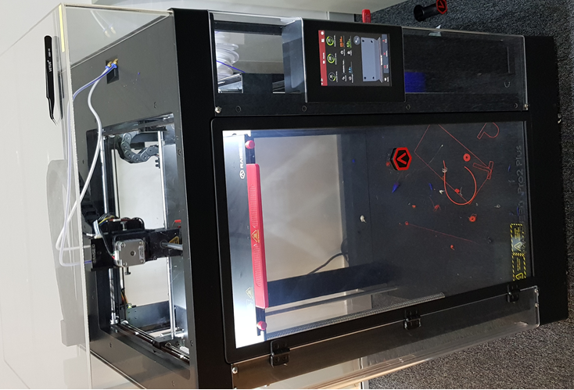 b.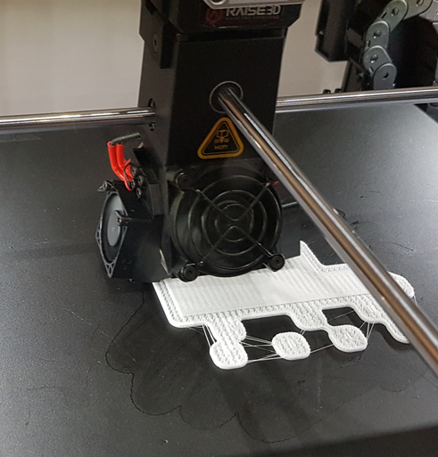
Using the FDM process, the original and optimised part (Figure 53) have been manufactured to determine the print times (appendix 22.6, page 106). Table 16 shows the difference in print times for 30% and 100% infill settings.
Table 16 – Print time results
 | Print time: 30% infill | Print time: 100% infill
Original part | 575 min | 1917 min
Optimised part | 483 min | 1610 min
Time Difference | 92 min | 307 min

Figure 53 – (a) Original and (b) optimised parts produced using FDM AM process
a.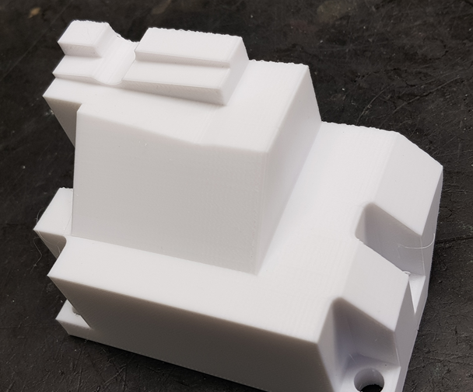 b. 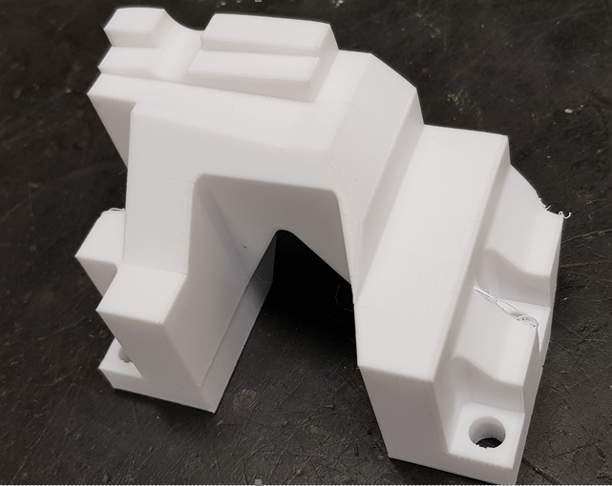
It should however be noted that the FDM process requires support structures to be built for overhanging features, so the optimised part will require more material than if it is carried out on an SLS machine which uses the surrounding powder as a support structure (Gibson, et al., 2015).
The infill settings were set to 30% for the test builds (see Appendix 22.7 for infill density settings). To manufacture a fully dense (100%) structure, the build time would increase to 1917 minutes for the original part and 1610 minutes for the optimised part, an increase of 307 minutes. Considering that the duration of the DfAM process is 45 minutes, then producing a 30% infill optimised part is 47 minutes faster than an original part, whereas a 100% dense optimised structure is 262 minutes faster. The chart in Figure 54 shows that for a less dense infill setting, the difference in build time between original and optimised is small. However, for higher density infill, the difference in build time can be much larger so it would be beneficial to use the DfAM process in this case as the reduction in lead time would be significant.
Figure 54 – Chart of build time at various infill settings

Chapter 4: Analysis of Results and Discussion

Ideal State VSM Construction
An ideal state VSM has been constructed to show how the number of process steps can be reduced with the introduction of AM. The FDM process used to manufacture the AJ Supercharger RH Clamp Jaw has been used as proof of concept for the purpose of this study. Figure 55 shows that the number of process steps has been reduced from seven to five, and the external material supplier has been eliminated as AM uses a common feedstock material to produce any size component. Therefore, a suitable inventory level of feedstock materials should be kept on-hand in the toolroom which should be replenished when it drops below a minimum level.
The VSM includes the DfAM optimisation process step which can reduce the overall build time by more than the DfAM process duration. The duration of the DfAM step is 45 minutes which needs to be added to the build time. However, the DfAM process only needs to be carried out once for each separate batch quantity of parts. Therefore, the reduction in material mass as a result of the DfAM process results in an overall reduction of lead time.

SM and AM Results Comparison
This project has proposed methods to optimise the SM process and AM process to reduce the lead time so that they can be compared in their optimum conditions. Figure 56 is a chart that plots the lead time of parts at various quantities for the SM and AM processes. The chart shows that the results of the original and optimised AM processes diverge as the batch quantity increases, primarily due the reduction in build time caused by the DfAM process. This shows that as the batch quantity increases, the lead time to produce the AM optimised part progressively becomes more economical than building the original design.
The optimised SM process can improve the lead time compared to the original SM process mainly due to a reduction in the duration of the non-value-added process steps. The chart shows that as the batch quantity increases, the lines are almost parallel which can be explained due to minimal improvements in the value-added steps. The shallow gradient of the SM line compared to AM line indicates that the process is more economical than SM for producing high batch quantities.

Figure 55 – Ideal state VSM

Figure 56 – Chart of lead time to completion for various batch quantities

Optimised Results Comparison
The economy of the optimised AM process can be determined by comparing it with the optimised SM process. In Figure 57, the lead time to completion for various batch quantities are shown. For a 1-off quantity component, the lead time to completion for AM is 543 minutes, whereas SM is 64% higher at 1523 minutes. In this case an AM would be the most efficient process. However, for a quantity of 10 components, the lead time for completion for AM is 4890 minutes, whereas SM is 50% lower at 2441 minutes making the SM process more efficient. However, the point at which the two lines intersect can determine the critical batch quantity above which SM is should be used and below which AM should be used (indicated by X in Figure 57). In this case, it can be deduced that if the batch quantity is 3 or below, the optimised AM process should be used whereas if the batch quantity is 4 or above, the optimised SM process should be used.
It should be stressed that this value has been deduced using the FDM process to produce a specific component. Therefore, the critical quantity would be different depending on the combination of AM process used and part manufactured. However, the results show that when producing a 1-off quantity component, AM is significantly more efficient than SM so it is likely that the lead time for most high priority jobs would be reduced in any circumstance.
Figure 57 – Chart of optimised SM and AM processes for various part quantities
x

Cost Analysis
The cost of downtime due to a breakdown was calculated as £44,024 per hour in section 10.1.2 (page 36) which was calculated by adding the cost of labour per hour to the cost of lost production. It was estimated that 20 hours of production per annum are lost due to breakdowns which are reliant on the completion of a part manufactured on the CNC mills. Therefore, the total cost of downtime is calculated as:
20 x £44,024 = £880,480 per annum
Considering that an optimised SM process can achieve a 22.1% reduction in lead time then the total cost saving of optimised SM implementation can be calculated as:
£880,480 x 22.1% = £194,586 per annum
However, for a 1-off quantity component, the optimised AM process lead time is a 64% improvement over the optimised SM process. Therefore, the total cost saving of implementing an optimised AM process, which considers that breakdowns are generally 1-off quantity components, can be calculated as:
£194,586 + (£194,586 x 64%) = £319,121 per annum
However, it should be considered that if the batch quantity of high priority components is higher than 1, the margin of cost savings will gradually reduce due to the increase in the lead time.

Management of Change
It is important that any change is managed effectively in the workplace to ensure a smooth transition to a new way of working. The introduction of an AM process to the toolroom is a fundamentally different method to the normal working practises of the toolroom. It would be beneficial to employ Kotter’s 8 step model for change as it offers a more comprehensive approach by considering more factors associated with change compared with Lewin’s 3 step model (see Appendix 22.3, page 95). Pollack & Pollack (2015) claims that Kotter’s model is recognised as one of the most effective methods to organise change in industry.
To carry out the change in the toolroom, the following steps can be taken according to Kotter’s model (Kotter, 2012):
- Awareness of the need for AM should be communicated from management to the toolroom employees to help them understand the economic benefits that can be gained from implementing the change.
- A coalition group should be formed to lead the change that includes skillsets from management, technicians and toolroom employees.
- A suitable vision and strategy should be developed that includes considering the different age groups of staff within the toolroom. Younger employees are often more willing and able to learn new skills than the older employees. However, older employees have certain skills that can be transferred to new ways of working.
- It is important that the vision and strategy is clearly communicated to the workforce. This could involve senior management to provide examples of the importance of the need to invest in new technology and remain competitive.
- Any obstacles that inhibit change can be removed by providing adequate training and support.
- Short term wins can be generated by breaking the entire change program into smaller achievable steps to realise accomplishment at regular intervals.
- Any gains made need to be consolidated by ensuring that they are built upon to facilitate a progressive change.
- Finally, once the AM process has been established within the toolroom, the new method of working needs to be reinforced to become part of the workplace culture.
It is evident in Ford BEP that there is a need for greater integration between production staff, supervision and management as one of the key factors to successful change is effective communication. Therefore, a greater sense of teamwork can be achieved by establishing open communication between the different levels of staff in regular meetings during the change.
It can be considered that the successful change depends on the dedicated motivation of all levels of staff which can help cement it to become the new normal way of working. The toolroom workforce has been using the same methods of working for 40 years so a deeply entrenched workplace culture exists. The transition from SM to AM is likely to appeal to the younger employees who are ambitious to learn new skills whereas older employees are generally set in their ways and less willing to learn new skills at a late stage in their career. Mullins (2016) argues that management should identify the factors that can motivate their employees on an individual level so that the change can be successful, not only for the toolroom, but for the organisation in its entirety.

Chapter 5: Conclusions and Recommendations

Conclusions
To conclude, the current SM method has been optimised using a current state and future state VSM to facilitate the implementation of lean principles. Using this method, a 22.1% improvement in lead time has been identified which could generate cost savings of £194,586 per annum as a result of reduced downtime. Further to this, the introduction of an AM process to produce low batch quantity components can potentially reduce annual costs by £319,121 as the lead time to completion for 1-off quantity components is shown to be 64% faster than the optimised SM. Whereas most high priority jobs in the toolroom are manufactured in 1-off quantities, an optimised AM method would be more beneficial than the current method as the duration of downtime instances in the plant can be reduced.
This project has demonstrated that AM can be used in the toolroom to produce parts faster and more economically than the current SM method. However, the economy of the process depends on the batch quantity of parts being less than a critical value determined by the type of work (volume, complexity, specification) and type of AM process used. A polymer FDM process was used for the purpose of this study in which the critical value was calculated as 3.5. In this scenario, the AM process is more economical for a quantity of 3 or less components whereas SM remains more economical for 4 or more components. It should be noted however that the critical value obtained is specific to the conditions of this study, so it is likely to vary depending on the type of job and the type of AM process used.
The study researched the various AM methods to determine their suitability to toolroom application and found that the most suitable method is hybrid WAAM primarily due to the high material construction rate and the capability to achieve high tolerances and surface finish as a result of the added SM functionality. It was discovered that most high priority work in the toolroom is constructed of mild steel so this AM process would be beneficial to reduce the duration of most downtime instances. The added CNC functionality can also replace the current CNC machines in the toolroom, improving reliability of the SM process. In addition, hybrid AM machines can repair damaged or worn components by selectively adding material and machining it back instead of making new. Further to this, PBF metal and SLS polymer have been identified as processes which could be beneficial as they satisfied many of the criteria relevant to the toolroom.
The ideal state VSM was constructed to show how an AM process can significantly reduce lead time by reducing non-value-added time that currently exists in the process. This has mainly been achieved by eliminating the need for an external material supplier, as common feedstock material can be used to make any size component using AM. It was also found that the number of process steps can be significantly reduced to improve continuous flow in the process.
Through implementation of DfAM, it was shown how the component mass can be reduced while its stiffness remains within acceptable levels to function. It was found that by reducing the mass volume, the lead times can be improved using AM. Considering that the DfAM process took 45-minutes to carry out, the lead time can be marginally improved compared to the original AM process when manufacturing a 1-off component. However, as the batch quantity increases, the lead time improvement becomes more beneficial due to the reduction in cycle time. On the other hand, when considering the original and optimised SM processes, the margin of lead time improvement does not significantly change as the batch quantity increases. This is due to the improvements mainly being made to the setup stage whereas only marginal improvements have been made to cycle time.
It is calculated that £319,121 per annum can be saved by implementing optimised AM whereas the capital cost of a hybrid WAAM machine from Mazak is approximately £350,000 (Mazak, 2018), meaning that the capital investment could be recovered within 13 months of successful AM operation. Also, it can be considered that the added capability of the hybrid AM machine would increase the productivity of the toolroom, enabling recovery the capital investment sooner than anticipated.
It has been identified that the transition to a new method of working can be challenging so this needs to be considered to maximise the cost benefits of the project. Kotter’s model for change can provide the steps needed to methodically facilitate a successful change, as many change initiatives can fail due to inappropriate planning and poor management.
There are many opportunities that arise from implementing AM due to the numerous possibilities it offers compared to traditional manufacturing. Whereas industrial AM technology is still in its infancy, recent advances indicate that the technology is heading towards mainstream adoption. There are limitations to the technology, such as poor surface finish and warpage, which can be addressed by utilising a secondary SM process or by integrating with SM to form a hybrid AM process. Whereas SM is capable of high accuracy and dimensional stability, AM utilises material more efficiently and complex shapes can be constructed more readily. The combination of AM and SM into a single workstation can exploit the merits of each process to provide a solution to many problems that exist in manufacturing today. It can be concluded that through successful adoption of this new technology, the Ford BEP toolroom can become more productive, increasing the efficiency and flexibility of the plant, and ultimately increasing profits for the company as a whole.

Recommendations

Short Term (0-3 months)
The recommendation in the short term is to implement the SM optimisation process by introducing lean principles. This can be implemented in a short timescale as it includes finding solutions that are easy to implement with relatively little effort needed. The process will require full participation from the toolroom employees and management alike. This could include setting up regular meetings to ensure the lean project is implemented correctly and any improvements that are put in place are maintained with regular inspections. It is important that 5S is maintained and a suitable local material supplier is sourced to reduce the lead time to an acceptable level.

Medium Term (3-6 months)
In the medium term it would be recommended to invest in a WAAM machine to replace the V4 CNC mill in the toolroom. This would add the AM functionality as well as improve the CNC capabilities. It would be beneficial to ensure employees are adequately trained during this period which will involve additional expense. However, to gain maximum benefit from the machine, a suitable level of competency needs to be gained by the programmers and operators. During this time, it would be recommended to allow employees from each shift to explore the capabilities of the machine by manufacturing a range of jobs.

Long Term (6+ months)
In the long term it would be recommended to invest in a polymer SLS machine to increase the range of material capability for AM to more than 75% of the materials used in the toolroom (Figure 33). This increased capability to print polymer parts will also have the benefit of increasing the availability of the CNC machines to focus on producing high priority work.
Depending on the successful introduction of the first WAAM machine, it would be recommended to purchase a second WAAM machine to replace the V5 CNC. This would provide the toolroom with increased metal AM capability as well as completely replacing the worn-out CNC machines, further improving the reliability of the process. At this stage, this introduction will benefit from the increased competency of trained toolroom employees to ensure the full capability of the hybrid AM technology is realised.
It is important that any adopted lean principles are transferred to the hybrid AM process to maximise productivity. At this stage, it would be recommended to carry out a new VSM study on the hybrid AM process to ensure that any non-value-added activities are minimised to further reduce the lead time.

References
3D Systems, 2018. ProJet MJP 2500/2500 Plus. [Online]
Available at: https://uk.3dsystems.com/3d-printers/projet-mjp-2500-series
[Accessed 5 December 2018].
Aboelmaged, M. G., 2010. Six Sigma Quality: A Structured Review and Implications for Future Research. The International Journal of Quality & Reliability Management, 27(3), pp. 269-318.
Additive Manufacturing, 2018. [Online]
Available at: additivemanufacturing.com
[Accessed 5 December 2018].
Ahmad, R. & Kamaruddin, S., 2012. An overview of time-based and condition-based maintenance in industrial application. Computers & Industrial Engineering, 63(1), pp. 135-149.
Attaran, M., 2017. The Rise of 3D Printing: The Advantages of Additive Manufacturing over Traditional Manufacturing. Business Horizons, Volume 60, pp. 677-688.
Berardinelli, C. F., 2012. To DMAIC or Not to DMAIC?. [Online]
Available at: http://asq.org/quality-progress/2012/11/back-to-basics/to-dmaic-or-not-to-dmaic.html
[Accessed 7 August 2018].
Bozzone, V., 2001. Speed to market : lean manufacturing for job shops. s.l.:AMACOM/American Management.
Burnes, B., 2014. Managing Change. Sixth ed. London: Pearson.
Carroll, B. E., Palmer, T. A. & Beese, A. M., 2015. Anisotropic tensile behavior of Ti–6Al–4V components fabricated with directed energy deposition additive manufacturing. Acta Materialia, Volume 87, pp. 309-320.
CES Edupack, 2018. Cambridge, UK: Granta Design Ltd.
Chahal, V. & Narwal, M. S., 2017. An empirical review of lean manufacturing and their strategies. Management Science Letters, 7(7), pp. 321-336.
Chen, J. C., Li, Y. & Shady, B. D., 2010. From value stream mapping toward a lean/sigma continuous improvement process: an industrial case study. International Journal of Production Research, 48(4), pp. 1069-1086.
Chowdhury, A. H., Shahriar, S., Hossen, T. & Mahmud, P., 2016. Reduction of Process Lead Time Using Lean Tool - Value Stream Mapping (VSM). Applied Mechanics and Materials, Volume 860, pp. 74-80.
Crawford, M., 2016. 5 Lean Principles Every Engineer Should Know. [Online]
Available at: www.asme.org
[Accessed 12 June 2018].
Cudney, E. A. & Agustiady, T. K., 2016. Design for Six Sigma. 1st ed. Boca Raton: CRC Press .
Cummings, S., Bridgman, T. & Brown, K., 2016. Unfreezing Change as Three Steps: Rethinking Kurt Lewin's Legacy for Change Management. Human Relations, 69(1), pp. 33-60.
Dana, B. G., 2015. 5S IN QUALITY MANAGEMENT. Annals of the University of Oradea, 25(1), pp. 1297-1306.
Davim, J. P., 2018. Progress in Lean Manufacturing. New York: Springer.
De Freitas, J. G., Costa, H. G. & Ferraz, F. T., 2017. Impacts of Lean Six Sigma over Organizational Sustainability: A Survey Study. Journal of Cleaner Production, Volume 156, pp. 262-275.
Debroy, T. et al., 2018. Additive manufacturing of metallic components – Process, structure and properties. Progress in Materials Science; Progress in Materials Science, Volume 92, pp. 112-224.
envisiontec, 2019. Large Format 3D Printer for Industrial Composites. [Online]
Available at: www.envisiontec.com
[Accessed 2 March 2019].
envisionTEC, 2019. Perfactory P4K. [Online]
Available at: envisiontec.com
[Accessed 2 March 2019].
eos, 2019. EOS P 500. [Online]
Available at: https://www.eos.info
[Accessed 3 March 2019].
ExOne, 2018. M-Print™ Industrial Production 3D Printer. [Online]
Available at: https://www.exone.com/Systems/Production-Printers/M-Print
[Accessed 4 December 2018].
Eyers, D. & Potter, A., 2017. Industrial Additive Manufacturing: A Manufacturing Systems Perspective. Computers In Industry, Volume 92-93, pp. 208-218.
Flynn, J. M., Shokrani, A., Newman, S. & Dhokia, V., 2016. Hybrid additive and subtractive machine tools – Research and industrial developments. International Journal of Machine Tools & Manufacture, Volume 101, pp. 79-101.
Ford 6-Sigma, 2006. Green Belt Training, Dearborn: Ford Motor Company.
Ford Motor Company, 2018. About Ford. [Online]
Available at: www.ford.com
[Accessed 8 February 2018].
Ford Motor Company, 2018. Global Rapid Manufacturing Centers. Dearborn: Ford Intranet.
Ford Motor Company, 2019. Ford Motor Company Intranet, Dearborne: Ford.
George, M., Rowlands, D., Maxey, J. & Price, M., 2005. The Lean Six Sigma Pocket Toolbook. London: McGraw-Hill.
Gibson, I., Rosen, D. W. & Stucker, B., 2015. Additive manufacturing technologies : 3D printing, rapid prototyping and direct digital manufacturing. Second ed. New York: Springer.
Herron, C. & Hicks, C., 2008. The transfer of selected lean manufacturing techniques from Japanese automotive manufacturing into general manufacturing (UK) through change agents. Robotics and Computer-Integrated Manufacturing, Volume 24, pp. 524-531.
Hider, J., 2018. 3D Printer Enables Toolmaker to Produce Fixturing. Modern Machine Shop, 90(12), pp. 108-112.
HP, 2019. HP Jet Fusion 3D 4210 Printing Solution. [Online]
Available at: www.hp.com
[Accessed 2 March 2019].
Imp, S., 2011. USING LEAN AND 5S TO DRIVE MANUFACTURING PROCESS IMPROVEMENTS. Quality, 50(9), pp. 30-33.
Iowa State University, 2017. Force Field Analysis. [Online]
Available at: http://www.extension.iastate.edu/communities/force-field-analysis
[Accessed 26 January 2017].
Kazmierski, R., 2016. Key Factors That Affect 5S Implementation in the Automotive Industry. The Journal for Quality and Participation, 39(2), p. 13.
Kocovic, P., 2017. 3D printing and its impact on the production of fully functional components: emerging research and opportunities,. Hershey, PA: Engineering Science Reference.
Kotter, J. P., 2012. Leading Change. Boston: Harvard Business Review Press.
Kumar, S., Dhingra, A. & Singh, B., 2018. Process improvement through Lean-Kaizen using value stream map: a case study in India. The International Journal of Advanced Manufacturing Technology, 96(5), pp. 2687-2698.
Langelaar, M., 2016. Topology optimization of 3D self-supporting structures for additive manufacturing. Additive Manufacturing, Volume 12, pp. 60-70.
Lean Enterprise Institute, 2018. Principles of Lean. [Online]
Available at: www.lean.org
[Accessed 5 July 2018].
Li, L., Haghighi, A. & Yang, Y., 2018. A novel 6-axis hybrid additive-subtractive manufacturing process: Design and case studies. Journal of Manufacturing Processes, Volume 33, pp. 150-160.
Lin, L. et al., 2014. Build-to-Last: Strength to Weight 3D Printed Objects.. CM Transactions on Graphics, 33(4), pp. 1-10.
Liu, J. et al., 2018. Current and future trends in topology optimization for additive manufacturing. Structural and Multidisciplinary Optimization, 57(6), pp. 2457-2483.
Liu, J. & To, A. C., 2017. Topology optimisation for hybrid additive-subtractive manufacturing. Structural and Multidisciplinary Optimization, 55(4), pp. 1281-1299.
Locker, A., 2018. 2018 Metal 3D Printer Guide – All About Metal 3D Printing. [Online]
Available at: https://all3dp.com/1/3d-metal-3d-printer-metal-3d-printing/
[Accessed 25 November 2018].
Loughborough University, 2018. About Additive Manufacturing. [Online]
Available at: https://www.lboro.ac.uk/research/amrg/about/the7categoriesofadditivemanufacturing
[Accessed 4 December 2018].
Lu, L., Sharf A & Haisen Z, 2014. Build-to-last: Strength to weight 3D printed objects. ACM Transactions on Graphics, 33(4), pp. 1-10.
Mançanares, C. G., Zancul, E., Cavalcante da Silva, J. & Cauchick Miguel, P. A., 2015. Additive manufacturing process selection based on parts’ selection criteria. The International Journal of Advanced Manufacturing Technology, 80(5), pp. 1007-1014.
Manogharan, G., Wysk, R. A. & Harrysson, O. L., 2016. Additive manufacturing-integrated hybrid manufacturing and subtractive processes: economic model and analysis. International Journal of Computer Integrated Manufacturing, 29(5), pp. 473-488.
Martin, K. & Osterling, M., 2014. Value Stream Mapping: How to visualise work and align leadership for organisational transformation. London: McGraw-Hill.
Marzagão, D. & Carvalho, L., 2016. Critical success factors for Six Sigma projects. International Journal of Project Management, 34(8), pp. 1505-1518.
Maylor, H., 2010. Project management. 4th ed. Harlow: Harlow : Financial Times Prentice Hall.
Mazak, 2018. Hybrid Additive Manufacturing, Worcester: Yamazaki Mazak.
Mcor technologies, 2019. ArkePro Office 3D Printer. [Online]
Available at: www.mcortechnologies.com
[Accessed 3 March 2019].
Merklein, M., Junker, D., Schaub, A. & Neubauer, F., 2016. Hybrid additive manufacturing technologies - An analysis regarding potentials and applications. Physics Procedia, Volume 83, pp. 549-559.
Mullins, L. J., 2016. Management and Organisational Behaviour. Eleventh ed. London: Pearson.
Murugesan, V., Rajenthirakumar, D. & Chandrasekar, M., 2016. Manufacturing Process Improvement using Lean Tools. Annals of the Faculty of Engineering Hunedoara, 14(2), pp. 151-154.
Neely, E. L., 2016. The Risks of Revolution: Ethical Dilemmas in 3D Printing from a US Perspective. Science & Engineering Ethics, 22(5), pp. 1285-1298.
Oliver, P., 2012. Succeeding with your literature review a handbook for students. Berkshire, England: McGraw-Hill.
Optomec, 2018. LENS 3D Printed Metal Technology. [Online]
Available at: https://www.optomec.com/3d-printed-metals/lens-technology/
[Accessed 4 December 2018].
Oxford University Press, 2009. A Dictionary of Physics. Oxford, UK: s.n.
Pandey, V., Bhattacharya, A. & Bhattacharya, S., 2013. Application of the Pareto Principle in Rapid Application Development Model. International Journal of Engineering and Technology, 5(3), pp. 2649-2654.
Pieńkowski, M., 2014. Waste Measurement Techniques For Lean Companies. International Journal of Lean Thinking, 5(1), pp. 9-24.
Pollack, J. & Pollack, R., 2015. Using Kotter's Eight Stage Process to Manage an Organisational Change Program: Presentation and Practice. Systemic Practice and Action Research, 28(1), pp. 51-66.
Redwood, B., Schoffer, F. & Garret, B., 2017. The 3D Printing Handbook. Amsterdam: Coers & Roest.
Rezaie, R., Badrossamay, M., A, G. & H, M., 2013. Topology Optimization for Fused Deposition Modeling Process. Procedia CIRP, Volume 6, pp. 521-526.
Rother, M., 2009. Learning to see : value-stream mapping to create value and eliminate muda. 1.4 ed. Cambridge, MA: Lean Enterprise Institute.
Shanler, M. & Basiliere, P., 2017. Hype Cycle for 3D Printing, 2017. [Online]
Available at: https://www.gartner.com/doc/3759564/hype-cycle-d-printing-
[Accessed 2 December 2018].
Sigmund, O. & Maute, K., 2013. Topology optimization approaches: A comparative review. Structural and Multidisciplinary Optimization, 48(6), pp. 1031-1055.
Solidworks, 2018. Material Database, Paris: Dassault Systemes.
Stadnicka, D. & Litwin, P., 2019. Value stream mapping and system dynamics integration for manufacturing line modelling and analysis. International Journal of Production Economics, Volume 208, pp. 400-411.
statista, 2018. Global car market share of the world's largest automobile OEMs in 2017. [Online]
Available at: www.statista.com/statistics/316786/global-market-share-of-the-leading-automakers
[Accessed 8 February 2019].
Stratasys, 2018. F123 Series Printers. [Online]
Available at: https://www.stratasys.com/3d-printers/f123
[Accessed 5 December 2018].
Stratasys, 2018. Realize What’s Possible with PolyJet. [Online]
Available at: https://www.stratasysdirect.com/technologies/polyjet
[Accessed 5 December 2018].
Tabarnero, I., Paskual, A., Alvarez, P. & Suarez, A., 2018. Study on Arc Welding Processes for High Deposition Rate Additive Manufacturing. Procedia CIRP, Volume 68, pp. 258-362.
The British Standards Institution, 2019. Wire arc additive manufacturing guide. [Online]
Available at: https://standardsdevelopment.bsigroup.com
[Accessed April 7 2019].
Thomas, J. R., 2018. Value Stream Mapping Workshop. Swansea: JRT Consultancy.
Thompson, M. K. et al., 2016. Design for Additive Manufacturing: Trends, Opportunities, Considerations, and Constraints. Manufacturing Technology, Volume 65, pp. 737-760.
Tofail, S. et al., 2018. Additive manufacturing: scientific and technological challenges, market uptake and opportunities. Materials Today, 21(1), pp. 22-37.
Watson, J. K. & Taminger, K. M. B., 2018. A decision-support model for selecting additive manufacturing versus subtractive manufacturing based on energy consumption. Journal of Cleaner Production, Volume 176, pp. 1316-1322.
Wilson, L., 2015. How to Implement Lean Manufacturing. Second ed. New York: Mcgraw-Hill.
Woodall, B., 2012. Ford: Go Further. [Online]
Available at: https://www.autonews.com
[Accessed 8 February 2019].
Wright, I., 2018. Hybrid Manufacturing & The Future of 3D Printing for Production. [Online]
Available at: www.engineering.com
[Accessed 1 April 2019].

Appendices

Current State and Future State VSM examples
Figure 58 – Current state VSM example (Chen, et al., 2010)
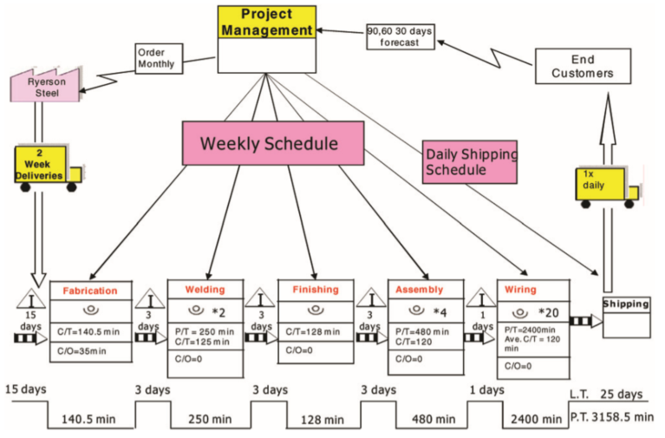
Figure 59 – Future state VSM example (Chen, et al., 2010)
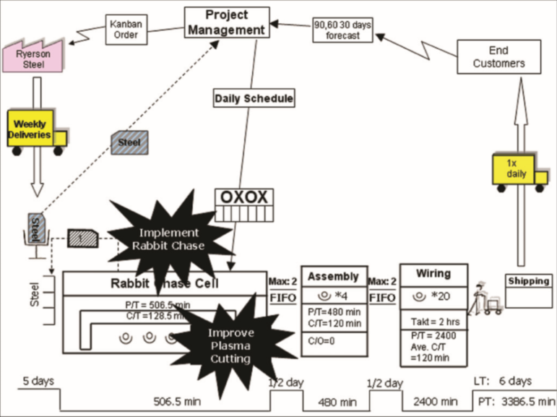

Ford Production Cost Data

Change Management Models
Burnes (2014) explains that change management is a tool used by management in response to any challenges or opportunities that may be encountered. Mullins (2016) argues that change can be either natural change, which involves replacing worn or aged systems within the workplace, or planned change, which involves management improving operations within the organisation to stay ahead of competitors. To manage the planned change within the organisation, two change management models will be considered for this project: Kurt Lewin’s 3 step model and Kotter’s 8 step change model.

Kurt Lewin’s 3 Step Model for Change
Burnes (2014) explains that this model was devised in 1947 by Kurt Lewin following the success of his ‘Field Theory’ in 1946 which the ‘Force Field Analysis’ method was put forward (Cummings, et al., 2016). The theory aims achieves to achieve a successful change in 3 simple steps:
Step 1: Unfreeze the current state
In this stage, the employees are prepared to undertake the change. This can be done by motivating the employees to recognise the benefits of the change. It is important that management engages with the workforce so that the workforce is involved. Lewin’s Force Field Analysis can be used in his stage to upset the equilibrium by promoting a driving factor for change or by reducing an inhibiting factor to change (Iowa State University, 2017).
Step 2: Undertaking the change
This involves the change being carried out with management clearly explaining the new working practises and providing the adequate training to ensure success. The success of the change relies upon employees being involved in solving any potential problems (Burnes, 2014).
Step 3: Refreezing the change
Once the change becomes stable then it becomes the new normal working practise. It is the responsibility of management to ensure the working practises do not revert to the old ways (Cummings, et al., 2016).

Kotter’s 8 Step Model for Change
Pollack & Pollack (2015) explain that this process is one of the most widely recognised models to manage a change program. The model is more detailed than Lewin’s model as it considers more factors that can be associated with change. The book entitled ‘Leading Change’ by Kotter (2012) sets out the steps needed for change:
Step 1: Establishing a sense of urgency
For change to happen, a sense of urgency should be created so that the employees understand a need for it. It is important that employees start talking about the change so that the urgency grows and feeds upon itself.
Step 2: Creating a guiding coalition
This step involves the formation of a group who can lead the change with authority. This can include internal employees or external change agents. The success of the program is highly dependent on their involvement and drive for change.
Step 3: Developing a vision and strategy
A vision should be formulated by the guiding coalition that is understood by everyone involved in the change. This can involve the creation of a defined mission statement.
Step 4: Communicating the change vision
The vision for change needs to be effectively communicated with the workforce and reinforced to ensure it is fully understood. Pollack & Pollack (2015) notes however that managers often underestimate the amount of communication needed to ensure the vision is consistently understood.
Step 5: Empowering broad-based change
This step involves removing obstacles which could inhibit change, changing structures that could endanger the vision and encouraging forward thinking ideas by the workforce. It is important at this stage that employees who support the change are rewarded to make their contribution feel valued.
Step 6: Generating short term wins
Short term wins increase the morale of individuals by demonstrating the viability of change. Kotter (2012) clearly states that short-term wins should be clearly identifiable and easily relatable to the overall direction of the change. The achievement of targets gives the workforce confidence in the progress being made.
Step 7: Consolidating gains and producing more change
Any progress made need to be built upon by identifying what is successful and what needs improving. Constant monitoring the progress of the change will allow efforts to be focused so that the change becomes perpetual.
Step 8: Anchoring new approaches in the culture
Finally, to reinforce the change, it should become part of the organisational culture. The success of the change should be communicated to all departments of the organisation so that the change is established within the workforce. It is important at this stage that managers continue to support the change so that any gains are not lost.

AM Process Categories

Binder Jetting
In the binder jet process, two materials are used; a powder-based material and a binder, which acts as an adhesive between the layers (Loughborough University, 2018). The build material is in powder form and the binder is in liquid form. Alternating layers of build powder and adhesive are deposited by the print head as it moves along the x and y axis. As each layer is printed, the build object is lowered incrementally on its build platform.
Figure 60 demonstrates that a roller spreads the powder material over the build platform and adhesive is deposited on top of the powder by the print head where required. The remaining unbound powder supports the structure as it remains in position surrounding the structure during the process.
Figure 60 – Binder jetting process basic schematic (CES Edupack, 2018)
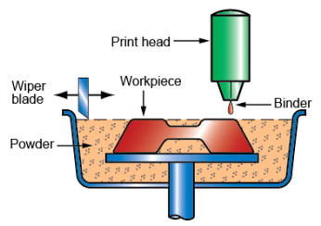
The process can use a range of materials: metal, polymer and ceramics, and is generally faster than other similar methods. For example, the XONE M-Print industrial metal printer has a build speed of 30-60 seconds per layer with a minimum layer thickness of 0.15mm (ExOne, 2018).
The process allows for different binder-powder combinations to allow different mechanical properties of the object. However, Loughborough University (2018) argues that due to the use of a binder material, the process is not always suitable for structural parts. Additionally, post processing requirements can add significantly to the duration of the overall process.

Directed Energy Deposition
In the directed energy deposition (DED) process, a component is built by depositing successive layers of metal onto a workpiece (Carroll, et al., 2015). A focused electron beam or laser melts metallic powder or wire feedstock in a programmed pattern to produce a desired component. Gibson, et al. (2015) argue that the most versatile feedstock is powder as most metals and ceramics are readily available in powder form.
Figure 61 shows that the machine has a nozzle which is mounted on a multi-axis arm which feeds material onto the surface (Loughborough University, 2018). Upon deposition, a laser or electron beam melts the feedstock material to fuse with the parent material of the object.
Figure 61 – Directed energy deposition process basic schematic (CES Edupack, 2018)
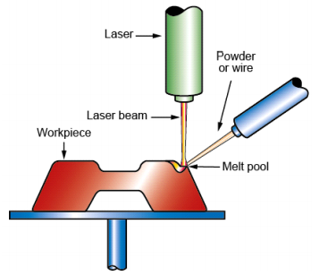
Materials that are suitable for this process include: titanium, nickel, tool steel, stainless steel, cobalt, aluminium and copper (Eyers & Potter, 2017). The LENS metal DED system from OPTOMEC performs the process in a hermetically sealed chamber purged with argon gas to prevent oxidation and it claims to produce fully dense structures with deposition rates to 0.5 kg per hour (Optomec, 2018). Similarly, the TRUMPF TruPrint 1000, which uses a 200W laser to melt the material, claims a build rate of up to 18cm³/hr.
The advantages of the process are the grain structure can be controlled to a high degree which can be beneficial for high quality, functional components. However, melting and solidification can occur at significantly different rates at each location in the AM build leading to residual stresses in the final part (Carroll, et al., 2015).

Material Extrusion
In the material extrusion process, a filament of material is fed into the system where it is liquefied in a heating chamber. The material is extruded onto the cross section of the part in layers often with a partly-solid infill structure for the interior. The build plate is lowered incrementally after each layer to allow enough space for the next layer to be created (Gibson, et al., 2015).
Figure 62 – Material extrusion process basic schematic (CES Edupack, 2018)
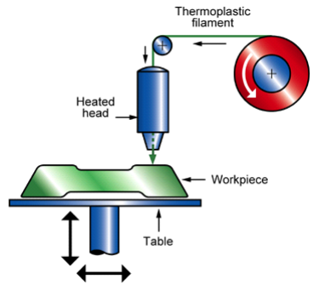
The most common extrusion-based AM method is Fused Deposition Modelling (FDM) (Gibson, et al., 2015). In FDM, a spool of thermoplastic filament is melted at the tip of the nozzle and upon deposition, the layers fuse together as the material is in a molten state. The Stratasys F370 FDM machine can build in polymeric materials including: PLA1, ABS-M30, ASA, PC-ABS and TPU 92A and within an accuracy of 0.002mm/mm (Stratasys, 2018).
The advantages of the process are that it is relatively inexpensive and widespread. Additionally, ABS can be used which is easily accessible and has good structural properties (Loughborough University, 2018). However, quality of finish is dependent on a constant pressure of extruded material. Speed and accuracy can also be low compared to other processes as accuracy is limited to nozzle thickness.

Material Jetting
Material jetting uses a similar process to an inkjet printer whereby material is jetted onto the build platform using a Drop on Demand (DOD) or continuous approach (Gibson, et al., 2015). The jet nozzle moves horizontally across the build platform and ultraviolet light (UV) is used to cure and harden the material layers. Droplets are deposited onto the surface using either a piezoelectric or thermal method (Loughborough University, 2018). However, a wider range of materials can be used with the piezoelectric method. Waxes and polymers are often used in this process as they are more able to form drops due to their viscous nature. Any droplets which are not used in the process can be recycled back into the printing system.
Figure 63 demonstrates that the build surface is lowered after construction of each layer whereby the next layer is built up on top of the previous.
Figure 63 – Material jetting process basic schematic (CES Edupack, 2018)
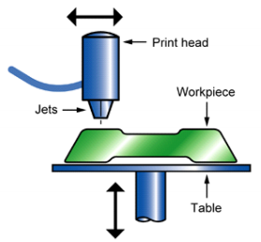
The StrataSys PolyJet DOD machine can print in several different colours with parts having a maximum tensile strength of 60 MPa (Stratasys, 2018) whereas the 3D Systems ProJet MJP 2500 Plus is capable of printing in various plastic and elastomeric materials (3D Systems, 2018).
The advantages of the process are that high accuracy of droplets is possible and multiple parts and colours can be produced in one process (Loughborough University, 2018). However, the process is not suitable for load bearing engineering parts as only polymers and waxes can be used. Support materials are also required in the process for overhanging component features.

Powder Bed Fusion
Powder bed fusion (PBF) melts and fuses powdered material together using either a laser or electron beam (Loughborough University, 2018). PBF processes generally involves spreading the powder material successively over previous layers using either a roller or a blade. A reservoir or a hopper is located beside the bed which provides fresh material supply. Direct metal laser sintering (DMLS) and selective laser sintering (SLS) are similar processes however SLS is used with plastics. In these processes, the powder is sintered, layer by layer, and the platform lowers the platform accordingly (Gibson, et al., 2015).
Figure 64 demonstrates that a layer, typically 0.1mm thick is spread over the build platform using a wiper. The platform is lowered, and a new layer of powder is deposited upon the previous. This process repeats until the entire component is created. Any loose, unfused powder remains in place to support the build structure until it is removed during post processing.
Figure 64 – Basic schematic of powder bed fusion process using SLS or DMLS method (CES Edupack, 2018)
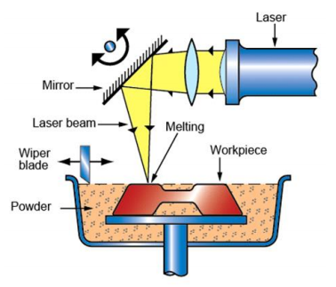
The EOS P 500 SLS machine is an industrial scale printer that is able to build up to a box height of 40mm/h with a layer thickness of 0.06mm up to 0.18mm (eos, 2019), whereas HP claim that its Jet Fusion 3D printer has dimensional accuracy of 0.3% with a typical build size of 380 x 285 x 380mm (HP, 2019).
The advantages of this process are that the unfused powder acts as an integrated support structure for overhanging component features. Also, SLS offers a large range of material options (Loughborough University, 2018). However, the material choice for MJF is limited to PA66. Also, the power consumption is relatively high compared to other AM processes and surface finish depends on the size of the powder grain used (Gibson, et al., 2015).

Sheet Lamination
Sheet lamination processes include ultrasonic additive manufacturing (UAM) in which sheets of metal are bound together using ultrasonic welding, and laminated object manufacturing (LOM) which uses paper as material and adhesive instead of welding (Gibson, et al., 2015). UAM uses relatively low temperatures and can bond dissimilar metals together, although the material is not melted. The LOM method is generally used for aesthetic or visual components as they are not suitable for structural use.
Figure 65 shows the LOM method in which firstly the material is bonded in place over the previous layer. The required shape is cut from the layer using a knife or laser before the next layer is added. The process is repeated to build a 3D object (Loughborough University, 2018).
Figure 65 – Sheet lamination process using LOM method
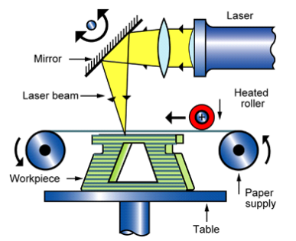
The Envisiontec SLCOM 1 LOM machine can print within a built area of 762 x 610 x 610 mm to within an accuracy of 0.1mm and uses a reinforced woven composite as the build medium (envisiontec, 2019), whereas the ARKePro from Mcor enables full colour 3D printing within a 184 x 168 x 125 mm build area using a specialist paper build medium (Mcor technologies, 2019).
The advantages of sheet lamination are high speed, low cost and ease of material handling (Gibson, et al., 2015). However, the components are not suitable for functional use as the strength of the models is reliant on the adhesive used. Also, the surface finish can vary dependant on the material used requiring post processing.

Vat Photopolymerisation
In vat polymerisation, a vat of liquid polymer resin is selectively cured using an ultraviolet (UV) light to construct a model layer by layer (Loughborough University, 2018). A platform moves the object down incrementally after each layer is cured. Support structures often need to be constructed using this process as the liquid does not provide structural support as with powder bed fusion methods. The UV light is directed onto the surface of the part using motor-controlled mirrors. When the UV light contacts the resin, it cures and hardens.
Figure 66 shows the stereolithography (SLA) process in which the UV laser follows a pre-programmed shape to create the model. SLA is often used for prototypes which can be used to assess the design of a component before commissioning full production (Gibson, et al., 2015).
Figure 66 – Basic schematic of vat photopolymerisation process using SLA method (CES Edupack, 2018)
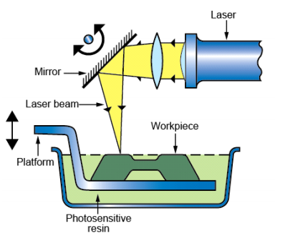
The ProJet 7000 HD SLA printer from 3D Systems can build up to a size of 380 x 380 x 250 and claims to produce parts accurate to +/-45 μm (3D Systems, 2018), whereas the P4K 90 from envisionTEC has a build envelope of 230 x 143 x 200 mm with a minimum voxel resolution of 25 μm (envisionTEC, 2019).
The advantages of the process are high level of accuracy and a good finish is attainable (Loughborough University, 2018). It is also a relatively quick process and large build volumes are possible. On the other hand, the machines are relatively expensive compared to other AM methods. Additionally, the process is limited to photo-resins which have limited material use.

WAAM Suitability Scale (The British Standards Institution, 2019)
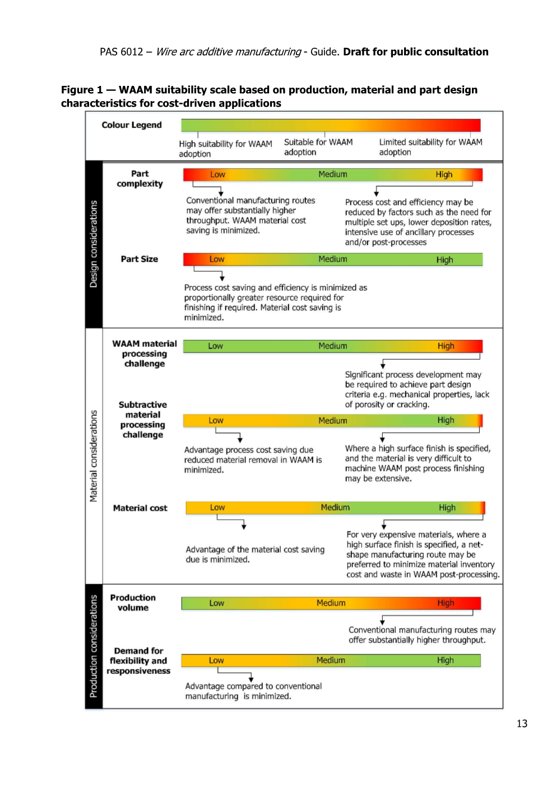

Print Results for Original and Optimised parts

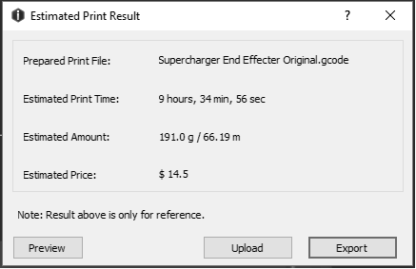

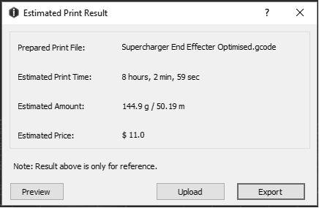

Infill Density Settings

Figure 67 – Infill density (all3dp.com)


