Problem Solving and Decision Making

Student name | Roxana Madalina Ciubotariu
Student ID | 1914603
Lecture name | Afzal Munna
Group number | CertHE T3G5_GRP
Module title | Problem Solving and Decision making

Contents

Introduction…………………………………………………………………………………………….3
The problem in my workplace………………………………………………………………….3
Solution of the problem……………………………………………………………………………3
PMI scheme……………………………………………………………………………………………..4
Decision making process…………………………………………………………………………..4
Decision making skills improvement………………………………………………………...5
Fish bone scheme……………………………………………………………………………………..5
Working effectively skills…………………………………………………………………………..5
Roll playing personal reflection…………………………………………………………………6
Conclusion………………………………………………………………………………………………..6
References…………………………………………………………………………………………..……7
Appendix one……………………………………………………………………………………………8
Appendix two……………………………………………………………………………………………9

Introduction
Problem solving is a process of finding solutions for a possible problem. Decision making is a part of the process which involves critical thinking and choose one of the option by making a choice. Problem solving is playing an important roll in life , at work , at home or anywhere else. Taking a decision needs a long or short process of thinking it depend on the situation. A small decision may be which kind of socks you want , what kind of ice cream flavor you prefer, however, the large decision is more serious and the person should think of any possibility of taking it because sometimes can lead to a problem and it is not good.
Problem solving is a good way of finding solutions to any problem , easy or more complicated , by finding out the way of making the issue to disappeared you need to take a decision or more , as result decision making is a key of solving. The process of solving is in a few steps which can lead to an easier way of finding out the answer for it by : identifying , investigating and implementing.
The problem in my workplace
At my workplace there is a problem which can be founded usually in most of the places where the team work do not communicate with each other and do not complete the effective work. The problem is “Lack of team working skills” , in many places working as a tea, is making the duty to be more easy to do and also is saving time as well , however, people should have team working skills to be able to do that. Every employee should know how to work with other people around because is very important for the company and as well for each other well being , when the duty is divided equally is easier for all sides to finish it and as well helping to rich the end may show that not just as a team and also as a second family we make our lifes easier. In my workplace sometimes here are some employees which you can work without any problem because they are helping and doing the duty which must be done, however some of them are just sitting and watching. Sometimes working alone can be fine and easy because you are the one which is taking all decisions , doing everything on your own stile and free, however is hard as well , finishing everything by yourself can lead to sickness , being excess of energy and many days of working hard. People may start working as a team when all sides are seeing how hard is to work on your own and now-one to help.
Solutions of the problem
Every problem is having no just one option , can have multiple , however, just few of them are the right ones for solving the issue definitive. Lack of team working skills can be solved by :
- Dividing the members into groups which can get along with each other and they have a good communication and cooperation between , because there like in every other workplaces are some people which are flexible and not having problems with other members , they can make other members to feel free beside making a good work together. Most of the time may bring to a very good result from nowhere and also take the tension between others. This kind of group can be made easily just observing the result of the work after shifts and seeing the way of acting, people dissatisfied are most of the time complaining.
- The second solution is dividing the duty to each member by the leader/ manager and being aware what they have to do . In this way by knowing that someone is keeping in track what they are doing they will feel more comfortable to start working with the members from the team than being supervised by management and also makes all the members to do something and even help each other to finish, people which do not have any other problem than being uncomfortable or the feeling not good when some people are working may find a way of starting cooperating with the specific person, other wise they can loose the job for not respecting the policy of the company.
This is a problem which can be solved with calm , discussing and pushing the tension away from people. Usually the tension starts when there is a new staff and most of the time needs to be lead by someone else to know what to do, and then is starting improving the skills and knowledge , in the same time cannot keep the steps as the one which is there from long time which brings the tension . New staff sometimes is complaining about other things seen because they may think is not right .On the beginning the new employees are doing their best to get employed and after probation period they start doing less which can be very disrespectful for others.
PMI scheme
There is a way of helping people to decide easier how to solve a problem , the name is PMI which can help someone to understand which are the positive , negative and interesting things about it. This scheme will help to take the best decision on solving problems or even taking a good decision about anything.
Decision making process
Decision making and problem solving may look similar however taking a decision is an action and solving is a proses. Taking an action quick may not be the right thing to do and it is not always the one which solves the problem, there is a need of time because it is needed to involve critical thinking.
There is a process of taking a decision which must be followed:
-identify the issue
-gain information about it
-find the alternative
-choose the best option
-place the decision
-keep in track the process
Decision making skills improvement
As human being we can take decisions , however that does not mean are the best or that the action can be taken everywhere, there are some ways of improving this skill:
-taking the information in all ways possible
-asking for other opinions
-study the action process
- think in a different way
-involve other members
-be rational
Fish bone scheme
Problem solving and decision making is a important process there are other ways of improving this skills, for example “Fish bone” is one of them, this diagram is very useful in solving problems analyzing them from many prospective and it is considered “one of the seven basic quality tools” . This diagram includes : people, method, measurement, machine, environment and material, being used most of the time by leaders or management to make sure that the problem is fully understood and the solution does not affect no-one , very important is that the team needs to be involved in this action and also the process.
Working effectively
Working effectively means that the employee must have some skills which can help on working as a team, having a good communication, cooperation, good behavior, right attitude , and not everyone can be good at this skills , however if there is any wish for them to change that can be done. As an employee in the company I am behaving in the way I should because I bam not at my home and I can do what I want when I want, in a workplace there are some rules and policy which must be followed by any employee, the roll must be understood and the duty which must be done, is very important to understand that working as a team can easily make everything simple and nobody is going to be that tired after shift, and also understanding that there is no perfection in someone, everybody is having their weaknesses ,if you can do something in one way and someone else in a different one it does not mean is not correct. When I start to do a new job I learn how should be done , however I have my own way of doing it, because is more simple and easy for me , same as other employees , I believe that understanding and knowing other employees is very important , in this way the relationship between is going to be friendly. I cannot say that every person is going to respect this , some of the people are not nice and the negative part is the impossible change of behavior, change of the way of thinking or looking at the things in a different way. I am not working from many years , however I can say there are some nice and less nice people in every place , it is important to be far from the less nice people, because they will try to bring you down by gossiping . Gossiping is other problem between employees, most of the time judging other for their decisions , way of working, and telling to someone else except the person which they do not like her/his attitude , being a mistake those things should be discussed with the person involved, having feedback there can be a change of behavior in good, not pushing the situation to far by telling others. I believe and this is my thinking , judging other before looking at your own personality is wrong, first you need to look at yourself , analyzing and observing that you make mistakes as well and then you will stop trying to see defects and imperfections in other. Some of the things can be done better , people can do that by trying to do them better, if there is no initiative it cannot be done. In this company where I work I spend many hours working , I think a workplace becomes the second home and family because we build relationships with other, we should treat each other with respect , they play a big roll for our well being, I am thankful for the few members of my team , those people makes me fell welcome there and I like that.
Roll playing personal reflection
The roll play which I had as management consultant showed me how hard can be sometimes to make a decisions which may impact employees , I understand that is not just about one person , I should think about everyone, asking for opinions, putting myself in their position, being faire with everyone, the most important is to take the right decision and solve the problem definitive, now I know how difficult is to be the one with the power of change in hands and how I have to use my critical thinking and look after good solutions.
Conclusion
The aim of this report was to show understanding of the working effectively, solving a problem and taking good decision, also improving my knowledge about it and thinking differently about the situations, asking opinions and choose the best option .

References

Margaret Rouse (1999-2020) “Fish bone diagram” [online]. Available from:
https://whatis.techtarget.com/definition/fishbone-diagram (Accessed on 15 December 2020)

Skills you need (2011-2020) “Decision making and research methods” [online]. Available from:
https://www.skillsyouneed.com/ips/decision-making-problem-solving.html ( Accessed on 14 December 2020)

Project management Institute (2011) “PMI ethical decision making framework (EDMF).Available from:
https://www.pmi.org/-/media/pmi/documents/public/pdf/ethics/ethical-decision-making-framework.pdf ( Accessed on 15 December 2020).

Appendix one
Fish bone

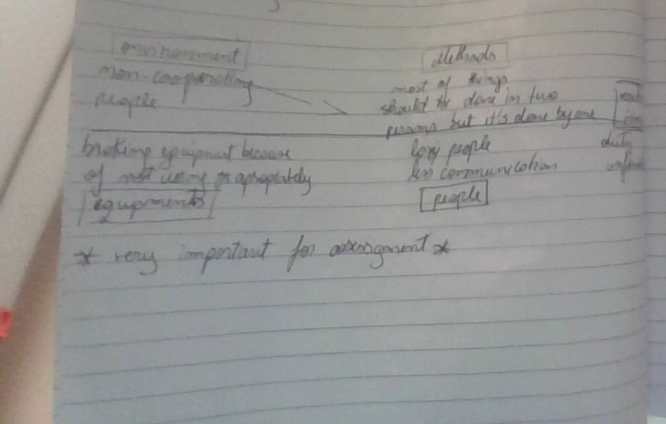

Appendix two

PMI scheme



