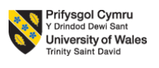
Organisational Culture: Toyota (Component 1)
Student Name: Ionela Lupșa
Student ID number:2416880
Programme: BA (Hons) Leadership and Management Skills for the Workplace
Module: Organisational Culture
Module code: LCLM 5005
Module Leader: David Oyebisi and Rameses Manalang

Table of Contents
1. Introduction 3
2. Organisational Culture and Its Influence on Toyota's Structure and Decision-Making 3
3. Identifying Toyota's Organisational Culture Using Organisational Culture Models 5
4. Toyota using culture to adapt to the external environment 8
5. Toyota's Organisational Culture is an Enabler or Barrier 10
6. Impact of Organisational Culture on Organisational Performance 11
7. Theory-Informed Recommendations 13
8. Conclusion 14
References 15

1. Introduction
Organisational culture refers to the shared values, beliefs, different assumptions and behaviour that influence how the employees interact and also perform in the organisation. It plays one of the fundamental roles for shaping the organisational structure, leadership, decision-making process and performance of the business. According to Mullins and Christy (2016), organisational culture is majorly defined as "how things are done around here" and also focuses on affecting the effectiveness of the organisation specifically for the global business that operates in the diverse cultural environment. Toyota is one of the leading automobile manufacturers in the world and has developed distinctive organisational culture with the help of the Toyota Way, which has emphasised on the continuous improvement, respecting of people and the long-term value creation. The report critically evaluated how the organisation culture of Toyota influences the organisational structure and the decision-making process which analyses the prevailing culture using the recognised organisation culture models and also assessing how the culture contributes for the organisation effectiveness and competitive advantages.

2. Organisational Culture and Its Influence on Toyota's Structure and Decision-Making
The organisational culture of Toyota is built upon the principle of Toyota Way, which promotes continuous improvement, respecting people, better teamwork, customer focused and long-term thinking (Toyota, 2023). All these values shape the management philosophy and the operational practices of Toyota that enables the organisation for maintaining the high standard of quality and efficiency across the global operations. Rather than treating culture as one of the separate organisation elements, Toyota integrates the cultural values into every aspect for the structure and managerial process, which creates consistency between the organisational objectives and the employee behaviour.
The organisational structure of Toyota reflects on collaborative and the learning oriented culture. Toyota has adopted a relatively decentralised structure that empowers employees for participating actively in the problem-solving and continuous improvement initiatives (Toyota, 2025). Production team, engineers and managers work collaboratively with the cross-functional teams which ensure that knowledge and expertise are shared across various departments. The structure reduces communication barriers and encourages faster identification of the operational issues. Additionally, employees are encouraged to stop the production when quality problems occur which demonstrate the organisational values are prioritised over the short term production. The inclusion of such practices presents accountability, improves product quality and also reinforces the culture of shared responsibility.
The decision-making process of Toyota is equally influenced by the organisational culture. The principle of Nemawashi encourages the consultation and consensus building before the important decisions are finalised (Kaio, 2023). Instead of relying on the senior management, employees from different organisational levels contribute ideas and evaluate the potential risk which is resulting in the well-informed decisions. Similarly, another philosophy of Genchi Genbutsu, which means “go and see", also requires managers to observe operations and issues directly before making the decisions. The evidence-based approach ensures that the decisions are properly grounded with practical understanding rather than any assumption. Toyota majorly applies the Plan-Do-Check-Act (PDCA) cycle, which supports the continuous evaluation and refinement for the organisational process, reinforcing the culture for innovation and learning.
Critically, the culture-driven organisational structure of Toyota offers various strategic advantages. Employee empowerment enhances job satisfaction, motivation and commitment while encouraging innovative problem-solving ability at the operational level (Hennig and Romar, 2023). Collaborative decision-making helps in improving the quality and the sustainability of the managerial decisions by incorporating diverse perspectives. Continuous innovation, on the other hand enabled Toyota for maintaining operations and establishing a global reputation for product reliability and manufacturing efficiency.
However, the organisational culture of Toyota presents various limitations. Consensus-based decision-making processes can delay the strategic responses during the period of any rapid technological changes as achieving the agreement with multiple stakeholders can be time consuming (Awan et al., 2025). In addition to this, the strong emphasis on preserving established organisational practices can also reduce the organisational flexibility when responding to the disruptive innovations specifically in the electric vehicle market. Implementing the consistent organisation culture in different international subsidiaries can be challenging as the national culture difference influences the overall employee expectation and management styles.

3. Identifying Toyota's Organisational Culture Using Organisational Culture Models
The organisational culture of Toyota can be analysed with the help of a theoretical framework that includes Schein's Three Levels of Organisational Culture, Handy's Cultural Types and Hofstede's Cultural Dimensions. Application of all these models can provide one of the comprehensive understanding for the value of Toyota influencing employee behaviour, organisational practices and strategic performance.
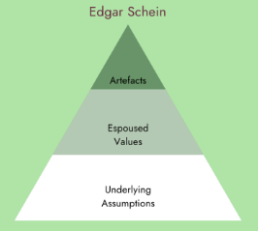
Figure 1: Schein's Three Levels of Organisational Culture
(Source: Geraghty, 2023)
Schein's Three Levels of Organisational Culture explain the culture with the help of artefacts, espoused values and basic underlining assumption (Coghlan, 2024). For the artifact level, Toyota has demonstrated the visible cultural characteristics with the help of Toyota production system, visual management techniques, different standardised to work procedures, quality circles and the collaborative working environment. Employees regularly focus on participating in different continuous improvement activities and problem-solving meetings, which reflect on the commitment of Toyota to operational excellence. These visible practices in the organisation reinforce the behaviour consistency across various business functions. At the level of espoused value, Toyota is promoting continuous improvement, respecting people, customer satisfaction, teamwork and long-term thinking. All these can be observed with Toyota Way, which influences leadership behaviour, employee development and the organisational decision-making process. Managers are expected for developing employees rather than simply supervising them, while the employees are observed to be encouraged for identification of operational improvement regardless of the organisational position (Ochieng, 2023). Consequently, the organisational values become embedded in different business activities rather than remaining one of the theoretical statements. The deepest level of the model concerns the basic underlying assumption. Toyota assumes the employees represent the valuable organisational resources capable of driving innovation and continuous improvement. The organisation also assumes that the waste is required to be eliminated, quality is never to be compromised and the long-term organisational sustainability is more important than any other short-term financial performance (Palhau et al., 2024). All these assumptions explain why Toyota consistently focuses on learning, quality and process improvement even during the period of economic uncertainty. The model demonstrates a significant alignment between the observable, organisational value and the fundamental belief of Toyota.
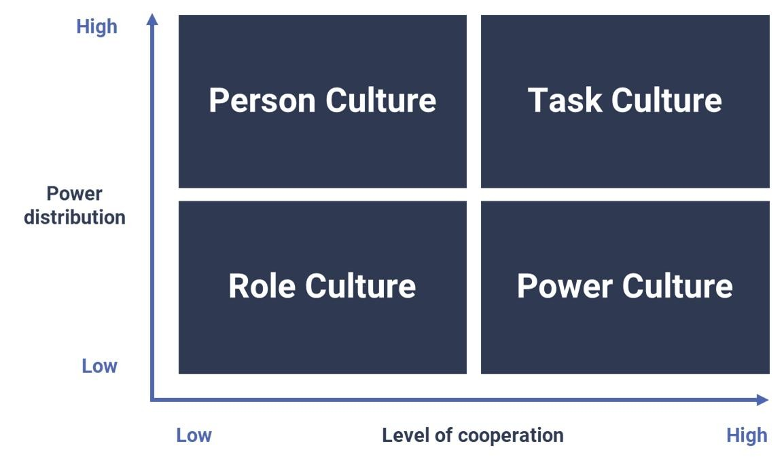
Figure 2: Handy's Cultural Type
(Source: Nine Dots Development, 2024)
It is essential to understand organisational culture as it has a major impact on effectiveness of a business ( Nasaireh, Abdullah and Obeidat, 2019). Handy's Cultural Types illustrate the prevailing organisational culture of Toyota. The elements of role culture are evidenced with the help of formal procedures, quality standards and defined responsibilities, Toyota reflects on the task culture. Employees operate in multidisciplinary teams where the expertise, relevant collaboration and shared problem solving are priorities over the hierarchical authorities. Decision making is largely considering knowledge and collective responsibility rather than considering individual managerial power (Chen et al., 2022). On the contrary, characteristics of power-culture are limited as the authority distributed across various levels in the organisation rather than concentrated in senior leadership. Likewise, the person-culture is also less relevant as the organisational objective consistently takes priority over the individual preferences. Consistently, Handy's model identifies that Toyota primarily acts as one of the task-oriented organisations that values teamwork and continuous improvement.
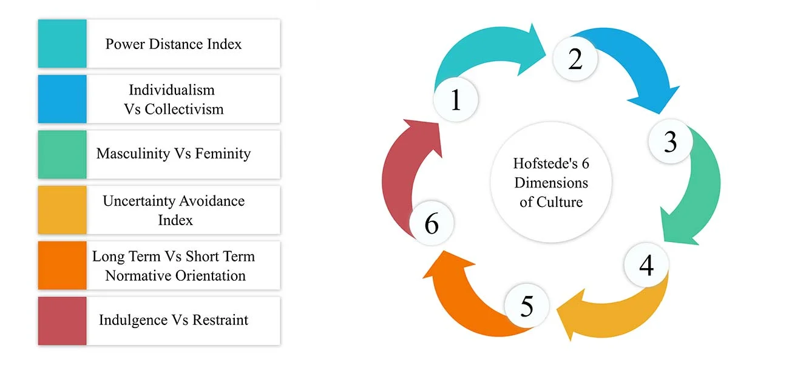
Figure 3: Hofstede's Cultural Dimensions
(Source: Nickerson, 2025)
Hofstede's Cultural Dimensions provides one of the additional insights regarding explaining the influence of Japanese culture on the management practices of Toyota. Toyota demonstrates collectivism with the help of strong teamwork, collaboration and shared responsibilities. Employees are encouraged to prioritise success over the individual achievements, strengthening the cooperation across the department. The organisation exhibits high uncertainty avoidance by implementation of the standardised procedures, various rigorous quality management systems and systematic risk reduction process. Additionally, Toyota also reflects on a strong long-term orientation by investing in employee development, research, innovation and sustainable business growth (Takeuchi et al., 2023). In the UK, Toyota has reduced hierarchical barriers by encouraging employee participation, open communication and continuous feedback.
Despite various strengths, the culture of Toyota requires adaptation when operating internationally. Consensus-based decision-making and collectivist management practices can be less effective for countries like the UK, where the employees prefer greater individual autonomy and a faster managerial decision. Consequently, Toyota balances the core cultural principles with the local management practices for improving the organisational effectiveness across the global market.

4. Toyota using culture to adapt to the external environment
The organisational culture of Toyota seems to enable the same to proactively respond to the shifting external environmental landscape. The organisational culture rigorously promotes continuous improvement, employee involvement, long-term thinking, along with customer value (Burt, 2026). All these are the key cultural characteristics that have become quite significant as the automotive industry of the UK faced major changes. These changes were mostly driven by technological innovation, decarbonisation policies, changing preferences of consumers, along with disrupted supply landscape. Rather than sharply reacting to the pressures from external environment using short-term measures, Toyota embeds adaptability within its culture. This decision allowed the workforce at the organisation to recognise the issues, recommend improvements, beside implementing sustainable solutions.
The strongest instance of cultural adaptation is the response of Toyota to the transition of the UK towards the low-emission mobility. Following the commitment of the UK to increase the adoption of zero-emission vehicles, Toyota decided to maintain a multi-pathway approach. In this approach, the brand expanded plug-in hybrid, hybrid, hydrogen technologies, and battery electric technologies (Toyota EU, 2025). Toyota bypassed its sole dependency on the electric vehicles ran by battery. It strongly reflects the organisational cultural emphasis of Toyota on long-term sustainability and evidence-based decision-making. The Environmental and Energy Policy of Toyota renewed in 2023 (Toyota UK, 2026b). This policy reinforces the similar cultural emphasis through the integration of environmental responsibility into continuous improvement and operational decision-making. Similarly, the Environmental Action Plan of Toyota aligns with organisational behaviour with waste minimisation, carbon reduction, along with resource efficiency (Toyota UK, 2026a). It also maintains compliance with national regulations that are constantly changing.
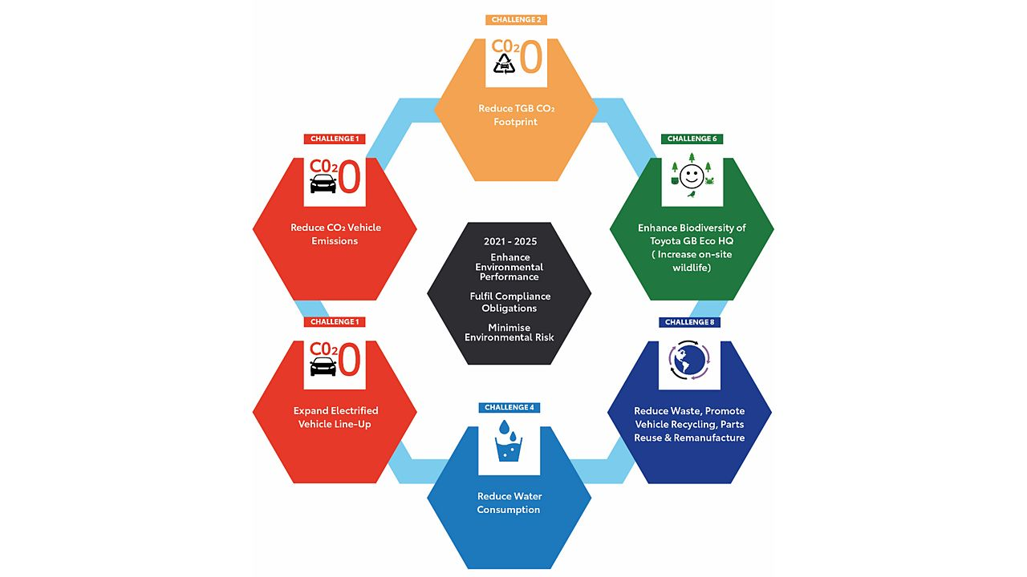
Figure 4: Environmental Action Plan of Toyota
(Source: Toyota UK, 2026a)
The culture of Toyota also supports organisational resilience against critical supply chain volatility and economic uncertainties. Since the recovery period after COVID-19 pandemic, and the subsequent disruptions across the globe, the brand relied on its established principles within Toyota Production System (Burt, 2026). It included waste elimination, problem-solving, along with supplier collaboration. These are necessary aspects of maintaining operational stability. Instead of solely prioritising cost reduction, Toyota motivates continuous process improvement besides cross-functional learning. This enables the brand to respond quickly to the challenges relating to any form of shortages or production.
Apart from these, the brand often leverages its organisational culture for responding to the increasing expectations of stakeholders. Stakeholder expectations are growing across ethical business and corporate social responsibility. Community engagement, environmental stewardship, and ethical governance, all are rooted within the values of Toyota (Toyota UK, 2026c). Continuous guidance is received by the employees in Toyota on sustainability objectives. Moreover, suppliers working with Toyota are expected to adhere to the strict ethical and environmental standards (Toyota Global, 2026).

5. Toyota's Organisational Culture is an Enabler or Barrier
The organisational culture at Toyota can be assessed critically as a primary enabler of proactive organisational functioning. However, it must be noted that its culture has led to certain internal barriers, especially when the environmental conditions rapidly change. According to the study of Mullins and Christy (2016), it is clarified that culture of an organisation significantly influences motivation, decision-making, coordination, and structure. In the case of Toyota, a shared, strong organisational culture is reflected that strengthens resilience, performance, and adaptability, instead of restricting these.
The key that the culture acts as an enabler is the deeply embedded Kaizen philosophy within Toyota (Burt, 2026). This philosophy highly empowers the employees of the organisation at all the organisational levels to find out the inefficiencies besides implementing improvements. Standardised processes for work in the Toyota Manufacturing UK allow for deviations to be recognised and resolved quickly (Toyota UK, 2026d). With this approach in place, quality and operational efficiency have improved across various operations. Such cultural practice improves functioning of an organisation through decentralisation of challenges and increasing responsiveness. This is a critical requirement in the automotive industry of the UK, in terms of being competitive.
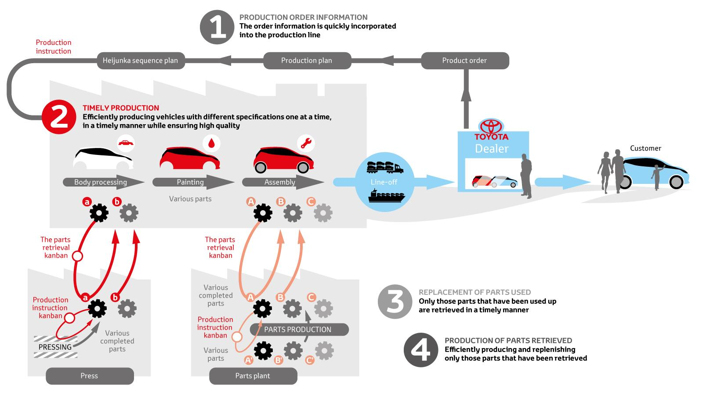
Figure 5: An illustration of the Toyota Production System
(Source: Toyota UK, 2026d)
Furthermore, the culture of Toyota promotes structured problem-solving along with strong employee involvement. This includes Genchi Genbutsu or going to the source and JIT (Just-in-Time) production (Toyota UK Magazine, 2024; Toyota, 2026a). All these values enable rapid decision-making while reducing waste generation. These also support agility in operations to respond to the external disruptions like the challenges across supply chain after Brexit and the pandemic-related volatility in manufacturing works noticed across the automotive industry of the UK. The significance put on waste reduction and continuous improvement ensures that decision-making process is mostly evidence-based rather than hierarchical in Toyota.
On the downside, in certain aspects, organisational culture may act as barrier, especially when the deeply embedded traditional values limit flexibility to respond to the disruptive changes. For instance, the long-standing culture at Toyota of engineering precision and incremental improvement might face criticism as it struggles to adapt digital shifts efficiently (Lien, 2025). This criticism stemmed as it slowed adaptation potentials of the organisation to the radical technical changes like software-led vehicle innovation. In the context of the UK, where the policies introduced by the government drive for rapid zero-emissions vehicle and decarbonisation adoption, such gradualist culture may become a challenge. This is because such organisational culture would restrict the speed of the strategic adaptation and transformation. This evidence indicates that an organisational culture builds around continuous improvement and stability may fall short during the requirement of discontinuous innovation.

6. Impact of Organisational Culture on Organisational Performance
A significant impact is noticed of the organisational of Toyota on the performance of the same within the automotive industry of the UK. The impact is clear across quality, efficiency, operational consistency, and employee engagement. According to Mullins and Christy (2016), culture significantly shapes the way something is done. Within Toyota, this fact can be clearly noticed in its performance outcomes that are mostly driven by the Toyota Way principles of Kaizen. These principles include continuous improvement, teamwork, and respect. The key positive impact of the organisational culture in Toyota is on its productivity and operational efficiency. The culture rooted within Kaizen approach motivates the workforce at Toyota to efficiently point out the wastes and then implement the incremental improvements in the day-to-day operations (Burt, 2026). It resulted in reduced operational downtime and faster production cycle. The usage of overall resources also became quite efficient. The Toyota Motor Manufacturing in the UK employs standardised processes as well as visual management systems. These are crucial to find out the abnormalities quickly which empowers overall productivity and operational consistency (Toyota UK, 2026).
Another noteworthy impact is improved reliability and quality of products. This impact supports the strong brand image of Toyota within the automotive market of the UK. Therefore, Toyota's culture of getting quality right at each step ensures workers emphasise precision and safety at each step of the production process (Toyota, 2026a). The systems of continuous improvement embedded within the production system of the organisation reduce the potentials of defective production, according to Jidoka principles. In broader perspective, this approach improved customer trust gradually along with long-term competitiveness.
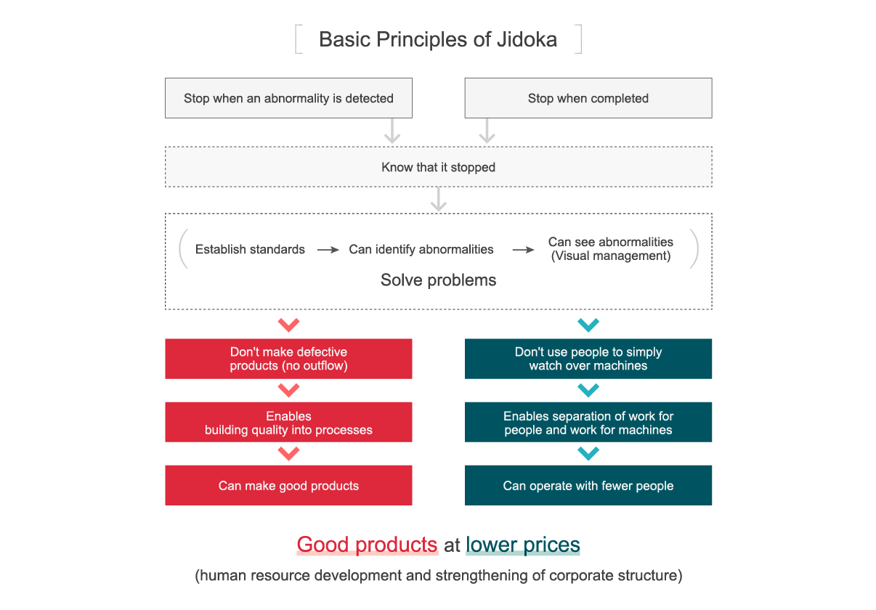
Figure 6: Jidoka principles
(Source: Toyota, 2026a)
Beside the improvements, there are certain limitations as well. The production process of the organisation is highly standardised and strictly process-driven. An intensely process-driven culture can limit operational flexibility within organisations (Setyadi et al., 2025). Therefore, there is a significant potential that such a process-driven and standardised organisation as Toyota may not respond to disruptive changes seamlessly.

7. Theory-Informed Recommendations
Several theory-informed recommendations are proposed to improve operational performance of Toyota within the intensely competitive automotive market of the UK.
Firstly, the organisation can develop a deeper culture around radical innovation beside its existing Kaizen incremental improvement. It is evident that Kaizen drives continuous efficiency, Schein’s model states that the underlying assumptions might become rigid over time (Asare Obeng et al., 2025). Therefore, the organisation must focus on expanding its cultural values to include strategic experimentation, explicitly. This approach can address cultural resistance during adoption of disruptive innovation.
Secondly, through the application of uncertainty avoidance dimension of Hofstede, the relatively standardised and structured culture may restrict agility within the volatile environments. This can be addressed by increasing the authority of decentralised decision-making, particularly within the production and engineering teams.
Thirdly, the organisations that perform best within dynamic environments tend to integrate structure, culture along with processes to ensure quick adaptation (Shafizadeh, 2024). Thus, Toyota UK must strengthen its current cross-functional agile teams. In this respect, digital innovation, production, and sustainability experts must be combined. It would align with the fact that the highly agile organisations often perform best amidst dynamic environments.
Finally, the recent investment of Toyota within the initiatives of circular economy can be embedded further within its organisational culture. The investment is done at the Toyota Circular Factor situated at Burnaston (Toyota UK, 2025). More investments like this can be considered as one of its core strategic values instead of treating it only as a sustainability project.

8. Conclusion
The organisational culture of Toyota is the fundamental drivers for the long-term success which is shaping the structure, decision making process and the business performance. The analysis has demonstrated that the Toyota is majorly built on continuous improvement, respecting people and the long-term thinking that has enabled the organisation for the establishing of the collaborative structure that also promotes employee empowerment, organisational efficiency and the high-quality decision-making. The application of important models such as Schein's Three Levels of Organisational Culture, Handy's Cultural Types and Hofstede's Cultural Dimensions has confirmed that the prevailing culture of Toyota is task-oriented and learning-focus which is supported by Value and assumptions. Toyota considered culture to respond to the various external environmental challenges which includes technological advancements, sustainability requirements and the changing market expectations. Although the consensus-based decision-making and the involvement of highly standardised practices did use the agility of the organisation, the benefits for continuous learning, resilience and innovation outweigh these limitations. Hence, the organisational culture of Toyota acts primary as the enabler for the organisational effectiveness and the sustainable competitive advantages. The ability of Toyota to compete successfully in the global industry is mainly because of the investment in cultural adaptability, agile innovation and cross-cultural leadership.

References
Asare Obeng, H., Arhinful, R., Mensah, L. and Teneng, R.C., (2025). Harmonizing growth: Leadership competencies’ mediation in SMEs’ organizational culture and structure through schein’s model. SAGE Open, 15(3), p.21582440251364954.
Awan, A., Walrave, B., de Gooyert, V., Bombaerts, G. and Talmar, M., (2025). Fixes That Fail in Collaborative Innovation: The dynamics of conflict, decision-making speed and time pressure. Organization Studies, 46(10), pp.1379-1408.
Burt, M., (2026). What is kaizen and how does Toyota use it? [Online] Available at: https://mag.toyota.co.uk/kaizen-toyota-production-system/ [Accessed: 25 June 2026]
Chen, Z.S., Zhang, X., Rodríguez, R.M., Pedrycz, W., Martínez, L. and Skibniewski, M.J., (2022). Expertise-structure and risk-appetite-integrated two-tiered collective opinion generation framework for large-scale group decision making. IEEE Transactions on Fuzzy Systems, 30(12), pp.5496-5510.
Coghlan, D., (2024). Edgar H. Schein: The artistry of a reflexive organizational scholar-practitioner. Routledge.
Hennig, A. and Romar, E., (2023). Learning from Japanese businesses: ethics in operational excellence. Humanistic Management Journal, 8(3), pp.329-354.
Kaio, D. (2023). Nemawashi: The Japanese Art of Decision-Making & Consensus Building. [online] Kaioken. Available at: https://kaioken.io/nemawashi-the-japanese-art-of-decision-making-consensus-building/ [Accessed 2 July. 2026].
Lien (2025). Toyota's Struggles with Digital Shift Delay Next-Gen EV Launch. [Online] Available at: https://www.pcauto.com/my/news/--toyota-faces-challenges-in-digital-transformation-delaying-the-launch-schedule-of-next-generation-electric-vehicle-models-16521 [Accessed: 20 June 2026]
Mullins, L. and Christy, G. (2016). Management and Organisational Behaviour (11th ed.). Pearson Education Limited.
Nasaireh, M. A., Abdullah, A. H., and Obeidat, K. A. (2019). The Relationship Between Cultural Types According to Handy’s Model and Organizational Structure in Jordanian Public Universities. International Journal of Academic Research in Business and Social Sciences, 9(1), 973–985.
Nickerson, C. (2025). Hofstede’s Cultural Dimensions Theory & Examples. [online] Simply Psychology. Available at: https://www.simplypsychology.org/hofstedes-cultural-dimensions-theory.html [Accessed 2 July. 2026].
Nine Dots Development (2024). A New Manager’s Guide to Handy’s Organisational Cultures. [online] www.linkedin.com. Available at: https://www.linkedin.com/pulse/new-managers-guide-handys-organisational-ca5se/ [Accessed 2 July. 2026].
Ochieng, E.M., (2023). A study of the history functions roles and challenges of human resources management. Journal of Enterprise and Business Intelligence, 3(1), pp.054-064.
Palhau, M., Sá, J.C., Ávila, P., Dinis-Carvalho, J., Rodrigues, C. and Santos, G., (2024). Toyota Way–the Heart of Toyota Production System and Its Impact on Sustainable Company Growth. Quality Innovation Prosperity, 28(3), pp.23-45.
Setyadi, A., Pawirosumarto, S. and Damaris, A., (2025). Embedding Circular Operations in Manufacturing: A Conceptual Model for Operational Sustainability and Resource Efficiency. Sustainability, 17(15), p.6737.
Shafizadeh, H., (2024). Decision-Making Under Uncertainty: How Organizations Adapt to Environmental Changes?. Journal of Resource Management and Decision Engineering, 3(1), pp.4-10.
Takeuchi, I.Y., Ohmae, H.T. and Ichijo, K.K., (2023). Navigating Competition through Alliances: An Analysis of Toyota's Strategy in the Japanese Auto Industry. Journal of Strategic Management, 7(6), pp.1-12.
Toyota (2023). The toyota way | toyota europe. [online] Toyota EU. Available at: https://www.toyota-europe.com/about-us/toyota-vision-and-philosophy/the-toyota-way [Accessed 2 July. 2026].
Toyota (2025). Toyota Production System. [online] Toyota Motor Corporation Official Global Website. Available at: https://global.toyota/en/company/vision-and-philosophy/production-system/ [Accessed 1 July. 2026].
Toyota (2026a). Toyota Production System. [Online] Available at: https://global.toyota/en/company/vision-and-philosophy/production-system/ [Accessed: 20 June 2026]
Toyota EU (2025). Toyota reinforces its multi-pathway approach and its commitment to customer-focused innovation. [Online] Available at: https://newsroom.toyota.eu/toyota-reinforces-its-multi-pathway-approach-and-its-commitment-to-customer-focused-innovation/ [Accessed: 20 June 2026]
Toyota Global (2026). Supplier Sustainability Guidelines. [Online] Available at: https://global.toyota/pages/global_toyota/sustainability/esg/supplier_csr_en.pdf [Accessed: 20 June 2026]
Toyota UK (2025). Old cars – new purpose: Toyota Circular Factory to maximise recycling and recovery from end-of-life vehicles. [Online] Available at: https://newsroom.toyota.eu/old-cars--new-purpose-toyota-circular-factory-to-maximise-recycling-and-recovery-from-end-of-life-vehicles/ [Accessed: 25 June 2026]
Toyota UK (2026a). Environmental Action Plan. [Online] Available at: https://www.toyota.co.uk/discover-toyota/sustainability/environmental-action-plan [Accessed: 20 June 2026]
Toyota UK (2026b). Reporting. [Online] Available at: https://www.toyota.co.uk/discover-toyota/sustainability/governance/reporting [Accessed: 20 June 2026]
Toyota UK (2026c). Sustainability at Toyota. Available at: https://www.toyota.co.uk/discover-toyota/sustainability [Accessed: 20 June 2026]
Toyota UK (2026d). Toyota Production System. [Online] Available at: https://www.toyotauk.com/toyota-in-the-uk/how-we-manufacture/toyota-production-system [Accessed: 25 June 2026]
Toyota UK Magazine (2024). What is Genchi Genbutsu? [Online] Available at: https://mag.toyota.co.uk/genchi-genbutsu/ [Accessed: 20 June 2026]

