TESCO
CASE OF STUDY

Assessment No₁
INTRODUCING THE MODERN WORCKPLACE LCBB4003
UWTSD 2019
Business Management
Forosigan Loredana Sorina-1816249
Lecturer HUSAM HELMI

Table of content
1.Introduction…………………………………………….3
2.Structure………………………………………………….5
3.Culture……………………………………………………..6
3.1 Hofstedes Cultural…………………………………7
4.People………………………………………………………8
5.Performance……………………………………………..9
6.Recommendation…………………………………….11
7.Conclusion……………………………………………….11
8.Reference\Source…………………………………….11

1.Introduction
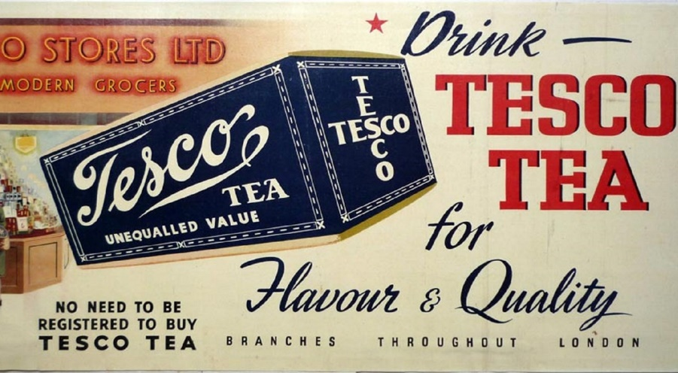

In Tesco case of study we will expose the following aspects related to the structure, culture, staff and performance of the Tesco company.
For example, Tesco culture can be defined as a company's personality based on the working environment of the mission, values, expectations and its purpose for facilitating clients.
Tesco was founded in 1919 by Jack Cohen as a market stand, and currently being the largest supermarket in the UK with an actual staff of over 450,000.6800 stores worldwide with a trading value of over £63.91 bn , based on a democratic management (McGregor´s Theory Y) where staff are taken into account for the proper functioning of the accompmissive that will be aimed at satisfying the needs of clients.
In 1924 by buying the first shipment of tea from T.E. Stockwe by J. Cohen was born the name of Tesco company today by abbreviation of the first letters from the seller and the first two letters from Cohen's surname.
Also in the year 1931 the first Tesco store in UK was officially opened, which until 1939 had acquired over 100 stores throughout the UK.
With extraordinary rapidity in 1990 it expanded into 11 other countries in Asia and Europe developing a diversification such as the sale of toys, furnitures,clothes,petrol,electonics,communication services, softweear; thus developed 2 categories: 1 "TESCO VALUE" low-cost products, 2. " TESCO FINEST "quality products.
Meanwhile Tesco developed subdivisions such as Tesco Extra as large space located in the city centers, Tesco Superstore smaller than the previous being stocked with food and a low number of non-foods goods, Tesco Express located in small neighbourhoods Having as the main source of food with sweets, gaseous and alcoholic beverages with semi-cooked dishes, chips and much more but in small quantities, Tesco Metro located in the urban centers beside railway stations, Tesco.com the first online store where it They made orders from home and last but not least Tesco Clubcard through which customers with such a card are rewarded by bonus points.
Developed oil stations under the name Tesco ExperessEsso in the Express stores.

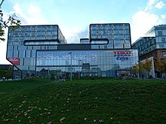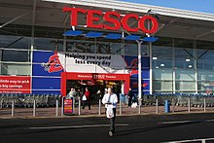
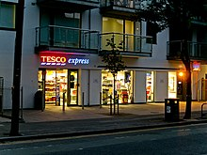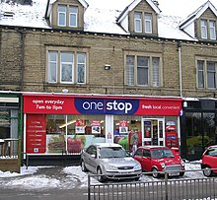

2.Structure
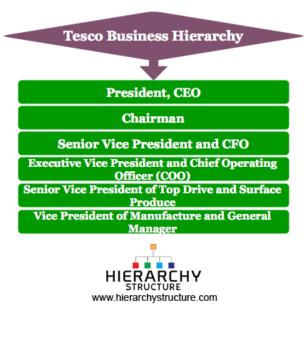
As a large company Tesco has a functional organizational structure formed hierarchically by those who lead it.
Based on Tesco's studies, it is classified as a tall hierarchy where each manager can observe a certain number of employees including several management departments.
This structure does not allow lower-level employees to take decisions within the company so managers have an internal control.
The tall hierarchical structure is formed from the lowest level consisting of employees without managerial authority who in turn has to report to the next layer of manager and this next and finally to the President of the company who has the power of decision .
As well as the advantages of these structures the company has the opportunity to promote employees in positions of leadership thus each knowing their role thoroughly, and each department is focused on its work where there is always someone responsible for the section.
Disadvantages of the structure: closed communication could lead to lack of focus, coordination can take too long, deparatements can become resistant to change, there is a gap between the top people and the lower level.

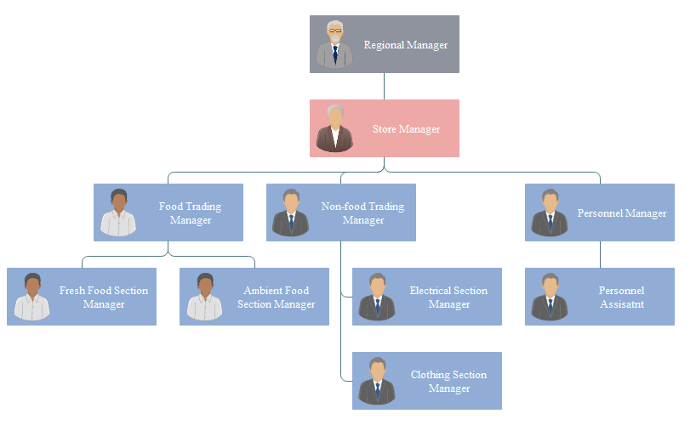
Tesco organizational structure at store level

3.Culture
A culture is a way of life of a group of people-the behaviors, beliefs, values, and symbols that they accept, generally without thinking about them, and that are passed along by communication and imitation from one generation to the next.
Scope -helps the organization to know the importance of cultural problems,provides knowledge about the management of cultural aspects,identifying and understanding the key dimensions of culture, helps to adapt the organization according to the culture of the business country,very much helps the organisation in safer terms of investment on the international market, help the organization understand crop contribution in managing changes.
3.1 Hofstede’s Cultural
Cultures are expanding more and more around the world of business, which causes managers to be able to work and collaborate with people from different parts of the world, and is being absorbed by its culture.
So G. Hofstede has developed a system whereby there is a differentiation between countries based on each other's culture.
These are the following:Power Distance, Individualism/Collectivism, Masculinity/Feminity, Uncertainty Avoidance, Long-term/Short-term Orientation and Restraint/Indulgence.

- Power Distance considers the extent to which inequality is tolerated and whether is a strong sense of position and status.
- Individualism/Collectivism have diferent impotance for value of individual,team or implication for financial rewards at work.
- Masculinity/Feminity considerated the differences in decision-making style,so for masculine is based on hard-edged and agressive styl but for feminine involved a much greater degree of consultation and intuitive analysis.
- Uncertainty Avoidance different attitudes to risk-taking between countries.
- Long-term/Short-term Orientation different emphases national cultures have on the time horizons for business planning,objectives and performance.
- Restraint/Indulgence stands for a society that allows relatively free gratification of basic and natural human drives related to ”enjoying life and having fun”(Tesco).

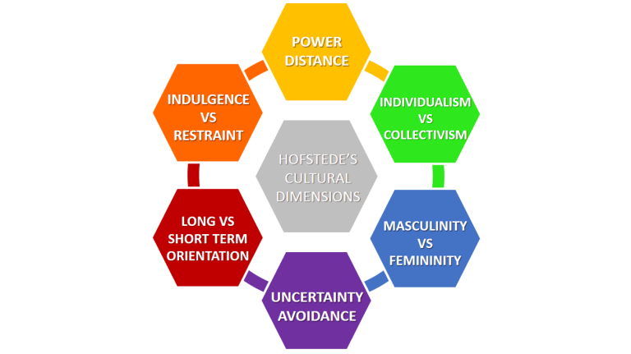
https://www.business-to-you.com/hofstedes-cultural-dimensions/

4. People
Motivation and engagement
Employees who have good quality jobs and are managed well, will not only be happier, healthier and more fulfilled, but are also more likely to drive productivity, better products or services, and innovation. This mutual gains view of motivation and people management lies at the heart of employee engagement.
Motivation can result from personal interest, it would be safe keeping or from external factors, it would be praise and reward.
Different theories have been suggested for motivating employees but payment is considered a main motivator.
Other motivating factors include: appreciation of hard work, a sense of accomplishment, accountability and empowerment, opportunity for advancement, a sense of challenge and joy.
Maslow Hierarchy of Needs for Tesco
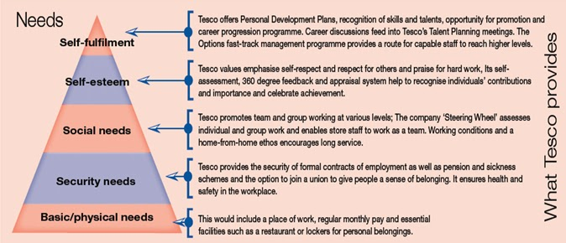

McGregor*s Theory X and Theory Y
Belive that Theory Y assumptions should guide Management practice and proposed that participation in decision making,responsible and challenging jobs,and good group relations would maaximize employee motivation.
This two theory are clasifficated for Theory X like a negative view of people and Theory Y like a pozitive view.
Tesco is guided by the theory of Y based on Democratic management (diplomatic), based on the following characteristics: Enjoy work, Seek and accept responsability, exercise self-direction.
5.Performance
Performance management is a management approach,wich seeks to get the most out of the human resource.
Flexible environment helps in increasing adaptability to change.
Shared culture and beliefs, increase employee loyalty towards the organization and hence, his performance.
Bureaucratic structures and cultures have been replaced with a decentralized structure if employee participation and flexibility has to be increased.
A rigid, inflexible culture hinders growth as an individual and thus, creates employee resistance towards work.
By having a shared culture, employees are better able to understand customers.
A wider span of control, reduces the chain of commands and improves employer-employee relations.
Inter-departmental coordination is improved in a decentralized structure.
There are many different types of appraisal system.Qualitative appraisal may take the form of a relatively structured interview in wich the appraiser develops a report on the performance of the appraisee.
Alternatively a quantitative appraisal may be employed in which the appraiser ranks performance along a scale:excellent,good,adequate,inadequate.
The appraisee will be seen at regular time intervals,and will be given feedback on job performance.
At a review meeting it is possible to establish individual objectives and targets for the subsequent time period.
Appraisal also provides an excellent framework for designing training and development programmes.The review will act as a basis for establishing ways of improving performance.
Clearly ,learning and development must be tied in with the reward system of the organisation,so that employees see them as both worthwhile in their own right and valued by the organisation.
Performance related pay is a system of relating pay to levels of achievement of work based objectives and targets.

6.Recomandation
Tesco's weakness is too much diversity in their business. The level of profit is low of bad debts, arback in credit cards and insurance (house Hold) application. Grocer sockets are not set to function as a specialised distributor. The company makes it late to increase their business to another new place this is another weakness of Tesco marketing. Tesco failed to fall out of their running cost, so the good cost is slightly higher in the market. In the UK comparative on ASDA and Iceland supermarket the price of some goods by Tesco is great. So Tesco should drop a certain food price eating food. High Capital and expense is another aspect of the weakness of Tesco.
- Conclusion
Tesco continually does marketing research and try to find out from the customer changing interest. The company also does research on new technologies and the business sector, so the business can continuously improve according to market demand. Should provide efficient services based on its scope. All marketing strategy should be used effectively, which helps to improve the company. It shows the strategy adopted by the company was effectivee.
8.Source
https://en.wikipedia.org/wiki/Tesco
https://www.tescoplc.com/about/100-years-of-great-value-1/
https://www.hierarchystructure.com/types-organizational-structures/
https://research-methodology.net/tesco-organizational-structure/
https://www.business-to-you.com/hofstedes-cultural-dimensions/
Geert Hofstede Country Comparison Tool: https://www.hofstede-insights.com/product/compare-countries/
https://is.muni.cz/el/1451/podzim2013/np2330/tesco_15_full.pdf

