CYBERSECURITY POLICY AND INCIDENT RESPONSE PLAN
FOR STEELFORM MANUFACTURING LTD (SFM)
Student Name: Eduard Fabian Pasare
Student Number: 2518439
Module Code and Title: Networks and Cyber Security Essentials
ACCA4024
Lecturer: Amit Naik
Assignment: Cybersecurity Policy and Incident Response Plan

Abstract
SteelForm Manufacturing Ltd (SFM) is a medium-sized manufacturer of customer-engineered steel components, supplying the automotive and aerospace industries. SteelForm uses connected machinery, automated production lines, remote monitoring and a cloud-based production management system. There is a broad cyber-attack surface that needs to be managed using a risk-based approach to cybersecurity. This report outlines proposed security measures for ransomware, supply-chain compromise, phishing and credential theft, insider misuse and disruption of OT. Proposed controls to support good cybersecurity practice are outlined. These measures support good cybersecurity practice and include measures to support governance, asset management, least-privilege access, multi-factor authentication, network segmentation, secure configuration, vulnerability management, and measures to support backups, endpoint detection, centralised logging, and an incident response. Staff training and a monitoring plan are also proposed. The proposed measures are aligned with NIST Cybersecurity Framework (CSF) 2.0, NCSC guidance, and the security measures expected to be in place to meet UK GDPR security expectations. Measures have been proposed to reduce the likelihood and impact of cyber-attacks. No measures have been proposed that could have an adverse impact on SFM’s manufacturing operations.

1. Introduction
The aim of SFM’s security program is to support and protect the company’s information and production to allow legitimate activity to take place. Recent ransomware attacks, and in particular supply-chain attacks, have left a number of organizations concerned about industrial espionage as well as the potential disruption of production in their manufacturing environments. These environments include offices, cloud services, engineering workstations, production environments, industrial environments, suppliers, etc.
NIST CSF 2.0 view of functions to Govern, Identify, Protect, Detect, Respond and Recover as concurrent and continuous activities as opposed to a list of individual activities. As an example the NCSC 10 Steps to Cyber Security outline risk management, asset management, secure architecture, vulnerability management, identity and access management, data security, logging and monitoring, incident management and supply-chain security as the core security functions.

2. Identification of Threats and Risk
Create an asset and data inventory. Include all of the manufacturing plant assets (including programmable and industrial control components) and all of the engineering workstations, servers, cloud-based services and issue devices of all of the employees. Also include all of the privileged user accounts, customer and supplier data and related records and any IP and the backups for these.
Threat | Likely entry point | CIA impact | Risk | Priority response
Ransomware | Phishing, exposed services, compromised credentials | A/I/C | Very high | MFA, EDR, segmentation, tested offline backups
Supply-chain compromise | Supplier access, remote maintenance, compromised software | C/I/A | Very high | Supplier assurance, least privilege, monitored access
Phishing / credential theft | Email, fake login pages, social engineering | C/I/A | High | MFA, email filtering, training, conditional access
Insider misuse | Excessive privilege or malicious/compromised account | C/I | High | RBAC, least privilege, logging, joiner/mover/leaver controls
OT disruption | Compromised engineering/production network | A/I | Very high | OT segmentation, allow-listing, safe recovery procedures
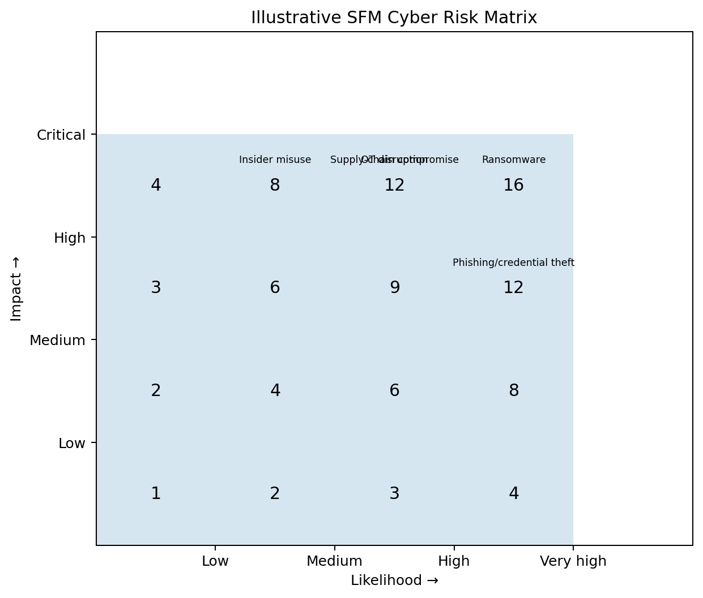
Ransomware, supply-chain compromise and OT disruption are the highest risks as they can cause both operational down time and data loss or manipulation. The above risk matrix is only illustrative and needs to be updated or even recalibrated after SFM has completed a formal likelihood-and-impact assessment.

3. Security Policies and Controls
3.1 Governance and policy framework
A Company Information Security Policy needs to be written and approved by senior management and then owned by the Security Manager. The Security Manager will also require a number of supporting policies such as Acceptable Use, Identity and Access Management, Remote Access, Secure Configuration, Vulnerability and Patch Management, Data Classification, Encryption, Backup and Recovery, Supplier Security, Incident Reporting, Logging and Monitoring and Employee Training. NIST CSF 2.0 maps to the above under the Govern function, showing Governance and roles for risk decisions and how risk decisions are to be made.
3.2 Identity and access management
Identity and access management, based on least privilege and role-based access control for all users and accounts, should be separated for normal users and administrators. All actions by privileged users and accounts must be logged. All dormant accounts must be removed from systems as soon as possible. Multi-factor authentication must be applied to cloud services, remote access, privileged accounts and all other high-risk access.
3.3 Network and OT security
These zones include corporate IT systems, production OT systems, engineering systems, guest networks and supplier remote access networks. In order to control traffic between all of these zones SFM should implement firewalls, where appropriate, tightly controlled conduits. Supplier access should be time limited, monitored and removed when no longer required. The NCSC states that organizations need to limit, control and monitor supplier access and that supplier connected systems should be segregated from the rest of the network. For any changes made to OT systems these should be tested and scheduled to ensure safe production at all times.
3.4 Endpoint, vulnerability and configuration management
All supported endpoints will be protected by centrally managed security software (anti-malware/EDR) as well as host-based firewalls. All supported endpoints will be configured securely and all latest patches will be applied in a timely manner (or deemed safe by the organization). A list of supported endpoints can be provided by the organization’s Assets, Services, and People (ASPs) group. Note that any organization using unsupported software should remove it from their assets or isolate it from the rest of the organization’s assets and services. For OT equipment that cannot be patched immediately, compensating controls will be put in place (e.g. network isolation, application allow-listing, restricted administrative access, etc.).

3.5 Data protection and resilience
Engineered designs for the products and services that SFM delivers, for its customers, for its employees, and for any other data that is operational in nature, must be classified and then protected with encryption in transit and at rest where applicable. The above point relates to the technical measures that must be put in place to ensure security and to protect the confidentiality, integrity and availability of personal data. The measures listed by the ICO, which are appropriate technical and organizational measures, include for example: encryption; access controls; measures to ensure business continuity; and, regular testing of security measures to ensure their effectiveness. As previously mentioned SFM must maintain multiple copies of backups, isolated from the rest of the organization where possible, and perform regular testing of the organization’s ability to restore services in the event of an incident. The NCSC comments that up-to-date isolated backups are a key measure to aid recovery from a ransomware attack.
3.6 Supply-chain security
Include security measures in contracts with suppliers, software providers and other third parties accessing the SFM IT environment. Carry out a security risk assessment of potential suppliers before onboarding and on an ongoing basis. Classify suppliers on a high risk basis and ask them to prove they have appropriate security controls in place (e.g. Cyber Essentials). Suppliers classified as critical require more in-depth assurance of their security controls. Supplier access should be tightly controlled and monitored at all times.

4. Mitigation Measures and CIA
Application of mitigation measures to the CIA triad: Confidentiality – enable MFA and implement least privilege access, ensure that data is encrypted and segregated where appropriate. Supplier access to be classified where appropriate and controlled by the supplier’s account holder at SFM. Integrity – implement secure configuration settings and apply application control and change management where appropriate. Ensure that all information about events that affect integrity is gathered and logged in an appropriate manner. Ensure that endpoint detection and monitoring software is in place to monitor for compromise and to control administrative access. Availability – enable architecture to withstand disaster. Isolate different functions of the business onto different networks. Test backup and implement means to restore service. Define priorities for response to and set goals to meet in the event of an incident. In the event of loss or destruction of data, enable the means to restore access to personal data as required by the UK GDPR security obligations and described in terms of the CIA triad.

5. Monitoring and Incident Response
Relevant logs should be collected from firewalls, identity management systems, endpoints, servers and cloud services. These logs should then be analyzed by a SIEM (Security Information and Event Management) system, or similar technology, to identify security incidents, for example attempted logins, privilege escalation, malware activity, unusual data transfer and network activity.
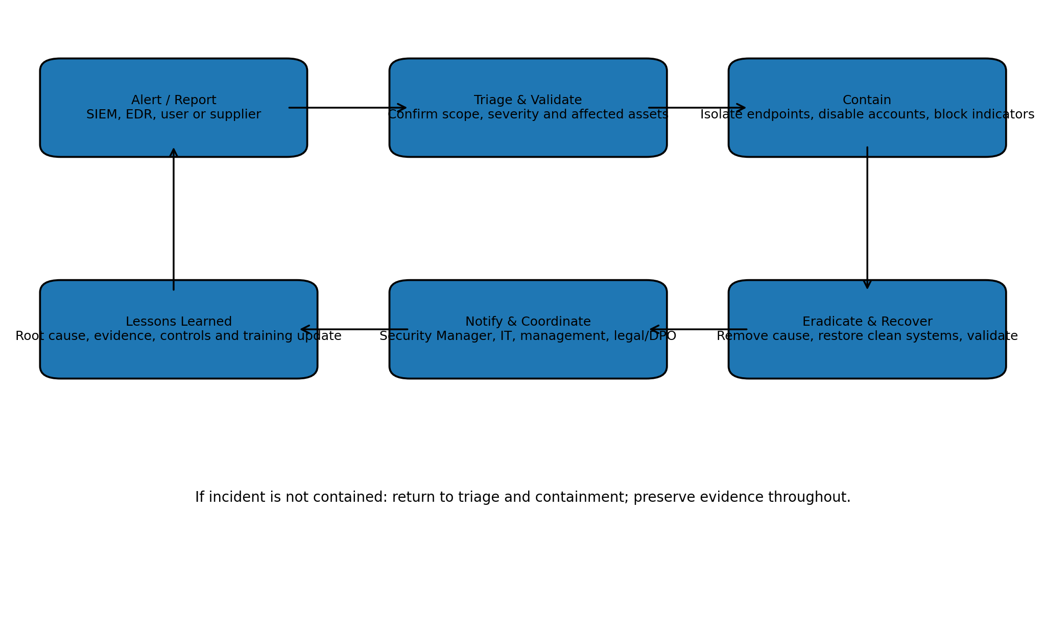
NIST has established a flow for handling an incident and the steps for preparation, detection/analysis, containment, eradication/recovery and lessons learned to handle an incident in the most efficient and effective manner. The older version of SP 800-61, Rev. 2 was superseded by the current version, Rev. 3 in April 2025. Therefore, when finalizing a procedure for incident response, SFM should use the current version of the NIST incident-response publication.
Incident Response – Ransomware Detection and Response. Security Managers identify severity of security incidents and gather together the best experts to deal with them. Where ransomware has infected a system the Security Manager isolates affected hosts from rest of the network and disables user accounts on them. Indicators of attack are blocked where possible. Where required evidence of an incident is preserved before any form of destruction is carried out to affected data and systems. Recovery from a ransomware attack involves the use of latest backups of data and systems, and methods to restore systems are validated before brought back online. Where personal data has been affected by an incident the organization assesses whether a UK GDPR breach has occurred and documents a decision on this matter, as required by the Information Commissioner’s Office. Security measures are risk-appropriate and the organization has processes in place to detect and minimize the impact of any security incidents.

6. Training and Awareness Programme
The biggest attack surface of SFM is the human behavior. Therefore employees of SFM need to be trained on a variety of subjects. This training needs to cover the following topics: phishing, malicious attachments, password management, Multi Factor Authentication (MFA), removable media, safe remote working, data management and reporting of suspicious activity. Quarterly sessions of about one hour each should cover the current threats like ransomware, social engineering and business email compromise.
Another measure to gauge learning from training as opposed to merely delivering information in a lecture format, are phishing simulations to test employees’ knowledge in order to provide coaching on a one-to-one basis to those who fail from time to time. In addition to the training sessions for all employees, the following groups of employees would require additional training: the engineering staff and OT staff, the vendors that remotely access the OT systems of SFM, and the privileged administrators. The subjects for their additional training would include safe use of USB storage devices, change control, reporting of unexpected behavior of machines and networks, and lastly, the secure administration of systems and protection of their credentials as well as establishing procedures for escalation of incidents. Metrics to test employees’ knowledge in order to provide coaching on a one-to-one basis to those who fail from time to time.

7. Implementation Priorities and Metrics
As SFM needs to be implemented in phases, a medium-sized manufacturer would probably need to work on several phases of implementation within a period of 1-2 years. In the first 0–90 days, implement the following activities: asset discovery, risk assessment, MFA for privileged and remote access, backup validation, critical patching, setting up incident-response contacts and basic security awareness training for users. In the next 3–6 months, complete the following activities: network segmentation, EDR/SIEM improvements, supplier security reviews and formal access reviews. In the following 6–12 months, implement the following activities: mature OT monitoring, conduct recovery exercises, test incident scenarios and review progress against an ISO/IEC 27001-aligned management approach.
Measure | Target | Review
MFA coverage | 100% of privileged and remote access | Monthly
Critical patch compliance | ≥95% within agreed SLA | Monthly
Backup restoration tests | Successful critical-system tests | Quarterly
Phishing reporting rate | Increasing trend; repeat failures coached | Quarterly
Privileged access reviews | 100% completed | Quarterly
Incident response exercise | At least 2 exercises per year | Biannual

Conclusion
SFM needs a Cybersecurity Program to protect information and manufacturing operations. The greatest risks to SFM are ransomware, supply-chain compromise, phishing and credential theft, insider misuse and disruption of OT. A practical approach to building a Cybersecurity Program is to build a program in layers, based on NIST CSF 2.0, NCSC guidance and UK GDPR security expectations. A Cybersecurity Program consists of identity controls, network segmentation, secure configuration management, vulnerability management, backups, monitoring and incident response. However, technology alone is not enough as staff can be misled by social engineering and also cause risk. So, staff training is also important to achieve necessary confidentiality, integrity and availability as well as required operational resilience for a 21st century manufacturing business. The controls can be implemented in stages and their outcomes measured

Reference List
Cichonski, P., Millar, T., Grance, T. and Scarfone, K. (2012) Computer Security Incident Handling Guide, NIST SP 800-61 Rev. 2. National Institute of Standards and Technology. Available at: https://csrc.nist.gov/pubs/sp/800/61/r2/final
Information Commissioner's Office (ICO) (2023) A guide to data security. Available at: https://ico.org.uk/for-organisations/uk-gdpr-guidance-and-resources/security/a-guide-to-data-security/
Information Commissioner's Office (ICO) (2025/2026) Security outcomes. Available at: https://ico.org.uk/for-organisations/uk-gdpr-guidance-and-resources/security/a-guide-to-data-security/security-outcomes/
International Organization for Standardization (ISO) (2022) ISO/IEC 27001:2022 Information security, cybersecurity and privacy protection — Information security management systems — Requirements. Available at: https://www.iso.org/standard/27001
National Cyber Security Centre (NCSC) (2021) 10 Steps to Cyber Security. Available at: https://www.ncsc.gov.uk/collection/10-steps
National Cyber Security Centre (NCSC) (2022) How to assess and gain confidence in your supply chain cyber security. Available at: https://www.ncsc.gov.uk/collection/assess-supply-chain-cyber-security
National Cyber Security Centre (NCSC) (2020) Mitigating malware and ransomware attacks. Available at: https://www.ncsc.gov.uk/guidance/mitigating-malware-and-ransomware-attacks
National Institute of Standards and Technology (NIST) (2024) Cybersecurity Framework 2.0. Available at: https://www.nist.gov/cyberframework
Appendix A – PowerPoint Presentation
Slide 1
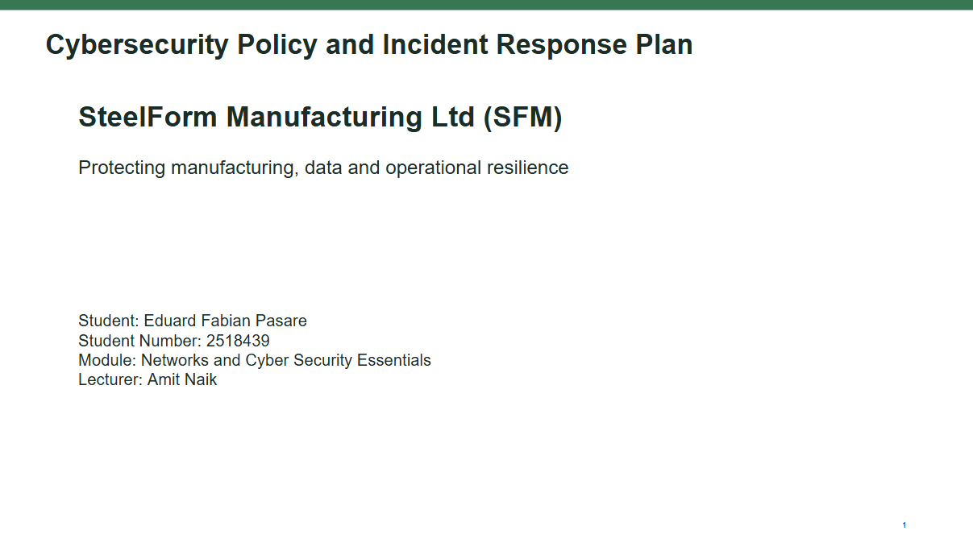

Slide 2
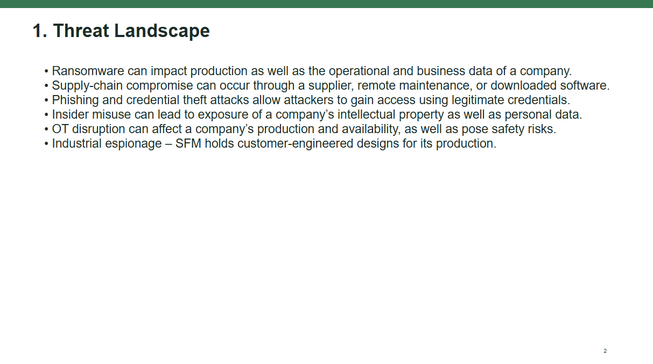

Slide 3
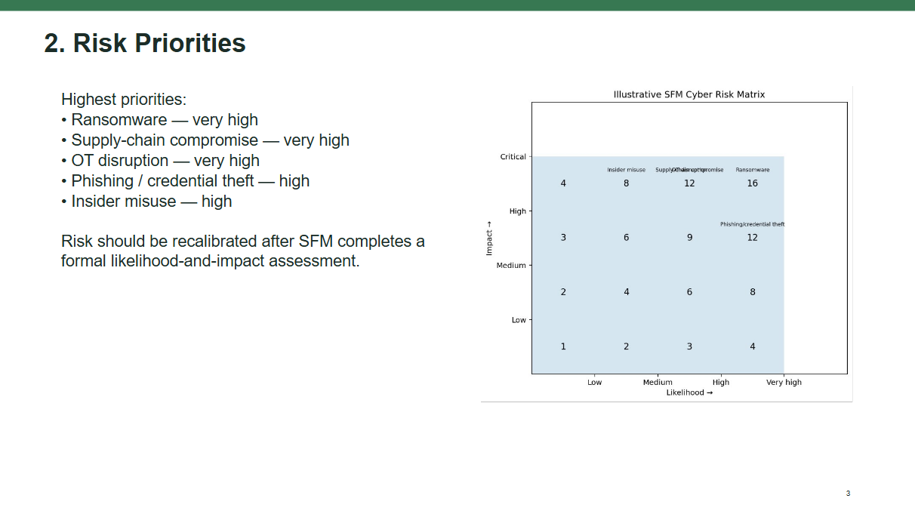
Slide 4
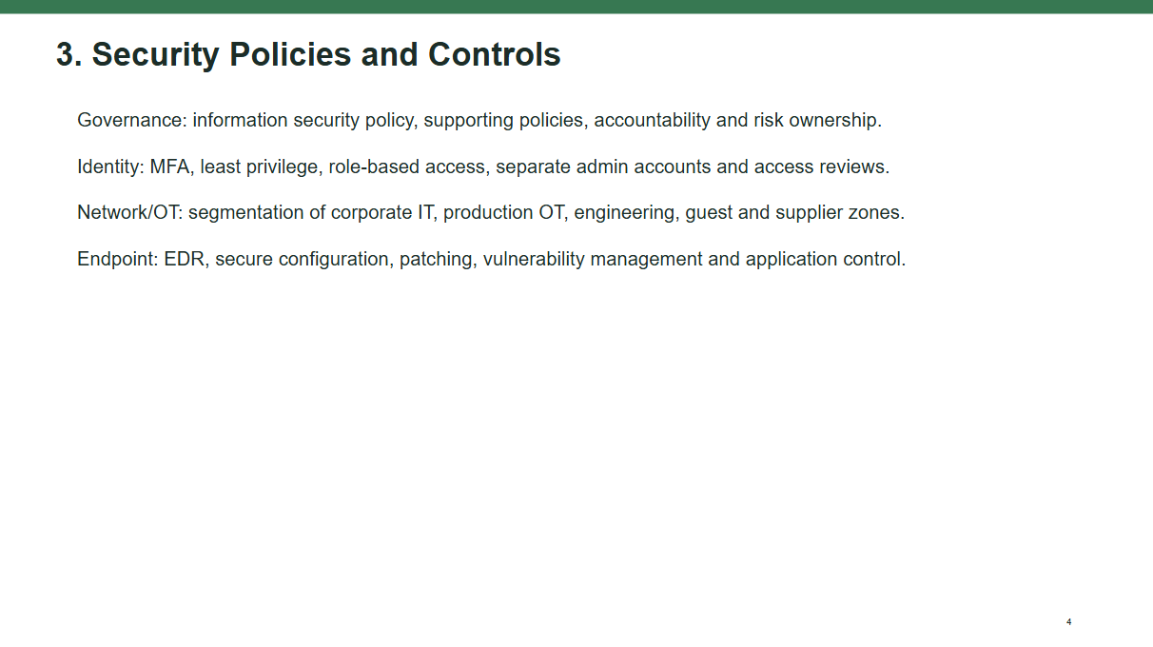

Slide 5
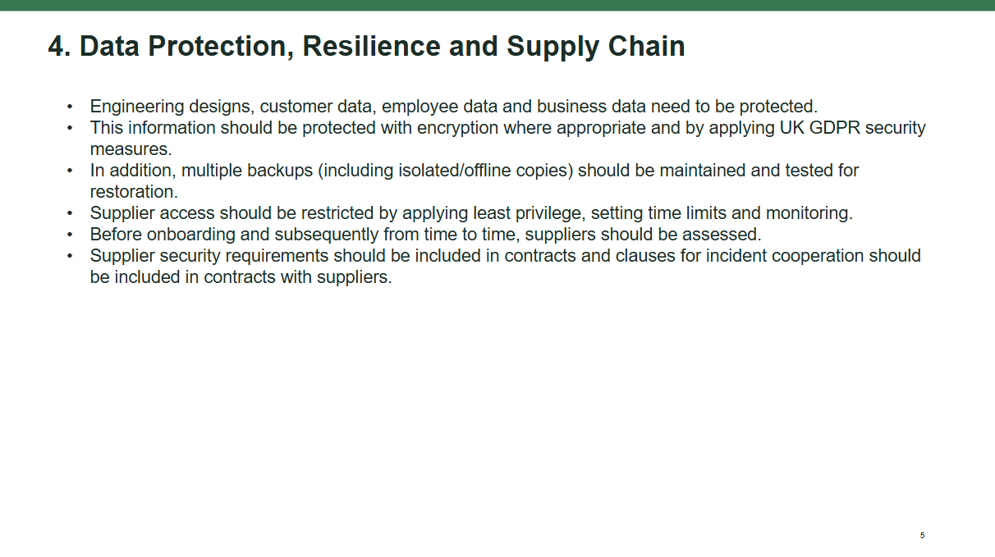
Slide 6
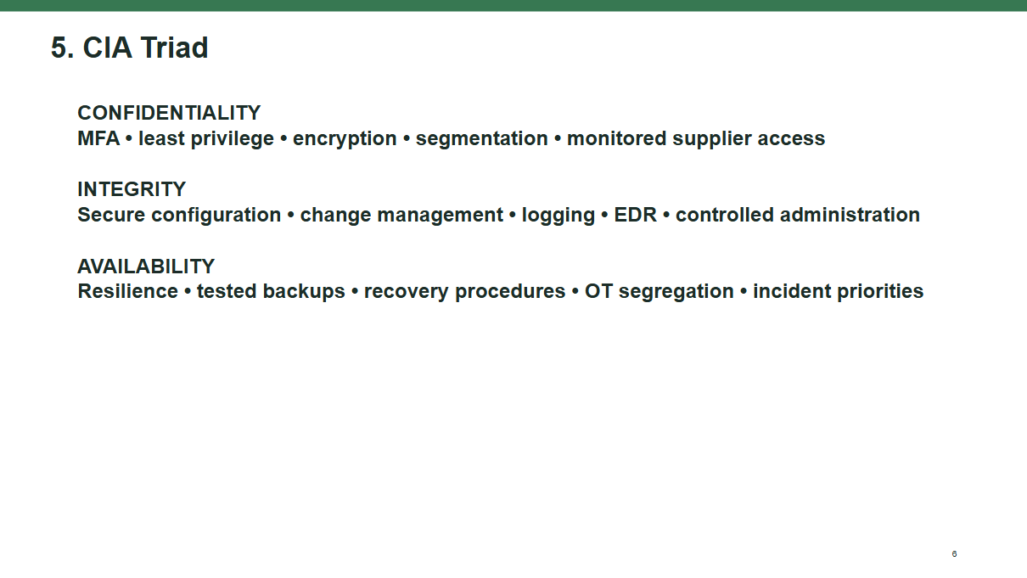
Slide 7
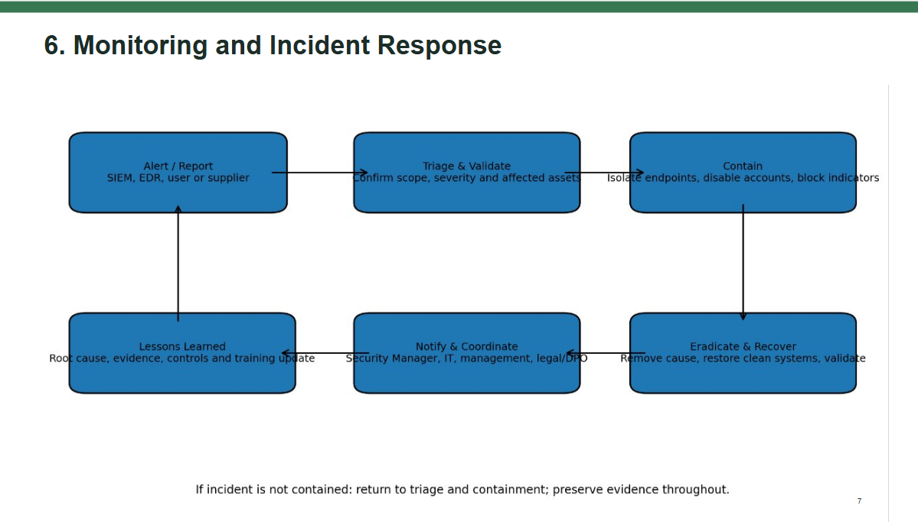
Slide 8
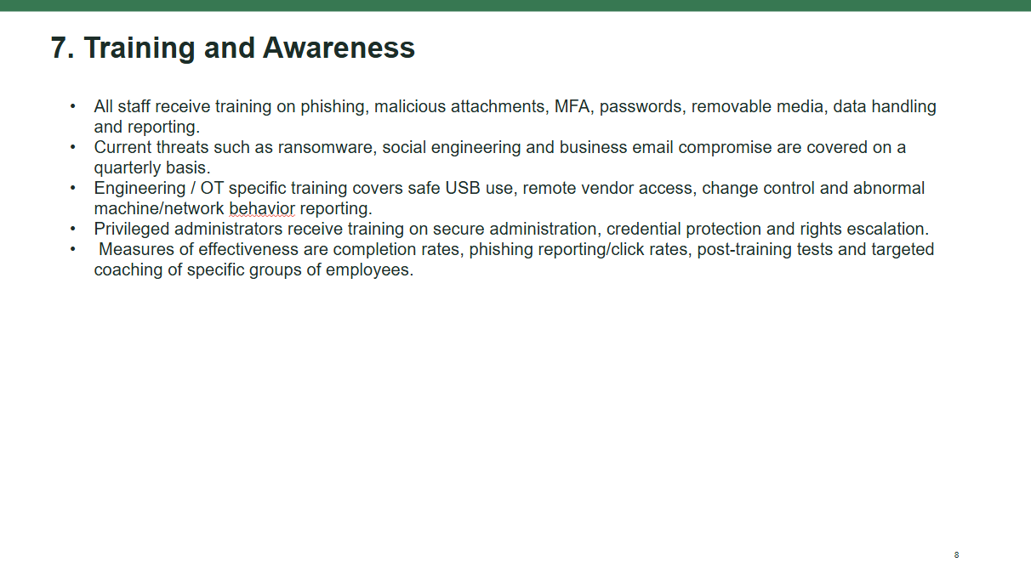
Slide 9
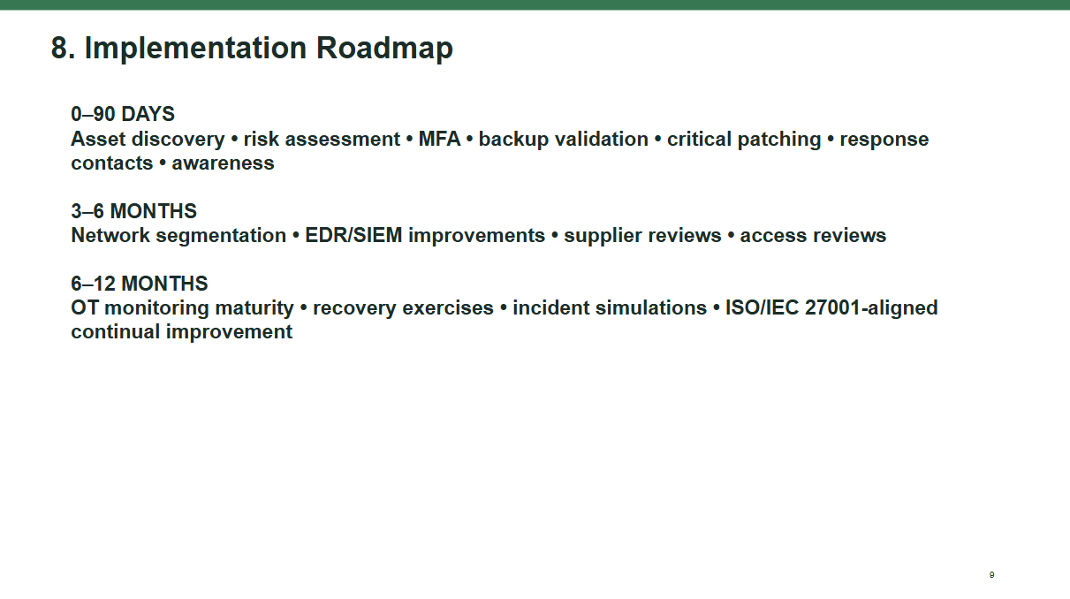

Slide 10
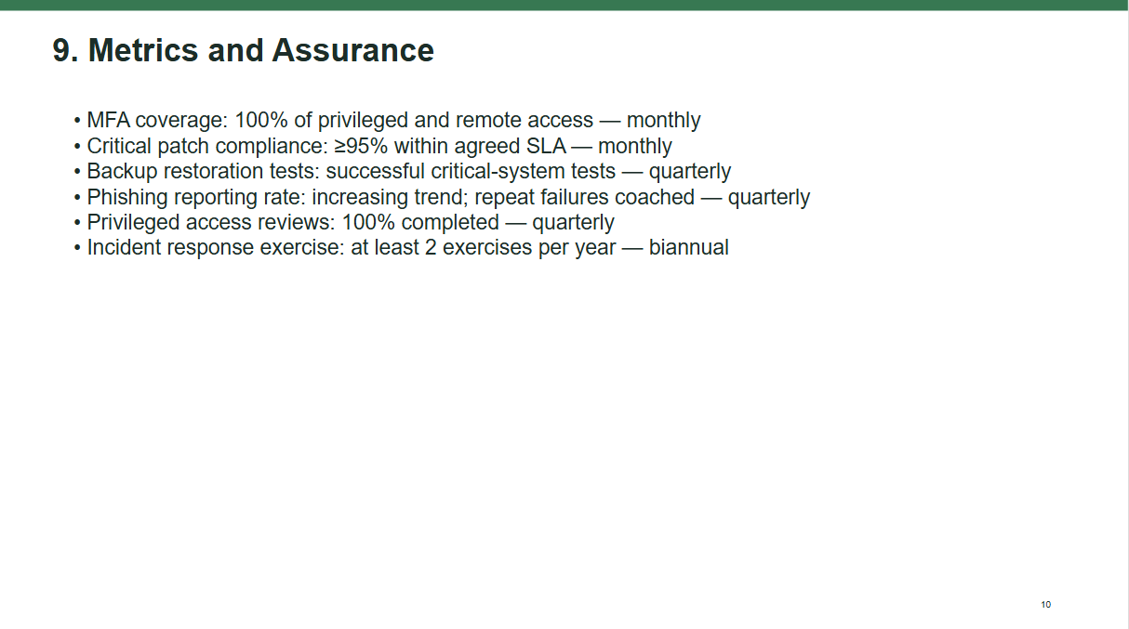
Slide 11
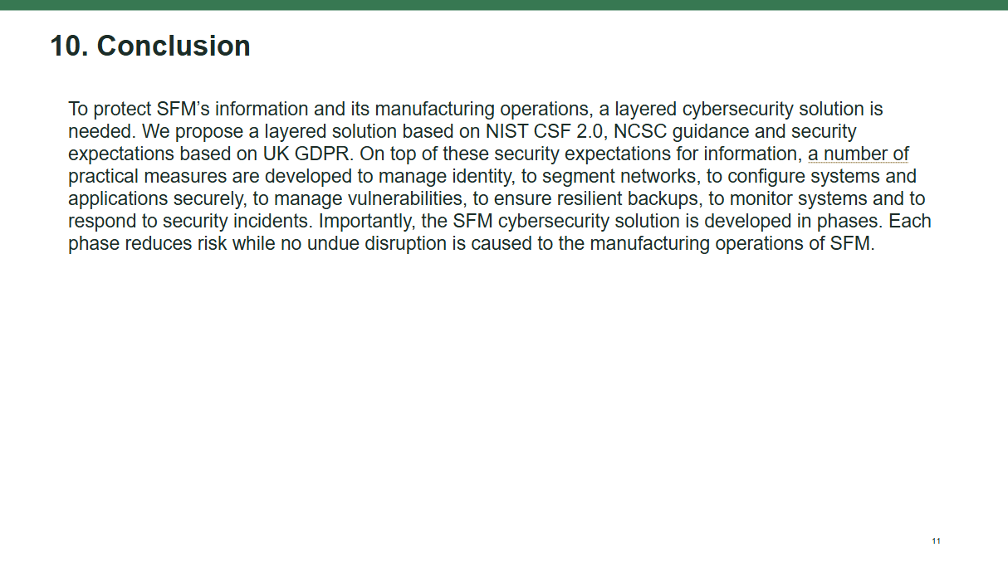

Slide 12


