Management Economics

Student Name
Ivan Gunchev
Student ID:
2030335

\

Contents
Question 1 3
(a). Discuss the fundamental economic problems identified in the case study 3
(b). Suggest various ways in which these economic problems can be resolved 6
Question 2 8
(a). Why is demand and supply relevant in this case study? 8
(b) What is the difference between elasticity and inelasticity of demand concerning price changes in the cost of fuel? 10
(c) List and explain the laws of supply and demand 12
References 14

Question 1

(a). Discuss the fundamental economic problems identified in the case study
The United Kingdom faces several economic challenges, including the effect of COVID-19 rules related to businesses, Brexit uncertainties, shortages of demand and supply, shortage of fuel supply, and increased fuel prices that have significantly affected its companies. In March 2020, the United Kingdom introduced several constraints to mitigate the prevalence of the COVID-19 virus in the state. Some of the regulations included closing businesses, shops, places of work, hotels and restaurants, schools, and leisure centres. Non-essential and tourist practices were also momentarily adjourned. These restrictions, repression measures, and consequent lockdowns brought about adverse economic impacts, fostering direct business costs and impacting income and lucrativeness, supply chains and actions, and social capital. The UK gross domestic product (GDP) fell by approximately 20% in the initial phases of the epidemic, as illustrated in the figure below (Office for National Statistics, 2021a). Nonetheless, with the continued cases of COVID-19 in 2021 and the adoption of national lockdown, the economy was greatly affected. According to the Office of National Statistics (2021a), in February 2021, the UK’s economy was 7.8% less than before the impacts of COVID-19. 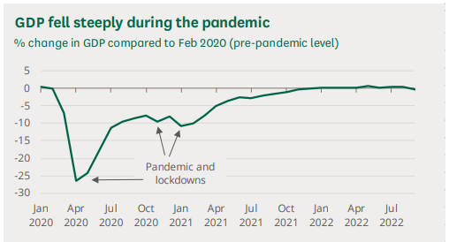
Figure 1: Decrease in the UK's GDP during the pandemic
At the onset of the national lockdown in the country in early 2021, the United Kingdom decided to leave the European Union, its chief trade and investment partner. Uncertainties brought about by Brexit led to an unambiguous fall in the number of goods traded in January by 19%, which was facilitated by a 40.7% drop in exports to the European Union due to the abolishment of free markets. Their exit from the European Union also translated to a decline in imports by 21.6%, with the drop in imports from the EU at 28.8% (Office of National Statistics, 2021b). The restrictions stemming from the pandemic and the trade disruptions and tariffs from Brexit exerted much pressure on the supply and demand chain in the UK, fostering disruptions that impacted the business. Travel restrictions, lockdowns, and closure of industries affected the supply and demand chains by decreasing the production capacity of products and services, delaying the production process and transportation of goods, and causing shortages of raw materials and components necessary for the smooth running of businesses (Igboekwu et al., 2023). Disruption of demand and supply chains has also been fostered by reduced labour shortages resulting from travel restrictions and immigration policies that have led to increased costs of commodities in the nation. The increased prices of commodities brought about by increased demand and compressed supply reduced the spending of the people in the government, which has translated to decreased GDP, reduced worker wages, and more aggregate demand, affecting the country's economy.
The pandemic and Brexit influenced the fuel sector, leading to disruptions and concerns that led to fuel shortages and increased fuel prices in different nations, including the UK. This has been chiefly steered by the lack of drivers that were difficult to replace due to Brexit and the COVID-19 effects. The heavy goods vehicle drivers played a massive role in transporting fuel from European nations to the United Kingdom. The immigration policies that restricted the free travel of drivers from one country to another made it hard for EU drivers to work efficiently in the area. As a result, there was a decrease in the number of EU workers eager to work in the UK, thus leading to reduced amounts of fuel being transported (De Lyon and Dhingra, 2021). The restrictions of COVID-19 also led to a decrease in significant truck drivers, leading to a decreased number of drivers limiting fuel transportation in the UK. These resulted in panic buying and increased demand for fuel, which led to an escalation of fuel prices. Ideally, the businesses that depended on fuel consumption were highly affected, leading to decreased performance and revenue.

(b). Suggest various ways in which these economic problems can be resolved
These challenges have greatly affected the UK’s economy and brought up the need for robust strategies to mitigate the challenges. Government intervention through regulation and financial support, lessening COVID-19 restrictions, establishing a shortage management team strategy, and developing and advancing supplier corroboration networks have been viable in mitigating the challenges. The UK government has played a crucial role in ensuring that the challenges affecting its supply and demand chain are efficiently addressed to encourage the growth of its economy. The government has intervened to address the challenges by providing regulations addressing immigration, offering financial support, providing informative communication, and providing friendly taxes. The main challenge faced by the UK was related to the shortages of drivers who facilitated the transportation of goods, such as fuel. In addressing this challenge, the government is involved in establishing accommodating requirements to facilitate the attraction of numerous drivers. This has been achieved by offering extra visas to address labour scarcities in the energy sector (Institute for Government, 2021). The government has also provided monetary provisions to address explicit supply chain glitches and actions to upsurge the size of government organisations. The government has provided grants, loans, and tax reliefs to support the affected businesses in effectively advancing in the changing business environment. For instance, in addressing the increased fuel prices in the country that have affected most of the companies, the government has worked to maintain the energy price cap for its internal consumers. As such, the £1,277 energy price cap was to be held from 2021 until a 54% increase was realised (Institute for Government, 2021). Shortly after, the government announced a £200 rebate on all internal energy bills to cushion its members from the harsh economy and provide a conducive environment for the businesses using fuel to thrive. The UK government has further declared the development of robust investments that will ensure the development of jobs, ensure the sufficiency of skilled labour to sustain business operations, and advance the general competitiveness of the country in the global market.
The government has engaged in providing crucial information through effective communication. Some of the communications addressed by the UK government encompassed an explanation of the causes of supply chain disruption. Through the Ministers, the government has addressed the troubles as a universal issue significantly associated with the universal supply chains following a surge in demand for goods. Additionally, the government has acknowledged Brexit’s role in contributing to labour shortages (Institute for Government, 2021). Communicating this to the public is a robust way of dealing with the situation as it instils a sense of trust in the people, as they are assured that their government is accountable, thus providing the government with an ample environment to address the issues. Lessening COVID-19 restrictions has also helped the UK government reduce the adverse implications of the epidemic on the nation’s economy. The uplifting of the national lockdown has enabled the United Kingdom to ensure that the affected businesses recover. Service businesses like hotels and restaurants depend primarily on traffic and sales and have benefited from this strategy. However, other companies also benefit since they can operate without restrictions. This has led to increased economic activities by businesses resuming operational activities, causing increased spending from the people that further impacts their increased revenue. The government has also engaged in cross-functional team development, which was established to monitor, recognise, and reduce shortages proactively. This is aimed at reducing the instances of supply and demand chain disruptions, guaranteeing the continued supply of consumers' needs that further allow the development of the economy.

Question 2

(a). Why is demand and supply relevant in this case study?
The relevance of supply and demand is exposed by its role in economics and its great application across different aspects of business, such as price determination, influencing consumer behaviour, and ensuring economic stability (Henchion et al.,2017). Supply and demand, in economics, encompasses the connection between the number of products the manufacturers desire to vend at different charges and the amount that customers want to buy. These two facets are the chief entities in price determination adopted in the economic theory. For example, the UK's fuel price was determined by the association of its supply and demand in the market. In fundamental financial analysis, all aspects are constant, excluding the commodity's charge. The analysis is then done to determine the association between different price degrees and the maximum number of commodities a client can afford. A combination of the prices and quantity, when plotted, is referred to as a demand curve. A demand curve in most economies slops downwards, highlighting the ability of customers to purchase more products at lower prices. Analysing supply in an economy entails the examination of the connection amid numerous prices and the quantity provided by manufacturers at each cost. A combination of the cost and amount produces the supply curve when plotted. The demand and supply curves are illustrated as follows;
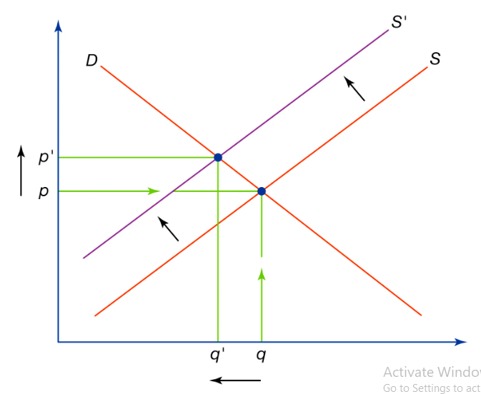
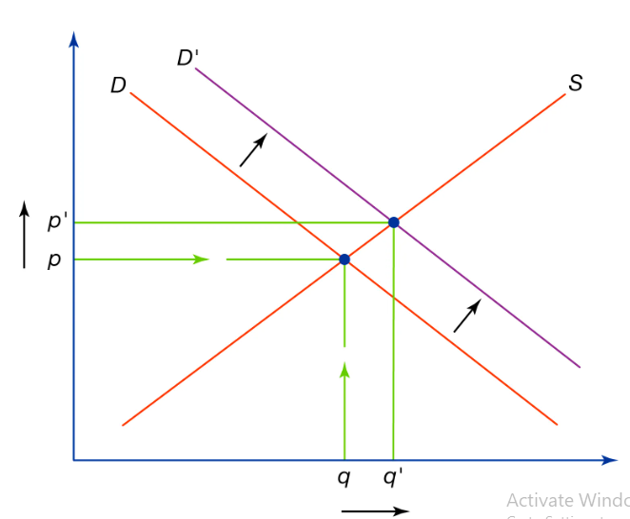
Figure 2 Change in demand Figure 3 Change in supply
Demand and supply are linked in the free market by the price mechanism. When shoppers obtain more goods than are present at the current price, the prices shoot up, while when the purchase is less than the usual price, merchants will drop the fees down. The charge mechanism, therefore, regulates the amounts of merchandise formed. Concerning the case study, the increased demand for fuel was more than what had been supplied. As such, the prices of the fuel increased tremendously. This placed significant pressure on demand and supply, which was addressed using the surge pricing strategy. Surge pricing relieves stress on demand and supply by increasing commodity prices to manage demand.
According to (Baker, 2002), organisations that discriminate in prices face a downside-sloping demand curve, thus increasing costs by decreasing output. As such, price discrimination applies to evaluating the probability of market power (Shapiro, 1987). Addressing demand and supply will help the UK and other governments manage factors influencing the demand and supply curve in favour of their economies. Engaging in marketing strategies is vital in controlling demand and supply in an economy to influence consumer behaviour, increase brand awareness, and optimise market presence (Aigner-Walder, 2015). Investors can increase product demand by engaging in advertisements and targeted campaigns. Fashioning marketing programs specific to different people and demographic places surge the demand for the product or service by exposing the unique benefits of the product. In addition, advertising as a market strategy increases knowledge about the product and the people, influencing their purchasing behaviour towards the product (Bagwell, 2007). In shaping supply, organisations can embrace market positioning where customers' perceptions and viewpoints are influenced to ensure that the demand reciprocates the supply levels. This allows companies to become competitive and manage supply and demand risks, thus maintaining the market price at equilibrium. In addition, it enables organisations to advance their performance through increased sales and maintaining a competitive advantage. Increased demand for products and services increases the wages offered to the employees, leading to more excellent worker retention and satisfaction. Through this, organisations can expand their productivity since employees will be motivated to reach their full potential.

(b) What is the difference between elasticity and inelasticity of demand concerning price changes in the cost of fuel?
The elasticity of demand denotes the measure of variation in quantity wanted for a product in reaction to the shift in other market variables, such as price and income (Cigliano, 1980). This is a dimensionless construct denoting the percentage of change in acquired quantity with a 1% change in price. In this case, the elasticity of demand is influenced by several factors: customer preferences, the presence of substitutes, the predictable duration of price change, household income, and the commodity’s share of household income. Demand for commodities in elasticity demand responds to a change in an economic factor, price, which is the chief economic factor in determining elasticity. An elastic demand is characterised by an elasticity coefficient greater than 1 (>1) (Andreyeva et al., 2010). Highly elastic products include luxurious items, consumer discretionary items, and certain foods and beverages. Companies involved in supplying elastic products are greatly affected by market fluctuations since changes in prices may cause the clients to buy other products. As such, these companies may need to adjust their manufacturing plans as the market changes. New entities in this venture experience few entry barriers, necessitating a smooth venture into the field. One advantage of elastic demand is that it allows businesses to maximise their profits and aids in pricing a substitute. However, the price elasticity of demand only works at a particular time since the demand of clients is ever-changing.
On the other hand, inelastic demand refers to the static quantity of goods and services demanded when the price changes. This means that when the prices of the products shoot up or decrease, the consumer’s buying habit remains the same. Inelastic products often do not have substitutes, and economic factors like price do not influence them. Inelastic demand is characterised by an elasticity coefficient lesser than 1 (<1) (Andreyeva et al., 2010). Examples of inelastic products are utilities, prescription drugs, and tobacco products. Companies selling inelastic products experience flexibility in pricing since changes in the prices of their commodities do not exhibit any change in consumer behaviour. Maximisation of profit can be achieved by increasing the costs of the commodities. Through market fluctuations, firms selling inelastic products may establish products and continue earning revenue because economic influences hardly affect their demand. Establishing a business in this setting may cause new companies to incur many financial and legal costs. The advantage of this form of demand is that it offers greater price flexibility since price changes do not influence it. Nonetheless, the price increase on price-inelastic products will likely boost profits considerably. Based on this, the fuel price is inelastic since the price changes do not change consumer behaviour in attaining the product.

(c) List and explain the laws of supply and demand
There are four basic laws of supply and demand: increased demand, decreased demand, increased supply, and decreased supply (Taylor, 2021). Increased demand happens when the supply of products remains the same, leading to increased prices and higher quantities needed. This illustrates that the consumers are willing to pay higher costs to attain the products. This incident offers a profitable environment for the manufacturers and sellers to increase their supply to the market. On the other hand, decreased demand is revealed when the supply of the commodities remains unchanged, leading to lower prices and quantities of goods and services demanded by the consumers. This exposes consumers' lack of interest in the product, and lowering costs cannot motivate them to buy. In this case, the producers of these commodities engage in marketing strategies to promote the sale of their products (Taylor, 2021). When little product sales are done, the suppliers and producers reduce the product's manufacturing. Increased supply is a fundamental law of supply and demand that works when product demand remains unchanged, causing lower prices and higher quantities. In this case, the supply surpasses the demand for the commodity, making it readily available from other suppliers. As a result, robust pricing and marketing strategies are implemented to attract customers from other competitors. Lastly, decreased supply occurs when the demand for a particular product exceeds the supply. In this environment, the demand remains unchanged, leading to higher prices and lower quantities. In this case, the clients will pay extra to secure what is available. This allows the producers to produce and supply more, increasing their profits and revenue.

References
Aigner-Walder, B., 2015. Effects of the Demographic Changes on Private Consumption: An Almost Ideal Demand System Analysis for Austria. Journal of Economic & Social Studies (JECOSS), 5(1).
Andreyeva, T., Long, M.W. and Brownell, K.D., 2010. The impact of food prices on consumption: a systematic review of research on the price elasticity of demand for food. American Journal of public health, 100(2), pp.216-222.
Bagwell, K., 2007. The economic analysis of advertising. Handbook of industrial organisation, 3, pp.1701-1844.
Baker, J.B., 2002. Competitive Price Discrimination: The Exercise of Market Power Without Anticompetitive Effects. Antitrust LJ, 70, p.643.
Cigliano, J.M., 1980. Price and income elasticities for airline travel: the North Atlantic market. Business Economics, pp.17-21.
De Lyon, J. and Dhingra, S., 2021. The impacts of Covid-19 and Brexit on the UK economy: early evidence in 2021. London: Centre for Economic Performance, London School of Economics and Political Science.
Henchion, M., Hayes, M., Mullen, A.M., Fenelon, M. and Tiwari, B., 2017. Future protein supply and demand: strategies and factors influencing a sustainable equilibrium. Foods, 6(7), p.53.
Igboekwu, A., Lindop, S. and Plotnikova, M., 2023. The Economic Impact of the COVID-19 Pandemic on Ceredigion Businesses and Self-employed.
Institute for Government. 2021. Supply chain problems. [Online] Available at https://www.instituteforgovernment.org.uk/explainer/supply-chain-problems [Accessed: 07 December 2023]
Office for National Statistics. 2021a. GDP monthly estimate, UK: February 2021. [Online] Available at; https://www.ons.gov.uk/economy/grossdomesticproductgdp/bulletins/gdpmonthlyestimateuk/february2021#:~:text=Monthly%20real%20gross%20domestic%20product,of%202.2%25%20in%20January%202020. [Accessed: 08 December 2023]
Office for National Statistics. 2021b. UK trade: February 2021. April. [Online] Available at: https://www.ons.gov.uk/releases/uktradefebruary2021 [Accessed: 08 December 2023]
Shapiro, M.D., 1987. Measuring market power in US industry.
Taylor, R. 2021. What is Supply and Demand? [Online] Available at https://fleximize.com/articles/002211/what-is-supply-and-demand [Accessed: 07 December 2023]

