Research Report
Is there a significant association between gender and university course choice?
Abstract
In this research report it is discussed using Empirical literature and studies the significant association between gender and university course choice as well as, using an original piece of research collected using Qualtrics to help determine the potential association between gender and university course choice using a chi-squared test of difference. To fully analyse all collected data and helped support the hypothesis “females would prefer studying on psychology course and males would prefer studying on computing courses” further secondary research was used. Further statistical data was gathered using the UK government website which could also be analysed as well as the secondary sources which is used to further draw conclusions on the research question: “Is there a significant association between gender and university course choice?”. In this report details of the procedure and design from the original study can be found and using the data gathered a discussion was created.

Introduction
There have been many studies discussions into the correlation between gender and the choice of university course and the reasoning behind this. Overall the majority of STEM (Science, technology, engineering and mathematics) courses are now increasing in female participation as more women are pursuing these subjects some have even improved to the point where they are no longer underrepresented in such as biology. However the opposite can be said for female participation in computing courses with women being largely unrepresented on these courses preferring to study the other STEM subjects: “women… have largely forsaken other STEM fields (e.g., computer science)” (Montoya, 2016). The gender differences between choosing each course can be explained in different ways such as through cultural differences “STEM fields can have very different cultures from one another when it comes to gender” (Montoya, 2016) this can cause a distinct association between gender and what university course they choose as due to the cultural background or implications that the course may come with it can either hinder or push them into choosing that course for example in PHD higher education courses “50.3% were female” (Gov.uk) this may be explained by many females felt threatened by the cultural expectations and stereotypes associated with computing courses as they are such a male dominated field therefore they would be more likely to turn to other STEM subjects where they would feel more comfortable and less out of place in. Furthermore the culture of the workplace can make women feel like they don’t belong in the environment due to the norms, values and structure that surrounds these jobs: “masculine culture… can cause women to feel a lower sense of belonging or be less successful than their male counterparts” (Montoya, 2016) these issues will push women into fields in which they feel themselves that they are more comfortable in and that appeal to them as society views many computer orientated courses as overly masculine. One theoretical explanation to why men and women choose there particular course is the student choice construct (St. John, 2001) this theoretical assumption states that an individuals choice to choose what university course they want to pursue is based off of there family background as well as the influence of those around them which can make them be more or less likely to choose a particular course. Furthermore this assumption states that it is also due to the environmental factors that surround them as certain universities would be more appealing depending on what course they are doing. Further factors come into play too such as teacher quality and what the course program offers the students. Therefore using previous research and studies I was able to come up with a sufficient research question which will allow me to come to the conclusions necessary to support my research that research question was “Is there a significant association between gender and university course choice?”. The hypothesis that I created that will allow me to answer my research question was “females would prefer studying on psychology course and males would prefer studying on computing courses”.
Methods
Participants
In the study thirty-two undergraduate students were asked in total seventeen females and fifteen males. These students were recruited using opportunity sampling when the participants took part in a module workshop for their respective classes of Psychology and Computing. The ages of participants ranged from as low as eighteen and as high as forty three.
Design
The variables that were involved in this study were categorical so therefore a chi-square test for independence was used in order to explore the association between these two variables. The first variable that was in the study was gender I.E. was the participant male or female and the second variable in the study was the current university course of the student I.E. Psychology or Computing course.
Materials
The materials that were used to record information about the different participants on each course was Qualtrics in which the participants were asked questions to record their gender, age and indicate which course they were currently studying on I.E. Psychology or Computing.
Procedure
In order to gather data for the study psychology and computing students were asked to answer questions on Qualtrics during a university module specific workshop. A module lead for psychology introduced the study to the students during a psychology class and a module lead from the computing discipline did the same for there students. During the workshop the participant were all given a short verbal description of what the study would involve. Participants were then informed that they required to complete a consent form (see appendices 2) and fill out and complete the three questions that was on Qualtrics. Finally once data collection was fully complete the researcher summarised all the data into one excel sheet ready for the data to be properly analysed.
Results
A Chi-Squared for independence was calculated to explore the association between gender and university course. The formula for the calculation was X² (1, N=32)= 3.14 P< 0.05 this shows that there was no significant association between gender and university course therefore, the hypothesis that females would prefer studying on psychology course and males would prefer studying on computing courses must be rejected.
Discussion
The findings of the study were that there was no significant association between the gender of participants and the university course that they chose therefore, the hypothesis that females would prefer studying on psychology courses and males would prefer studying on computing courses must be rejected by the researcher. However our own results does conflict with other studies such as in (Holdstock, 2015) which shows a significant association between gender and the aims of the participants in what course they desired to study in university this shows a stark difference in our own study as the data directly contrasts and comes to two totally different conclusions based on the association of gender and university course choice. Another study which contrasts with our own findings is (Montoya, 2016) also shows a correlation between the increase in gender and course choice in particular with the increase in females choosing STEM course from 1983 onwards while that increase is not prevalent in computing courses (See Appendix 1) these differences show that overtime there is a distinct change in what courses women choose as the graph shows an increase attendance for STEM courses whereas a clear decrease is shown in women attending computing courses potentially showing a close correlation between gender and course choice in the study and graph. These previous studies have shown that our own study has consistently been proven wrong or at least been shown to be not as accurate as other studies in predicting the true association between gender and university course choice this may be because the Chi-squared test of difference in this case clearly doesn’t show the true reality of the study this could decrease the ecological validity and could be overcome by adapting the study to be given to a larger range of courses which also see similar trends in gender this would allow, more participants data to be collected which could help the researcher further come to proper conclusions and as the previous studies have shown come to a more accurate conclusion based on a larger database that would be collected if the parameters of the study were increased to include other university students on other courses. However a positive aspect of this study is the fact that by using a questionnaire and Qualtrics it has allowed for a much faster and more efficient means of collecting data which can be further utilised if this study was ever repeated on a grander scale. To conclude in this study using a Chi-squared test of difference it has shown that there is no significant association between gender and university course choice therefore the hypothesis that females would prefer studying on psychology course and males would prefer studying on computing courses must be rejected as the data from this study does not correlate with that statement. However I believe that due to previous studies proving that hypothesis to be correct and the data collected using the chi-squared test of difference to be incorrect then further research must be required if true and conclusive assumptions can be made for the research question. Research would have to be gathered on a much larger scale to allow for researchers to fully understand any correlation between gender and university course choice.

References
Holdstock, J. R. (2015). Gender Differences in Higher Education Aims Between Computing And Psychology Students. Research in Science & Technological, 163-176.
Montoya, S. C. (2016, June 4). Why Are Some STEM Fields More Gender Balanced Than Others? Psychological Bulletin, pp. 1-35.
St. John, E. A. (2001). The role of finances in student choice: A review of theory and research. Pittsburgh: Agathon Press.
Education and training statistics for the UK, Reporting year 2022 – Explore education statistics – GOV.UK (explore-education-statistics.service.gov.uk)

Appendix
(1)
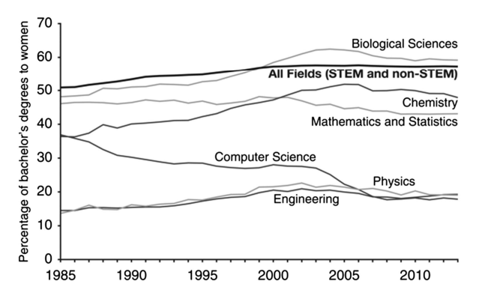
Percentage of bachelor’s degrees awarded to women in STEM fields from 1985–2013. SOURCE: National Science Foundation, National Centre for Science and Engineering Statistics, Integrated Science and Engineering Resources Data System (Montoya, 2016)
(2)

Consent Form
(3)

Data Collection Questions
(4)

Debrief Sheet

