Golden Sands Restaurant – Business plan
Module Name: Managing Enterprise in the 21st century
Module code: BMSW4006
Lecturer name: Mohammad Rahman

Students’ names:
Mariyan Tsochev (student ID: 2120444)
Iliyana Ilieva (student ID: 2120454)
Tihomira Kaneva(student ID: 2118131)
Marius Nehoianu(student ID: 2125290)
Zelyunka Kushlova(student ID: 1921690)

Table of Contents
Introduction 3
Business description and business history 3
Aim and objectives 5
References 9

Introduction
This group report aims to analyse a business plan for the opening of a restaurant with a Romano-Bulgarian theme under the name "Golden Sands". The purpose as well as the mission of the report is to closely analyse the history of the business, the purpose, the objectives, the mission and the vision of the business, what type of structure it is as well as the advantages and disadvantages of the structure, the analysis of the companies and also the marketing trends, the analysis of internal and external factors through the use of SWOT and PESTLE analysis tools, but also all the operations and the technological plan. Therefore, the internal processes of the companies will be closely analysed, such as the organization and its management, social responsibility and sustainability, its development, milestone and exit plan, the financial data of the company, the profit and loss account, the state of cash flows and the company balance sheet.
The French term testator, which means "restored food" and really refers to a delicious soup, is where the word restorative originally appeared, dating to the 16th century. The modern sense of the word was born in 1765, when Boulanger, a Parisian rights seller, opened its restaurant.
Since the beginning of time, hotels and restaurants have been a common sight, but because this was a popular tourist destination, few residents ate there. In France in 1810, the Russian Prince Krakin developed the custom of daily dinner service in Russian, when patrons were given a plate of prepared cuisine. It spread rapidly to England and other countries.

Business description and business history
It may help to establish a Company Background that attracts attention of the customers and creates relationships in order to become successful (Rizwan, 2018). People are not really hesitant to expect reliability from the businesses with where they do deal, as 81% of all clients worldwide believe in the importance of establishing a bond between, when asked what would be more significant when selecting a chain's services or products. This connection is regularly reaffirmed by investing in the restaurant's narrative and leveraging it to illustrate the sincerity of the devotion to consumers (Legacy, 2020).
A restaurant is a place where customers pay for food, drinks and desserts. Although packaged meals can now be served elsewhere, meals are often served on the premises. A chef prepares food in a restaurant. Sometimes restaurants specialize in the food they serve.
The term "family restaurant" describes places with set menus and fixed pricing, frequently with lots of space for seating. Themed restaurants and hotels tended to be found in rural locations and were more prevalent in the 19th and early 20th century. Home-cooked meals like pastry baskets are served at certain informal venues (Mattias, 2020).
The "Golden Sands" restaurant is a restaurant with a Romanian-Bulgarian theme that serves food cooked with a Bulgarian and Romanian accent, both separately and together. The history of the companies originates as a family heritage thanks to the members of the families that are part of Bulgaria, as well as Romania. This family tradition is extremely reflected in the company's operations as well as in its mission. The creativity of mixing two cultures is an extremely effective way of offering cultural lessons as well as increasing the profitability of companies. "The Golden Sands" restaurant wants to offer both traditional Romanian and Bulgarian food, but also services such as renting the place for weddings, baptisms and birthdays or any different celebrations required. Offering technological services such as the use of the mobile application for online orders, but also for the delivery of hot food to customers directly at home, were implemented straight from the beginning of the business (Hansen, P. H., 2012).
Trying to make the restaurant even toddler friendly, it might gain more customers, up to 25%.
First of all, and foremost, it is critical to comprehend why toddlers are an appealing target customer for restaurant:
• Children have a big impact on their families' eating patterns since people usually choose to dine where their children are at ease and satisfied.
• If the eatery is not toddler pleasant, families with youngsters generally would not remain for prolonged or they do not attend at all.
• Diners are frequently utilised for special occasions such as birthday celebrations for children or family events.
As a result, youngsters and their purchasing power should never be undervalued. Kids are among the main customers who may turn into best attendees if their parents believe that the catering facility will attract to the entire family (G. Mac, 2019).
A family dinner promotes interaction. Our clients will have to encourage each other’s to move the platters all around the table and they will almost definitely talk about how good the dinner is (which opens up the opportunity for further discussion). Family dinners also provides our customers greater choices in terms of what they put on their dishes. When it comes to serving themselves, they have the ability to make individual choices.
Introducing family-style meals and drinks to our venue is a way to enhance our community members' eating experience all while working to improve their mental wellbeing. Aside from bringing more people around each other, dining as a community might evoke memories for our citizens when groups could sit together around a table and consume food whilst also sharing their lives.

Aim and objectives
In everyday world, the terms goals and objectives are occasionally employed simultaneously. There seems to be, nevertheless, a distinction between both of these terminologies. As a result, the objective reflects a broad statement often used to convey someone's ideal desire 'goal' somewhere at completion of a project. It essentially explains what will be accomplished on a long-term basis. These objectives ought to be wide and challenging, but not impossible to attain (Alruwaili, 2020).
The "Golden Sands" restaurant is dedicated to expanding its operations beyond the limits of Romania by offering clients the convenience of home delivery of its tasty, all-natural and low-priced meals. One of the restaurant's key goals is to develop the brand internationally, thus opening more than a hundred locations in various regions of the world is a focus in the next six years, in addition to giving the franchise (Geary, R. S., et. al., 2021). The "Golden Sands" restaurant welcomes customers of all nationalities with the aim that they may get an appreciation for Romania and Bulgaria's rich cultural history.
To achieve its SMART objectives, the company must be:
Precise- in order to be successful, its aims must be as precise as possible. Establishing a definite deadline will also help to focus the aim.
Measurable- a great goal, while increasing the revenue of the restaurant, must be measurable in order to be accomplished. If we aim to increase monthly sales by 10%, we need to reach £33,000 by the end of the third quarter. Also, with a certain value, we can accurately see how close we are to the goal at any given time and whether or not we actually reached the goal.
Achievable- restaurant objectives are designed to challenge staff and managers without becoming completely astounding. Establishing an unreasonable objective, such as increasing sales by 1,000% monthly, is highly difficult and produces a sense of failure when a team falls short. A better course of action would be to divide the 1,000% into smaller, more manageable chunks. It would be more practical to begin with a 10% increase over three months and then add further 10% until the full objective is accomplished. As we achieve the lesser objectives, we get the motivation to keep working for the larger ones.
Relevant- Any business initiatives ought to be appropriate to the overall performance of the company. Is it important to want to provide the greatest chicken dish in town if the eatery is recognized for its filet mignon? Is this also the moment to set future initiatives or targets for the company employees? There should be a clear scope and relationship between the menu and the restaurant's specifics.
Timely- "A goal without a deadline is nothing more than a fantasy" (Herjavec, 2021).
A wide aim without the need for a tight deadline is highly unlikely to be achieved. When a timeframe to endeavour toward is surpassed, the motivation and willingness to finish the task might diminish. Establishing a timeline allows the objective to be broken down into much more manageable components and quantifiable stages towards to the eventual outcome. With a schedule in place, it is straightforward to monitor progress and determine what is and isn't contributing to the final objective.
A very important goal for the business is to serve as many people as possible while introducing them to the cuisine and traditions of many countries throughout the world using only natural ingredients (Hepgul, N., 2020). Along with its Service Goals and Objectives, it also considers Revenue Goals and Objectives, Expense Goals and Objectives, and Marketing Goals and Objectives. Quality of service, traffic revenue, price transparency and customer loyalty are some of the goals taken into account.
Cash flow, Generating Profit, Controlling Cost Of labour, Kitchens Key performance indicators, Preparation Time, Food Standards, Standardization, Quality Of service, Hostess, Waiters, Restaurant Sanitary conditions, Marketing Options, Online Communities, Rewards Program, Digital Marketing are all examples of goals that ought to be addressed.
This entity will be subject to a SWOT analysis and Porter's five forces analysis. A SWOT analysis will assess the restaurant's internal advantages and disadvantages as well as its external challenges and opportunities. It describes what success elements are within the company's sphere of influence, and also what can be carried out to assist the eatery succeed. Porter's Five Elements Analysis, by contrast side, investigates five primary forces in defining a company's effectiveness: customer dominance, supplier bargaining power, existing competitors, the danger of replacement, and the possibility of a new entrance into the sector. Ideally, the research would show that the eatery is unlikely to fail due to a lack of external threats.
Important considerations for restaurant placement:
- The first stage to identify its prospective customers, should be taking into account factors such as age, gender, ethnicity and income.
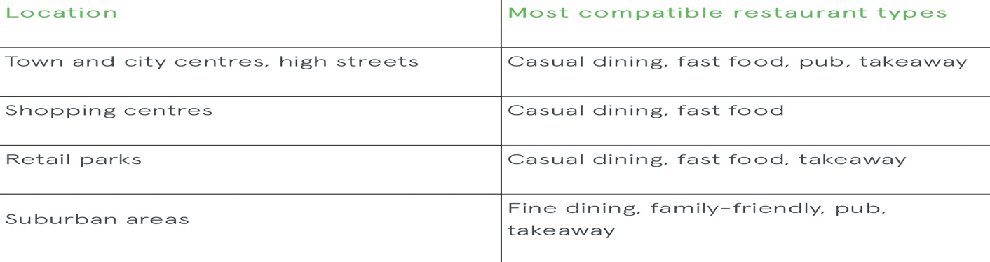

- Footfall levels must suit operating hours: in order to increase revenue, it is recommended to select a place that is busy during the working hours.
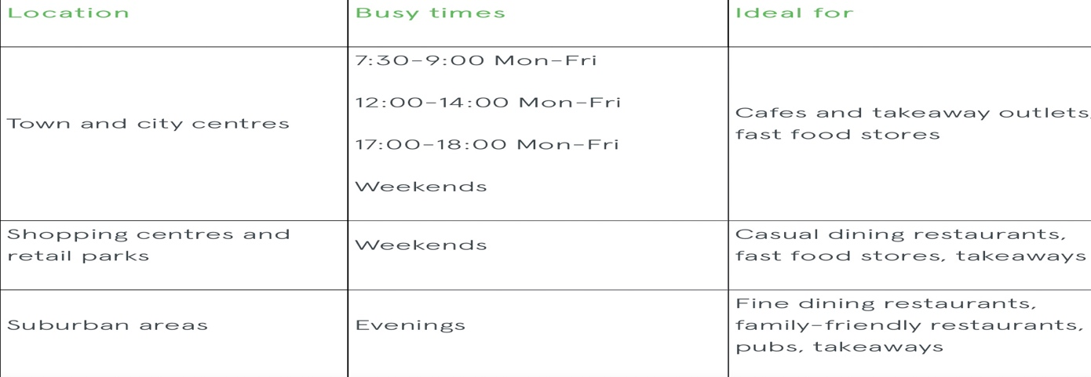

- Excessively rivalry can sometimes be disastrous, while inadequate competitors might be a bonus to the restaurant.
- Large parking site can be an advantage in front of competitors.
Crime statistics in the vicinity where the business is situated. For example, if a community is famous for its frequent robbery figures, prospective clients will be hesitant to visit the restaurant (Furmanik, 2020).
To be genuine to our consumers, we deliberately foregone the use of a highly centralised cuisine, like many eateries operate, which creates semi-ready dishes that are afterwards cooked and supplied to the consumers. We respect our consumers by offering them its most natural, tasty, and genuine delicious food imaginable.

References

Alruwaili, M., 2020. What is the difference between Aims and Objectives. [online] ResearchGate. Available at: <https://www.researchgate.net/publication/341540519_What_is_the_difference_between_Aims_and_Objectives> [Accessed 3 September 2022].
Furmanik, G., 2020. 10 things you should know about selecting a restaurant location. [online] Blog.realla.co.uk. Available at: <https://blog.realla.co.uk/10-things-you-should-know-about-selecting-a-restaurant-location> [Accessed 4 September 2022].
Geary, R. S., Gurol-Urganci, I., Mamza, J. B., Lynch, R., El-Hamamsy, D., Wilson, A.,
Hansen, P. H. (2012). Business history: A cultural and narrative approach. Business History Review, 86(4), 693-717.
Hepgul, N., Wilson, R., Yi, D., Evans, C., Bajwah, S., Crosby, V., (2020). Aim and objectives. NIHR Journals Library.
Herjavec, R., 2021. How To Set Restaurant Goals | The Kitchen Spot. [online] The Kitchen Spot. Available at: <https://thekitchenspot.com/resources/guide-to-streamlining-restaurant-operations/how-to-set-restaurant-goals/> [Accessed 3 September 2022].
Legacy, M., 2020. Why Your Company's History Is Important to Your Customers. [online] Müllerhaus Legacy. Available at: <https://mullerhauslegacy.com/blog/why-your-companys-history-is-important-to-your-customers/> [Accessed 2 September 2022].
Mac, G., 2019. Business benefits of being a child friendly restaurant. [Blog] Available at: <https://www.craftis.co.uk/our-blog/business-benefits-of-being-a-child-friendly-restaurant> [Accessed 2 September 2022].
Mattias, H., 2020. Thesis Paper on Restaurant. [online] Assignment Point. Available at: <https://assignmentpoint.com/project-report-on-restaurant/> [Accessed 2 September 2022].
Meulen, J. (2021). Aim and objectives. Variation in availability and use: a mixed-methods study. NIHR Journals Library.
Rizwan, M., 2018. The relationship of Brand Commitment, Brand Credibility, Perceived Quality, Customer Satisfaction and brand loyalty. [online] Citeseerx.ist.psu.edu. Available at: <https://citeseerx.ist.psu.edu/viewdoc/download?doi=10.1.1.674.4165&rep=rep1&type=pdf> [Accessed 2 September 2022].

