


McDonald’s: Analysis of External and Internal Environments

Tan Zhi Yan 2226088
BMBM6016 Strategic Marketing
Lecturer: Gwyneth Jones

Table of Contents
Executive Summary 1
1.0 Introduction 2
2.0 PESTEL Analysis 3
3.0 Porter’s 5 Forces 6
4.0 VRIO Analysis 8
5.0 SWOT Analysis 10
6.0 Recommendation 12
7.0 Conclusion 13
8.0 References 14

Executive Summary
This study investigates McDonald's from a range of views, both internal and external to the corporation itself. The PESTEL, Porter's Five Forces, VRIO, and SWOT analyses of McDonald's will each have five important takeaways highlighted here. McDonald's was subjected to a PESTEL analysis, which led to the discovery of two significant results concerning the social and technological aspects affecting the company. The results of Porter's Five Forces analysis on McDonald's revealed that its customers have a high degree of bargaining power. The analysis of McDonald's use of VRIO revealed the importance of the company's digital strategy, which was successfully implemented. Key results from McDonald's SWOT analysis include the company's exposure to competition, changing cultural standards, and economic uncertainty. Finally, this research offered recommendations for how McDonald's could enhance their operations or otherwise better respond to the market.

1.0 Introduction
In light of the current difficulties facing the global economy, the purpose of this audit is to ensure that the manager's proposal has been complied with. As a result, there will be four different sorts of analysis (PESTEL, Porter’s 5 Forces, VRIO, SWOT) carried out in order to comprehend McDonald's Malaysia's internal and external analysis.
When the Movement Control Order (MCO) and Conditional Movement Control Order (CMCO) were enacted, the Covid-19 pandemic had already been adversely affecting fast-food restaurants like McDonald's, KFC, and Subway's brand, shift in demand, and revenue. In accordance with the government's mandated operating hours for the fast-food industry once the second phase of MCO was announced, restaurants were open from 8:00 am to 8:00 pm daily (Jr, 2020). Even if the nation is afflicted by a pandemic, these major industries must maintain operations and support their workers. Although challenging, they will need to adjust to the new circumstances and embrace the opportunity to continue operating as usual. For this reason, the government of Malaysia has been easing some regulations (CMCO) in an effort to maintain economic stability. The Prime Minister claims that Malaysia's economy faced severe setbacks as a result of the economy's poor performance (Kanyakumari & Yusof, 2021). According to news outlets on 11 February 2021, Malaysia's GDP fell 3.4% in the final quarter of 2020 compared to the same period the previous year. To add insult to injury, Malaysia's GDP shrank by 5.6% in all of 2020, making it the poorest performing economy in the region since the Asian Financial Crisis of 1998 (Shukry, 2021).
As the most well-known fast-food chain, McDonald's is ideally positioned to take advantage of the growing popularity of online food delivery services like Grab and FoodPanda. McDonald's is well-known as a prosperous company with a rigorous method in establishing its brand into the markets of Malaysia due to its instantly recognizable logo, "I'm lovin' it" advertising campaign, speedy service, drive-thru's dedication to accessibility, creative locally-inspired menu items, and a focus on providing customers with value (Kee et al., 2021). McDonald's is reputable since it has been honored by the Malaysia Book of Records for its drive-thru challenges, has been named one of the Aon Hewitt Best Employers in Malaysia for three consecutive years, and has been awarded gold at the Putra Brand Awards for five consecutive years (Teo, 2022).

2.0 PESTEL Analysis
One of the methods employed to detect and assess the primary determinants of alteration in the organizational environment is known as the PESTLE Analysis. Analyzing a situation from a variety of perspectives, including the political, economic, social, technological, environmental, and legal, is known as a PESTEL Analysis. A PESTLE analysis aims to assess a company's exterior environment and identify the various elements and variables that contribute to or detract from its performance (Buye, 2021).
Factors | Definitions | McDonald's PESTEL
Political | Governmental rules and legal challenges that businesses must address comprise the political aspect. From a political standpoint, businesses need to take into account the rules and regulations of their native countries (Issa et al., 2010). | Political elements, such as laws and regulations enacted by the government, affect the standards of cleanliness that citizens are obligated to uphold. Numerous national governments, including that of Malaysia, have exerted pressure on the fast-food restaurant sector. The declining popularity of fast food can be attributed to the public's growing belief that it contributes to the development of health problems like obesity, hyperlipidemia, and cardiovascular disease (Dilip et al., 2021).
Economics | Among these are material costs, monetary effects, and material employment prospects (Fosher, 2018). | External variables will have specific effects on McDonald's industrial environment at the international, regional, and local levels, such as in undeveloped nations, slow but consistent development (opportunity), the Covid-19 epidemic (threat), and in industrialized ones, fast expansion (opportunity) (Jian et al., 2021).
Social | It is important to take into account that the operational market's customs, cultural traits, mythologies, religious beliefs, and ethical standards as well as people's thoughts and attitudes about the business and industry (Perera, 2020). | McDonald's success in Malaysia can be attributed to the country's strong emphasis on hospitality, family, and community. McDonald's does not introduce any product containing pork, utilizing the Halal emblem, out of respect for local customs and in accordance with local rules (Malaysiakini, 2022).
Technological | Technological considerations refer to the evolution and progress of technology. All of these things affect how a business runs. If a business doesn't adapt to the latest technological trends, such as those involving machine learning, the Internet of Things, Artificial Intelligence, and deep learning, it risks being left behind (Pathak, 2020). | McDonald's uses online social media platforms in addition to its website to disseminate news about things like seasonal promotions and events. Self-service ordering kiosks are just one example of how McDonald's has embraced cutting-edge technology to improve the customer experience and increase profits (Peterson, 2017).
Environmental | Aspects are critical because of the rising cost of raw materials, the need to reduce pollution, maintain a socially and environmentally responsible business model, and reduce the company's carbon footprint (LibGuides, 2022). | McDonald's indirectly impacts climate change and loss of forest cover in a roundabout way due to its penchant for beef products. Straws made of plastic and other potentially dangerous packaging are also the target of a ban in various nations (Cuofano, 2023a).
Legal | Common examples of legal considerations include statutes, administrative rules, standards, and labor laws (Matovic, 2020). | McDonald's has at least two Muslim cooks on staff and has appointed two Sharia specialists to serve as Sharia consultants to the internal halal committee to ensure that all of their products are prepared in accordance with Islamic law (Rajawat et al., 2020).
Table 1, McDonald’s PESTEL Analysis.
The PESTEL analysis conducted on McDonald's allowed for the discovery of two important findings, which concerned the company's social and technological factors. Consumer purchasing patterns and tastes are strongly influenced by the norms and values of the larger society. Changes in popular culture can have a positive or negative effect on the demand for a product. Providing vegan food options is one of the social and cultural factors that could affect McDonald's expansion (Dzafri, 2021b). As a result, the trend in Malaysia is towards replacing traditional meat with plant-based alternatives. McDonald's is losing popularity among vegetarians because they can't meet up with the need for vegetarian options at their fast-food restaurants.
McDonald's is constantly launching emerging technologies in an effort to better serve its customers and keep up with the rapid pace at which technology is evolving nowadays. To eliminate the need for consumers to wait in line at the ordering counter, the company has installed self-order kiosks in each of its restaurants whereas other fast-food restaurants in Malaysia did not offer these services. Customers are more likely to spend more money when they make their selections alone instead of at the counter (Hafner & Limbachia, 2018). McDonald's locations now display a dynamic electronic menu that changes with the seasons, the period of the day, and the diner's location.

3.0 Porter’s 5 Forces
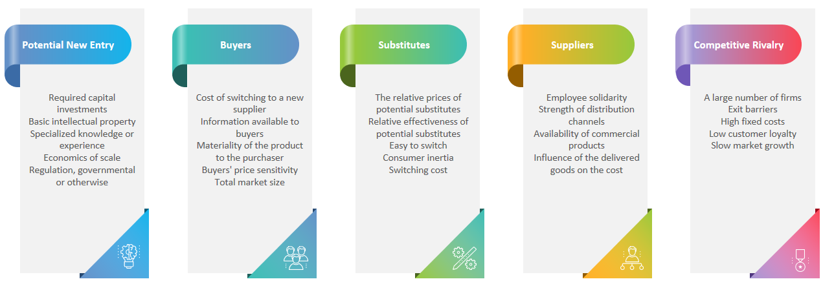
Figure 1, Porter’s Five Forces
This research uses Porter's (2008) Five Forces model as a starting point for reasoning about how local factors affect the success of McDonald’s in Malaysia. Maumbe (2012) claims that the model has shown to be a useful instrument for analyzing the impact of the microenvironment on businesses. The threat of new entrants and replacement products, bargaining power of buyers and suppliers, and competitive rivalry are the five dynamics represented in Figure 1 above that affect the success of McDonald's.
Firstly, markets in which McDonald's competes are often reserved for entrenched companies such as Starbucks, and KFC food chains. McDonald's widespread presence in the food service industry, especially amongst fast food chains, makes it difficult for upstarts to break into the market, especially mom-and-pop establishments that adhere to more traditional business practices. As it can be expensive to establish a recognizable brand in the fast-food market (Gregory, 2022).
Secondly, which is also the key finding from this analysis, it doesn't cost anything extra for customers to go from McDonald's to another fast-food restaurant like Starbucks, or KFC. To put it another way, in contrast to technology firms like Apple and Microsoft, which makes it difficult for consumers to exit the environment, the environment that McDonald's operates in at the moment is not able to successfully retain customers (Dudovskiy, 2022). The demand for fast food is affected by various factors, including rising consumer disposable income and shifting consumer preferences towards healthier and more upscale products. McDonald's consumers have greater bargaining power because of the lack of switching fees.
Thirdly, the restricted variety of products available is a major contributor to the company's declining sales. Hence, many consumers will switch to alternatives. Products from competing fast food restaurants, such as Burger King and roadside stands, will fill the void left by McDonald's. Notwithstanding McDonald's application of 24 hours throughout Malaysia, other fast-food restaurants are also open 24/7, as are roadside burger stands that stay open late (UKEssays, 2018).
Moreover, suppliers can exert pressure through various means, including threats of forward integration and supply disruption. McDonald's has considerable sway over its suppliers because of the company's generous assistance and extensive training programs for them (Vrontis & Pavlou, 2008). McDonald's businesses are so massive that suppliers value maintaining relationships with the company. McDonald's globalization could potentially increase suppliers' prospects and revenue.
Lastly, despite McDonald's fast-food popularity in Malaysia as well as worldwide, competition is still fierce. A major competitor to McDonald's is KFC. KFC offers a variety of food items that are comparable to what McDonald's offers. Additionally, several local burger joints compete with McDonald's by offering similar meals at lower prices, which threatens the chain's growth (Fernandez et al., 2022). In such a case, diners would look elsewhere for burgers.

4.0 VRIO Analysis
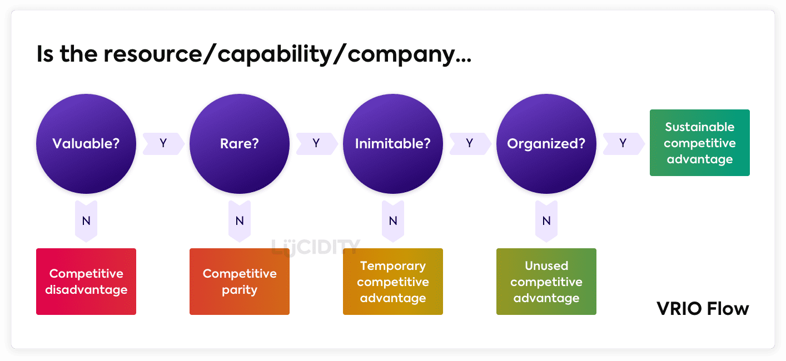
Figure 2, VRIO Analysis (Lucidity, 2023)
As shown in figure 3, by analyzing the management of a business's assets and identifying its competitive advantages and strengths, VRIO analysis can help a business keep its competitive edge, enter new markets, and foster innovation. Barney, (1991, 1995) introduced the VRIO analysis, classifying management assets according to their economic value, rarity, imitability, and organization.
As shown in Table 2 below, the most important takeaways from McDonald's VRIO investigation are the locations where emerging order handling technologies are organizational resources, and where these innovations are also seen to be a part of the digital initiative being undertaken by the company. For instance, the mobile app that McDonald's offers in Malaysia enables customers to place their order and then pick it up at either the drive-through or the counter. This strategic asset enhances the efficiency of the value chain and the convenience of the purchase process for clients. But since this can be replicated by rivals, it cannot be relied upon to deliver a lasting advantage.

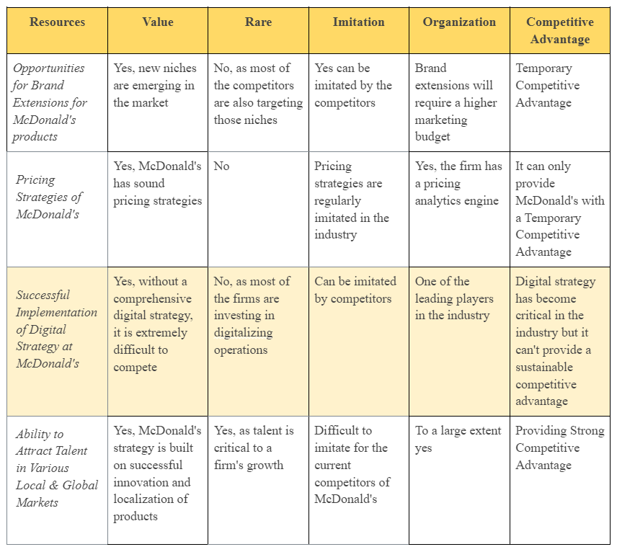
Table 2, McDonald’s VRIO Analysis (Fern Fort, 2023)

5.0 SWOT Analysis
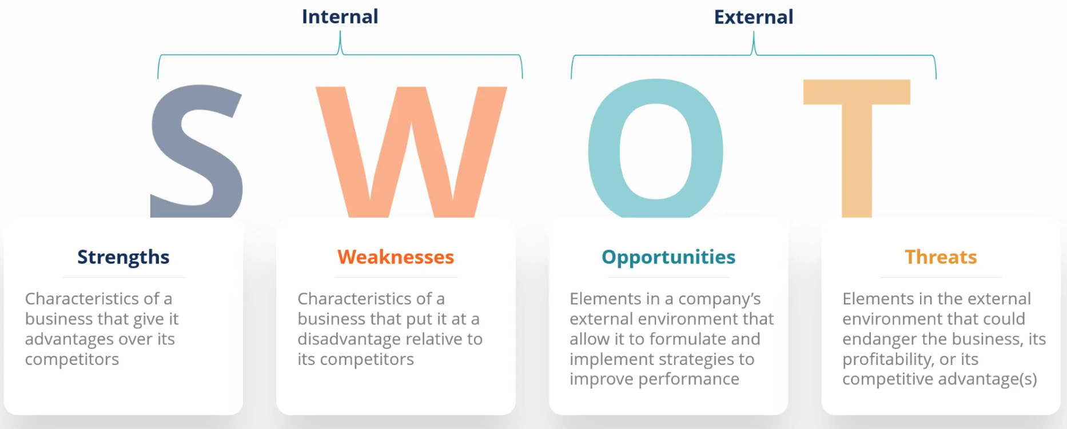
Figure 3, SWOT Analysis (CFI, 2023)
SWOT analysis is a planning technique used to assess the strengths (excess), weaknesses (deficiency), opportunities (prospect), and threats (barrier) associated with a project or commercial endeavor. It entails defining the target business endeavor or project and determining the internal and exterior factors that are favorable and unfavorable to achieving that target (Lestari & Yunita, 2020).
McDonald's Malaysia took several measures to aid the Ministry of Health in its fight against the Covid-19 outbreak has helped fuel the company's greatest strengths. In 2021, they distributed 10,000 free meal tickets to frontline workers who have been caring for COVID-19 patients in the ICU or CCU (Aziz, 2021). This gift is intended as an expression of gratitude to all frontline staff for their dedicated efforts in caring for patients. Moreover, McDonald's has provided three million Americanos to immunized individuals at the same time.
Supply chain disruptions are problematic for McDonald's because of the company's flawed strategy and organizational structure. As one of the world's busiest fast-food franchises, McDonald's is frequently affected by supply chain disruptions. The availability of French fries in early 2022 was hampered by shortages of potatoes in Malaysia and Indonesia, joining Japan's struggle (Meisenzahl, 2022). Therefore, when franchise operations are disrupted, costs to maintain the business rise, leading to decreased earnings and profitability (Gupta, 2019).
Furthermore, the Asian region presents tremendous opportunities for McDonald's to expand its operations. Fast food is in high demand among today's population in Asia's metropolitan centers including Malaysia, Singapore, and Indonesia (Angela, 2022). Fast food is the go-to for many individuals. McDonald's would benefit from expanding its presence in the booming Asian market, where the middle class has grown in size and disposable money due to the region's economic growth.
The key findings of McDonald’s SWOT analysis are that McDonald's faces threats from competitor businesses, shifting cultural norms, and unstable economic situations. McDonald's market dominance could be threatened by a shift in consumer attitudes towards healthier fast-food options (Cuofano, 2023b). A growing number of people are opting for better lifestyles and products, such as salads and organic smoothies. However, the majority of things on McDonald's menu are harmful, and as a result, the restaurant risks losing consumers who are concerned about their health (Gupta, 2019). Even with a refreshed menu, the organization may have trouble competing with well-established rivals in the healthy food market such as Subway. As a result of this tendency, McDonald's has been subjected to increased regulatory scrutiny as well as the accompanying expenditures.

6.0 Recommendation
After a thorough examination of McDonald’s, I have found three suggestions that can be made to account for the key findings. Firstly, McDonald's is aware that it lags behind rivals like Starbucks when it comes to digital approaches and customer incentive programs. McDonald's is currently developing a loyalty program in the hopes of increasing both consumer satisfaction and repeat purchase. However, in order to better serve its clients, the app needs to be made more intuitive to use because it is now fairly difficult to navigate around within the app.
Secondly, in 2020, McDonald's will roll out the McPlant, a plant-based burger, to meet the demand of customers in nations where the number of vegetarians and vegans is expected to increase (AFP, 2020). McDonald's McPlant would be a welcome addition to the Malaysian market, where plant-based fast-food options are increasingly widespread (Dzafri, 2021a).
Last but not least, the development of new core competencies could help McDonald's strengthen its defenses against the tactical difficulties posed by rivalry and regulations. Value chain efficiency is bolstered by things like cutting-edge automation of processes in the food service industry. McDonald's has already begun moving in this direction strategically with its cashier-less eateries, albeit this level of technology has not yet been implemented across the franchise system. McDonald's Malaysia VRIO highlights the importance of bolstering competitive advantages, and from a resource-based perspective, doing so involves cultivating new core competencies.

7.0 Conclusion
In conclusion, this study examines McDonald's from a variety of perspectives, both internal and external to the company. After completing the audit, I determined that there were five noteworthy takeaways from the McDonald's PESTEL, Porter's Five Forces, VRIO, and SWOT analyses. These were either McDonald's areas of excellence or areas for improvement that deserved to be acknowledged. Nevertheless, if McDonald's can maintain its current comprehensive strategies and make certain innovations, these obstacles can be overcome. On top of this, suggestions were made in this study for McDonald's to improve their situation or strengthen their capabilities. The company has experienced rapid expansion and sustained success because to its openness to globalization, and it has a strong foundation upon which to build and flourish in the years to come.

(Total word count: 2703)

8.0 References
AFP (2020) McDonald’s launching meatless ‘McPlant’ burger, Free Malaysia Today. Available at: https://www.freemalaysiatoday.com/category/business/2020/11/10/mcdonalds-launching-meatless-mcplant-burger/ (Accessed: March 30, 2023).
Angela (2022) McDonald's SWOT analysis 2023: A yummy and detailed report!, McDonald's SWOT Analysis 2023: A Yummy and Detailed Report! Available at: https://swothub.com/mcdonalds-swot-analysis/ (Accessed: March 30, 2023).
Aziz, S. (2021) McDonald's Malaysia spreads positivity in the nation's road to recovery, New Straits Times. Available at: https://www.nst.com.my/topic/lifestyle/2021/09/732438/mcdonalds-malaysia-spreads-positivity-nations-road-recovery (Accessed: March 30, 2023).
Barney, J. (1991) “Firm Resources and sustained competitive advantage,” Journal of Management, 17(1), pp. 99–120. Available at: https://doi.org/10.1177/014920639101700108.
Barney, J.B. (1995) “Looking inside for competitive advantage,” Academy of Management Perspectives, 9(4), pp. 49–61. Available at: https://doi.org/10.5465/ame.1995.9512032192.
Buye, R. (2021) “Critical examination of the PESTEL Analysis Model,” Action research for development [Preprint]. Available at: https://www.researchgate.net/publication/349506325_Critical_examination_of_the_PESTEL_Analysis_Model (Accessed: March 27, 2023).
CFI (2023) SWOT analysis, Corporate Finance Institute. Available at: https://corporatefinanceinstitute.com/resources/management/swot-analysis/ (Accessed: March 28, 2023).
Cuofano, G. (2023) McDonald's Pestel Analysis, FourWeekMBA. What is The FourWeekMBA. Available at: https://fourweekmba.com/mcdonalds-pestel-analysis/ (Accessed: March 29, 2023).
Cuofano, G. (2023) McDonald's SWOT analysis, FourWeekMBA. What is The FourWeekMBA. Available at: https://fourweekmba.com/mcdonalds-swot-analysis/ (Accessed: March 30, 2023).
Dilip, D. et al. (2021) “Effective/differentiating marketing strategies of McDonald’s in Malaysia and Indonesia,” Journal of The Community Development in Asia, 4(1), pp. 16–33. Available at: https://doi.org/10.32535/jcda.v4i1.995.
Dudovskiy, J. (2022) McDonald's Porter's five forces analysis - research-methodology, Research. Available at: https://research-methodology.net/mcdonalds-porters-five-forces-analysis/#google_vignette (Accessed: March 29, 2023).
Dzafri, D. (2021) McDonald's is testing out "Beyond meat" mcplant burgers. will it reach Malaysian Shores?, SoyaCincau. Available at: https://soyacincau.com/2021/10/18/mcdonalds-is-testing-out-beyond-meat-mcplant-burgers-will-it-reach-malaysian-shores (Accessed: March 30, 2023).
Dzafri, D. (2021) McDonald's is testing out "Beyond meat" mcplant burgers. will it reach Malaysian Shores?, SoyaCincau. Available at: https://soyacincau.com/2021/10/18/mcdonalds-is-testing-out-beyond-meat-mcplant-burgers-will-it-reach-malaysian-shores/ (Accessed: March 29, 2023).
Fern Fort (2023) McDonald's VRIO / Vrin Analysis: Assignment help, Fern Fort University. Available at: http://fernfortuniversity.com/term-papers/vrio/c/1005-mcdonald-s.php (Accessed: March 30, 2023).
Fernandez, C.T. et al. (2022) “Management of Strategy: Mcdonald Malaysia,” Management of Strategy BSM 3114 [Preprint]. Available at: https://pdfcoffee.com/management-of-strategy-mcdonald-malaysia-pdf-free.html#Chiaki+Hidayah (Accessed: March 29, 2023).
Fosher, H. (2018) “Understanding the Marketing and Management of trails using PESTEL Analysis,” Semantic Scholar [Preprint]. Available at: https://www.semanticscholar.org/paper/Understanding-the-Marketing-and-Management-of-using-Fosher/1038c84544c84ad29d345640aa852eb5ba44084f (Accessed: March 28, 2023).
Gregory, L. (2022) McDonald's five forces analysis (Porter's Model) & Recommendations, Panmore Institute. Available at: https://panmore.com/mcdonalds-five-forces-analysis-porters-model (Accessed: March 29, 2023).
Gupta, S.K. (2019) McDonald's SWOT analysis(2023), Business Strategy Hub. Available at: https://bstrategyhub.com/mcdonalds-swot-analysis/ (Accessed: March 30, 2023).
Hafner, J. and Limbachia, D. (2018) McDonald's: You buy more from touch-screen kiosks than a person. so expect more kiosks, USA Today. Gannett Satellite Information Network. Available at: https://www.usatoday.com/story/money/nation-now/2018/06/07/mcdonalds-add-kiosks-citing-better-sales-over-face-face-orders/681196002/ (Accessed: March 29, 2023).
Issa, T., Chang, V. and Issa, T. (2010) “Sustainable business strategies and PESTEL framework,” GSTF International Journal on Computing, 1, pp. 73–80. Available at: http://hdl.handle.net/20.500.11937/45566 (Accessed: March 28, 2023).
Jian, O.Z. et al. (2021) “Effective marketing strategies of McDonald’s in Malaysia and Indonesia,” International Journal of Applied Business and International Management, 6(2), pp. 33–46. Available at: https://doi.org/10.32535/ijabim.v6i2.1167.
Jr, J.K. (2020) Ismail Sabri: Eateries, supermarkets to only operate from 8am to 8pm from April 1, The Star. Available at: https://www.thestar.com.my/news/nation/2020/03/30/ismail-sabri-eateries-supermarkets-to-only-operate-from-8am-to-8pm-from-april-1 (Accessed: March 31, 2023).
Kanyakumari, D. and Yusof, A. (2021) Full lockdown would guarantee safety, but Malaysia's economy could collapse: Muhyiddin on targeted covid-19 curbs, CNA. Available at: https://www.channelnewsasia.com/asia/malaysia-muhyiddin-yassin-covid19-mco-interview-economy-safety-1397616 (Accessed: March 31, 2023).
Kee, D.M. et al. (2021) “The impact of COVID-19 on the fast-food industry in Malaysia,” Journal of The Community Development in Asia, 4(2), pp. 44–57. Available at: https://doi.org/10.32535/jcda.v4i2.1072.
Lestari, T.I. and Yunita, L. (2020) “The Implementation of SWOT Analysis As a Basis For Determining Marketing Strategies,” Enrichment: Journal of Management, 10(2), pp. 25–29. Available at: https://enrichment.iocspublisher.org/index.php/enrichment/article/view/16 (Accessed: March 30, 2023).
Libguides (2022) Libguides: Industry Research: Pestel Analysis, PESTEL Analysis - Industry Research - LibGuides at Washington State University. Available at: https://libguides.libraries.wsu.edu/c.php?g=294263&p=4358409 (Accessed: March 28, 2023).
Lucidity (2023) The VRIO framework: A tool to effectively evaluate your strategy, Lucidity. Available at: https://getlucidity.com/strategy-resources/introduction-to-the-vrio-framework/ (Accessed: March 30, 2023).
Malaysiakini (2022) Hanya Yang Halal Di McDonald's Malaysia, Malaysiakini. Available at: https://www.malaysiakini.com/brandedcontent/622974 (Accessed: March 29, 2023).
Matovic, I.M. (2020) “PESTEL Analysis of External Environment as a Success Factor of Startup Business ,” Consciens Conference On Science And Society, pp. 96–102. Available at: https://doi.org/10.5281/zenodo.4058794.
Maumbe, B. (2012) “The rise of South Africa's Quick Service Restaurant Industry,” Journal of Agribusiness in Developing and Emerging Economies, 2(2), pp. 147–166. Available at: https://doi.org/10.1108/20440831211272607.
Meisenzahl, M. (2022) More Global McDonald's customers are facing French fry shortages as the supply chain continues to face strain, Business Insider. Business Insider. Available at: https://www.businessinsider.com/mcdonalds-faces-french-fry-shortages-in-malaysia-indonesia-and-taiwan-2022-2 (Accessed: March 30, 2023).
Pathak, R. (2020) What is pestle analysis? factors, advantages and disadvantages of Pestle analysis, What is PESTLE Analysis? Factors, Advantages and Disadvantages of PESTLE Analysis. Available at: https://www.analyticssteps.com/blogs/what-pestle-analysis (Accessed: March 28, 2023).
Perera, R. (2020) The PESTAL analysis. Sri Lanka: Nerdynaut.
Peterson, H. (2017) McDonald's shoots down fears it is planning to replace cashiers with kiosks, Business Insider. Business Insider. Available at: https://www.businessinsider.com/what-self-serve-kiosks-at-mcdonalds-mean-for-cashiers-2017-6 (Accessed: March 29, 2023).
Porter, M.E. (2008) The five competitive forces that shape strategy, Harvard Business Review. Available at: https://hbr.org/2008/01/the-five-competitive-forces-that-shape-strategy (Accessed: March 29, 2023).
Rajawat, A. et al. (2020) “Factors: Responsible for McDonald's performance,” Journal of The Community Development in Asia, 3(2), pp. 11–17. Available at: https://doi.org/10.32535/jcda.v3i2.806.
Shukry, A. (2021) Malaysia's economy suffers worst year since 1998 Asian crisis, Bloomberg.com. Bloomberg. Available at: https://www.bloomberg.com/news/articles/2021-02-11/malaysia-s-economy-suffers-worst-year-since-1998-asian-crisis (Accessed: March 31, 2023).
Teo, R. (2022) McDonald's Malaysia recognised as best of the best employer, Borneo Post Online. Borneo Post Online. Available at: https://www.theborneopost.com/2022/01/21/mcdonalds-malaysia-recognised-as-best-of-the-best-employer/ (Accessed: March 31, 2023).
UKEssays (2018) Analysis of McDonalds in Malaysia, UKEssays. UK Essays. Available at: https://www.ukessays.com/essays/communications/mcdonalds-in-malaysia.php#citethis (Accessed: March 29, 2023).
Vrontis, D. and Pavlou, P. (2008) “The external environment and its effect on strategic marketing planning: A case study for McDonald's,” J. for International Business and Entrepreneurship Development, 3(3/4), p. 289. Available at: https://doi.org/10.1504/jibed.2008.019163.

