

LEVEL 4 ASSESSMENT SPECIFICATION

Student name: |  | Student ID number: | 145430
Programme: | HNC Process Operations Engineering
Module: | Plant Maintenance and Asset Care
Module code: | PCPO4005 | Contribution to Overall Module Assessment (%): | 100%
Lecturer: | P R Taylor/ Nigel Richards | Internal Verifier: | Lance Rutherford
Assignment Title: | Asset Management | Word count (or equivalent): | 2000
Submission deadline: | 08 April 2020 | Return date of provisional marks & written feedback: | 06 May 2020
Submission method: | All written assessments, where practical and possible, must be submitted via Turnitin unless otherwise instructed by the Lecturer. (Please DO NOT put this assessment specification into Turnitin or it will match many similarities with other students’ submissions.)  Alternative submission method (if applicable):  Late submission of the assessment will result in a late penalty mark. Penalties for late submission: Up to one week late, maximum mark of 40%. Over one week late, 0%. Only the Extenuating Circumstances Panel may approve a change to submission dates.
Academic honesty / referencing: | Academic honesty is required. In the main body of your submission you must give credit to authors on whose research and ideas your work is based. Append to your submission a reference list that indicates the books, articles, etc. that you have used, cited or quoted in order to complete this assessment.

Module Learning Outcomes
(from module syllabus)
- Explain maintenance strategies and asset care methodologies.

- Select an appropriate maintenance strategy based on an assessment of the operational, business and legal requirements for the asset.

- Develop and implement asset care improvement techniques

TASK DESCRIPTION

Task 1. System Life Cycle (SLC)

Many companies adopt a System Life Cycle approach to the management of their assets. Explain this strategy and how it applies to the purchase, commissioning, operation, maintenance and decommissioning of equipment.

Task 2. Improvement techniques - Kaizen

Kaizen is an approach to creating continuous improvement in lean manufacturing that is adopted by a number of business. Explain this methodology and how it can be applied in an industrial setting.

Task 3. Total Productive Maintenance (TPM)

Total Productive Maintenance (TPM) is a maintenance methodology that is used to optimise asset utilisation. Explain this methodology and the key principles.

Task 4

A company has completed the installation of two electrically driven centrifugal pumps (see figure 1). The pumps will be operated in a duty/standby configuration and supply cooling water to a chemical processing vessel carrying out an endothermic reaction. The maintenance department are now assessing the new equipment to determine the most appropriate intervention strategy.

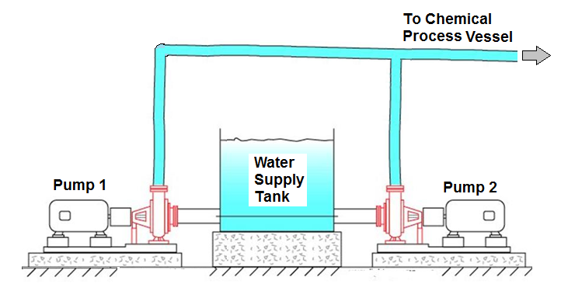

In order that a maintenance strategy can be put in place, operating information must be gathered from the new plant. Discuss a range of monitoring equipment which can be used to obtain this information. With respect to the above scenario and equipment, discuss the advantages and disadvantages of adopting either a run to failure or a planned preventative maintenance strategy. Select which strategy you would adopt, providing your justifications based on operational, business and legal requirements.

Task 5

Assets deteriorate over time which risks affecting production requirements.

For an asset that you are familiar with at your place of work, conduct an asset care assessment. Based on your assessment, develop an asset care improvement plan and describe how this might be implemented.

Report writing

To complete this assignment you are required to generate a report of 2000 words. Your report should critically present the research work undertaken. Present and discuss the results obtained with reference to any background material and draw appropriate conclusions to the results obtained.

Note: Any hand written submission will not be accepted.

Student FEEDBACK FORM

This section details the extent to which the assessment criteria are demonstrated by you, which in turn determines your mark. The marks available for each category of skill are shown. Lecturers will use the space provided to comment on the achievement of the task(s), including those areas in which you have performed well and areas that would benefit from development/improvement.

Generic Assessment Criteria | Marks available | Marks  awarded
1. Engagement with Literature Skills
.
 | 10
2. Knowledge and Understanding Skills

 | 40
3. Cognitive and Intellectual Skills

 | 20
4. Practical Application Skills

 | 20
5. Transferable Skills for Life and Professional Practice

 | 10

Assessment Mark (Assessment marks are subject to ratification at the Exam Board. These comments and marks are to give feedback on module work and are for guidance only until they are confirmed. ) | Late Submission Penalties (tick if appropriate) |  | %
 | Up to 1 week late (40% Max) |  | %
 | Over 1 week late (0%) |  | %

Learner Name: Harry Thomas-Dawe
Course: HNC Process Operations Engineering Year 1
Module Code: PCPO4005
Module Name: Plant Maintenance and Asset Care
Element: 1

Contents Page
Intro - Page No. 3
Task 1 – Page No. 4
Task 2 – Page No. 5
Task 3 – Page No. 6
Task 4 – Page No. 6 – 8
Task 5 – Page No. 9 – 10

Introduction
The purpose of this assignment is to display a basic understanding into industrial process care, as well as maintenance management and different approaches followed by different companies.

System Life Cycle:
The system life cycle is a management technique that is used to predict the cost effectiveness of purchasing assets within a company. Firstly the purchase of the item is evaluated. This is evaluated on cost, quality and time until purchase can be delivered etc. Usually if it is low cost it could be questionable on quality, this also works the other way around and time is also an important factor as quicker delivery may cost more or the delivery may take too long and not be worth missing the asset for that length of time. The purchase of the SLC also linked to the design as the design of the product id the start of the SLC, when purchasing assets they must meet the required specifications. So with the design and purchase comes the start of the system life cycle.
The next step in the SLC is the commissioning of the purchased equipment. This is the installing and the start up of new equipment. When undergoing commission there is a need to consider the costs of:
- Labour/ Man Power
- Training
- Resources & Consumables
- Space to install and necessary facilities
- Testing and approval for use
These factors will determine the cost effectiveness of buying and commissioning this equipment, also the operation of this new equipment is considered as the useful running life of the equipment. Put in simpler terms, how long can it be used for profit. This will include some variables similar to commission in the form of resources, training and man power to run the equipment also considered is the cost of repairs. This is a major factor as there is no point in buying equipment that won’t last.
The final step in the SLC is the decommission of equipment. When the equipment fails and is beyond repair or has out served its purpose the equipment is made redundant and decommissioned. Now that the equipment is decommissioned, the management will have to think about:
- Disposal, possible need for specialised disposal under legal requirements.
- Removal, man power, proper training and how long it will take
- Possible selling as parts or second hand to other companies to possibly make some money back on decommissioned equipment.
In summary there are many factors that will be considered in the SLC including, purchase, commission, operation and decommission that will be evaluated when companies use the SLC approach on assets.

Kaizen
Kaizen, originating in Japan is a maintenance technique used to improve the state of mind of employees and humanise the workplace. This focuses more on improvement of productivity which uses:
- Utilization of resources
- Small inexpensive changes
- An increase in efficiency of productivity
- Proper training
- And removal of unnecessary operations
Kaizen is a terminology that requires “team input” which can be easier said than done as differences and conflicts can arise which will alter the team relation therefore effecting their input. In Kaizen there is a review of the process that focuses on:
- Why the process needs to change
- What work is being done
- Where is it being done and where should it be done
- When is it done compared to when should it be done
- Who is doing this work and who should be doing this work
- How is the work being done and how should it be done
- How often is the work done and how often should it be done
All the above points should be taken into account to make Kaizen effective. This method often proves ineffective due to incorporation of the wrong steps or the refusal to change by individuals that have done their process a certain way for a long time.

TPM
Total Productive Maintenance is a method of optimising asset use. There are key principles of TPM that are used to evaluate the Total productive maintenance. These key principles are:
- Autonomous Maintenance. Standardisation of the maintenance activity so it can be followed by simple steps.
- Planned Maintenance. The panning of maintenance tasks on a regular basis to prevent failures.
- Focused Improvement. Focusing on areas and improving them to make them more efficient.
- Early Equipment Managements. Managing equipment from early stages to provide effective maintenance strategies.
- Quality Maintenance. Maintenance that will make a difference and keep the plant in a maintained state.
Some people believe these are the 5 Pillars and some add these other three to make it 8 pillars:
- Education and Training. Providing staff with adequate training and information to properly maintain assets.
- Safety, Health and Environment. Legal factors that should be considered in all tasks.
- Office TPM. Focusing on the office staff for better management and planning.
TPM uses these key principles to alter the maintenance into a more productive and efficient task. The principles are used to achieve this goal.

Task 4 – A Range of Measuring Equipment and Best Strategy
The new plant will require a range of different measuring equipment in order to record vital information to help maintenance strategy etc.
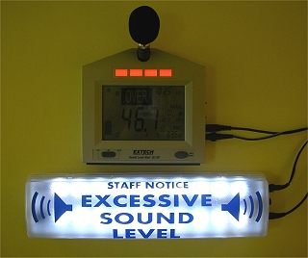
- Temperature- The temp of this new equipment should be measured from the pumps also from the tank. The temperature of the pumps could lead to overheating or ineffective oil type used. The temperature of the tank should also be measured because extreme conditions could lead to freezing or evaporation. Thermometers could be used to measure the temperature at different points over the system.
- Noise Levels- for legal reasons I believe the noise levels should be measured on initial operation to determine the need for PPE etc. this could simply be measured by personnel with sound level meters.
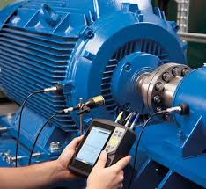
- Vibration analysis- vibrations can lead to problems all over the plant. High vibes on the pumps could lead to damage of the pumps and make them unreliable in their time of need as this cooling system should be constant from at least one pump. There are many ways to do this and personally I would suggest the use of vibration points that are checked regularly personnel with handheld vibration meters.
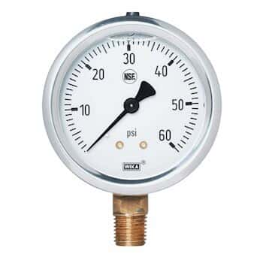
- Output/Product flow/ energy out from motors/pump speed/discharge pressure- on the output line there are many variables to measure. The discharge pressure should be measured to ensure the water leaving the pump is not too high or too low. The energy used from the motors should also be measured as if these motors are working too hard to run the pumps this could be shown in the Amps etc. and catching this here could prevent further problems. The speed of the pump is also important as the speed at which the pump is going will affect the suction and discharge and could lead to more problems. The flow from the pumps will also need to be measured as too low flow could mean a problem from the pump or other equipment and too high flow could mean the configuration of the equipment is wrong. For energy readings multimeters can be used, for flow measurement, transducers can be added to points on the systems water lines. Tachometers can be used to measure the speed on the pumps and discharge pressure can be measured using transducers or bourdon tube gauges in field.
- Input/flow in/suction pressure/power used- the input should also be measured as this could affect how the system works. The power being used should be measured as too much power being used could mean problems, also the suction pressure from the pumps is important ad a low suction would mean there is a problem with the operation for the pump which could cause more problems. The flow into the pump should also be measured to allow for insight to possible issues. Flow transducers, pressure gauges or transducers and multimeters can be used to measure these variables as well.
- Oil analysis- the oil in the pumps is vital to allowing these pumps to operate in their conditions without overheating or causing damage. Oil levels can be shown using sight glasses and sample points will allow for personnel to check the oil integrity.
- Level in tank- the level in the tank is important as this level cant be too low or too high. This can be measure by using sight glasses infield or by using ultrasonic level transducers.
- Pressure in tank- the pressure of the tank is important as high pressure will lead to damage and the possibility of the tank bursting. The pressure of the tank can be measured by gauges infield.
A run to failure approach would lead to less need for training and man power and less purchase of consumables, however the RTF strategy would mean the loss of critical and expensive equipment which will overall lead to more cost and possible legal problems as improper care of the cooling water system could lead to the system overheating causing serious H&S implications.
A planned preventative maintenance strategy would allow for the system to be kept in safe state and allow for a longer system life. This planned preventative system would require a more frequent need for labour but in the long run would cost a lot lest than replacing this expensive equipment.
Due to the nature of the system and the use of certain types of monitoring systems I have suggested I believe that planned preventative maintenance is the only reasonable strategy to be implemented on this system this is due to:
- Replacing this equipment is expensive
- Proper monitoring would need a scheduled routine
- The system is too important to just let fail and wait for replacement
- Also letting this equipment just fail could be dangerous and lead to legal consequences
- The use of PPM allows for longer system life

Task 5- Asset Care Assessment on Fire Water Pump
This fire water pump is used on the Jetty and is a deep well pump that takes water from the haven and distributes to fire water points. This pump is only used when needed and is critical if a fire breaks out. The hydraulic control opens the suction line for availability of water, the electrically driven motor is button start and the system is lubricated by a lube oil tank that distributes oil over the system.
Asset Care Steps:
- Initial cleaning and tagging- this Pump is tagged as 01-FP-1
01-FP-1 is Cleaned on the annual planned maintenance.
- Eliminate causes of contamination - make cleaning easier
All key components are guarded from the elements and dirt does not accumulate much due to protective painting.
- Prepare cleaning and lubrication standards
The lubrication oil is replaced on every annual PM. And the standards are that the oil must be fresh and clean from contaminants.
- Improve inspection and technical Skills
Inspection of the coupling and critical components is carried out on annual PM. I would suggest a more thorough inspection of oil samples and coupling state.
- Operator self-managed standards and visual controls
The operators visually check the pump occasionally to ensure there is no problems with the pump.
- Standardise procedures
The annual PM is a standardised procedure.
- Full cell based care routines
Oil change, coupling checks and damage checks on every PM.

FMECA Assessment
Component Number | Description | Failure risk to personnel in area | Time taken to rectify | Cost of rectification | Failure risk to Plant | Total
1 | Lube Oil | 2 | 1 | 2 | 5 | 20
2 | Coupling | 3 | 3 | 3 | 5 | 135
3 | Pneumatic control | 2 | 4 | 3 | 5 | 120
4 | Emergency stop | 2 | 3 | 2 | 5 | 60
5 | Motor start button | 2 | 3 | 2 | 5 | 60
This FMECA assessment has been carried out as if there is a fire on sight, this is why there is such a high total on all of the components. If parts fail the risk to plant could be catastrophic as this would be used to fight the fires.
To improve the risks implemented I would suggest a more occasional planned maintenance routine and also another way apart from a hydraulic control to start the pump. Also an instalment of a backup pump with the same PM schedule to be help lower the risk of system failure.

References
- https://moodle.pembrokeshire.ac.uk/pluginfile.php/263305/mod_resource/content/1/---%20Rolls%20Royce-Asset-care%20---.pdf (asset care assessment steps)
- https://www.explainthatstuff.com/soundlevelmeters.html (what to use for noise measurement)
- https://www.pce-instruments.com/english/measuring-instruments/test-meters/vibration-meter-kat_40108.htm (what to use for vibes)
- https://www.coleparmer.co.uk/i/wika-50072391-nsf-certified-pressure-gauge-0-to-100-psi-bottom-mount-1-4-npt-m-connection/6804905 (Pressure Guage)

