E-PORTOFOLIO REPORT
Learning in the Digital Era – BMPL4007

MARIA-MADALINA FEIER (2207140)

Table of Contents
Task 1 – Written Summary
Task 2 – Mind Map
Task 3 – Presentation
Task 4 – Reflection
Reference List

Task 1 - Summary

Preparing for higher education takes courage, dedication, and commitment. As a starting point any student should be able to create a few good strategies to overcome the pressure of studying such as environment, time management and an effective plan to familiarize themselves with the new modern technology techniques. Studying at a University level can be particularly challenging, but experience is gained from trying the best if there is enjoyment with Cantrell (2019). Study place is where they reach their absolute best potential in achieving their goal somewhere quiet with less or non-distraction and a lot of light such as a home office because it will conduct their studies to be more’’ effective and efficient’’ as stated by Contrell (2019). Not having a plan and not being able to conduct a suitable time management can lead students to fail behind their task. Eisenhower stated in his principles that ‘’urgent and important task’’ should be priorities to achieve professional goals. Students that assess their time management will improve skills ability and overcome procrastination and perfectionism.
Put an End to Procrastination - REBEL EM - Emergency Medicine Blog by Unknown Author is licensed under CC BY-NC-ND
During their time at the university students should improve their digital skills in using technology software such as Microsoft Word, Power Point, Microsoft Teams and learn how to stay safe online while doing searches for academic resources. Through the time at university students would be required to complete different assignments showing their critical thinking writing abilities alongside various reading materials. However, they should be able create their own work by giving knowledge to other’s writing ideas using Harvard Referencing.
Task 2 – Mind Map

a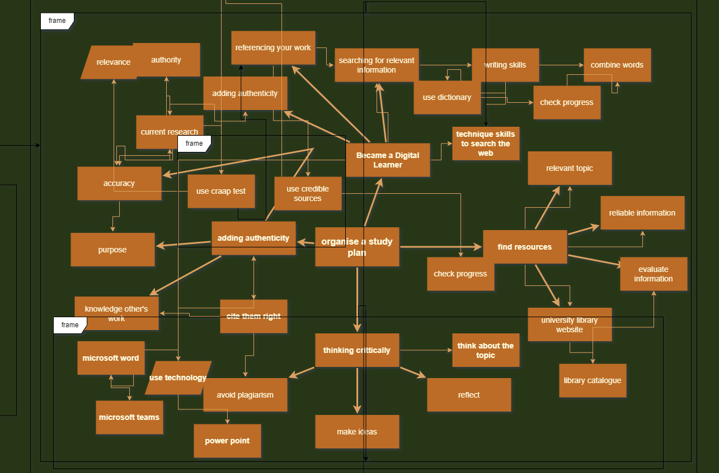
Hafner and Miller (2019) see the digital era as a two-way approach ‘’using technology to learn’ and’ learning to use technology’.
Task 3 – Presentation
This is my link to video presentation:


Task 4 – Reflection
Starting University is a challenging step for every student especially when it comes to a different age, different language and in a modern world where technology is the key for the future.
Following Borton’s (1970) model of reflection, I am going to reflect on my time at the university from the beginning until now and how I am going to overcome all the challenges. For me studying policing at a higher level of education was something I always wanted to do but never had the chance or opportunity to achieve my dream. What happened during inductions events gave me the hope that I was doing the right thing and that I was in the right place as the others. The lecturers were all extremely helpful, giving us all the information and support regarding the course. At first, I was scared with all the information given about academic skills and I had no idea what I was going to do in terms of digital technology. At that point I realized that being aware of my own reflection is vital to succeed. I started to reflect over my time between studying, work, and family. I realized that my reflective thinking should have more insight into my purpose, being critical but positive and always engaging and taking note of everything. ‘’Strategic Study Technique’ explains that reflection should be used to clarify your thoughts while making development study plan. Despite my tendency toward procrastination, I believe that in time I will develop better academic skills. I still have a lot of work to do in controlling my time, especially to increase my effectiveness, efficiency, and productivity. As my conclusion I strongly believe reflection should apply in the same way personally and academically and be the same for all students (Barton, G., & Ryan, M. (2020)) Communications and listening skills are essential as part of higher education Contrell (2019).
REFERENCING LIST
Barton, G., & Ryan, M. (2020). What Does Reflection Look and Feel Like for International Students: An Exploration of Reflective Thinking, Reflexivity and Employability. (“What Does Reflection Look and Feel Like for International Students ... - ed”) Journal of International Students, 10(S2), 1-16. https://doi.org/10.32674/jis.v10iS2.2848
Contrell's 2019, The Study Skills Handbook, Bloomsbury Publishing Plc, London. Available from: ProQuest E-book Central (accessed 11 November 2021), http://ebookcental.proquest.com/lib/trinity/detail.action?docID=6234945
Hafner, C.A., & Pun ji. (2020). English for Academic and Professional Purposes in the Digital Era. (“(PDF) Editorial: Introduction to this Special Issue: English for ...”) RELC Journal, 51(1), 3-13. http://doi-org.ezproxy.uwtsd.ac.uk/10.1177//0033688220917472.
Mind Tools (no date) Eisenhower’s Urgent/Important Principal. Available at: https://www.mindtools.com/pages/article/newHTE_91.htm (Accessed: 24 March 2022).
UWTSD Library and Learning Resources (no date) Referencing handbook: Harvard. Available at: https://uwtsd.ac.uk/media/uwtsd-website/content-assets/documents/library-and-learning-resources/infoskills/Harvard-eng_v.1.2.pdf (Accessed: 26 April 2022).

Open University Skills for OU Study: Strategic Study Techniques: http://www2.open.ac.uk/students/skillsforstudy/be-aware-of-your-habits.php (Accessed 11 April 2017)
Marco Proper's, ‘’ Put an End to Procrastination’’, REBEL EM blog, Marchn,2021 (Available at: http://rebelem.com/put-an-end-to-procrastination/
Ro, C. (2021) Dunbar’s theory: Why we can only maintain 150 relationships. Available at: https://bbc.com/future/article/20191001-dunbars-number-why-we-can-only-maintain-150-relationships (Accessed 3 July 2021).

