16/05/2025
Report – Development Appraisal
Advanced Project Management – (ACBA 6010)
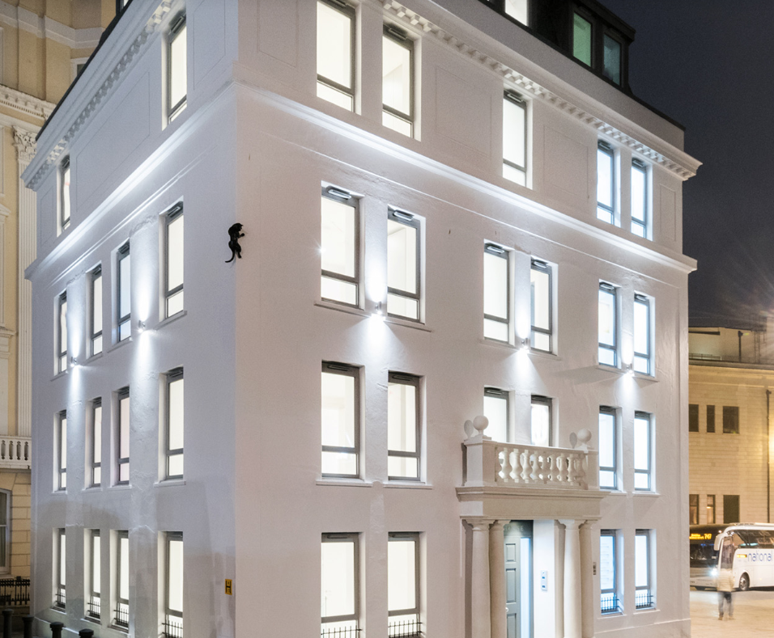
Luke Hunt (2220977)
Word Count: 2473
Prepared for: Ian Brown
Table of Contents
1.0 - Introduction 2
1.1 – History 2
1.2 - Location 3
1.3 - Brief of proposed development 3
1.4 - Current state of property 4
1.5 - Market research sources and evidence 4
2.0 – Capital Expenditure 5
2.1 - Gross Development Value (GDV) 5
2.2 - Asset acquisition 7
2.3 - Assumed design phase costs 8
2.4 - Contingency 8
2.5 – Developer Profit 8
2.6 - Contract value for construction phase 9
2.7 - Additional infrastructure upgrades required 10
2.9 – Marketing and Sales 11
3.0 - Case studies of Similar Developments 12
3.1 - Critique a development of similar scale and specification 12
3.2 - Critique a best practice development 12
4.0 – Risks and opportunities 13
4.1 - Risk/Opportunities Register 13
5.0 – Return on Investment Calculations 16
5.1 – Finance/Interest Rates 16
5.2 - Total Development Cost (with interest) 17
5.3 – Total Development Cost (Calculate residual land value) 17
5.4 – Return on Investment 18
5.0 – Summary 19
6.0 - References 20
7.0 - Appendices 23
7.1 – Appendix 1 23
7.2 – Appendix 2 25

1.0 - Introduction
This report aims to provide a comprehensive development appraisal to assess the viability of the Lace House, an historic building located in the Valley Gardens Conservation Area of Brighton and Hove (Brighton and Hove City Council, 2025). Our construction firm is looking to analyse the financial viability of refurbishing the Lace House into flats by considering key factors like construction costs, market conditions, and potential returns on investment. By incorporating historical sales data, historical background, current market trends, and industry standard costing benchmarks, we can assess risks, opportunities and the overall project feasibility to establish whether this project is fundamentally profitable.
The key outcomes of a positive development appraisal are that the project covers its development costs, meets required planning obligations, pays the landowner an appropriate site value and delivers the developer a market-risk adjusted return. The following pages will break this down into a fundamental comprehension of the project outcomes.

1.1 – History
Lace House is a five-storey 19th-century building with a basement that is locally recognised as a heritage asset. It retains distinctive architectural features, and a prominent sculpture of a black cat that was installed during the early 20th century which has now become an established feature of the building’s façade. These features are protected under the local conservation policy and are to be preserved throughout redevelopment (HAPA, 2018).
Originally constructed as Woodgate’s Library in the 18th century, Lace House evolved into a cultural hub for Brighton’s gentry, to confectionary store, and then later to a milliner’s shop. In the early 19th century, it was converted into a car showroom, displaying brands like Rolls-Royce, Bentley, and Jaguar, hence the black cat. From the 1950s through to the 1970s, it was home to a variety of car dealerships before being converted into office space in 1974 (Lace Wilson Properties Ltd, 2018).
In its current state it is now redundant, but with planning permission sought, Lace House is to be converted into nine residential flats. With the building’s history, the redevelopment must respect its architectural and historical legacy while meeting contemporary residential standards.

1.2 - Location
Brighton and Hove is a coastal city on the south coast of England that is widely recognised as a leading regional centre for tourism, creative industries, the University of Sussex and the University of Brighton. With its dynamic economy and diverse population, it has become a central location for residents of diverse backgrounds and investors (Staunton, 2023).
Lace House is located in the very centre of Brighton’s Valley Gardens Conservation Area where it is within walking distance from various rail connections like London, and major cultural landmarks. This makes it an ideal place for an apartment setting for the ongoing residential demands.

1.3 - Brief of proposed development
Our company is to convert Lace House into nine luxury apartments. To succeed in the development of such a building, heavy works will need to take place internally. However, externally, there will be minimal changes proposed due to its historic nature. The building is to be converted in the following dynamic (Lace Wilson Properties Ltd, 2018):

Flat Type | Quantity | Description
Two-bedroom Penthouse | 1 | Located on the top floor, includes balcony
Two-bedroom Duplex | 1 | Spans basement and ground floor
One- or Two-bedroom Flats | 7 | Standard configuration

To see the floor plans of each apartment please see section 7.1 of the Appendices, pages 19 and 20.

1.4 - Current state of property
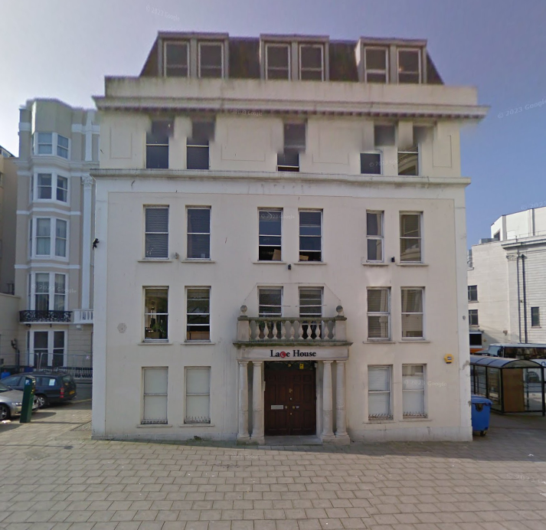
Lace House is currently vacant and in a deteriorating state with need of refurbishment. While structurally sound, the interior is obnoxiously outdated for the area with insufficient daylight in basement areas, outdated M&E systems, Water ingress risk in lower levels and the need for the removal of office partitions. Its heritage elements both internally and externally are intact, but require repair, cleaning and conservation management (Dpmaree.com, 2015). Figure 1 below gives a graphical indication of this. For the site location plan, please see section 7.2 appendix 2 on page 21.
Figure 1 (Google Maps, 2009)

1.5 - Market research sources and evidence
The market evaluation for this property is based on various aspects that influence price, all of which give a balanced final price for sections that follow. For simplified comprehension, section 2.0 looks at costs based on 2025 figures.

2.0 – Capital Expenditure
The following sections go into detail on the capital expenditure for this project, to help evaluate the financial risk associated with the redevelopment and whether our construction firm is able to make profit.
These values have been inflation-adjusted to 2025 (Beattee, 2025) figures and cross-referenced with comparable market data to find the most accurate costs for the following sections.

2.1 - Gross Development Value (GDV)

The market evaluation for this property is based on various aspects that influence price, all of which give a balanced final price for sections that follow. These include:

- Rightmove (2024–2025) data for central Brighton (Rightmove, 2025)
- Zoopla (2024-2025) data for central Brighton (Zoopla, 2025)
- Sales history of Lace House post-refurbishment in 2018 (Land Registry, 2016)
- RICS valuation methods (RICS, 2024)
- Office-to-residential schemes in Hove and Brighton (Nathaniel Lichfield and Partners, 2013)

(The market value price in 2018 when it was refurbished for each apartment are as follows. The reason for using these benchmarks, are to allow me, as the project manager to back date costs and help to find the future values and accurate inflation rates. For the purposes of this development appraisal however, the Lace House was not refurbished in 2018, and the building is to have a full refurbishment.)

Historical Sales (Post-2018 Refurbishment):

Flat | Sale Price (2018)
Flat 1 (2-bed) | £435,000
Flat 2 | £261,000
Flat 3 | £327,500
Flat 4 | £280,000
Flat 5 | £325,000
Flat 6 | £265,000
Flat 7 | £325,000
Flat 8 | £265,000
Flat 9 (Penthouse) | £507,000
Total | £2,990,500

The land and property were, as stated by Land Registry, purchased for £1,100,000 in 2017 (Land Registry, 2016)

- 2018 GDV was £2,990,500

- Average house price in Brighton & Hove in 2018: £350,000 approx.

- Average house price in Brighton & Hove in February 2025: £424,000 approx.

Therefore:

- Price increase: £424,000 / £350,000 = 1.211 or 21.1% increase

- 2025 GDV: £2,990,500 × 1.211 = £3,624,936

With a 21.1% increase, the flats are now adjusted to the following prices:
Flat No. | Type | 2018 Sale Price | 2025 Adjusted Price (21.1%)
Flat 1 | 2-bed | £435,000 | £526,785
Flat 2 | 1-bed | £261,000 | £316,671
Flat 3 | 1-bed | £327,500 | £396,413
Flat 4 | 1-bed | £280,000 | £339,080
Flat 5 | 1-bed | £325,000 | £393,575
Flat 6 | 1-bed | £265,000 | £320,915
Flat 7 | 1-bed | £325,000 | £393,575
Flat 8 | 1-bed | £265,000 | £320,915
Flat 9 | Penthouse (2-bed) | £507,000 | £613,977
Total |  | £2,990,500 | £3,624,936

2.2 - Asset acquisition

- Lace House, in its dilapidated state, was bought for £1,100,000 in 2017 (Land Registry, 2016).

- With a land value increase over the 8-year period between 2017 and 2025 of about 2% (Bank of Enlgand, 2025)

Therefore:

- Adjusted Land Value = £1,100,000 x (1.02)⁸
= £1,288,825

2.3 - Assumed design phase costs
The following costs are standard estimates based on typical percentages given of the total construction cost. However, there are references to specific guides to help specify more accurate sums.

Planning and Surveying Fees
2% - 3% of total project and so range from £30,000 - £45,000

Design Fees
7% - 10% of total project and so range from £105,000 - £150,000 (RIBA Plan of Work, 2020)

2.4 - Contingency
A contingency fee is in place to allow for any unknowns on the project, this is normally between 5% and 10% of total project budget:

- 7.5% of total project budget: £3,624,936 x 7.5% = £271,870.20

2.5 – Developer Profit
The Developer Profit is again, a standard percentage given as a total of the project once completed. This is anywhere between 10% and 15% of the GDV.

Calculation – £3,624,936 x 15% = £543,740.40

- Contract value for construction phase

Based on the SPONS 2023 document, please see the following:

- Average refurbishment cost per m² in 2023 for an apartment is: £1,900/m² (SPONS, 2023)

- The building square meterage is 527.2m² (SPONS, 2023)

- However, based on inflation rate over the last 2 years, the square meterage will have increased, and so a revised figure based on 6% interest would be more appropriate (SPONS, 2023).

So:

£1,900 x (1+0.06)² = £2,134.84 (or £2,135)

Therefore:

Total refurbishment cost: 527.2m² x £2,135/m² = £1,125,092

2.7 - Additional infrastructure upgrades required

The following infrastructure upgrades chosen are those that are not already on the building fabric. These upgrades would significantly improve the buildings efficiency and bring it up to the standard of luxury we want it to be. These costs come from figures based in, and around Brighton and Hove.

Upgrade | Estimated Cost Range
Improved Loft Insulation (GreenMatch, 2024) | £930 – £1,500
Mechanical Ventilation with Heat Recovery (My Builder, 2024) | £3,000 – £7,000
Triple Glazing (Green Match, 2025) | £4,000 – £6,000
Passive Ventilation Measures (Checkatrade, 2024) | £900 – £1,200
Rainwater Harvesting System (Checkatrade, 2024) | £2,000 – £3,000
Solar PV Panels (4kW system) (The Renewable Energy Hub, 2025) | £5,500 – £7,000

Looking at the higher end estimates for luxury and quality, the total cost of these upgrades would be £25,700.

2.9 – Marketing and Sales
Marketing and Sales is another valuation that is considered standard practice within construction. As a rule, 1% of the total GDV should be set aside for marketing and sales. (Contractor Scale.com, 2024).

Calculation: £3,624,936 x 1% = £36,249.36

3.0 - Case study of a Similar Development
Below is brief introduction to a case study in the area of Brighton and Hove that help to give a feel about what returns we could pursue as a firm by refurbishing the Lace House.

3.1 - Critique a development of similar scale and specification
Norfolk Terrice in Brighton is grading II listed building in Brighton that was converted from office spaces into flats. Similar to the Lace House, it is located in Brighton and Hove, not too far from the Lace House. The reason this case study is useful is because it was considered a successful redevelopment. It was a vey complicated job as it was extremely deteriorated and needed a lot of work, yet it had to be maintained through conservation guidelines. Just like the Lace House, it holds an historic presence and is in need of gentle yet significant works to bring it back to its former glory (grumittwademason, 2016).
Being in the same area as the Lace House, it would give a positive view on the potential of redeveloping similar buildings, while generating a similar return on investment, making it a worth while project. This is not the only redevelopment that has taken place within the area, so there is hope for the Lace House redevelopment. For more information, please go to the references in section 6.0 of the appraisal.

4.0 – Risks and opportunities
This Risk and Opportunity Register outlines the key factors that could impact the financial and operational success of the Lace House refurbishment project. It identifies potential risks that may increase costs, cause delays, or interrupt the return on investment, as well as opportunities that could enhance its value, reduce expenditure, or improve marketability. Each risk and opportunity have been assessed by its potential impact and likelihood and given mitigation or enhancement solutions. This approach allows for more informed decision-making, supports proactive risk management, and helps to optimise the overall return on investment.

4.1 - Risk/Opportunities Register

Reference | Category | Risk / Opportunity | Description | Impact | Likelihood | Mitigation / Action
Risk 1 | Finance | Interest Rate Increase | If interest rates rise above 4.5%, finance costs will increase, reducing ROI or causing a potential loss. | High | Medium | Lock in fixed-rate loan terms early or protect against future rate increases.
Risk 2 | Market | Sales Value Drop (GDV Risk) | GDV assumed at £3.62M may not be achieved if the local market weakens, reducing return or affecting residual land value. | High | Medium | Monitor market trends.
Risk 3 | Planning | Planning Delays or Conditions | Unexpected planning conditions, delays or objections could affect project start and cost. | Medium | Medium | Early engagement with planners; consult planning specialists.
Risk 4 | Construction | Cost Overruns | Construction costs may rise beyond £1.125M due to unforeseen conditions or inflation. | High | High | Include adequate contingency. Use fixed-price contracts where possible.
Risk 5 | Sustainability | Technology Cost Increase / Installation Complexity | Sustainable upgrades (e.g. solar panels, MVHR) may require more expensive retrofitting or design changes. | Medium | Medium | Complete design coordination early; apply for grants
Risk 6 | Design & Scope | Scope Creep | Changes to client brief or compliance with updated building regs could increase professional or fit-out costs. | Medium | Medium | Freeze scope early and ensure robust contract documentation.
Risk 7 | Sales | Delays in Sales/Lettings | If units don’t sell or let promptly, holding costs may increase and reduce ROI. | Medium | Medium | Early marketing campaign; consider multiple exit strategies (e.g., rental).
Risk 8 | Profitability | Low or Negative ROI | Final ROI is projected at 15.63% based on high estimates—any cost increases or GDV reductions could make ROI unrealistic. | High | Medium | Monitor costs tightly; revisit budget for savings; adjust profit expectations.
Opportunity 1 | Market | Price Appreciation | If Brighton & Hove market improves, GDV could exceed expectations, increasing profit margin and ROI. | High | Medium | Track sales comparisons; time sales to coincide with market peaks.
Opportunity 2 | Sustainability Grants | Grant Funding for Green Technologies | Potential to offset the cost of upgrades via green incentive funding. | Medium | High | Apply early for relevant schemes; consult local authorities and energy advisors.
Opportunity 3 | Reputation / Branding | Premium Value for Sustainable Features | Adding features like solar panels, MVHR, rainwater harvesting can attract higher-value buyers and improve sell-through. | Medium | High | Market the development as a “green” scheme; highlight savings and sustainability credentials.
Opportunity 4 | Efficiency | Under-budget Spending on Construction or Design | Potential cost savings from efficient procurement or fewer design revisions could reduce total development cost and increase profit. | Medium | Medium | Regular cost reviews; consider value engineering without compromising quality.

5.0 – Return on Investment Calculations
This Section of the appraisal focuses on the ROI of the Lace House Refurbishment which identifies the figures used to make a decision on whether this project is worth investing in financially. Each section is broken down in a clear fashion to aid in the comprehension of the figures.

5.1 – Finance/Interest Rates
In order to finance this project a loan will need to be applied for to ensure the costs are covered.

Total Development Cost (without interest):
- Construction: £1,125,092
- Professional Fees: £150,000
- Planning & Surveys: £45,000
- Contingency: £271,870.20
- Marketing & Sales: £36,249.36
- Additional Sustainable Upgrades: £25,700
- Land Value: £1,288,825

Total = £2,942,736.56

The duration of the project will be 2 years. With an interest rate of 4.5% per annum, the interest to be paid on top of the loan is as follows:

Loan Interest: £2,942,736.56 x 4.5% x2 = £264,846.30

5.2 - Total Development Cost (with interest)

Total Development Cost (with interest):
- Construction: £1,125,092
- Professional Fees: £150,000
- Planning & Surveys: £45,000
- Contingency: £271,870.20
- Marketing & Sales: £36,249.36
- Additional Sustainable Upgrades: £25,700
- Land Value: £1,288,825
- Loan interest: £264,846.30

Therefore:

Loan amount required is: £2,942,736.56 + £264,846.30 = £3,207,582.86

5.3 – Total Development Cost (Calculate residual land value)
Total Development Cost (Excluding Land):

- Construction: £1,125,092
- Professional Fees: £150,000
- Planning & Surveys: £45,000
- Contingency: £271,870.20
- Marketing & Sales: £36,249.36
- Additional Sustainable Upgrades: £25,700
- Loan interest: £264,846.30
- Developer Profits: £543,740.40

Total Cost: £2,462,498.26
Residual Land Value:
£3,624,936 (GDV) - £2,462,498.26 (Total development costs) = £1,162,437.74

This calculation is significant because it sets a maximum price that could be spent on the project while still achieving the expected profit margins. The cost of the site was £1,288,825, which means we would be looking at losing £126,387.26 in the profit margins. However, these figures are set to the top end of all percentages to give the most expensive outcome. We could look at reducing profits or may spend less in specific areas of the job.

5.4 – Return on Investment

ROI = (Profit/Equity Invested) x 100

Equity Invested = £3,751,322.26 (total cost) - £2,942,736.56 (Loan Amount)
Equity Invested = £808,585.70

Profit = £3,624,936 (GDV) – £3,751,322.26 (Total Development Cost)

Profit = - £126,386.26

ROI = (£126,386.26/£808,585.70) X 100
ROI = 15.63%

5.0 – Summary
This appraisal goes into great detail surrounding the redevelopment of the Lace House in Brighton and Hove. It looks at the current state and value of the property which evolves into the expansion of figures that identify capital expenditure, market research of the surrounding area, costs, profits, risks and opportunities, and most importantly, Return on Investment. The appraisal has enabled us to make an informed decision about whether the project is financially viable for us a company or not. It is concluded that this project will not bring a good yield, with only a 15.63% return on investment.
With some alterations to the figures and changes to some of the processes, we may be looking at closing the gap between the GDV and the Total Development cost. However, the yield on this project would not out way the return on investment, and £126,386.26 is a large figure for a medium sized company to be losing. Even with upgraded sustainable systems in place to aid in savings in the long term, it does not seem to be a viable option. Therefore, through comprehensively examining the research and evidence surrounding this project, I do not believe it would be worth the investment.

6.0 - References
Bank of Enlgand, 2025. Bank of Enlgand. [Online]
Available at: https://www.bankofengland.co.uk/monetary-policy/inflation/inflation-calculator%20
[Accessed 1st May 2025].
Beattee, A., 2025. Retruns on Investment. [Online]
Available at: https://www.investopedia.com/articles/basics/10/guide-to-calculating-roi.asp
[Accessed 1st May 2025].
Brighton and Hove City Council, 2025. Valley Gardens Conservation Area. [Online]
Available at: https://www.brighton-hove.gov.uk/planning/heritage/valley-gardens-conservation-area
[Accessed 01st may 2025].
Checkatrade, 2024. PIV installation cost. [Online]
Available at: https://www.checkatrade.com/blog/cost-guides/piv-installation-cost/
[Accessed 2nd May 2025].
Checkatrade, 2024. Rainwater harvesting system cost guide. [Online]
Available at: https://www.checkatrade.com/blog/cost-guides/rainwater-harvesting-system-cost/
[Accessed 2nd May 2025].
Contractor Scale.com, 2024. Setting a Budget: How Much Should Builders Spend on Ads?. [Online]
Available at: https://contractorscale.com/construction-marketing-budget/
[Accessed 2nd may 2025].
Dpmaree.com, 2015. Pre, s.l.: Dom Maree.
Google Maps, 2009. Google Maps. [Online]
Available at: https://www.google.co.uk/maps/@50.8200901,-0.1375894,3a,90y,201.28h,92.57t/data=!3m8!1e1!3m6!1so1fdFaXFLqf88NeOGhu5XA!2e0!5s20090401T000000!6shttps:%2F%2Fstreetviewpixels-pa.googleapis.com%2Fv1%2Fthumbnail%3Fcb_client%3Dmaps_sv.tactile%26w%3D900%26h%3D600
[Accessed 01st may 2025].
Green Match, 2025. Triple Glazed Windows: Pros, Cons & Costs In The UK (2025). [Online]
Available at: https://www.greenmatch.co.uk/windows/triple-glazing
[Accessed 2nd May 2025].
GreenMatch, 2024. Loft Insulation Cost Guide: Understanding UK Prices 2025. [Online]
Available at: https://www.greenmatch.co.uk/insulation/loft/cost
[Accessed 2nd May 2025].
grumittwademason, 2016. Norfolk Terrace: Listed Building Restoration in Brighton. [Online]
Available at: https://www.grumittwademason.com/our_work/listed-regency-building-in-brighton/
[Accessed 2nd may 2025].
HAPA, 2018. Lace House, Brighton. [Online]
Available at: https://hapa-architects.co.uk/portfolio/lace-house/
[Accessed 01st May 2025].
Lace Wilson Properties Ltd, 2018. ace House Luxury Apartments. [Online]
Available at: https://oakleyproperty.com/public/data/chalk/file/7/4/Lace%20House%20Brochure.pdf
[Accessed 01st May 2025].
Land Registry, 2016. Land Registry. [Online]
Available at: https://landregistry.data.gov.uk/data/ppi/transaction/5A9D8B56-242E-68EB-E053-6B04A8C0D293/current
[Accessed 1st may 2025].
My Builder, 2024. How Much Does an MVHR System Cost?. [Online]
Available at: https://www.mybuilder.com/central-heating/price-guides/mvhr-installation-cost
[Accessed 2nd May 2025].
Nathaniel Lichfield and Partners, 2013. Brighton & Hove City Council. [Online]
Available at: https://ww3.brighton-hove.gov.uk/sites/brighton-hove.gov.uk/files/Brighton%20PD%20Rights%20Slides%20v2.pdf
[Accessed 1st May 2025].
RIBA Plan of Work, 2020. RIBA Plan of Work. [Online]
Available at: https://www.architecture.com/knowledge-and-resources/resources-landing-page/riba-plan-of-work
[Accessed 2nd May 2025].
RICS, 2024. RICS Valuation technical professional standards and practice information programme. [Online]
Available at: https://www.rics.org/profession-standards/rics-standards-and-guidance/sector-standards/valuation-standards/rics-valuation-standards-programme-and-how-to-contribute
[Accessed 1st may 2025].
Rightmove, 2025. Rightmove. [Online]
Available at: https://www.rightmove.co.uk/property-for-sale/find.html?locationIdentifier=REGION%5E61480&index=0&sortType=2&channel=BUY&transactionType=BUY&displayLocationIdentifier=Brighton-and-Hove&maxBedrooms=1&propertyTypes=flat
[Accessed 1st may 2025].
SPONS, 2023. SPONS 2023, s.l.: SPONS.
Staunton, N., 2023. Why Brighton is one of Uk’s fastest growing cities. [Online]
Available at: https://brightonjournal.co.uk/why-brighton-is-one-of-uks-fastest-growing-cities/
[Accessed 01st may 2025].
The Renewable Energy Hub, 2025. How much do Solar Panel Systems Cost? UK Prices 2025. [Online]
Available at: https://www.renewableenergyhub.co.uk/main/solar-panels/how-much-do-solar-panel-systems-cost
[Accessed 2nd May 2025].
Zoopla, 2025. Zoopla. [Online]
Available at: https://www.zoopla.co.uk/for-sale/flats/east-sussex/brighton/?beds_max=2&beds_min=1&price_max=600000&q=Brighton%2C%20East%20Sussex&search_source=for-sale
[Accessed 1st may 2025].

7.0 - Appendices

7.1 – Appendix 1
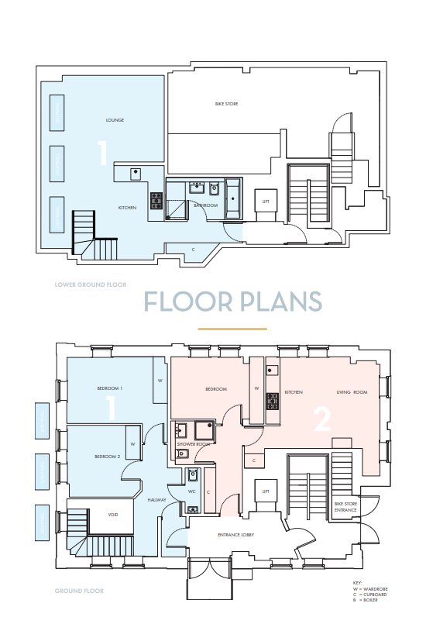

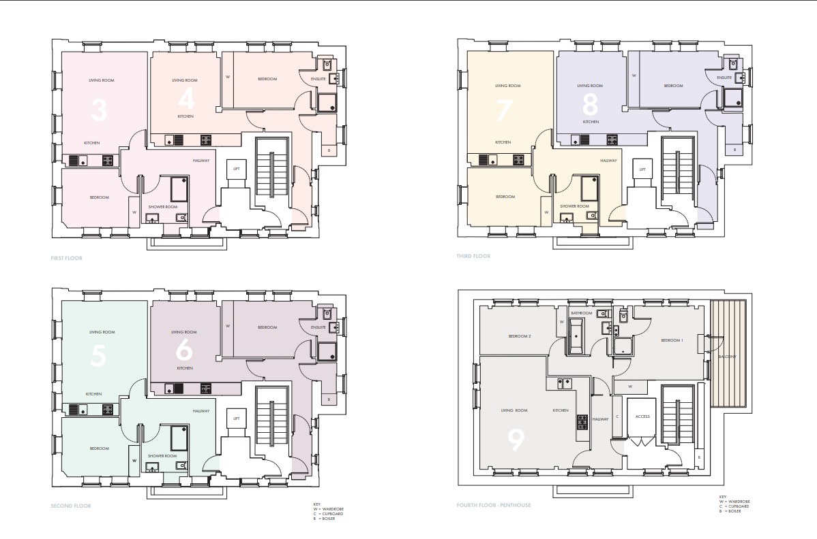

7.2 – Appendix 2


