Dissertation Research Proposal Sustainability in fashion:
Savvy spenders or eco warriors?
A Critical Investigation into the Influences on the Buying Habits of 18-25year old’s and the Impacts on the Industry’s Sustainable Footprint.
Charlotte Koochekzadeh-yazdi (1903136)

Table of Contents
1.0 Introduction 3
1.1 Background 3
1.2 Rationale 5
1.3 Aims and Objectives 6
2.0 Research Design and Methodology 6
2.1 Philosophy 7
2.2 Research Approach 8
2.3 Research Strategy and Method 8
2.4 Sample 9
2.5 Data Collection Methods and Analysis 9
2.6 Limitations 9
2.7 Ethical Risks 10
2.8 Reliability and Validity 10
3.0 Resources and Planning 10
3.1 Resources 11
3.2 Gantt Chart 11
References 13

Table of Figures
Figure 1.1 The Share of individuals who purchase clothes online …………………. 4
Figure 2.1- The Research Onion ……………………………………………………….. 7
Figure 3.1 – Gantt Chart ………………………………………………………………… 12

1.0 Introduction
This dissertation aims to establish what encourages consumers’ purchases and the consequential effect that this has on the fashion industry and in turn fashions’ impact on sustainability. Previous studies have been conducted around the sustainability of the fashion industry paying particular attention to the supply chain; however, few have delved into what is compelling consumers when purchasing clothes.
The industry is adopting changes; several organisations are modifying their work to operate with more environmentally and socially responsible practices (Lechmann et al, 2018). However, WRAP (2017) estimated that in 2016 1,130,000 tonnes of clothes were purchased in the UK alone; this saw close to a 200,000 tonne increase from 2012. Therefore, it is paramount to highlight what the driving factors are for consumers when purchasing new apparel as consumption is at an all-time high.

1.1 Background
Sustainability, meeting the needs of consumers now without jeopardising the ability of future generations to do the same (WCED, 1987), is a word thrown around a lot in today’s society as a result of the imminent pressure we face in regard to climate change and pollution. Therefore, it is prevalent to tackle the unsustainability in fashion as it is the fourth dominant burden on our natural resources in the UK (WRAP, 2017). The consumption of clothes continues to rise (WRAP, 2016) with 1.1 million tonnes of clothes being consumed in the UK per year with consumers spending an estimated £52.7bn (WRAP, 2016). In today’s society fast fashion has somewhat become the norm on the high street (Clark, 2008) which has contributed to the 300,000 tonnes of clothes sent to landfill in 2016 (WRAP, 2017).
Perhaps more so now than ever before, it has become more primitive to leave behind the linear model of take, make, waste and adopt a circular economy, closing the loop by keeping products and materials in use, designing out waste (McArthur, 2019). Which many brands are beginning to do, for example; Adidas, Patagonia and H&M. Despite these efforts, the issue of high levels of consumption still exists presenting the need for more research to be completed in order for the industry to understand the consumer.
Womenswear is the largest segment of the apparel industry in the UK, accounting for 59.2% of the industry’s total value’ (MarketLine, 2016). Furthermore, Figure 1.1 depicts the percentage of online fashion consumers based on age, the largest age groups for consumption are 16-24 and 25-34. Due to this, the researcher will explore the demographic of 18-25-year-old female consumers so to gain a good representative of the more prominent consumers and build a deeper understanding of what they are motivated by with the aid of both primary and secondary research.
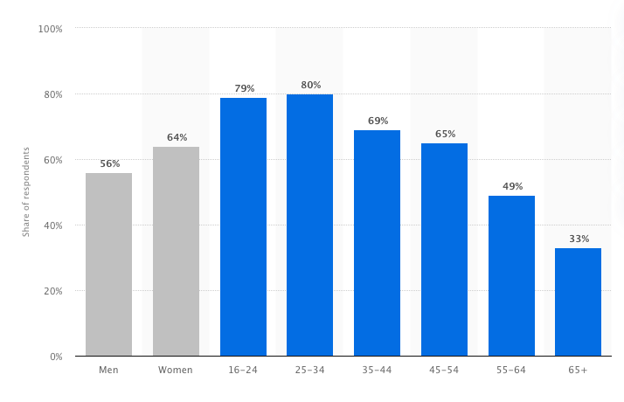
Figure 1.1 Share of individuals who purchased clothes online. (Statista, 2019)
The application of current theoretical literature will be referred to and reinforce the investigation; for example, The Consumption Values Theory (Sheth et al, 1991), will provide background to understanding the difference in consumption values and choice behaviour (Lin and Haung, 2012, Lee et al, 2015). Furthermore, The Triple Bottom Line introduced by Elkington (1998) otherwise coined as the three P’s, is commonly used when expressing sustainable practice and will therefore be referenced when identifying the sustainability of the industry.

1.2 Rationale
The fashion industry has been under a lot of scrutiny (BBC, 2018, McAlea, 2018, Helmore, 2019, Kent, 2019, Parliament, 2019) to become more sustainable thus, many studies have been conducted to highlight what companies should be doing along with academic theory. This underpins the pillars of sustainability and how to achieve it. More research (Statista, 2019, Townsend, 2018) is being carried out to explore consumers changing behaviour towards sustainability; nevertheless, there still exists a paucity in findings relating to consumer buying motives.
Sustainability is a predominate driving force in the fashion industry as of late as highlighted by the Global Fashion Agenda (2019). Therefore, this research will be beneficial in helping to reduce the sustainable footprint in regard to over consumption which has been emphasised by WRAP (2017). Moreover; by gaining an understanding on the motivating factors of consumers, conclusions can be drawn to assist the industry in mitigating these factors through more sustainable practices.

1.3 Aims and Objectives
The overriding aim of this dissertation is to critically investigate the influences on 18-25-year-old female consumer buyer behaviour in the fashion industry and analyse the consequent sustainable impact. In order to achieve this aim, research will be conducted around the following objectives:
- To explore the current sustainable practices in fashion.
- To critically analyse existing academic research pertaining to consumer buying behaviour in order to provide context and comparability for this research.
- To investigate the correlation between consumer values and consumer behaviour when purchasing fashion.
- To integrate primary and secondary research to achieve a greater level of understanding regarding consumer motives and recommend changes that can be implemented by organisations to better meet these motives in a sustainable manner.

2.0 Research Design and Methodology
Research as defined by Saunders et al (2009) is a systematic process people undertake to find things out to increase their knowledge, therefore elucidating the impression that, data collected in this systematic way is logical and not based solely on beliefs (Ghauri and Grønhaug, 2005). Walliman (2005) underlines that research is not conducted without purpose, therefore it is undergone in order to solve a problem (Ariola, 2006).
As shown in Figure 2.1 The research onion developed by Saunders et al (2009), is an illustrative model of data collection and data analysis. Broken down into stages it depicts the different pathways of research, it can be utilised to develop an effective research strategy. The research onion will be used when conducting research for this dissertation in order to best ascertain the most suited methodology to achieve the objectives.
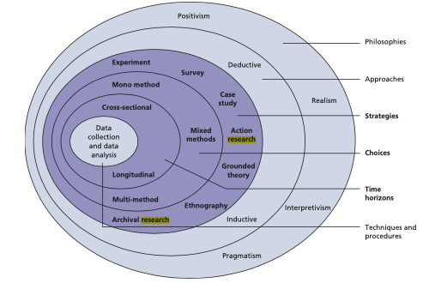
Figure 2.1 The Research Onion. (Saunders et al, 2009)

2.1 Philosophy
Research philosophy refers to the development of knowledge through the perpetuation of beliefs and assumptions (Saunders et al, 2016). The researcher will adopt an interpretivism philosophy, collecting data through both quantitative and qualitative methods, such as questionnaires and interviews. This philosophy will enable the researcher to gain the opinions of consumer buying motivations. The data produced from each method can be analysed and collated in order to answer the researcher’s objectives.

2.2 Research Approach
There are three approaches: these being deductive, inductive and abductive. A deductive approach is when you develop a research strategy to test theory often read in academic literature (Saunders et al, 2016). Whereas an inductive approach occurs when you set about collecting data in order to build a theory (Saunders et al, 2016). The third approach is abductive where data is collected to investigate a phenomenon, recognising common themes and patterns to update or produce a theory which is then tested through data collection (Saunders et al, 2016).
The research will adopt an inductive approach, collecting data in order to understand consumer buying behaviour and thereby develop a theory as to what is the true motivating factor. Do we really care about sustainability or do we just want more for our money?

2.3 Research Strategy and Method
A research strategy is defined by Saunders et al (2016) as the approach designed by the researcher on how they will conduct their research to answer the proposed research question.
This study looks to utilise techniques such as, interviews, online polls and questionnaires. The use of questionnaires and online polls will be adopted in order to collect quantitative data to be used for statistical analysis. This data will then be further explored through the use of interviews in order to gain a breadth of knowledge and allow for comparison. The combination of several research methods is otherwise known as triangulation which this researcher will employ.

2.4 Sample
When conducting research, it is impractical to research a whole population due to the size, hence samples are adopted in order to find a relative representative of the population (Saunders et al, 2009). The research is looking to investigate 18-25-year-old females therefore, a cluster sample is most suitable in order to fulfil the research objectives. The researcher will use a sample of at least 100 participants, which will be made up with voluntary contributors from the university, friends and family that fit the research criteria.

2.5 Data Collection Methods and Analysis
As previously stated this dissertation will use mixed methods. Employing both qualitative and quantitative methods of research along with industry statistics at the researcher’s disposal. Through the adoption of this triangulation design, it allows the variety of data collected to be better collated and compared in order to reach more logical findings. In order to analyse the data compiled the researcher will make use of graphs and spreadsheets whilst also taking advantage of the university’s software and IT equipment for analysing data. For example, the researcher will use thematic analysis to underline the common themes within any interviews carried.

2.6 Limitations
There are limitations that exist within this research project, the main factors being cost and time due to the length of the project. Time constraints may impact the research as it might not be representative of the wider population. A Gantt Chart will be used to ensure the timely completion of this project. Furthermore, the budget for the project produces limitations in regard to the sort of research that can be collected.

2.7 Ethical Risks
We are morally obligated to be ethically considerate; this is paramount when conducting primary research. Therefore, any research carried out for this dissertation will meticulously adhere to ethical regulations and practices, supported by an ethics document.
There are minimal ethical risks that could arise from this research as the population used for primary research will not be that of a vulnerable nature. Participants will be between the ages of 18 and 25 and participation is completely voluntary, all data that is collected will remain anonymous and will be securely stored on a password protected computer.

2.8 Reliability and Validity
When conducting research, reliability and validity is important. Reliability refers to the consistency of research, in other words can the research be replicated (McAvoy & Brace, 2017), on the other hand validity is concerned with whether the research question is being fulfilled (McAvoy & Brace, 2017). Therefore, it is vital to mitigate any factors affecting reliability and validity. For instance, using standard questions for primary research that are easily replicated and ensuring good time management.

3.0 Resources and Planning
A variety of resources will be gathered so to better understand the topic of the dissertation and to coherently deliver a reliable research document. Additionally, a Gantt Chart will be adopted to ensure proper planning and consideration.

3.1 Resources
The universities available resources; such as, academic books, academic journals, databases and previous dissertations will be utilised throughout the completion of the dissertation in conjunction with the researchers existing knowledge and understanding of the subject area. These resources will be compiled consciously and coherently in the literature review. Moreover, the use of other resource hubs such as google scholar will be used in order to obtain journals and reports.
Additionally, primary data will be collected and analysed through the use of the university IT equipment and software by the researcher. The findings will be used in concurrence with secondary data.

3.2 Gantt Chart
A Gantt Chart is a ‘visual representation of the tasks and activities that make up your research project, each being plotted against a timeline’ (Saunders et al, 2009). The Gantt chart presented below is an illustration of the timeline of the project and the activities required for completion, aiding the researcher in time management and ensuring the deadline is met.

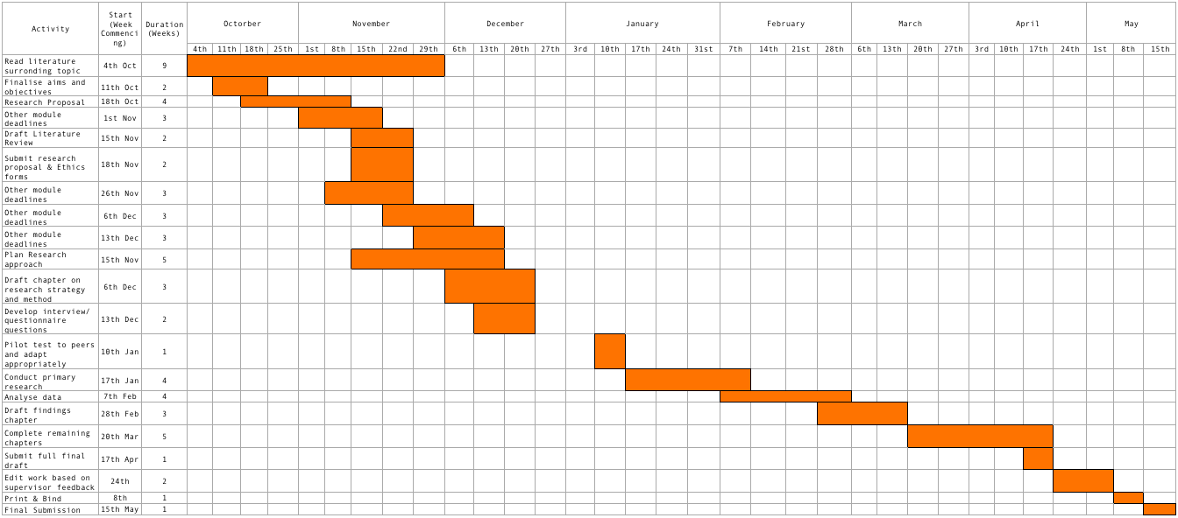
References
Figure 3.1. Gantt Chart. (Authors Own)
Ariola. M (2006) Principals and Methods or Research. First edn. Manila: Rex Book Store.
BBC (2018). Can the broken fashion industry become more sustainable? [online] BBC News. Available at: https://www.bbc.co.uk/news/business-46347337 [Accessed 15 Nov. 2019]
Clark, H. (2008). SLOW + FASHION—an Oxymoron—or a Promise for the Future …?. Fashion Theory, [online] 12(4), pp.428-429. Available at: https://www.tandfonline.com/doi/pdf/10.2752/175174108X346922?needAccess=true [Accessed 17 Oct. 2019]
Elkington, J. (1998). Partnerships from cannibals with forks: The triple bottom line of 21st-century business. Environmental Quality Management, 8(1), pp.37-51.
Ghauri. P, and Grønhaug. K (2005) Research Methods in Business Studies: A Practical Guide, third edn. Financial Times Prentice Hall, Harlow.
Global Fashion Agenda (2019). Global Fashion Agenda releases CEO Agenda 2019 highlighting the urgency of combating climate change during the World Economic Forum. CEO Agenda. [online] Global Fashion Agenda, pp.1-3. Available at: https://www.globalfashionagenda.com/wp-content/uploads/2019/01/Global-Fashion-Agenda-releases-CEO-Agenda-2019-highlighting-the-urgency-of-combating-climate-change-during-World-Economic-Forum-.pdf [Accessed 24 Oct. 2019].
Helmore, E. (2019). Can fashion keep its cool … and help save the planet [online] The Guardian. Available at: https://www.theguardian.com/fashion/2019/aug/31/can-fashion-keep-its-cool-and-help-save-the-planet [Accessed 15 Nov. 2019]
Kent, S. (2019) UK takes aim at Fashion’s Sustainability Problem [online] Business Of Fashion. Available at: https://www.businessoffashion.com/articles/news-analysis/uk-takes-aim-at-fashions-sustainability-problem [Accessed 15 Nov. 2019]
Lee, C., Levy, D. and Yap, C. (2015). How does the theory of consumption values contribute to place identity and sustainable consumption?. International Journal of Consumer Studies, [online] 39(6), pp.597-607. Available at: https://onlinelibrary-wiley-com.plymouth.idm.oclc.org/doi/epdf/10.1111/ijcs.12231 [Accessed 20 Oct. 2019].
Lehmann, M., Tärneberg, S., Tochtermann, T., Chalmer, C., Eder-Hansen, J., Seara, D., Boger, S., Hase, C., Von Berlepsch, V. and Deichmann, S. (2018). Pulse of the Fashion Industry. [online] Global Fashion Agenda and The Boston Consulting Group. Available at: https://www.peta.org.uk/wp-content/uploads/2019/03/Pulse_of_the_fashion_industry_report_2018-1.pdf [Accessed 17 Oct. 2019].
Lin, P. and Huang, Y. (2012). The influence factors on choice behaviour regarding green products based on the theory of consumption values. Journal of Cleaner Production. [online] Available at: https://www-sciencedirect-com.plymouth.idm.oclc.org/science/article/pii/S0959652611003738 [Accessed 17 Oct. 2019].
MacArthur, E. (2019). What is the circular economy?. [online] Ellenmacarthurfoundation.org. Available at: https://www.ellenmacarthurfoundation.org/circular-economy/what-is-the-circular-economy [Accessed 17 Oct. 2019].
MarketLine (2016). Apparel Retail in the United Kingdom. [online] MarketLine.com, p.2. Available at: https://advantage-marketline-com.plymouth.idm.oclc.org/Analysis/ViewasPDF/united-kingdom-apparel-retail-46418 [Accessed 17 Oct. 2019].
McAlea, L. (2018). MPs put fast fashion under scrutiny [online] Traid.org. Available at: https://www.traid.org.uk/fast-fashion-under-scrutiny/ [Accessed 15 Nov. 2019]
McAvoy, J. and Brace, N. (2017). Investigating Methods. 2nd ed. Milton Keynes: The Open University.
Saunders. M, Lewis. P and Thornhill. A, (2009) Research Methods for Business Students, fifth edn. Pearson Education Limited, Harlow.
Saunders. M, Lewis. P and Thornhill. A, (2016) Research Methods for Business Students, seventh edn. Pearson Education Limited, Harlow.
Sheth, J., Newman, B. and Gross, B. (1991). Why we buy what we buy: A theory of consumption values. Journal of Business Research, 22(2), pp.159-170.
Statista (2019). Share of individuals who purchased clothes and sports goods online in Great Britain in 2019, by age and gender [online] Statista.com, Available at: https://www.statista.com/statistics/286096/clothes-and-sports-goods-online-purchasing-in-great-britain-by-demographic/ [Accessed 15 Nov. 2019]
Townsend, S (2018) 88% of Consumers Want You to Help them make a difference. [online] Forbes.com. Available at: https://www.forbes.com/sites/solitairetownsend/2018/11/21/consumers-want-you-to-help-them-make-a-difference/ [Accessed 15 Nov. 2019]
UK Parliament (2019). Fixing Fashion: Clothing Consumption and Sustainability. [online] Available at: https://publications.parliament.uk/pa/cm201719/cmselect/cmenvaud/1952/report-summary.html [Accessed 15 Nov. 2019].
Walliman, N. (2005) Your Research Project: A Step by Step Guide for the First-Time Researcher. Second edn. Sage, London.
WCED: World Commission on Environment and Development (1987). Our Common Future. [online] Oxford: Oxford University Press. Available at: http://www.un-documents.net/wced-ocf.htm [Accessed 17 Oct. 2019].
WRAP (2016). Textiles Market Situation Report. [online] Waste & Resources Action Programme, pp.2-4. Available at: http://www.wrap.org.uk/sites/files/wrap/Textiles_Market_Situation_Report_2016.pdf [Accessed 17 Oct. 2019].
WRAP (2017). Valuing Our Clothes: The cost of UK fashion. [online] Waste & Resources Action Programme, pp.2-9. Available at: http://www.wrap.org.uk/sites/files/wrap/valuing-our-clothes-the-cost-of-uk-fashion_WRAP.pdf [Accessed 17 Oct. 2019].

