

University of Wales Trinity Saint David
Master of Business Administration

Module Name: international Business Concepts

Module Code: LCMB7003

Pharmaceutical Industry in Germany: Pfizer

Lecturer’s Name: Dr. Jean Wang

Student Name: Pratap Chauhan
Student ID: 2436029
Submission date 27th April 2026

Table of Contents
1. Introduction 4
2. Industry & Country Overview 4
2.1 German Economic Analysis 4
2.2 Pharmaceutical Industry in Germany 4
2.3 Main Players & Environment 5
3. Porter’s Diamond 6
3.1 Factor Conditions 6
3.2 Demand Conditions 7
3.3 Supporting Industries 7
3.4 Business Strategy, Organisation and Competition 8
4. Pfizer Analysis 9
4.1 Pfizer in Germany: An Overview 9
4.2 Mode of Entry 10
4.3 Use of FDI Theories 10
4.4 Country Attractiveness Analysis 12
4.5 Risk Analysis 13
4.6 VUCA Analysis 13
4.7 Critical Evaluation 14
5. Conclusion 15
Section 2: Reflective Report 16
1. Description 16
2. Feelings 17
3. Evaluation 17
4. Analysis 18
5. Conclusion 18
6. Action Plan 19
Reference 21

1. Introduction
Germany is a prominent pharmaceutical centre in the world, with a sophisticated healthcare infrastructure, robust research and development (R&D) sector and a well-trained workforce. Germany's pharmaceutical market is growing, and industry growth is driven by the growing demand for health care, an ageing population and growing investment in research and biotechnology (Technavio,2024; DataM Intelligence, 2025). Moreover, the German pharmaceutical industry has a robust industrial cluster, including niche areas like active pharmaceutical ingredients (APIs) and digital health, enhancing its global competitiveness (Verified Market Research,2024).
Pfizer is a global pharmaceutical giant and operates extensive manufacturing, research and distribution operations in Germany. Pfizer, as a global company, capitalises on Germany for global manufacturing and innovation.
The purpose of this report is to critically examine the pharmaceutical industry in Germany with Porter’s Diamond Model and assess Pfizer's strategies by applying international business theories such as foreign direct investment and market attractiveness.

2. Industry & Country Overview

2.1 German Economic Analysis
Germany is the largest economy in Europe and is regarded as a safe and favourable destination for foreign direct investment (FDI) due to the institutional security, stability and infrastructure. High government expenditure on health care and high medical infrastructure also leads to a high demand for pharmaceuticals. However, despite these merits, there are structural problems in Germany, including high energy and labour costs, which have a negative impact on the cost structure of firms. Thus, it creates a tradeoff between high productivity and cost of production for multinational enterprises (MNE) in Germany.

2.2 Pharmaceutical Industry in Germany
Germany's pharmaceutical industry is the biggest in Europe and fourth largest in the world, making it a key player of global importance in the healthcare industry (Germany Trade & Invest,2025; IMARC Group,2025). Sales in 2023 amounted to around €59.8 billion, demonstrating strong growth (Germany Trade & Invest, 2025). In 2024, the market size is estimated to be around USD 95 billion, with a continued growth trend expected due to innovation and growing healthcare needs (Grand View Research, 2024).
The sector is benefiting from various factors driving growth, such as an ageing population, the increase in chronic diseases and substantial investments in R&D. Biopharmaceuticals, digital health, and manufacturing technologies are areas of strength for Germany. Furthermore, the pharmaceutical industry is export-intensive, serving international markets and leveraging Germany's excellent logistics and trade infrastructure.
However, regulatory challenges, especially in the areas of drug pricing and reimbursement, can limit profits. In summary, the German pharmaceutical industry offers a high level of innovation potential, but also cost and regulatory complexities, presenting a double-edged opportunity for multinational companies.
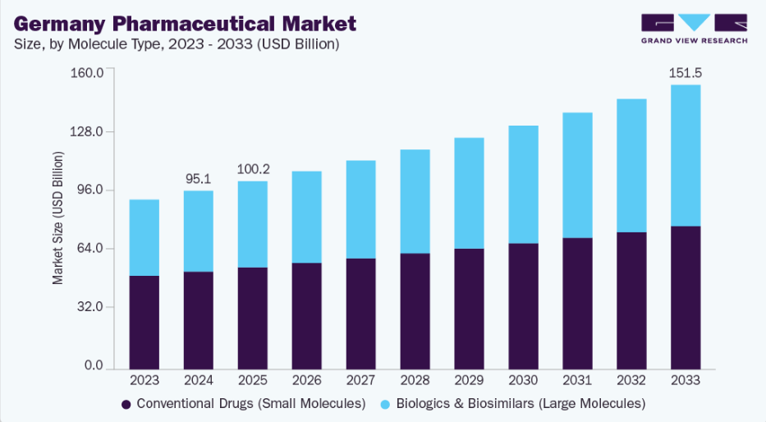
Figure 1. Germany pharmaceutical market growth (2020–2030)
Source: (Grand View Research, 2024)

2.3 Main Players & Environment
German pharmaceutical industry has a fierce competitive environment with both domestic and international players. Both large local companies like Bayer and Boehringer Ingelheim are key players, especially in innovation and globalisation. For instance, Boehringer Ingelheim has recently become one of the most important pharmaceutical companies in Germany, due to the success of its products and strong growth in global sales.
At the same time multinational enterprises such as Pfizer, Roche and Sanofi also operate in Germany due to the advanced infrastructure and research and development (R&D) setups in Germany. Their strategies are innovation, differentiation and R&D.
Domestics may have local advantages (knowledge and reputation) but multinationals have global knowledge and scale. This results in competition. This is good as it leads to productivity and innovation, but also, importantly, to downward pressure on profits, via price and regulation.

3. Porter’s Diamond

3.1 Factor Conditions
Germany has very advanced factor conditions, which affect the competitiveness of the pharmaceutical industry. It has a highly skilled and educated workforce with strong education and training in science, technology and health-related disciplines. This is a key factor for innovation and productivity in pharmaceuticals. And Germany is a leading global hub for pharmaceutical research and development (R&D), with an investment of €9.6 billion on R&D in 2022, showing that it has a strong research and development focus (Germany Trade & Invest, 2025; DrugPatentWatch, 2026).
Moreover, Germany boasts state-of-the-art technological infrastructure, such as advanced manufacturing technologies, automation and digital health technologies, that drive efficient production and innovation. Germany's robust patenting activity also positions it as an innovation leader in Europe, fostering the creation of high-value products (Germany Trade & Invest, 2025).
However, while Germany has these advantages, it also has high costs. Labour costs and increasing energy costs, as well as the need to meet stringent regulatory and quality standards increase the cost of doing business. This reduces cost competitiveness with other low cost economies and the need for efficiency and innovation to be competitive.
To summarise, Germany's advanced factor conditions contribute to the competitiveness of the pharmaceutical industry, but the cost of operations has a negative impact on multinational companies.

3.2 Demand Conditions
Demand conditions in Germany greatly contribute to the competitiveness and growth of pharmaceuticals. Germany is one of Europe's highest spenders on health care (European Observatory on Health Systems and Policies, 2025), with strong public and private investment in the sector, ensuring strong and reliable demand for pharmaceutical products. This ensures access to pharmaceutical products and underpins the growth of the pharmaceutical market.
Demand is also driven by Germany's ageing population, which leads to more chronic illnesses and chronic health conditions. This leads to an increase in demand for specialist and innovative medicines. Moreover, the emphasis on preventative health and increasing health consciousness also drives demand for pharmaceuticals and health care products.
The German pharmaceutical market also shows growth, driven by technology and growing health care demands. Projections show growth in the market due to innovation and the demand for innovative therapies (Grand View Research, 2024; Mordor Intelligence, 2026).
However, demand is constrained by Germany's health system's price and reimbursement laws. Regulations on price setting, cost containment and other factors limit the pricing flexibility of pharmaceutical companies and affect their profits.
Thus, while domestic demand is strong and supports the industry, regulations create a dynamic environment in which firms must innovate and optimise costs.

3.3 Supporting Industries
Germany has a sophisticated cluster of related and supporting industries to support its pharmaceutical sector, leading to innovation, efficiency gains and competitiveness. It has a vibrant cluster of biotech companies, contract manufacturers, and suppliers that support the research, development and manufacture of pharmaceuticals.
In addition, Germany is home to a number of leading universities and research institutes that contribute to research and innovation. Close ties between industry and academia drive the development of new drugs and technologies, helping to drive innovation in the pharmaceutical industry.
Additionally, Germany has a well-developed logistics and export system, allowing pharmaceutical companies to export their products around the world. Pharmaceutical exports are also very strong, with many pharmaceuticals serving the export market (International Trade Administration, 2025).
Moreover, the German pharmaceutical industry is very research-driven, with an R&D investment rate of 15-16% of turnover, contributing to its innovation potential (DrugPatentWatch, 2026).
Importantly, this is a critical factor of competitiveness, enabling innovation and collaboration. However, the globalisation and importation of pharmaceutical ingredients may be a risk, particularly in a crisis.

3.4 Business Strategy, Organisation and Competition
The German pharmaceutical industry is very innovative. This includes large domestic firms (such as Bayer, Boehringer Ingelheim) and multinationals. This drives companies to conduct R&D, product innovation and internationalisation.
The latest market trends suggest pharmaceutical firms are increasingly using new technologies such as biotechnology, personalised medicine and digital health technologies to create competitive advantages. This helps companies to innovate and remain competitive.
High levels of competition in the industry are conducive to efficiency, innovation and technological change. Firms are motivated to enhance productivity, reduce costs and design and produce quality products to compete in the local and international markets.
But competition also has a negative impact on profitability, especially when it is combined with regulatory constraints on pricing and high production costs. This makes constant innovation and cost management crucial to profitability.
In summary, while fierce competition is one of the drivers of the competitiveness of the German pharmaceutical market, it also poses problems in terms of profitability, driving companies to adopt efficient and innovative approaches.
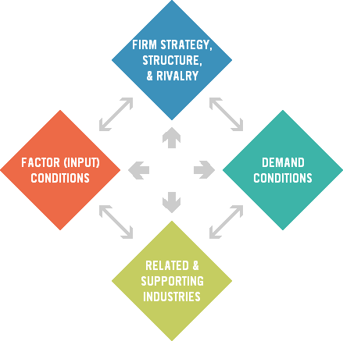
Figure 2. Porter’s Daimond Model
Source: Harvard Business School,2025

4. Pfizer Analysis

4.1 Pfizer in Germany: An Overview
Germany plays a crucial role in Pfizer's operations, and is a pivotal position in its European and global business. Pfizer has a presence in various operations, such as research and development, production and supply chains, showing Germany's role in Pfizer's global value chain. A key site for Pfizer is in Freiburg, a key manufacturing facility. Freiburg facility manufactures about 6-7 billion tablets per year and ships to over 180 countries, showcasing Germany's importance as a global production and supply hub (Freiburg Business Portal, 2024).
There are various reasons why Germany is an attractive location for Pfizer, including a well-educated workforce, cutting-edge technology and a strategic position in Europe. This facilitates seamless sourcing and distribution of pharmaceuticals across the globe. And Germany's high-quality standards are in line with Pfizer's global standards, allowing for uniform quality and safety across products.
Germany is a two-fold opportunity for Pfizer, strategically. It is a large local market and an export base. This makes it more efficient and allows Pfizer to grow. But there are also disadvantages of operating in Germany due to the high cost of labour and regulation. This makes it more expensive to operate and Pfizer needs to be efficient and innovative.

4.2 Mode of Entry
Pfizer's operations in Germany are predominantly through foreign direct investment (FDI) as a wholly-owned subsidiary. Multinational corporations in technology-intensive industries, like pharmaceuticals, often use this entry mode, due to the importance of technology and other forms of intellectual property in this sector. Through this mode of entry, Pfizer can control its subsidiaries in terms of production, quality control, decision-making, and so on.
Theoretically, this is in line with the idea that companies prefer to have fully-owned subsidiaries when they want to reduce the risks associated with knowledge spillovers and intellectual property protection. In pharmaceuticals, where high investments are made in research and development and innovation is a key factor for success, control is crucial. Pfizer's internalised organisation enables it to protect its technologies, as well as comply with German and EU regulatory standards.
Having its own subsidiaries also allows Pfizer to integrate its German subsidiaries in the global value chain. For instance, its plant in Freiburg is not only geared towards the German market but it is also part of the global manufacturing network of Pfizer. This allows economies of scale in production and distribution and increases efficiency and productivity.
But there are risks associated with the FDI entry mode. Wholly owned subsidiaries entail significant investments, especially in a high-cost country like Germany. Wage costs, energy costs and regulatory costs are much higher than in many developing countries, leading to higher costs for the firm. Further, Pfizer bears all the operational risks, such as regulatory and market risks.
So, Pfizer has the benefits of control and flexibility in the wholly owned subsidiary strategy but also the costs of financial and operational risks. This is an example of the cost-efficiency-control dilemma in international business.

4.3 Use of FDI Theories
Internalisation Theory
Internalisation theory explains that companies internalise functions rather than use market mechanisms because this will minimise transaction costs and guard against possible leakage of their proprietary knowledge. This is clearly evident in Pfizer's German operations. By internalising production and distribution, Pfizer can eliminate any potential inefficiencies that might be found in outsourcing and protect precious intellectual property. This is critical in the pharmaceutical sector, where patents and innovation is a crucial source of competitive advantage.
Internalisation also enables Pfizer to control quality and comply with regulations, which is critical in the German market. This enhances operational efficiency, and helps to reinforce Pfizer's brand.
Location Advantage Theory
Pfizer is investing in Germany due to its location advantages. These advantages include a well-educated workforce, superior infrastructure and a robust research and development environment. Germany is a major pharmaceutical innovation centre with significant research and development (R&D) investment and a robust research infrastructure (Germany Trade & Invest, 2025).
Furthermore, Germany has a highly advanced healthcare system and rigorous regulatory regime, ensuring high-quality and safe products. All of this makes Germany a prime destination for pharmaceutical manufacturing of high value products, despite the high cost of doing business.
Market Size Hypothesis
The market size theory proposes that companies will establish operations in countries with a large and expanding market size in order to benefit from economies of scale. The German pharmaceutical market is the biggest in Europe, and one of the biggest in the world, with a market volume of USD 95 billion in 2024 (Grand View Research, 2024). This gives Pfizer access to the German market, as well as the EU, giving it a greater market share and revenue opportunity.
Critical Evaluation
While there are advantages for Pfizer in investing in Germany, there are also trade-offs. Although Germany has robust institutional and technological infrastructure, labour costs and regulatory demands drive up costs. As recent reports indicate, pharmaceutical companies may face profitability constraints due to price control and cost factors (Mordor Intelligence, 2016).
As such, Pfizer needs to weigh up the advantages of innovation, quality and market opportunity against the disadvantage of cost and regulatory hurdles. This underscores the intricacies of global business strategies in mature markets.

4.4 Country Attractiveness Analysis
Political Factors
Political stability in Germany is a key factor in minimising risk for foreign investors. German political stability, transparent legal frameworks and EU membership provide a safe and stable business environment. This, in turn, is critical for pharmaceutical companies, which need to make long-term investments because of the lengthy drug development process.
Economic Factors
The German market is a lucrative one for pharmaceuticals due to its high GDP and strong consumer purchasing power. Germany also ranks among the highest in Europe in terms of healthcare spending which is around 12.7% of GDP, which creates a high demand for pharmaceutical products (European Observatory on Health Systems and Policies, 2025).
But high costs of labour and operations pose a big challenge. Germany's cost environment, relative to emerging markets, leads to lower profitability and a need for efficiency.
Legal Factors
IP protection is strong in Germany, which is crucial for pharmaceutical companies. But the regulatory framework is very strict, especially in terms of price and reimbursement regulations. Policies like cost containment restrict price setting and may impact negatively on profits, for example for Pfizer.
Cultural Factors
Germany has a robust healthcare culture with a high degree of trust in the healthcare system and the demand for high-quality medicines. This presents good market opportunities for pharmaceutical companies. Both consumers and health professionals are highly concerned with safety and innovation, which is in line with Pfizer's emphasis on high-quality products.
Critical Evaluation
Overall, Germany is a highly desirable, but difficult market. There is a stable demand and political climate, as well as good legal frameworks, but this is accompanied by high costs and regulations which affect profitability. As a result, there is a requirement for efficiency and innovation in the market to stay competitive.

4.5 Risk Analysis
Despite the stable and favourable business climate in Germany, there are some risks for Pfizer.
Political Risk: Political risk is low as the country has a stable political environment and institutional system. But EU policy changes, such as in the healthcare sector, can impact the market.
Economic Risk: Economic risk is primarily due to high costs. Germany's cost levels are not comparable to many emerging markets, which results in a loss of cost advantage and margin.
Legal Risk: Legal risk is a major issue in the pharmaceuticals industry due to regulatory constraints. Reimbursement structures and price controls restrict revenue opportunities and add to costs.
Most importantly, regulatory risk is a critical issue. Price controls to limit health care costs limit firms' ability to capitalise on innovations. This means firms need to pursue efficiency and value creation strategies.

4.6 VUCA Analysis
The pharmaceutical sector is in a VUCA world with volatility, uncertainty, complexity and ambiguity.
Volatility: Market and demand volatility, such as during pandemics, can affect supply chains.
Uncertainty: Research and development, as well as regulatory approval, processes are unpredictable and have high attrition rates and long development cycles.
Complexity: Global pharmaceutical operations result in complex supply chains, regulations and markets.
Ambiguity: New technologies like artificial intelligence and biotech make future directions in the industry uncertain.
Pfizer must be agile to stay competitive, with a focus on innovation.
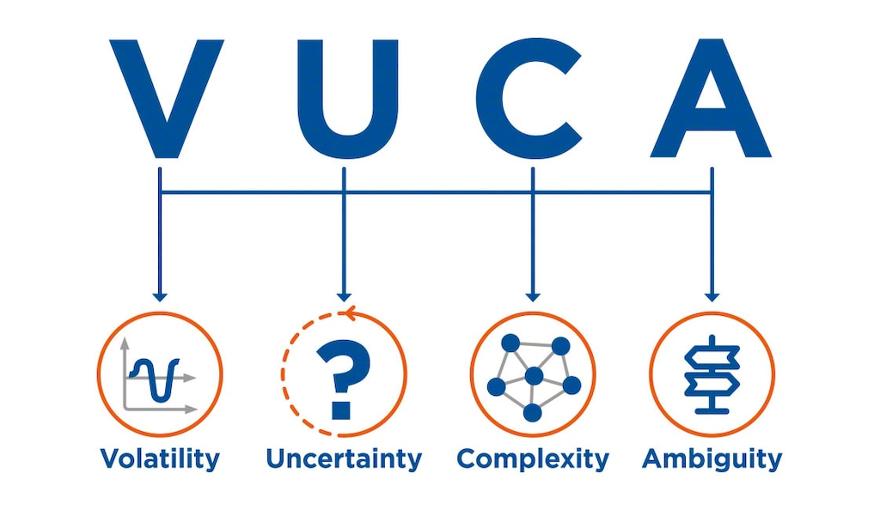
Figure 3. VUCA Model
Source: (Mecalux, 2025)

4.7 Critical Evaluation
Pfizer's future in Germany is likely to be strong, given its strong manufacturing and global integration, and access to Germany's innovation system. This nation's infrastructure and market opportunities offer a competitive advantage.
But the high cost of operations, regulatory hurdles and price pressures remain challenges. This demands a balance between innovation and cost control from Pfizer.
In summary, Germany is a very attractive market, but the key to Pfizer's success in the market will be its capacity to be able to manage regulations, cost structures and compete on innovation.

5. Conclusion
In this report, the German pharmaceutical industry has been critically examined, along with Pfizer's role in this industry. The study reveals that the German pharmaceutical market remains one of the most sophisticated and competitive pharmaceutical markets in the world with sophisticated factor conditions, highly skilled human resources and a highly developed research and development infrastructure. The industry's scale (it is projected to be worth USD 95 billion by 2024) and continuous growth fuelled by innovation and technological change, and an ageing population, explain why the industry is a strategic resource for multinational corporations (Grand View Research, 2024).
The Porter's Diamond Model shows that the competitive advantage of Germany is driven by strong demand conditions, well developed related and supporting industries and an innovation supporting business culture. However, these advantages are tempered by structural weaknesses, in particular labour and energy costs and regulatory costs. These increase the complexity and decrease the profitability of doing business, making Germany a high-value yet costly market.
Pfizer's presence in Germany is part of a global business strategy which includes foreign direct investment (FDI) in wholly-owned subsidiaries. It enables it to manage its technology and quality control as well as to include Germany in its global value chain. Germany's location and infrastructure also makes Pfizer more competitive in the world.
Despite these advantages, the analysis shows that Pfizer is confronted with a number of challenges including price regulations, high cost structures and competition. These challenges require the company to continually improve its efficiency and maintain its innovation efforts.
Overall, Germany is a highly promising, yet challenging, market for Pfizer. Although this environment offers considerable long-term market potential and benefits, long-term success by the company will depend on its capacity to achieve innovation and efficiency through cost management, its adjustment to regulatory frameworks, and its ability to compete in a rapidly evolving global pharmaceutical market.

Section 2: Reflective Report
(Using Gibbs Reflective Cycle)
Gibbs' Reflective Cycle is a structured approach that involves six steps - description, feelings, evaluation, analysis, conclusion and action plan - to promote reflection and learning (Bandara, 2026; University of Edinburgh, 2024). It is commonly used in tertiary education settings as it promotes critical reflection, awareness of self, and a capacity to learn from experience to improve practice (Rook et al., 2026). Using this approach, this reflection critically assesses the research, analysis and preparation of the international business report on Pfizer in Germany.

1. Description
The project was the creation of an international business report which examined the pharmaceutical industry in Germany and assessed Pfizer's business strategies in this market. This involved the application of theoretical concepts, such as Porter's Diamond Model, foreign direct investment (FDI) theories and market attractiveness, to the pharmaceutical industry data.
The first step involved choosing Germany as a market of one of the world's largest pharmaceutical markets. This was driven by the availability of data, and the presence of multinational corporations like Pfizer. Next, a significant amount of research was undertaken using reliable and up-to-date sources such as industry reports, government reports and journals.
The next step was to analyse the competitiveness of the German pharmaceutical industry and Pfizer's strategy using theoretical frameworks. It included not only describing but understanding the effects and dynamics of the factors on business.
Lastly, the report was written in the academic format, with a clear introduction, main body, and conclusion; proper referencing and a clear and coherent argument. This involved distilling and organising complex data into a well-researched and academically sound report.

2. Feelings
Initially, I found the assignment to be challenging and uncertain, largely due to the multiple theoretical perspectives to be incorporated with data. The need to only use reliable and up-to-date sources also added a level of complexity, as it required the evaluation and selection of information sources.
I also thought that I would not be able to reach an adequate degree of criticality. At a postgraduate level, it is important to not only describe but to evaluate and justify arguments, which was initially daunting. Specifically, I felt like I needed to better understand the use of models like Porter's Diamond and FDI theories to apply them in a critical manner.
But as time went on, my self-esteem began to improve. I grew more familiar with using databases and analysing industry publications. I also learned how to better organise and argue and apply theory to practice.
Looking back on these emotions, I realise that this initial confusion was a key part of my learning journey, as it challenged me to learn new things, and to enhance my academic experience.

3. Evaluation
The most significant thing I took away from this assignment was the fact that it was positive and challenging. A key success factor in my work was the ability to source relevant and reliable data from recent sources. This allowed the report to be well researched and to meet academic standards. Referencing credible sources such as government reports and industry analyses helped to bolster the credibility of the report.
The report also received a boost from the use of theories. The use of Porter’s Diamond Model and the theories of Foreign Direct Investment (FDI) gave a framework for the analysis of the industry and Pfizer’s strategies. This allowed the report to shift from a descriptive to a more analytical and academic piece of work.
The assignment also helped to enhance critical thinking. I could assess the benefits and drawbacks of Germany's pharmaceutical sector, taking into account strengths such as innovation, as well as weaknesses like regulatory issues. This is in line with reflective learning theories, with a focus on engagement and understanding (Rook et al., 2026).
But there was room for improvement. I sometimes over-emphasised description before moving onto analysis. This sometimes compromised the quality of analysis. Additionally, limiting the word count while still being critical was at times difficult, causing issues with conciseness.
It was also important to establish a consistent referencing and writing style. The essay was well organised but it also could have been more succinct.

4. Analysis
This task has helped me to understand the application of theories to business. For instance, the application of Porter’s Diamond Model allowed for a systematic examination of Germany's competitive advantage, whereas theories of Foreign Direct Investment (FDI) provided some insight into Pfizer's approach to investment and market entry.
The key learning point was the integration of theory and practice. At the postgraduate level it is not sufficient to understand the theoretical models, but to also apply them critically to the business world. This assignment showed the use of theoretical models as tools to understand business.
Moreover, it accentuated the need for critical analysis in writing. It is essential to critically analyse and assess multiple viewpoints and provide evidence to support claims. This enhances the analysis and authenticity of the work.
The assignment also enhanced my research skills, including the location of reliable and up-to-date sources. I became proficient at recognising quality academic and industry sources and separating this from non-reliable information sources. I also learned how to consolidate information from various sources and incorporate it into the discussion.
In short, this exercise further solidified the skills in critical thinking, evidence analysis and argumentation in postgraduate studies.

5. Conclusion
Finally, this assignment gave me insight into both analysing international business and my learning experience. I effectively created a well-organised and researched report but there are areas to improve by increasing the critical perspectives and minimising the description.
Applying Gibbs’ Reflective Cycle allowed me to critically reflect on my learning journey, recognising my strengths (research and use of theory) and opportunities for improvement (time management and writing consistency). This type of reflection is important for development and improvement (University of Edinburgh, 2024).
For future assignments, I should try to critically assess the arguments that are required for an assignment early on in the writing process and edit more.
In summary, this assignment has developed my critical analysis, research and academic writing skills, which are crucial for success at postgraduate level and in the workplace.

6. Action Plan
In the future, I will employ a number of strategies to enhance my academic performance. Firstly, I will strengthen my research skills by concentrating on the effective search for quality academic and industry sources. This will help me to ensure that my arguments are supported by reliable and relevant evidence.
Second, I will work to enhance my critical thinking by practising the analysis of alternative viewpoints and developing more balanced arguments. This will assist me in writing more than a description, and reaching a level of analysis.
Third, I will work more efficiently by starting early on assignments and planning my research, writing and editing. This will allow time for editing, and so improve the quality.
Finally, I will continue to reflect on my learning experiences using reflective models such as Gibbs’ Reflective Cycle. Reflection has been found to improve learning outcomes and professional practices through the process of continuous learning and development (Rook et al., 2026).
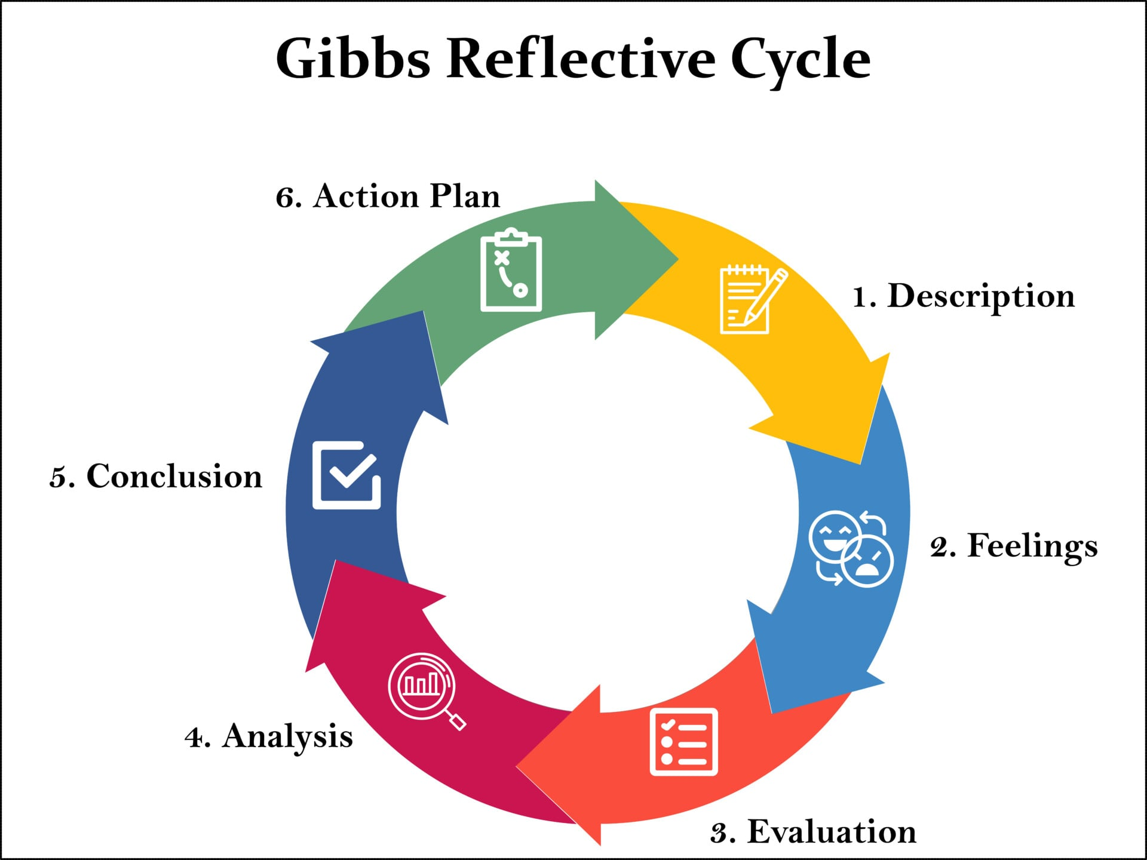
Figure 4. Gibbs Reflective Cycle
Source: (McLeod, 2025)

Reference
Technavio (2024) Pharmaceuticals market in Germany size is set to grow by USD 21.44 billion from 2023–2027. https://www.prnewswire.com/news-releases/germany-pharmaceuticals-market-size-to-grow-by-usd-21-44-billion-from-2022-to-2027the-high-investment-in-the-pharmaceutical-industry-boosts-market-growth---technavio-301884178.html
DataM Intelligence (2025) Germany digital health market size, share analysis, growth insights and forecast 2025–2033. Available at: https://www.datamintelligence.com/research-report/germany-digital-health-market
Verified Market Research (2024) Germany active pharmaceutical ingredients (API) market size, share, growth and forecast. Available at: https://www.verifiedmarketresearch.com/product/germany-active-pharmaceutical-ingredients-api-market/
Germany Trade & Invest (2025) The pharmaceutical industry in Germany. Available at: https://www.gtai.de/en/invest/industries/healthcare-market-germany/pharmaceutical-industry
IMARC Group (2025) Germany pharmaceutical market size, share, trends and forecast 2026–2034. Available at: https://www.imarcgroup.com/germany-pharmaceutical-market
Grand View Research (2024) Germany pharmaceuticals market size, share and trends analysis report. Available at: https://www.grandviewresearch.com/industry-analysis/germany-pharmaceuticals-market
DrugPatentWatch (2026) Germany’s pharmaceutical renaissance: Navigating the future of drug development in Europe’s powerhouse. Available at: https://www.drugpatentwatch.com/blog/germanys-pharmaceutical-renaissance-navigating-the-future-of-drug-development-in-europes-powerhouse/
European Observatory on Health Systems and Policies (2025) Germany: Country health profile 2025. Available at: https://eurohealthobservatory.who.int/docs/librariesprovider3/country-health-profiles/chp2025pdf/soheu-2025-germany-final-web.pdf
Mordor Intelligence (2026) Germany pharmaceutical market size, share and growth analysis. Available at: https://www.mordorintelligence.com/industry-reports/germany-pharmaceutical-market
International Trade Administration (2025) Germany: Healthcare and medical technology. Available at: https://www.trade.gov/country-commercial-guides/germany-healthcare-and-medical-technology
Bandara, H. (2026) Gibbs Reflective Cycle – 6 stage model comprehensive guide. Available at: https://creately.com/guides/gibbs-reflective-cycle/
Hassani Nia, N., Karami, S., Shahraki, F. and Kohan, M., 2026. Structured reflective sessions enhance knowledge and clinical skills in operating room technology students: a Solomon four-group study. BMC Medical Education, 26(1), p.121. https://doi.org/10.1186/s12909-025-08431-w
Rook, L., Dean, B.A., Tofa, M., Ellmers, G., Villeneuve-Smith, S., Kennedy, M., Twyford, E., Eady, M.J., Heath, A., Moores, M. and Wakefield, B., 2026. Student feedback for integrating reflection into the higher education curriculum; a cross disciplinary study. Higher Education Research & Development, 45(3), pp.766-780. https://doi.org/10.1080/07294360.2025.2548274
Beldar, P.R., 2025. Case Study: Enhancing Learning in C Programming Through Gibbs Reflective Cycle. Journal of Engineering Education Transformations, pp.61-68. https://doi.org/10.16920/jeet/2024/v38i4/25096
University of Edinburgh (2024) Gibbs’ Reflective Cycle. Available at: https://reflection.ed.ac.uk/reflectors-toolkit/reflecting-on-experience/gibbs-reflective-cycle
Harvard Business School – Institute for Strategy and Competitiveness (2025) The Diamond Model. Available at: https://www.isc.hbs.edu/competitiveness-economic-development/frameworks-and-key-concepts/Pages/the-diamond-model.aspx
Mecalux (2025) VUCA and its impact on businesses. Available at: https://www.mecalux.com/blog/vuca
McLeod, S. (2025) Gibbs’ Reflective Cycle. Available at: https://www.simplypsychology.org/gibbs-reflective-cycle.html

