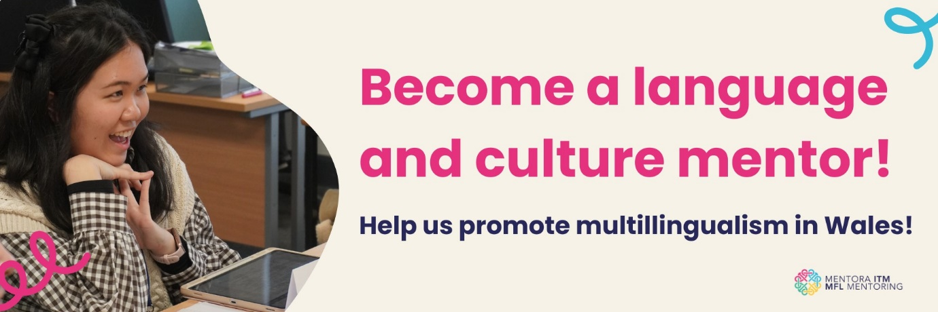
Become a Language & Culture Mentor for 2025-26!
Come and join MFL Mentoring to share your love of all things language and culture!
Click here for the application guide and submit your application by 11th April 2024: https://sway.cloud.microsoft/dAtCnz8EJsXgep8J?ref=Link
MFL Mentoring is offering a super exciting opportunity for undergraduate and postgraduate students from all disciplines with enthusiasm for languages and cultures! You don’t need to be studying a language to participate.
You will be promoting the benefits of multilingualism through a series of mentoring sessions with a small group of learners aged 12-14 years in secondary schools in Wales. You will also benefit from up to £250 bursary, an opportunity to develop your professional transferable skills, gain classroom experience and be part of a like-minded community!
Check out the project website and follow us on Twitter and Instagram.
If you have any questions, please email the MFL Mentoring team at mflmentoring@cardiff.ac.uk.

