

UNIVERSITY OF WALES TRINITY SAINT DAVID

Assignment 1: Coursework (Written Report)

Data Handling and Business Intelligence
LCBB5000

Student Name: Sorina-Iulia Cosa
Student Number: 2211474
Module Leader/Lecturer: Ejike Robert Udeogu

Table of Contents
1. Introduction 3
2. Business Intelligence 3
3. Agile Business Intelligence 5
4. Big Data 6
5. Data Mining 7
6. Conclusions 7
7. References 8

Introduction
Business intelligence (BI) refers to computer-based techniques for detecting, finding, and assessing firm data, such as sales revenue broken down by departments, items, or related costs and incomes. BI tools provide both current and forecast historical insights on business operations. Business intelligence technology is commonly used for benchmarking, data mining, web-based statistical analytics, reporting, predictive analytics, and firm performance management. Facilitating better business decision-making is the aim of business intelligence (Elena, 2011) .
Decision-makers in the rapidly evolving healthcare industry of today must meet increasing demands for clinical and administrative data in order to adhere to regulatory and client-specific criteria. Business intelligence (BI) applications are seen to offer a potential remedy for this real problem (Mettler & Vimarlund, 2009).
Below the health sector will be analysed based on the current business intelligence trends.

Business Intelligence
As a novel approach to organisational design, business intelligence (BI) is characterised by its ability to quickly and accurately analyse data in order to make intelligent business choices. This involves a variety of analytical and functional programmes (Eidizadeh et al., 2017).
Numerous tasks may be included in BI development. Creating a functional system that adds business context to data and presents information so that end users may analyse actionable information is the main goal of the development phase. Coding ETL, setting up logical layers in a BI tool, or writing scripts to schedule tasks are examples of activities. Data collection to staging, staging to presentation, and presentation to information distribution and access are all possible components of the development scope (Larson & Chang, 2016).

The integration of information and communication technology in the healthcare sector is presently viewed as a chance to enhance not only the efficiency, efficacy, and calibre of medical services, but also the transparency of business operations and the instant access to information. Healthcare has separate administrative and clinical reporting, although most other industries have unified management. Healthcare contains a multitude of players with diverse demands, as opposed to most industries which normally have a defined client base with a limited number of product versions (e.g. patients, insurance companies, governmental bodies, physicians). People's decisions and sentiments are important in healthcare, just as they are in most industrial systems with concrete measurements, as seen below in Figure 1 (Mettler & Vimarlund, 2009).
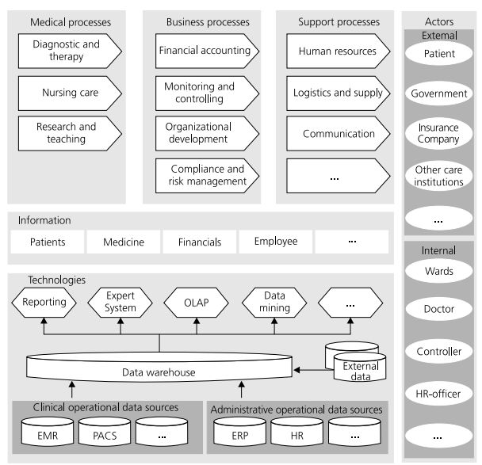

Figure 1, Framework for BI in healthcare (Mettler & Vimarlund, 2009).

Social media is becoming a real-time business intelligence tool for gaining commercial insights from social conservations, rather than just a place to have fun. It is regarded as a potent business intelligence tool as it helps companies develop personalities, spot market trends, and formulate strategies for their goods and services (Mirchandani, 2019).

Agile Business Intelligence
Within Business Intelligence (BI) context, technology functions as a facilitator for the storage, analysis, visualisation, and accessibility of vast amounts of data. A BI system uses a variety of expert systems, OLAP, and data mining technologies in tandem to achieve this goal (Mettler & Vimarlund, 2009).
Due to the similarities between the Agile methodology and BI projects, it is a desirable solution to the issues they encounter. Using an agile approach results in a less formal, more dynamic, and customer-focused technique. Agile approaches are a strong fit for BI because of the dynamism involved in its delivery. However, experience with Agile techniques has led to modifications to the well-known Agile methodologies, which now prioritise information usefulness above software development. Agile approaches fit in well with Big Data as well, as the focus is on producing small projects rapidly rather than putting a lot of effort into defining requirements upfront (Larson & Chang, 2016).

The agile business intelligence trends that help the healthcare sector have already been adapted and in use, as Kokol, (2022) says, patient management and engagement with chronic illness using high-quality and user-friendly mobile apps: when it comes to healthcare software, particularly mobile applications, patient engagement is primarily influenced by two factors: quality and usability.
Agile user-cantered design for intelligent eHealth applications: About 15 years ago, it was realised how important user-cantered design was while creating medical software and eHealth solutions. Not adopting it will lead to software with poor functionality and content, difficult-to-use user interfaces, and a major waste of financial and human resources. Virtual reality apps and software for medical devices should be developed quickly. Therapeutic virtual reality systems must also have regulatory approval before being used in homes and clinics. Empirical evidence suggests that virtual reality development may potentially profit from agile approaches when risk assessment is done appropriately. Numerous educational virtual reality products and settings have successfully incorporated agile development principles. Digital public health that is agile during COVID-19, in which software developers faced a novel challenge: how to create software in a setting where it's required to create entirely new mission-critical software solutions (like emergency software or vaccine distribution) in a matter of days with constantly shifting requirements. Implementing safe telemedicine with mHealth and designing secure clinical decision support systems through testing was essential, since electronic health record-based clinical decision assistance frequently has flaws.

Big Data
Mills, (2017) defines big data as ‘’ rapidly generated, digitally encoded information of significant volume, velocity, variety, value, and veracity’’. Like footprints indicating time and place, digital data—such as third-party cookies, online and marketing analytics, on-site web engagement analytics, GPS tracking, and other monitoring technologies—creates continuous recordings of social communication and geographical activity (Mills, 2019).
This complex system involves several participants, including patients, hospitals, doctors, pharmaceutical companies, and healthcare decision-makers. This business is likewise constrained by stringent rules and regulations. The healthcare sector has always generated a lot of data, and these days, data streams are continuously expanding due to the use of electronic medical records, the massive volume of data transmitted by various sensors, and the data generated by patients on social media. Big data analytics is used in the medical and healthcare domains to describe the integration and analysis of large amounts of complicated heterogeneous data, such as electronic health record data, biological data, and telemedicine data such as sensor and medical device data (Batko & Ślęzak, 2022).
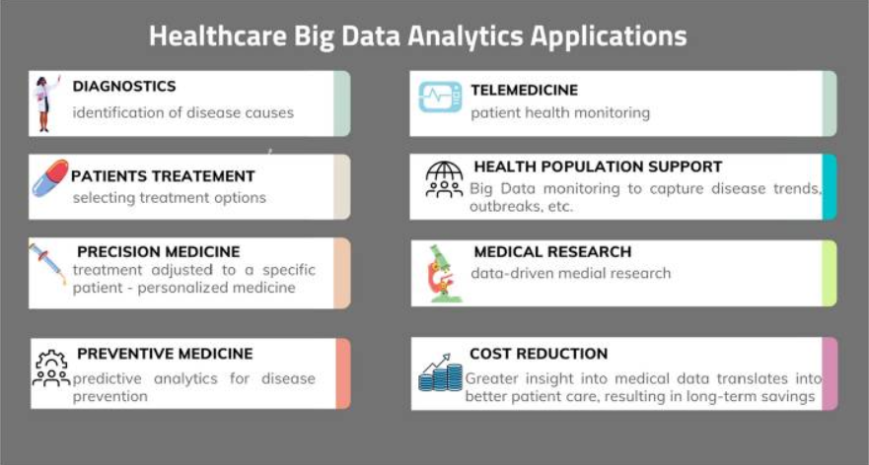
Figure 1, Healthcare Big Data Analytics applications (Batko & Ślęzak, 2022).

Data Mining
Data mining, mostly employed by statisticians, database researchers, and business groups, it is the examination of data in a database using technologies that seek for patterns or anomalies without knowing the meaning of the data (Lakshmi and Raghunandhan, 2011).

The size of data is often increasing daily and large, complicated, information-rich data sets are becoming more and more important to comprehend in all the many branches of science, industry, and technology. The capacity to extract valuable knowledge from the vast amount of data that is concealed in it because in today's cutthroat world, acting on the information is becoming more and more crucial. The diagnosis, treatment, and prevention of illness, injury, and other physical and mental disabilities in humans are all included in the comprehensive process of healthcare. Because the healthcare sector generates a lot of data, including electronic medical records, administrative reports, and other benchmarking findings, it may be thought of as a location with rich data. The majority and minority classifiers in the healthcare data sets are significantly unbalanced, which causes the classifiers to run with incorrect predictions. This is one of the common characteristics of the data sets (Jothi, Rashid and Husain, 2015).

Conclusions
Implementing the current trends of Business Intelligence offers the businesses more visibility and gives the customers a dynamic approach that helps both parties. The healthcare sector has already approached the agile business intelligence trends and has succeeded, alongside with data mining and processing the big data. Business Intelligence trends play a big role in the organisations and especially the healthcare sector benefited from them, enhancing the customers to have an more facile way of accessing the medical help, as it helps providing better patient care and medical services while also having the ability to cut costs; these services include more insightful and accurate patient diagnoses, individualised treatment plans, patient monitoring, preventive medicine, support for medical research, and higher-quality medical services (Batko and Ślęzak, 2022).

References
Batko, K. and Ślęzak, A. (2022) ‘The use of Big Data Analytics in healthcare’, Journal of big data (Accessed: 26 October 2024).
Eidizadeh, R., Salehzadeh, R. and Chitsaz Esfahani, A. (2017) ‘Analysing the role of business intelligence, knowledge sharing and organisational innovation on gaining competitive advantage’, The journal of workplace learning (Accessed: 28 October 2024).
Elena, C. (2011) ‘Business intelligence’, Journal of Knowledge Management, Economics and Information Technology (Accessed: 28 October 2024).
Jothi, N., Rashid, N. A. and Husain, W. (2015) ‘Data mining in healthcare – A review’, Procedia computer science (Accessed: 25 October 2024).
Kokol, P. (2022) ‘Agile software development in healthcare: A synthetic scoping review’, Applied sciences (Basel, Switzerland) (Accessed: 26 October 2024).
Lakshmi, B. N. and Raghunandhan, G. H. (2011) ‘A conceptual overview of data mining’, in 2011 National Conference on Innovations in Emerging Technology (Accessed: 25 October 2024).
Larson, D. and Chang, V. (2016) ‘A review and future direction of agile, business intelligence, analytics and data science’, International journal of information management (Accessed: 26 October 2024).
Mettler, T. and Vimarlund, V. (2009) ‘Understanding business intelligence in the context of healthcare’, Health informatics journal (Accessed: 24 October 2024).
Mills, K. A. (2017) ‘What are the threats and potentials of big data for qualitative research?’, Qualitative Research (Accessed: 26 October 2024).

Mills, K. A. (2019) Big data for qualitative research. Taylor & Francis (Accessed: 25 October 2024).
Mirchandani, A. (2019) ‘Current trends & future prospects of social media analytics in business intelligence practices’ (Accessed: 26 October 2024).

