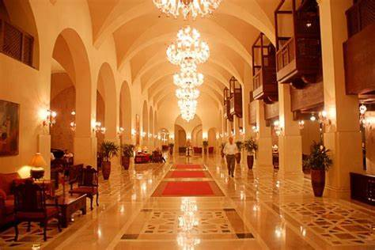

Consulting Report for
Sareena Hotel Islamabad!
Nimra Imran：2018843 :
Jaliya de Silva
International Hotel Management
January 24, 2024

Executive Summary

Report was to identify. The role of management consultant initiative and carry out a project That is of strategic relevance to an organization. To undertake a systematic analysis of data Everything. A report should produce a critical evaluates Arguments and assumptions draw realistic and appropriate conclusion. Make sound. An informed judgment to achieve a solution.
Report provides A brief overview of Islamabad Serena hotel locations, facilities and Services it provides. This includes hotels, core value, mission, philosophy And goals. Several readers suggested challenges affecting the tourism destination as well as to Reduce. Absenteeism and hotel's weakness? and provides guidance of on decision making.
Report provides problematic within the hotels and provides solution, advice and recommendations. Within the report, it uses Cotten's models and other related theories. It discusses chain management is in sustainability transformation. Report consists of a pastel and a SWAT analysis. For hotels External environment factors affecting Serena.
It also provides free recommendation. Suggestions to improve the problems at Serena's hotel Report consist of action plan of serious hotels Islamabad which entails problems, solutions , Desired outcome time scale it takes to complete. Completion date and a planned budget.

Content Page!

Front Cover-------------------------------1
Executive Summary--------------------2
Introduction-------------------------------4-7
Analysis-----------------------------------8-13
Recommendation----------------------14-16
Action Plan-------------------------------17-32
Conclusion--------------------------------33
Reference---------------------------------34-41
Biblography-------------------------------42

Introduction

According Sareena’s official website Islamabad is a central location in islamabad being only 45 minutes and 35km away from islamabad international airport. Islamabad and much of pakistan still remains undiscovered by international travellers. The people are warm and welcoming, greeting with genuine friendiness.

According to Abdul Basit Sultani Sareena group was founded in 1970 under the leadership of Agha Khan development Network. The group has flourished half decades and has 32 luxuary resorts, safari’s and hotels located in east africa, kenya, rwanda, uganda and in southern asia. It started its operations in 2001. Sareena targeting and positioning are corporate clients, embassies, families, wedding,parties and quality concious and executive class. It offers 387 rooms and suits with all air-conditioning, television, wifi and voicemail.

Munaza Kazmi defines Sareena Core Values
a. Integrity
b. Compassion
c. Innovation & Creativity
d. Empowerment
e Compassion
f. Teamwork
g. Love & Care

Philosophy of Serena
• Our Team
• Our Product
• Our Guest
• Our honor

5. OBJECTIVES & Goals
The objective of Serena Hotels is to
become # 1 hotel of Pakistan.

Five Years Goals
• To Increase Profitability
Islamabad Serena Hotel has planned to
increase their earnings by 15% annually
and to reach at least 40% increase over
the next five years.

• To Increase Market Share
Islamabad Serena hotel has a goal over
the next five years to amplify their
market share from Internet sources and
through alliances with airlines and to
give more attractive packages to their
customers.

• Maximize Shareholder
Value
Islamabad Serena Hotel is committed
for the constant growth of the
company. The primary business
objective is to maximize current
returns to the shareholders by
increasing cash flow available to pay
distributions and provide long-term
total returns to shareholders.

- Being the Best
Islamabad Serena hotel has a target to
become a novel leader in the hotel
industry and to continuously improve
their products and services. They will
be seeking from their supplier
uppermost quality of product and
services at the best value.
•
Concentrate on CSR
Islamabad Serena Hotel has always
outdone others in CSR activities. Future
objectives in this regard to include
schooling, elderly homes and eco
environment efforts.

• Working Together
T h e y e m p h a s i z e o n s h a r i n g
responsibility, accountability and
recognition through a climate of
teamwork, because this will ultimately
help to improve their overall efficiency.
•
Contribute To National Growth
Tourism can be a significant sector of
Pakistan's economy and can assist in
increasing the foreign earnings.
Operating under the “Serena” brand
name, Tourism Promotion Services owns
and manages more than thirty hotels in
East Africa and Asia.

Besides earning
foreign exchange and increasing
e m p l o y m e n t a n d m a n p o w e r
development, tourism can contribute to
national growth in more qualitative
ways.

So the main objective over the
next five years is to satisfy the wants
and needs of tourists and consumers as
well in the 21st century.

Sareena has a high standard quality regarding goods and services. Lens
On above, it is manifested that Serena
Hotel is a Mechanistic Organization
with highly formal structure.

Deloitte consulting firm does more than just audits. It is one of the “Big Four” aaccounting firm and largest global professional services network in world based on employed professional and revenue. Delliotte offers services such as tax, consulting, audits, assurance and risk financial advisory.

Munawar khan states challenges effecting the tourism industry in pakistan. Synchroneity of correlative and related responsibility can often prove to be challenge. One of the major challenge is an effective coordination's between federal and the administrative district government for the realisation of marketing and development strategies. Federal government is addressing these issues by holding inter-ministeial meetings of provincial tourism minister at orderly quantity

Currently diffusion of the tourist to non-traditional tourist destination is very slow across pakistan. (https://core.ac.uk/download/pdf/38077686.pdf accessed 19/10/2023)

Analysis
Munaza Kazmi states that Sareena hotel weakness are as follows:
- exisiting rent a car service
- No property in major cities like karachi or lahore
- Limitation of advertising
- No latest technical equipment in resort properties such as heating and air conditioning
- Contribution of foreign earning and increasing employment and manpower development
- To increase profitability
- To increase market share from internet sources through alliance with airlines and give customers more attractive packages.
- Maximise shareholder value and growth of the company. To maximise current returns to share holders by increasing cash flow available to pay distributions and provide long term total returns to shareholder.
- Provide a climate of enthusiasm such as training staff, encouraging invdividuality and initiative.
- To create alliance such increasing business via internet sources and throught partnership. Additionally banks to increase turnover, guest experience which will bring revenue.

According to European Journals of Economic, finance and administrative Sciences states that absentieesm was low at Sareena Hotel islamabad, which was due to different level of prestigiousness was offered to them. learning environment (in-house and external trainings), promotions and growth, empowerment and sense of ownership, facilities (like laundry, percentage off, free medical, tea, lunch and etc.), chances of socialization and recreational activities, international brand name (Serena) and good will, team work and cooperation, ease of communication, Retirement plans (employee old age benefits i.e. provident fund, pension and insurances), easy accessibility, flexibility in work, lack of alternatives and lastly the rightsizing of workforce

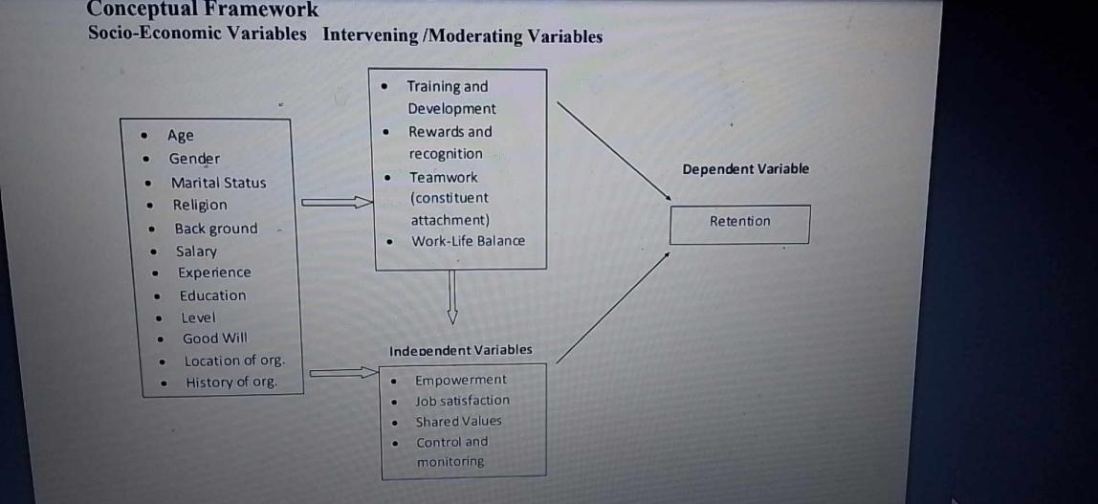

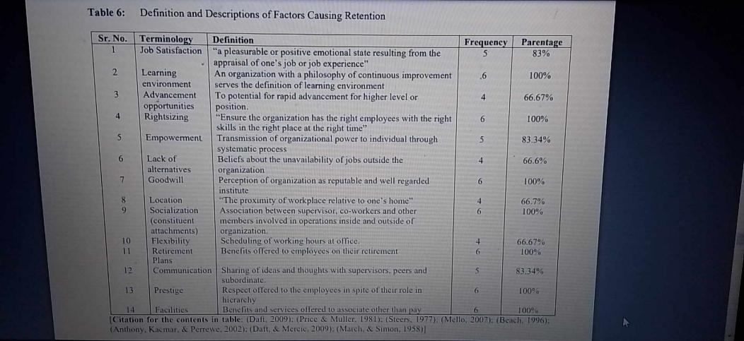

Rabia Akram, defines Sareena hotel needs to provide corporate policies with broad guidance for decision making throughout the organisation. This includes strong corporate culture, high quality services, training and development programme, competent employee, credit worthiness and brand recognition. Furthermore not giving emphaisise on cost reduction if quality of service is effected as well as on market share at the expense of profability. This also includes staff do their duties and obligation honestly, professionally that is essential for economic growth.

Cost can be controlled, avoid time consuming task such as advertising through magazine and newspapers etc. Report also suggests work with american airline to reduce marking cost and to increase market share. Hotel need to have a strategy formulation to be succesful it needs excellent implementation plan that leads towards failure such as unforseen problems, lack of coordinations amongs activities, insufficient staff who are involved in implementation process.

Sareena hotel external environment threats of new entrants because of rapidly growing industry with strong potential growth. Additionally it needs to identify factors which limits the new entrance or become barrier of the new entrant this includes legal requirement, capital intensive industry, correct research and development. Sareena needs to analyse and determine opportunities and threats which exits within a competitive environment. This includes examination of important stakeholders. Main issue for sareena hotel are managing customer taste , change of trends of a market and maintain high quality of All products and services. Another issue for this is bargaining of power of suppiers which can effect the industry by raising their prices. Sareena needs to bargain power of suppliers by obtaining products and services which are unique to Sareena, no close substitute of hotels who have forwarded integration and have direct contact with their customers.

Sareena needs to find alternative hotels in Islamabad to bargain power of buyers, switch cost towards competitors is low as well as offer discount if reservation is done online. There is great strong level of competition within the hotel industry and all compete aggressively or alliance due to less opportunities to target the market are few. In regards to Sareena competition is intense due to hotel is growing rapidly and competitors have opportunity to grow, high exit barriers and finally all competitors are equal in size and power. Specific research was carried out by Naeem Akhtar in regards to strategic groups and found that there are no such competitors of Sareena hotel because they provide full range of products and services with relatively higher prices. However Marriott and Pearl are competitors of Sareena hotel.

As for opportunities meaning generating high performance and income. Disposition to tourism operating under Sareena brand name, tourism promotion services owns and manages fifteen hotels in East Asia and Asia, as well as earning foreign exchange and increasing employment, manpower development and tourism can contribute to national qualitivies ways. Sareena has the power to introduce more attractive packages as tourism trends is continuesly increasing. Sareena hotel is in a growing stage and they have to lower their prices to gain progresively share within the market and with this Sareena can retain old consumers and attract new tourists. Sareena has a great opportunity to established new branches in major cities of pakistan, lahore and karachi, because Karachi is corportate city in Pakistan that has sea-port and international airport and most business class comes from that side.

In regards to Alliance with airlines and shipping corporation, Sareena has great opportunity to create with airlines, because it helps to increase their revenue, boost the tourism so they have great opportunity to maximise revenue out of it. Additionally contruction of makran costal, indus highway gives Sareena more opportunites regarding tourism and ultimately will be beneficial to the hotel.

As for organisational threats means an areas in environment that is increasing the difficulty to achieve high performance. For Sareena the threats is opening of Sheraton Hotel branch in Islamabad which is a big threat to the hotel as Sheraton has tremendiously established in Karchi and the hotel services is known to everyone and this can be big threat for Sareena Hotel. Another threat for Sareena is Marriott, Holiday Inn and Pearl Hotel due to lowering prices and offering more attractive packages that will reflect Sareena customer going to another hotel.

Some other periodical can be changing government regulations and policies which can effect in not sticking to the regulation that willl reflect in stablizing Sareena’s prices, packages and for this customer will endure.

Sareena’s strength are location and culture of the property where the hotel is located. It provides high quality services such as airport pick-ups, free wife, local telephone calls and much more. Sareena has a health and recreation featuring outdoor heated pool, well equipted ladies and gender gym and much more. Futhermore it has training and development programe for their employee primary purpose to improve their professional competence, also to meet and satisfy needs of guest and employee.

Additionally best strength is having competent and skilled employee. Most importantly Sareena credit worthiness is very high as everyone is familiar with the hotel and Agha Khan Fund for Economic Funds as if needed loan for business puropose could get it easily.

Sareena hotel weakness that is very expensive as its built purpose for high class people. Its leadership style is very aggressive and this lead to fail to handle and expected customers. Sareena does not have a suggestion box to get feedback from staff, customers and management.hotel does not have a branch in major cities and limited targeted market and high tariff rates with no alliance with multi-national companies.

- Vielba et al defines role of external consultant is someone that provides expert and professional advice. Advantages of using a consultant as it brings expert advice that is lacking in the organisation, as well as achieving results within tight deadlines.

Indeed Career Guide states a consultant who uses their expertise to do several things to improve client workforce by analysing company strategies to create plans for better workforce. External consultant is who is professional person who is not employed within the company. Companies or businesses advices by identifying and solving problems within the company.

However internal consultant is professional consultant who is already employed in a company who works in Human Resource Department who handles employer and staff relations. Consultant may report directly with company executive leadership regarding strategic planning.
Henry Mzere declares Kotter’s model (1996,1998) which is used at the strategic level of an organisation by changing its vision and subsequently transform the orgnaisation.

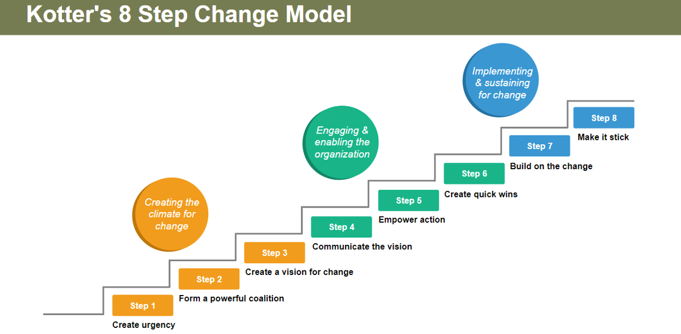

- Lebryk (2021) defines Structural topic model is a form of topic modelling
Specifically designed with social science research in mind. It allows us to incorporate meta data into our model and uncover how different documents talks about the same underlying topics using different word choices.

- E. Sancak (2023) identify change management in sustainability transformation, a model for business organisation. The transformations towards sustainability notion has taken an inncreasingly central position in globla sustainability research and policy dicourse in recent years. However achieving greater sustainability is the greatest challenge in organisational change management in the contemporary world (Matos and Clegg, 2013).

Expert Programme Management website declares Mckinsey Model helps us understand if an organisation is set-up in a way that allows to reach its objectives. The model consit of strategy, structure, systems, style, staff, skill and shared and core values.

- Pestle Analysis of Sareena for external factors be contributing to the
- problems the hotel is experiencing. The PESTEL analysis should relate directly to hospitality and
- hotels. The PESTEL analysis can be presented in a table, the word count will be included.

- After the SWOT analysis has been completed, a TOWS analysis should then be included, to
- highlight possible future directions for the hotel. It is essential that a consultancy report is able to
- strategically convert problems into solutions – that is why you have been hired! The TOWS analysis
- can be presented in a table.

Recommendation and change management

https://www.scribd.com/doc/26758813/Project-Making-of-Sareena-Hotel?fbclid=IwAR2Wmc2g6mb3jYY1g5pDGtAeBljIbCVFJ4xEiUoI07N7DzIrA0qL2oQw9Sg accessed 19/10/23

https://www.academia.edu/41689883/Report_on_Analysis_of_Islamabad_Serena_Hotel page 13 see report insert here if needed.

Sareena needs to intelligibly put across the objectives straregies and policies with the line management, being competence in management and having a successful strategic plan .Sareena hotel needs to retain old employee and hire new with training plan that teaches required skilled. Furthermore hiring capable staff, having a proper direction and successful implementation of new strategy. In order to ensure success proposed strategies management needs to have a good culture compatibility which involves by evaluating specific change in strategy will mean to the corporate culture.However if culture cannot be changed then modify to make it compatible with the new strateegy

https://www.scribd.com/doc/26758813/Project-Making-of-Sareena-Hotel?fbclid=IwAR2Wmc2g6mb3jYY1g5pDGtAeBljIbCVFJ4xEiUoI07N7DzIrA0qL2oQw9Sg) 19 October 2023

Vision Statement
“The Goal of our organization is to
m e e t a n d e x c e e d g u e s t ’ s
expectations.”
Vision statement should be purpose
driven and characterize the core
competencies of the company. This
vision statement is purpose driven and
emphasize on the guest’ expectations
which will lead them to achieve goals
and eventually going towards their
mission and visions.

Vision also known
as something elusive.
Mission statement of Serena lacks the
commitment towards company’s
growth and influence of technology.

Revised Mission Statement

Our mission is the creation of buildings
of stupendous ethnic designs offering
the premier standards of service and
product, providing our employees with
a m o d e r n a n d t e c h n o l o g i c a l
environment which enables all of us to
deliver operating standards beyond the
level of our guests’ expectations
resulting in pleasing returns to our
stakeholders and constant growth of
the company

Revised Vision Statement
“Our vision is to exceed our guest’s
expectations.”
In this improved version I replaced the
word goal with vision and removed the
word “meet” because I was wondering
j u s t m e e t i n g t h e c u s t o m e r s ’
expectations is not sufficient and it’s
hard to consider it a vision, so the
improved version focuses on going
beyond the expectation of customers.

Sareena needs to bargain power of suppliers by obtaining products and services which are unique to Sareena, no close substitute of hotels who have forwarded integration and have direct contact with their customers. Sareena needs to find alternative hotels in Islamabad to bargain power of buyers, switch cost towards competitors is low as well as offer discount if reservation is done online.

https://www.scribd.com/doc/26758813/Project-Making-of-Sareena-Hotel?fbclid=IwAR2Wmc2g6mb3jYY1g5pDGtAeBljIbCVFJ4xEiUoI07N7DzIrA0qL2oQw9Sg accessed

Action Plan
Name | Problem | Solution | Desired Outcome | Time Scale | Completion Date | Planned Budget
Sareena Hotel Islamabad | effective coordination's between federal and the administrative district government for the realisation of marketing and development strategies. | Begum et al (2019) suggest designing public policy  or any action increasingly connects diversity of  stakeholders, and territorial decentralization in  terms of regionalization, and multiple sources of  funding leading to differentiation in organiza-  tional capacities and responsibilities (Edler and  Kuhlmann 2008; Nilsson and Moodysson 2015).  Given the importance of coordination in organi-  zation, Boston (1992)deﬁnes it as a dynamic  process that facilitates the process of organiza-  tional activities and avoids overlapping and  inconsistencies in policy and directions.  POSDCORB in a very practical way, which  stands for Planning, Organizing, Stafﬁng,  Directing, Coordinating, Reporting,  planning and organizing, point out what to  include in a good plan and how to successfully  implement it in organization. It is also important  in case of stafﬁng, as it indicates who should be  the right staff and at the appropriate place as well.  Even coordination highlights on directing,  because it indicates to a speciﬁc focus in organi-  zation. Coordination helps coordinating the tasks  of organization. When it is talked about reporting  of organization, it produces realistic and coordi-  nated information received from all sections or  groups. Finally, coordination is part of budgeting  there are different tech-  niques of coordination, such as planning as an  important means of coordination; institutional or  organizational arrangement, such as inter- or  intradepartmental meetings, planning among per-  sons and units of organization, and so on; and  standardization of procedures and methods like  forms, manuals, regulations, verbal and written  many developing countries in the world have  introduced national strategies for their develop-  ment efforts; however, there are doubts whether  these strategies maintain policy coherence in pro-  moting their development goals.  It also suggested having colaboration is a effective way to communicate approach fosters meaningful  coordination that can be achieved only through  developing a common collective goal among the  appropriate stakeholders in the process; however  the collective goal must be in place that enables all  the relevant stakeholders to feel and share that  - they are achieving or going to achieve something  - in future through the efforts of mutual cooperation  - and reciprocation (Bardach 1998) |  | 1 and haf year | 2026
 | exisiting rent a car service | - Dessie (2015) describes by designing a service design as a key element to help innovate or improve services to make them more useful, desirable and efficient for clients and organizations (Moritz 2005: 51).  User-centered service design focuses on the interaction between a service provider and customer. To put the customer at the center of the service design, a good understanding of the customer needs to be analyzed. To understand the customers’ needs, service designer needs to experience the service through the customers’ eyes (Stickdorn & Jakob 2011: 35). Additionally, a real value is delivered when services are designed based on a genuine insight of the customers (Polaine et al 2013: user-centered adapted to the LBS car rental platform should consist of the insights from customers.  Co-creation Service design focuses at putting the customer in the center of the design process. Because service design itself is not created by the customers, the input of various stakeholders needs to be considered. Location-based services (LBS) are defined as services that depend on and are enabled by the location of the users’ mobile device. These services provide valuable information to the user based on the users’ geographical location. The use of LBS has been increasing 44 in the areas of information services, tracking and advertising (Dhar & Varshney 2011: 122). |  | 3 years | 2027
 | Limitation of advertising | - Whitney (2024) suggest being easily searchable online, remarket and ensuring you are targeting the correct audience as well as allocating more marketing budget during peak booking season time. It also states to provide incentives to get people interested, building a local partnership, marketing the location and having a hotels website simple and breath-taking. Moreover going beyond the customer service before, during and after. Finally buildiing a customer loyalty programme. |  | 6 -8 months | October 2024
 | No latest technical equipment in resort properties such as heating and air conditioning | Having a budget for technical equipment and updating the service and equipment regulary |  | 3-5 years | 2029
 | To increase profitability | Indeed career website defines to increase profitability hotel needs to do several things which includes facilitating team contributions, conducting a market research. Other includes analysing financial statements, eliminating none-essential processess. Moreover decrease waste, re-organised physcical spaces and create budgets. Furthermore conducting extensive training, developing vendor relationships, develop marketing and branding as well as increasing sale prices. |  | 6-8 months | October 2024
 | To increase market share from internet sources through alliance with airlines and give customers more attractive packages | - Kianmer (2023) states strategies to increase market share is being innovative with things that attract customers, create loyality and having a skill-full workforce. Other includes lowering price strategies to help company win market share. To prevent loss of market share, hotels needs to monitor its market share and keeping an eye on performance of its competitors. |  | 3-4 months | June 2024
 | Maximise shareholder value and growth of the company. | - Rappaport states to create shareholders value by not managing earning or to provide earning guidance. Also making strategic decisions that maximise expected value even lowering near term earning. Other include returning cash to shareholder when there is no credible value-creating opportunities to invest in the business. Finally rewarding CEO’s and other seniors executive for delivering superior long term value. |  | 6 months | August 2024
 | To maximise current returns to share holders by increasing cash flow available to pay distributions and provide long term total returns to shareholder. | C.Banton (2022) defines ways to boost portfolio returns by equities over bonds, use of small companies than large ones. You also need to manage your expenses, diversification and finally rebalancing it. |  |  | 1-2 years | 2026
 | Provide a climate of enthusiasm such as training staff, encouraging invdividuality and initiative | Indeed website states ways to improve organisational climate by identifying current organisational climate, raising awareness of companies missions, identifying motivational factors, improving and understanding of task delegation and boosting team cooperation. |  |  | 9 months | November 2024
 | To create alliance such increasing business via internet sources and throught partnership. | Strategic advisor board declares to bring a strong alliance for the business success is by increasing innovations, shared resources and expertise. Additionally reduce cost, increase market reach and strengthened reputation |  | 6 months | August 2024
 | banks to increase turnover, guest experience which will bring revenue. | - Johansson (2023) state to do personalisation and contribution to increase revenue and profits by collecting the correct data, reasoning for the travel and the second most critical peace of data where the guest comes from. Knowing a guest’s booking behaviour is critical to personalising offering and services to the hotels guest. Hotels can create micro-segment where to collect, analyse guest data, identify common characteristics and create micro-segments. Additionally to contribute to revenue and profits to increase guest satisfaction and higher occupancy rates as well as higher average revenue by guest. |  | 3-4 years | 2027
 | absentieesm was low at Sareena Hotel islamabad, which was due to different level of prestigiousness was offered to them. | - Rodgers (2023) decribes to reduce absenteeism at workplace by firstly undertanding the cause of absent. To track and monitor employee absences, improve communication, monitor metrics related to absenteeism and make teamwork part of the company culture. Additionally tailor benefits to employee needs and invest in employee wellness. |  | 8 months to 1 year | 2025
 | provide corporate policies with broad guidance for decision making throughout the organisation. | - Schwartz ( website defines guidance to writing effective policies and procedures by when planning for documentation decide on focus and avoid creating policies. A succesful documentation should include a standard text at the top that states the purpose and scope of the process, identify responsible department ad key term definition. Avoid errors in documenting policies and procedures to adhering to context, consitency, completeness, control, compliance, correctness and clarity. Hotel ca save money and improve productivity by creating policies and proceedures for continual improvement. When drafting quality objectives start by identifying the target markets customers and their needs as well as criteria and control. |  | 7 months | September 2024
 | strong corporate culture, high quality services, training and development programme, competent employee, credit worthiness and brand recognition | Guest delight International website defines building a strong organisational culture in hotel by understanding organisational culture, leadership as the cultural compass,having clear values and shared visions. Defining and communicating core values fundemental to building a strong organisational culture. An engaged and empowered workforce is at the heart of vibrant culture. Having a continuous learning and adaptability is crucial. A strong organisational culture extends beyond internal operations, it shapes the guest experience. Finally having a recognition and celebration can reinforce a positive culture. |  | 2-3 years | 2027
 | not giving emphaisise on cost reduction if quality of service is effected as well as on market share at the expense of profability | - Miller (2023) declares cost reduction strategies without sacrificing quality by understanding the cost-quality relationship, effective cost reduction strategies,such as streamlining operations, leverage technology and automation. Having a smart sourcing and procurement and reduce waste reduction and resource optimization. Managing quality during cost cuts and challenges and consideratin of risk of compromising quality and employee morale and resistance to change. |  | 1 and half year | 2025
 | includes no staff do their duties and obligation honestly, professionally that is essential for economic growth.  cost can be controlled, | - Han (2023) states to create a culture of ethics accountability in the workplace by leading with the example of organisational leader, provide meaningful feedback and combat workplaxe bias. To give employee a voice, develop a authentic leadership style and finally take accountability |  | 8 months | October 2024
 | leadership style is very aggressive and this lead to fail to handle and expected customers | - Rajdeep (2023) states negative leadership styles, aggressive, assertive and passive approaches by chosing the right approach by understanding the situation, consider the impact on team dynamics, align with organisational values and culture, adapt to individual team members and seek feedback and self-reflection as well as balancing leadership styles. |  | 1 year | 2025
 | Sareena does not have a suggestion box to get feedback from staff, customers and management | Vintage circle website defines having a employee suggestion to improve employee engagement, setting up a suggestion box can be a great way to get employees involved. The privacy of the suggestion should be upto the employee, tailor the suggestion form. Employee suggestion boxes should be convenient, easily accessible and secure. Hotels should set a review schedule and incetivize winning ideas. |  | 3 months | May 2024

Conclusion

To conclude report was to identify the role of management consultant initiative and carry out a project That is of strategic relevance to an organization. To undertake a systematic analysis of data Everything. A report should produce a critical evaluates Arguments and assumptions draw realistic and appropriate conclusion. Make sound. An informed judgment to achieve a solution.
Report provides A brief overview of Islamabad Serena hotel locations, facilities and Services it provides. This includes hotels, core value, mission, philosophy And goals. Several readers suggested challenges affecting the tourism destination as well as to Reduce. Absenteeism and hotel's weakness? and provides guidance of on decision making.
Report provides problematic within the hotels and provides solution, advice and recommendations. Within the report, it uses Cotten's models and other related theories. It discusses chain management is in sustainability transformation. Report consists of a pastel and a SWAT analysis. For hotels External environment factors affecting Serena.
It also provides free recommendation. Suggestions to improve the problems at Serena's hotel Report consist of action plan of serious hotels Islamabad which entails problems, solutions , Desired outcome time scale it takes to complete. Completion date and a planned budget.

Reference

- Wellbeing, recovery and mental health (no date) Google Books. Available at: https://books.google.com.pk/books?id=7YXuDQAAQBAJ&lpg=PR7&ots=Q4MMEKT6m2&dq=mental+health+wellbeing+&lr&pg=PR7#v=onepage&q=mental%20health%20wellbeing&f=false - Wellbeing recovery and mental halth by mike slade etc (Accessed: 06 October 2023).
- Walker K, Yates J, Dening T, Völlm B, Tomlin J, Griffiths C. Quality of life, wellbeing, recovery, and progress for older forensic mental health patients: a qualitative investigation based on the perspectives of patients and staff. Int J Qual Stud Health Well-being. 2023 Dec;18(1):2202978. doi: 10.1080/17482631.2023.2202978. PMID: 37079294; PMCID: PMC10120527. Available at: https://pubmed.ncbi.nlm.nih.gov/37079294/ (Accessed at 06 October 2023).
- Tijani, Bashir & Xiaohua, Jin & Robert, Osei-Kyei. (2022). PESTEL Analysis of Mental Health Management of Project Management Practitioners (PMPs) in Architecture, Engineering and Construction (AEC) Project Organization. Smart and Sustainable Built Environment. 10.1108/SASBE-04-2022-0074, Available at: (https://www.researchgate.net/publication/362227260_PESTEL_Analysis_of_Mental_Health_Management_of_Project_Management_Practitioners_PMPs_in_Architecture_Engineering_and_Construction_AEC_Project_Organization ) Accessed on 09 October 2023
- Ed Diener & Eunkook Suh (1997) MEASURING QUALITY OF LIFE: ECONOMIC, SOCIAL, AND SUBJECTIVE INDICATORS, Available at : (https://link.springer.com/article/10.1023/a:1006859511756#author-information), Accessed on 08 October 2023.
- World Health Organisation, (2022), Mental Health Available at: ( https://www.who.int/news-room/fact-sheets/detail/mental-health-strengthening-our-response) Accessed on 20 October 2023.
- Longhurst GJ, Stone DM, Dulohery K, Scully D, Campbell T, Smith CF (2020) Strength, Weakness, Opportunity, Threat (SWOT) Analysis of the Adaptations to Anatomical Education in the United Kingdom and Republic of Ireland in Response to the Covid-19 Pandemic. Anat Sci Educ. 2020 May;13(3):301-311. doi: 10.1002/ase.1967. Epub 2020 May 9. PMID: 32306550; PMCID: PMC7264742. Available at : (https://pubmed.ncbi.nlm.nih.gov/32306550/) Accessed on 20 October 2023.
- M Student life, (2023) Pre- Event Planning Meeting, Available at (https://campusinvolvement.umich.edu/article/pre-event-planning-meeting#:~:text=The%20Pre%2DEvent%20Planning%20(PREP,it%20from%20a%20previous%20event), Accessed on 20 October 2023.
- Degree, Tania, (2023) Mental Health and Wellbeing Event, Available at (https://www.thisiscalmer.com/events) Accessed on 20 October 2023.
- Murphy, O., Looney, K., McNulty, M. et al. Exploring the factors that predict quality of life, and the relationship between recovery orientation and quality of life in adults with severe mental health difficulties. Curr Psychol 42, 22419–22428 (2023). https://doi.org/10.1007/s12144-022-03296-4 accessed 08/10/2023
- Medical Student Worldwide, (2016) Annual Report, Mental Health Programme, Available at: (https://ifmsa.org/wp-content/uploads/2016/09/Mental-Health-August-2016.pdf) Accessed 08 October 2023)
- F. Richard Ferraro, (2022) Exploring the factors that predict quality of life, and the relationship between recovery orientation and quality of life in adults with severe mental health difficulties Available at (https://link.springer.com/article/10.1007/s12144-022-03296-4 ) Accessed on 08 October 2023)
- Smith, J (2023) Everything you need to know about Pre-Event planning
Available at: (https://www.lumoslearning.com/llwp/teachers-speak/everything-you-need-to-know-about-pre-event-planning.html) Accessed on 07 October 2023.
- Simplylearn, ( 2023) Feasibility Study and Its Importance in Project Management Available at: (https://www.simplilearn.com/feasibility-study-article) Accessed on 07 October 2023.
- Marketing Business, (2021) What is Quality of Life, Available at: (https://www.youtube.com/watch?v=L8jUqyUBOrE) Accessed on 08 October 2023.
- Drury, A, (2023) Feasability Study Available at (https://www.investopedia.com/terms/f/feasibility-study.asp) Accessed on 07 October 2023.
- https://www.academia.edu/download/30873102/EJEFAS_29_01.pdf accessed on 14/10/23
- (https://www.academia.edu/41689883/Report_on_Analysis_of_Islamabad_Serena_Hotel accessed 19/01/24
- (https://www.slideshare.net/BASIT554/serena-hotel-islamabad accessed 19/10/23)
- (https://www.serenahotels.com/islamabad/location-contact accessed 19/10/23)
- (https://managementconsulted.com/consulting-firm/deloitte-consulting/#:~:text=Deloitte%20is%20one%20of%20the,%2C%20and%20Risk%20%26%20Financial%20Advisory accessed 19/10/23)
- (https://www.academia.edu/41689883/Report_on_Analysis_of_Islamabad_Serena_Hotel accessed 19/10/23)
- Extra links- see to use for the report
- https://thenewstoday.com.pk/serena-islamabad-becomes-first-energy-efficient-hotel-in-pakistan/?doing_wp_cron=1697012233.4954969882965087890625
- https://psf.gov.pk/downloads/Content%20of%20ANNUAL%20REPORT%202021-2022.pdf
- https://d1wqtxts1xzle7.cloudfront.net/67262316/c6cb16b2973368d610e18c0f741d8c795086-libre.pdf?1620491819=&response-content-disposition=inline%3B+filename%3DThe_Impact_of_Rewards_on_Employee_Motiva.pdf&Expires=1697711287&Signature=bVySUt~lOKta8QmVT86oQxQRuPy80spDoXpUWn~islhmfW18YPm4o~ClEAPF0Mbv-IAUk3TNlw2d-0NvfI0JzosFmBZyqEdolxrs59dc9iQNg~Znr2DfzcYBWvLK9vJsUqdtapBxIAfKRXhq8-tq2owZ31Hmui6QBUDMT0uklO-KhlcCFkohgInZfYHp1li3S4lYfKZsBeO868lb9GQDcT0heRZ7lgaDuNc3H-~XhLYo5~KIn~3fkX-A4HlS-KXpwEa2uthDO6z3xGHSyduneftdH87MmNxtId4OIcFdbM2-QMNTpDzBOQJehw4SAfjpW7Ka4aG3fcB1MEJNPp4ESw__&Key-Pair-Id=APKAJLOHF5GGSLRBV4ZA
- https://www.researchgate.net/profile/Zafar-Ullah-4/publication/360995709_Opinion_Mining_of_Online_Reviews_about_Certain_Islamabad_Hotels_A_Business_Intelligence_Study/links/6297129255273755ebc791e9/Opinion-Mining-of-Online-Reviews-about-Certain-Islamabad-Hotels-A-Business-Intelligence-Study.pdf
- Available at:(http://artechjournals.com/uploads/documents/file_870_55.pdf) Accessed on 19 October 2023
- A.Khan (2011) An Empirical Study of Retention Issues in Hotel Industry: A Case Study of Serena Hotel, Faisalabad, Pakistan Available at:(https://www.academia.edu/download/30873102/EJEFAS_29_01.pdf) Accessed on : 14 October 2023
- Kazmi (2020) Report on Analysis of Islamabad Serena Hotel , Available at:(https://www.academia.edu/41689883/Report_on_Analysis_of_Islamabad_Serena_Hotel) Accessed on: 19 January 2024
- Available at:(https://www.slideshare.net/BASIT554/serena-hotel-islamabad) Accessed on: 19 October 2023)
- Available at:(https://www.serenahotels.com/islamabad/location-contact) Accessed on: 19 October 2023)
- Deloitte Available at: (https://managementconsulted.com/consulting-firm/deloitte-consulting/#:~:text=Deloitte%20is%20one%20of%20the,%2C%20and%20Risk%20%26%20Financial%20Advisory) Accessed on:19 October 2023)
- F. Vielba et al (2023) The Role of the External Consultant (Available at:(The Role of the External Consultant | SpringerLink ) Accessed on: 14 January 2024
- Indeed (2022) External vs. Internal Consultants: What’s the Difference?
- H. Mzera (2008) Change Management Models and theoriesAvailable at: (External vs. Internal Consultants: What’s the Difference? | Indeed.com) Accessed onL 15 January 2024
- H.Mzera (2023) Change Management Models and theories, Available at:(Change Management Models and theories | HENRY MZERA - Academia.edu) Accessed on:18 January 2024
- R.Mishra (2022) Management and Organizational Research: Structural Topic Modeling for a Better Understanding of Theory Application, Available at:(Sustainability | Free Full-Text | Management and Organizational Research: Structural Topic Modeling for a Better Understanding of Theory Application (mdpi.com) Accessed on:15 January 2024
- Expert Program Management (2018) McKinsey 7S Framework Explained, Available at:(https://www.bing.com/videos/riverview/relatedvideo?&q=Mckinsey+Model&&mid=F74BD55CFABDE7EAAE4DF74BD55CFABDE7EAAE4D&&FORM=VRDGAR) Accessed on: 29 February 2024
- I.Sancak (2023) Change management in sustainability transformation: A model for business organizations Available at: (https://www.sciencedirect.com/science/article/abs/pii/S0301479722027384) Accessed on 29 February 2024
- R.Iram (2022) Rabia Iram Project Management 2 Assignment Presented To: Sir. Naeem Akhter Allama Iqbal Open University, Islamabad, Available at:(https://www.scribd.com/doc/26758813/Project-Making-of-Sareena-Hotel?fbclid=IwAR2Wmc2g6mb3jYY1g5pDGtAeBljIbCVFJ4xEiUoI07N7DzIrA0qL2oQw9Sg accessed) Accessed on:19 October 2023
- M.Begum (2019) Coordination and Effective Governance, Available at: (https://www.researchgate.net/publication/343264706_Coordination_and_Effective_Governance ) Accessed on: 23 February 2024
- Available at:(https://core.ac.uk/download/pdf/38122848.pdf ) Accessed on: 23 February 2024
- M.Whitney (2024) 10 Smart Hotel Marketing Strategies to increase booking, Available at:(https://www.wordstream.com/blog/ws/2018/09/07/hotel-marketing) Accessed on: 23 February 2024
- Indeed, Career development to increase profitability, Available at: (https://www.indeed.com/career-advice/career-development/increase-profitability) Accessed on: 23 February 2024
- Available at:(https://www.investopedia.com/ask/answers/031815/what-strategies-do-companies-employ-increase-market-share.asp) Accessed on: 22 February 2024
- Rappaport, 10 Ways to create shareholder value, Available at: (http://www.competetowin.co.uk/wp-content/uploads/2012/02/TenWaysToCreateShareholderValue.pdf) Accessed on: 23 February 2024
- Available at:(https://www.investopedia.com/articles/stocks/11/6-ways-improve-portfolio-returns.asp) Accessed on: 29 February 2024
- Available at:(https://www.indeed.com/career-advice/career-development/improve-organizational-climate) Accessed on: 29 February 2024
- Available at: (https://www.strategicadvisorboard.com/blog-posts/collaboration-and-partnership-how-to-build-strong-alliances-for-business-success) 29 February 2024
- Available at:(https://insights.ehotelier.com/insights/2023/03/17/how-personalization-contributes-to-increased-revenue-and-profits/) Accessed on: 29 February 2024

- Available on:(https://www.wellics.com/blog/reduce-workplace-absenteeism) Accessed on: 29 February 2024
- Available at:(https://smallbusiness.chron.com/guidelines-writing-policies-procedures-1803.html) Accessed on: 29 February 2024
- Available at:(https://www.linkedin.com/pulse/building-strong-organizational-culture-hotel-coyuc/) Accessed on: 29 February 2024
- Available at:(https://www.linkedin.com/pulse/cost-reduction-strategies-without-sacrificing-quality-jason-miller-nthcc/) Accessed on: 29 February 2024
- Available at:(https://online.hbs.edu/blog/post/ethics-and-accountability-in-the-workplace) Accessed on:29 February 2024
- Available at:(https://www.linkedin.com/pulse/navigating-leadership-styles-aggressive-assertive-passive-dutta/) Accessed on: 29 February24
- Available at:(https://blog.vantagecircle.com/employee-suggestion-box/) Accessed on: 29 February 2024
- Available at:(https://smallbusiness.chron.com/guidelines-writing-policies-procedures-1803.html) Accessed on: 29 February 2024
- Available at:(https://www.linkedin.com/pulse/building-strong-organizational-culture-hotel-coyuc/) Accessed on: 29 February 2024
- Available at:(https://www.linkedin.com/pulse/cost-reduction-strategies-without-sacrificing-quality-jason-miller-nthcc/) Accessed on: 29 February 2024
- Available at:(https://online.hbs.edu/blog/post/ethics-and-accountability-in-the-workplace) Accessed on:29 February 2024
- Available at:(https://www.linkedin.com/pulse/navigating-leadership-styles-aggressive-assertive-passive-dutta/) Accessed on: 29 February24
- Available at:(https://blog.vantagecircle.com/employee-suggestion-box/) Accessed on: 29 February 2024

Bibliography- Additional

Organization Chart at Islamabad
Serena Hotel -

Departmentalization
Serena is divided into different
divisions according to the operational
function.

In Serena, the division of the
employees is on basis of their work
specialization and they are allocated
into different departments according to
educational background, consequently
it can also help employees to develop a
professional career.
Human Resources
Recruitment
Staff Management
Training & Development
Rooms Division
Front Office
Housekeeping
Laundry
Food & Beverages
Service
Production
MICE & Event Management
Finance
1. Purchasing
Payable
Audit
Credit
Cashiering
Sales & Marketing
1. Sales
2. Marketing & Communication
Engineering
Security

