Finley Perry

2501009

Computer Science (Networks and Cybersecurity)

Database and Web Design

Background and Context 3
Overview of the System 4
Database Design 6
3NF Compliance 9
Validation Rules 9
Queries and Testing 9
Design Decisions, Summary and Reflections 10
Conclusion 12

Background and Context

The local authority has launched the EcoRide initiative, an electric bike rental service designed to promote sustainable and healthy commuting. The system enables riders to collect bikes from public locations, such as parks, train stations, and university campuses, and return them at any other station. While the service has grown in popularity, the operational management faced challenges due to reliance on manual record keeping with paper forms and spreadsheets. This resulted in limited visibility of bike availability, occasional double-bookings, unreturned bikes, and difficulties in summarizing service usage.
This assignment focuses on designing and implementing a structured database system in Microsoft Access to streamline EcoRide’s operations. The system supports registration of riders, management of bike inventory, recording of rental transactions, tracking staff involvement in maintenance, and generating operational queries.
The database aims to:
- Ensure accurate tracking of bike availability and rentals.
- Maintain comprehensive maintenance records linked to staff members.
- Provide reporting and query capabilities for operational decisions.
- Minimize redundancy and enforce data integrity through normalization and validation rules.
By digitizing the system, EcoRide can reduce human error, prevent double-bookings, and improve visibility over bike usage and maintenance schedules.

Overview of the System
The EcoRide system has these tables: Riders, Bikes, Transactions, Staff, and Maintenance Records. Each entity stores essential information required for the operation of the bike rental scheme:
- Riders: Stores personal and contact information for users.
- Bikes: Tracks each electric bike, its type, current location, and status.
- Transaction: Records each rental transaction including the bike rented, rider details, rental duration, cost, and dates.
- Staff: Contains information on employees responsible for bike maintenance.
- Maintenance: Logs all maintenance activities, linking each task to a bike and the staff member who performed it.
The system ensures relationships are enforced, allowing efficient data management and retrieval.
Bike Table
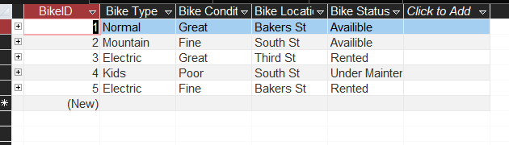
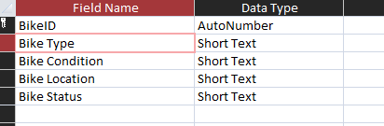
Maintenance Table
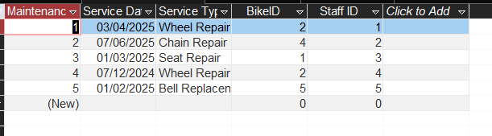
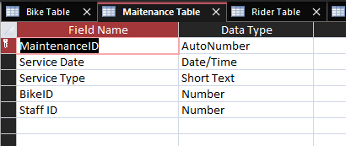
Rider Table
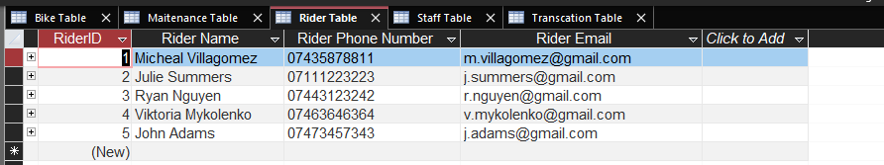
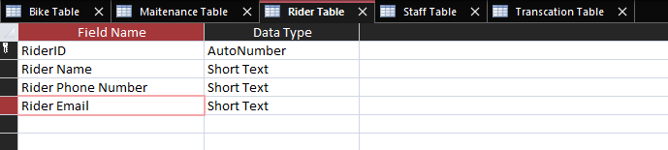
Staff Table
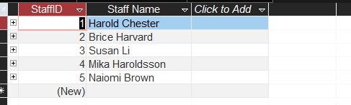
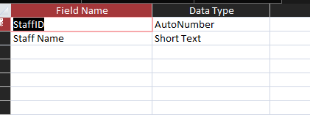
Transaction Table
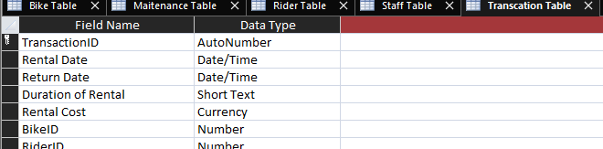
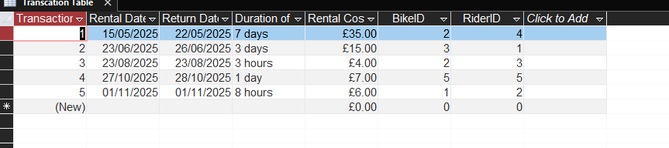

Database Design
The database includes five primary tables, designed for 3NF compliance:
- Rider Table
  - RiderID (Primary Key, AutoNumber)
  - RiderName (Text)
  - Phone (Text)
  - Email (Text)
- Bike Table
  - BikeID (Primary Key, AutoNumber)
  - BikeType (Lookup Wizard with options like Mountain)
  - Status (Lookup Wizard: Available, Rented, Maintenance)
  - CurrentLocation (Text)
  - Bike Condition (Lookup Wizard)
- Staff Table
  - StaffID (Primary Key, AutoNumber)
  - StaffName (Text)
- Transaction Table
  - RentalID (Primary Key, AutoNumber)
  - RentalDate (Date/Time)
  - ReturnDate (Date/Time)
  - Duration (Text)
  - Cost (Currency)
  - BikeID (Foreign Key)
  - RiderID (Foreign Key)
- Maintenance Table
  - MaintenanceID (Primary Key, AutoNumber)
  - ServiceDate (Date/Time)
  - ServiceType (Text)
  - BikeID (Foreign Key)
  - StaffID (Foreign Key)
These tables are designed to eliminate redundancy, avoid transitive dependencies, and ensure all non-key attributes depend only on the primary key.
- Primary Keys (PKs) uniquely identify records within each table. AutoNumber fields were used for IDs to ensure uniqueness.
- Foreign Keys (FKs) link tables:
  - Transaction.BikeID → Bike.BikeID
  - Transaction.RiderID → Rider.RiderID
  - Maintenance.BikeID → Bike.BikeID
  - Maintenance.StaffID → Staff.StaffID
Foreign keys enforce referential integrity, preventing orphaned records and maintaining relationships between entities.
ERD
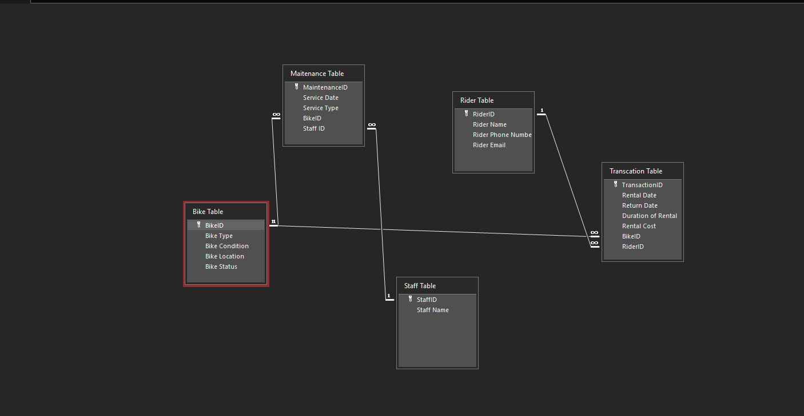

3NF Compliance
The database was normalized to Third Normal Form (3NF):
- 1NF: All tables have atomic values; no repeating groups.
- 2NF: No partial dependencies; all non-key attributes depend on the full primary key.
- 3NF: No transitive dependencies; maintenance and staff information were separated into their own table.
This structure reduces redundancy, simplifies updates, and ensures data integrity.

Validation Rules
I made some validation rules.
I made a validation rule for email, to ensure a “@” is detected. This ensures there is a valid email typed. I also did a length check on phone number, to ensure a valid phone number is typed.
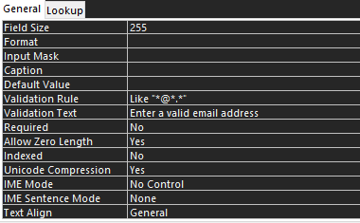

Queries and Testing
Three key queries were developed:
- Bikes Currently Out on Rental – Shows all bikes whose status is “Rented” or have not been returned.
- Bikes Due for Service – Identifies bikes not serviced in the last 30 days or never serviced.
- Rentals by a Particular Rider – Retrieves all rental transactions for a selected rider, allowing management to monitor activity.
Testing involved:
- Data entry validation – Added sample riders, bikes, staff, rentals, and maintenance records.
- Referential integrity checks – Attempted invalid entries (e.g., rental for a non-existent bike) to confirm enforcement.
- Query testing – Verified that queries returned accurate results.
Outcomes: All functional requirements were met, queries returned correct data, and constraints prevented invalid operations.

Design Decisions, Summary and Reflections

An important consideration in designing the EcoRide database was minimizing human error. Manual record keeping with spreadsheets and paper forms is prone to mistakes such as duplicate entries, missing data, or incorrect formatting. Studies in information systems emphasize that human error is a leading cause of operational inefficiency, data inconsistencies, and poor decision making in organizations. (1) By using a structured relational database, EcoRide can enforce rules, constraints, and validation checks that automatically prevent invalid data from being stored. For example, implementing a validation rule for email ensures that each rider’s contact information follows a standard format, which reduces the risk of sending notifications to incorrect addresses.
The usability of the database was also a key consideration. Lookup Wizards and dropdown menus improve data entry accuracy and efficiency. According to research on human computer interaction, interfaces that guide users and reduce cognitive load significantly decrease input errors.(2) In the context of EcoRide, ensuring staff can quickly and accurately select bike types, statuses, and maintenance activities makes daily operations smoother and reduces training requirements.
Testing and validation were crucial in confirming that the system meets operational needs. By simulating real-world scenarios such as attempting to rent a bike that is already checked out or logging maintenance for a bike not in inventory the database’s safeguards were verified. This iterative testing process highlights the importance of careful database design in creating reliable systems that support decision making, reduce operational risk, and enhance overall efficiency.
In addition to data integrity and usability, the ability to generate queries and reports is a critical feature of databases. Well designed queries allow staff and management to quickly track certain things within a database. For example, a query showing bikes due for service ensures that maintenance is scheduled proactively, reducing the likelihood of breakdowns and improving service reliability. Reporting functions support operational decisions by summarizing usage patterns, highlighting popular routes or frequently used bikes, and providing insights into staff performance. Research in information systems emphasizes that timely and accurate reporting is essential for decision making, as it allows managers to respond quickly to operational issues and optimize resources effectively.
One of the first decisions was to create five primary tables: Rider, Bike, Transaction, Staff, and Maintenance. This design separates key entities logically, allowing each table to represent a real-world concept clearly.
- Rider Table: Stores personal and contact details for each rider. Each rider is uniquely identified by RiderID. This ensures that multiple rentals for the same person are linked correctly, and allows management to generate reports about rider activity.
- Bike Table: Tracks the inventory of bikes, including type, condition, location, and operational status. Separating this table ensures that changes to a bike (e.g., status or location updates) do not interfere with other parts of the system.
- Transaction Table: Records each rental, linking riders and bikes. By centralizing rental data in a separate table, it is easy to produce operational queries, such as identifying which bikes are currently rented or calculating usage statistics.
- Staff Table: Maintains information about employees responsible for maintenance, allowing accountability and reporting on staff activity.
- Maintenance Table: Logs all service tasks, linking bikes to staff members. By creating a separate table, multiple maintenance records can exist for a single bike without duplicating staff or bike data, keeping the system normalized.
Primary keys were AutoNumber fields in all tables to guarantee uniqueness and simplify data entry. For instance, RiderID, BikeID, and RentalID automatically generate unique identifiers for each record, avoiding manual errors.
Foreign keys were established to link the tables.These links enforce referential integrity, preventing orphaned records.
To make the database easier to use, Lookup Wizards were applied to certain fields, such as BikeType, Status, and Bike Condition. This provides dropdown menus for data entry, ensuring consistent and accurate inputs. For example, bike status can only be "Available," "Rented," or "Maintenance," reducing the risk of typos or invalid data.
Lookup Wizards also make querying and reporting easier, because all entries use consistent values. For example, filtering all bikes with status “Rented” is reliable because users cannot accidentally type “rentd” or “in use.”
I used validation rules within this database because it prevents human error. You do want invalid data being put into a database, as this would cause struggles. Like if a user inputted an email that is not formatted correctly, this may make the user uncontactable.
Normalization was a key design decision to reduce redundancy and maintain data integrity. The database was structured to Third Normal Form. This normalization ensures that updates, deletions, and inserts are consistent, reducing the risk of anomalies.
I had some errors occur when developing my database.
When creating relationships, errors occurred because AutoNumber fields in primary tables were sometimes being joined to Number fields in child tables. Resolving this required aligning data types and ensuring each foreign key matched the type of the corresponding primary key.
Designing queries that filtered correctly on bikes “currently rented” or “due for service” required attention to data types, lookup values, and handling null
Designing the EcoRide database reinforced the importance of data integrity, normalization, and usability. Key lessons include:
- Proper table structure matters: Separating Maintenance from Bikes prevents redundant data and simplifies updates.
- Referential integrity is essential: It prevents orphaned records and ensures relationships reflect real-world constraints.
- Validation rules improve reliability: Simple rules like phone number format or bike status prevent operational errors.
- Testing is crucial: Running edge-case scenarios and queries ensures the system works as intended.
The system demonstrates how a well-designed relational database can streamline operations, reduce human error, and provide actionable insights for management.

Conclusion
This EcoRide database demonstrates how a well-designed relational database can streamline operations, reduce human error, and provide actionable insights for management. Through careful table design, normalization, validation, and testing, the system provides accurate tracking of bike rentals, maintenance records, and rider activity. Although challenges arose during development, the solutions implemented ensure the database is robust, reliable, and scalable, ready to support a growing bike rental service.

References

- G. Pitagorsky, “How Does Your Organization Handle Human Error? - Project Management Articles, Webinars, Templates and Jobs,” Project Management Articles, Webinars, Templates and Jobs, May 15, 2025. https://www.projecttimes.com/articles/how-does-your-organization-handle-human-error/ (accessed Jan. 19, 2026).

- B. Bassett, “Cognitive Load: Streamlining Product Interfaces for Decision Making,” Nudge Notes, Sep. 28, 2023. https://medium.com/nudge-notes/cognitive-load-streamlining-product-interfaces-for-decision-making-201626503865
‌

