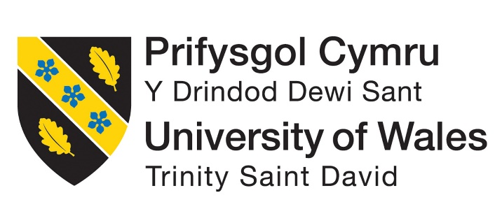

BA International Hotel Management
BMIH5004 Management & Organisational Behaviour

Student Name: Mashuda Begum
Student ID:2119256 Lecturer name-Ernest Wavei

Executive Summary
This paper offers a profile of Hilton Hotel Group by covering aspects such as the organization structure, organizational culture, recent change activities, strategic planning, and organizational performance. Applying Schein's model of levels of culture and Porter's Five Forces models, we analyze Hilton's position in the aggressive global hospitality market. Despite the competitive threats from rivals and new technologies, Hilton focuses on continuous innovation, a customer-driven philosophy, and environmental responsibility to be a world-class hospitality company. Hilton has a diversified product portfolio with 22 brands and hotels in more than 7500 locations and thus is ready to face the changes and capture more opportunities.

Table of Contents
Executive Summary 1
Introduction 3
Main Body 3
Organisation Structure, Culture and Goals 3
Recent Change Initiatives, their Impact and how well they managed 6
Strategic Direction and Current Performance Evaluation 8
Conclusion 13
Reference List 14

Introduction
The hospitality industry is a very competitive industry that requires regular updating and adaptation to happen in order to suit the customers' needs. This paper aims to establish Hilton's organisational structure, culture, recent change initiatives, strategy, and performance. The Five Forces and the Three Levels of Culture theories are then applied in analyzing Hilton's operations and identifying its SWOT. Having 22 different brands of hotels in the worldwide chain and operating over 7,500 hotels, Hilton has many opportunities and threats in keeping up as the worldwide leader of the premium segment. Hilton has been under intense pressure to revamp its current strategies and performance and develop new directions for the future.

Main Body

Organisation Structure, Culture and Goals
Organisation Structure
At the corporate level of business, Hilton Hotel Group has one of the most utilized structures known as divisional structure, which comes as various divisions or units that address unique geographical locations or markets. This enables Hilton to efficiently administer its complicated chain of operations with different types of properties ranging from luxury resorts to full-service hotels right to budget hotels (Hilton, 2023). Each division is somewhat self-contained, but all have their own management teams that report directly on operations, marketing initiatives, and financial performance. This structure allows Hilton to make adjustments based on different markets and also adapt to the changing needs of the customer (Huczynski and Buchanan, 2013).
Concerning the organizational structure on an individual level, Hilton has a hierarchical structure common to large multinational companies. They include operation, marketing, finance and human resource departments each of which is led by managers who are at the higher executive level and who report directly to the CEO of the organization (Mullins and Dosser, 2013). This structure provides a distinct organizational structure of reporting and decision-making, allowing for corporate strategies to be implemented properly through the various levels of the organization.
Culture
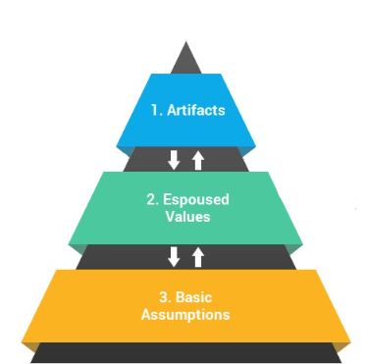
Schein's Levels of Culture provide a framework for understanding the deeper layers of organizational culture:

Figure 1: Schein's Levels of Culture (Schein, 2019)
- Artefacts: These are the features of culture that have been commented on most, namely objects, gestures, and the surrounding context. For the Hilton Hotel Group, such artefacts include its service delivery standards, extra services, and architectural aesthetics for its properties because of its purpose to provide luxurious services (Schein, 2019).
- Espoused Values: These are the actual and official views, principles, and values held within an organisation. Hilton's official values are integrity, teamwork, and innovation which shape the actions and choices of employees to provide them with an organisational identity (Mullins and Dosser, 2013).
- Underlying Assumptions: These are the assumptions that are usually hidden and are considered to be the truth about reality and human conduct within the organization (Schein, 2019). Some organizational assumptions about Hilton may include the perceptions of the organization that it should foster long-term relationships with the guests, the pursuit of excellence, and that the tourism business should gain value in continuous improvement as a culture of the organization.
The culture at Hilton is also supported by the company’s training processes for employees and its recognition efforts, which focus on creating memorable guest experiences and promoting employee satisfaction in the workplace (Mullins, 2020). This culture of hospitality defines Hilton’s operations to the extent that it shapes how it relates to the customers as well as how the rooms are built and other facilities offered.
Goals
The key objective of Hilton Hotel Group is to sustain its market dominance as a hospitality chain, and profitability and sustainable growth at the same time. To this end, Hilton has provided the following strategic goals, namely, market penetration in major markets, customer retention programs, and the efficiency drive through technological enablement.
Moreover, Hilton worried about environmental issues and corporate social responsibility providing specific goals on decreasing the impact on the environment and developing communities. In this case, by aligning the various objectives with societal goals and consumer preferences, Hilton is seeking to maximize shareholders' value and the company's sustainability and environmentalism.

Recent Change Initiatives, their Impact and how well they managed
Overview of Recent Change Initiatives at Hilton
The Hilton Hotel Group has implemented a number of changes over the past few years primarily in relation to operations, customers and market environment. These are measures such as the use of digital check-in and mobile technology keys, new sustainable development processes, and the incorporation of new privileges to its members’ point reward system (Hilton, 2023). Similarly, to increase organizational performance and guest satisfaction, Hilton has worked on its human capital and technology in its properties across the globe.
Impact Analysis
The organizational change that has recently taken place in Hilton through various change initiatives has impacted the employees, customers and stakeholders in a number of ways. Employees have also been given more training and technology, which has enhanced employee satisfaction and productivity (Mullins and Dosser, 2013). This leads to increased satisfaction and brand loyalty as guests prefer using their mobile devices to check in and use smartphone technology to unlock their rooms.
Other stakeholders that have been affected by Hilton's program include investors and local community members who have also benefitted from the positive effects. Policies in sustainability have reduced adverse impacts on the environment and also shaped Hilton's image as a responsible company. Additionally, the expansion of the loyalty program benefits would lead to new customer acquisition and incremental revenues for the firm (Mullins, 2016).
In the case of change management initiatives at the Hilton organization, the recent change initiatives demonstrated positive organizational outcomes in aspects such as enhanced employee satisfaction, better customer experience, and enhancing the overall stakeholder value of the organisation in the competitive context of the hospitality industry.
Drivers Behind Changes at Hilton
- Market Competition: High competition has been the norm in the hospitality industry and therefore it has to come up with new strategies on how to capture and sustain the market.
- Changing Consumer Preferences: Global consumer preferences such as contactless convenience and sustainability drive Hilton to rethink or create new services.
- Technological Advancements: Technological advancement is a threat to Hilton in the sense that advances can be used to provide customers satisfaction, efficiency, and income (Smith, 2022).
- Sustainability and Corporate Responsibility: Increasing environmental and social awareness creates pressure on Hilton to include eco-friendly measures and practices in its functioning.
- Strategic Growth Objectives: Those at Hilton sought to achieve specific objectives, including growth in market share and overall revenues.
Future Changes
Hilton Hotel Group is already considering further alterations for the improvement of the guest experience and the optimization of business processes. Future plans include the application of artificial intelligence and machine learning to enhance the guest experience and improve the revenue generation process (Rollinson et al., 2008). Furthermore, Hilton has the goal of growing its presence in the sustainable hotel market and integrating sustainable solutions into all its activities.
The reasons for these changes are the focus on innovations, customers, and sustainable development (Boddy, 2014). Hilton aims at keeping up with the modern trends in the rapidly growing hospitality industry and at the same time reducing the negative impact on the environment. Potential benefits include higher guest satisfaction, additional revenues, and an improved brand image as a sustainable hospitality company.

Strategic Direction and Current Performance Evaluation
SWOT Analysis
Strengths | Weaknesses
- Global Brand Recognition: Hilton is a reputable global chain with a reputation for providing quality service and a wide range of accommodation options.  - Customer Loyalty: Hilton's reward program, Hilton Honors, has membership millions across the globe, which helps in customer retention and increases the company's revenues (Lashley and Morrison, 2010).  - Innovation: Hilton as a company incorporates technology and innovation into guest services, for example, digital check-in and mobile key access (Kotler and Armstrong, 2018).  - Diverse Portfolio: Hilton has a diverse chain of products that it offers in the market and its ability to adapt to various market situations. | - Dependence on Franchise Model: Though the franchise model helps in expanding the business at a faster pace, it also restricts the direct control of the properties and the quality of services being offered (Boddy, 2014).  - Revenue Dependency on Business Travel: Hilton has a significant exposure to the business travel market, and as such, may be negatively impacted by economic cycles or geopolitical forces.
Opportunities | Threats
- Emerging Markets: Hilton can leverage the increasing market for hospitality services, especially in the Asia-Pacific and Africa regions (Kotler and Armstrong, 2018).  - Technology Integration: Continued advances in technology, including artificial intelligence and data analytics, provide the potential for enhancing guest engagement and streamlining operations( Baum, 2015). | - Competitive Landscape: Competitors from around the world, including global hotel chains, boutique hotels and other accommodation options threaten Hilton’s market share and pricing strategy.  - Economic Uncertainty: Economic fluctuations or crises, including the current pandemic, are some factors that may lead to a reduction in travel and hotel bookings (Kandampully, 2012).  - Regulatory Challenges: New policies and rules regarding employment, taxes, and environmental policies can pose threats to Hilton by raising operating costs and compliance challenges (Huczynski and Buchanan, 2013).

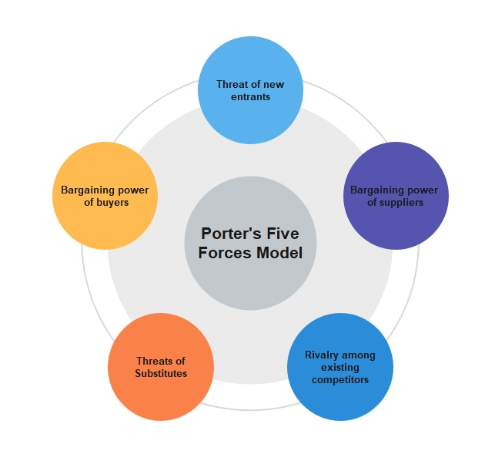
Porter's Five Forces Analysis for Hilton Hotel Group
Figure 2: Porter's Five Forces Analysis (Porter, 2018)

Threat of New Entrants: Moderate
Even though overall the hospitality industry has low entry barriers, the high-end segment in which Hilton operates is capital-intensive and brand-focused. The business already has competition from established players such as Hilton while other key competitors such as Marriott and Hyatt exist (Porter, 2018). Nonetheless, the threats in this case may be moderate, especially in certain segments of the market such as boutique hotels and other forms of accommodation.
Bargaining Power of Buyers: High
In the niche of premium hotels, it seems that the customers wield considerable bargaining power due to the availability of numerous choices and relevant information provided by online search services (Bloisi et al., 2007). This has a great implication since customers can easily compare the price and services offered between the different chains thus exerting pressure on Hilton to offer service competitively and at a cheaper price.
Bargaining Power of Suppliers: Low
Hilton works with over 4,000 suppliers around the globe, while most products and services are homogeneous; thus, Hilton has negotiating power. Hilton's order volume plays a significant role in the suppliers' business, and there are few barriers to switching between suppliers (Porter, 2018). Also, Hilton has a Supplier diversity program that helps socially diverse suppliers increasing the bargaining power of the company.
Threat of Substitute Products or Services: Moderate
Direct threats like accommodation with friends or apartment rentals are firmly in place, nevertheless, the comfort of using services like Hilton negates this somewhat. However, substitutes that are induced by technology like video conferencing are of moderate threat as they may reduce the need for business travel and hotel accommodations (Hilton, 2023).
Competitive Rivalry: High
The general environment of the hotel industry is quite competitive and Hilton operates in the high-end segment of the industry its key competitors include the likes of Marriott, Sheraton, and Hyatt. This competition is a result of factors such as brand image, service differentiation, and rewards programs (Armstrong, 2012). Nevertheless, Hilton has improved its income in recent years in comparison to competitors; nevertheless, continued differentiation and innovation remain important to sustain a proper market share in such environments.
Current Performance Evaluation
The Hilton Hotel Group remains a standout performer in the highly contested hospitality industry. Revenues and profitability metrics reveal the ability of the company to utilize geographic expansion and multiple brands (Wheelen, Hunger, Hoffman and Bamford, 2017). Also, the commitment of Hilton to its customers through programs like the Hilton Honors program has also ensured that it sustains loyal customers and generates more traffic for the company.
Economic threats like volatility and competitiveness also affect Hilton’s strategic management, which focuses on advancing innovation, markets, and operational strategies. These fundamental strategic directions, along with focusing on sustainability and nurturing its human capital, allow Hilton to thrive in the changing environment of the industry (Mullins, 2020). However, continuous tracking of market signals and immediate response to shifts in consumer behaviour patterns will be vital in maintaining competitive standing and pursuing future profitability.

Conclusion
In summary, Hilton Hotel Group's strategic plan repositioning strategy demonstrates the company's focus on innovation, customers, and corporate social responsibility. Although Hilton competes intensely in the high-end segment and is threatened by technology disruptions, the company has the strategic endurance to adapt to the market environment. Hilton's experience in using brand image, customer base, and international presence makes the company competitive in capturing new niches in the hospitality sector. In future steps, the focus should be made on innovations, human resources, and environmental management as the key factors for sustaining Hilton's competitive advantage and boosting its future evolution. Hilton's passion for delivering memorable guest experiences across its multiple brands ensures that the company is well-positioned to define trends for the hospitality industry of the future and generate value for customers, employees, and shareholders alike.

Reference List
Arnold, J. (2005). Work Psychology (4th edition) Harlow: Prentice Hall.
Armstrong, M. (2012). Armstrong’s Handbook of Management and Leadership (3rd Ed), London: Kogan Page.
Baum, T. (2015). Hospitality management and organizational behavior (4th ed.). Prentice Hall.
Bloisi, W. et al (2007). Management and Organisational Behaviour, (2nd edition) Maidenhead: McGraw-Hill.
Boddy, D. (2014). Management: An Introduction (6th Ed), Harlow, Pearson.
Buchanan, D. And Huczynski, A. (2007) Organisational Behaviour: An Introductory Text (6th edition), Harlow: Prentice Hall.
Hilton. (2023). Hilton Annual Report 2023. Retrieved from https://investor.hilton.com/financial-information/annual-reports.
Huczynski, A. and Buchanan, D. (2013). Organisational Behaviour (8th Ed), Harlow:Pearson
Kandampully, J. (2012). Service management in hospitality and tourism. Kendall Hunt.
Kotler, P., and Armstrong, G. (2018). Principles of marketing. Pearson Education Limited.
Lashley, C., and Morrison, A. (2010). In search of hospitality: Theoretical perspectives and debates. Routledge.
Mullins, L. and Dosser, P. (2013). Hospitality Management and Organisational Behaviour (5th Ed) Harlow, Pearson.
Mullins, L (2020). Organisational Behaviour in the Workplace (12th edition) Harlow: Pearson
Mullins, L. (2016). Management and Organisational Behaviour (11th edition) Harlow: Pearson
Porter, M. E. (2018). The five competitive forces that shape strategy. Harvard Business Review, 86(1), 25-40.
Robbins, S. Et al (2008). Organizational Behaviour (5th edition) Harlow: Pearson Education Limited.
Rollinson, D. et al (2008). Organisational Behaviour and Analysis (4th edition) Harlow: Addison-Wesley Longman.
Schein, E. H. (2010). Organizational culture and leadership. John Wiley & Sons.
Smith, A. (2022). The impact of technology on the hospitality industry: Opportunities and challenges. Journal of Hospitality and Tourism Technology, 13(2), 178-192.
Wheelen, T. L., Hunger, J. D., Hoffman, A. N., and Bamford, C. E. (2017). Strategic management and business policy: Globalization, innovation, and sustainability. Pearson.

