BMSW5103
Understanding and Engaging in the Customer Experience
Student name: Luncasu Daniela Elena
Student ID: 2119889

Executive Summary
The following context has focused on the significance of the customer relationship management service of the chosen airline organisation named Ryanair. The key marketing theories such as marketing mix and Ansoff matrix have been used here to understand the quality system of the organisation as well as the customer service. Furthermore, porters five forces have been used to understand the influence of marketing on customer relationship management. The internal and external factors that impact the quality system have also been stated here by using SWOT and PESTLE analysis. The system that supports the quality processes of the organisation has been discussed in the following context.

Table of Contents
Introduction 4
Background of the chosen organisation 5
Introducing some marketing theories with respect to Ryanair 6
7 Ps of the marketing mix 6
Ansoff Matrix of Ryanair 10
Marketing theories 12
Porter’s 5 Forces 12
Customer relationship management theory 13
Internal and External factors of Ryanair that impact the quality system and customer control of the organisation 17
SWOT Analysis 17
PESTLE Analysis 18
Identifying the systems of the quality process of the respective airline Ryanair for maintaining effective relationships with the customers 21
Conclusion 23
References 24

Introduction
Customer relationship service is essential for businesses to attain success and growth in the market. The quality of the system of the organisation requires to be maintained to improve the services of the business. Delivering improved services to customers is essential in terms of attaining growth and success. There are various internal and external factors as well as marketing theories that affect and control customer services. Customer relations involve both the proactive and reactive functions which are performed by the teams of customer services. The following context will provide a background of the chosen airline company named Ryanair. Different marketing theories such as marketing mix, and Ansoff matrix will also be focused on in the following report. Furthermore, a customer relationship management theory will also be discussed in this specific context. The effect of marketing theory such as Porter’s five forces on the quality system as well as on customer service of the aforesaid organisation will be mentioned in the following discussion. The way the above-mentioned organisation handles new customer demand to achieve the objectives of the business by maintaining a good relationship with the customer will be stated here. The benefit of AI in managing the quality of the organisation will be mentioned in the respective report.

Background of the chosen organisation
The ultra-low-cost Irish carrier Ryanair was founded in 1984 by Tom Ryan, Christopher Ryan and Liam Lonergan. The company has its headquarters in Swords, Ireland, and Dublin. It is the biggest airline in Ireland, which became the world’s largest airline in 2016. The fleet size of the company is 562 and it includes 222 destinations. The chairman of the aforesaid company is David Bonderman. The overall employee number of the airline company is 19,000. The net income of the company is −€1.145 billion in 2021, which has been reduced from the previous years (Ryanair, 2023).

Introducing some marketing theories with respect to Ryanair
Marketing theories are mainly used by different companies to analyse their marketing aspects and improve their business and also financial performance. It focuses on some objectives to reach the final customers in a better way. This on the other hand, also helps customers to get engaged with the businesses. There are various specific theories which will be discussed in the below section in detail.

7 Ps of the marketing mix
The marketing mix is a specific framework which is used to analyse the different requirements of the customers and includes various aspects such as product, price and some other components which complete the 7 Ps of the marketing mix. In the below sections, the marketing mix will be highlighted with respect to a specific business entity which as Ryanair.
Services
Ryanair usually offers different types of products and services to the customers and people of the United Kingdom and also other countries where they operate. Among those services, some of them are accommodation services and car rentals. People from other places within the UK or outside UK can purchase accommodation services from the company website and applications as well. This allows the customers to grab different services from the company in a single place. Other than the above-mentioned services of the respective company, there are various other services as well which they offer to the customers such as holiday packages and also travel insurance services to the people travelling with them and others (Harvey and Turnbull, 2020). Along with that, Ryanair can also include some other services as well such as customised services for customers such as travel flight booking along with car rentals and accommodations. In addition to this, the respective business entity can also include some kind of drinks which they can provide to the people on a long-distance flight as a complementary drink item.
Price
The pricing strategy that the respective company follows is the dynamic pricing strategy for the customers and people of the country. Moreover, the strategic pricing of the respective business entity they follow is low fares and low-cost policy. This also attracts more customers towards their services to a great extent. In addition to this, the specific company states that there is a division for their pricing for the company. It includes 70% of the seats which are offered at two different lowest fares and along with that 30% of the seats are charged at a bit higher rate than normal (Bezruchonak and de Almeida, 2023). Moreover, the final 6% of the seats are offered at the expensive sides. This allows all kinds of customers to grab the services from the particular company.
Place
According to the component of place in the marketing mix, the respective company deliver their services to various states and different countries. According to the marketing strategy in terms of places, it can be said that the respective company uses a secondary airport which is at Stanstead in Essex. This is because that particular airport is not as busy as some other main airports such as Heathrow and Gatwick (Rodríguez-García et al., 2020). This allows them to travel and make return trips more than usual. In other words, the respective airline business can make more round trips as compared to the other airports where there is more number of flights that operates.
Promotion
Apart from other aspects of the specific company, Ryanair can not be seen using different kinds of promotional strategies for their marketing of the business services. Moreover, they also state that they use simple advertisements regarding their low fares to let customers and people from different parts of the world know about the same. They also ran into some issues and controversy in the year 2009 where they use to charge £1 for every time the passengers uses the toilet while on the flight (Kelemen et al., 2019). Therefore, it can also be suggested to the respective company introduce some effective marketing strategies or the promotion of their respective services in different parts of the world.
People
People include various individuals such as employees of the respective company and also the number of loyal customers of Ryanair. In terms of customers, there is a huge number of customers in the respective company especially in the European countries. The year 2019 has seen about 148.6 million customers travelling and taking services from Ryanair which reduced to a great extent and reached about 27.5 million customers during the pandemic situation. Moreover, it can also be seen that the respective company has again gained a number of customers in the latter year and reached about 97 million in 2022.
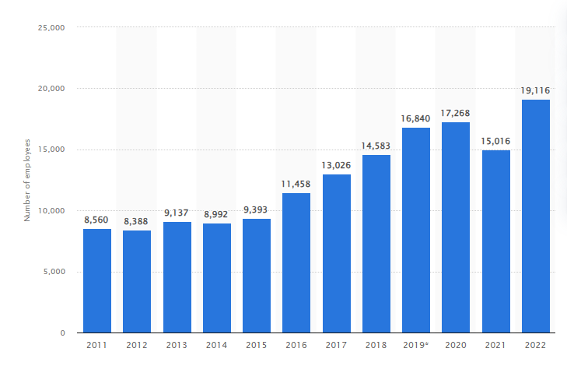
Figure: Number of employees of Ryanair
Source: (Statista, 2023)
Along with the count of customers, the number of employees of the respective business is about 19,116 until the year 2022. According to the number of employees, it can be seen that the number of employees of the respective company has gradually increased over the years until 17,268 employees in the year 2020. Later in the year 2021, the number of employees since Raynair had to terminate multiple employees to sustain their business during the pandemic. Apart from the reduced number of employees in 2021, the count again increased to 19,116 in the year 2022 (Statista, 2023).
Process
According to the processes of the respective business entity, it can be seen that the customers of Ryanair are not allowed to book and select their own seats. In contrast to that, the seats are allotted on a first come first serve basis. Along with that, the specific flights of the respective business organisation do not have any air bridge or anything. Rather, the customers of the specific company need to walk or take buses from the airport to the place where the flights are waiting (Hoffmann, 2022). Along with that, the baggage of the customers or the passengers is transported directly to the aircraft from the terminals. However, according to the reviews of the passengers, the customer services are not that good.
Physical Evidence
According to the physical evidence, the respective business approaches their customers in various ways. The particular company has their own websites from where they can book their flights and other services for vacation and other travel purposes. Along with that, the specific company also has a mobile application which people in the UK can find and access from anywhere anytime and book their services (Numanoğlu, 2020).

Ansoff Matrix of Ryanair
Ansoff matrix includes four different components such as market penetration, market development, product development and diversification. These four different elements of the Ansoff matrix are used to determine the market conditions of the respective industry and determine strategies to expand their business into other markets. Four different elements of the Ansoff matrix will be discussed in the below sections.
Market penetration
In terms of market penetration, the respective company can develop their existing services in the airline and service industry only. It can usually be done based on better marketing strategies, reducing prices and some other ways to involve in the existing market (Páscoa, 2022).
Market development
In case of market development, the respective business entity can explore the other markets in the country and also other countries with their same and existing products. This can include taking their services to another part of the country or expanding their business internationally (Kreutzer and Kreutzer, 2019).
Product development
This aspect of the particular model refers to developing different kinds of services and promoting them on other markets other than the existing ones. Moreover, the specific business also needs to invest some of its money in research and development to determine the right market for selling its services to customers (Kreutzer and Kreutzer, 2019).
Diversification
The component of diversification includes both the development of the products as well as the market and due to this reason, the specific element is also known as the most risky factor among others. In this case, the specific business needs to develop new services and also promote those services to a totally new market. This particular aspect or the approach can be most successful or it can decline the business conditions (Olaru, 2019).

Marketing theories

Porter’s 5 Forces
Competitive rivalry- The competition among established competitors is relatively intense as the companies are aiming at providing services at low cost. Therefore, the rivalry threat is quite high in the fiercely competitive airline industry. There are several strong companies such as EasyJet, Wizz Air, and others operating similar routes to Ryanair. Every player in the airline sector is determined to low their costs by minimising airport costs and onboarding facilities (Adelakun 2020). The airline industry has converted the entry of new airlines easier throughout the European Region surging competition for the existing operators like Ryanair.
Powers of suppliers- There are two major manufacturers of aircraft such as Airbus and Boeing. Hence, the aircraft manufacturers charge high prices for the aeroplane due to the duopoly market. However, the purchasing ability of Ryanair for Boeing is comparatively high in the Europe region. Bargaining ability is comparatively high for the fuel suppliers of the aviation company due to the existence of few suppliers, which is a high threat. Due to this, the mentioned company could not attempt to the make bargaining the costs of the jet fuel from various suppliers of the market.
Powers of buyers- The customers in the airline market are negotiable because of the low fares of the airline companies. Most of the players serve a reasonable price rate for attracting huge numbers of customers or passengers. Hence, the switching strength of the purchasers is quite less. If any company intends to enhance fares, the buyers will change their preferences. All aviation players are aiming at lowering their operational costs or expenses and delivering passengers with standard facilities (Efthymiou et al., 2021). It facilitates the customers to purchase airline services in an organised manner. Therefore, the threats to customers’ bargaining power are relatively higher for the mentioned British airline Ryanair.
Threats for substitute- This type of threat can be high if the company offers a unique or differentiated value proposition. Within the European region, there are more means of transport systems such as buses, cars, and trains over the routes of short-haul. The train fares are relatively high and it takes a longer time. It reflects a low threat of alternative for Ryanair. The respective company needs to focus on delivering service-oriented facilities rather than product oriented. The company must focus on understanding the core demands of the passengers (Adelakun 2020).
Threats for the new entrants- The entry barriers in the respective industry are comparatively high. Hence, the new airlines can face several issues like purchasing jets, getting slots at the preferable airports, leasing jets, massive marketing costs, finding efficient staff, and others. Hence, the chosen airline company has low costs of operations and it has developed economies of scale. The low fare for flights can make the respective business more profitable. Thus, this type of threat is not more for Ryanair.

Customer relationship management theory
The CRM approach concerns the connection between the business entity and its customers. The chosen airline and budget-friendly carrier Ryanair is a customer-oriented business and it focuses on establishing and maintaining customer support and determining to satisfy the goals and targets of both the company and its customers as well. The approaches of CRM of several organisations streamline their offerings according to customer requirements (Anastasiu et al., 2020). The respective company must retain the customers rather than attract new customers because retaining customers by 5% can help the business to gain more income in the future. The particular business can gain more customers by applying the framework of the Kano model. As the company is facing massive problems while providing customer service throughout the world. The particular model is discussed in the following section.;
The application of the Kano Model - The respective framework was postulated by Noriaki Kano in 1984. The model explains three particular attributes of services and products such as the threshold, performance, and excitement attributes.
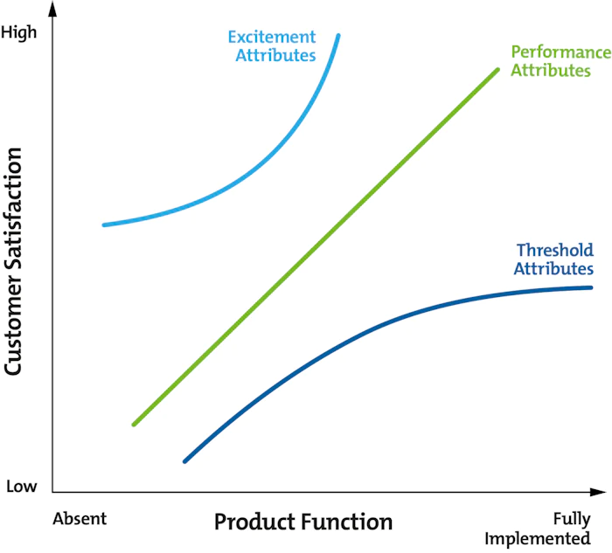
Figure- Kano Model
Source: (Dace et al., 2020)
1. The basic feature of the threshold is customers can expect a particular type of service or product. Ryanair must focus on the threshold services to meet the expectations of the passengers.
2. The next attributes or satisfiers are known as performance elements. It is required to enhance the enjoyment of the customers by getting services. The aforementioned airline business requires to provide high-quality and luxurious services to passengers at a low budget.
3. The third element is the excitement attribute that is used to increase the competitive edge of the services. The budget-friendly complementary services in the flight and easy onboarding facilities in the airport ground are necessary to satisfy the customers.
The chosen business named Ryanair is facing major issues like retention of old customers in the highly competitive environment. By employing this specific model, the business can understand the requirements of the consumers as well as the current market trends and interpret those customers’ needs. It is significant for the company to gain more revenue and earnings by satisfying passengers and maintaining good relationships with them. The business needs to implement the upgraded technique in the workplace environment to provide improved customer services in the era of digitalisation (Dace et al., 2020). Several modifications in the marketing and service design with innovation can help the business to gain a competitive advantage in the marketplace. Customer loyalty relies on the good quality of the services of the respective airline business.
Numbers of passengers carried by Ryanair
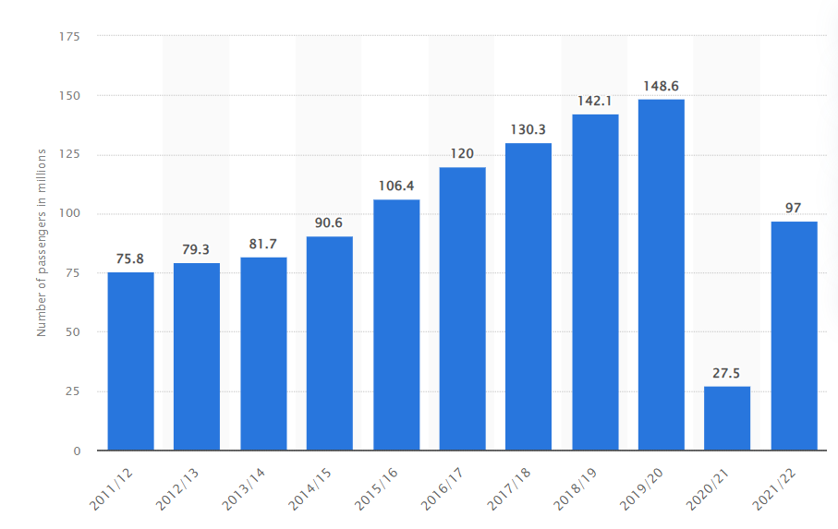
Figure: Numbers of customers in the context of Ryanair
Source: (Statista, 2022)
The sudden outbreak of COVID-19 hit the airline industry of the UK badly and due to this, the passenger traffic of Ryanair dropped to 27.5 million consumers. The mentioned carrier business was able to rise the passengers' numbers sharply and it was recorded as 14.9 million visitors in 2019. After the pandemic, the numbers were witnessed as 97 million because of their better-quality services.

Internal and External factors of Ryanair that impact the quality system and customer control of the organisation

SWOT Analysis
Strengths | Weaknesses
Low-cost airline: The fleet of more than 450 aircraft is run by the respective company. It enables the company to become the largest low-cost organisation. The passenger network of the company is getting expanded to 225 million by the year 2026. It helps the organisation to control the quality of the process and provide a rate of satisfaction to the customers (Tassinari et al., 2020).  Better routes and low-airport prices: The different routes that are covered by Ryanair provide the company with a competitive advantage. The low prices of the airport lead the customers to choose this specific airline company. Therefore, better customer relationship is built by the airline company (Gil-Gomez et al., 2020). | Bad reputation: A survey states that Ryanair was ranked poorly in the context of customer satisfaction. Uncomfortable seats, additional surcharges, bad customer service and so on are some of the concerns which were raised in the survey. The hidden expenditures are one of the main aspects that lead to disrupting the customer relationship of the organisation. The refund policy of the respective company is also very complex which increases the level of dissatisfaction in people (Bugajski, 2020).  Short-staffed: The company has laid off 3000 employees, which affects the overall performance of the business. Due to the shortage of staff, the airline is unable to provide the required services to the customers as per their preferences. Hence, the customer relationship also gets affected.
Opportunities | Threats
Government assistance: The outbreak of covid has affected the operations of the airline businesses. Therefore, the financial facility provided by the Bank of England will provide the respective company with beneficial aspects to function properly. 800 million is borrowed by Ryanair to operate properly in the market by hiring skilled employees. It will help the company to improve its services and customer relationship.  Shares market: The surge in Southwest Airlines Stock is advantageous for the aforesaid company due to the increased number of travellers. It will allow the business to develop its services as well (Budd et al., 2020). | Competitors: There are several airline companies that provide similar and better services to customers at a budget price. It can be a threat to Ryanair as people will prefer o choose airline companies with no hidden charges and better customer care services.  The trust of the customer: The lack of a proper recovery strategy disrupts the trust of the customer in the respective organisation. Along with that, poor customer service is another reason which can lead the company to lose customers (Setiawati et al., 2019).

PESTLE Analysis
Political factor: The unstable condition of politics affects the functions of the airline industry. A sharp decline can be seen in the airline companies that work in political turmoil. People choose to avoid countries that are under political threats. It leads the airline industry to lose customers, which affects the overall profit of the business. The companies of the airline industry are required to follow the rules and regulations implemented by the government. However, the airline industry can also gain profit from the investment of the government as it is profitable in the long run. Along with that, the airline industry is also required to follow the aviation, custom, and travel rules of every destination to avoid any kind of political consequences. It will also allow the airline businesses to check on its quality processes and customer management.
Economic factor: The economic condition of a country is associated with the operating businesses in the respective country. Instability in the economic condition and recession affect the industry of airline. The increased price of raw materials may lead to a decrease in the number of passengers of the businesses of the airline industry. It makes the companies lower the overall prices as well as lay off employees. The suspended flights during the pandemic or any other reason negatively impact the revenue and profit of the business. The respective industry can also get affected due to the increased cost of machinery and oil. It can affect the industry negatively in the long run (Amankwah-Amoah, 2020).
Social factor: The sociological condition of different destinations influences the airline industry. Companies that function internationally have a severe impact on social factors. It is important for the businesses of the airline industry to maintain a proper brand image to retain its customers. Maintaining a good reputation and providing better hospitality services is essential for the businesses of the respective industry. The aviation industry also requires to ensure the comfort of the passengers. Good customer service is beneficial in terms of attracting customers to the respective business.
Technological factors: Technology is important for the growth of the airline industry. The implementation of advanced technologies is able to improve the operations of the airline industry. The airline industry is required to invest in advanced technologies to ensure the safety of the customers during the flight. The business of the respective industry requires to incorporate constant technological changes in order to improve the provided services. Regular technical upgradation in the airline industry allows the company to avoid technical faults and rashes. For instance, the use of Boeing 737 Max Jets in Ryanair will allow the company to stay ahead of its competition (Belhadi et al., 2021).
Legal factor: Different countries have different legal regulations which the businesses of the airline industry require to follow. There are several laws regarding the protection of passengers as well as employees. Therefore, airline companies require to abide by the rules to stay away from legal proceedings. The condition of the employees and flight time are essential aspects the airline companies need to put focus on. The labour law needs to be adhered to by the respective industry. For instance, Ryanair experienced legal actions as a result of labour complaints in 2018.
Environmental factor: The CFC emission of the airline industry is one of the significant concerns of environmental factor. Companies in the airline industry require to reduce their carbon footprints in order to become responsible for the environment. Research regarding environment-friendly aircraft needed to be done to improve the impression and service. The corporate responsibility of the airline industry is able to maintain the reputation of the brand and protect the environment (Bendak et al., 2020).

Identifying the systems of the quality process of the respective airline Ryanair for maintaining effective relationships with the customers
There are multiple types of external as well as internal elements that can assist the company to meet the requirements and preferences of the customers to some extent. It is essential to develop an immense understanding of these factors that support the business to integrate CRM and rearrange the ongoing workflow successfully. 24/7 customer service in an efficient manner can drive the business to generate more revenues and remain competitive in the UK market (Tien et al., 2021). There are great connections between maintenance of the customer relationships and the quality assurance of the company that helps to build core competencies within the market. Some internal factors are stated as follows;
Management commitment- The top authority board or management team of the selected company require to communicate with each and every employee to streamline their work procedures. The upgraded business model with the assistance of managers can enable the company to offer innovative and constructive services to the customers.
Organisational culture- The employees of Ryanair are needed to be familiar with the organisational strategies and CRM. The cooperative types of work culture can enhance the participation of all personnel. It leads to a surge in the productivity of the company (Cruz-Jesus et al., 2019).
There are different external factors some of which are mentioned as follows;
Regulation of data privacy- The respective business requires to protect the individual information and data of the passengers. The use of personal data of the public without consent is related to GDPR can restrict the company Ryanair to gain profits. It leads to creating a bad brand image in the market.
Technological changes- The implementation of upgraded CRM software and emerging technology such as AI or Artificial Intelligence can grasp the attention of the passengers. The use of this technology can allow the business to advance flight operations by mitigating several obstacles of the aviation business named Ryanair.

Conclusion
The above report has been prepared on focusing on different discussions about the management and leadership skills of a particular organisation. Ryanair is a popular airline company in the UK that has been running its business since 1985. A brief section has been added in the above section that has showcased details about the respective company. Some of the marketing theories marketing mix, Ansoff matrix, Porter 5 forces and Kano model have been described in detail. The report has further described some external and internal environments of the business. SWOT and PESTLE analyses have been done for Ryanair in there. Some systems that have been reflected in the quality process for maintaining customer relationships have been mentioned. Some internal quality processes that are management commitment and organisational culture have been described. Other than that. Some external processes that are data privacy regulations and technological changes have been highlighted there.

References
Setiawati, A.P., Susetyorini Susetyorini, U.E., Rusdiyanto, R., Astanto, D., Ulum, B., Khadijah, S.N., Trimarjono, A., Syafii, M., Mubarroq, A., Kristiningsih, K. and Pratiwi, R.D., (2019). The Role Of Customer Service Through Customer Relationship Management (CRM) To Increase Customer Loyalty And Good lmage. International Journal of Scientific and Technology Research, 8(10).
Gil-Gomez, H., Guerola-Navarro, V., Oltra-Badenes, R. and Lozano-Quilis, J.A., (2020). Customer relationship management: digital transformation and sustainable business model innovation. Economic research-Ekonomska istraživanja, 33(1).
Bugajski, J., (2020). Political Parties of Eastern Europe: A Guide to Politics in the Post-communist Era: A Guide to Politics in the Post-communist Era. Routledge.
Tassinari, A. and Maccarrone, V., (2020). Riders on the storm: Workplace solidarity among gig economy couriers in Italy and the UK. Work, employment and society, 34(1).
Budd, L., Ison, S. and Adrienne, N., (2020). European airline response to the COVID-19 pandemic–Contraction, consolidation and future considerations for airline business and management. Research in Transportation Business & Management, 37.
Amankwah-Amoah, J., (2020). Stepping up and stepping out of COVID-19: New challenges for environmental sustainability policies in the global airline industry. Journal of Cleaner Production, 271.
Belhadi, A., Kamble, S., Jabbour, C.J.C., Gunasekaran, A., Ndubisi, N.O. and Venkatesh, M., (2021). Manufacturing and service supply chain resilience to the COVID-19 outbreak: Lessons learned from the automobile and airline industries. Technological forecasting and social change, 163.
Bendak, S. and Rashid, H.S., (2020). Fatigue in aviation: A systematic review of the literature. International Journal of Industrial Ergonomics, 76.
Ryanair, (2023). Flights. [Online] Available at: https://www.ryanair.com/ie/en [Accessed 11 August 2023].
Tien, N.H., Diem, P.T., Van On, P., Anh, V.T., Van Dat, N., Hung, N.T. and Tam, B.Q., (2021). The formation and development of CRM system at Thien Hoa electronics supermarket in Vietnam. International Journal of Research and Growth Evaluation, 2(4).
Cruz-Jesus, F., Pinheiro, A. and Oliveira, T., (2019). Understanding CRM adoption stages: empirical analysis building on the TOE framework. Computers in Industry, 109.
Adelakun, A., (2020). Should Porters Five Forces have Value in Businesses Today. Computing for Business (BSC).
Efthymiou, M., Usher, D., O'Connell, J.F., Warnock-Smith, D. and Conyngham, G., (2021). The factors influencing entry level airline pilot retention: An empirical study of Ryanair. Journal of Air Transport Management, 91.
Anastasiu, L., Gavriş, O. and Maier, D., (2020). Is human capital ready for change? A strategic approach adapting Porter’s five forces to human resources. Sustainability, 12(6).
statista, (2022). Number of passengers traveling with Ryanair from 2011 to 2022(in millions). [Online] Available at: https://www.statista.com/statistics/864922/ryanair-annual-passenger-figures/ [Accessed 5 August 2023].
Dace, E., Stibe, A. and Timma, L., (2020). A holistic approach to manage environmental quality by using the Kano model and social cognitive theory. Corporate Social Responsibility and Environmental Management, 27(2).

