  Component One:  What are the key skills required when working in the housekeeping team? 750 words (+/- 10%)  Contribution to Overall Module Assessment: 25% | Student No: | 2125398
 | Module Title: | Operating Hotel Facilities
 | Module Code: | BMIH4006
 | Lecturer: | Lola Villeard
Introduction
The housekeeping team acts as the backbone of the hotel administration and management that assists in providing satisfaction to the guest and maintaining the room hygiene. The housekeeping department provides the services of overall cleanliness, bed making, ensuring the maintenance of the room, and laundry that also helps to safety and security of the guest.

Key skills for working in the housekeeping team
There are skills to be a part of the housekeeping team such as organisation, time management, self-discipline, careful listening, and interpersonal communication that develops the quality of services in the hotel services. As per Bridger (2018), organisation skill assists the housekeeping manager of hotels to double-check the housekeeping cart and identify the right supplies to maintain the room services effectively. This factor guides in monitoring the room to determine the areas of cleaning to enhance the room services by providing bed-making, laundry and cleaning services. The organisation skill guides the team leader to split the big tasks into small tasks to develop the efficiency of the housekeeping task and promote the room management process. On the other hand, time management skill assists to mark the timeline to complete the task efficiently and prioritizing important tasks in housekeeping tasks, and collaborating with the other team members to finish the room services on time.
According to Cottrell (2019), time management of the housekeeping team guides to cleaning services of multiple rooms and develops the efficiency of the room management task and enhances the quality of services to the guest during their hotel visit. In my view, being organised and having time management skills help my working process as the hotel manager to establish communication with other team members that develop my way of structuring the list of room service tasks. Sometimes, housekeeping can be involved in unpleasant tasks and develops hassle in maintaining the room management services. In this scenario, self-discipline assists to reduce the amount of distraction during working hours and develops communication with the other team members to determine the progress of the divided work. This factor helps the individual employees to focus on their own health condition by organising their diet plan to maintain their efficiency in providing services to hotel guests.
Moreover, in the words of Mullins and Dossor (2013), the thoroughness among the housekeeping staff guides the individual to follow the guideline as avoiding wrinkles in bed making, maintaining the laundry services and resolving the q queries of the guest efficiently. This factor highlights the impact of the trustworthiness of the individuals to maintain the privacy of the guest and hotel details that enhance the security of the valuable items of the guest such as money, jewellery and other valuable documents (Casado, 2012). Being a part of the housekeeping team, thoroughness and trustworthiness guide the housekeeping professionals to develop the safety and security of the guest’s items and enhance the quality of room service offerings. The utilisation of active listening guides the individual staff of housekeeping to pay attention to requirements in the hotel services and understand the guest requirements in the room services (Fallon and Rutherford, 2010). This factor helps the managers to fulfil the guest's needs and promote the room services with the additional services of complementary drinks or services to enhance the satisfaction level of the guest.
The author stated Raghubalan and Raghubalan (2016) that active listening helps the housekeeping team to promote their interpersonal communication skill for developing the success rate of the room service task and engaging with the guest for resolving their issues related to hotel services. However, Leiter and Bakker (2010) stated that physical strength acts as a critical area of skill due to the involvement of lifting heavy furniture and rearranging the room decoration to enhance the outlook of rooms. This factor portrays the bend and body strengthening actions in doing the sweeping and mopping the rooms and arranging the furniture that includes providing room services for guests. From my perspective, active listening guides to maintain the relationship with the other team members in prioritising the room service task and utilisation of physical strength helps to develop my cleaning skills related task. Trash management is part of housekeeping that helps to dump the waste of each room into the large garbage bin to promote cleanliness in the hotel premises (Quick, 2020). In my view, trash management and knowledge of room cleaning and laundry equipment guide to promoting efficiency in providing the services to the guest of the hotel

Conclusion
The skills of the housekeeping services assist to [provide better accommodation for the guest in offering the room services and mitigate the issues related to the cleaning process of rooms and laundry. This factor guides the housekeeping staff to establish communication with the guest and team leaders to develop the efficiency of the operating room services in the hotel premises.

Word Count | 805

Component Two:
Contribution to Overall Module Assessment: 25%
In this scenario – You have just been promoted to team leader for a floor within the hotel. A guest complains that on their arrival, their room had not been properly cleaned. Create an action plan and answer the following questions.

Problem | Why did it happen? | What are you going to do? | How will you prevent this from happening in the future? | What measures would you introduce to improve team effectiveness?
Presence of used bed sheets | This event happened due to the negligence of the hotel staff in inspecting the room. | As a team leader, my concern should be first to apologise to the guest, then provide complementary services such as drinks or food for cooling down their temper. | Checking double time helps to resolve this issue with bed sheet changing. I will consult with my team to identify the areas of improvement in-room services | Construction of a to-do-list assists to develop the work list for room maintenance as per my understanding.
Slippery floor of the bathroom | Absence of checking the floor polishing impact on the bathroom and its impact on future events. | From my perspective as team head, consulting with that room cleaner and taking some time from the guest to allocate another room. | Maintenance of the bathroom helps to avoid slippery floors. I will develop team communication between the room service team | In my view, the offering of training helps to mitigate the room service issues.
Absence of fresh towels | Faulty room checking process after check-out previous guests. | Providing of fresh towels as soon as the complaint arrived in my aspect. | The maintenance of providing room service equipment is efficient. I will develop inventory management for offering room services. | My understanding of room services guides to inspecting the allocation of room amenities.
Dirty water coming from the AC | The lack of maintenance of AC services and the absence of effective room inspection | Changing the allocated room of guests as the view of the team leader | Checking of the servicing period guides to provide better room services. I will monitor the room services' efficiency. | In my concern, monitoring the room management to track down the room needs.
Dirty curtains and uncleaned trash can | Lack of time duration between the check-in and check-out of two guests and allocating the same room without checking its cleanliness. | Changes the curtain with fresh and clean curtains in my view as the team leader of the floor. | Changing of the room amenities essential before allocating the room. I will improve the room allocation process. | As per my perspective, the analysis of the room services assists to understand the room requirements.

Component Three:
Contribution to Overall Module Assessment: 50%
Your task is to create and prepare a presentation following the detailed scenario provided below.

As the floor housekeeping manager and given the recent guest complaints you need to put together a basic training presentation for your colleagues within the housekeeping team to get the best out of them, ensure that brand standard is being achieved and that Health and Safety procedures are also being followed.

The bathroom is slippery due to the faulty tap and leakage of the water that increases the number of incidents happening in the hotel. As per Ferdinand, N. and Kitchin, P. (2017), the slippy bathroom factor increases the dissatisfaction of the guest and develops the number of complaints about maintaining the services. In my view, the miscommunication between the housekeeping staff is the main reason for this accident in the room service.

Training Notes: The construction of meetings with room service staff to provide them with understanding about the bathroom issues and develop the cleaning process of the bathroom and monitor plumbing issues. From my perspective, enhancement of the communication between the housekeeping staff guides to resolving the issues of bathroom cleaning management.
The presence of used bed sheets develops the guest’s concern about the room services of the hotel and the irresponsibility of the housekeeping staff that reflects the lack of supervision of the housekeeping services. The author Johnston et al., (2012) stated that This factor enhances the chances to raise the number of complaints due to the lack of inventory management among the housekeeping staff.
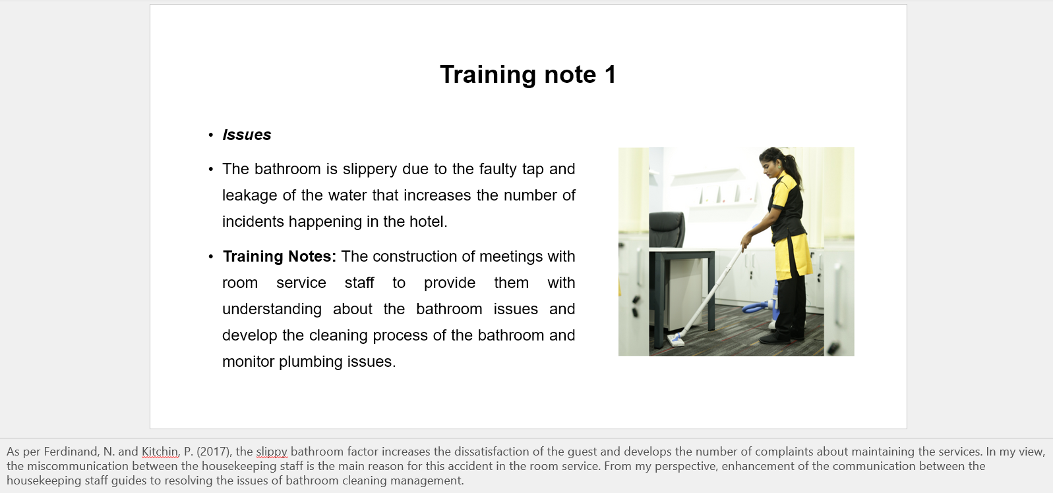

Training Notes: The training about bed cleaning and set-up process assists the housekeeping staff to understand the proper way to the bed-making process to resolve the raised issues. In my view, knowledge about bed-making and sheet-changing helps to develop cleanliness in the allocated rooms for guests.
The lack of communication skills among housekeeping staff reserves the issue of basin changing and bathroom management that increases the rate of guest complaints related to room services. This factor assists the hotel to notice the reduced number of guests due to poor service in room management (Rogers, 2008). In my view, the development of room services increases the problem of understanding the inspection process of room services and decreases the efficiency of the room management process.
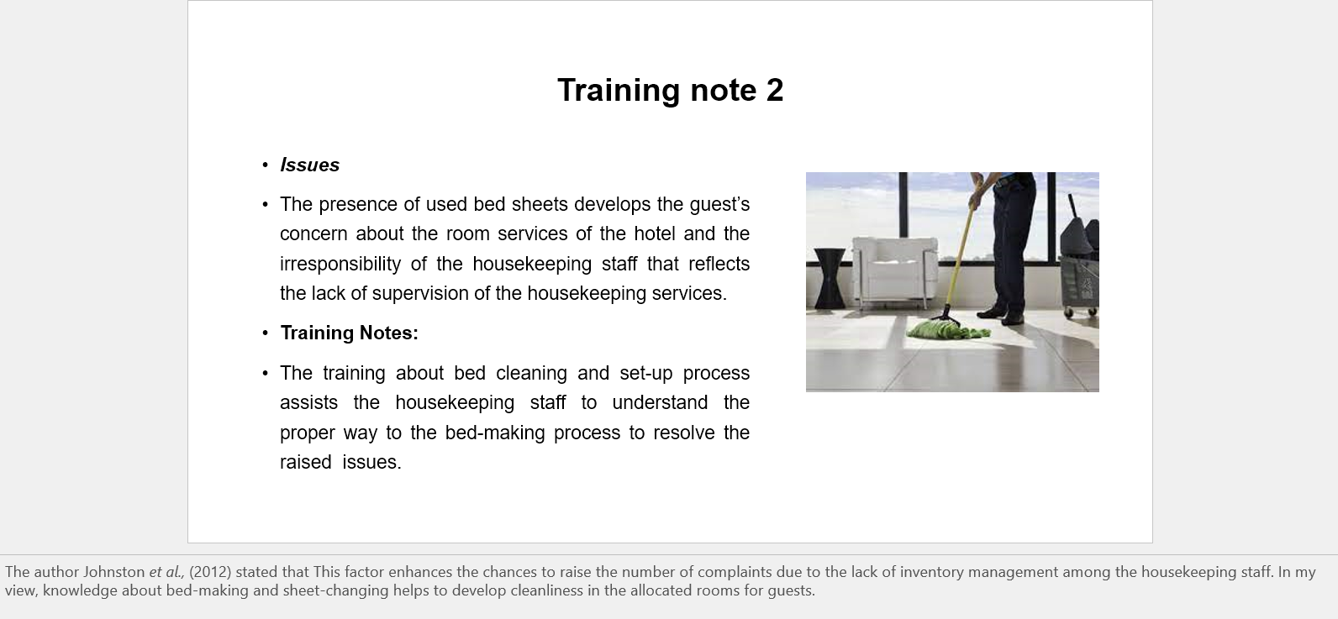
Training Notes: The introduction of daily meetings about housekeeping guides the room services process to mitigate bed sheet and bathroom-related issues and promote positive working culture. Being team leader of housekeeping, the development of communication between the housekeeping staff and managers helps to get effective results in a short period and increase the satisfaction level of guests.
The absence of proper observation about the needs of in-room services causes an increase in the issue of providing fresh towels in the allocated room and leads the guest to face issues in their freshen-up process. This factor increases the date of anger among the guest due to the irresponsibility of the housekeeping supervising process that promotes the conflict between guests and hotel services (Sharma et al., 2019).
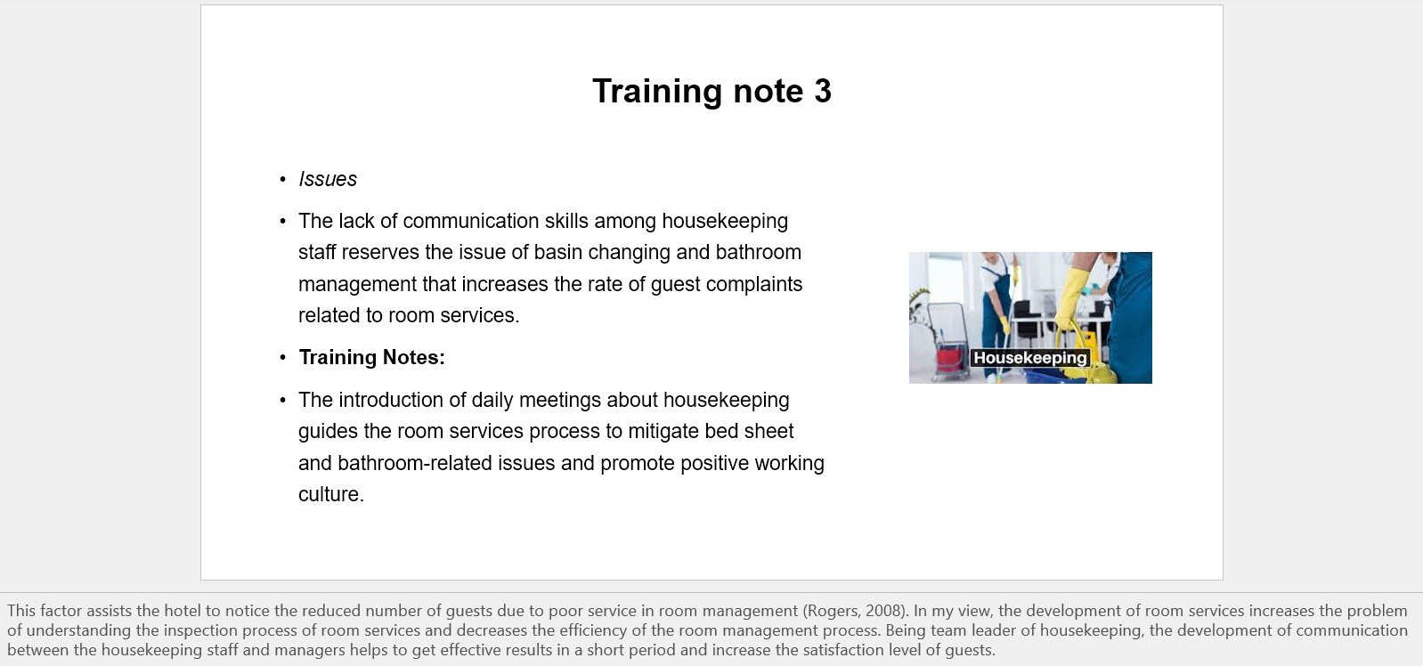

Training Notes: The enhancement of discussion about improving the areas of faulty in the service provided to guests to enhance the stay with the hotel services that motivate the staff to understand the standard of room service. In my view, the application of internal communication among the housekeeping staff guides to enhance the way of delivering fresh towels and bathroom essentials in the allocated rooms.
The lack of maintenance in AC services causes problems in developing the ventilation services in the allocated room and the absence of supervision of the room that reduces the quality of room services. This factor guides the operating team of housekeeping to not understand the way to promote the quality of services among the guests and management of housekeeping staff works (Tesone, 2010).
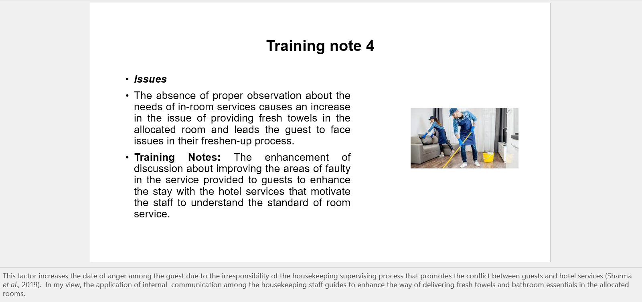

Training Notes: The development of the supervision process guides the housekeeping manager to encourage the staff to use the technology for tracking records of the completed work that reflects its impact on the operational process. Being part of the housekeeping staff, the operating process of housekeeping should keep an eye on the AC services to improve the efficiency of the room services.

The lack of proper training about the room services causes the problem of not understanding the possible outcome of housekeeping service that affected the room management of the guest in a negative way. The lack of training in the room cleaning process increases the chances to develop a level of conflict with the guests (Vallen and Vallen, 2012).
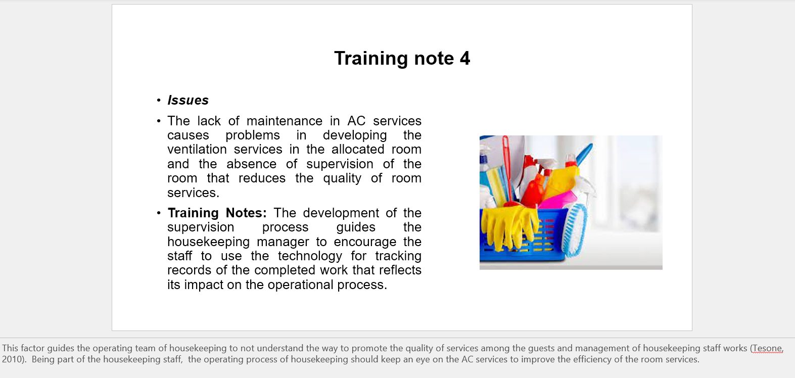

Training Notes: The knowledge about operating the machines such as washing machines, vacuum cleaners and garment steamers for enhancing the room service quality for the guests. From the aspect of housekeeping staff, the knowledge and practical experience in order to enhance the quality of room services.
The absence of inspection about room services develops the concern in providing services to the guest and faces issues due to the language barrier among the staff and guests. In the words of Wood (2013), this factor leads the room maintenance in generating a number of flaws that portray the event of a failure in providing services to the guests in the hotel services.
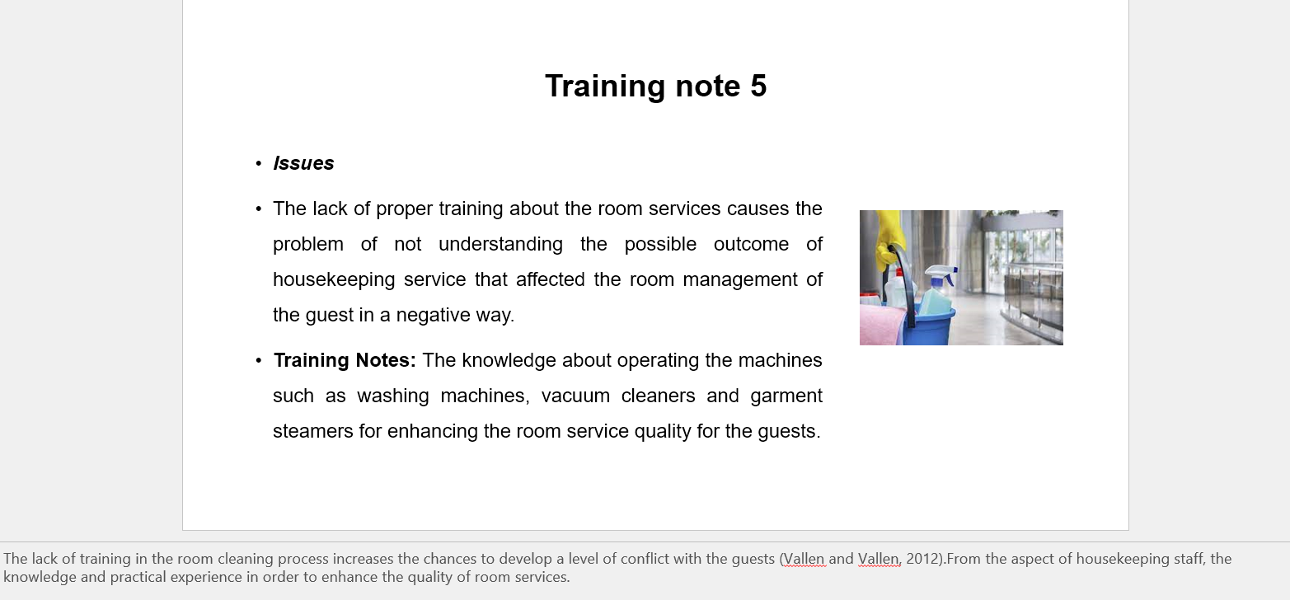

Training Notes: The observation of rooms assists to develop the quality of room services and promotes the execution of efficient services by the housekeeping staff for developing the approach towards hotel room offers. In my view, the acceptance of the idea in prompting the execution of the inspecting process to generate more efficient in-home services.
The ill-behaviour of the housekeeping staff develops conflict in the servicing process of room facilities that reflects the flaws in the managerial process of the supervision process that affected the guest’s staying process in a negative way. This factor guides in providing the overview of the mishap happening in the operation of housekeeping services (Hotelowner, 2022).
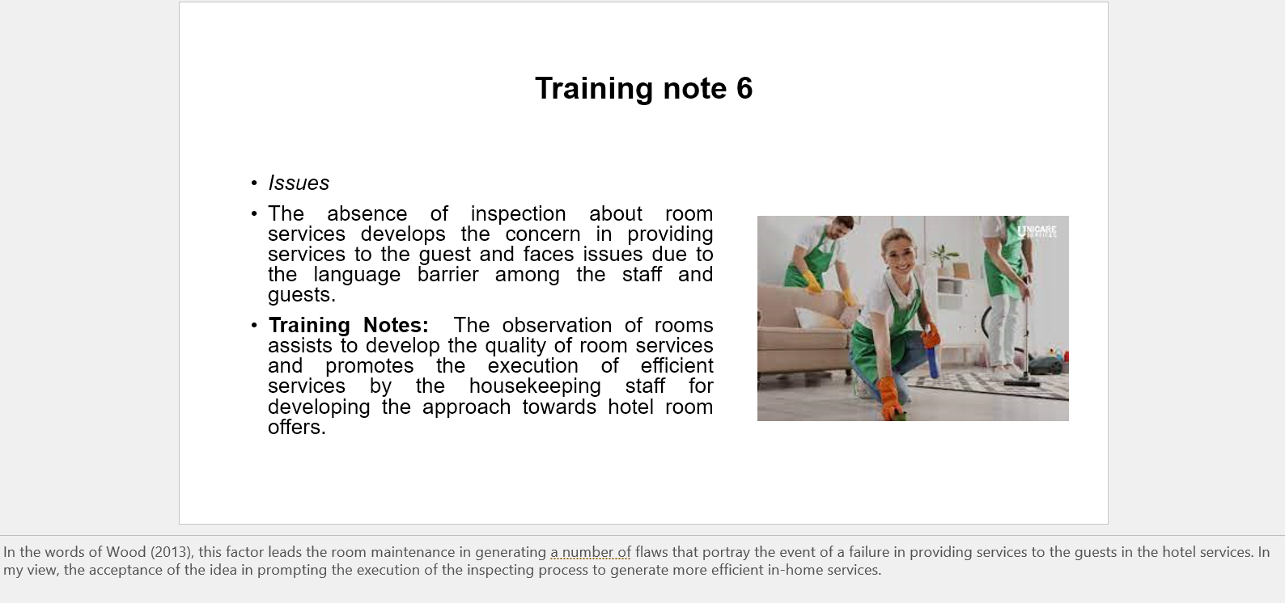

Training Notes: Guidance of the hotel authority guides to resolve the behavioural issues of staff that helps to promote the quality of housekeeping services and increases the level of satisfaction among the guest. In my view, this factor assists to enhance the staff's approach to the guest and resolving their complaints relates to housekeeping services.
The absence of optimisation of housekeeping standards generates a malfunction in the operating process of room services that affected the service delivery process of housekeeping staff. The lack of information on the on-site incidents happening in regulating room services through housekeeping management generates issues in understanding the approach of the housekeeping process (Bighospitality.co.uk, 2022).

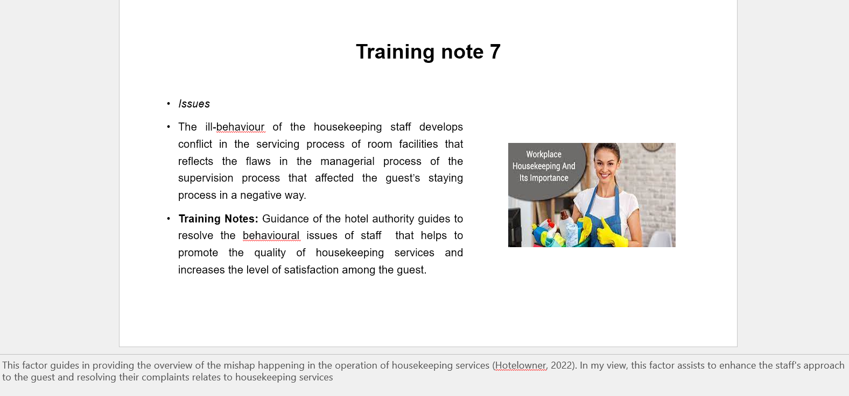

Training Notes: The training about housekeeping standards guides the management process to face difficult situations in generating the quality of service and mitigates the regulating issues of staff. From my perspective, the housekeeping supervisor should motivate the staff to develop a working approach to housekeeping service and improve the outcome of room services.
The lack of training about the managerial settings makes it difficult for managers to track down the progress of the operating activities in the room services that affected the housekeeping services. This factor develops queries among the staff in understanding the way of delivering the room services and maintaining the quality of standards in housekeeping work (SchroeterBooking, 2022).

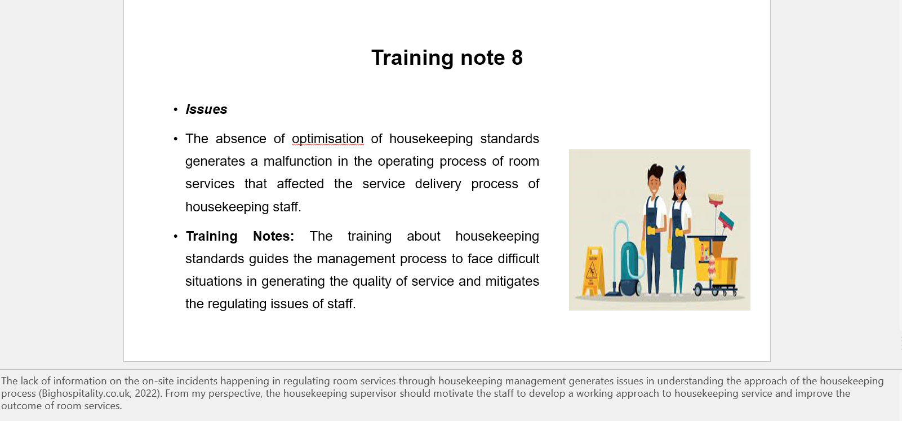

Training Notes: The construction of the training program guides the individual staff to determine the effectiveness of applying standard housekeeping in developing offerings towards guests. In my view. This factor generates a good amount of connection between the working standard and offering of the services that improve the way of representation of the guest’s services.

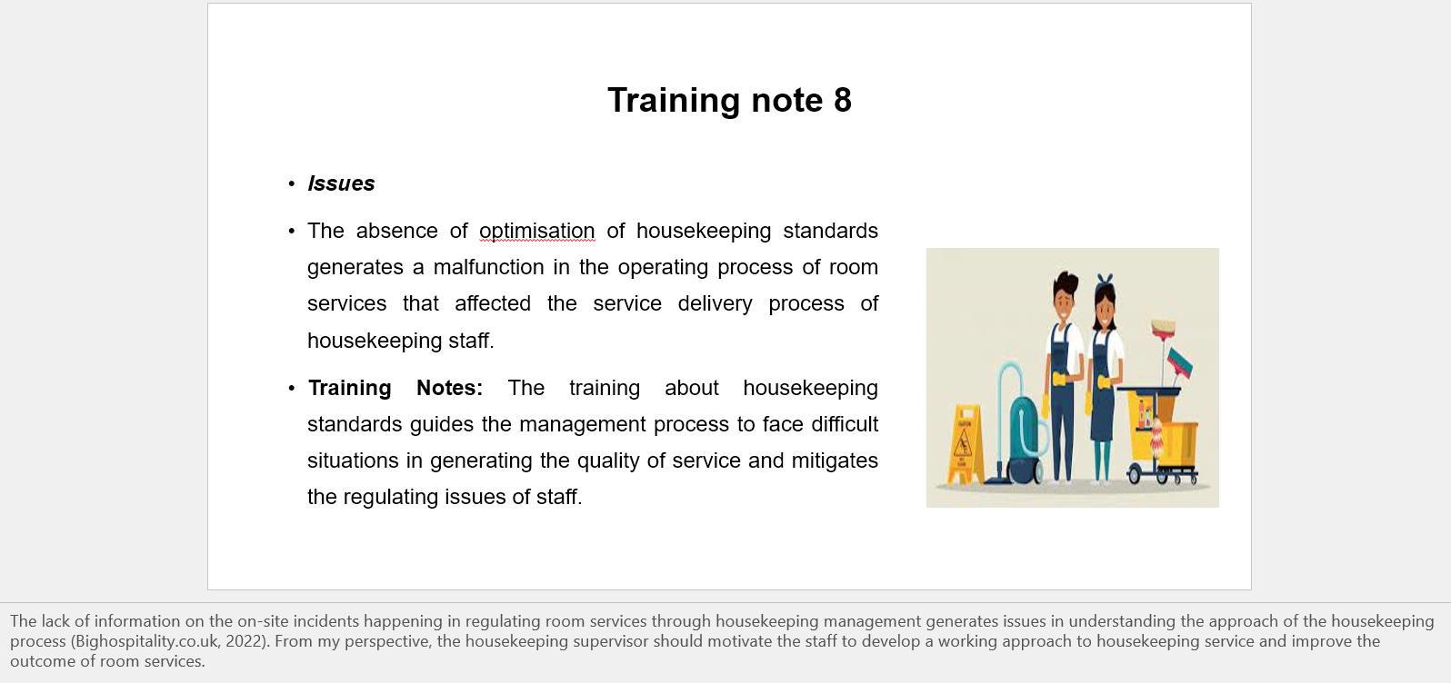
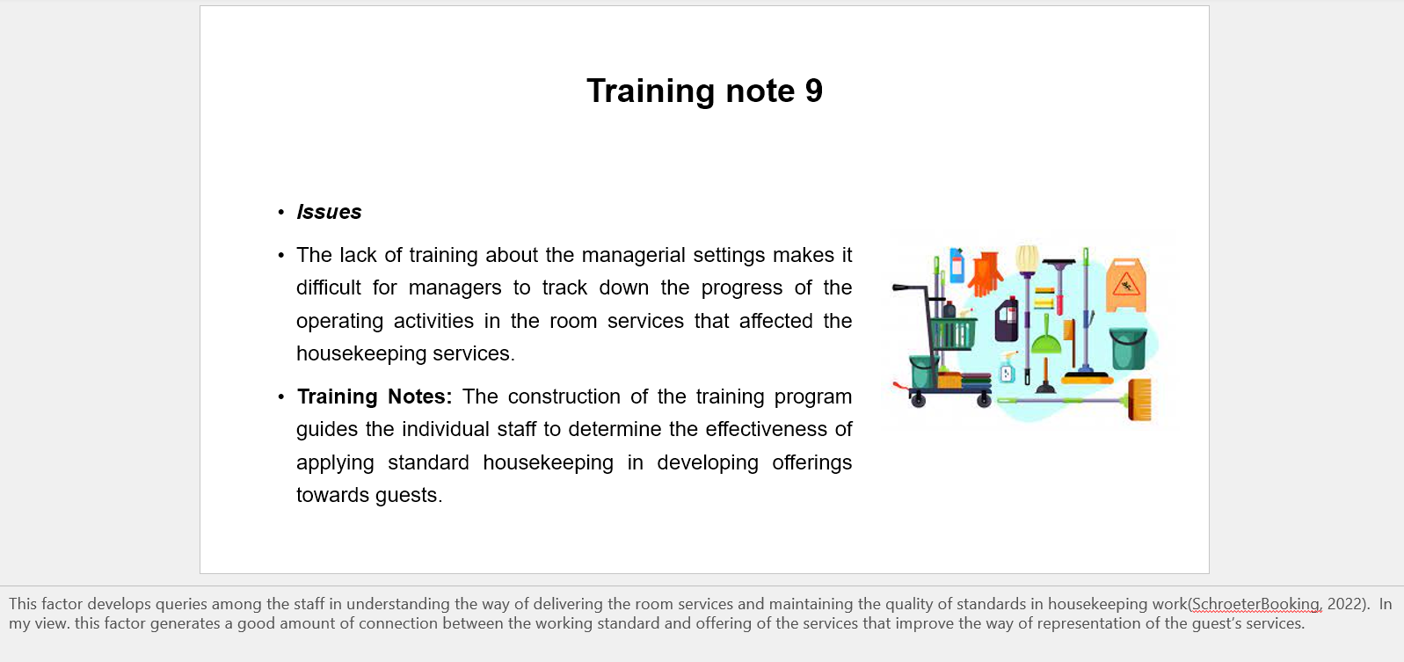

References

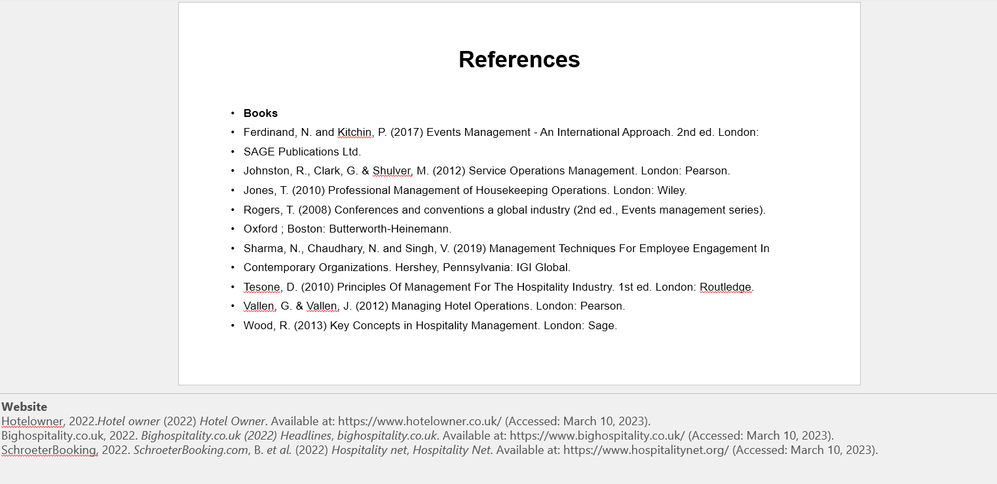

References
Component 1
Books
Bridger, E. (2018) Employee engagement: a practical introduction. 2nd ed. HR Fundamentals.London: CIPD and Kogan Page.
Casado, M. (2012) Housekeeping Management. London: Wiley.
Cottrell, S. (2019) The Study Skills Handbook. 5th ed. London: Red Globe Press.
Fallon, M. & Rutherford, D. (2010) Hotel Management and Operations. London: Pearson.
Hove [England]: Psychology Press.
India: Oxford University Press.
Leiter, M. P. and Bakker, A. B. (2010) Work Engagement : A Handbook of Essential Theory and Research.
Mullins, L. and Dossor, P. (2013) Hospitality Management and Organisational Behaviour. 5th ed. Harlow:
Pearson.
Quick, L. (2020) Managing Events. Real Challenges, Real Outcomes. London: SAGE Publications Ltd.
Raghubalan, G. and Raghubalan, S. (2016) Hotel Housekeeping - Operations And Management. 3rd ed.
Component 3
Books
Contemporary Organizations. Hershey, Pennsylvania: IGI Global.
Ferdinand, N. and Kitchin, P. (2017) Events Management - An International Approach. 2nd ed. London:
Johnston, R., Clark, G. & Shulver, M. (2012) Service Operations Management. London: Pearson.
Jones, T. (2010) Professional Management of Housekeeping Operations. London: Wiley.
Oxford ; Boston: Butterworth-Heinemann.
Rogers, T. (2008) Conferences and conventions a global industry (2nd ed., Events management series).
SAGE Publications Ltd.
Sharma, N., Chaudhary, N. and Singh, V. (2019) Management Techniques For Employee Engagement In
Tesone, D. (2010) Principles Of Management For The Hospitality Industry. 1st ed. London: Routledge.
Vallen, G. & Vallen, J. (2012) Managing Hotel Operations. London: Pearson.
Wood, R. (2013) Key Concepts in Hospitality Management. London: Sage.
Website
Bighospitality.co.uk, 2022. Bighospitality.co.uk (2022) Headlines, bighospitality.co.uk. Available at: https://www.bighospitality.co.uk/ (Accessed: March 10, 2023).
Hotelowner, 2022.Hotel owner (2022) Hotel Owner. Available at: https://www.hotelowner.co.uk/ (Accessed: March 10, 2023).
SchroeterBooking, 2022. SchroeterBooking.com, B. et al. (2022) Hospitality net, Hospitality Net. Available at: https://www.hospitalitynet.org/ (Accessed: March 10, 2023).

