Impact of CSR activities on profitability: A case study on John Lewis
Module: Dissertation (Proposal).
Lecturer Name: Anupam Mazumdar
Student Name: Georgiana Stan
Student number: 1915942
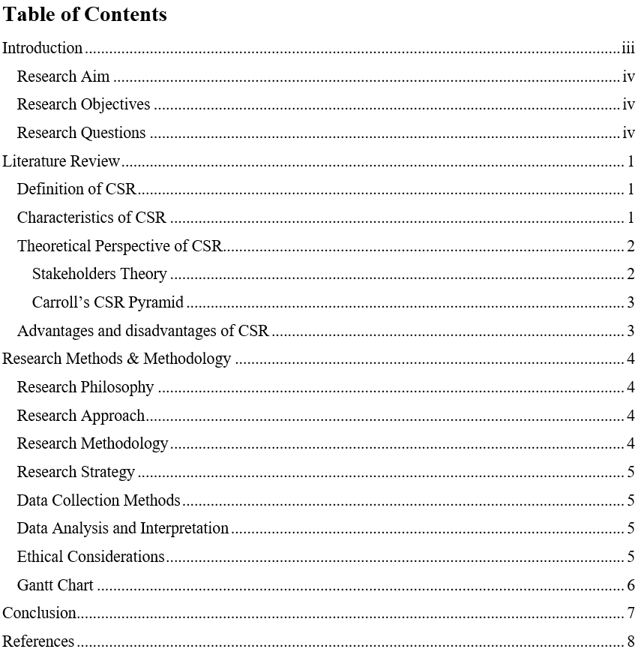

Introduction
With the changing dynamics of business, the expectations of society toward business organizations are increasing. Sun, Stewart and Pollard (2021) stated that in recent times, the term corporate social responsibility is gaining more prominence due to the appeal of society toward business organizations. Corporate social responsibility is a concept of management through which organizations include social and environmental concerns with the business operations (Gjerdrum Pedersen, 2022). World Business Council for Sustainable Development (WBCSD) defined CSR as the incessant commitment by business organizations to act in an ethical way in order to provide economic well-being while ensuring the quality of the workforce, the respective families of the employees, the local community and the society as a whole (WBCSD, 2022). Every business has certain responsibilities towards its stakeholders and performing these specific obligations ensures the profitability of the company. This issue of corporate social relationships is important in the current business landscape. Business organizations in society expert influential power and it is the responsibility of the business to exercise this power responsibly and for the betterment of the social causes (Gjerdrum Pedersen, 2022). The purpose of this research is to identify the importance of corporate social responsibility in order to increase the growth of the organisation and ensure increased profitability.

Research Aim
The aim of the research is to gauge the importance and impact of CSR activities on business profitability.

Research Objectives
The research objectives are:
- To understand the concept of corporate social responsibility in business.
- To identify the importance of CSR on a company’s profitability.
- To find out the CSR activities that can maximize the profitability of the business.

Research Questions
The research questions are:
- What is CSR in the context of business?
- What is the importance of CSR on business performance and profitability?
- CSR activities can maximize the profitability of the business and ensure business growth. [this is not a question; this is a statement. You can rephrase this properly to make it a standard research question].

Literature Review
The demand for performing wider social values on business and organisation managers is all-time high especially in the events of globalization, in the face of insecurity and poverty, mistrust in the global business arena and depletion of ozone layers. As per Mayorova (2021), the demand for CSR activities got intense in the initiation of the 21st century after the European Commission declared 2005 as the year of Corporate Social Responsibility in European Union countries. To comply with the initiatives taken by European Commission, countries like the UK have appointed a CSR minister in the Department of Trade and Industry, France established mandatory CSR performance standards on business, and Denmark launched a specialized CSR-focused research Centre namely Copenhagen Centre etc. (Mayorova, 2021).
European Union (2022) defines CSR as the voluntary inclusion of social and ecological concerns into companies' business operations and maintaining a healthy relationship with the stakeholders of the organisation. The definition further posits that being socially responsible doesn’t mean solely performing or fulfilling the applicable legal goals and applications, rather it means going beyond and investing more in the protection of the environment, development of stakeholders relations and developing human capital.
The definition of International Organisation for Standardization (2022) includes CSR as the responsibility of an organisation that impacts the decision and activities of the company’s operations and obligations towards society and the environment (International Organisation for Standardization, 2022). It also means transparency in behaviour and contributing to sustainable development which also includes the well-being of the society, taking consideration of the stakeholders, compliance with the existing laws and regulations, and maintaining an international sustainable standard.

Characteristics of CSR
According to Tilt (2020), there are six core characteristics of CSR which are voluntary, management of externalities, multiple stakeholders’ orientation, alignment of social and economic responsibilities, practices and values, and beyond philanthropy. The first aspect or characteristic of CSR is the nature of voluntarism which means all the company should perform CSR activities voluntarily. CSR activities that are forced or just for eye wash will not be considered CSR activities. So, the voluntary nature of CSR is important. Externalities are CSR activities that are not taken care of directly (Tilt, 2020). For instance, the degradation of the environment is considered an externality as it will be felt by the general public through the production process. CSR activities should deal with such externalities as minimization of the rationalization impact, protecting the rights of the workers, positive stakeholders’ management etc. The third characteristic of CSR is to locate the orientation of the stakeholders by basing on three important attributes which are power, urgency and legitimate claim. Mayorova (2021) suggested that CSR activities should manage the balance between different stakeholders' needs so that there is no chance of raising stakeholders' conflicts of interest. This is one of the most important features of CSR. Corporate social responsibilities are about managing and following a set of business practices that deal with different societal issues. The last characteristic is CSR is the activities that should go beyond philanthropy and should be integrated with the core policy of business.

Theoretical Perspective of CSR on profitability
The amount of attention the issue of CSR has received over the years is overwhelming. For this reason, many theories and frameworks have been developing over the years.

Stakeholders Theory
Stakeholders’ theory focused on the relationship between the business and the group of people that are integrated into the process of achieving organisational objectives. To Chen, Srinidhi, Tsang and Yu (2021), the stakeholder's theory stated that organizations should not only look for their benefits rather then they should seek the benefits of different stakeholders associated with the organisation. The theory classifies CSR activities into three classes which are descriptive, normative and instrumental. Wasieleski and Weber (2021) stated that the descriptive aspects of CSR focus on managing the relationship with the stakeholders, normative aspects deal with treating stakeholders, and instrumental aspects focus on aligning the relationship between corporate performance and stakeholder management.

Carroll’s CSR Pyramid
Carroll’s CSR pyramid classifies four responsibilities in terms of managing CSR for the organisation. The four types of CSR activities include economic responsibilities, legal responsibilities, ethical responsibilities and philanthropic responsibilities (Nalband and Kelabi, 2021). The economic responsibilities focused on becoming economically profitable. It also includes being cost-effective, appropriate investment, and attentive to revenue. Legal responsibilities include complying and obeying the law and practicing appropriate business practices. Ethical responsibilities mean doing what is right for society and for the business within ethical boundaries. Lastly, philanthropic responsibilities mean becoming a good corporate citizen.

Advantages and disadvantages of CSR in terms of profitability of the companies
There are many advantages and disadvantages of CSR activities for improving business performance and profitability. It can enhance the image of the business. According to Sun, Stewart and Pollard (2021), the company can get the good publication of being a follower of regulatory authorities which can eventually help the company to draw in new investment. Besides, the company can increase its values and profitability margin and CSR acts as a motivating factor for the employees. Besides, there are some disadvantages too such as the expenses of the company will increase. Nalband and Kelabi (2021), argued that the company may face resistance from investors. Another disadvantage is it promotes greenwashing. If the company’s CSR policies are not made with enough planning, they can backfire in an instant.

Research Methods & Methodology

Research Philosophy
The research philosophy that will be used here is positivism. The reason for using positivism is because of the objective nature of the research (John, 2022). As the research will undergo minimal to no interaction with any kind of primary data source, the positivist philosophy is suitable for this research purpose. Besides, the research topic is dependent on gaining factual knowledge which purports the uses of positivism.

Research Approach
The research will follow a deductive approach. A deductive approach to research tests the causal relationship between variables in research (Rushton and Lucas, 2021). It also tests the hypothesis in a research project. Moreover, this approach is based on deducting conclusions from predefined propositions or conclusions. As the research will test the relationship and impact between CSR and profitability based on the premise of the stakeholder's theory, and Carroll’s CSR pyramid, the deductive research approach is selected.

Research Methodology
The research methods that will be used here are qualitative research methods. Qualitative methods are used to locate rich descriptive findings about a research topic (Rushton and Lucas, 2021). As the research topic will deal with factual data rather than hands-on experience by taking interviews, qualitative research methods will be used here. Besides, the research will seek facts and information from population-supported experience and assisted perception, qualitative research methods are suitable here. Moreover, qualitative research methods are helpful in identifying problems from a research project. As this research project is also intended for these Objectives, qualitative research methods are best suited.

Research Strategy
The secondary research strategy will be followed in this research strategy. As the research will only collect factual information rather than talking face to face interviews with the participants, the second research strategy is suitable here. Secondary research is very time convenient as it can be completed within a short period.

Data Collection Methods
Data for this research will be collected from secondary sources. Secondary sources such as journals, newspaper articles, and books will be used for data collection. Journals such as Science Direct, Research Gate, and Springer link will be used for data collection for this research purpose.

Data Analysis and Interpretation
For qualitative data analysis, the research will use a thematic analysis. For performing thematic analysis, the six steps process suggested by Kiger and Varpio will be applied here (Kiger and Varpio, 2020). First, collected data will get acquainted with the analysis to generate themes. After finding out the theme, the theme will be named. As the research will try to collect the experience of businesses and how their business profitability was impacted due to CSR activities, from different case studies and secondary sources, thematic data analysis will be the best way to analyses this qualitative data.

Ethical Considerations
Data that will be collected from journals, books, the internet or any public forums, the main author of the data should be acknowledged in the research project. If the obtained data is a part of another research and if the data is not freely available, then written permission from the actual research team should be obtained.

Gantt Chart
Activity | 5 May-8 May 2022 | 10 May -13 May 2022 | 25 May 2022 – 28 May 2022 | 1 June-10 June 2022 | 13 June 2022 – 29 June 2022 | 5 June -10 June 2022 | 11  July-  17  July 2022 | 18  July -24  July 2022 | 25  July -30  July 2022
Research Proposal
Background of the Research
Methodology of the research
Data Collection
Data Interpretation
Conclusion and Recommendations
Conclusion

Conclusion
CSR is an important aspect of business in today’s competitive business landscape and any company devoid of such responsibility will find it difficult to become profitable and sustainable. A business develops through interconnectedness with various stakeholders such as customers, suppliers, strategic partners, communities etc. Without synergy between these stakeholders, a business cannot improve its profitability and growth. The research proposal will address the issues and impact of CSR on business profitability.

References
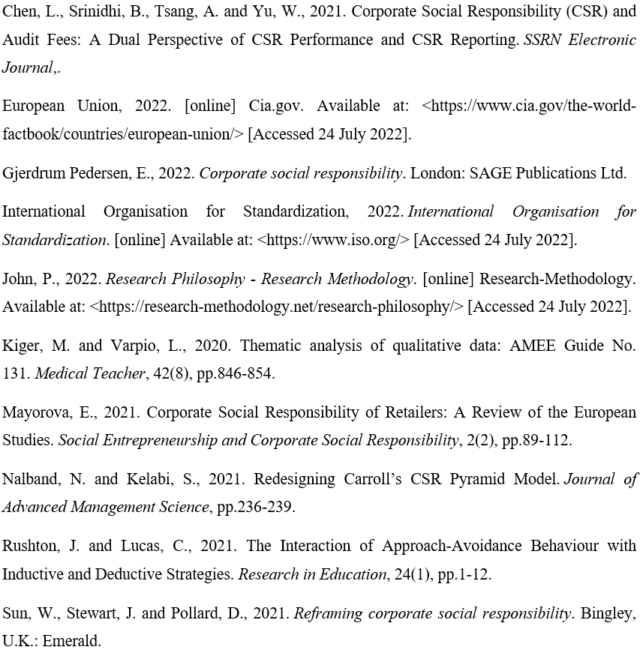Tilt, C., 2020. Corporate social responsibility research: the importance of context. International Journal of Corporate Social Responsibility, 1(1).
Wasieleski, D. and Weber, J., 2021. Stakeholder management.
WBCSD, 2022. World Business Council for Sustainable Development (WBCSD). [online] World Business Council for Sustainable Development (WBCSD). Available at: <https://www.wbcsd.org/> [Accessed 24 July 2022].

